Supplementary figures and tables
Fig. S1 Chromosomal distribution of HIPP genes in P. virgatum. Chromosome names and gene identifiers are indicated on the left and right sides of each chromosome, respectively. The vertical axis represents chromosome length as a reference

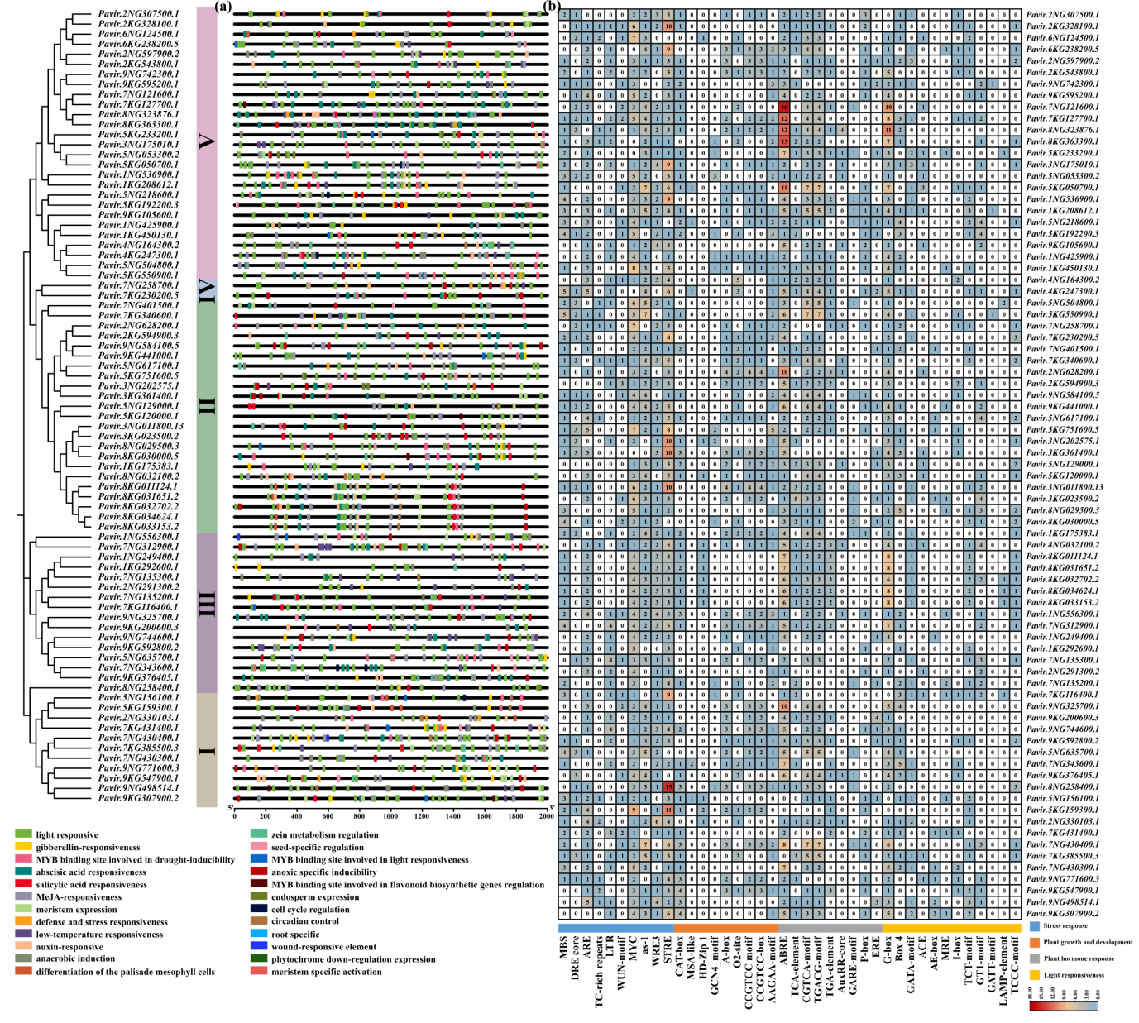
Fig. S2 Analysis of cis-acting elements in the promoter regions of the PvHIPP gene family. The figure illustrates the major types and distributions of cis-acting elements within the 2000-bp upstream regions of the PvHIPP transcription start sites. (a) Distribution of cis-acting elements within the promoter regions. (b) Statistical analysis of the identified cis-acting elements according to functional categories

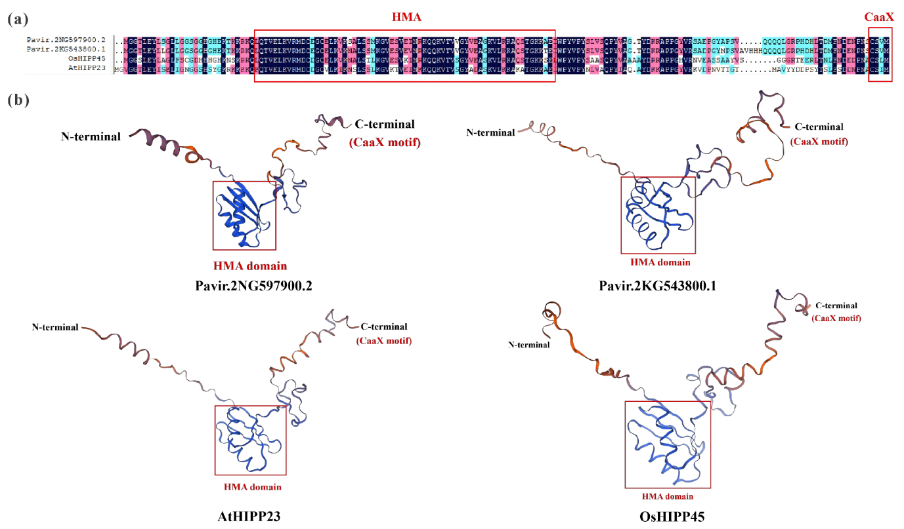
Fig. S3 Structural analysis of PvHIPP23 and its homologous proteins. (a) Amino acid sequence alignment of PvHIPP23 and its homologous proteins. (b) Predicted tertiary structures of PvHIPP23 and its homologous proteins. Red boxes indicate the conserved HMA domain and C-terminal CaaX motif

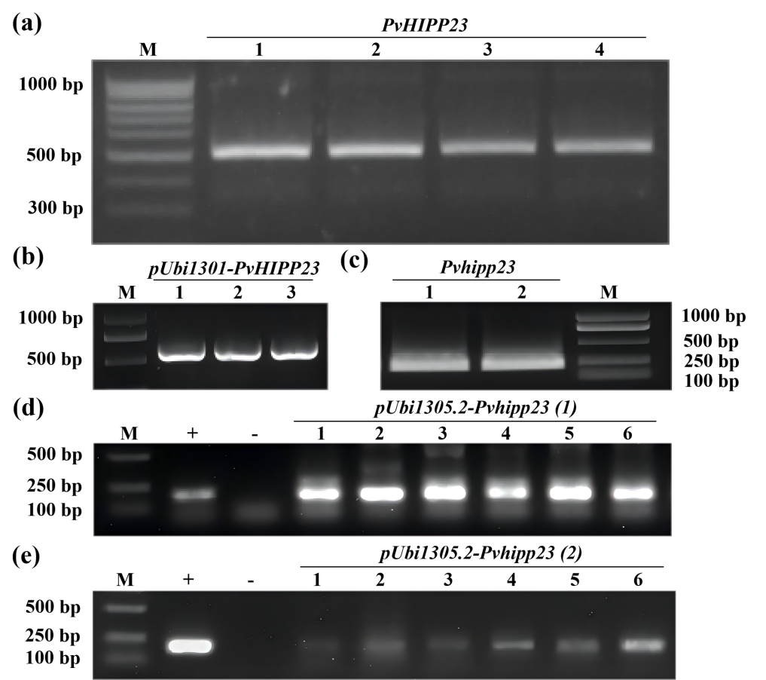
Fig. S4 Amplification of PvHIPP23 gene fragments and verification of recombinant vectors in Agrobacterium single colonies. (a) Amplification of PvHIPP23 gene fragments. Lanes 1–4 represent PvHIPP23 gene fragments. (b) PCR verification of pUbi1301-PvHIPP23 in Agrobacterium single colonies. Lanes 1–3 represent positive single colonies containing pUbi1301–PvHIPP23. (c) Amplification of PvHIPP23 gene interference fragments. Lanes 1 and 2 represent PvHIPP23 interference fragments. (d, e) PCR verification of forward-connected interference fragments (d) and reverse-connected interference fragments (e) of PvHIPP23 interference vectors in Agrobacterium single colonies. +: positive plasmids of PvHIPP23 interference vectors; −: H₂O; lanes 1–6: positive single colonies containing PvHIPP23 interference vectors in Agrobacterium. M: DNA marker

Fig. S5 Callus induction and culture following genetic transformation of switchgrass. (a) Callus induction. (b) Screening and culture of resistant calli. (c) Differentiation and culture of resistant calli. (d) Rooting and culture of resistant calli. (e) Greenhouse cultivation of regenerated plants

Fig. S6 PCR verification of PvHIPP23-overexpressing and RNAi switchgrass lines. (a, b) Verification of PvHIPP23-overexpressing plants. +: positive plasmids of PvHIPP23 overexpression vectors. OE1–OE3: positive PvHIPP23-overexpressing switchgrass lines. (c–f) Verification of PvHIPP23-RNAi plants. (c, e) Verification of forward-connected interference fragments. (d, f) Verification of reverse-connected interference fragments. +: positive plasmids of PvHIPP23 interference vectors. RNAi-PvHIPP23 (1): verification of forward-connected interference fragments in PvHIPP23-RNAi switchgrass. RNAi-PvHIPP23 (2): verification of reverse-connected interference fragments in PvHIPP23-RNAi switchgrass. Lanes 1–33 represent different PvHIPP23-RNAi switchgrass lines. M: DNA marker. −: H₂O. WT: wild-type switchgrass

Fig. S7 Analysis of PvHIPP23 expression levels in PvHIPP23-overexpressing and RNAi switchgrass lines. (a) Expression levels of PvHIPP23 in overexpressing lines. (b) Expression levels of PvHIPP23 in RNAi lines. WT: wild-type switchgrass. OE1–OE3: positive PvHIPP23-overexpressing switchgrass lines. RNAi: positive PvHIPP23-RNAi switchgrass lines. *, **, and *** indicate significant differences in PvHIPP23 expression between transgenic lines and WT plants at P < 0.05, P < 0.01, and P < 0.001, respectively

Fig. S8 PCR verification of pUbi1301–PvHIPP23 and analysis of PvHIPP23 expression levels. (a) PCR verification of pUbi1301–PvHIPP23 in Agrobacterium single colonies. Lanes 1–6 represent monoclonal colonies of transformed Agrobacterium GV3101. (b) PCR verification of pUbi1301–PvHIPP23 in T1 Arabidopsis. Lanes 2–10 represent T1 PvHIPP23 ectopic expression Arabidopsis lines. M: DNA marker; +: positive control of recombinant plasmid pUbi1301–PvHIPP23; −: H₂O. (c) Relative expression levels of PvHIPP23 in T3 Arabidopsis. WT: Arabidopsis Col-0. OP (overexpression of PvHIPP23)2-10, OP6-3, OP6-6, OP6-8, OP8-2, OP8-4, and OP10-5 represent T3 PvHIPP23-expressing Arabidopsis lines. The expression level of PvHIPP23 in WT was normalized to 1. Data represent mean ± SD (n = 3). Asterisks indicate significant differences compared with WT: * indicates P < 0.05, ** indicates P < 0.01, and *** indicates P < 0.001
Fig. S9 Identification and growth phenotype analysis of PvHMA2.1-overexpressing switchgrass. (a) PCR verification in Agrobacterium single colonies. Lanes 1–5 represent monoclonal colonies of pUbi1301–PvHMA2.1-transformed Agrobacterium EHA105. (b) PCR verification of transgenic switchgrass plants. −: H₂O; M: DNA marker; +: positive control of recombinant plasmid pUbi1301-PvHMA2.1. (c) Relative expression levels of PvHMA2.1 in switchgrass. Expression levels of PvHMA2.1 in WT were normalized to 1. Data represent mean ± SD (n = 3). (d–g) Growth phenotype analysis of PvHMA2.1-overexpressing switchgrass at the R2 stage. Analysis of plant height (d); spike, leaf, and internode length (e); leaf and internode width (f); and numbers of leaves, nodes, and spikelets (g). Data represent mean ± SD (n ≥ 5). WT: wild-type switchgrass. OE1–OE5: PvHMA2.1-overexpressing switchgrass lines. Asterisks indicate significant differences compared with WT: * indicates P < 0.05, ** indicates P < 0.01, and *** indicates P < 0.001
Table S1 Accession numbers of HIPPs in P. virgatum, A. thaliana, and O. sativa
Species | Accession numbers | Sequence names
P. virgatum | Pavir.1NG556300.1
P. virgatum | Pavir.1NG536900.1
P. virgatum | Pavir.1NG425900.1
P. virgatum | Pavir.1NG249400.1
P. virgatum | Pavir.2NG330103.1
P. virgatum | Pavir.2NG307500.1
P. virgatum | Pavir.2NG291300.2
P. virgatum | Pavir.2NG628200.1
P. virgatum | Pavir.2NG597900.2 | PvHIPP23
P. virgatum | Pavir.3NG011800.13
P. virgatum | Pavir.3NG202575.1
P. virgatum | Pavir.3NG175010.1
P. virgatum | Pavir.4NG164300.2
P. virgatum | Pavir.5NG156100.1
P. virgatum | Pavir.5NG635700.1
P. virgatum | Pavir.5NG218600.1
P. virgatum | Pavir.5NG617100.1
P. virgatum | Pavir.5NG053300.2
P. virgatum | Pavir.5NG129000.1
P. virgatum | Pavir.5NG504800.1
P. virgatum | Pavir.6NG124500.1
P. virgatum | Pavir.7NG430300.1
P. virgatum | Pavir.7NG430400.1
P. virgatum | Pavir.7NG135300.1
P. virgatum | Pavir.7NG135200.1
P. virgatum | Pavir.7NG258700.1
P. virgatum | Pavir.7NG343600.1
P. virgatum | Pavir.7NG312900.1
P. virgatum | Pavir.7NG401500.1
P. virgatum | Pavir.7NG121600.1
P. virgatum | Pavir.8NG323876.1
P. virgatum | Pavir.8NG032100.2
P. virgatum | Pavir.8NG258400.1
P. virgatum | Pavir.8NG029500.3
P. virgatum | Pavir.9NG771600.3
P. virgatum | Pavir.9NG325700.1
P. virgatum | Pavir.9NG744600.1
P. virgatum | Pavir.9NG498514.1
P. virgatum | Pavir.9NG584100.5
P. virgatum | Pavir.9NG742300.1
P. virgatum | Pavir.1KG208612.1
P. virgatum | Pavir.1KG292600.1
P. virgatum | Pavir.1KG175383.1
P. virgatum | Pavir.1KG450130.1
P. virgatum | Pavir.2KG594900.3
P. virgatum | Pavir.2KG543800.1
P. virgatum | Pavir.2KG328100.1
P. virgatum | Pavir.3KG023500.2
P. virgatum | Pavir.3KG361400.1
P. virgatum | Pavir.4KG247300.1
P. virgatum | Pavir.5KG751600.5
P. virgatum | Pavir.5KG120000.1
P. virgatum | Pavir.5KG159300.1
P. virgatum | Pavir.5KG233200.1
P. virgatum | Pavir.5KG192200.3
P. virgatum | Pavir.5KG050700.1
P. virgatum | Pavir.5KG550900.1
P. virgatum | Pavir.6KG238200.5
P. virgatum | Pavir.7KG431400.1
P. virgatum | Pavir.7KG127700.1
P. virgatum | Pavir.7KG340600.1
P. virgatum | Pavir.7KG230200.5
P. virgatum | Pavir.7KG116400.1
P. virgatum | Pavir.7KG385500.3
P. virgatum | Pavir.8KG030000.5
P. virgatum | Pavir.8KG363300.1
P. virgatum | Pavir.8KG011124.1
P. virgatum | Pavir.8KG031651.2
P. virgatum | Pavir.8KG032702.2
P. virgatum | Pavir.8KG034624.1
P. virgatum | Pavir.8KG033153.2
P. virgatum | Pavir.9KG592800.2
P. virgatum | Pavir.9KG376405.1
P. virgatum | Pavir.9KG105600.1
P. virgatum | Pavir.9KG547900.1
P. virgatum | Pavir.9KG307900.2
P. virgatum | Pavir.9KG200600.3
P. virgatum | Pavir.9KG595200.1
P. virgatum | Pavir.9KG441000.1
A. thaliana | AT2G28090.1 | AtHIPP01
A. thaliana | AT5G26690.1 | AtHIPP02
A. thaliana | AT5G60800.1 | AtHIPP03
A. thaliana | AT1G29000.1 | AtHIPP04
A. thaliana | AT2G36950.1 | AtHIPP05
A. thaliana | AT5G03380.1 | AtHIPP06
A. thaliana | AT5G63530.1 | AtHIPP07
A. thaliana | AT3G02960.1 | AtHIPP08
A. thaliana | AT5G24580.1 | AtHIPP09
A. thaliana | AT5G52720.1 | AtHIPP10
A. thaliana | AT5G52730.1 | AtHIPP11
A. thaliana | AT5G52740.1 | AtHIPP12
A. thaliana | AT5G52750.1 | AtHIPP13
A. thaliana | AT5G52760.1 | AtHIPP14
A. thaliana | AT1G63950.1 | AtHIPP15
A. thaliana | AT3G07600.1 | AtHIPP16
A. thaliana | AT1G57780.1 | AtHIPP17
A. thaliana | AT4G13380.1 | AtHIPP18
A. thaliana | AT3G21490.1 | AtHIPP19
A. thaliana | AT1G71050.1 | AtHIPP20
A. thaliana | AT5G17450.1 | AtHIPP21
A. thaliana | AT1G22990.1 | AtHIPP22
A. thaliana | AT4G39700.1 | AtHIPP23
A. thaliana | AT4G08570.1 | AtHIPP24
A. thaliana | AT4G35060.1 | AtHIPP25
A. thaliana | AT4G38580.1 | AtHIPP26
A. thaliana | AT5G66110.1 | AtHIPP27
A. thaliana | AT1G06330.1 | AtHIPP28
A. thaliana | AT1G29100.1 | AtHIPP29
A. thaliana | AT2G18196.1 | AtHIPP30
A. thaliana | AT3G48970.1 | AtHIPP31
A. thaliana | AT3G06130.1 | AtHIPP32
A. thaliana | AT5G19090.1 | AtHIPP33
A. thaliana | AT3G05220.1 | AtHIPP34
A. thaliana | AT1G56210.1 | AtHIPP35
A. thaliana | AT5G27690.1 | AtHIPP36
A. thaliana | AT1G23000.1 | AtHIPP37
A. thaliana | AT1G01490.1 | AtHIPP39
A. thaliana | AT1G55790.1 | AtHIPP41
A. thaliana | AT3G04900.1 | AtHIPP42
A. thaliana | AT3G05920.1 | AtHIPP43
A. thaliana | AT4G10465.1 | AtHIPP44
A. thaliana | AT3G56891.1 | AtHIPP45
A. thaliana | AT5G48290.1 | AtHIPP46
A. thaliana | AT3G20180.1 | AtHIPP47
O. sativa | LOC_Os04g32800.1 | OsHIPP01
O. sativa | LOC_Os04g32810.1 | OsHIPP02
O. sativa | LOC_Os04g32820.1 | OsHIPP03
O. sativa | LOC_Os04g32840.1 | OsHIPP04
O. sativa | LOC_Os04g32850.1 | OsHIPP05
O. sativa | LOC_Os03g29920.1 | OsHIPP06
O. sativa | LOC_Os07g41600.1 | OsHIPP07
O. sativa | LOC_Os03g54050.1 | OsHIPP08
O. sativa | LOC_Os07g48390.1 | OsHIPP09
O. sativa | LOC_Os10g14050.1 | OsHIPP10
O. sativa | LOC_Os11g41120.1 | OsHIPP11
O. sativa | LOC_Os04g39290.1 | OsHIPP12
O. sativa | LOC_Os02g37160.1 | OsHIPP13
O. sativa | LOC_Os04g39320.1 | OsHIPP14
O. sativa | LOC_Os04g39300.1 | OsHIPP15
O. sativa | LOC_Os02g37330.1 | OsHIPP16
O. sativa | LOC_Os09g09930.1 | OsHIPP17
O. sativa | LOC_Os04g39360.1 | OsHIPP18
O. sativa | LOC_Os04g39350.1 | OsHIPP19
O. sativa | LOC_Os04g39010.1 | OsHIPP20
O. sativa | LOC_Os09g09830.1 | OsHIPP21
O. sativa | LOC_Os04g56570.1 | OsHIPP22
O. sativa | LOC_Os01g14700.1 | OsHIPP23
O. sativa | LOC_Os04g57200.1 | OsHIPP24
O. sativa | LOC_Os10g38870.1 | OsHIPP25
O. sativa | LOC_Os12g23280.1 | OsHIPP26
O. sativa | LOC_Os03g03500.1 | OsHIPP27
O. sativa | LOC_Os10g14870.1 | OsHIPP28
O. sativa | LOC_Os04g32030.1 | OsHIPP29
O. sativa | LOC_Os04g50020.1 | OsHIPP30
O. sativa | LOC_Os02g57360.1 | OsHIPP31
O. sativa | LOC_Os07g20340.1 | OsHIPP32
O. sativa | LOC_Os02g30650.1 | OsHIPP33
O. sativa | LOC_Os03g64340.1 | OsHIPP34
O. sativa | LOC_Os10g30450.1 | OsHIPP35
O. sativa | LOC_Os03g05750.1 | OsHIPP36
O. sativa | LOC_Os10g30430.1 | OsHIPP37
O. sativa | LOC_Os01g20830.1 | OsHIPP38
O. sativa | LOC_Os03g02860.1 | OsHIPP39
O. sativa | LOC_Os10g39210.1 | OsHIPP40
O. sativa | LOC_Os03g06080.1 | OsHIPP41
O. sativa | LOC_Os04g17100.1 | OsHIPP42
O. sativa | LOC_Os01g32330.1 | OsHIPP43
O. sativa | LOC_Os09g20000.1 | OsHIPP44
O. sativa | LOC_Os03g26650.1 | OsHIPP45
O. sativa | LOC_Os08g31140.1 | OsHIPP46
O. sativa | LOC_Os01g55320.1 | OsHIPP47
O. sativa | LOC_Os06g35060.1 | OsHIPP48
O. sativa | LOC_Os01g48710.1 | OsHIPP49
O. sativa | LOC_Os01g03490.1 | OsHIPP50
O. sativa | LOC_Os11g05010.1 | OsHIPP51
O. sativa | LOC_Os12g05040.1 | OsHIPP52
O. sativa | LOC_Os03g22490.1 | OsHIPP53
O. sativa | LOC_Os07g47480.1 | OsHIPP54
O. sativa | LOC_Os05g05820.1 | OsHIPP55
O. sativa | LOC_Os01g70710.1 | OsHIPP56
O. sativa | LOC_Os05g30570.1 | OsHIPP57
O. sativa | LOC_Os04g52530.1 | OsHIPP58
O. sativa | LOC_Os08g10490.1 | OsHIPP59

Table S2 Primers in the research
Primer name | Primer sequences (5'→3')
qPvHIPP23-F | TGGACTGCGAGGGCTGTGAG
qPvHIPP23-R | CACCGTCACCTTCTGCTGCTTC
qPvHMA2.1-F | TGGACGGAGTGAGGTTGATGAGAG
qPvHMA2.1-R | GCAGAGTTGTCAGCCATAGCAGTC
qUbiquitin-F | CAGCGAGGGCTCAATAATTCCA
qUbiquitin-R | TCTGGCGGACTACAATATCCA
qAtActin2-F | GTCGTACAACCGGTATTGTG
qAtActin2-R | GAGCTGGTCTTTGAGGTTTC
gfp-PvHIPP23-F | GGGGACAAGTTTGTACAAAAAAGCAGGCTTCATGGGGGGCACCTTGGAG
gfp-PvHIPP23-R | GGGGACCACTTTGTACAAGAAAGCTGGGTCCATGACCGAGCAGGAATTCG
PvHIPP23-M-F | CGCGGATCCGCGATGGGGGGCACCTTGGAG
PvHIPP23-M-R | CGGGGTACCCCGTCACATGACCGAGCAGGAATTCG
PvHIPP23-F | ATGGGGGGCACCTTGGAG
PvHIPP23-R | TCACATGACCGAGCAGGAATTCG
Pvhipp23-M-F | TGCTCTAGAGTCGACCCTACGTGCCCTACAGCC
Pvhipp23-M-R | CCCAAGCTTGAATTCTTCTCGTCGTTGAACATGTCG
Pvhipp23-F | CCTACGTGCCCTACAGCC
Pvhipp23-R | TTCTCGTCGTTGAACATGTCG
pDonr-F | CTGGCAGTTCCCTACTCTCG
pDonr-R | TGTAACATCAGAGATTTTGAGACAC
pMDC83-F | AGAGGACCTCGACTCTAGAACTAG
pMDC83-R | TTGTGCCCATTAACATCACCA
PvHMA2.1-M-F | CGCGGATCCGCGATGGGGGACGCGCCGCC
PvHMA2.1-M-R | CGGGGTACCCCGCTACTCTACCACGATCTCGGGCAG
PvHMA2.1-F | ATGGGGGACGCGCCGCC
PvHMA2.1-R | CTACTCTACCACGATCTCGGGCAG
M13-F | GTTGTAAAACGACGGCCAG
M13-R | CAGGAAACAGCTATGAC
ZmUbi-F | TGATGGCCCTGCCTTCATACGCT
Noster-R | TATTGCCAAATGTTTGAACG

Table S3 Physicochemical property analysis of PvHIPP23 protein
Number of amino acids | Molecular weight | Isoelectric point | Instability index | Hydrophilicity | Aliphatic index | Aromaticity | Signal peptide | Transmembrane domain | Subcellular localization prediction
158 | 17314.58 | 9.19 | 41.58 | GRAVY = −0.63 | 68.99 | 0.06 | None | None | Nucleus

