Supplementary Information for

A Proline-Based 'Redox–Release' Platform for Programmed Access to Diverse Sulfur(VI) and Fluoroalkyl Radicals

Elijah T. Marris^{1†}, Amir D. Johnson-Sammy^{1†}, Brandon D. Davis¹, Davis J. Fowler¹, Emanuele Casali², Dilhumar Uyghur¹, Nick Onuska³, Jon Day³, Xiaoyong Li³, Giuseppe Zanoni², and Jennifer M. Schomaker^{1*}

Affiliations:
¹Department of Chemistry, University of Wisconsin-Madison; Madison, Wisconsin 53706, USA
²Department of Chemistry, University of Pavia, Via Torquato Taramelli, 12, 27100 Pavia PV, Italy
³Lilly Research Laboratories, Eli Lilly and Company, Indianapolis, Indiana 46285, United States
†Contributed equally
*Corresponding author. Email: schomakerj@chem.wisc.edu

Table of Contents

- General Information S-2
- Synthesis and Characterization of Alkene Starting Materials S-3
- Synthesis and Characterization of S(VI) Radical Precursors S-6
- Synthesis and Characterization of Fluoroalkyl Radical Precursors S-13
- Optimization, Control, and Mechanistic Experiments S-18
- Synthesis and Characterization of Hydrofluorosulfonylated Products S-26
- Synthesis and Characterization of Hydrosulfonylated Products S-33
- Synthesis and Characterization of Hydrotri(di)fluoromethylated Products S-43
- Synthesis and Characterization of Postfunctionalization Products S-51
- Synthetic Applications (AM3506 and PROTAC Synthesis and Characterization) S-55
- Cyclic Voltammetry Studies S-58
- Computations S-63

I. General Information.
All glassware was either oven-dried overnight at 130 ºC or flame-dried using a Bunsen burner. All glassware was then allowed to cool to room temperature in a desiccator filled with DrieriteTM as a desiccant or under a stream of dry nitrogen prior to use. Unless otherwise specified, reagents were used as obtained from Sigma-Aldrich, Oakwood Products, Alfa Aesar, Tokyo Chemical Industry, Combi-Blocks, or Acros Organics and directly used without further purification. Non-commercially available iridium photocatalysts were synthesized according to known procedures (40). Diethyl ether (Et2O), tetrahydrofuran (THF), dichloromethane (CH2Cl2), acetonitrile (CH3CN), and toluene were passed through an alumina column before use. All other solvents were purified using accepted procedures from the sixth edition of “Purification of Laboratory Chemicals” (41). Air- and moisture-sensitive reactions were performed using standard Schlenk techniques under a nitrogen atmosphere. Analytical thin-layer chromatography (TLC) was performed using precoated silica gel 60 F₂₅₄ plates containing a fluorescent indicator. Preparative separations were performed using SilicaFlash P60 silica gel (230–400 mesh) via Still’s method, a Teledyne ISCO CombiFlash automated chromatography system equipped with prepacked silica gel columns, or preparative thin-layer chromatography (42). Column chromatography was typically run using a gradient method employing mixtures of hexanes and ethyl acetate (EtOAc). Various stains and UV light were used to visualize reaction products, including p- anisaldehyde, KMnO4, ceric ammonium molybdate (CAM stain) and iodine powder. 1H NMR, 13C NMR, ¹⁹F NMR spectra were obtained using Bruker Avance-400 (400 and 100 MHz) and Bruker Avance-500 (500 and 125 MHz) spectrometers. Chemical shifts were reported with reference to residual protiated or carbon solvent peaks (note: CDCl3 referenced to δ 7.26 and 77.16 ppm, respectively) unless otherwise noted. Accurate mass measurements were acquired at the University of Wisconsin-Madison using a Micromass LCT (electrospray ionization, time-of-flight analyzer or electron impact methods). The following instrumentation in the Paul Bender Chemistry Instrumentation Center was supported by: Thermo Q ExactiveTM Plus by NIH 1S10 OD020022-1; Bruker Avance-500 by a generous gift from Paul J. and Margaret M. Bender; Bruker Avance-400 by NSF CHE- 1048642 and the University of Wisconsin-Madison.

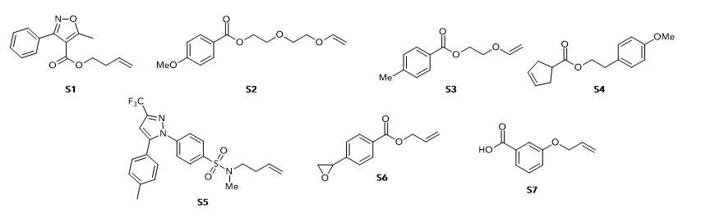
II. Synthesis and Characterization of Alkene Starting Materials

Figure S1. Synthesized alkene starting materials.

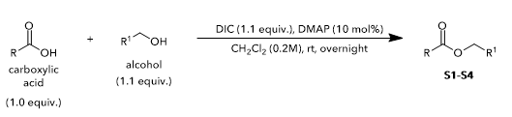

General Procedure A (GPA): Preparation of starting alkenes. The carboxylic acid (1.0 equiv) was dissolved in CH₂Cl₂ (0.2 M). To this solution was added 4-dimethylaminopyridine (DMAP) (10 mol%), N,N’-diisopropyl-carbodiimide (DIC) (1.1 equiv), and alcohol (1.1 equiv) were then added in succession. The reaction was stirred at room temperature overnight. The reaction mixture was then poured into 75 mL of water and extracted with CH₂Cl₂ (3 x 50 mL). The combined organic phase was dried over Na₂SO₄, filtered, and concentrated in vacuo. The resulting residue was purified via flash chromatography on silica gel to afford compounds S1-S4.

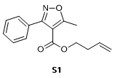

S1. S1 was prepared from 5-methyl-3-phenylisoxazole-4-carboxylic acid (1.02 g, 5.00 mmol, 1.0 equiv) and but-3-en-1-ol (0.47 mL, 5.5 mmol, 1.1 equiv) according to GPA. After workup and purification, S1 was obtained as a clear liquid (1.01 g, 3.93 mmol, 79%). ¹H NMR (CDCl₃, 500 MHz): δ 7.64 – 7.57 (m, 2H), 7.44 (m, 3H), 5.66 (ddt, J = 18.0, 9.4, 6.6 Hz, 1H), 5.05 – 5.03 (m, 1H), 5.01 (s, 1H), 4.24 (t, J = 6.5 Hz, 2H), 2.72 (s, 3H), 2.38 – 2.29 (m, 2H). HRMS (ESI) m/z calcd. for C₁₅H₁₅NO₃ [M+H]+ : 258.1125, found: 258.1122.

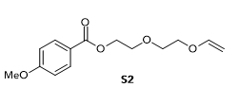

S2. S2 was prepared from 4-methoxybenzoic acid (1.0 g, 6.6 mmol, 1.0 equiv) and 2-(2-(vinyloxy)ethoxy)ethan-1-ol (0.99 mL, 7.23 mmol, 1.1 equiv) according to GPA. After workup and purification, S2 was obtained as a clear liquid (1.1 g, 4.1 mmol, 63% yield). ¹H NMR (CDCl₃, 500 MHz): δ 8.01 (d, J = 8.7 Hz, 2H), 6.91 (d, J = 8.7 Hz, 2H), 6.49 (dd, J = 14.3, 6.7 Hz, 1H), 4.45 (t, 2H), 4.19 (dd, J = 14.3, 2.1 Hz, 1H), 4.00 (dd, J = 6.8, 2.2 Hz, 1H), 3.84 (m, 7H), 3.79 – 3.76 (m, 2H). ¹³C NMR (CDCl₃, 125 MHz): δ 166.4, 163.5, 151.8, 151.8, 131.8, 122.6, 113.7, 86.9, 69.7, 69.6, 67.4, 63.9, 55.5. HRMS (ESI) m/z calcd. for C₁₄H₁₈O₅ [M+H]+ : 267.1227, found: 267.1222.

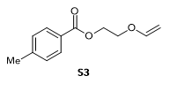

S3. S3 was prepared from 4-methylbenzoic acid (1.0 g, 7.34 mmol, 1.0 equiv) and 2-(vinyloxy)ethan-1-ol (0.73 mL, 8.1 mmol, 1.1 equiv) according to GPA. After workup and purification, S3 was obtained as a clear liquid (812 mg, 3.94 mmol, 54% yield). ¹H NMR (CDCl₃, 500 MHz): δ 7.94 (d, J = 8.0 Hz, 2H), 7.22 (d, J = 7.9 Hz, 2H), 6.50 (dd, J = 14.3, 6.7 Hz, 1H), 4.56 – 4.50 (m, 2H), 4.23 (dd, J = 14.3, 2.3 Hz, 1H), 4.05 (dt, J = 6.9, 1.4 Hz, 1H), 4.00 (t, 2H), 2.39 (s, 3H). ¹³C NMR (CDCl₃, 125 MHz): δ 166.6, 151.7, 151.7, 143.9, 129.9, 129.2, 127.3, 87.2, 66.1, 63.1, 21.7. HRMS (ESI) m/z calcd. for C₁₂H₁₄O₃ [M+H]+ : 207.1016, found: 207.1014.

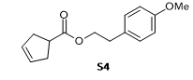

S4. S4 was prepared from cyclopent-3-ene-1-carboxylic acid (560 mg, 5.0 mmol, 1.0 equiv) and 2-(4-methoxyphenyl)ethan-1-ol (837 mg, 5.5 mmol, 1.1 equiv) according to GPA. After workup and purification, S4 was obtained as a clear oil (900 mg, 3.6 mmol, 73% yield). ¹H NMR (CDCl₃, 500 MHz): δ 7.12 (d, J = 8.6 Hz, 2H), 6.83 (d, J = 8.5 Hz, 2H), 5.64 (s, 2H), 4.26 (t, J = 7.0 Hz, 2H), 3.77 (s, 3H), 3.08 (p, J = 8.2 Hz, 1H), 2.87 (t, J = 7.0 Hz, 2H), 2.61 (d, J = 8.2 Hz, 4H). ¹³C NMR (CDCl₃, 125 MHz): δ 176.2, 158.4, 130.0, 129.1, 114.0, 65.3, 55.3, 41.7, 36.4, 34.4. HRMS (ESI) m/z calcd. for C₁₅H₁₈O₃ [M+Na]+ : 269.1148, found: 269.1145.

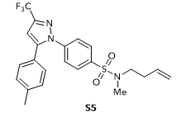

S5. S5 was prepared from N-(but-3-en-1-yl)-4-(5-(p-tolyl)-3-(trifluoromethyl)-1H-pyrazol-1-yl)benzenesulfonamide and methyl iodide according to a modified literature procedure (43). After workup and purification, S5 was obtained as white solid. ¹H NMR (CDCl₃, 500 MHz): δ 7.77 (d, J = 8.6 Hz, 2H), 7.47 (d, J = 8.6 Hz, 2H), 7.16 (d, J = 7.8 Hz, 2H), 7.09 (d, J = 8.2 Hz, 2H), 6.74 (s, 1H), 5.73 (ddt, J = 17.0, 10.1, 6.7 Hz, 1H), 5.12 – 5.03 (m, 2H), 3.08 (t, J = 7.3 Hz, 2H), 2.74 (s, 3H), 2.37 (s, 3H), 2.33 – 2.24 (m, 2H). ¹³C NMR (CDCl₃, 125 MHz): δ 145.4, 144.4, 144.1, 142.6, 140.0, 137.6, 134.4, 129.9, 128.9, 128.4, 125.8, 125.7, 122.3, 120.1, 117.5, 49.8, 34.9, 32.4, 21.5, 0.1. ¹⁹F NMR (CDCl₃, 376 MHz): δ -62.4. HRMS (ESI) m/z calcd. for C₂₂H₂₂F₃N₃O₂S [M+H]+ : 450.1458, found: 450.1453.

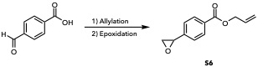
S6. Styrene oxide S6 was prepared from 4-formylbenzoic acid according to reported protocols from Kerwat (44) (allylation) and Gao (45) (Corey-Chaykovsky epoxidation). The NMR data matched that reported by Phan and colleagues (46). ¹H NMR (400 MHz, CDCl₃) δ 8.05 (d, J = 8.3 Hz, 1H), 7.36 (d, J = 8.3 Hz, 2H), 6.11 – 5.97 (m, 1H), 5.46 – 5.36 (m, 1H), 4.83 (dt, J = 5.7, 1.5 Hz, 2H), 3.91 (dd, J = 4.2, 2.5 Hz, 1H), 3.19 (dd, J = 5.5, 4.1 Hz, 1H), 2.79 (dd, J = 5.6, 2.5 Hz, 1H).

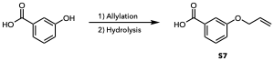
S7. Benzoic acid S7 was prepared from 3-hydroxybenzoic acid according to a reported protocol from Yan (allylation and base hydrolysis) (47). The NMR data matched that reported by Wen and colleagues (48). ¹H NMR (500 MHz, DMSO-d₆) δ 7.53 (dd, J = 7.6, 1.1 Hz, 2H), 7.45 (dd, J = 2.5, 1.5 Hz, 2H), 7.40 (t, J = 7.9 Hz, 1H), 7.20 (ddd, J = 8.2, 2.6, 0.8 Hz, 3H), 6.04 (ddt, J = 17.2, 10.4, 5.1 Hz, 1H), 5.40 (dq, J = 17.3, 1.6 Hz, 1H), 5.27 (dq, J = 10.5, 1.4 Hz, 2H), 4.62 (dt, J = 5.0, 1.4 Hz, 3H).

III. Synthesis and Characterization of S(VI) Radical Precursors

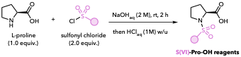

General Procedure B (GPB): Preparation of S(VI)-Pro-OH derivatives by N-sulfonylation of L-proline. L-Proline (1.0 equiv) was dissolved in 2 M aqueous NaOH to give a 0.5 M solution with respect to proline. The desired sulfonyl chloride (2.0 equiv) was added, and the resulting mixture was heated at 70 °C for 2 h. The reaction mixture was cooled to room temperature and filtered. The aqueous filtrate was acidified to pH 1-3 with 1 M aqueous HCl and extracted 3x with EtOAc. The combined organic layers were washed with brine, dried over MgSO₄, filtered, and concentrated under reduced pressure. The resulting material was dried under high vacuum to afford the corresponding S(VI)-Pro-OH derivative.

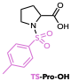

Ts-Pro-OH. Ts-Pro-OH was prepared from L-proline (5.76 g, 50.0 mmol, 1.0 equiv) and p-toluenesulfonyl chloride (19.1 g, 100 mmol, 2.0 equiv) according to GPB using 2 M aqueous NaOH (100 mL, 0.5 M with respect to L-proline). After workup and drying under high vacuum, Ts-Pro-OH was obtained as a white powder (13.27 g, 49.27 mmol, 99% yield). The ¹H NMR spectrum was consistent with previously reported data (49).

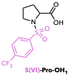

S(VI)-Pro-OH₁. S(VI)-Pro-OH₁ was prepared from L-proline (1.13 g, 9.81 mmol, 1.0 equiv) and 4-(trifluoromethyl)benzenesulfonyl chloride (4.80 g, 19.6 mmol, 2.0 equiv) according to GPB using 2 M aqueous NaOH (19.6 mL, 0.50 M with respect to L-proline). After workup and drying under high vacuum, S(VI)-Pro-OH₁ was obtained as a white powder (2.00 g, 6.16 mmol, 63% yield). ¹H NMR (CDCl₃, 500 MHz): δ 8.02 (d, J = 8.0 Hz, 2H), 7.81 (d, J = 8.0 Hz, 2H), 4.39 (dd, J = 7.2, 5.4 Hz, 1H), 3.51 (ddd, J = 9.0, 7.5, 4.5 Hz, 1H), 3.36 (dt, J = 9.0, 7.3 Hz, 1H), 2.14 (dt, J = 12.6, 6.8 Hz, 2H), 2.02 (dq, J = 13.2, 8.0, 7.8 Hz, 1H), 1.92 – 1.83 (m, 1H). ¹³C NMR (CDCl₃, 125 MHz): δ 177.2, 141.8, 135.0, 134.8, 134.5, 134.3, 128.0, 126.5, 126.4, 126.3, 126.3, 126.3, 124.3, 122.2, 120.0, 60.3, 48.5, 30.9, 24.7. ¹⁹F NMR (CDCl₃, 376 MHz): δ -63.1. HRMS (ESI) m/z calcd. for C₁₂H₁₂F₃NO₄S [M-H]- : 322.0366, found: 322.0365.

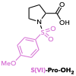

S(VI)-Pro-OH₂. S(VI)-Pro-OH₂ was prepared from L-proline (2.76 g, 24.0 mmol, 1.0 equiv) and 4-methoxybenzenesulfonyl chloride (9.92 g, 49.0 mmol, 2.0 equiv) according to GPB using 2 M aqueous NaOH (48.0 mL, 0.50 M with respect to L-proline). After workup and drying under high vacuum, S(VI)-Pro-OH₂ was obtained as a white powder (5.64 g, 19.8 mmol, 82% yield). ¹H NMR (CDCl₃, 500 MHz): δ 7.84 – 7.80 (m, 2H), 7.04 – 6.99 (m, 2H), 4.24 (dd, J = 8.2, 3.5 Hz, 1H), 3.89 (s, 3H), 3.54 – 3.48 (m, 1H), 3.24 (dt, J = 9.3, 7.4 Hz, 1H), 2.25 – 2.15 (m, 1H), 1.98 – 1.86 (m, 2H), 1.80 – 1.70 (m, 1H). ¹³C NMR (CDCl₃, 125 MHz): δ 174.4, 163.7, 130.0, 128.5, 114.6, 60.7, 55.8, 49.2, 30.4, 24.8. HRMS (ESI) m/z calcd. for C₁₂H₁₅NO₅S [M-H]-: 284.0598, found: 284.0601.

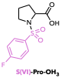

S(VI)-Pro-OH₃. S(VI)-Pro-OH₃ was prepared from L-proline (1.38 g, 12.0 mmol, 1.0 equiv.) and 4-fluorobenzenesulfonyl chloride (4.67 g, 24.0 mmol, 2.0 equiv.) according to GPB using 2 M aqueous NaOH (24.0 mL, 0.50 M with respect to L-proline). After workup and drying under high vacuum, S(VI)-Pro-OH₃ was obtained as a white powder (2.05 g, 7.49 mmol, 63%). ¹H NMR (CDCl₃, 500 MHz): δ 7.96 – 7.88 (m, 2H), 7.22 (t, J = 8.5 Hz, 2H), 4.32 (dd, J = 8.5, 3.7 Hz, 1H), 3.50 (ddd, J = 9.4, 7.1, 4.4 Hz, 1H), 3.30 (dt, J = 9.4, 7.3 Hz, 1H), 2.16 (ddt, J = 12.1, 6.2, 4.0 Hz, 1H), 2.09 – 1.94 (m, 2H), 1.88 – 1.78 (m, 1H). ¹³C NMR (CDCl₃, 125 MHz): δ 176.0, 166.6, 164.6, 134.0, 133.9, 130.5, 130.4, 116.7, 116.5, 60.4, 48.8, 30.8, 24.8. ¹⁹F NMR (CDCl₃, 376 MHz): δ -104.4. HRMS (ESI) m/z calcd. for C₁₁H₁₂FNO₄S [M-H]-: 272.0398, found: 272.0399.

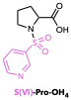

S(VI)-Pro-OH₄. S(VI)-Pro-OH₄ was prepared from L-proline (2.30 g, 20.0 mmol, 1.0 equiv) and pyridine-3-sulfonyl chloride (7.10 g, 40.0 mmol, 2.0 equiv) according to GPB using 2 M aqueous NaOH (40.0 mL, 0.50 M with respect to L-proline). After workup and drying under high vacuum, S(VI)-Pro-OH₄ was obtained as a white powder (0.76 g, 2.97 mmol, 15% yield). ¹H NMR (Acetone-d₆, 500 MHz): δ 11.16 (s, 1H), 9.03 (d, J = 2.3 Hz, 1H), 8.83 (dd, J = 4.8, 1.6 Hz, 1H), 8.25 (dt, J = 8.1, 1.9 Hz, 1H), 7.63 (ddd, J = 8.1, 4.7, 0.9 Hz, 1H), 4.38 (dd, J = 8.7, 3.7 Hz, 1H), 3.48 (ddd, J = 9.4, 7.3, 4.7 Hz, 1H), 3.39 (dt, J = 9.3, 7.1 Hz, 1H), 2.15 (dtd, J = 12.4, 8.8, 7.2 Hz, 1H), 2.07 – 1.91 (m, 2H), 1.83 (dtt, J = 12.0, 7.1, 4.4 Hz, 1H). ¹³C NMR (Acetone-d₆, 125 MHz): δ 173.2, 154.2, 148.8, 136.3, 136.0, 124.9, 61.4, 49.2, 31.6, 25.3. HRMS (ESI) m/z calcd. for C₁₀H₁₂N₂O₄S [M+H]+: 257.0591, found: 257.0587.

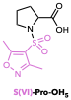

S(VI)-Pro-OH₅. S(VI)-Pro-OH₅ was prepared from L-proline (1.15, 10.0 mmol, 1.0 equiv) and dimethyl-1,2-oxazole-4-sulfonyl chloride (3.91 g, 20.0 mmol, 2.0 equiv) according to GPB using 2 M aqueous NaOH (20.0 mL, 0.50 M with respect to L-proline). After workup and drying under high vacuum, S(VI)-Pro-OH₅ was obtained as a white powder (2.43 g, 8.86 mmol, 89% yield). ¹H NMR (CDCl₃, 500 MHz): δ 4.37 (dd, J = 8.6, 3.6 Hz, 1H), 3.52 (ddd, J = 9.0, 7.4, 4.4 Hz, 1H), 3.45 (dt, J = 9.0, 7.3 Hz, 1H), 2.65 (s, 3H), 2.42 (s, 3H), 2.32 – 2.24 (m, 1H), 2.24 – 2.16 (m, 1H), 2.13 – 2.04 (m, 1H), 2.04 – 1.94 (m, 1H). ¹³C NMR (CDCl₃, 125 MHz): δ 176.0, 173.9, 158.0, 115.5, 59.6, 48.4, 31.1, 24.7, 12.9, 11.1. HRMS (ESI) m/z calcd. for C₁₀H₁₄N₂O₅S [M+H]+: 275.0696, found: 275.0693.

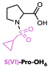

S(VI)-Pro-OH₆. S(VI)-Pro-OH₆ was prepared from L-proline (1.15, 10.0 mmol, 1.0 equiv) and cyclopropanesulfonyl chloride (2.81 g, 20.0 mmol, 2.0 equiv) according to GPB using 2 M aqueous NaOH (20.0 mL, 0.50 M with respect to L-proline). After workup and drying under high vacuum, S(VI)-Pro-OH₆ was obtained as an off-white powder (0.81 g, 3.70 mmol, 37% yield). ¹H NMR (CDCl₃, 500 MHz): δ 4.52 (dd, J = 8.7, 3.7 Hz, 1H), 3.53 (t, J = 6.7 Hz, 2H), 2.60 – 2.48 (m, 1H), 2.30 (dq, J = 12.6, 8.3 Hz, 1H), 2.20 (ddd, J = 13.3, 6.6, 4.4 Hz, 1H), 2.04 (dtt, J = 8.3, 6.2, 3.6 Hz, 2H), 1.28 – 1.14 (m, 2H), 1.07 – 0.92 (m, 2H). ¹³C NMR (CDCl₃, 125 MHz): δ 176.9, 60.4, 48.4, 30.7, 28.7, 25.1, 5.4, 4.7. HRMS (ESI) m/z calcd. for C₈H₁₃NO₄S [M-H]-: 218.0493, found: 218.0488.

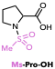

Ms-Pro-OH. Ms-Pro-OH was prepared from L-proline (5.76 g, 50.0 mmol, 1.0 equiv) and methanesulfonyl chloride (7.74 mL, 11.45 g, 100 mmol, 2.0 equiv) according to GPB using 2 M aqueous NaOH (100 mL, 0.50 M with respect to L-proline). After workup and drying under high vacuum, Ms-Pro-OH was obtained as a white powder (2.26 g, 11.7 mmol, 23% yield). The ¹H NMR spectrum was consistent with previously reported data (50).

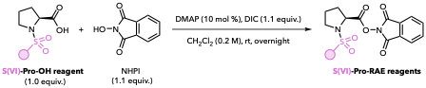

General Procedure C (GPC): Preparation of S(VI)-Pro-RAE derivatives. To a flame-dried round bottom flask equipped with a stir bar were added the desired S(VI)-Pro-OH derivative (1.0 equiv), N-hydroxyphthalimide (NHPI, 1.1 equiv), and DMAP (10 mol%). The flask was evacuated and backfilled with N₂ three times, after which anhydrous CH₂Cl₂ was added (0.2 M). The reaction mixture was stirred vigorously at room temperature, and N,N’-diisopropylcarbodiimide (DIC, 1.1 equiv) was added dropwise. The reaction mixture was stirred overnight at room temperature. Upon completion, the mixture was passed through a short plug of silica gel, eluting with CH₂Cl₂, and the filtrate was concentrated under reduced pressure. The resulting residue was purified by flash chromatography on silica gel using 100% CH₂Cl₂ as the eluent. The resulting material was dried under high vacuum to afford the corresponding S(VI)-Pro-RAE derivative.

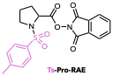

Ts-Pro-RAE. Ts-Pro-RAE was prepared from Ts-Pro-OH (9.16 g, 34.0 mmol, 1.0 equiv), N-hydroxyphthalimide (6.10 g, 37.4 mmol, 1.1 equiv), DMAP (415 mg, 3.40 mmol, 10 mol%), and DIC (5.82 mL, 37.4 mmol, 1.1 equiv) according to GPC. Purification by flash chromatography on silica gel using 100% CH₂Cl₂ as the eluent afforded Ts-Pro-RAE as a white powder (11.6 g, 27.9 mmol, 82% yield). ¹H NMR (CDCl₃, 500 MHz): δ 7.89 (dd, J = 5.4, 3.0 Hz, 2H), 7.84 – 7.78 (m, 4H), 7.33 – 7.30 (m, 2H), 4.80 (dd, J = 8.8, 3.2 Hz, 1H), 3.50 – 3.40 (m, 2H), 2.41 (s, 3H), 2.36 (ddt, J = 12.8, 7.2, 3.7 Hz, 1H), 2.27 (dtd, J = 12.8, 9.3, 9.2, 7.1 Hz, 1H), 2.13 – 2.03 (m, 1H), 1.99 – 1.91 (m, 1H). ¹³C NMR (CDCl₃, 125 MHz): δ 168.6, 161.5, 160.5, 143.8, 135.4, 134.8, 129.8, 128.9, 127.7, 124.0, 58.4, 48.2, 31.5, 24.7, 21.6. HRMS (ESI) m/z calcd. for C₂₀H₁₈N₂O₆S [M+H]+: 415.0958, found: 415.0952.

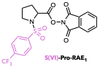
S(VI)-Pro-RAE₁. S(VI)-Pro-RAE₁ was prepared from S(VI)-Pro-OH₁ (2.00 g, 6.19 mmol, 1.0 equiv), N-hydroxyphthalimide (1.11 g, 6.81 mmol, 1.1 equiv), DMAP (76 mg, 0.62 mmol, 10 mol%), and DIC (1.06 mL, 6.81 mmol, 1.1 equiv) according to GPC. Purification by flash chromatography on silica gel using 100% CH₂Cl₂ as the eluent afforded S(VI)-Pro-RAE₁ as a white powder (1.83 g, 3.91 mmol, 63% yield). ¹H NMR (CDCl₃, 500 MHz): δ 8.07 (d, J = 8.1 Hz, 2H), 7.89 (dd, J = 5.5, 3.1 Hz, 2H), 7.83 – 7.75 (m, 4H), 4.92 (t, J = 5.9 Hz, 1H), 3.56 (dt, J = 9.1, 7.6 Hz, 1H), 3.44 (ddd, J = 9.2, 7.6, 4.3 Hz, 1H), 2.39 (dt, J = 7.4, 5.5 Hz, 2H), 2.16 – 2.02 (m, 2H). ¹³C NMR (CDCl₃, 125 MHz): δ 168.4, 161.5, 142.2, 134.9, 134.7, 134.4, 128.8, 128.1, 126.3, 126.3, 126.3, 126.2, 124.4, 124.1, 122.2, 58.4, 48.1, 31.6, 24.7. ¹⁹F NMR (CDCl₃, 376 MHz): δ -63.1. HRMS (ESI) m/z calcd. for C₂₀H₁₅F₃N₂O₆S [M+H]+: 469.0676, found: 469.0671.

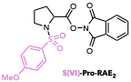

S(VI)-Pro-RAE₂. S(VI)-Pro-RAE₂ was prepared from S(VI)-Pro-OH₂ (2.50 g, 8.76 mmol, 1.0 equiv), N-hydroxyphthalimide (1.57 g, 9.64 mmol, 1.1 equiv), DMAP (107 mg, 0.88 mmol, 10 mol%), and DIC (1.50 mL, 9.64 mmol, 1.1 equiv) according to GPC. Purification by flash chromatography on silica gel using 100% CH₂Cl₂ as the eluent afforded S(VI)-Pro-RAE₂ as a white powder (1.28 g, 2.97 mmol, 34% yield). ¹H NMR (CDCl₃, 500 MHz): δ 7.93 – 7.85 (m, 4H), 7.83 – 7.76 (m, 2H), 7.01 – 6.95 (m, 2H), 4.80 (dd, J = 8.8, 3.3 Hz, 1H), 3.86 (s, 3H), 3.47 – 3.41 (m, 2H), 2.35 (ddt, J = 14.7, 7.6, 3.6 Hz, 1H), 2.28 (ddt, J = 16.1, 9.0, 4.4 Hz, 1H), 2.14 – 2.01 (m, 1H), 2.01 – 1.91 (m, 1H). ¹³C NMR (CDCl₃, 125 MHz): δ 168.7, 163.2, 161.5, 134.8, 130.0, 129.8, 128.9, 124.0, 114.3, 58.3, 55.6, 48.1, 31.6, 24.7. HRMS (ESI) m/z calcd. for C₂₀H₁₈N₂O₇S [M+H]+: 431.0908, found: 431.0902.

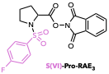

S(VI)-Pro-RAE₃. S(VI)-Pro-RAE₃ was prepared from S(VI)-Pro-OH₃ (1.70 g, 6.22 mmol, 1.0 equiv), N-hydroxyphthalimide (1.12 g, 6.84 mmol, 1.1 equiv), DMAP (76 mg, 0.62 mmol, 10 mol %), and DIC (1.06 mL, 6.84 mmol, 1.1 equiv) according to GPC. Purification by flash chromatography on silica gel using 100% CH₂Cl₂ as the eluent afforded S(VI)-Pro-RAE₃ as a white powder (1.75 g, 4.18 mmol, 67% yield). ¹H NMR (CDCl₃, 500 MHz): δ 7.99 – 7.94 (m, 2H), 7.89 (dd, J = 5.5, 3.0 Hz, 2H), 7.80 (dd, J = 5.4, 3.0 Hz, 2H), 7.18 (d, J = 8.8 Hz, 2H), 4.87 (dd, J = 7.9, 4.0 Hz, 1H), 3.54 – 3.48 (m, 1H), 3.43 (ddd, J = 9.1, 7.5, 4.0 Hz, 1H), 2.42 – 2.31 (m, 2H), 2.16 – 1.98 (m, 2H). ¹³C NMR (CDCl₃, 125 MHz): δ 168.7, 166.5, 164.5, 161.6, 135.0, 134.9, 134.8, 130.6, 130.5, 129.0, 124.2, 116.6, 116.4, 58.5, 48.2, 31.7, 24.8. ¹⁹F NMR (CDCl₃, 376 MHz): δ -105.0. HRMS (ESI) m/z calcd. for C₁₉H₁₅FN₂O₆S [M+H]+: 419.0708, found: 419.0701.

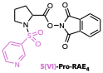

S(VI)-Pro-RAE₄. S(VI)-Pro-RAE₄ was prepared from S(VI)-Pro-OH₄ (0.76 g, 2.96 mmol, 1.0 equiv), N-hydroxyphthalimide (0.53 g, 3.25 mmol, 1.1 equiv), DMAP (36 mg, 0.30 mmol, 10 mol%), and DIC (0.51 mL, 3.25 mmol, 1.1 equiv) according to GPC. Purification by flash chromatography on silica gel using 100% CH₂Cl₂ as the eluent afforded S(VI)-Pro-RAE₄ as a white powder (117 mg, 0.29 mmol, 10% yield). ¹H NMR (CDCl₃, 500 MHz): δ 9.13 (d, J = 2.2 Hz, 1H), 8.79 (dd, J = 4.7, 1.6 Hz, 1H), 8.23 (dt, J = 8.3, 1.8 Hz, 1H), 7.89 (dd, J = 5.5, 3.0 Hz, 2H), 7.80 (dd, J = 5.4, 3.0 Hz, 2H), 7.48 – 7.44 (m, 1H), 4.93 (t, J = 5.9 Hz, 1H), 3.58 (dt, J = 9.1, 7.6 Hz, 1H), 3.45 (ddd, J = 9.1, 7.4, 4.3 Hz, 1H), 2.40 (dt, J = 7.4, 5.8 Hz, 2H), 2.17 – 2.05 (m, 2H). ¹³C NMR (CDCl₃, 125 MHz): δ 168.4, 161.4, 153.5, 148.3, 135.5, 135.4, 134.9, 128.8, 124.1, 123.8, 58.5, 48.0, 31.6, 24.7. HRMS (ESI) m/z calcd. for C₁₈H₁₅N₃O₆S [M+H]+: 402.0754 found: 402.0750.

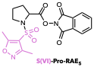

S(VI)-Pro-RAE₅. S(VI)-Pro-RAE₅ was prepared from S(VI)-Pro-OH₅ (2.50 g, 9.11 mmol, 1.0 equiv), N-hydroxyphthalimide (1.64 g, 10.0 mmol, 1.1 equiv), DMAP (111 mg, 0.91 mmol, 10 mol%), and DIC (1.56 mL, 10.0 mmol, 1.1 equiv) according to GPC. Purification by flash chromatography on silica gel using 100% CH₂Cl₂ as the eluant afforded S(VI)-Pro-RAE₅ as a white powder (2.44 g, 5.82 mmol, 64% yield). ¹H NMR (CDCl₃, 500 MHz): δ 7.87 (dt, J = 7.3, 3.8 Hz, 2H), 7.79 (dd, J = 5.4, 3.1 Hz, 2H), 4.85 (dd, J = 8.4, 3.6 Hz, 1H), 3.68 – 3.61 (m, 1H), 3.52 (dt, J = 9.1, 5.9 Hz, 1H), 2.68 (s, 3H), 2.52 – 2.43 (m, 2H), 2.42 (s, 3H), 2.18 – 2.09 (m, 2H). ¹³C NMR (CDCl₃, 125 MHz): δ 174.0, 168.4, 161.4, 157.9, 134.9, 128.8, 124.1, 115.7, 57.8, 48.5, 31.8, 24.6, 12.9, 11.0. HRMS (ESI) m/z calcd. for C₁₈H₁₇N₃O₇S [M+NH₄]+: 437.1126, found: 437.1124.

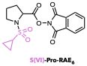

S(VI)-Pro-RAE₆. S(VI)-Pro-RAE₆ was prepared from S(VI)-Pro-OH₆ (2.17 g, 9.89 mmol, 1.0 equiv), N-hydroxyphthalimide (1.77 g, 10.9 mmol, 1.1 equiv), DMAP (121 mg, 0.99 mmol, 10 mol%), and DIC (1.69 mL, 10.9 mmol, 1.1 equiv) according to GPC. Purification by flash chromatography on silica gel using 100% CH₂Cl₂ as the eluant afforded S(VI)-Pro-RAE₆ as a white powder (599 mg, 1.64 mmol, 17% yield). ¹H NMR (CDCl₃, 500 MHz): δ 7.91 – 7.86 (m, 2H), 7.81 (ddd, J = 5.5, 4.0, 2.4 Hz, 2H), 4.87 (dd, J = 8.6, 3.3 Hz, 1H), 3.70 – 3.62 (m, 1H), 3.58 (ddd, J = 8.9, 7.5, 4.5 Hz, 1H), 2.63 – 2.55 (m, 1H), 2.45 (m, 2H), 2.22 – 2.07 (m, 2H), 1.21 (dtt, J = 6.5, 4.8, 2.7 Hz, 2H), 1.07 – 0.98 (m, 2H). ¹³C NMR (CDCl₃, 125 MHz): δ 169.5, 161.8, 135.1, 129.0, 124.2, 58.6, 48.4, 31.7, 30.0, 24.9, 5.6, 5.5. HRMS (ESI) m/z calcd. for C₁₆H₁₆N₂O₆S [M+NH₄]+: 382.1067, found: 382.0161.

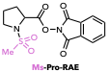

Ms-Pro-RAE. Ms-Pro-RAE was prepared from Ms-Pro-OH (2.20 g, 11.4 mmol, 1.0 equiv), N-hydroxyphthalimide (2.04 g, 12.5 mmol, 1.1 equiv), DMAP (139 mg, 1.14 mmol, 10 mol%), and DIC (1.95 mL, 12.5 mmol, 1.1 equiv) according to GPC. Purification by flash chromatography on silica gel using 100% CH₂Cl₂ as the eluent afforded Ms-Pro-RAE as a white powder (3.27 g, 9.67 mmol, 85% yield). ¹H NMR (CDCl₃, 500 MHz): δ 7.90 (dd, J = 5.5, 3.1 Hz, 2H), 7.81 (dd, J = 5.5, 3.0 Hz, 2H), 4.93 (dd, J = 8.3, 3.6 Hz, 1H), 3.66 (m, 1H), 3.49 (ddd, J = 8.9, 7.0, 5.0 Hz, 1H), 3.05 (s, 3H), 2.52 – 2.39 (m, 2H), 2.22 – 2.10 (m, 2H). ¹³C NMR (CDCl₃, 125 MHz): δ 169.2, 161.7, 135.1, 129.0, 124.3, 58.6, 48.0, 40.1, 31.5, 25.1. HRMS (ESI) m/z calcd. for C₁₄H₁₄N₂O₆S [M+NH₄]+: 356.0911, found: 356.0907.

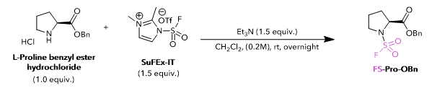
FS-Pro-OBn. A flame dried 500 mL RBF was charged with L-proline benzyl ester hydrochloride (12.1g, 50 mmol, 1.0 equiv) and anhydrous CH₂Cl₂ (250 mL, 0.2 M) at room temperature. Triethylamine (10.5 mL, 75 mmol, 1.5 equiv) was added portion-wise and the resulting solution was stirred at room temperature for 15 min. SuFEx-IT (24.6g, 75 mmol, 1.5 equiv) was then added in three portions and the reaction was stirred at room temperature overnight. The next day the solvent was removed by rotary evaporation, and the resulting residue was dissolved in 150 mL of EtOAc. The organic layer was washed with 1 M HCl (3 x 50 mL) and brine (3 x 50 mL), dried over Na₂SO₄, filtered and concentrated to afford FS-Pro-OBn as a golden oil that solidified after standing under vacuum in near quantitative yield (14.2 g, 49.5 mmol, 99% yield). The material was carried forward without further characterization according to literature precedent (51).

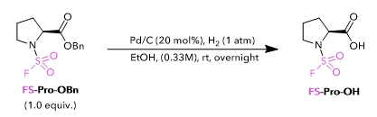

FS-Pro-OH. A 250 mL RBF was charged with palladium on carbon 10% wt (1.05g, 9.9 mmol, 0.2 equiv) and equipped with a reflux condenser fitted with a rubber septum (reflux condenser helps keep catalyst out of Schlenk line during backfills). The vessel was evacuated (5 min) and backfilled with nitrogen three times. A solution of FS-Pro-OBn (14.2 g, 49.5 mmol) in 150 ml EtOH (0.33M) was then added. The flask was then placed under vacuum until the solution started to bubble and backfilled with nitrogen. This process was repeated two more times, and the flask was placed under static vacuum. The condenser was then fitted with two H₂ balloons, and the reaction was stirred for room temperature overnight. The following day the reaction mixture was filtered over celite, and the solvent was removed via rotary evaporation to afford FS-Pro-OH as an off-white solid in quantitative yield (9.76 g, 49.5 mmol, 100%) ¹H NMR spectrum was consistent with previously reported data (51).
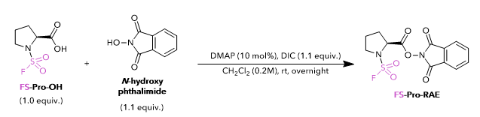

FS-Pro-RAE. Fs-Pro-RAE was prepared from FS-Pro-OH (9.76 g, 49.5 mmol, 1.0 equiv), N-hydroxyphthalimide (8.89 g, 54.5 mmol, 1.1 equiv), DMAP (605 mg, 4.95 mmol, 10 mol%), and DIC (8.48 mL, 54.5 mmol, 1.1 equiv) according to GPC. Purification by flash chromatography on silica gel using 100% CH₂Cl₂ as the eluent afforded FS-Pro-RAE as a white powder (14.6 g, 42.6 mmol, 86% yield). ¹H NMR (CDCl₃, 500 MHz): δ 7.91 (dd, J = 5.5, 3.1 Hz, 2H), 7.82 (dd, J = 5.5, 3.1 Hz, 2H), 4.86 (td, J = 6.0, 1.8 Hz, 1H), 3.80 (dddt, J = 8.5, 7.0, 4.3, 2.2 Hz, 1H), 3.73 – 3.61 (m, 1H), 2.58 – 2.51 (m, 2H), 2.30 – 2.16 (m, 2H). ¹³C NMR (CDCl₃, 125 MHz): δ 167.15, 161.34, 134.99, 128.81, 124.17, 59.74, 49.98, 31.50, 24.43. ¹⁹F NMR (CDCl₃, 376 MHz): δ 44.49. HRMS (ESI) m/z calcd. for C₁₃H₁₁FN₂O₆S [M+NH₄]+: 360.0660, found: 360.0656.

IV. Synthesis and Characterization of Fluoroalkyl Radical Precursors

Tf-Pro-OH and Tf-Pro-RAE Syntheses
Note: The following ¹H NMR and ¹³C NMR chemical shift data were reported with reference to TMS (0.00 ppm). ¹⁹F NMR chemical shift data were reported with reference to hexafluorobenzene (-164.9 ppm).

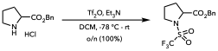
Tf-Pro-OBn. H-Pro-OBn∙HCl (1.70 g, 7.06 mmol, 1.0 equiv) was dissolved in CH₂Cl₂ (35 mL). The resulting solution was cooled to -78 °C. Et₃N (1.48 mL, 10.6 mmol, 1.5 equiv) was then added in one portion. Tf₂O (1.79 mL, 10.6 mmol, 1.5 equiv) was then added over a couple minutes. The solution was left to stir overnight with slow warming to rt. The reaction mixture was diluted with CH₂Cl₂ (30 mL) and poured into water (30 mL). The biphasic mixture was separated and the organic layer washed twice with saturated aqueous NH₄Cl (40 mL). The organic extract was dried (MgSO₄), filtered, and concentrated to afford Tf-Pro-OBn (7.06 mmol, 100% yield). The material was used without further purification. ¹H NMR (CDCl₃, 500 MHz): δ 7.40 – 7.30 (m, 5H), 5.18 (s, 2H), 4.54 (d, J = 8.3 Hz, 1H), 3.78 – 3.70 (m, 1H), 3.67 – 3.58 (m, 1H), 2.37 – 2.19 (m, 1H), 2.17 – 1.96 (m, 3H). ¹³C NMR (CDCl₃, 125 MHz): δ 170.6, 135.1, 128.7, 128.6, 128.3, 120.1 (q, J = 323.2 Hz), 67.6, 61.5, 49.5, 31.1, 24.4. ¹⁹F NMR (CDCl₃, 376 MHz): δ -78.51 (s, 3F).

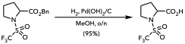

Tf-Pro-OH. A 250 mL round bottom flask was charged with Pd(OH)₂/C (1.24 g, 20% by wt, 1.76 mmol, 0.1 equiv). The solid was suspended in MeOH (19 mL), and a methanolic (2 mL) solution of Tf-Pro-OBn (2.438 g, 7.06 mmol, 1.0 equiv) was then added. The flask was evacuated. Once the solvent began to bubble, the atmosphere in the flask was carefully backfilled with nitrogen and the process repeated a total of three times. A hydrogen ballon was then attached to the flask. With the hydrogen balloon closed, the flask was evacuated. Once the solvent began to bubble, the balloon was carefully opened to backfill the flask atmosphere with hydrogen (repeated three times). A second hydrogen balloon was then affixed to the flask. The black heterogeneous mixture was left to stir overnight. The reaction mixture was filtered through a celite pad and washed with additional MeOH. The filtrate was concentrated to afford Tf-Pro-OH as a white solid (1.65 g, 6.68 mmol, 95% yield over two steps). ¹H NMR (CDCl₃, 500 MHz): δ 11.11 (s, 1H), 4.53 (d, J = 5.9 Hz, 1H), 3.80 – 3.72 (m, 1H), 3.70 – 3.61 (m, 1H), 2.44 – 2.33 (m, 1H), 2.31 – 2.22 (m, 1H), 2.22 – 2.03 (m, 2H). ¹³C NMR (CDCl₃, 125 MHz): δ 177.0, 120.1 (q, J = 323.1 Hz), 61.2, 49.6, 31.2, 24.4. ¹⁹F NMR (CDCl₃, 376 MHz): δ -78.39 (s, 3F).

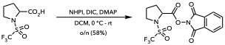
Tf-Pro-RAE. N-Hydroxyphthalimide (1.24 g, 7.61 mmol, 1.0 equiv) and DMAP (92.9 mg, 761 μmol, 0.1 equiv) were dissolved in CH₂Cl₂ (70 mL). A CH₂Cl₂ (6.0 mL) solution of Tf-Pro-OH (1.88 g, 7.61 mmol, 1.0 equiv) was then added. The solution was cooled to 0 °C. DIC (1.31 mL, 8.37 mmol, 1.1 equiv) was then added dropwise. The reaction was left to stir overnight with slow warming to rt. The crude mixture was filtered through celite and washed with methanol. The filtrate was concentrated, resuspended in CH₂Cl₂ and filtered. The precipitate was washed with CH₂Cl₂ (2 x 30 mL). The filtrate was concentrated to afford a yellow solid. Purification by column chromatography (100% CH₂Cl₂) afforded Tf-Pro-RAE as a white solid (1.72 g, 4.37 mmol, 58% yield). ¹H NMR (CDCl₃, 400 MHz): δ 7.93 – 7.85 (m, 2H), 7.85 – 7.77 (m, 2H), 4.92 (d, J = 5.6 Hz, 1H), 3.87 – 3.57 (m, 2H), 2.61 – 2.44 (m, 2H), 2.34 – 2.13 (m, 2H). ¹³C NMR (CDCl₃, 125 MHz): δ 166.6, 160.3, 134.0, 127.7, 123.1, 118.9 (q, J = 322.9 Hz), 58.4, 48.6, 30.7, 23.3. ¹⁹F NMR (CDCl₃, 470 MHz): δ -78.48 (s, 3F).

Df-Pro-OH Synthesis
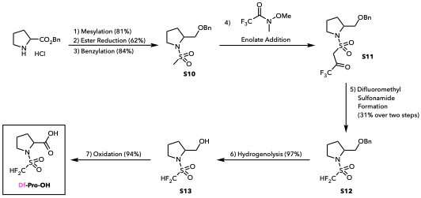

Figure S2. Synthetic route for Df-Pro-OH.

Note: The following ¹H NMR and ¹³C NMR chemical shift data were reported as referenced to TMS (0.00 ppm). ¹⁹F NMR spectra were secondarily (Ξ) referenced to the appropriate ¹H spectrum prior to reporting the chemical shift data (52).

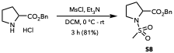
S8. MsCl (3.5 mL, 46 mmol, 1.1 equiv) was added dropwise to a stirred solution of H-Pro-OBn∙HCl (10.0 g, 41 mmol, 1.0 equiv) and Et₃N (14.4 mL, 103 mmol, 2.5 equiv) in anhydrous CH₂Cl₂ (30 mL) at 0 °C. The reaction mixture was allowed to warm to rt and stirred for 3 h. Upon completion, the organic layer was washed successively with water (30 mL), 1 N aqueous HCl (2 × 30 mL), saturated aqueous NaHCO₃ (30 mL), and brine (30 mL). The organic layer was dried (Na₂SO₄), filtered, and concentrated. The crude product was purified by flash column chromatography (5% EtOAc in hexanes) to afford Ms-Pro-OBn S8 as a colorless crystalline solid (9.5 g, 34 mmol, 81% yield). ¹H NMR (CDCl₃, 500 MHz): δ 7.41 – 7.29 (m, 5H), 5.21-5.14 (ABq J = 12.2 Hz, 2H), 4.56 (dd, J = 8.6, 3.8 Hz, 1H), 3.60 – 3.51 (m, 1H), 3.43 (ddd, J = 9.5, 7.2, 5.3 Hz, 1H), 2.96 (s, 3H), 2.33 – 2.22 (m, 1H), 2.10 – 1.91 (m, 3H). ¹³C NMR (CDCl₃, 125 MHz): δ 172.3, 135.3, 128.7, 128.5, 128.2, 67.2, 60.6, 47.8, 39.4, 30.9, 24.9. HRMS (ESI) m/z calcd. for C₁₃H₂₇NO₄S [M+H]⁺ = 284.0951, found: 284.0950.

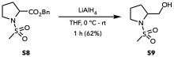
S9. To a stirred solution of Ms-Pro-OBn S8 (8.3 g, 29 mmol, 1.0 equiv) in anhydrous THF (40 mL) at 0 °C was added a 1.0 M solution of LiAlH₄ in THF (44 mL, 44 mmol, 1.5 equiv) dropwise. After stirring at 0 °C for 15 min, the ice bath was removed. The reaction mixture was allowed to warm to rt with stirring for an additional 1 h. The reaction was then cooled to 0 °C and carefully quenched by the sequential addition of H₂O (1 mL), 15% aqueous NaOH (1 mL), and H₂O (3 mL). The resulting suspension was stirred at rt for 15 min and filtered through a pad of Celite, which was washed with Et₂O (3 × 20 mL). The combined filtrates were concentrated, and the resulting residue was purified by flash column chromatography (silica gel; 75% EtOAc in hexanes) to afford S9 as a colorless oil (3.25 g, 18.1 mmol, 62% yield). ¹H NMR (CDCl₃, 500 MHz): δ 3.80 – 3.72 (m, 1H), 3.67 (ddd, J = 11.2, 6.9, 4.1 Hz, 1H), 3.61 (dt, J = 11.3, 5.6 Hz, 1H), 3.45 (dt, J = 10.0, 6.2 Hz, 1H), 3.39 (dt, J = 10.2, 6.5 Hz, 1H), 2.87 (s, 3H), 2.56 (dd, J = 6.9, 5.3 Hz, 1H), 2.11 – 1.92 (m, 2H), 1.91 – 1.81 (m, 2H). ¹³C NMR (CDCl₃, 125 MHz): δ 65.7, 61.9, 49.8, 34.9, 29.1, 24.7. HRMS (ESI) m/z calcd. for C₆H₁₃NO₃S [M+H]⁺ = 180.0689, found: 180.0687.

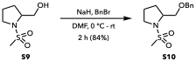

S10. A solution of S9 (3.24 g, 18.1 mmol, 1.0 equiv) in DMF (20 mL) was added dropwise to a stirred suspension of NaH (2.17 g, 60% wt, 36.2 mmol, 2.0 equiv) in DMF (10 mL) at 0 °C. The reaction mixture was stirred at 0 °C for 15 min, after which BnBr (2.58 mL, 21.7 mmol, 1.2 equiv) was added dropwise. The resulting mixture was allowed to warm to rt and stirred for 2 h. The reaction was quenched by the careful addition of water (30 ml) and extracted with ethyl acetate (3 × 30 mL). The combined organic layers were washed with brine (2 × 30 mL), dried (MgSO₄), filtered, and concentrated. The crude product was purified by flash column chromatography (silica gel; 30% → 50% EtOAc in hexanes) to afford S10 as a light yellow oil (4.09 g, 15.2 mmol, 84% yield). ¹H NMR (CDCl₃, 500 MHz): δ 7.40 – 7.26 (m, 5H), 4.54 (s, 2H), 3.98 – 3.79 (m, 1H), 3.63 (dd, J = 9.5, 4.2 Hz, 1H), 3.46 (dd, J = 9.5, 7.2 Hz, 1H), 3.41 – 3.36 (m, 1H), 3.36 – 3.29 (m, 1H), 2.82 (s, 3H), 2.03 – 1.83 (m, 4H). ¹³C NMR (CDCl₃, 125 MHz): δ 138.2, 128.5, 127.8, 127.8, 73.5, 72.7, 59.2, 49.1, 35.9, 29.2, 24.7. HRMS (ESI) m/z calcd. for C₁₃H₁₉NO₃S [M+H]⁺ = 270.1158, found: 270.1152.

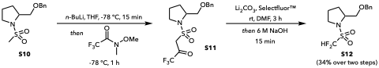

S11. To a solution of S10 (500 mg, 1.86 mmol, 1.0 equiv) in THF (15 mL) at −78 °C was added a 2.5 M solution of n-BuLi in hexane (1.11 mL, 2.78 mmol, 1.5 equiv) dropwise. The resulting mixture was stirred at −78 °C for 15 min, after which 2,2,2-trifluoro-N-methoxy-N-methylacetamide (0.56 mL, 4.64 mmol, 2.5 equiv) was added neat. The reaction mixture was stirred at −78 °C for 1 h and then quenched with saturated aqueous NH₄Cl solution (15 ml). The aqueous layer was extracted with CH₂Cl₂ (3 × 15 ml). The combined organic extracts were dried over MgSO₄, filtered, and concentrated. Purification of the crude residue by flash column chromatography (20 → 40% EtOAc in hexanes) afforded S11 with minor impurities. The material was used without further purification and characterization. HRMS (ESI) m/z calcd for C₁₅H₁₈F₃NO₄S [M+H]⁺ 366.0981, found 366.0979.
S12. A solution of S11 (389 mg, 1.06 mmol, 1.0 equiv) in DMF (15 mL) was treated with lithium carbonate (197 mg, 2.66 mmol, 2.5 equiv) and Selectfluor™ (943 mg, 2.66 mmol, 2.5 equiv) at rt. The reaction mixture was stirred at rt for 3 h, after which 6 M aq. NaOH (1.77 mL, 10.6 mmol, 10 equiv) was added, and the mixture was stirred for an additional 15 min to complete the fluorination reaction. The reaction mixture was diluted with water (10 ml) and extracted with EtOAc (3 × 15 ml). The combined organic layers were washed with brine, dried (MgSO₄), filtered, and concentrated. The crude residue was purified by flash column chromatography (silica gel; 20 → 40% EtOAc/hexane) to afford S12 as a light yellow oil (177 mg, 580 μmol, 54% yield). ¹H NMR (CDCl₃, 500 MHz): δ 7.38 – 7.25 (m, 5H), 6.21 (t, J = 53.9 Hz, 1H), 4.54-4.50 (ABq, J = 11.8 Hz, 2H), 4.22 (dtd, J = 8.0, 5.3, 2.8 Hz, 1H), 3.66 (dt, J = 9.8, 6.8 Hz, 1H), 3.54 (dd, J = 9.8, 5.0 Hz, 1H), 3.51 – 3.36 (m, 2H), 2.14 – 1.86 (m, 4H). ¹³C NMR (CDCl₃, 125 MHz): δ 137.8, 128.5, 127.8, 127.7, 114.6 (t, J = 280.8 Hz), 73.3, 72.0, 59.8, 49.4, 28.8, 24.8. ¹⁹F{¹H} NMR (CDCl₃, 376 MHz): δ -120.78 (d, J = 272.6 Hz, 1F), -122.00 (d, J = 272.8 Hz, 1F). HRMS (ESI) m/z calcd. for C₁₃H₁₇F₂NO₃S [M+H]⁺ = 306.0970, found: 306.0961.

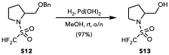

S13. To a solution of S12 (954 mg, 3.12 mmol, 1.0 equiv) in methanol (25 mL) was added Pd(OH)₂/C (878 mg, 10% wt, 625 μmol, 20 mol%). The reaction mixture was stirred at rt o/n under an atmosphere of hydrogen gas. Upon completion, as indicated by TLC, the mixture was filtered through a pad of Celite, and the celite was washed thoroughly with methanol (30 ml). The filtrate was concentrated to afford S13 as a colorless oil (650 mg, 3.02 mmol, 96.7 %). ¹H NMR (CDCl₃, 400 MHz): δ 6.34 (t, J = 53.8 Hz, 1H), 4.12 (dq, J = 8.8, 4.8 Hz, 1H), 3.72 (dq, J = 11.3, 5.4, 4.4 Hz, 2H), 3.61 (dd, J = 11.6, 5.5 Hz, 1H), 3.53 – 3.42 (m, 1H), 2.20 – 1.86 (m, 5H). ¹³C NMR (CDCl₃, 125 MHz): δ 114.9 (t, J = 280.9 Hz), 64.9, 62.5, 49.9, 28.7, 24.9. ¹⁹F{¹H} NMR (CDCl₃, 376 MHz): δ -120.59 (d, J = 271.8 Hz, 1F), -121.43 (d, J = 272.3 Hz, 1F). HRMS (ESI) m/z calcd. for C₆H₁₁F₂NO₃S [M+H]⁺ = 216.0501, found: 216.0499.

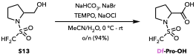

Df-Pro-OH. A solution of S13 (650 mg, 3.02 mmol, 1.0 equiv) in MeCN (15 mL) was added to saturated aqueous NaHCO₃ (10 mL, 10.7 mmol, 3.5 equiv). NaBr (31.1 mg, 302 μmol, 0.10 equiv) and TEMPO (47.2 mg, 302 μmol, 0.10 equiv) were added. The reaction mixture was cooled to 0 °C, and commercial bleach (~5% aqueous NaOCl, 13.5 mL, 9.06 mmol, 3.0 equiv) was added dropwise. The resulting mixture was stirred at rt o/n. The reaction was quenched with sat. aq. Na₂SO₃ solution and acidified to pH 2–3 with concentrated HCl. The aqueous layer was extracted with EtOAc (3 × 10 mL). The combined organic extracts were washed with brine, dried (MgSO₄), filtered, and concentrated to afford Df-Pro-OH as an off-white solid (650 mg, 2.84 mmol, 94% yield). ¹H{¹⁹F} NMR (CDCl₃, 400 MHz): δ 6.37 (s, 1H), 4.61 (dd, J = 8.7, 3.8 Hz, 1H), 3.75 – 3.59 (m, 2H), 2.48 – 2.34 (m, 1H), 2.28 – 2.16 (m, 1H), 2.13 – 2.01 (m, 2H). ¹³C NMR (CDCl₃, 125 MHz): δ 176.5, 114.5 (t, J = 281.1 Hz), 60.9, 49.3, 30.9, 24.9. ¹⁹F{¹H} NMR (CDCl₃, 376 MHz): δ -120.64 (d, J = 275.3 Hz, 1F), -121.86 (d, J = 275.2 Hz, 1F). HRMS (ESI) m/z calcd. for C₆H₉F₂NO₄S [M–H]⁻ = 228.0148, found: 228.0142.

V. Optimization, Control, and Mechanistic Experiments

Hydrofluorosulfonylation optimization

The light source was the AS&S Lumidox II. Samples were irradiated with 445 nm light and shaken at 500 rpm CW. Reaction parameters were optimized in the order presented.

A)
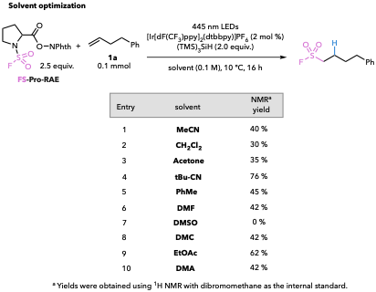

B)
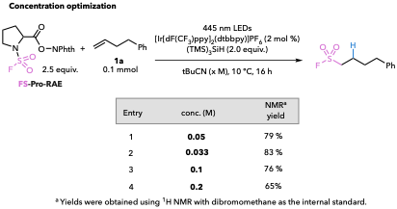

C)
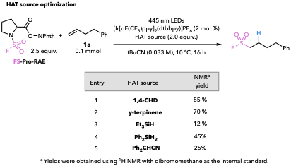

D)
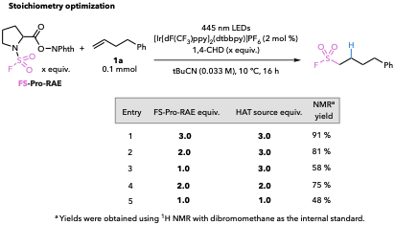

E)
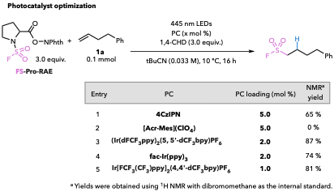

F)
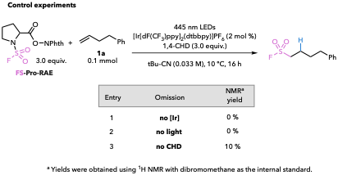

Figure S3 (A–F). Hydrofluorosulfonylation optimization and control experiments.

Hydrotrifluoromethylation Optimization and Control Experiments
Yields were obtained using ¹⁹F NMR with hexafluorobenzene as the internal standard. The light source was the AS&S Lumidox II. Samples were irradiated with 445 nm light and shaken at 500 rpm CW. The reaction parameters were optimized in the order presented.

A)
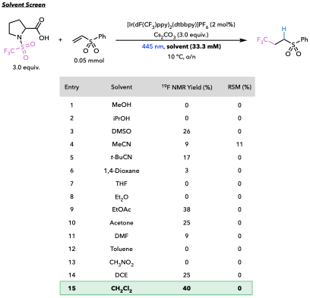

B)
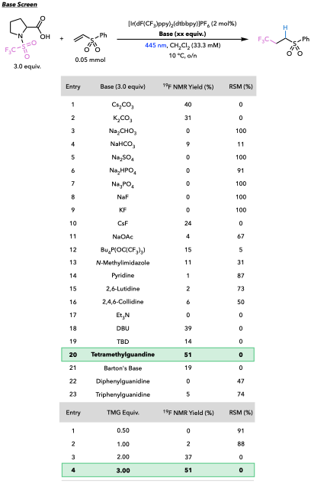

C)

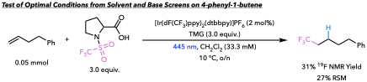

D)
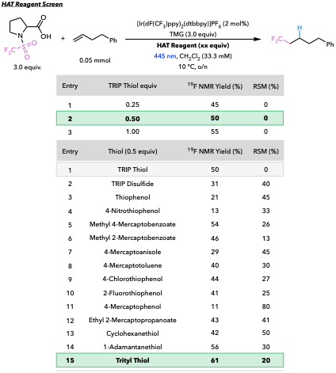

E)
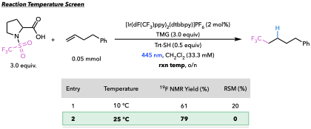

F)
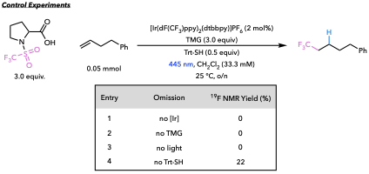
Figure S4 (A–F). Hydrotrifluoromethylation optimization and control experiments.

The productive reactivity observed in Entry 4 can be explained by an alternative reaction mechanism (detailed in the text, Figure 6b). Rather than an HAT event furnishing the hydrotrifluoromethylated product, the carbon-centered radical intermediate can undergo radical polar crossover with Ir(II) to regenerate the Ir(III) photocatalyst. The resulting carbanion then deprotonates the conjugate acid of TMG to provide the desired product. The reaction yield (22%) is significantly lower than that observed for the final optimized condition (79%).

Productive hydrotrifluoromethylation (reductive activation) with Tf-Pro-RAE:

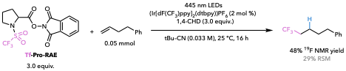

Mechanistic Experiments
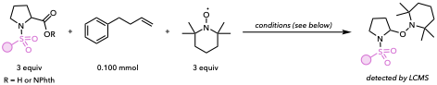

TEMPO trapping experiment for hydrotrifluoromethylation:
TrtSH (13.8 mg, 50.0 µmol, 0.5 equiv), [Ir(dF(CF₃)ppy)₂(dtbbpy)]PF₆ (2.2 mg, 20.0 µmol, 2 mol%), and TEMPO (46.9 mg, 0.300 mmol, 3.0 equiv) were dissolved in CH₂Cl₂ (3.00 mL) in a 4 mL borosilicate vial equipped with five small glass beads. Tf-Pro-OH (74.2 mg, 0.300 mmol, 3.0 equiv), TMG (37.7 µL, 300 µmol, 3.0 equiv), and 4-phenyl-1-butene (15.0 µL, 0.100 mmol, 1.0 equiv) were added to the solution. The vial was capped and placed in a Lumidox® II photoreactor equipped with a 24-position, 18 mm spacing LED array. With the chiller temperature set to 25 ºC, reaction mixtures were irradiated with 445 nm blue light (345 mW per well) and shaken at 500 rpm overnight (18 h). The hydrotrifluoromethylated product, (5,5,5-trifluoropentyl)benzene, was not detected by ¹H nor ¹⁹F NMR. LCMS analysis revealed the formation of a TEMPO adduct of the α-amino radical (m/z = 359.03) proposed to form from trifylproline after oxidative decarboxylation.

TEMPO trap experiment for hydrotosylation:
[Ir(dF(CF₃)ppy)₂(dtbbpy)]PF₆ (2.2 mg, 20.0 µmol, 2 mol%), Ts-Pro-RAE (124 mg, 0.300 mmol, 3.0 equiv) and TEMPO (46.9 mg, 0.300 mmol, 3.0 equiv) were dissolved in t-BuCN (2.70 mL) in a 4 mL borosilicate vial equipped with five small glass beads. Tris(trimethylsilyl)silane (46.3 μL, 0.150 mmol, 1.5 equiv) was then added, followed by 2,4,6-triisopropylthiophenol (4.73 mg, 20.00 μmol, 0.2 equiv) as a solution in Pivalonitrile (300 μL) and 4-phenyl-1-butene (15.0 μL, 0.100 mmol, 1.0 equiv). The vial was capped and placed in a Lumidox® II photoreactor equipped with a 24-position, 18 mm spacing LED array. With the chiller temperature set to 10 ºC, reaction mixtures were irradiated with 445 nm blue light (345 mW per well) and shaken at 500 rpm overnight (18 h). The hydrotosylated product, (4-tosylbutyl)benzene, was not detected by ¹H NMR. LCMS analysis revealed the formation of a TEMPO adduct of the α-amino radical (m/z = 381.03) proposed to form from Ts-Pro-RAE after single-electron reduction.

TEMPO trap experiment for hydrofluorosulfonylation:
[Ir(dF(CF₃)ppy)₂(dtbbpy)]PF₆ (2.2 mg, 20.0 µmol, 2 mol%), FS-Pro-RAE (103 mg, 0.300 mmol, 3.0 equiv) and TEMPO (46.9 mg, 0.300 mmol, 3.0 equiv) were dissolved in t-BuCN (3.00 mL) in a 4 mL borosilicate vial equipped with five small glass beads. 1,4-cyclohexadiene (28.3 μL, 0.300 mmol, 3.0 equiv) and 4-phenyl-1-butene (15.0 μL, 0.100 mmol, 1.0 equiv) were then added. The vial was capped and placed in a Lumidox® II photoreactor equipped with a 24-position, 18 mm spacing LED array. With the chiller temperature set to 10 ºC, reaction mixtures were irradiated with 445 nm blue light (345 mW per well) and shaken at 500 rpm overnight (18 h). The hydrofluorosulfonylated product, (4-(fluorosulfonyl)butyl)benzene, was not detected by ¹H NMR. LCMS analysis revealed the formation of a TEMPO adduct of an α-amino radical (m/z = 308.99) proposed to form from FS-Pro-RAE after single-electron reduction.
VI. Synthesis and Characterization of Hydrofluorosulfonylated Products
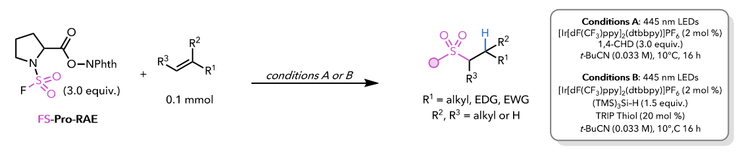
General Procedure D (GPD): Parallel reactions (one to three) were conducted on 0.1 mmol scale as follows. To each 4 mL borosilicate vial under ambient conditions were added [Ir[dF(CF₃)ppy]₂(dtbbpy)]PF₆ (PC1) (2.2 mg, 2.0 µmol, 2 mol %), FS-Pro-RAE (0.3 mmol, 3.0 equiv.). Pivalonitrile (3.0 mL, 0.033 M) was then added to each vial, followed by 1,4-CHD (0.3 mmol, 28.3 µL, 3.0 equiv.) and desired alkene (0.1 mmol, 1.0 equiv.) [Condition A]. Each vial was charged with 5 small glass beads, capped, and placed in a Lumidox II photoreactor equipped with a 24-position, 18 mm spacing LED array. The chiller temperature was set to 10 ºC to keep the internal temperature below 25 ºC. The shaker was set to 500 rpm, and the 445 nm wavelength light at 2/5 intensity was turned on. Upon reaction overnight, the parallel reaction mixtures were combined, concentrated to near dryness, diluted with CH₂Cl₂, and washed 3x with 10% aqueous K₂CO₃. The organic layers were combined, dried over MgSO₄, filtered, and concentrated via rotary evaporation. The crude residue was purified by flash chromatography on silica gel.

General Procedure E (GPE): Parallel reactions (one to three) were conducted on 0.1 mmol scale as follows. To each 4 mL borosilicate vial under ambient conditions were added [Ir[dF(CF₃)ppy]₂(dtbbpy)]PF₆ (PC1) (2.2 mg, 2.0 µmol, 2 mol %) and FS-Pro-RAE (0.3 mmol, 3.0 equiv.). Pivalonitrile (3.0 mL, 0.033 M) was then added to each vial, followed by (TMS)₃SiH (0.15 mmol, 46.3 µL, 1.5 equiv.), TRIP-SH (4.7 mg, 20.0 µmol, 20 mol %) and the desired alkene (0.1 mmol, 1.0 equiv.) [Condition B]. Each vial was charged with 5 small glass beads, capped, and placed in a Lumidox II photoreactor equipped with a 24-position, 18 mm spacing LED array. The chiller temperature was set to 10 ºC to keep the internal temperature below 25 ºC. The shaker was set to 500 rpm, and the 445 nm wavelength light at 2/5 intensity was turned on. Upon reaction overnight, the parallel reaction mixtures were combined, concentrated to near dryness, diluted with CH₂Cl₂, and washed 3x with 10% aqueous K₂CO₃. The organic layers were combined, dried over MgSO₄, filtered, and concentrated via rotary evaporation. The crude residue was purified by flash chromatography on silica gel.
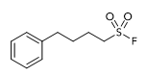

Compound 2a. Sulfonyl fluoride 2a was prepared from FS-Pro-RAE (309 mg, 0.90 mmol, 3.0 equiv) and 4-phenyl-1-butene (1a) (40 mg, 0.30 mmol, 1.0 equiv) according to GPD using three parallel reactions on 0.1 mmol scale. Purification by flash chromatography on silica gel (2→5% EtOAc/hexanes) afforded 2a as a white crystalline solid (45 mg, 0.21 mmol, 70% yield). ¹H NMR (CDCl₃, 500 MHz): δ 7.29 (t, J = 7.5 Hz, 2H), 7.24 – 7.15 (m, 3H), 3.38 – 3.33 (m, 2H), 2.68 (t, J = 7.4 Hz, 2H), 2.03 – 1.93 (m, 2H), 1.82 (p, J = 7.5, 7.4 Hz, 2H). ¹³C NMR (CDCl₃, 125 MHz): δ 140.8, 128.7, 128.5, 126.4, 51.0, 50.8, 35.2, 29.6, 23.1. ¹⁹F NMR (CDCl₃, 376 MHz): δ 53.6. HRMS (ESI) m/z calcd. for C₁₀H₁₃FO₂S [M+H]+ : 217.0693, found: 217.0694.
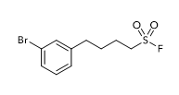

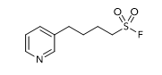
Compound 2b. Sulfonyl fluoride 2b was prepared from FS-Pro-RAE (309 mg, 0.90 mmol, 3.0 equiv) and 1-bromo-3-(but-3-en-1-yl)benzene (63 mg, 0.30 mmol, 1.0 equiv) according to GPD using three parallel reactions on 0.1 mmol scale. Purification by flash chromatography on silica gel (0→30% EtOAc/hexanes) afforded 2b as a clear oil (54 mg, 0.19 mmol, 62% yield). ¹H NMR (CDCl₃, 500 MHz): δ 7.37 – 7.30 (m, 2H), 7.16 (t, J = 7.7 Hz, 1H), 7.09 (d, J = 7.6 Hz, 1H), 3.37 (td, J = 7.6, 4.0 Hz, 2H), 2.65 (t, J = 7.5 Hz, 2H), 1.97 (h, J = 7.2, 7.0 Hz, 2H), 1.81 (p, J = 7.6, 7.4 Hz, 2H). ¹³C NMR (CDCl₃, 125 MHz): δ 143.0, 131.4, 130.2, 129.5, 127.0, 122.7, 50.7, 50.6, 34.7, 29.3, 23.0. ¹⁹F NMR (CDCl₃, 376 MHz): δ 53.8. HRMS (ESI) m/z calcd. for C₁₀H₁₂BrFO₂S [M+Na]+ : 316.9618, found: 316.9613.

Compound 2c. Sulfonyl fluoride 2c was prepared from FS-Pro-RAE (309 mg, 0.90 mmol, 3.0 equiv) and 3-(but-3-en-1-yl)pyridine (40 mg, 0.30 mmol, 1.0 equiv) according to GPD using three parallel reactions on 0.1 mmol scale. Purification by flash chromatography on silica gel (0→90% EtOAc/hexanes) afforded 2c as a yellow oil (54 mg, 0.27 mmol, 89%). ¹H NMR (CDCl₃, 500 MHz): δ 8.50 – 8.44 (m, 2H), 7.50 (dt, J = 7.9, 1.9 Hz, 1H), 7.28 – 7.20 (m, 1H), 3.39 (td, J = 7.6, 4.1 Hz, 2H), 2.69 (t, J = 7.6 Hz, 2H), 2.05 – 1.95 (m, 2H), 1.84 (p, J = 7.7, 7.5 Hz, 2H). ¹³C NMR (CDCl₃, 125 MHz): δ 149.7, 147.8, 135.8, 123.5, 50.7, 50.6, 32.3, 29.2, 23.0. ¹⁹F NMR (CDCl₃, 376 MHz): δ 53.9. HRMS (ESI) m/z calcd. for C₉H₁₂FNO₂S [M+H]+ : 218.0646, found: 218.0647.
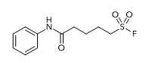

Compound 2d. Sulfonyl fluoride 2d was prepared from FS-Pro-RAE (309 mg, 0.90 mmol, 3.0 equiv) and N-phenylpent-4-enamide (53 mg, 0.30 mmol, 1.0 equiv) according to GPD using three parallel reactions on 0.1 mmol scale. Purification by flash chromatography on silica gel (0→50% EtOAc/hexanes) afforded 2d as a white solid (54 mg, 0.21 mmol, 69% yield). ¹H NMR (CDCl₃, 500 MHz): δ 7.49 (d, J = 7.8 Hz, 2H), 7.32 (t, J = 7.6 Hz, 2H), 7.12 (t, J = 7.4 Hz, 1H), 3.41 (td, J = 7.7, 7.6, 4.1 Hz, 2H), 2.42 (t, J = 7.0 Hz, 2H), 2.09 – 1.99 (m, 2H), 1.91 (p, J = 7.2, 7.0 Hz, 2H). ¹³C NMR (CDCl₃, 125 MHz): δ 169.9, 137.7, 129.2, 124.7, 120.1, 50.8, 50.7, 36.4, 23.5, 23.2. ¹⁹F NMR (CDCl₃, 376 MHz): δ 53.8. HRMS (ESI) m/z calcd. for C₁₀H₁₂BrFO₂S [M+H]+ : 260.0751, found: 260.0751.

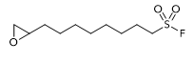

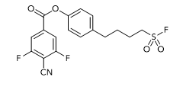
Compound 2e. Sulfonyl fluoride 2e was prepared from FS-Pro-RAE (309 mg, 0.90 mmol, 3.0 equiv) and 2-(oct-7-en-1-yl)oxirane (46 mg, 0.30 mmol, 1.0 equiv) according to GPD using three parallel reactions on 0.1 mmol scale. Purification by flash chromatography on silica gel (0→35% EtOAc/hexanes) afforded 2e as a clear oil (54 mg, 0.21 mmol, 43% yield). ¹H NMR (CDCl₃, 500 MHz): δ 3.39 – 3.31 (m, 2H), 2.93 – 2.86 (m, 1H), 2.74 (td, J = 4.4, 3.8, 1.0 Hz, 1H), 2.48 – 2.43 (m, 1H), 1.94 (ddd, J = 15.3, 8.6, 6.9 Hz, 2H), 1.61 – 1.37 (m, 6H), 1.36 – 1.34 (m, 6H). ¹³C NMR (CDCl₃, 125 MHz): δ 52.4, 51.1, 50.9, 47.2, 32.5, 29.3, 29.2, 28.8, 27.9, 26.0, 23.5. ¹⁹F NMR (CDCl₃, 376 MHz): δ 53.3. HRMS (ESI) m/z calcd. for C₁₀H₁₉FO₃S [M+H]+ : 239.1112, found: 239.1110.

Compound 2f. Sulfonyl fluoride 2f was prepared from FS-Pro-RAE (206 mg, 0.60 mmol, 3.0 equiv) and 4-(but-3-en-1-yl)phenyl 4-cyano-3,5-difluorobenzoate (63 mg, 0.20 mmol, 1.0 equiv) according to GPD using two parallel reactions on 0.1 mmol scale. Purification by flash chromatography on silica gel (0→50% EtOAc/hexanes) afforded 2f as a white solid (42 mg, 0.11 mmol, 53% yield). ¹H NMR (CDCl₃, 500 MHz): δ 8.09 (d, J = 8.2 Hz, 2H), 7.37 – 7.31 (m, 2H), 7.08 – 7.02 (m, 2H), 3.39 (td, J = 7.5, 7.4, 3.8 Hz, 2H), 2.80 (t, J = 7.5 Hz, 2H), 2.06 – 1.95 (m, 2H), 1.88 (p, J = 7.6, 7.3 Hz, 2H). ¹³C NMR (CDCl₃, 125 MHz): δ 148.4, 134.5, 131.0, 129.1, 126.2, 123.8, 107.2, 107.2, 107.0, 107.0, 50.8, 50.7, 35.4, 29.2, 23.1. ¹⁹F NMR (CDCl₃, 376 MHz): δ 54.0, -102.0. HRMS (ESI) m/z calcd. for C₁₈H₁₄F₃NO₄S [M+NH₄]+ : 415.0934, found: 435.0932.
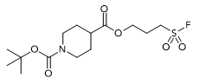

Compound 2g. Sulfonyl fluoride 2g was prepared from FS-Pro-RAE (206 mg, 0.60 mmol, 3.0 equiv) and 4-allyl 1-(tert-butyl) piperidine-1,4-dicarboxylate (54 mg, 0.20 mmol, 1.0 equiv) according to GPD using two parallel reactions on 0.1 mmol scale. Purification by flash chromatography on silica gel (0→20% EtOAc/hexanes) afforded 2g as a colorless amorphous solid (50 mg, 0.14 mmol, 72% yield). ¹H NMR (CDCl₃, 500 MHz): δ 4.24 (t, J = 5.9 Hz, 2H), 4.05 (s, 2H), 3.50 – 3.43 (m, 2H), 2.82 (t, J = 12.5 Hz, 2H), 2.47 (tt, J = 11.2, 3.8 Hz, 1H), 2.34 – 2.25 (m, 2H), 1.88 (dd, J = 13.3, 3.8 Hz, 2H), 1.67 – 1.56 (m, 2H), 1.46 (s, 9H). ¹³C NMR (CDCl₃, 125 MHz): δ 174.3, 154.8, 79.9, 61.4, 48.1, 48.0, 41.2, 28.6, 28.1, 23.4. ¹⁹F NMR (CDCl₃, 470 MHz): δ 53.9. HRMS (ESI) m/z calcd. for C₁₄H₂₄FNO₆S [M+Na]+ : 376.1201, found: 376.1198.
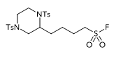

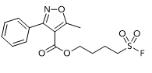
Compound 2h. Sulfonyl fluoride 2h was prepared from FS-Pro-RAE (103 mg, 0.30 mmol, 3.0 equiv) and 2-(but-3-en-1-yl)-1,4-ditosylpiperazine (45 mg, 0.10 mmol, 1.0 equiv) according to GPD on 0.1 mmol scale. Purification by flash chromatography on silica gel (0→40% EtOAc/hexanes) afforded 2h as a white crystalline solid (35 mg, 0.066 mmol, 66% yield). ¹H NMR (CDCl₃, 400 MHz): δ 7.59 (d, J = 7.9 Hz, 2H), 7.52 (d, J = 7.9 Hz, 2H), 7.31 (d, J = 7.9 Hz, 2H), 7.23 (d, J = 8.0 Hz, 2H), 3.95 (s, 1H), 3.81 – 3.73 (m, 1H), 3.62 – 3.54 (m, 1H), 3.50 (d, J = 11.7 Hz, 1H), 3.28 (td, J = 7.6, 4.0 Hz, 2H), 3.20 (td, J = 14.1, 13.0, 3.3 Hz, 1H), 2.45 (s, 3H), 2.39 (s, 3H), 2.28 (dd, J = 11.8, 3.5 Hz, 1H), 2.17 (td, J = 11.8, 3.3 Hz, 1H), 1.98 – 1.79 (m, J = 7.0 Hz, 2H), 1.76 – 1.56 (m, 2H), 1.41 (p, J = 7.8, 7.7 Hz, 2H). ¹³C NMR (CDCl₃, 125 MHz): δ 144.1, 143.9, 137.4, 132.4, 129.9, 129.8, 127.5, 127.0, 52.3, 50.6, 50.4, 48.0, 45.1, 40.0, 27.5, 24.3, 23.0, 21.6, 21.5. ¹⁹F NMR (CDCl₃, 376 MHz): δ 53.7. HRMS (ESI) m/z calcd. for C₂₂H₂₉FN₂O₆S₃ [M+NH₄]+ : 550.1510, found: 550.1510.

Compound 2i. Sulfonyl fluoride 2i was prepared from FS-Pro-RAE (206 mg, 0.60 mmol, 3.0 equiv) and but-3-en-1-yl 5-methyl-3-phenylisoxazole-4-carboxylate (52 mg, 0.20 mmol, 1.0 equiv) according to GPD using two parallel reactions on 0.1 mmol scale. Purification by flash chromatography on silica gel (0→25% EtOAc/hexanes) afforded 2i as a viscous golden oil (56 mg, 0.16 mmol, 82% yield). ¹H NMR (CDCl₃, 500 MHz): δ 7.57 – 7.53 (m, 2H), 7.50 – 7.43 (m, 3H), 4.22 – 4.16 (m, 2H), 3.15 (tdd, J = 7.2, 3.9, 1.9 Hz, 2H), 2.75 (d, J = 1.1 Hz, 3H), 1.79 – 1.66 (m, 4H). ¹³C NMR (CDCl₃, 125 MHz): δ 176.6, 162.5, 162.0, 134.5, 129.9, 129.5, 128.9, 128.2, 123.7, 108.4, 63.4, 50.4, 50.3, 26.8, 20.5, 13.6. ¹⁹F NMR (CDCl₃, 376 MHz): δ 53.9. HRMS (ESI) m/z calcd. for C₁₅H₁₆FNO₅S [M+H]+ : 342.0806, found: 342.0797.
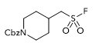

Compound 2j. Sulfonyl fluoride 2j was prepared from FS-Pro-RAE (206 mg, 0.60 mmol, 3.0 equiv) and benzyl 4-methylenepiperidine-1-carboxylate (46 mg, 0.20 mmol, 1.0 equiv) according to GPD using two parallel reactions on 0.1 mmol scale. Purification by flash chromatography on silica gel (0→30% EtOAc/hexanes) afforded 2j as a viscous yellow oil (42 mg, 0.13 mmol, 66% yield). ¹H NMR (CDCl₃, 500 MHz): δ 7.35 (m, 5H), 5.12 (s, 2H), 4.23 (s, 2H), 3.30 (dd, J_{H-H} = 6.6, J_{H-F} = 3.4 Hz, 2H), 2.84 (s, 2H), 2.24 (ttt, J = 10.7, 6.8, 3.6 Hz, 1H), 1.40 – 1.28 (m, 2H). ¹³C NMR (CDCl₃, 125 MHz): δ 155.2, 136.7, 128.7, 128.3, 128.1, 67.4, 56.7, 56.6, 43.6, 32.2, 31.2. ¹⁹F NMR (CDCl₃, 376 MHz): δ 59.5. HRMS (ESI) m/z calcd. for C₁₄H₁₈FNO₄S [M+H]+ : 316.1013, found: 316.1008.
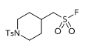

Compound 2k. Sulfonyl fluoride 2k was prepared from FS-Pro-RAE (206 mg, 0.60 mmol, 3.0 equiv) and 4-methylene-1-tosylpiperidine (50 mg, 0.20 mmol, 1.0 equiv) according to GPD using two parallel reactions on 0.1 mmol scale. Purification by flash chromatography on silica gel (0→20 % EtOAc/hexanes) afforded 2k as a white powder (44 mg, 0.13 mmol, 68% yield). ¹H NMR (CDCl₃, 500 MHz): δ 7.63 (d, J = 8.3 Hz, 2H), 7.33 (d, J = 7.9 Hz, 2H), 3.86 – 3.79 (m, 2H), 3.28 (dd, J_{H-H} = 6.2, J_{H-F} = 3.5 Hz, 2H), 2.44 (s, 3H), 2.30 (td, J = 12.1, 2.3 Hz, 2H), 2.01 – 1.96 (m, 3H), 1.59 – 1.49 (m, 2H). ¹³C NMR (CDCl₃, 125 MHz): δ 144.0, 133.0, 129.9, 127.9, 56.3, 56.2, 45.8, 31.6, 30.8, 30.8, 21.7, 0.1. ¹⁹F NMR (CDCl₃, 470 MHz): δ 59.2. HRMS (ESI) m/z calcd. for C₁₃H₁₈FNO₄S₂ [M+H]+ : 336.0734, found: 336.0730.

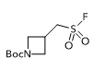

Compound 2l. Sulfonyl fluoride 2l was prepared from FS-Pro-RAE (309 mg, 0.90 mmol, 3.0 equiv.) and tert-butyl 3-methyleneazetidine-1-carboxylate (51 mg, 0.30 mmol, 1.0 equiv) according to GPD using three parallel reactions on 0.1 mmol scale. Purification by flash chromatography on silica gel (0→40 % EtOAc/hexanes) afforded 2l as a white solid (60 mg, 0.24 mmol, 79% yield). ¹H NMR (CDCl₃, 500 MHz): δ 4.20 (t, J = 8.6 Hz, 2H), 3.79 (dd, J = 9.1, 5.4 Hz, 2H), 3.66 (dd, J = 7.6, 4.2 Hz, 2H), 3.21 – 3.09 (m, 1H), 1.44 (s, 9H). ¹³C NMR (CDCl₃, 125 MHz): δ 156.1, 80.4, 54.3, 54.2, 28.5, 24.2. ¹⁹F NMR (CDCl₃, 376 MHz): δ 55.6. HRMS (ESI) m/z calcd. for C₉H₁₆FNO₄S [M+H]+ : 254.0857, found: 254.0853.

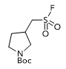

Compound 2m. Sulfonyl fluoride 2m was prepared from FS-Pro-RAE (309 mg, 0.90 mmol, 3.0 equiv.) and tert-butyl 3-methylenepyrrolidine-1-carboxylate (55 mg, 0.30 mmol, 1.0 equiv.) according to GPD using three parallel reactions on 0.1 mmol scale. Purification by flash chromatography on silica gel (0→30 % EtOAc/hexanes) afforded 2m as a waxy yellow solid (56 mg, 0.21 mmol, 70% yield). Compound 2m was observed as a mixture of rotamers by NMR spectroscopy. ¹H NMR (CDCl₃, 500 MHz): δ 3.81 – 3.67 (m, 1H), 3.58 – 3.29 (m, 4H), 3.11 (dd, J = 11.1, 8.1 Hz, 1H), 2.80 (s, 1H), 2.25 (s, 1H), 1.76 (s, 1H), 1.46 (s, 9H). ¹³C NMR (CDCl₃, 125 MHz): δ 154.3, 80.0, 53.8, 53.7, 50.5, 50.3, 45.2, 44.8, 34.2, 33.4, 31.2, 31.1, 30.7, 28.6. ¹⁹F NMR (CDCl₃, 376 MHz): δ 56.7, 56.5. HRMS (ESI) m/z calcd. for C₁₀H₁₈FNO₄S [M+H]+ : 268.1013, found: 268.1008.

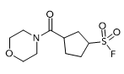

Compound 2n. Sulfonyl fluoride 2n was prepared from FS-Pro-RAE (103 mg, 0.30 mmol, 3.0 equiv) and cyclopent-3-en-1-yl(morpholino)methanone (18 mg, 0.10 mmol, 1.0 equiv) according to GPD on 0.1 mmol scale. Purification by flash chromatography on silica gel (0→50% EtOAc/hexanes) afforded 2n as yellow solids (16 mg, 0.062 mmol, 62% yield). ¹H NMR (CDCl₃, 500 MHz): δ 4.07 (tt, J = 8.8, 5.8 Hz, 1H), 3.70 – 3.66 (m, 4H), 3.64 – 3.60 (m, 2H), 3.57 – 3.45 (m, 2H), 3.26 (p, J = 7.1 Hz, 1H), 2.60 (dt, J = 14.9, 7.6 Hz, 1H), 2.39 – 2.24 (m, 3H), 2.21 – 2.11 (m, 1H), 1.98 – 1.87 (m, 1H). ¹³C NMR (CDCl₃, 125 MHz): δ 171.0, 67.0, 66.8, 60.3, 60.2, 46.1, 42.6, 40.8, 31.5, 29.1, 27.8. ¹⁹F NMR (CDCl₃, 470 MHz): δ 46.0. HRMS (ESI) m/z calcd. for C₁₀H₁₆FNO₄S [M+H]+ : 266.0857, found: 266.0856.

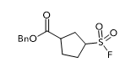

Compound 2o. Sulfonyl fluoride 2o was prepared from FS-Pro-RAE (103 mg, 0.30 mmol, 3.0 equiv) and benzyl cyclopent-3-ene-1-carboxylate (20 mg, 0.10 mmol, 1.0 equiv) according to GPD on 0.1 mmol scale. Purification by flash chromatography on silica gel (0→20% EtOAc/hexanes) afforded 2o as a clear oil (16 mg, 0.056 mmol, 56% yield). ¹H NMR (CDCl₃, 500 MHz): δ 7.37 – 7.29 (m, 5H), 5.13 (s, 2H), 3.96 (tt, J = 8.9, 6.0 Hz, 1H), 3.14 (app p, J = 7.0, 6.8 Hz, 1H), 2.57 – 2.48 (m, 1H), 2.46 – 2.39 (m, 1H), 2.34 – 2.19 (m, 3H), 2.05 – 1.94 (m, 1H). ¹³C NMR (CDCl₃, 125 MHz): δ 174.1, 135.7, 128.8, 128.7, 128.4, 67.0, 60.3, 60.2, 43.4, 31.3, 29.6, 27.7. ¹⁹F NMR (CDCl₃, 470 MHz): δ 46.0. HRMS (ESI) m/z calcd. for C₁₃H₁₅FO₄S [M+NH⁴]+ : 304.1013, found: 304.1013.

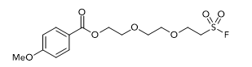

Compound 2p. Sulfonyl fluoride 2p was prepared from FS-Pro-RAE (206 mg, 0.60 mmol, 3.0 equiv) and 2-(2-(vinyloxy)ethoxy)ethyl 4-methoxybenzoate (53 mg, 0.20 mmol, 1.0 equiv) according to GPE using two parallel reactions on 0.1 mmol scale. Purification by flash chromatography on silica gel (0→30 % EtOAc/hexanes) afforded 2p as a brown wax (36 mg, 0.104 mmol, 52% yield). ¹H NMR (CDCl₃, 400 MHz): δ 8.00 (d, J = 8.8 Hz, 2H), 6.91 (d, J = 8.8 Hz, 2H), 4.46 – 4.42 (m, 2H), 3.98 (td, J = 5.9, 1.4 Hz, 2H), 3.85 (s, 3H), 3.82 – 3.80 (m, 2H), 3.69 (app s, 4H), 4.01 – 3.97 (m, 2H). ¹³C NMR (CDCl₃, 125 MHz): δ 166.4, 163.6, 131.8, 122.6, 113.8, 71.2, 70.8, 69.6, 64.4, 63.8, 55.6, 51.4, 51.3. ¹⁹F NMR (CDCl₃, 376 MHz): δ 58.9. HRMS (ESI) m/z calcd. for C₁₄H₁₉FO₇S [M+H]+ : 351.0908, found: 351.0905.

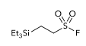

Compound 2q. Sulfonyl fluoride 2q was prepared from FS-Pro-RAE (309 mg, 0.90 mmol, 3.0 equiv) and triethyl(vinyl)silane (42 mg, 0.30 mmol, 1.0 equiv) according to GPD using three parallel reactions on 0.1 mmol scale. Purification by flash chromatography on silica gel (0→5% ether/pentanes) afforded 2q as a clear oil (48 mg, 0.22 mmol, 72% yield). ¹H NMR (CDCl₃, 400 MHz): δ 3.34 – 3.24 (m, 2H), 1.23 – 1.14 (m, 2H), 0.96 (t, J = 7.9 Hz, 9H), 0.64 – 0.46 (m, 6H). ¹³C NMR (CDCl₃, 125 MHz): δ 48.1, 48.0, 7.3, 5.7, 3.0. ¹⁹F NMR (CDCl₃, 376 MHz): δ 47.7. HRMS (ESI) m/z calcd. for C₈H₁₉FO₂SSi [M-H]- : 225.0786, found: 225.0786.

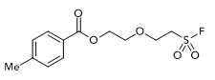

Compound 2r. Sulfonyl fluoride 2r was prepared from FS-Pro-RAE (203 mg, 0.60 mmol, 3.0 equiv) and 2-(vinyloxy)ethyl 4-methylbenzoate (42 mg, 0.20 mmol, 1.0 equiv) according to GPE using two parallel reactions on 0.1 mmol scale. Purification by flash chromatography on silica gel (0→30% EtOAc/hexanes) afforded 2r as a viscous golden oil (46 mg, 0.16 mmol, 78% yield). : ¹H NMR (CDCl₃, 500 MHz): δ 7.93 (d, J = 7.8 Hz, 2H), 7.24 (d, J = 8.5 Hz, 2H), 4.49 – 4.44 (m, 2H), 4.07 – 4.00 (m, 2H), 3.88 – 3.82 (m, 2H), 3.68 – 3.62 (m, 2H), 2.41 (s, 3H). ¹³C NMR (CDCl₃, 125 MHz): δ 166.7, 144.0, 129.9, 129.3, 127.3, 69.8, 64.2, 63.5, 51.4, 51.3, 21.8. ¹⁹F NMR (CDCl₃, 376 MHz): δ 59.2. HRMS (ESI) m/z calcd. for C₁₂H₁₅FO₅S [M+H]+ : 291.0697, found: 291.0696.
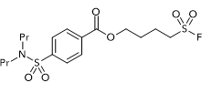

Compound 2s. Sulfonyl fluoride 2s was prepared from FS-Pro-RAE (203 mg, 0.60 mmol, 3.0 equiv) and but-3-en-1-yl 4-(N,N-dipropylsulfamoyl)benzoate (68 mg, 0.20 mmol, 1.0 equiv) according to GPD using two parallel reactions on 0.1 mmol scale. Purification by flash chromatography on silica gel (0→40% EtOAc/hexanes) afforded 2s as a viscous clear oil (66 mg, 0.154 mmol, 77% yield). ¹H NMR (CDCl₃, 500 MHz): δ 8.14 (d, J = 8.2 Hz, 2H), 7.88 (d, J = 8.3 Hz, 2H), 4.42 (t, J = 6.0 Hz, 2H), 3.47 (td, J = 7.8, 4.0 Hz, 2H), 3.10 (t, J = 7.7 Hz, 4H), 2.14 (app p, J = 7.9, 7.6 Hz, 2H), 2.06 – 1.97 (m, 2H), 1.61 – 1.49 (m, 4H), 0.87 (t, J = 7.3 Hz, 6H). ¹³C NMR (CDCl₃, 125 MHz): δ 165.3, 144.8, 133.2, 130.4, 127.3, 64.2, 50.6, 50.5, 50.1, 27.2, 22.1, 20.6, 11.3. ¹⁹F NMR (CDCl₃, 376 MHz): δ 54.1. HRMS (ESI) m/z calcd. for C₁₇H₂₆FNO₆S₂ [M+H]+ : 424.1258, found: 424.1256.
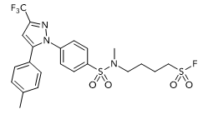

Compound 2t. Sulfonyl fluoride 2t was prepared from FS-Pro-RAE (103 mg, 0.30 mmol, 3.0 equiv) and N-(but-3-en-1-yl)-N-methyl-4-(5-(p-tolyl)-3-(trifluoromethyl)-1H-pyrazol-1-yl)ben-zenesulfonamide (45 mg, 0.10 mmol, 1.0 equiv) according to GPD. Purification by flash chromatography on silica gel (0→30% EtOAc/hexanes) afforded 2t as a white solid (33 mg, 0.061 mmol, 61% yield). ¹H NMR (CDCl₃, 500 MHz): δ 7.76 (d, J = 8.4 Hz, 2H), 7.50 (d, J = 8.3 Hz, 2H), 7.17 (d, J = 7.8 Hz, 2H), 7.10 (d, J = 7.8 Hz, 2H), 6.75 (s, 1H), 3.48 (td, J = 7.3, 3.9 Hz, 2H), 3.04 (t, J = 6.5 Hz, 2H), 2.72 (s, 3H), 2.38 (s, 3H), 2.07 (p, J = 7.5, 7.4 Hz, 2H), 1.78 (p, J = 6.7 Hz, 2H). ¹³C NMR (CDCl₃, 125 MHz): δ 145.5, 144.5, 144.2, 143.9, 142.8, 140.0, 136.7, 129.9, 128.8, 128.4, 125.8, 125.7, 106.5, 106.4, 50.1, 50.0, 48.9, 34.9, 25.4, 21.4, 20.4. ¹⁹F NMR (CDCl₃, 376 MHz): δ 54.5, -62.5. HRMS (ESI) m/z calcd. for C₂₂H₂₃F₄N₃O₄S₂ [M+H]+ : 534.1139, found: 534.1137

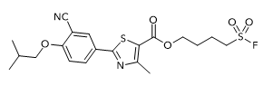

Compound 2u. Sulfonyl fluoride 2u was prepared from FS-Pro-RAE (203 mg, 0.60 mmol, 3.0 equiv) and but-3-en-1-yl 2-(3-cyano-4-isobutoxyphenyl)-4-methylthiazole-5-carboxylate (74 mg, 0.20 mmol, 1.0 equiv) according to GPD using two parallel reactions on 0.1 mmol scale. Purification by flash chromatography on silica gel (0→25% EtOAc/hexanes) afforded 2u as a white solid (56 mg, 0.124 mmol, 62% yield). ¹H NMR (CDCl₃, 500 MHz): δ 8.18 (d, J = 2.3 Hz, 1H), 8.09 (dd, J = 8.7, 2.3 Hz, 1H), 7.01 (d, J = 8.8 Hz, 1H), 4.36 (t, J = 6.1 Hz, 2H), 3.90 (d, J = 6.4 Hz, 2H), 3.47 (td, J = 7.6, 4.0 Hz, 2H), 2.76 (s, 3H), 2.26 – 2.08 (m, 3H), 2.02 – 1.93 (m, 2H), 1.09 (d, J = 6.6 Hz, 6H). ¹³C NMR (CDCl₃, 125 MHz): δ 167.7, 162.8, 162.0, 162.0, 132.8, 132.3, 126.0, 121.2, 115.5, 112.8, 103.2, 75.9, 63.8, 50.6, 50.5, 28.3, 27.2, 20.7, 19.2, 17.7. ¹⁹F NMR (CDCl₃, 376 MHz): δ 54.0. HRMS (ESI) m/z calcd. for C₂₀H₂₃FN₂O₅S₂ [M+H]+ : 455.1105, found: 455.1115.

VII. Synthesis and Characterization of Hydrosulfonylated Products

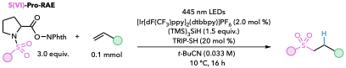

General Procedure F (GPF): Three parallel reactions were conducted on 0.1 mmol scale as follows. To each 4 mL borosilicate vial under ambient conditions were added [Ir[dF(CF₃)ppy]₂(dtbbpy)]PF₆ (PC1) (2.2 mg, 2.0 µmol, 2 mol%) and the desired S(VI)-Pro-RAE reagent (0.3 mmol, 3.0 equiv). Pivalonitrile (3.0 mL, 0.033 M) was then added to each vial, followed by (TMS)₃SiH (0.15 mmol, 46.3 µL, 1.5 equiv), TRIP-SH (4.7 mg, 20.0 µmol, 20 mol%) and the desired alkene (0.1 mmol, 1.0 equiv). Each vial was charged with 5 small glass beads, capped, and placed in a Lumidox II photoreactor equipped with a 24-position, 18 mm spacing LED array. The chiller temperature was set to 10 ºC to keep the internal temperature below 25 ºC. The shaker was set to 500 rpm, and the 445 nm wavelength light at 2/5 intensity was turned on. Upon reaction overnight, the three parallel reaction mixtures were combined, concentrated to near dryness, diluted with CH₂Cl₂, and washed 3x with 10% aqueous K₂CO₃. The organic layers were combined, dried over MgSO₄, filtered, and concentrated via rotary evaporation. The crude residue was purified by flash chromatography on silica gel.

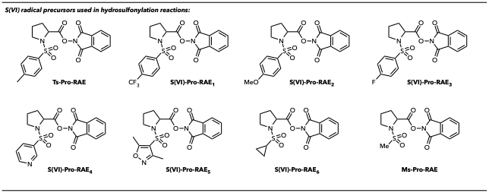
Table S2. Radical precursors used in these studies.
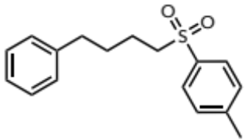
Compound 3a. Sulfone 3a was prepared from Ts-Pro-RAE (373 mg, 0.90 mmol, 3.0 equiv) and 4-phenyl-1-butene (1a) (40 mg, 0.30 mmol, 1.0 equiv) according to GPF using three parallel reactions on 0.1 mmol scale. Purification by flash chromatography on silica gel (0→15% EtOAc/hexanes) afforded 3a as an off-white powder (64 mg, 0.22 mmol, 74% yield). ¹H NMR (CDCl₃, 500 MHz): δ 7.75 (d, J = 8.2 Hz, 2H), 7.34 (d, J = 7.9 Hz, 2H), 7.27 – 7.22 (m, 3H), 7.19 – 7.14 (m, 1H), 7.11 – 7.07 (m, 2H), 3.10 – 3.03 (m, 2H), 2.58 (t, J = 7.3 Hz, 2H), 2.45 (s, 3H), 1.79 – 1.63 (m, 4H). ¹³C NMR (CDCl₃, 125 MHz): δ 144.7, 141.4, 136.4, 130.0, 128.6, 128.5, 128.2, 126.2, 56.4, 35.4, 30.2, 22.5, 21.8. HRMS (ESI) m/z calcd. for C₁₇H₂₀O₂S [M+NH₄]+ : 306.1522, found: 306.1518.
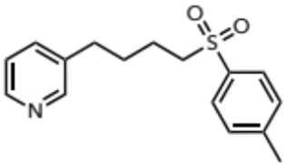
Compound 3b. Sulfone 3b was prepared from Ts-Pro-RAE (373 mg, 0.90 mmol, 3.0 equiv) and 3-(but-3-en-1-yl)pyridine (40 mg, 0.30 mmol, 1.0 equiv) according to GPF using three parallel reactions on 0.1 mmol scale. Purification by flash chromatography on silica gel (0→100% EtOAc/hexanes) afforded 3b as a light-yellow viscous oil (71 mg, .25 mmol, 82% yield). ¹H NMR (CDCl₃, 500 MHz): δ 8.43 (d, J = 4.7 Hz, 1H), 8.38 (s, 1H), 7.76 (d, J = 7.8 Hz, 2H), 7.43 (d, J = 7.7 Hz, 1H), 7.35 (d, J = 7.9 Hz, 2H), 7.19 (dd, J = 7.8, 4.7 Hz, 1H), 3.11 – 3.05 (m, 2H), 2.59 (t, J = 7.4 Hz, 2H), 2.45 (s, 3H), 1.82 – 1.64 (m, 4H). ¹³C NMR (CDCl₃, 125 MHz): δ 149.8, 147.7, 144.9, 136.7, 136.3, 135.9, 130.1, 128.2, 123.5, 56.2, 32.6, 29.8, 22.5, 21.8. HRMS (ESI) m/z calcd. for C₁₆H₁₉NO₂S [M+H]+ : 290.1209, found: 290.1204.
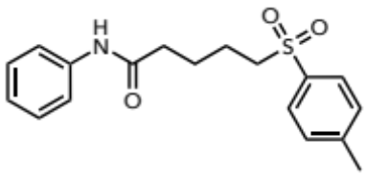
Compound 3c. Sulfone 3c was prepared from Ts-Pro-RAE (373 mg, 0.90 mmol, 3.0 equiv) and N-phenylpent-4-enamide (53 mg, 0.30 mmol, 1.0 equiv) according to GPF using three parallel reactions on 0.1 mmol scale. Purification by flash chromatography on silica gel (0→40% EtOAc/hexanes) afforded 3c as a yellow powder (52 mg, 0.16 mmol, 53% yield). ¹H NMR (CDCl₃, 500 MHz): δ 7.79 – 7.74 (m, 2H), 7.48 (d, J = 7.9 Hz, 2H), 7.32 (dd, J = 18.5, 7.9 Hz, 4H), 7.10 (t, J = 7.3 Hz, 1H), 3.11 (t, J = 6.9 Hz, 2H), 2.44 (s, 3H), 2.36 (t, J = 6.6 Hz, 2H), 1.88 – 1.79 (m, 4H). ¹³C NMR (CDCl₃, 125 MHz): δ 170.3, 144.9, 137.9, 136.3, 130.1, 129.2, 128.2, 124.5, 119.9, 56.1, 36.9, 24.2, 22.4, 21.8. HRMS (ESI) m/z calcd. for C₁₈H₂₁NO₃S [M+H]+ : 332.1315, found: 332.1312.

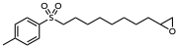

Compound 3d. Sulfone 3d was prepared from Ts-Pro-RAE (373 mg, 0.90 mmol, 3.0 equiv) and 2-(oct-7-en-1-yl)oxirane (46 mg, 0.30 mmol, 1.0 equiv) according to GPF using three parallel reactions on 0.1 mmol scale. Purification by flash chromatography on silica gel (0→20% EtOAc/hexanes) afforded 3d as a beige waxy solid (55 mg, 0.18 mmol, 59% yield). ¹H NMR (CDCl₃, 500 MHz): δ 7.81 – 7.75 (m, 2H), 7.35 (d, J = 7.9 Hz, 2H), 3.07 – 3.02 (m, 2H), 2.88 (tdd, J = 6.2, 4.4, 3.2 Hz, 1H), 2.73 (dd, J = 5.0, 3.9 Hz, 1H), 2.47 – 2.42 (m, 4H), 1.73 – 1.65 (m, 2H), 1.56 – 1.39 (m, 4H), 1.36 – 1.24 (m, 8H). ¹³C NMR (CDCl₃, 125 MHz): δ 144.7, 136.5, 130.0, 128.2, 56.5, 52.5, 47.2, 32.6, 29.4, 29.3, 29.0, 28.4, 26.0, 22.8, 21.8. HRMS (ESI) m/z calcd. for C₁₇H₂₆O₃S [M+H]+ : 311.1675, found: 311.1673.

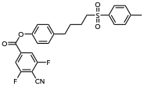

Compound 3e. Sulfone 3e was prepared from Ts-Pro-RAE (373 mg, 0.90 mmol, 3.0 equiv) and 4-(but-3-en-1-yl)phenyl 4-cyano-3,5-difluorobenzoate (94 mg, 0.30 mmol, 1.0 equiv) according to GPF using three parallel reactions on 0.1 mmol scale. The standard K₂CO₃ workup procedure was omitted for this compound due to suspected decomposition. Purification by flash chromatography on silica gel (0→20% EtOAc/hexanes) afforded 3e as a brown viscous oil (77 mg, 0.17 mmol, 56% yield). ¹H NMR (CDCl₃, 500 MHz): δ 8.07 – 8.03 (m, 2H), 7.77 (d, J = 8.0 Hz, 2H), 7.36 (d, J = 7.9 Hz, 2H), 7.28 (d, J = 8.0 Hz, 2H), 7.07 – 7.03 (m, 2H), 3.08 (t, J = 7.2 Hz, 2H), 2.71 (t, J = 7.1 Hz, 2H), 2.46 (s, 3H), 1.77 (qd, J = 11.5, 9.1, 4.6 Hz, 4H). ¹³C NMR (CDCl₃, 125 MHz): δ 163.4, 149.1, 144.9, 136.4, 130.8, 130.1, 129.1, 128.2, 125.8, 108.9, 107.2, 107.2, 107.0, 107.0, 56.2, 35.6, 29.7, 22.4, 21.8. ¹⁹F NMR (CDCl₃, 376 MHz): δ -102.0. HRMS (ESI) m/z calcd. for C₂₅H₂₁F₂NO₄S [M+NH₄]+ : 487.1498, found: 487.1497.

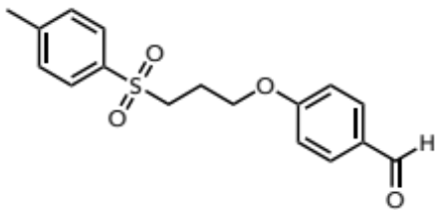

Compound 3f. Sulfone 3f was prepared from Ts-Pro-RAE (373 mg, 0.90 mmol, 3.0 equiv) and 4-(allyloxy)benzaldehyde (49 mg, 0.30 mmol, 1.0 equiv) according to GPF using three parallel reactions on 0.1 mmol scale. Purification by flash chromatography on silica gel (0→50% EtOAc/hexanes) afforded 3f as a light-brown waxy solid (44 mg, 0.13 mmol, 44% yield). ¹H NMR (CDCl₃, 500 MHz): δ 9.88 (s, 1H), 7.81 (d, J = 8.6 Hz, 4H), 7.38 – 7.34 (m, 2H), 6.95 – 6.91 (m, 2H), 4.12 (t, J = 5.9 Hz, 2H), 3.30 (dd, J = 8.4, 6.7 Hz, 2H), 2.45 (s, 3H), 2.30 – 2.23 (m, 2H). ¹³C NMR (CDCl₃, 125 MHz): δ 190.8, 163.4, 145.1, 136.3, 132.1, 130.5, 130.2, 128.2, 114.8, 66.0, 53.3, 23.0, 21.8. HRMS (ESI) m/z calcd. for C₁₇H₁₈O₄S [M+H]+ : 319.0999, found: 319.0998.

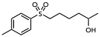

Compound 3g. Sulfone 3g was prepared from Ts-Pro-RAE (373 mg, 0.90 mmol, 3.0 equiv) and hex-5-en-2-ol (30 mg, 0.30 mmol, 1.0 equiv) according to GPF using three parallel reactions on 0.1 mmol scale. Purification by flash chromatography on silica gel (0→40% EtOAc/hexanes) afforded 3g as a viscous golden-brown oil (58 mg, 0.23 mmol, 75% yield). ¹H NMR (CDCl₃, 500 MHz): δ 7.77 (dd, J = 8.2, 1.6 Hz, 2H), 7.35 (d, J = 7.8 Hz, 2H), 3.75 (heptet, J = 6.0 Hz, 1H), 3.07 (t, J = 8.1 Hz, 2H), 2.45 (s, 3H), 1.79 – 1.65 (m, 2H), 1.54 – 1.36 (m, 4H), 1.18 – 1.12 (m, 3H). ¹³C NMR (CDCl₃, 125 MHz): δ 144.8, 136.4, 130.0, 128.2, 67.7, 56.5, 38.6, 24.6, 23.8, 22.9, 21.8. HRMS (ESI) m/z calcd. for C₁₃H₂₀O₃S [M+H]+ : 257.1206, found: 257.1201.

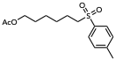

Compound 3h. Sulfone 3h was prepared from Ts-Pro-RAE (373 mg, 0.90 mmol, 3.0 equiv) and hex-5-en-1-yl acetate (43 mg, 0.30 mmol, 1.0 equiv) according to GPF using three parallel reactions on 0.1 mmol scale. Purification by flash chromatography on silica gel (0→30% EtOAc/hexanes) afforded 3h as a clear oil (55 mg, 0.18 mmol, 61% yield). ¹H NMR (CDCl₃, 400 MHz): δ 7.78 (d, J = 8.2 Hz, 2H), 7.36 (dt, J = 7.8, 0.7 Hz, 2H), 4.01 (t, J = 6.6 Hz, 2H), 3.09 – 3.02 (m, 2H), 2.45 (s, 3H), 2.03 (s, 3H), 1.71 (tt, J = 7.9, 6.1 Hz, 2H), 1.58 (ddd, J = 14.4, 7.3, 5.0 Hz, 2H), 1.45 – 1.27 (m, 4H). ¹³C NMR (CDCl₃, 125 MHz): δ 171.3, 144.8, 136.4, 130.0, 128.2, 64.3, 56.4, 28.4, 28.1, 25.6, 22.8, 21.8, 21.1. HRMS (ESI) m/z calcd. for C₁₂H₂₂O₄S [M+H]+ : 299.1312, found: 299.1310.
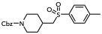

Compound 3i. Sulfone 3i was prepared from Ts-Pro-RAE (373 mg, 0.90 mmol, 3.0 equiv) and benzyl 4-methylenepiperidine-1-carboxylate (64 mg, 0.30 mmol, 1.0 equiv) according to GPF using three parallel reactions on 0.1 mmol scale. Purification by flash chromatography on silica gel (0→30% EtOAc/hexanes) afforded 3i as a beige-orange oily solid (58 mg, 0.15 mmol, 50% yield). ¹H NMR (CDCl₃, 500 MHz): δ 7.78 (d, J = 8.1 Hz, 2H), 7.39 – 7.28 (m, 7H), 5.10 (s, 2H), 4.13 (s, 2H), 2.98 (d, J = 6.2 Hz, 2H), 2.87 – 2.74 (m, 2H), 2.45 (s, 3H), 2.24 – 2.13 (m, 1H), 1.93 – 1.84 (m, 2H), 1.26 (qd, J = 12.0, 4.1 Hz, 2H). ¹³C NMR (CDCl₃, 125 MHz): δ 155.3, 144.9, 137.3, 136.9, 130.2, 128.6, 128.2, 128.0, 127.9, 67.3, 62.1, 43.8, 32.0, 31.3, 21.8. HRMS (ESI) m/z calcd. for C₂₁H₂₅NO₄S [M+H]+ : 388.1577, Found: 388.1570.

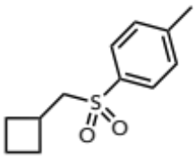

Compound 3j. Sulfone 3j was prepared from Ts-Pro-RAE (373 mg, 0.90 mmol, 3.0 equiv) and methylenecyclobutane (20 mg, 0.30 mmol, 1.0 equiv) according to GPF using three parallel reactions on 0.1 mmol scale. Purification by flash chromatography on silica gel (0→10% EtOAc/hexanes) afforded 3j as a white powder (44 mg, 0.20 mmol, 65% yield). ¹H NMR (CDCl₃, 500 MHz): δ 7.78 – 7.74 (m, 2H), 7.34 (d, J = 7.8 Hz, 2H), 3.18 (d, J = 7.2 Hz, 2H), 2.69 (heptet, J = 7.8 Hz, 1H), 2.44 (s, 3H), 2.08 – 1.99 (m, 2H), 1.94 – 1.83 (m, 1H), 1.83 – 1.65 (m, 3H). ¹³C NMR (CDCl₃, 125 MHz): δ 144.7, 136.9, 130.0, 128.2, 62.4, 30.0, 28.5, 21.8, 19.3. HRMS (ESI) m/z calcd. for C₁₂H₁₆O₂S [M+H]+ : 225.0944, found: 225.0944.

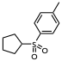

Compound 3k. Sulfone 3k was prepared from Ts-Pro-RAE (373 mg, 0.90 mmol, 3.0 equiv) and cyclopentene (20 mg, 0.30 mmol, 1.0 equiv) according to GPF using three parallel reactions on 0.1 mmol scale. Purification by flash chromatography on silica gel (0→10% EtOAc/hexanes) afforded 3j as a viscous cloudy oil (46 mg, 0.21 mmol, 69% yield). ¹H NMR (CDCl₃, 500 MHz): δ 7.79 – 7.75 (m, 2H), 7.34 (d, J = 7.9 Hz, 2H), 3.50 – 3.41 (m, 1H), 2.05 (ddd, J = 14.1, 7.2, 7.1 Hz, 2H), 1.91 – 1.81 (m, 2H), 1.80 – 1.70 (m, 2H), 1.65 – 1.53 (m, 2H). ¹³C NMR (CDCl₃, 125 MHz): δ 144.5, 136.2, 129.9, 128.6, 64.4, 27.4, 26.0, 21.7. HRMS (ESI) m/z calcd. for C₁₂H₁₆O₂S [M+NH₄]+ : 242.1209, found: 242.1205.

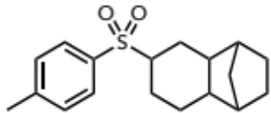

Compound 3l. Sulfone 3l was prepared from Ts-Pro-RAE (373 mg, 0.90 mmol, 3.0 equiv) and 1,2,3,4,4a,5,8,8a-octahydro-1,4-methanonaphthalene (45 mg, 0.30 mmol, 1.0 equiv) according to GPF using three parallel reactions on 0.1 mmol scale. Purification by flash chromatography on silica gel (0→5% EtOAc/hexanes) afforded 3l as a viscous cloudy oil (78 mg, 0.26 mmol, 85% yield). ¹H NMR (CDCl₃, 500 MHz): δ 7.74 (d, J = 6.7 Hz, 2H), 7.34 (d, J = 7.8 Hz, 2H), 3.09 (ddt, J = 12.1, 10.0, 4.6 Hz, 1H), 2.44 (s, 3H), 2.16 – 2.08 (m, 1H), 1.89 – 1.84 (m, 2H), 1.71 – 1.66 (m, 1H), 1.59 – 1.31 (m, 8H), 1.17 – 1.07 (m, 3H), 1.02 – 0.97 (m, 1H). ¹³C NMR (CDCl₃, 125 MHz): δ 144.5, 135.1, 129.8, 129.0, 58.4, 42.3, 42.3, 42.2, 41.5, 32.9, 29.6, 29.6, 23.6, 22.8, 21.8, 20.2. HRMS (ESI) m/z calcd. for C₁₈H₂₄O₂S [M+NH₄]+ : 322.1835, found: 322.1837.

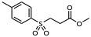

Compound 3m. Sulfone 3m was prepared from Ts-Pro-RAE (373 mg, 0.90 mmol, 3.0 equiv) and methyl acrylate (26 mg, 0.30 mmol, 1.0 equiv) and diethyl 1,4-dihydro-2,6-dimethyl-3,5-pyridinedicarboxylate (Hantzsch ester) (228 mg, 0.9 mmol, 3.0 equiv) as the HAT source according to modified GPF using three parallel reactions on 0.1 mmol scale. Purification by flash chromatography on silica gel (0→20% EtOAc/hexanes) afforded 3m as a light beige powder (70 mg, 0.29 mmol, 96% yield). ¹H NMR (CDCl₃, 500 MHz): δ 7.80 – 7.77 (m, 2H), 7.37 (d, J = 8.0 Hz, 2H), 3.64 (s, 3H), 3.43 – 3.37 (m, 2H), 2.77 – 2.72 (m, 2H), 2.45 (s, 3H). ¹³C NMR (CDCl₃, 125 MHz): δ 170.6, 145.2, 135.7, 130.2, 128.4, 52.4, 51.7, 27.9, 21.8. HRMS (ESI) m/z calcd. for C₁₁H₁₄O₄S [M+NH₄]+ : 260.0951, found: 260.0947.

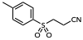

Compound 3n. Sulfone 3n was prepared from Ts-Pro-RAE (373 mg, 0.90 mmol, 3.0 equiv) and acrylonitrile (16 mg, 0.30 mmol, 1.0 equiv) and diethyl 1,4-dihydro-2,6-dimethyl-3,5-pyridinedicarboxylate (Hantzsch ester) (228 mg, 0.9 mmol, 3.0 equiv) as the HAT source according to modified GPF using three parallel reactions on 0.1 mmol scale. Purification by flash chromatography on silica gel (0→20% EtOAc/hexanes) afforded 3n as white crystals (56 mg, 0.27 mmol, 89% yield). ¹H NMR (CDCl₃, 500 MHz): δ 7.80 (d, J = 8.0 Hz, 2H), 7.41 (d, J = 8.0 Hz, 2H), 3.36 (t, J = 7.7 Hz, 2H), 2.82 – 2.77 (m, 2H), 2.48 (s, 3H). ¹³C NMR (CDCl₃, 125 MHz): δ 146.2, 134.7, 130.6, 128.5, 116.1, 51.4, 21.9, 12.2. HRMS (ESI) m/z calcd. for C₁₀H₁₁NO₂S [M+NH₄]+ : 227.0849, found: 227.0845.

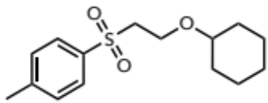

Compound 3o. Sulfone 3o was prepared from Ts-Pro-RAE (373 mg, 0.90 mmol, 3.0 equiv) and (vinyloxy)cyclohexane (38 mg, 0.30 mmol, 1.0 equiv) according to GPF using three parallel reactions on 0.1 mmol scale. Purification by flash chromatography on silica gel (0→20% EtOAc/hexanes) afforded 3o as a clear oil (60 mg, 0.21 mmol, 71% yield). ¹H NMR (CDCl₃, 500 MHz): δ 7.79 (d, J = 7.9 Hz, 2H), 7.33 (d, J = 7.9 Hz, 2H), 3.78 (t, J = 6.4, 2H), 3.37 (t, J = 6.4 Hz, 2H), 3.14 (tt, J = 8.1, 3.7 Hz, 1H), 2.44 (s, 3H), 1.71 (dt, J = 8.6, 3.6 Hz, 2H), 1.66 – 1.59 (m, 2H), 1.51 – 1.43 (m, 1H), 1.23 – 1.07 (m, 5H). ¹³C NMR (CDCl₃, 125 MHz): δ 144.7, 137.2, 129.8, 128.3, 78.1, 61.3, 57.0, 31.9, 25.8, 23.9, 21.8. HRMS (ESI) m/z calcd. for C₁₅H₂₂O₃S [M+NH₄]+ : 300.1628, found: 300.1629.

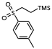

Compound 3p. Sulfone 3p was prepared from Ts-Pro-RAE (373 mg, 0.90 mmol, 3.0 equiv) and vinyltrimethyl silane (30 mg, 0.30 mmol, 1.0 equiv) according to GPF using three parallel reactions on 0.1 mmol scale. Purification by flash chromatography on silica gel (0→10% EtOAc/hexanes) afforded 3p as a white crystalline solid (69 mg, 0.27 mmol, 90% yield). ¹H NMR (CDCl₃, 500 MHz): δ 7.81 – 7.75 (m, 2H), 7.36 (d, J = 7.9 Hz, 2H), 3.02 – 2.92 (m, 2H), 2.45 (s, 3H), 0.95 – 0.88 (m, 2H), 0.00 (s, 9H). ¹³C NMR (CDCl₃, 125 MHz): δ 144.6, 136.0, 130.0, 128.4, 53.0, 21.8, 9.4, -1.9. HRMS (ESI) m/z calcd. for C₁₂H₂₀O₂SSi [M+NH₄]+ : 274.1292, found: 274.1291.

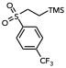

Compound 3q. Sulfone 3q was prepared from S(VI)-Pro-RAE₁ (422 mg, 0.90 mmol, 3.0 equiv) and vinyltrimethyl silane (30 mg, 0.30 mmol, 1.0 equiv) according to GPF using three parallel reactions on 0.1 mmol scale. The standard K₂CO₃ workup procedure was omitted for this compound due to suspected decomposition. Purification by flash chromatography on silica gel (0→10% EtOAc/hexanes) afforded 3q as an off-white powder (72 mg, 0.23 mmol, 77% yield). ¹H NMR (CDCl₃, 500 MHz): δ 8.05 (d, J = 8.0 Hz, 2H), 7.85 (d, J = 8.1 Hz, 2H), 3.05 – 2.99 (m, 2H), 0.95 – 0.90 (m, 2H), 0.02 (s, 9H). ¹³C NMR (CDCl₃, 125 MHz): δ 142.5, 135.7, 135.4, 129.1, 126.6, 126.6, 126.5, 126.5, 124.4, 122.2, 53.0, 9.2, -1.9. ¹⁹F NMR (CDCl₃, 376 MHz): δ -63.2. HRMS (ESI) m/z calcd. for C₁₂H₁₇ F₃O₂SSi [M+H]+ : 311.0743, found: 311.0743.

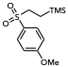

Compound 3r. Sulfone 3r was prepared from S(VI)-Pro-RAE₂ (387 mg, 0.90 mmol, 3.0 equiv) and vinyltrimethyl silane (30 mg, 0.30 mmol, 1.0 equiv) according to GPF using three parallel reactions on 0.1 mmol scale. Purification by flash chromatography on silica gel (0→15% EtOAc/hexanes) afforded 3r as a light golden-brown oil (68 mg, 0.25 mmol, 83% yield). ¹H NMR (CDCl₃, 500 MHz): δ 7.84 – 7.79 (m, 2H), 7.04 – 6.99 (m, 2H), 3.88 (s, 3H), 2.99 – 2.93 (m, 2H), 0.94 – 0.87 (m, 2H), -0.00 (s, 9H). ¹³C NMR (CDCl₃, 125 MHz): δ 163.8, 130.5, 130.5, 114.5, 55.8, 53.1, 9.5, -1.9. HRMS (ESI) m/z calcd. for C₁₂H₂₀O₃SSi [M+H]+ : 273.0975, found: 273.0975.

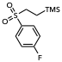

Compound 3s. Sulfone 3s was prepared from S(VI)-Pro-RAE₃ (377 mg, 0.90 mmol, 3.0 equiv) and vinyltrimethyl silane (30 mg, 0.30 mmol, 1.0 equiv) according to GPF using three parallel reactions on 0.1 mmol scale. The standard K₂CO₃ workup procedure was omitted for this compound due to suspected decomposition. Purification by flash chromatography on silica gel (0→10% EtOAc/hexanes) afforded 3s as a clear oil (63 mg, 0.24 mmol, 80% yield). ¹H NMR (CDCl₃, 500 MHz): δ 7.94 – 7.88 (m, 2H), 7.26 – 7.21 (m, 2H), 3.01 – 2.94 (m, 2H), 0.94 – 0.87 (m, 2H), 0.00 (s, 9H). ¹³C NMR (CDCl₃, 125 MHz): δ 167.0, 164.9, 135.0, 134.9, 131.3, 131.2, 116.8, 116.6, 53.1, 9.4, -1.9. ¹⁹F NMR (CDCl₃, 376 MHz): δ -103.8. HRMS (ESI) m/z calcd. for C₁₁H₁₇ FO₂SSi [M+H]+ : 261.0775, found: 261.0774.

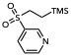

Compound 3t. Sulfone 3t was prepared from S(VI)-Pro-RAE₄ (361 mg, 0.90 mmol, 3.0 equiv) and vinyltrimethyl silane (30 mg, 0.30 mmol, 1.0 equiv) according to GPF using three parallel reactions on 0.1 mmol scale. Purification by flash chromatography on silica gel (0→60% EtOAc/hexanes) afforded 3t as a golden viscous oil (62 mg, 0.25 mmol, 85% yield). ¹H NMR (CDCl₃, 500 MHz): δ 9.14 – 9.08 (m, 1H), 8.88 (dd, J = 4.9, 1.6 Hz, 1H), 8.19 (dt, J = 8.0, 2.1 Hz, 1H), 7.56 – 7.50 (m, 1H), 3.07 – 2.99 (m, 2H), 0.97 – 0.89 (m, 2H), 0.02 (s, 9H). ¹³C NMR (CDCl₃, 125 MHz): δ 154.3, 149.5, 136.3, 135.4, 124.0, 53.4, 9.3, -1.9. HRMS (ESI) m/z calcd. for C₁₀H₁₇NO₂SSi [M+H]+ : 244.0822, found: 244.0823.

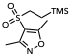

Compound 3u. Sulfone 3u was prepared from S(VI)-Pro-RAE₅ (377 mg, 0.90 mmol, 3.0 equiv) and vinyltrimethyl silane (30 mg, 0.30 mmol, 1.0 equiv) according to GPF using three parallel reactions on 0.1 mmol scale. Purification by flash chromatography on silica gel (0→20% EtOAc/hexanes) afforded 3u as a white crystalline solid (50 mg, 0.19 mmol, 64% yield). ¹H NMR (CDCl₃, 500 MHz): δ 2.99 – 2.94 (m, 2H), 2.66 (s, 3H), 2.43 (s, 3H), 0.94 – 0.89 (m, 2H), 0.05 (s, 9H). ¹³C NMR (CDCl₃, 125 MHz): δ 175.1, 158.2, 114.8, 53.8, 12.8, 11.1, 9.2, -1.9. HRMS (ESI) m/z calcd. for C₁₀H₁₉NO₃SSi [M+H]+ : 262.0928, found: 262.0927.

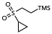

Compound 3v. Sulfone 3v was prepared from S(VI)-Pro-RAE₆ (328 mg, 0.90 mmol, 3.0 equiv) and vinyltrimethyl silane (30 mg, 0.30 mmol, 1.0 equiv) according to GPF using three parallel reactions on 0.1 mmol scale. Purification by flash chromatography on silica gel (0→10% EtOAc/hexanes) afforded 3v as an oily clear/white solid (48 mg, 0.23 mmol, 78% yield). ¹H NMR (CDCl₃, 500 MHz): δ 2.97 – 2.91 (m, 2H), 2.41 – 2.33 (m, 1H), 1.27 – 1.20 (m, 2H), 1.11 – 1.05 (m, 2H), 1.05 – 1.00 (m, 2H), 0.08 – 0.05 (m, 9H). ¹³C NMR (CDCl₃, 125 MHz): δ 50.2, 28.4, 8.8, 4.6, -1.9. HRMS (ESI) m/z calcd. for C₈H₁₈O₂SSi [M+NH₄]+ : 224.1135, found: 224.1132.

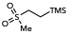

Compound 3w. Sulfone 3w was prepared from Ms-Pro-RAE (304 mg, 0.90 mmol, 3.0 equiv) and vinyltrimethyl silane (30 mg, 0.30 mmol, 1.0 equiv) according to GPF using three parallel reactions on 0.1 mmol scale. Due to the volatility of 3w, the reaction mixtures were combined without aqueous workup or purification, and CH₂Br₂ (1.0 equiv) was added as an internal standard for determination of the yield by ¹H NMR spectroscopy. 3w was obtained in 68% NMR yield (see crude ¹H NMR spectrum).

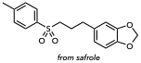

Compound 3x. Sulfone 3x was prepared from Ts-Pro-RAE (373 mg, 0.90 mmol, 3.0 equiv) and safrole (49 mg, 0.30 mmol, 1.0 equiv) according to GPF using three parallel reactions on 0.1 mmol scale. Purification by flash chromatography on silica gel (0→20% EtOAc/hexanes) afforded 3x as an off-white powder (42 mg, 0.13 mmol, 44% yield). ¹H NMR (CDCl₃, 500 MHz): δ 7.77 – 7.73 (m, 2H), 7.34 (d, J = 7.9 Hz, 2H), 6.69 (d, J = 7.7 Hz, 1H), 6.57 (d, J = 1.6 Hz, 1H), 6.53 (dd, J = 7.8, 1.8 Hz, 1H), 5.91 (s, 1H), 3.06 – 2.99 (m, 2H), 2.60 (t, J = 7.4 Hz, 2H), 2.45 (s, 3H), 1.98 (tt, J = 10.4, 6.7 Hz, 2H). ¹³C NMR (CDCl₃, 125 MHz): δ 147.9, 146.2, 144.8, 136.4, 133.8, 130.0, 128.2, 121.4, 108.9, 108.4, 101.0, 55.6, 34.0, 24.7, 21.8. HRMS (ESI) m/z calcd. for C₁₇H₁₈O₄S [M+NH₄]+ : 336.1264, found: 336.1258.

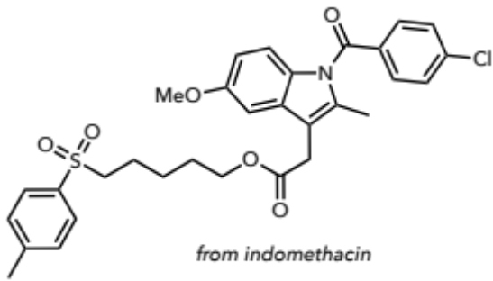

Compound 3y. Sulfone 3y was prepared from Ts-Pro-RAE (373 mg, 0.90 mmol, 3.0 equiv) and pent-4-en-1-yl 2-(1-(4-chlorobenzoyl)-5-methoxy-2-methyl-1H-indol-3-yl)acetate (128 mg, 0.30 mmol, 1.0 equiv) according to GPF using three parallel reactions on 0.1 mmol scale. Purification by flash chromatography on silica gel (0→40% EtOAc/hexanes) afforded 3y as waxy yellow crystals (70 mg, 0.12 mmol, 40% yield). ¹H NMR (CDCl₃, 500 MHz): δ 7.78 – 7.73 (m, 2H), 7.67 – 7.62 (m, 2H), 7.50 – 7.44 (m, 2H), 7.35 (d, J = 7.9 Hz, 2H), 6.94 (d, J = 2.4 Hz, 1H), 6.85 (d, J = 9.0 Hz, 1H), 6.65 (dd, J = 9.0, 2.4 Hz, 1H), 4.05 (t, J = 6.4 Hz, 2H), 3.81 (s, 3H), 3.63 (s, 2H), 2.99 – 2.92 (m, 2H), 2.44 (s, 3H), 2.37 (s, 3H), 1.72 – 1.64 (m, 2H), 1.59 (p, J = 6.8 Hz, 2H), 1.35 (p, J = 6.6 Hz, 2H). ¹³C NMR (CDCl₃, 125 MHz): δ 170.9, 168.4, 156.2, 144.8, 139.5, 136.4, 136.1, 134.0, 131.3, 131.0, 130.8, 130.1, 129.3, 128.2, 115.1, 112.7, 111.6, 101.7, 64.5, 56.2, 55.9, 30.5, 28.3, 24.9, 22.5, 21.8, 13.5. HRMS (ESI) m/z calcd. for C₃₁H₃₂ClNO₆S [M+H]+ : 582.1712, found: 582.1713.

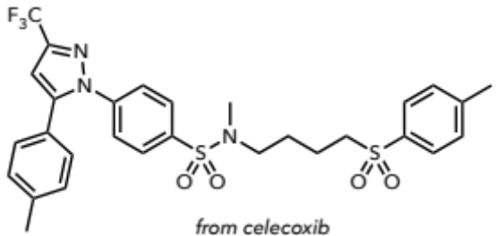

Compound 3z. Sulfone 3z was prepared from Ts-Pro-RAE (373 mg, 0.90 mmol, 3.0 equiv) and N-(but-3-en-1-yl)-N-methyl-4-(5-(p-tolyl)-3-(trifluoromethyl)-1H-pyrazol-1-yl)benzenesulfonamide (135 mg, 0.30 mmol, 1.0 equiv) according to GPF using three parallel reactions on 0.1 mmol scale. Purification by flash chromatography on silica gel (0→50% EtOAc/hexanes) afforded 3z as a beige powder (111 mg, 0.18 mmol, 61% yield). ¹H NMR (CDCl₃, 500 MHz): δ 7.81 – 7.76 (m, 2H), 7.75 – 7.71 (m, 2H), 7.50 – 7.44 (m, 2H), 7.40 – 7.33 (m, 2H), 7.17 (d, J = 7.8 Hz, 2H), 7.12 – 7.07 (m, 2H), 6.74 (s, 1H), 3.12 (t, J = 7.7 Hz, 2H), 2.96 (t, J = 6.8 Hz, 2H), 2.67 (s, 3H), 2.45 (s, 3H), 2.38 (s, 3H), 1.79 (p, J = 7.4 Hz, 2H), 1.68 (p, J = 7.0 Hz, 2H). ¹³C NMR (CDCl₃, 125 MHz): δ 145.3, 144.8, 142.6, 139.9, 136.8, 136.1, 130.0, 129.8, 128.7, 128.3, 128.1, 125.6, 125.6, 106.3, 106.3, 55.3, 49.2, 34.7, 26.0, 21.6, 21.3, 19.8. ¹⁹F NMR (CDCl₃, 376 MHz): δ -62.5. HRMS (ESI) m/z calcd. for C₂₉H₃₀F₃N₃O₄S₂ [M+H]+ : 606.1703, found: 606.1702.

VIII. Synthesis and Characterization of Hydrotri(di)fluoromethylated Products

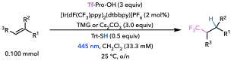

General Procedure G (GPG): To a 4 mL borosilicate vial under ambient conditions was added the alkene starting material (0.100 mmol, 1.0 equiv). CH₂Cl₂ stock solutions of each reagent were prepared such that a 750 µL aliquot of each stock solution would lead to the addition of the appropriate amount of material. 750 µL of a CH₂Cl₂ stock solution of Tf-Pro-OH (74.2 mg, 0.300 mmol, 3.0 equiv), [Ir(dF(CF₃)ppy)₂(dtbbpy)]PF₆ (2.24 mg, 20.0 µmol, 2 mol%), TMG (37.7 µL, 0.300 mmol, 3.0 equiv), and TrtSH (13.8 mg, 50.0 µmol, 0.5 equiv) were added the reaction vial in that order. The vial was equipped with 5 small glass beads, capped, and placed in a Lumidox® II photoreactor equipped with a 24-position, 18 mm spacing LED array. With the chiller temperature set to 25 ºC, reaction mixtures were irradiated with 445 nm blue light (345 mW per well) and shaken at 500 rpm overnight (16 – 18 h). After removal from the photoreactor, hexane was added to the crude reaction mixture (~10 mL) until the formation of a precipitate was observed. The heterogeneous mixture was filtered through a short silica plug (~2 mL silica, ~1 cm in height), and the plug was washed with 50% EtOAc in hexane (~30 mL). The filtrate was concentrated, and the resulting residue was purified by preparatory TLC or column chromatography.

General Procedure H (GPH): To a 4 mL borosilicate vial under ambient conditions was added the alkene starting material (0.100 mmol, 1.0 equiv). CH₂Cl₂ stock solutions of each reagent were prepared such that a 750 µL aliquot of each stock solution would lead to the addition of the appropriate amount of material. An aliquot of 750 µL of a CH₂Cl₂ stock solution of Tf-Pro-OH (74.2 mg, 0.300 mmol, 3.0 equiv) and [Ir(dF(CF₃)ppy)₂(dtbbpy)]PF₆ (2.24 mg, 20.0 µmol, 2 mol%) were added to the vial in that order. Cs₂CO₃ (97.7 mg, 0.300 mmol, 3.0 equiv) was added as a solid, followed by CH₂Cl₂ (750 µL). Next, 750 µL of a CH₂Cl₂ stock solution of TrtSH (13.8 mg, 50.0 µmol, 0.5 equiv) was added. The vial was equipped with 5 small glass beads, capped, and placed in a Lumidox® II photoreactor equipped with a 24-position, 18 mm spacing LED array. With the chiller temperature set to 25 ºC, reaction mixtures were irradiated with 445 nm blue light (345 mW per well) and shaken at 500 rpm overnight (16 – 18 h). After removal from the photoreactor, the reaction mixture was filtered and the filtrate washed with DCM (~30 mL). The filtrate was concentrated, and the resulting residue was purified by preparatory TLC or column chromatography.

Note: In the following section, ¹H NMR and ¹³C NMR chemical shift data were reported with reference to TMS (0.00 ppm). ¹⁹F NMR chemical shift data were reported with reference to hexafluorobenzene (-164.9 ppm). ¹¹B NMR spectra were secondarily (Ξ) referenced to the appropriate ¹H spectrum prior to reporting the chemical shift data (52).

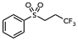
Compound 4b. Sulfone 4b was prepared from phenyl vinyl sulfone (16.8 mg, 0.100 mmol, 1.0 equiv) according to GPH with the omission of TrtSH to avoid side reactivity; CH₂Cl₂ (750 µL) was added instead. Purification by preparatory TLC (15% EtOAc in hexane) afforded 4b as a light-yellow solid (13.7 mg, 57.5 µmol, 58% yield). ¹H NMR (CDCl₃, 500 MHz): δ 7.93 (d, J = 7.5 Hz, 2H), 7.72 (t, J = 7.3 Hz, 1H), 7.62 (t, J = 7.6 Hz, 2H), 3.32 – 3.23 (m, 2H), 2.63 – 2.50 (m, 2H). ¹³C NMR (CDCl₃, 125 MHz): δ 138.2, 134.4, 129.7, 128.1, 125.4 (q, J = 276.4 Hz), 49.4 (q, J = 2.8 Hz), 28.1 (q, J = 31.5 Hz). ¹⁹F NMR (CDCl₃, 376 MHz): δ -69.1 (t, J = 9.9 Hz, 3F). HRMS (ESI) m/z calcd. for C₉H₉F₃O₂S [M–H]⁻ = 237.0203, found: 237.0201. (0.8 ppm).

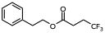

Compound 4c. Ester 4c was prepared from phenylethyl acrylate (17.6 mg, 0.100 mmol, 1.0 equiv) according to GPG with the omission of TrtSH to avoid side reactivity; CH₂Cl₂ (750 µL) was added instead of the TrtSH stock solution. Purification by preparatory TLC (10% EtOAc in hexane) afforded 4c as a yellow solid (10.8 mg, 43.9 µmol, 44% yield). ¹H NMR (CDCl₃, 500 MHz): δ 7.34 – 7.27 (m, 2H), 7.27 – 7.23 (m, 1H), 7.23 – 7.18 (m, 2H), 4.33 (t, J = 7.0 Hz, 2H), 2.94 (t, J = 7.0 Hz, 2H), 2.59 – 2.52 (m, 2H), 2.42 (m, 2H). ¹³C NMR (CDCl₃, 125 MHz): δ 170.9, 137.5, 128.9, 128.6, 126.7, 126.5 (q, J = 275.9 Hz), 65.5, 35.0, 29.3 (q, J = 30.1 Hz), 27.1 (q, J = 3.2 Hz). ¹⁹F NMR (CDCl₃, 376 MHz): δ -70.2 (t, J = 10.5 Hz, 3F). ASAP-MS m/z calcd. for C₁₂H₁₃F₃O₂ [M+H]⁺ = 247.0940, found: 247.0936.

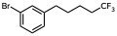

Compound 4d. Phenyl bromide 4d was prepared from 4-(3-bromophenyl)-1-butene (21.1 mg, 0.100 mmol, 1.0 equiv) according to GPG. Purification by preparatory TLC (100% hexane) afforded 4d as a yellow oil (18.6 mg, 66.2 µmol, 66% yield). ¹H NMR (CDCl₃, 500 MHz): δ 7.35 – 7.30 (m, 2H), 7.15 (t, J = 7.8 Hz, 1H), 7.08 (d, J = 7.6 Hz, 1H), 2.60 (t, J = 7.5 Hz, 2H), 2.15 – 2.02 (m, 2H), 1.68 (p, J = 7.5 Hz, 2H), 1.59 (p, J = 7.7, 7.5 Hz, 2H). ¹³C NMR (CDCl₃, 125 MHz): δ 144.0, 131.4, 130.0, 129.1, 127.1 (q, J = 276.4 Hz), 127.0, 122.5, 35.2, 33.6 (q, J = 28.4 Hz), 30.2, 21.5 (q, J = 2.9 Hz). ¹⁹F NMR (CDCl₃, 376 MHz): δ -69.5 (t, J = 10.8 Hz, 3F). ASAP-MS m/z calcd. for C₁₁H₁₂BrF₃ [M]⁺ = 280.0069, found: 280.0069.

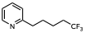

Compound 4e. Pyridine 4e was prepared from homoallyl pyridine (13.3 mg, 0.100 mmol, 1.0 equiv) according to GPG. Purification by preparatory TLC (35% EtOAc in hexane) afforded 4e as a yellow oil (13.0 mg, 64.0 µmol, 64% yield). ¹H NMR (CDCl₃, 500 MHz): δ 8.38 (d, J = 4.8 Hz, 2H), 7.41 (dt, J = 7.8, 2.0 Hz, 1H), 7.15 (dd, J = 7.8, 4.7 Hz, 1H), 2.57 (t, J = 7.6 Hz, 2H), 2.10 – 1.97 (m, 2H), 1.64 (p, J = 7.5 Hz, 2H), 1.57 – 1.50 (m, 2H). ¹³C NMR (CDCl₃, 125 MHz): δ 148.8, 146.6, 135.8, 134.7, 126.0 (q, J = 276.6 Hz), 122.4, 32.5 (q, J = 28.5 Hz), 31.6, 29.1, 20.5 (q, J = 3.0 Hz). ¹⁹F NMR (CDCl₃, 376 MHz): δ -69.5 (t, J = 10.8 Hz, 3F). HRMS (ESI) m/z calcd. for C₁₀H₁₂F₃N [M+H]⁺ = 204.0995, found: 204.0995.

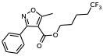
Compound 4f. Isoxazole 4f was prepared from 3-butenyl 5-methyl-3-phenylisoxazole-4-carboxylate (25.7 mg, 0.100 mmol, 1.0 equiv) according to GPG. Purification by preparatory TLC (10% EtOAc / 10% toluene / 80% hexane) afforded 4f as a yellow oil (22.0 mg, 67.2 µmol, 67% yield). ¹H NMR (CDCl₃, 500 MHz): δ 7.56 (d, J = 8.0 Hz, 2H), 7.50 – 7.39 (m, 3H), 4.17 (t, J = 6.0 Hz, 2H), 2.74 (s, 3H), 2.03 – 1.89 (m, 2H), 1.61 (p, J = 6.6 Hz, 2H), 1.45 – 1.36 (m, 2H). ¹³C NMR (CDCl₃, 125 MHz): δ 176.2, 162.5, 162.0, 129.7, 129.3, 128.7, 128.0, 126.9 (q, J = 276.3 Hz), 108.4, 65.0, 33.3 (q, J = 28.5 Hz), 27.5, 18.7 (q, J = 3.0 Hz), 13.5. ¹⁹F NMR (CDCl₃, 376 MHz): δ -69.5 (t, J = 10.7 Hz, 3F). HRMS (ESI) m/z calcd. for C₁₆H₁₆F₃NO₃ [M+H]⁺ = 328.1155, found: 328.1155.

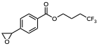

Compound 4g. Styrene oxide 4g was prepared from allyl 4-(2-oxiranyl)benzoate (20.4 mg, 0.100 mmol, 1.0 equiv) according to GPG. Purification by preparatory TLC (1% Et₃N / 10% EtOAc / 89 % petroleum ether) afforded 4g as a yellow oil (15.6 mg, 56.9 µmol, 57% yield). ¹H NMR (CDCl₃, 500 MHz): δ 8.02 – 7.97 (m, 2H), 7.40 – 7.31 (m, 2H), 4.38 (t, J = 6.2 Hz, 2H), 3.91 (dd, J = 4.1, 2.4 Hz, 1H), 3.19 (dd, J = 5.5, 4.0 Hz, 1H), 2.79 (dd, J = 5.5, 2.4 Hz, 1H), 2.33 – 2.18 (m, 2H), 2.10 – 1.99 (m, 2H). ¹³C NMR (CDCl₃, 125 MHz): δ 166.0, 143.2, 129.8, 129.7, 126.9 (q, J = 276.1 Hz), 125.5, 63.2, 51.9, 51.5, 30.8 (q, J = 29.3 Hz), 21.7 (q, J = 3.1 Hz). ¹⁹F NMR (CDCl₃, 470 MHz): δ -69.5 (t, J = 10.7 Hz, 3F). ASAP-MS m/z calcd. for C₁₃H₁₃F₃O₃ [M+H]⁺ = 275.0890, found: 275.0885.

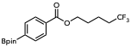

Compound 4h. Aryl boronic ester 4h was prepared from 3-butenyl 4-(4,4,5,5-tetramethyl-1,3,2-dioxaborolan-2-yl)benzoate (30.2 mg, 0.100 mmol, 1.0 equiv) according to GPH with the following adjustment: two parallel reactions were conducted and combined immediately after removal from the light source. Purification by column chromatography (silica gel treated with H₃BO₃ according to a procedure from Hitosugi and colleagues (53); eluent: 0→3% EtOAc in petroleum ether) afforded 4h as a white solid (50.7 mg, 136 µmol, 68% yield). ¹H NMR (CDCl₃, 500 MHz): δ 8.00 (d, J = 7.9 Hz, 2H), 7.87 (d, J = 7.8 Hz, 2H), 4.35 (t, J = 6.1 Hz, 2H), 2.16 (m, 2H), 1.86 (p, J = 6.8 Hz, 2H), 1.77 – 1.69 (m, 2H), 1.35 (s, 12H). ¹³C NMR (CDCl₃, 125 MHz): δ 166.6, 134.7, 132.3, 128.6, 127.0 (q, J = 276.2 Hz), 84.2, 64.2, 33.4 (q, J = 28.7 Hz), 27.8, 24.9, 18.8 (q, J = 3.0 Hz). ¹⁹F NMR (CDCl₃, 376 MHz): δ -69.6 (t, J = 11.1 Hz, 3F). ¹¹B NMR (161 MHz, CDCl₃) δ 30.2. ASAP-MS m/z calcd. for C₁₈H₂₄BF₃O₄ [M+H]⁺ = 373.1793, found: 373.1786.

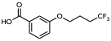

Compound 4i. Benzoic acid 4i was prepared from 3-allyloxybenzoic acid (17.8 mg, 0.100 mmol, 1.0 equiv) according to GPG. Purification by preparatory TLC (2% AcOH / 35% EtOAc / 63% hexane) afforded 4i as a white solid (10.4 mg, 41.9 µmol, 42%). ¹H NMR (CDCl₃, 500 MHz): δ 7.73 (d, J = 7.6 Hz, 1H), 7.60 (s, 1H), 7.39 (t, J = 7.8 Hz, 1H), 7.15 (d, J = 7.9 Hz, 1H), 4.08 (t, J = 5.9 Hz, 2H), 2.40 – 2.27 (m, 2H), 2.12 – 2.02 (m, 2H). ¹³C NMR (CDCl₃, 125 MHz): δ 171.5, 158.7, 130.6, 129.67, 127.1 (q, J = 276.0 Hz), 123.0, 120.8, 115.0, 66.3, 30.7 (q, J = 29.2 Hz), 22.2 (q, J = 3.1 Hz). ¹⁹F NMR (CDCl₃, 376 MHz): δ -69.5 (t, J = 10.8 Hz, 3F). ASAP-MS m/z calcd. for C₁₁H₁₁F₃O₃ [M–H]⁻ = 247.0588, found: 247.0583.

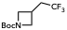

Compound 4j. Azetidine 4j was prepared from tert-butyl 3-methyleneazetidine-1-carboxylate (16.9 mg, 0.100 mmol, 1.0 equiv) according to GPH with the following adjustment: two parallel reactions were conducted and combined immediately after removal from the light source. Purification by column chromatography (0% EtOAc / 20% toluene / 80% hexane → 10% EtOAc / 20% toluene / 70% hexane) afforded 4j as a yellow oil (25.8 mg, 108 µmol, 54% yield). ¹H NMR (CDCl₃, 500 MHz): δ 4.10 (t, J = 8.5 Hz, 2H), 3.68 (dd, J = 8.6, 5.9 Hz, 2H), 2.90 – 2.78 (m, 1H), 2.39 (qd, J = 10.5, 7.3 Hz, 2H), 1.43 (s, 9H). ¹³C NMR (CDCl₃, 125 MHz): δ 156.1, 126.3 (q, J = 277.1 Hz), 79.7, 53.9, 37.9 (q, J = 28.4 Hz), 28.4, 23.0 (q, J = 3.2 Hz). ¹⁹F NMR (CDCl₃, 376 MHz): δ -69.1 (t, J = 10.5 Hz, 3F). HRMS (ESI) m/z calcd. for C₁₀H₁₆F₃NO₂ [M+H]⁺ = 240.1206, found: 240.1205.

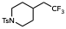

Compound 4k. Piperidine 4k was prepared from 4-methylene-1-tosylpiperidine (25.1 mg, 0.100 mmol, 1.0 equiv) according to GPH. Purification by preparatory TLC (10% EtOAc in petroleum ether) afforded 4k as a light yellow solid (27.2 mg, 84.6 µmol, 85% yield). ¹H NMR (CDCl₃, 500 MHz): δ 7.67 – 7.54 (m, 2H), 7.35 – 7.29 (m, 2H), 4.12 – 3.59 (m, 2H), 2.43 (s, 3H), 2.24 (td, J = 12.0, 2.5 Hz, 2H), 2.01 (qd, J = 11.2, 6.6 Hz, 2H), 1.83 (d, J = 12.8 Hz, 2H), 1.70 – 1.52 (m, 1H), 1.42 (m, 2H). ¹³C NMR (CDCl₃, 125 MHz): δ 143.6, 133.0, 129.7, 127.7, 126.3 (q, J = 277.1 Hz), 46.0, 39.7 (q, J = 27.7 Hz), 31.3, 29.8 (q, J = 2.5 Hz), 21.5. ¹⁹F NMR (CDCl₃, 376 MHz): δ -66.7 (t, J = 11.2 Hz, 3F). HRMS (ESI) m/z calcd. for C₁₄H₁₈F₃NO₂S [M+H]⁺ = 322.1083, found: 322.1077.

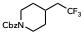

Compound 4l. Piperidine 4l was prepared from benzyl 4-methylenepiperidine-1-carboxylate (23.1 mg, 0.100 mmol, 1.0 equiv) according to GPH. Purification by preparatory TLC (5% EtOAc in petroleum ether) afforded 4l as a yellow oil (22.7 mg, 75.3 µmol, 75% yield). ¹H NMR (CDCl₃, 500 MHz): δ 7.39 – 7.27 (m, 5H), 5.12 (s, 2H), 4.18 (br s, 2H), 2.80 (br s, 2H), 2.02 (qd, J = 11.3, 6.5 Hz, 2H), 1.91 – 1.80 (m, 1H), 1.78 (d, J = 13.4 Hz, 2H), 1.32 – 1.17 (m, 2H). ¹³C NMR (CDCl₃, 125 MHz): δ 155.2, 136.8, 128.5, 128.0, 127.9, 126.8 (q, J = 277.2 Hz), 67.1, 43.8, 40.0 (q, J = 27.5 Hz), 31.8, 30.5 (q, J = 2.4 Hz). ¹⁹F NMR (CDCl₃, 376 MHz): δ -66.5 (t, J = 11.2 Hz, 3F). HRMS (ESI) m/z calcd. for C₁₅H₁₈F₃NO₂ [M+H]⁺ = 302.1362, found: 302.1361.

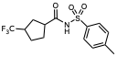

Compound 4m. Compound 4m was prepared from N-tosylcyclopent-3-ene-1-carboxamide (26.5 mg, 0.100 mmol, 1.0 equiv) according to GPG. Purification by preparatory TLC (25% EtOAc in hexane) afforded 4m as a pale yellow solid (17.5 mg, 52.2 µmol, 52% yield). ¹H NMR (CDCl₃, 400 MHz): δ 7.93 (d, J = 8.0 Hz, 2H), 7.35 (d, J = 8.0 Hz, 2H), 2.84 – 2.64 (m, 2H), 2.45 (s, 3H), 2.14 – 1.82 (m, 4H), 1.82 – 1.56 (m, 2H). ¹³C NMR (CDCl₃, 125 MHz): δ 172.5, 145.4, 135.3, 129.7, 128.32, 127.9 (q, J = 277.4 Hz), 44.9, 42.3 (q, J = 27.7 Hz), 29.7, 28.9 (q, J = 2.5 Hz), 25.9 (q, J = 2.3 Hz), 21.7. ¹⁹F NMR (CDCl₃, 376 MHz): δ -74.8 (d, J = 9.6 Hz, 3F). HRMS (ESI) m/z calcd. for C₁₄H₁₆F₃NO₃S [M-H]⁻ = 334.0730, found: 334.0731. (0.3 ppm).

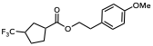

Compound 4n. Anisole 4n was prepared from 4-methoxyphenethyl cyclopent-3-ene-1-carboxylate (24.6 mg, 0.100 mmol, 1.0 equiv) according to GPG. Purification by preparatory TLC (25% EtOAc in hexane) afforded 4n as a yellow oil (20.9 mg, 66.1 µmol, 66% yield). ¹H NMR (CDCl₃, 500 MHz): δ 7.12 (d, J = 8.6 Hz, 2H), 6.84 (d, J = 8.4 Hz, 2H), 4.26 (t, J = 6.9 Hz, 2H), 3.78 (s, 3H), 3.08 – 2.75 (m, 3H), 2.80 – 2.64 (m, 1H), 2.18 – 1.88 (m, 4H), 1.86 – 1.64 (m, 2H). ¹³C NMR (CDCl₃, 125 MHz): δ 175.1, 158.4, 129.8, 129.7, 128.2 (q, J = 277.0 Hz), 113.9, 65.3, 55.3, 43.5, 42.3 (q, J = 27.5 Hz), 34.2, 29.8, 29.4 (q, J = 2.4 Hz), 25.8 (q, J = 2.3 Hz). ¹⁹F NMR (CDCl₃, 376 MHz): δ -74.7 (d, J = 9.6 Hz, 3F). ASAP-MS m/z calcd. for C₁₆H₁₉F₃O₃ [M+H]⁺ = 317.1359, found: 317.1359.

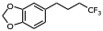

Compound 4o. Safrole derivative 4o was prepared from safrole (14.8 µL, 0.100 mmol, 1.0 equiv) according to GPH. Purification by preparatory TLC (10% toluene in petroleum ether) afforded 4o as a yellow oil (12.9 mg, 55.6 µmol, 56% yield). ¹H NMR (CDCl₃, 500 MHz): δ 6.66 (d, J = 7.9 Hz, 1H), 6.58 (d, J = 1.2 Hz, 1H), 6.54 (dd, J = 7.9, 1.3 Hz, 1H), 5.85 (s, 2H), 2.53 (t, J = 7.5 Hz, 2H), 2.08 – 1.90 (m, 2H), 1.77 (p, J = 7.7 Hz, 2H). ¹³C NMR (CDCl₃, 125 MHz): δ 146.7, 145.0, 133.4, 126.2 (q, J = 276.6 Hz), 120.2, 107.7, 107.2, 99.9, 33.3, 31.9 (q, J = 28.5 Hz), 22.7 (q, J = 2.8 Hz). ¹⁹F NMR (CDCl₃, 470 MHz): δ -69.3 (t, J = 10.8 Hz, 3F). ASAP-MS m/z calcd. for C₁₁H₁₁F₃O₂ [M+H] ⁺ = 233.0784, found: 233.0780.

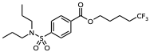

Compound 4p. Probenecid derivative 4p was prepared from 3-butenyl 4-(N,N-dipropyl-sulfamoyl)benzoate (33.9 mg, 0.100 mmol, 1.0 equiv) according to GPG. Purification by preparatory TLC (10% EtOAc / 20% toluene / 70% petroleum ether) afforded 4p as a yellow oil (29.7 mg, 72.5 µmol, 73% yield). ¹H NMR (CDCl₃, 500 MHz): δ 8.18 – 8.10 (m, 2H), 7.91 – 7.84 (m, 2H), 4.38 (t, J = 6.3 Hz, 2H), 3.13 – 3.06 (m, 4H), 2.24 – 2.11 (m, 2H), 1.96 – 1.82 (m, 2H), 1.80 – 1.69 (m, 2H), 1.55 (h, J = 7.4 Hz, 4H), 0.87 (t, J = 7.4 Hz, 6H). ¹³C NMR (CDCl₃, 125 MHz): δ 165.2, 144.4, 133.4, 130.2, 127.1, 127.0 (q, J = 276.2 Hz), 64.8, 50.0, 33.4 (q, J = 28.7 Hz), 27.8, 22.0, 18.8 (q, J = 3.0 Hz), 11.2. ¹⁹F NMR (CDCl₃, 470 MHz): δ -69.5 (t, J = 10.8 Hz, 3F). ASAP-MS m/z calcd. for C₁₈H₂₆F₃NO₄S [M+H]⁺ = 410.1607, found: 410.1607.

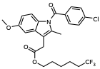

Compound 4q. Indomethacin derivative 4q was prepared from 4-pentenyl 2-(1-(4-chlorobenzoyl)-5-methoxy-2-methyl-1H-indol-3-yl)acetate (42.6 mg, 0.100 mmol, 1.0 equiv) according to GPG. Purification by preparatory TLC (10% EtOAc / 10% toluene / 80% petroleum ether) afforded 4q as a yellow oil (20.4 mg, 41.1 µmol, 41% yield). ¹H NMR (CDCl₃, 500 MHz): δ 7.65 (d, J = 7.8 Hz, 2H), 7.46 (d, J = 8.0 Hz, 2H), 6.96 (d, J = 1.6 Hz, 1H), 6.86 (d, J = 9.2 Hz, 1H), 6.70 – 6.63 (m, 1H), 4.10 (t, J = 6.4 Hz, 2H), 3.82 (s, 3H), 3.65 (s, 2H), 2.39 (s, 3H), 2.08 – 1.91 (m, 2H), 1.63 (p, J = 6.8 Hz, 2H), 1.52 (p, J = 7.9 Hz, 2H), 1.35 (p, J = 7.8, 7.5 Hz, 2H). ¹³C NMR (CDCl₃, 125 MHz): δ 170.9, 168.3, 156.1, 139.3, 136.0, 133.9, 131.2, 130.9, 130.7, 129.1, 127.1 (q, J = 276.3 Hz), 114.9, 112.6, 111.4, 101.6, 64.6, 55.7, 33.5 (q, J = 28.4 Hz), 30.4, 28.3, 25.1, 21.5 (q, J = 3.0 Hz), 13.3. ¹⁹F NMR (CDCl₃, 376 MHz): δ -69.6 (t, J = 10.9 Hz, 3F). HRMS (ESI) m/z calcd. for C₂₅H₂₅ClF₃NO₄ [M+H]⁺ = 496.1497, found: 496.1496.

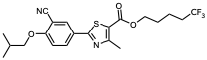
Compound 4r. Febuxostat derivative 4r was prepared from 3-butenyl 2-(3-cyano-4-isobutoxyphenyl)-4-methylthiazole-5-carboxylate (37.0 mg, 0.100 mmol, 1.0 equiv) according to GPG. Purification by preparatory TLC (10% EtOAc / 10% toluene / 80% petroleum ether) afforded 4r as a yellow oil (20.9 mg, 47.4 µmol, 47% yield). ¹H NMR (CDCl₃, 500 MHz): δ 8.18 (d, J = 2.2 Hz, 1H), 8.09 (dd, J = 8.8, 2.3 Hz, 1H), 7.01 (d, J = 8.7 Hz, 1H), 4.32 (t, J = 6.2 Hz, 2H), 3.90 (d, J = 6.3 Hz, 2H), 2.76 (s, 3H), 2.26 – 2.09 (m, 3H), 1.85 (p, J = 6.5 Hz, 2H), 1.77 – 1.67 (m, 2H), 1.09 (d, J = 6.5 Hz, 6H). ¹³C NMR (CDCl₃, 125 MHz): δ 167.4, 162.6, 162.0, 161.5, 132.6, 132.2, 127.0 (q, J = 276.3 Hz), 126.0, 121.5, 115.4, 112.7, 103.1, 75.7, 64.5, 33.4 (q, J = 28.7 Hz), 28.2, 27.8, 19.1, 18.8 (q, J = 3.3 Hz), 17.5. ¹⁹F NMR (CDCl₃, 376 MHz): δ -69.5 (t, J = 10.8 Hz, 3F). HRMS (ESI) m/z calcd. for C₂₁H₂₃F₃N₂O₃S [M+H]⁺ = 441.1454, found: 441.1454.

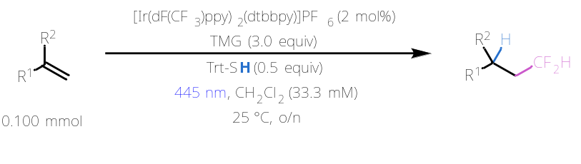

General Procedure I (GPI): To a 4 mL borosilicate vial under ambient conditions was added the alkene starting material (0.100 mmol, 1.0 equiv). CH₂Cl₂ stock solutions of each reagent were prepared such that a 750 µL aliquot of each stock solution would lead to the addition of the appropriate amount of material. An aliquot of 750 µL of a CH₂Cl₂ stock solution of Df-Pro-OH (68.8 mg, 0.300 mmol, 3.0 equiv), [Ir(dF(CF₃)ppy)₂(dtbbpy)]PF₆ (2.24 mg, 20.0 µmol, 2 mol%), TMG (37.7 µL, 0.300 mmol, 3.0 equiv), and TrtSH (13.8 mg, 50.0 µmol, 0.5 equiv) were added the reaction vial in that order. The vial was equipped with 5 small glass beads, capped, and placed in a Lumidox® II photoreactor equipped with a 24-position, 18 mm spacing LED array. With the chiller temperature set to 25 ºC, reaction mixtures were irradiated with 445 nm blue light (345 mW per well) and shaken at 500 rpm overnight (16 – 18 h). After removal from the photoreactor, hexane was added to the crude reaction mixture (~10 mL) until the formation of a precipitate was observed. The heterogeneous mixture was filtered through a short silica plug (~2 mL silica, ~1 cm in height), and the plug was washed with EtOAc (~30 mL). The filtrate was concentrated, and the resulting residue was purified by preparatory TLC.

Note: In the following section, ¹H NMR and ¹³C NMR chemical shift data were reported with reference to TMS (0.00 ppm). ¹⁹F NMR spectra were secondarily (Ξ) referenced to the appropriate ¹H spectrum prior to reporting chemical shift data (52).

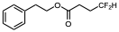

Compound 5a. Ester 5a was prepared from phenylethyl acrylate (17.6 mg, 0.100 mmol, 1.0 equiv) according to GPI with the omission of TrtSH to avoid side reactivity; CH₂Cl₂ (750 µL) was added instead of the TrtSH stock solution. Purification by preparatory TLC (100% hexanes) afforded 5a as a colorless oil (11.0 mg, 48.0 µmol, 48% yield).¹H NMR (CDCl₃, 500 MHz): δ 7.27 – 7.20 (m, 2H), 7.20 – 7.11 (m, 3H), 5.79 (tt, J = 56.6, 4.2 Hz, 1H), 4.25 (t, J = 7.0 Hz, 2H), 2.87 (t, J = 7.0 Hz, 2H), 2.40 (t, J = 7.4 Hz, 2H), 2.05 (ttd, J = 17.3, 7.4, 4.2 Hz, 2H). ¹³C NMR (CDCl₃, 125 MHz): δ 172.0, 137.7, 129.0, 128.7, 126.8, 116.2 (t, J = 239.0 Hz), 65.4, 35.2, 29.4 (t, J = 22.3 Hz), 27.0 (t, J = 6.1 Hz). ¹⁹F{¹H} NMR (CDCl₃, 470 MHz): δ -117.6 (s, 2F). HRMS (ESI) m/z calcd. for C₁₂H₁₄F₂O₂ [M+NH₄]⁺ = 246.1300, found: 246.1300.

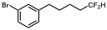

Compound 5b. Phenyl bromide 5b was prepared from 4-(3-bromophenyl)-1-butene (21.1 mg, 0.100 mmol, 1.0 equiv) according to GPI. Purification by preparatory TLC (100% hexane) afforded 5b as a colorless oil (9.2 mg, 35 µmol, 35% yield). ¹H NMR (CDCl₃, 500 MHz): δ 7.34 – 7.27 (m, 2H), 7.17 – 7.04 (m, 2H), 5.79 (tt, J = 56.8, 4.4 Hz, 1H), 2.60 (t, J = 7.6 Hz, 2H), 1.94 – 1.76 (m, 2H), 1.66 (p, J = 7.7 Hz, 2H), 1.53 – 1.43 (m, 2H). ¹³C NMR (CDCl₃, 125 MHz): δ 144.3, 131.4, 129.9, 129.0, 127.0, 122.5, 117.2 (t, J = 238.8 Hz), 35.3, 33.9 (t, J = 20.8 Hz), 30.6, 21.7 (t, J = 5.4 Hz). ¹⁹F{¹H} NMR (CDCl₃, 470 MHz): δ -115.8 (s, 2F). HRMS (ESI) m/z calcd. for C₁₁H₁₃BrF₂ [M+H]⁺ = 263.0242, found: 263.0242.

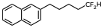

Compound 5c. Naphthalene 5c was prepared from 4-naphthyl-1-butene (18.2 mg, 0.100 mmol, 1.0 equiv) according to GPI. Purification by preparatory TLC (100% hexane) afforded 5c as a colorless oil (7.9 mg, 34 µmol, 34% yield). ¹H NMR (CDCl₃, 400 MHz): δ 7.83 – 7.74 (m, 3H), 7.60 (s, 1H), 7.49 – 7.37 (m, 2H), 7.31 (dd, J = 8.4, 1.7 Hz, 1H), 5.79 (tt, J = 56.8, 4.4 Hz, 1H), 2.80 (t, J = 7.6 Hz, 2H), 1.94 – 1.70 (m, 4H), 1.59 – 1.46 (m, 2H). ¹³C NMR (CDCl₃, 100 MHz): δ 139.4, 133.6, 132.0, 127.9, 127.6, 127.4, 127.2, 126.4, 125.9, 125.2, 117.3 (t, J = 238.9 Hz), 35.8, 34.0 (t, J = 20.9 Hz), 29.7, 21.8 (t, J = 5.7 Hz). ¹⁹F{¹H} NMR (CDCl₃, 376 MHz): δ -115.7 (s, 2F). HRMS (ESI) m/z calcd. for C₁₅H₁₆F₂ [M+H]⁺ = 235.1293, found: 235.1292.

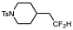

Compound 5d. Piperidine 5d was prepared from 4-methylene-1-tosylpiperidine (25.1 mg, 0.100 mmol, 1.0 equiv) according to GPI. Purification by preparatory TLC (10% EtOAc in hexane) afforded 5d as a colorless oil (17.1 mg, 56.4 µmol, 56% yield). ¹H NMR (CDCl₃, 500 MHz): δ 7.56 (d, J = 8.1 Hz, 2H), 7.25 (d, J = 7.9 Hz, 2H), 5.75 (tt, J = 56.4, 4.5 Hz, 1H), 3.69 (dt, J = 11.1, 2.3 Hz, 2H), 2.36 (s, 3H), 2.17 (td, J = 11.8, 2.5 Hz, 2H), 1.77 – 1.60 (m, 4H), 1.49 – 1.38 (m, 1H), 1.33 (qd, J = 12.0, 11.8, 3.9 Hz, 2H). ¹³C NMR (CDCl₃, 125 MHz): δ 143.7, 133.2, 129.8, 127.9, 116.3 (t, J = 239.2 Hz), 46.2, 40.2 (t, J = 20.5 Hz), 31.6, 30.0 (t, J = 5.0 Hz), 21.7. ¹⁹F{¹H} NMR (CDCl₃, 376 MHz): δ -115.2 (s, 2F). HRMS (ESI) m/z calcd. for C₁₄H₁₉F₂NO₂S [M+H]⁺ = 304.1177, found: 304.1176.

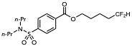

Compound 5e. Probenecid derivative 5e was prepared from 3-butenyl 4-(N,N-dipropyl-sulfamoyl)benzoate (33.9 mg, 0.100 mmol, 1.0 equiv) according to GPI. Purification by preparatory TLC (20% EtOAc in hexane) afforded 5e as a colorless oil (16.5 mg, 42.1 µmol, 42% yield). ¹H NMR (CDCl₃, 500 MHz): δ 8.14 (d, J = 8.4 Hz, 2H), 7.96 – 7.82 (m, 2H), 5.84 (tt, J = 56.5, 4.2 Hz, 1H), 4.37 (t, J = 6.4 Hz, 2H), 3.10 (dd, J = 8.6, 6.6 Hz, 4H), 2.09 – 1.73 (m, 4H), 1.70 – 1.60 (m, 2H), 1.55 (h, J = 7.4 Hz, 4H), 0.87 (t, J = 7.3 Hz, 6H). ¹³C NMR (CDCl₃, 125 MHz): δ 165.2, 144.4, 133.5, 130.2, 127.1, 117.0 (t, J = 239.0 Hz), 65.1, 49.9, 33.6 (t, J = 21.0 Hz), 28.2, 22.0, 18.8 (t, J = 5.5 Hz), 11.2. ¹⁹F{¹H} NMR (CDCl₃, 376 MHz): δ -116.1 (s, 2F). HRMS (ESI) m/z calcd. for C₁₈H₂₇F₂NO₄S [M+H]⁺ = 392.1702, found: 392.1699.
IX. Synthesis and Characterization of Postfunctionalization Products
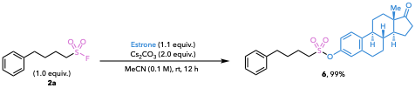

Compound 6. To a flame-dried vial equipped with a stir bar and puncturable cap was added sulfonyl fluoride 2a (22 mg, 0.1 mmol, 1.0 equiv), estrone (30 mg, 0.11 mmol, 1.1 equiv), and anhydrous Cs₂CO₃ (65 mg, 0.2 mmol, 2.0 equiv). The vial was evacuated and backfilled with N₂ three times, after which anhydrous MeCN was added via syringe. The reaction mixture was stirred vigorously under N₂ for 12 h. Upon completion, the mixture was filtered over celite to remove Cs₂CO₃, washing with CH₂Cl₂. The combined filtrate was concentrated under reduced pressure. Purification by flash chromatography on silica gel (0→20% EtOAc/hexanes) afforded 6 as a white sticky wax (46 mg, 0.099 mmol, 99% yield). ¹H NMR (CDCl₃, 500 MHz): δ 7.29 (t, J = 7.6 Hz, 3H), 7.23 – 7.14 (m, 3H), 6.99 – 6.94 (m, 2H), 3.25 – 3.20 (m, 2H), 2.91 (dd, J = 9.0, 4.3 Hz, 2H), 2.68 (t, J = 7.5 Hz, 2H), 2.51 (dd, J = 18.9, 8.6 Hz, 1H), 2.39 (dt, J = 12.9, 3.6 Hz, 1H), 2.28 (td, J = 11.0, 4.2 Hz, 1H), 2.19 – 2.10 (m, 1H), 2.10 – 1.91 (m, 5H), 1.81 (p, J = 7.6 Hz, 2H), 1.68 – 1.39 (m, 8H), 0.91 (s, 3H). ¹³C NMR (CDCl₃, 125 MHz): δ 220.7, 147.1, 141.2, 139.1, 138.9, 128.7, 128.5, 127.0, 126.3, 122.2, 119.2, 50.6, 50.4, 48.0, 44.3, 38.1, 36.0, 35.4, 31.7, 30.0, 29.5, 26.4, 25.9, 23.2, 21.7, 14.0. HRMS (ESI) m/z calcd. for C₂₈H₃₄O₄S [M+H]+ : 467.2251, found: 467.2248.

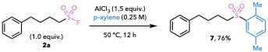

Compound 7. Sulfone 7 was prepared according to a modified literature procedure (54). Sulfonyl fluoride 2a (22 mg, 0.10 mmol, 1.0 equiv) was dissolved in p-xylene (0.40 mL, 0.25 M) under ambient atmosphere. AlCl₃ (20.0 mg, 0.15 mmol, 1.5 equiv) was added in one portion, and the reaction mixture was stirred vigorously at 50 °C for 12 h. Upon completion, the reaction was quenched with water and extracted 3x with CH₂Cl₂. The combined organic layers were dried over MgSO₄, filtered, and concentrated under reduced pressure. Purification by flash chromatography on silica gel (5% EtOAc/hexanes) afforded 7 as a cloudy oil (23 mg, 0.076 mmol, 76% yield).¹H NMR (CDCl₃, 500 MHz): δ 7.77 (d, J = 1.8 Hz, 1H), 7.30 (dd, J = 7.7, 1.9 Hz, 1H), 7.27 – 7.22 (m, 2H), 7.21 – 7.14 (m, 2H), 7.11 – 7.08 (m, 2H), 3.14 – 3.07 (m, 2H), 2.60 (d, J = 12.5 Hz, 5H), 2.37 (s, 3H), 1.81 – 1.65 (m, 4H). ¹³C NMR (CDCl₃, 125 MHz): δ 141.4, 137.1, 136.7, 134.8, 134.5, 132.8, 130.6, 128.6, 128.4, 126.2, 55.4, 35.5, 30.2, 22.2, 21.0, 20.1. HRMS (ESI) m/z calcd. for C₁₈H₂₂O₂S [M+H]⁺ : 303.1413, found: 303.1409.

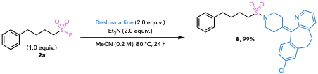

Compound 8. To a pressure tube were added sulfonyl fluoride 2a (22 mg, 0.10 mmol, 1.0 equiv), desloratadine (62 mg, 0.20 mmol, 2.0 equiv), and Et₃N (28 µL, 0.20 mmol, 2.0 equiv), followed by MeCN (0.5 mL, 0.2 M). The pressure tube was sealed, and the reaction mixture was stirred vigorously at 80 ºC for 24 h. Upon completion, the reaction mixture was transferred to a flask with CH₂Cl₂ and concentrated under reduced pressure. Purification by flash chromatography on silica gel (40% EtOAc/hexanes) afforded 8 as a white powder (50 mg, 0.099 mmol, 99% yield). ¹H NMR (CDCl₃, 500 MHz): δ 8.40 (dd, J = 4.8, 1.6 Hz, 1H), 7.44 (dd, J = 7.7, 1.6 Hz, 1H), 7.28 (dd, J = 8.4, 6.8 Hz, 2H), 7.21 – 7.13 (m, 5H), 7.13 – 7.07 (m, 2H), 3.54 – 3.40 (m, 2H), 3.41 – 3.28 (m, 2H), 3.16 – 3.07 (m, 2H), 2.95 – 2.75 (m, 4H), 2.67 – 2.56 (m, 3H), 2.47 (ddd, J = 13.1, 8.4, 4.2 Hz, 1H), 2.37 (ddt, J = 13.7, 6.6, 3.5 Hz, 2H), 1.90 – 1.80 (m, 2H), 1.74 (p, J = 7.5 Hz, 2H). ¹³C NMR (CDCl₃, 125 MHz): δ 156.8, 146.9, 141.5, 139.7, 137.8, 137.6, 136.2, 135.2, 133.5, 133.3, 130.5, 129.2, 128.6, 128.5, 126.4, 126.2, 122.6, 49.7, 47.2, 35.5, 31.8, 31.7, 31.0, 30.8, 30.4, 22.9. HRMS (ESI) m/z calcd. for C₂₉H₃₁ClN₂O₂S [M+H]⁺ : 507.1868, found: 507.1868.

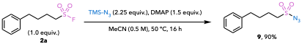

Compound 9. Sulfonyl fluoride 2a (22 mg, 0.10 mmol, 1.0 equiv) was dissolved in MeCN (0.2 mL, 0.5 M) under ambient atmosphere, and DMAP (18 mg, 0.15 mmol, 1.5 equiv) was added in one portion. TMSN₃ (10 µL, 0.075 mmol, 0.75 equiv) was added via microsyringe, and the reaction mixture was heated to 50 °C with vigorous stirring. After 15 min, a second portion of TMSN₃ (10 µL, 0.075 mmol, 0.75 equiv) was added, followed by a third portion (10 µL, 0.075 mmol, 0.75 equiv) after an additional 15 min (30 µL, 0.225 mmol, 2.25 equiv total). The reaction mixture was stirred vigorously at 50 ºC for 16 h, cooled to room temperature, and concentrated under reduced pressure. Purification by flash chromatography on silica gel (5% EtOAc/hexanes) afforded sulfonyl azide 9 as a clear oil (22 mg, .90 mmol, 90% yield). ¹H NMR (CDCl₃, 500 MHz): δ 7.29 (t, J = 7.6 Hz, 2H), 7.23 – 7.18 (m, 1H), 7.18 – 7.14 (m, 2H), 3.34 – 3.27 (m, 2H), 2.67 (t, J = 7.5 Hz, 2H), 1.99 – 1.90 (m, 2H), 1.80 (p, J = 7.4, 7.1 Hz, 2H). ¹³C NMR (CDCl₃, 125 MHz): δ 141.0, 128.7, 128.5, 126.4, 55.9, 35.3, 29.8, 23.1. HRMS (ESI) m/z calcd. for C₁₀H₁₃N₃O₂S [M+NH₄]⁺ : 257.1067, found: 257.1066.

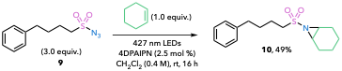

Compound 10. Aziridine 10 was prepared according to a modified literature procedure (16). To a flame-dried vial equipped with a stir bar and puncturable cap were added 4DPAIPN (X mg, 3.75 µmol, 2.5 mol%) and sulfonyl azide 9 (108 mg, 0.45 mmol, 3.0 equiv). The vial was evacuated and backfilled with N₂ three times, after which cyclohexene (15.2 µL, 0.15 mmol, 1.0 equiv) and anhydrous CH₂Cl₂ (0.38 mL, 0.4 M) were added via syringe. The vial was sealed and irradiated with a 40 W Kessil 427 nm LED lamp at 100% intensity with fan cooling for 16 h. Upon completion, the reaction mixture was concentrated under reduced pressure. Purification by flash chromatography on silica gel (0→10% EtOAc/hexanes) afforded 10 as a clear green-gray oil (22 mg, 0.073 mmol, 49% yield).¹H NMR (CDCl₃, 500 MHz): δ 7.31 – 7.24 (m, 2H), 7.21 – 7.15 (m, 3H), 3.14 – 3.08 (m, 2H), 2.95 – 2.90 (m, 2H), 2.67 (t, J = 7.4 Hz, 2H), 1.92 (tt, J = 7.9, 6.1 Hz, 2H), 1.86 – 1.75 (m, 6H), 1.45 – 1.36 (m, 2H), 1.25 (tdd, J = 13.9, 7.7, 3.4 Hz, 2H). ¹³C NMR (CDCl₃, 125 MHz): δ 141.5, 128.6, 128.5, 126.2, 52.7, 39.3, 35.4, 30.1, 23.1, 22.9, 19.6. HRMS (ESI) m/z calcd. for C₁₆H₂₃NO₂S [M+H]⁺ : 294.1522, found: 294.1517.

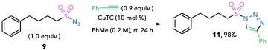

Compound 11. Sulfonyl triazole 11 was prepared according to a modified literature procedure (56). To a suspension of CuTC (1.9 mg, 0.01 mmol, 10 mol%) in anhydrous toluene (0.5 mL) was added phenylacetylene (11 µL, 0.09 mmol, 0.9 equiv) with vigorous stirring. After 10 min, sulfonyl azide 9 (26 mg, 0.10 mmol, 1.0 equiv) was added via microsyringe. The reaction mixture was stirred at room temperature for 24 h and then concentrated under reduced pressure. Purification by flash chromatography on silica gel (0→15% EtOAc/hexanes) afforded 11 as a white crystalline solid (33 mg, 0.098 mmol, 98% yield).¹H NMR (CDCl₃, 500 MHz): δ 8.23 (s, 1H), 7.89 – 7.84 (m, 2H), 7.51 – 7.45 (m, 2H), 7.44 – 7.39 (m, 1H), 7.24 (d, J = 7.7 Hz, 2H), 7.18 – 7.14 (m, 1H), 7.12 – 7.08 (m, 2H), 3.69 – 3.61 (m, 2H), 2.62 (t, J = 7.3 Hz, 2H), 1.87 – 1.70 (m, 4H). ¹³C NMR (CDCl₃, 125 MHz): δ 147.5, 140.7, 129.4, 129.2, 128.8, 128.7, 128.4, 126.4, 126.3, 119.6, 55.3, 35.1, 29.5, 22.6. HRMS (ESI) m/z calcd. for C₁₈H₁₉N₃O₂S [M+H]⁺ : 342.1271, found: 342.1268.

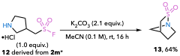

*12 was prepared by subjecting 2m to standard Boc deprotection conditions (57).

Compound 13. Sultam 13 was prepared according to a modified literature procedure (58). To a suspension of 12 (50 mg, 0.24 mmol, 1.0 equiv) in MeCN (2.4 mL, 0.1 M) was added K₂CO₃ (71 mg, 0.51 mmol, 2.1 equiv). The reaction mixture was stirred vigorously at room temperature for 16 h. Upon completion, the mixture was concentrated under reduced pressure, diluted with CH₂Cl₂, and filtered through a short plug of silica gel. The silica gel was washed with CH₂Cl₂, and the combined filtrate was concentrated under reduced pressure to afford 13 as an off-white powder (23 mg, 0.16 mmol, 64% yield). ¹H NMR (CDCl₃, 500 MHz): δ 3.75 (dddd, J = 13.4, 8.5, 4.8, 2.3 Hz, 1H), 3.53 (dt, J = 11.5, 2.3 Hz, 1H), 3.18 – 3.07 (m, 3H), 2.87 (ddd, J = 11.5, 2.9, 1.9 Hz, 1H), 2.62 (dd, J = 11.8, 2.9 Hz, 1H), 1.91 – 1.82 (m, 1H), 1.59 (dtd, J = 10.1, 5.5, 2.6 Hz, 1H) ¹³C NMR (CDCl₃, 125 MHz): δ 57.7, 57.6, 48.5, 41.3, 27.9. HRMS (ESI) m/z calcd. for C₅H₉NO₂S [M+H]⁺ : 148.0427, Found: 148.0426.

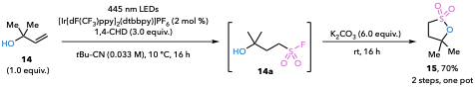

Compound 15. Sultone 15 was prepared through a two-step, one-pot sequence. In the first step, 2-methylbut-3-en-2-ol (14) (26 mg, 0.30 mmol, 1.0 equiv) was subjected to hydrofluoro-sulfonylation Condition A according to GPD using three parallel reactions on 0.1 mmol scale. Following overnight irradiation, the light source was turned off and K₂CO₃ (83 mg, 0.60 mmol, 6.0 equiv) was added directly to each reaction vial. A stir bar was added to each vial, and the reaction mixtures were stirred vigorously at room temperature for an additional 16 h. Upon completion, the three parallel reaction mixtures were combined, diluted with CH₂Cl₂, and washed three times with 10% aqueous K₂CO₃. The combined organic layers were dried over MgSO₄, filtered, and concentrated under reduced pressure. Purification by flash chromatography on silica gel (20→60% EtOAc/hexanes) afforded sultone 15 as an off-white powder (32 mg, 0.21 mmol, 70% yield). ¹H NMR (CDCl₃, 500 MHz): δ 3.34 (t, J = 7.5 Hz, 2H), 2.45 (t, J = 7.5 Hz, 2H), 1.56 (s, 6H). ¹³C NMR (CDCl₃, 125 MHz): δ 88.9, 46.0, 36.1, 28.4. HRMS (ESI) m/z calcd. for C₅H₁₀O₃S [M+H]⁺ : 151.0423, Found: 151.0422.
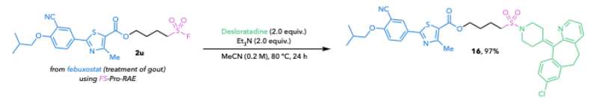
Compound 16. A 10 mL pressure tube was charged with 2u (45.5 mg, 0.1 mmol, 1.0 equiv) and desloratadine (62.2 mg, 0.2 mmol, 2.0 equiv) MeCN (0.6 mL, 0.16 M) and Et₃N (28 µL, 0.2 mmol, 2.0 equiv) were then added. The tube was sealed and the reaction was heated at 80 °C for 24 h. The mixture was transferred to a round bottom flask rinsing with CH₂Cl₂ and the solvent was removed under reduced pressure. Purification by flash chromatography on silica gel (0→40 % EtOAc /hexanes) afforded 16 as a white solid (72 mg, 0.097 mmol, 97% yield). ¹H NMR (CDCl₃, 500 MHz): δ 8.41 – 8.36 (m, 1H), 8.17 (d, J = 2.2 Hz, 1H), 8.07 (dd, J = 8.8, 2.3 Hz, 1H), 7.43 (dd, J = 7.7, 1.6 Hz, 1H), 7.16 (d, J = 2.1 Hz, 1H), 7.13 – 7.05 (m, 3H), 6.97 (d, J = 8.8 Hz, 1H), 4.33 (t, J = 6.0 Hz, 2H), 3.88 (d, J = 6.4 Hz, 2H), 3.57 – 3.44 (m, 2H), 3.42 – 3.28 (m, 2H), 3.19 (dtd, J = 11.5, 7.7, 7.2, 3.4 Hz, 2H), 2.98 (t, J = 7.5 Hz, 2H), 2.89 – 2.78 (m, 2H), 2.76 (s, 3H), 2.62 (ddd, J = 13.2, 8.4, 4.2 Hz, 1H), 2.50 (ddd, J = 13.0, 8.2, 4.2 Hz, 1H), 2.44 – 2.35 (m, 2H), 2.26 – 2.14 (m, 1H), 1.98 (q, J = 7.9, 7.5 Hz, 2H), 1.92 (q, J = 7.4, 6.8 Hz, 2H), 1.08 (d, J = 6.6 Hz, 6H). ¹³C NMR (CDCl₃, 125 MHz): δ 162.7, 162.1, 161.7, 156.8, 146.9, 139.7, 137.8, 137.6, 136.0, 135.3, 133.5, 133.3, 132.8, 132.3, 130.5, 129.2, 126.4, 126.1, 122.6, 121.5, 115.5, 112.8, 103.2, 75.9, 64.4, 49.2, 47.3, 31.8, 31.7, 31.0, 30.8, 28.3, 27.7, 20.3, 19.2, 17.7. HRMS (ESI) m/z calcd. for C₃₉H₄₁ClN₄O₅S₂ [M+H]⁺ : 745.2280, found: 745.2280.

X. Synthetic Applications (AM3506 and PROTAC Synthesis)

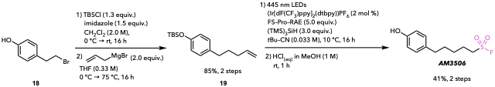
Compound 19. Compound 19 was prepared according to a modified literature procedure (59). To a stirred solution of 4-(2-bromoethyl)phenol (18) (3.44 g, 17.1 mmol, 1.0 equiv) and imidazole (1.75 g, 25.7 mmol, 1.5 equiv) in anhydrous CH₂Cl₂ (9.0 mL, 2.0 M) at 0 °C was added TBSCl (3.35 g, 22.2 mmol, 1.3 equiv). The reaction mixture was allowed to warm to room temperature and stirred overnight. Upon completion, the reaction mixture was filtered through a pad of celite, and the celite was washed with CH₂Cl₂. The filtrate was concentrated under reduced pressure, and the crude silyl-protected intermediate was used directly in the subsequent step without further purification.
The crude intermediate was dissolved in anhydrous THF (50 mL) and cooled to 0 °C. Allylmagnesium bromide (34.2 mL of a 1.0 M solution in Et₂O, 34.2 mmol, 2.0 equiv) was added dropwise, and the reaction mixture was heated at reflux overnight. Upon completion, the reaction mixture was concentrated under reduced pressure, diluted with CH₂Cl₂, and quenched with saturated aqueous NH₄Cl. The aqueous layer was extracted with CH₂Cl₂, and the combined organic layers were dried over MgSO₄, filtered, and concentrated under reduced pressure. Purification by flash chromatography on silica gel (0→5% EtOAc/hexanes) afforded 19 as a colorless oil (4.03 g, 14.6 mmol, 85% yield). Characterization data were consistent with those previously reported (59).
AM3506. Covalent warhead AM3506 was prepared in a two-step sequence. Eight parallel reactions were conducted on 0.1 mmol scale. Compound 19 (221 mg, 0.80 mmol total, 1.0 equiv) was subjected to modified hydrofluorosulfonylation Condition A (GPD) using FS-Pro-RAE (1.37 g, 4.0 mmol total, 5.0 equiv) and (TMS)₃SiH (0.74 mL, 2.40 mmol total, 3.0 equiv). Following irradiation, the eight reaction mixtures were combined and filtered through a short pad of silica gel, eluting with EtOAc. The filtrate was concentrated under reduced pressure, and the resulting residue was dissolved in CH₂Cl₂ and washed 3x with 10% aqueous K₂CO₃. The organic layer was concentrated under reduced pressure, and the crude TBS-protected sulfonyl fluoride was used directly in the subsequent deprotection without further purification.
The crude intermediate was dissolved in 1 M HCl in MeOH (8.0 mL, prepared by dilution of 12 M aqueous HCl with MeOH) and stirred at room temperature for 1 h. Upon completion, the reaction mixture was diluted with CH₂Cl₂ and carefully quenched with saturated aqueous NaHCO₃. The organic layer was washed 3x with saturated aqueous NaHCO₃, once with brine, dried over MgSO₄, filtered, and concentrated under reduced pressure. Purification by flash chromatography on silica gel (0→15% EtOAc/hexanes) afforded AM3506 as a light-yellow oil (80 mg, 0.32 mmol, 41% yield). ¹H NMR (CDCl₃, 500 MHz): δ 7.04 – 6.99 (m, 2H), 6.78 – 6.72 (m, 2H), 4.65 (s, 1H), 3.36 – 3.29 (m, 2H), 2.56 (t, J = 7.5 Hz, 2H), 1.96 (p, J = 7.6, Hz, 2H), 1.64 (p, J = 7.6, Hz, 2H), 1.53 – 1.44 (m, 2H). ¹³C NMR (CDCl₃, 125 MHz): δ 153.9, 134.0, 129.6, 115.4, 51.0, 50.9, 34.6, 30.9, 27.5, 23.5. ¹⁹F NMR (CDCl₃, 376 MHz): δ 53.3. HRMS (ESI) m/z calcd. for C₅H₁₀O₃S [M-H]⁻ : 245.0653, found: 245.0651.
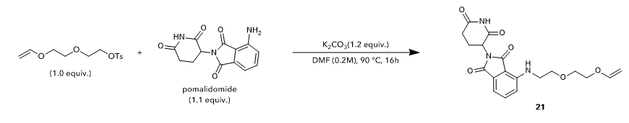
Compound 21. 2-(2-(vinyloxy)ethoxy)ethyl 4-methylbenzenesulfonate (4.34 g, 15.2 mmol, 1.0 equiv), commercially available 4-amino-2-(2,6-dioxopiperidin-3-yl)isoindoline-1,3-dione (4.56 g, 16.7 mmol, 1.1 equiv), and potassium carbonate (2.51 g, 18.2 mmol, 1.2 equiv) were dissolved in DMF (76 mL, 0.2 M). The reaction was then heated at 90 °C for 16 h. The mixture was then diluted with 150 mL of water and extracted with EtOAc (3 x 100 mL). The combined organic layers were washed with water (3 x 150 mL) and brine (3 x 150 mL). The combined organic layers were dried of Na₂SO₄, filtered, and concentrated under reduced pressure. The resulting residue was purified via flash chromatography on silica gel (0→5% DCM/MeOH) to give Compound 21 as a sticky, bright yellow solid (2.95 g, 7.62 mmol, 50% yield). ¹H NMR (CDCl₃, 500 MHz): δ 7.42 (t, J = 7.7 Hz, 1H), 7.15 (d, 1H), 6.86 (d, J = 8.1 Hz, 1H), 6.48 (dd, J = 14.2, 6.7 Hz, 1H), 5.24 (s, 2H), 4.98 – 4.89 (m, 1H), 4.19 (dt, J = 14.3, 1.6 Hz, 1H), 4.14 – 4.03 (m, 2H), 4.00 (dt, J = 6.5, 1.3 Hz, 1H), 3.85 – 3.76 (m, 2H), 3.70 (t, J = 4.7 Hz, 2H), 3.65 (t, J = 5.9 Hz, 2H), 3.02 – 2.90 (m, 1H), 2.84 – 2.70 (m, 2H), 2.15 – 2.03 (m, 1H) ¹³C NMR (CDCl₃, 125 MHz): δ 171.1, 169.2, 169.0, 167.7, 152.0, 145.8, 135.7, 132.5, 121.5, 113.3, 111.1, 86.8, 69.1, 67.7, 67.5, 49.8, 39.4, 32.1, 22.2. HRMS (ESI) m/z calcd. for C₁₉H₂₁N₃O₆ [M+NH₄]⁺ : 405.1769, found: 405.1762.
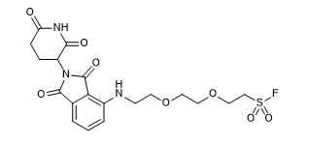
Note: 2-(2-(vinyloxy)ethoxy)ethyl 4-methylbenzenesulfonate was prepared according to literature precedent (60).

Compound 21a. Sulfonyl fluoride 21a was prepared from FS-Pro-RAE (1.88g, 5.5 mmol, 5.0 equiv) and Compound 21 (426 mg, 1.10 mmol, 1.0 equiv) according to modified GPD using eleven parallel reactions on 0.1 mmol scale. Purification by flash chromatography on silica gel (0→30 % EtOAc/hexanes) afforded 21a as a yellow solid. (260 mg, 0.61 mmol, 51% yield). ¹H NMR (CDCl₃, 500 MHz): δ 7.42 (t, 1H), 7.14 (d, J = 6.9 Hz, 1H), 6.87 (d, J = 8.2 Hz, 1H), 5.27 (s, 2H), 4.98 – 4.91 (m, 1H), 4.14 – 3.93 (m, 4H), 3.72 – 3.55 (m, 8H), 3.00 – 2.91 (m, 1H), 2.83 – 2.73 (m, 2H), 2.14 – 2.00 (m, 2H). ¹³C NMR (CDCl₃, 125 MHz): δ 171.2, 169.2, 169.1, 167.8, 145.8, 135.7, 132.5, 121.6, 113.2, 110.9, 71.0, 70.4, 67.9, 64.4, 60.8, 51.4, 51.3, 50.2, 49.9, 46.5, 46.4, 39.6, 32.2, 30.7, 26.3, 24.7, 24.1, 22.1. ¹⁹F NMR (CDCl₃, 376 MHz): δ 58.8. HRMS (ESI) m/z calcd. for C₁₉H₂₂FN₃O₈S [M+H]⁺ : 472.1184, found: 472.1177.

Note: 4CzIPN (43.3 mg, 0.055 mmol, 5 mol%) was used as the photocatalyst to demonstrate compatibility with organic photocatalysts.
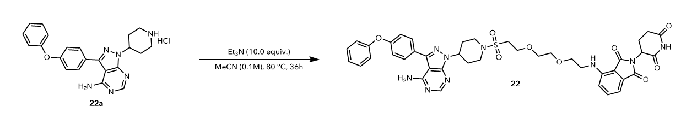
Compound 22. A 10 mL pressure tube was charged with 21a (47.1 mg, 0.1 mmol, 1.0 equiv) and 3-(4-phenoxyphenyl)-1-(piperidin-4-yl)-1H-pyrazolo[3,4-d]pyrimidin-4-amine hydrochloride (22a). MeCN (1 mL, 0.1 M) and Et₃N (0.14 mL, 1.0 mmol, 10.0 equiv.) were then added. The tube was sealed and the reaction was heated at 80 °C for 36 h. The mixture was transferred to a round bottom flask rinsing with CH₂Cl₂ and the solvent was removed under reduced pressure. Purification by flash chromatography on silica gel (0→10 % CH₂Cl₂ /MeOH) afforded 22 as a yellow solid (67 mg, 0.08 mmol, 80% yield). ¹H NMR (CDCl₃, 500 MHz): δ 8.36 (d, J = 7.4 Hz, 1H), 7.64 (d, J = 8.1 Hz, 2H), 7.47 – 7.35 (m, 3H), 7.20 – 7.12 (m, 4H), 7.08 (d, J = 8.0 Hz, 2H), 6.86 (t, J = 7.5 Hz, 1H), 5.45 (s, 2H), 5.27 – 5.20 (m, 2H), 5.00 – 4.82 (m, 2H), 4.18 – 3.99 (m, 2H), 3.97 – 3.81 (m, 3H), 3.76 – 3.54 (m, 8H), 3.32 – 3.26 (m, 1H), 3.14 – 3.06 (m, 2H), 3.02 – 2.88 (m, 1H), 2.82 – 2.73 (m, 2H) 2.50 – 2.39 (m, 2H), 2.13 – 2.07 (m, 3H). ¹³C NMR (CDCl₃, 125 MHz): δ 171.2, 169.2, 169.0, 167.8, 158.7, 157.9, 156.5, 155.8, 154.2, 145.8, 135.7, 130.1, 130.1, 128.0, 124.2, 121.5, 119.7, 119.3, 113.3, 98.8, 70.8, 70.1, 67.8, 65.1, 53.7, 50.8, 49.9, 45.0, 39.5, 32.2, 31.4, 22.2, 0.1. HRMS (ESI) m/z calcd. for C₄₁H₄₃N₉O₉S [M+H]⁺: 838.2977, found: 838.2970.

Note: 22a was prepared in a two-step sequence according to literature precedent (61).

XI. Cyclic Voltammetry Studies
Cyclic voltammetry experiments were conducted using a CH Instruments electrochemical analyzer (model CHI620A) with a three-electrode configuration consisting of a glassy carbon working electrode, a platinum wire counter electrode, and an Ag/AgNO₃ (0.1 M AgNO₃ in MeCN) reference electrode. Measurements were performed in MeCN containing recrystallized tetrabutylammonium hexafluorophosphate (TBAPF₆, 0.25 M) as the supporting electrolyte. S(VI)-Pro-RAE derivatives were typically analyzed at approximately 5 mM, whereas S(VI)-Pro-OH derivatives were analyzed at concentrations of 20–40 mM in the presence of 1.0 equiv. of 1,1,3,3-tetramethylguanidine (TMG) to generate the corresponding carboxylates in-situ. Solutions were sparged with N₂ for 5 min prior to measurement, and voltammograms were recorded at a scan rate of 100 mV s⁻¹. The S(VI)-Pro-OH derivatives often resulted in fouling of the glassy carbon working electrode; therefore, the electrode was polished with alumina, rinsed thoroughly with deionized water, and dried between measurements. Because the observed oxidation and reduction events were irreversible, onset potentials (E_{onset}) were determined graphically by extrapolating a tangent along the rising portion of the corresponding wave to the local background current.
Ferrocene was used as an internal standard to reference measured potentials to the Fc/Fc⁺ redox couple. Sublimed ferrocene was added to the analyte solutions, and the midpoint potential (E_{1/2}) of the Fc/Fc⁺ couple was assigned to 0.00 V. Under the experimental conditions, the Fc/Fc⁺ couple was observed at approximately +0.07 V versus Ag/AgNO₃. Accordingly, potentials measured versus Ag/AgNO₃ were converted to the Fc/Fc⁺ scale by subtracting approximately 0.07 V. All onset potentials reported in the main text are referenced to Fc/Fc⁺.

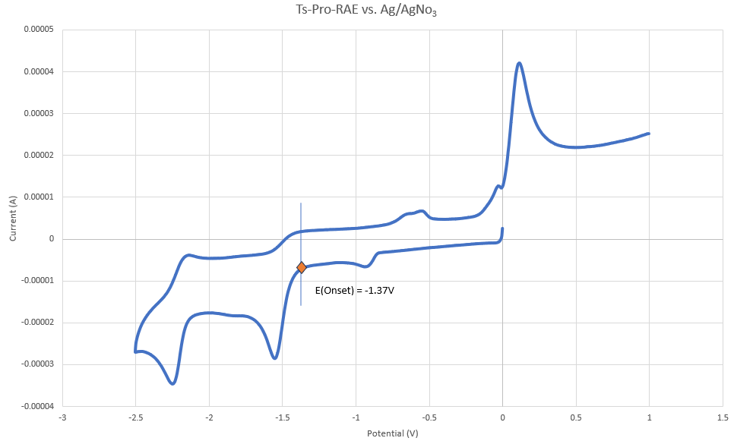
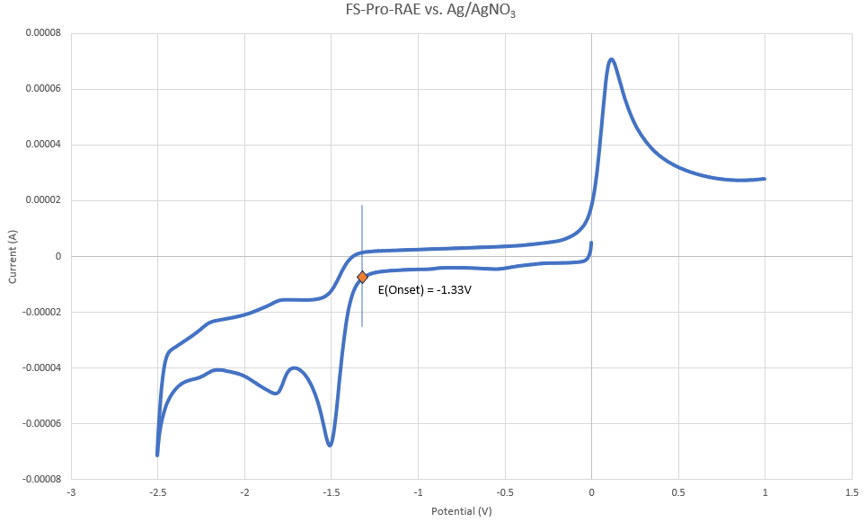
Figure S5. Cyclic voltammogram of Fs-Pro-RAE vs Ag/AgNO₃.

Figure S6. Cyclic voltammogram of Ts-Pro-RAE vs Ag/AgNO₃.

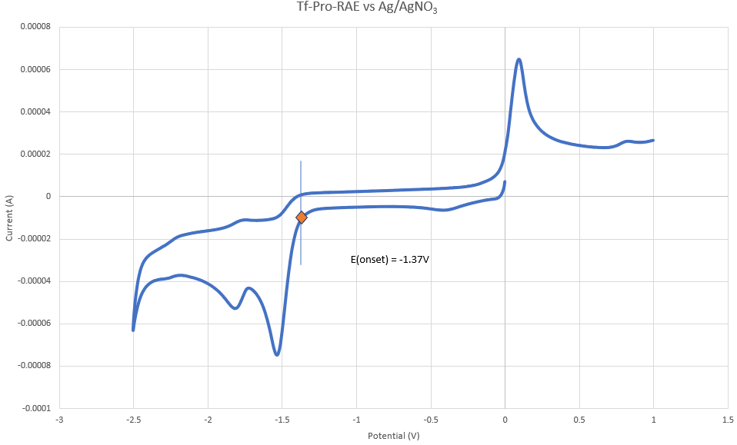
Figure S7. Cyclic voltammogram of Tf-Pro-RAE vs Ag/AgNO₃.
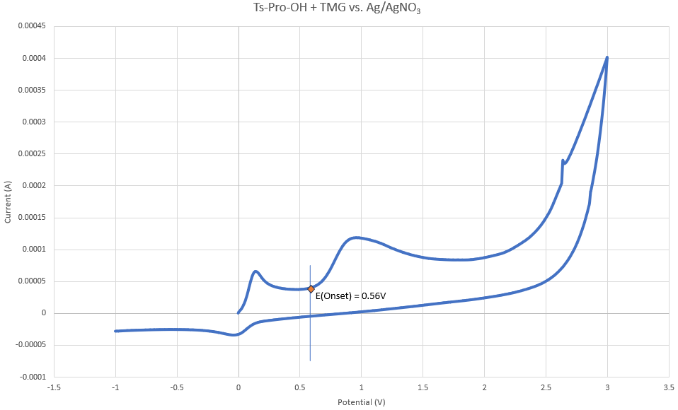

Figure S8. Cyclic voltammogram of Ts-Pro-OH + TMG vs Ag/AgNO₃.

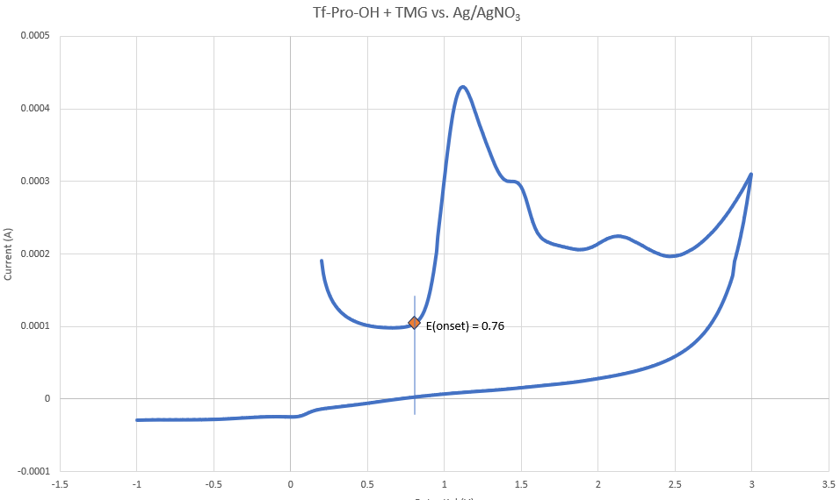
Figure S9. Cyclic voltammogram of Tf-Pro-OH + TMG vs Ag/AgNO₃.
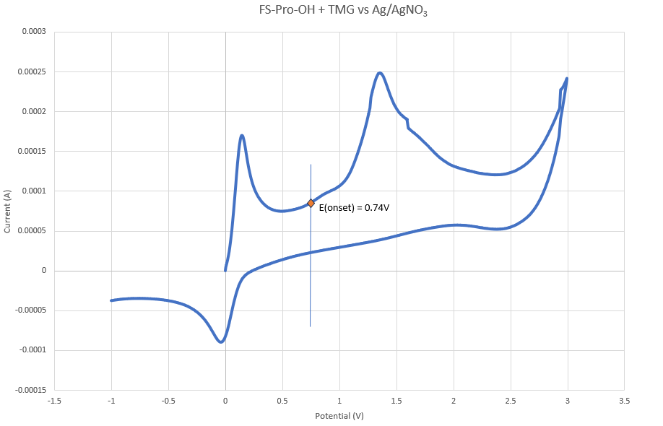

Figure S10. Cyclic voltammogram of FS-Pro-OH + TMG vs Ag/AgNO₃.

*Onset redox potentials were standardized to the Fc/Fc+ redox couple.
FS-Pro-OH + TMG : 0.74V vs. Ag/AgNO₃ → 0.67 V vs Fc/Fc⁺
Ts-Pro-OH + TMG: 0.56V vs. Ag/AgNO₃ → 0.49 V vs Fc/Fc⁺
Tf-Pro-OH + TMG: 0.76V vs. Ag/AgNO₃ → 0.69 V vs Fc/Fc⁺
FS-Pro-RAE: -1.33V vs. Ag/AgNO₃ → -1.40 V vs Fc/Fc⁺
Ts-Pro-RAE: -1.37V vs. Ag/AgNO₃ → -1.44 V vs Fc/Fc⁺
Tf-Pro-RAE: -1.37V vs. Ag/AgNO₃ → -1.44 V vs Fc/Fc⁺

XII. Computations

The structures of all starting materials were generated and subjected to conformational sampling using both manual searches and the open-source CREST program, included in the xTB software package. CREST employs the semiempirical GFN2-xTB extended tight-binding method, which provides an efficient balance between computational cost and accuracy for exploring extensive conformational spaces. Owing to the limited accuracy of this approach for thermochemical properties, all selected conformers were subsequently refined using higher-level quantum chemical calculations (62-64).

The conformational ensembles generated by CREST were filtered to remove duplicate structures based on a root-mean-square deviation (RMSD) criterion, using a cutoff of 1.0 Å for the atomic coordinates. Representative conformers were then fully optimized with Gaussian 16 at the B3LYP/6-311++G(d,p) level of theory for all atoms, a computational protocol previously shown to provide a reliable description of related reactive systems (65-72, 18). Solvent effects were included throughout using the SMD implicit solvation model (73). Dichloromethane (CH₂Cl₂) was modeled directly using the solvent parameters available in Gaussian 16. In calculations corresponding to reactions performed in pivalonitrile, acetonitrile (MeCN) was employed as a surrogate solvent because the SMD parameters required for pivalonitrile are not available. Open-shell species were treated using unrestricted wave functions.

Frequency calculations were carried out for all optimized structures to verify their nature as either local minima or transition states (TSs). Intrinsic reaction coordinate (IRC) calculations were subsequently performed to confirm that each transition state correctly connects the corresponding reactants, intermediates, and products (74, 75). Thermochemical corrections were evaluated at 293.15 K or 308.15 K, according to the experimental conditions, with the pressure fixed at 1 atm.
Final Gibbs free energies were obtained by combining the thermal corrections from the geometry optimizations with electronic energies computed through single-point calculations at a higher level of theory. Specifically, single-point energies were evaluated using the (U)M06-2X functional, including Grimme’s D2 empirical dispersion correction(76), together with the 6-311++G(2d,p) basis set for all atoms (68-72, 18). Solvent effects were consistently described using the same SMD model adopted during the geometry optimization step (73).

Figure S11. Full Electronic + Zero Point Energy (ZPE) profile for reaction mechanism of FSO₂· radical trapping by the alkene at 20°C. [SMD(MeCN)-(U)M06-2X/6-311++g(2d,p)//SMD(MeCN)-(U)B3LYP/6-311+g(d,p)]].

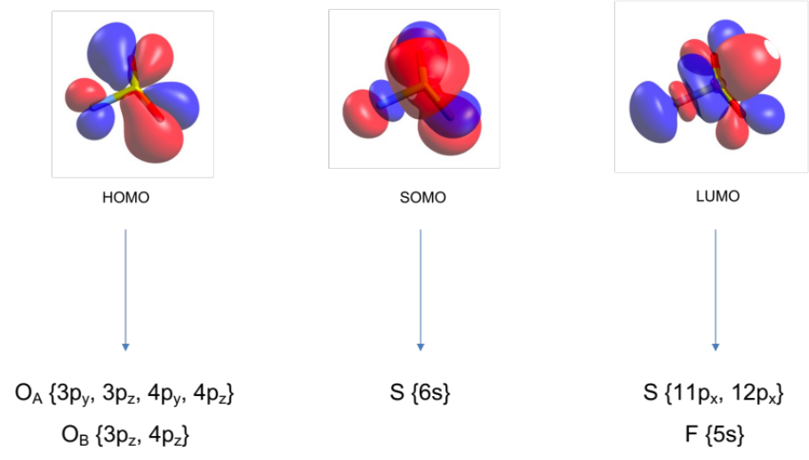
Figure S12. Molecular orbital representation for HOMO, SOMO and LUMO alongside with the atomic orbital contributions to the molecular one. [SMD(MeCN)-(U)B3LYP/6-311+g(d,p)]]

Table S3. Energies, thermal corrections, and free energies for each structure described.

Species | Electronic Energy (a.u.)  (U)B3LYP | Zero-Point Energy correction (a.u.)  (U)B3LYP | Thermal correction Free Energy (a.u.)  (U)B3LYP | Electronic Energy (a.u.)  (U)M06-2X
Proline-FSO₂-Rad | -859.925887 | 0.116072 | 0.081575 | -859.746826
TS-FSO₂-Rad | -859.917171 | 0.114954 | 0.080293 | -859.734739
Imine (in MeCN) | -211.441494 | 0.104629 | 0.077773 | -211.343479
FSO₂-Rad | -648.484019 | 0.009332 | -0.017671 | -648.384378
Proline-MeSO₂-Rad | -799.985176 | 0.151807 | 0.116888 | -799.812696
TS-MeSO₂-Rad | -799.980231 | 0.150317 | 0.115174 | -799.798032
Imine (in MeCN) | -211.441494 | 0.104629 | 0.077773 | -211.343479
MeSO₂-Rad | -588.563436 | 0.044595 | 0.016941 | -588.466591
Proline-TolSO₂-Rad | -1031.095558 | 0.231614 | 0.188692 | -1030.837149
TS-TolSO₂-Rad | -1031.090155 | 0.230209 | 0.186987 | -1030.822902
Imine (in MeCN) | -211.441494 | 0.104629 | 0.077773 | -211.343479
TolSO₂-Rad | -819.675219 | 0.124743 | 0.08782 | -819.490789
Proline-CF₃SO₂-Rad | -1097.77551 | 0.128123 | 0.085963 | -1097.532203
TS-CF₃SO₂-Rad | -1097.770864 | 0.126952 | 0.084792 | -1097.519753
Imine (in DCM) | -211.441823 | 0.104671 | 0.076145 | -211.343848
CF₃SO₂-Rad | -886.347695 | 0.021028 | -0.01401 | -886.17873
TS-CF₃-Rad | -886.339432 | 0.019183 | -0.018777 | -886.165638
CF₃-Rad | -337.668714 | 0.011588 | -0.01511 | -337.562147
SO₂ | -548.67063 | 0.006643 | -0.018536 | -548.601182
Proline-CF₂HSO₂-Rad | -998.504633 | 0.136585 | 0.095365 | -998.282823
TS-CF₂HSO₂-Rad | -998.500674 | 0.135485 | 0.094637 | -998.270677
Imine (in DCM) | -211.441823 | 0.104671 | 0.076145 | -211.343848
CF₂HSO₂-Rad | -787.081554 | 0.029188 | -0.00409 | -786.934326
TS-CF₂H-Rad | -787.072357 | 0.026655 | -0.007094 | -786.919507
CF₂H-Rad | -238.395994 | 0.018705 | -0.007324 | -238.312045
SO₂ | -548.67063 | 0.006643 | -0.018536 | -548.601182
Alkene | -157.273787 | 0.107489 | 0.080517 | -157.183732
FSO₂-Rad | -648.484019 | 0.009332 | -0.017671 | -648.384378
VdW Adduct | -805.776832 | 0.117774 | 0.080736 | -805.583094
TS-Alkene-FSO₂-Rad | -805.776383 | 0.117997 | 0.080227 | -805.588933
Product | -805.778511 | 0.119369 | 0.083123 | -805.602664

Cartesian coordinates

Proline-FSO₂-Rad (doublet)
SMD(MeCN)-(U)B3LYP/6-311+g(d,p),
el. energy = -859.925887 a.u.
C -2.62096100 0.67381400 -0.10230300
C -1.18928100 1.20060600 0.03748700
N -0.37446700 -0.00511400 -0.34920100
C -1.14191100 -1.17636300 -0.22478900
C -2.51303600 -0.82806500 0.23745500
S 1.24919100 0.00919500 -0.15021600
O 1.82052600 -1.21486400 -0.66656400
O 1.77512400 1.31677300 -0.47601000
H -3.30080800 1.21313000 0.55730100
H -2.96176400 0.79857600 -1.13235400
H -0.95403000 2.02688000 -0.62944500
H -0.95758300 1.47675100 1.06840500
H -0.69106300 -2.14138000 -0.39015700
H -3.28091200 -1.43109800 -0.25282500
H -2.61661600 -0.99149000 1.32142200
F 1.49143600 -0.12198900 1.52877700

TS-FSO₂-Rad (doublet)
SMD(MeCN)-(U)B3LYP/6-311+g(d,p),
im. frequency = -361.84,
el. energy = -859.917171 a.u.
C -2.36843200 -0.76549800 0.43520500
C -1.20075900 -1.14573900 -0.48205800
N -0.40812300 0.12204300 -0.61958800
C -1.23999700 1.18293200 -0.33785100
C -2.58324400 0.73659700 0.14405900
S 1.19624400 0.09548700 0.18600700
O 1.74833200 1.43392400 0.12868800
O 1.38930000 -0.73786500 1.36634700
H -3.25283700 -1.36929700 0.23103000
H -2.08513000 -0.90925600 1.48073100
H -0.58097800 -1.95874300 -0.10700000
H -1.53310700 -1.39874900 -1.49080600
H -0.88616100 2.19597000 -0.46128600
H -2.91438600 1.30092900 1.02195700
H -3.34295900 0.88842800 -0.63486200
F 1.95178300 -0.74995600 -1.02168500

Imine
SMD(MeCN)-B3LYP/6-311+g(d,p),
el. energy = -211.441494 a.u.
C 0.94812100 -0.76375600 -0.04420700
C -1.21940300 -0.20260900 0.08671200
C 1.01490700 0.73626400 0.08918000
H 1.83642500 -1.39053200 -0.10608300
C -0.46363800 1.13289800 -0.11196000
H -1.66404600 -0.28587900 1.08489700
H -2.02345100 -0.35585000 -0.63708000
H 1.39491600 0.99533000 1.08533300
H 1.69810200 1.18321500 -0.63792500
H -0.79426500 1.90534600 0.58351500
H -0.61815300 1.50645500 -1.12712400
N -0.21563600 -1.28212500 -0.05198300

FSO₂-Rad (doublet)
SMD(MeCN)-(U)B3LYP/6-311+g(d,p),
el. energy = -648.484019 a.u.
S 0.30096800 0.06796700 0.00000000
O 0.30096800 -0.63446100 1.28181300
O 0.30096800 -0.63446100 -1.28181300
F -1.07010800 1.00710000 0.00000000

Proline-MeSO₂-Rad (doublet)
SMD(MeCN)-(U)B3LYP/6-311+g(d,p),
el. energy = -799.985176 a.u.
C -2.63738300 0.68013600 -0.08091300
C -1.20141300 1.18375700 0.09659300
N -0.40324800 0.01506000 -0.38012200
C -1.13863200 -1.17199200 -0.17847500
C -2.54231600 -0.83438100 0.21376000
S 1.27256400 0.01781900 -0.14981200
O 1.79088700 -1.15319700 -0.86562900
O 1.73962300 1.35579700 -0.53049000
H -3.32960300 1.20423200 0.57918700
H -2.95667700 0.83910200 -1.11395900
H -0.96695000 2.06271500 -0.50036100
H -0.98343600 1.39239900 1.14960400
H -0.77364900 -2.09597800 -0.60107400
H -3.28304400 -1.41841400 -0.33962900
H -2.71787400 -1.02975300 1.28202400
C 1.57190900 -0.21961300 1.60968700
H 2.65432500 -0.24542700 1.74275500
H 1.13855700 0.61851900 2.15482500
H 1.12300600 -1.16615800 1.90951100

TS-MeSO₂-Rad (doublet)
SMD(MeCN)-(U)B3LYP/6-311+g(d,p),
im. frequency = -314.25,
el. energy = -799.980231 a.u.
C -2.39552200 -0.75462300 0.48218000
C -1.23085800 -1.20100100 -0.41475500
N -0.46143400 0.04759900 -0.70150200
C -1.29353300 1.10389400 -0.50391500
C -2.62837900 0.71189100 0.05589100
S 1.22523500 0.11979700 0.19847200
O 1.60910000 1.54357200 0.16021100
O 1.27006800 -0.57330400 1.50897400
H -3.27658200 -1.38413400 0.35106600
H -2.09648600 -0.79699700 1.53258200
H -0.59270800 -1.96012600 0.03706400
H -1.58374200 -1.57927000 -1.37791000
H -0.95249500 2.10920700 -0.70813000
H -2.93835700 1.35676300 0.88522400
H -3.41179100 0.78696300 -0.71105700
C 2.23904500 -0.79975400 -0.96821000
H 2.18092600 -0.30051100 -1.93383700
H 3.25715300 -0.78573400 -0.57615100
H 1.86248600 -1.82068300 -1.02452200

MeSO₂-Rad (doublet)
SMD(MeCN)-(U)B3LYP/6-311+g(d,p),
el. energy = -588.563436 a.u.
S 0.19337900 0.00002900 -0.28307100
O 0.76284300 -1.28647200 0.20983900
O 0.76302500 1.28632800 0.20988300
C -1.59725800 0.00008900 0.10667500
H -2.02037800 -0.90154800 -0.33276000
H -1.67724200 -0.00117000 1.19495400
H -2.01984400 0.90287100 -0.33088300

Proline-TolSO₂-Rad (doublet)
SMD(MeCN)-(U)B3LYP/6-311+g(d,p),
el. energy = -1031.095558 a.u.
C 2.98067300 -1.93612600 -0.80188000
C 2.12256000 -0.74328600 -1.23671600
N 2.01479700 0.04647800 0.02716100
C 2.17108700 -0.80957200 1.12731700
C 2.56674200 -2.17481200 0.66747200
S 0.89974300 1.33501300 0.08721800
O 1.10775800 1.96756700 1.39366900
O 1.11860100 2.10327800 -1.14236400
C -0.75255900 0.64894600 0.04603500
C -1.32652400 0.17624900 1.22862600
C -2.58366300 -0.41871100 1.17763900
C -3.27948100 -0.54700100 -0.03217000
C -2.67683100 -0.06533200 -1.20269100
C -1.41848600 0.52763300 -1.17539400
C -4.65460600 -1.15992600 -0.07027600
H 2.81410300 -2.80266900 -1.44287400
H 4.03867100 -1.66683300 -0.85125300
H 2.57622700 -0.13533800 -2.01687000
H 1.13037000 -1.07163700 -1.56408400
H 2.20554800 -0.40023000 2.12474000
H 3.37275900 -2.60211200 1.27034800
H 1.72209500 -2.87848100 0.72063000
H -0.81099600 0.28393400 2.17442500
H -3.03332500 -0.78385500 2.09486000
H -3.19928300 -0.15385900 -2.14929500
H -0.96748500 0.89979500 -2.08658500
H -5.42212700 -0.38584500 0.04416200
H -4.83863400 -1.66390500 -1.02183200
H -4.79173500 -1.87966200 0.73980700

TS-TolSO₂-Rad (doublet)
SMD(MeCN)-(U)B3LYP/6-311+g(d,p),
im. frequency = -293.27,
el. energy = -1031.090155 a.u.
C -3.30532500 -1.65727900 0.50801700
C -1.83129300 -1.58144000 0.08220600
N -1.70416700 -0.28322400 -0.64673100
C -2.94735800 0.07908400 -1.07235800
C -4.02986900 -0.83330300 -0.57940200
S -0.75153600 1.03507000 0.32157800
O -0.95502700 2.25426600 -0.48077900
O -1.08292500 1.08853200 1.76346800
C 0.93761600 0.46908400 0.14106800
C 1.53580100 0.50697200 -1.12059500
C 2.83698300 0.04093000 -1.26053400
C 3.55156100 -0.46320500 -0.16207200
C 2.92219700 -0.49092600 1.08761000
C 1.61556900 -0.03334400 1.24859700
C 4.96694100 -0.94856200 -0.33203800
H -3.65876500 -2.68719200 0.57187100
H -3.43830700 -1.18732500 1.48563600
H -1.12701900 -1.63670600 0.91204900
H -1.57705900 -2.36793100 -0.63323500
H -3.07660700 0.96690600 -1.67522300
H -4.89713200 -0.28415700 -0.19746600
H -4.39752900 -1.47738700 -1.39056000
H 1.00013800 0.89839900 -1.97682600
H 3.30761700 0.07007100 -2.23765300
H 3.45724800 -0.87693100 1.94849600
H 1.13691800 -0.06139000 2.21936000
H 5.63758200 -0.11173700 -0.55470900
H 5.33016000 -1.44131800 0.57156000
H 5.04316100 -1.65230900 -1.16594800

TolSO₂-Rad (doublet)
SMD(MeCN)-(U)B3LYP/6-311+g(d,p),
el. energy = -819.675219 a.u.
S 2.15490300 -0.00000800 -0.24080200
O 2.67823700 -1.28958000 0.29045200
O 2.67822600 1.28959000 0.29038400
C 0.35445800 -0.00000700 -0.08867800
C -0.32049000 -1.22010800 -0.08363500
C -1.70938300 -1.20622000 -0.01946900
C -2.42442800 0.00001600 0.01540800
C -1.70937000 1.20623300 -0.01943800
C -0.32046700 1.22010000 -0.08360900
C -3.92590700 0.00000100 0.11032200
H 0.22146200 -2.15685900 -0.11258700
H -2.24629000 -2.14827800 0.00145100
H -2.24625600 2.14830200 0.00150800
H 0.22149400 2.15684500 -0.11254000
H -4.23918300 -0.00061900 1.16074200
H -4.35391000 0.88868000 -0.35840700
H -4.35394800 -0.88812000 -0.35943600

Proline-CF₃SO₂-Rad (doublet)
SMD(DCM)-(U)B3LYP/6-311+g(d,p),
el. energy = -1097.775510 a.u.
C 3.15827400 -0.11604700 -0.67312500
C 1.76208500 0.29261300 -1.15538100
N 1.02878600 0.46031200 0.14342200
C 1.65939100 -0.27943200 1.16696900
C 2.89902000 -0.90894900 0.62790600
S -0.56352400 0.87913800 0.19299900
O -0.91189200 1.22594700 1.56366200
O -0.84318000 1.76552900 -0.92815600
H 3.68185500 -0.69790800 -1.43221600
H 3.74680500 0.77728700 -0.45206100
H 1.74343800 1.22784000 -1.71011100
H 1.29404900 -0.49611100 -1.74874800
H 1.31895700 -0.18815400 2.18560000
H 3.73276400 -0.84985600 1.33196200
H 2.74195300 -1.97528800 0.40543800
C -1.59396900 -0.69257700 -0.15860400
F -1.28374400 -1.18286300 -1.36308100
F -2.89481700 -0.39139800 -0.13507300
F -1.34512400 -1.62481300 0.76455000

TS-CF₃SO₂-Rad (doublet)
SMD(DCM)-(U)B3LYP/6-311+g(d,p),
im. frequency = -339.63,
el. energy = -1097.770864 a.u.
C -3.12428900 -0.65225000 0.39413600
C -1.76518900 -1.28055900 0.06074400
N -0.94303000 -0.13455400 -0.44762100
C -1.79804100 0.83595500 -0.90415500
C -3.23050100 0.52584000 -0.60002500
S 0.41671800 0.39953800 0.66671400
O 0.53526100 1.85823600 0.63971800
O 0.54138900 -0.35882900 1.91868800
H -3.93882100 -1.37028800 0.29410800
H -3.11885400 -0.27806000 1.42117400
H -1.27733100 -1.76606900 0.90386000
H -1.83340000 -1.99489500 -0.76293200
H -1.40947300 1.71961800 -1.38894000
H -3.76136700 1.39002300 -0.18703800
H -3.76683200 0.23316000 -1.51325200
C 1.83719900 -0.23872300 -0.41603800
F 1.73127300 -1.55868900 -0.57901900
F 2.99553800 0.03378300 0.18977400
F 1.81891500 0.35589900 -1.60812000

Imine
SMD(DCM)-B3LYP/6-311+g(d,p),
el. energy = -211.441823 a.u.
C 0.93841000 -0.77533700 -0.04399000
C -1.22120800 -0.18894800 0.08560600
C 1.02405300 0.72470500 0.08824100
H 1.81852000 -1.41364000 -0.10531800
C -0.45025800 1.13880500 -0.11050000
H -1.67013800 -0.26820400 1.08218900
H -2.02519300 -0.33299700 -0.64010100
H 1.40922800 0.98119900 1.08312700
H 1.71065500 1.16358300 -0.64072000
H -0.77106300 1.91391700 0.58673400
H -0.60150700 1.51711500 -1.12440100
N -0.23092600 -1.27947500 -0.05109300

CF₃SO₂-Rad (doublet)
SMD(DCM)-(U)B3LYP/6-311+g(d,p),
el. energy = -886.347695 a.u.
S 1.04045900 0.00000000 -0.34004600
O 1.51631100 1.28769200 0.20549000
O 1.51631100 -1.28769200 0.20549000
C -0.90586500 0.00000000 0.00690500
F -1.41828400 1.08755300 -0.53995200
F -1.41828500 -1.08755000 -0.53995700
F -1.10488800 -0.00000300 1.31451700

TS-CF₃-Rad (doublet)
SMD(DCM)-(U)B3LYP/6-311+g(d,p),
im. frequency = -65.11,
el. energy = -886.339432 a.u.
S 1.45227100 0.00087000 -0.37639100
O 1.83512000 1.24925300 0.28629100
O 1.80868900 -1.25510600 0.28698400
C -1.28579300 0.00325500 0.00383700
F -1.73413200 1.13439400 -0.49393200
F -1.73853700 -1.04484700 -0.64849600
F -1.49089200 -0.08806000 1.29943000

CF₃-Rad (doublet)
SMD(DCM)-(U)B3LYP/6-311+g(d,p),
el. energy = -337.668714 a.u.
C 0.00000000 0.00000000 0.32784500
F 0.00000000 1.26245000 -0.07285500
F 1.09331400 -0.63122500 -0.07285500
F -1.09331400 -0.63122500 -0.07285500

SO₂
SMD(DCM)-B3LYP/6-311+g(d,p),
el. energy = -548.670630 a.u.
S 0.00000000 0.00000000 0.37777500
O 0.00000000 1.24954400 -0.37777500
O 0.00000000 -1.24954400 -0.37777500

Proline-CF₂HSO₂-Rad (doublet)
SMD(DCM)-(U)B3LYP/6-311+g(d,p),
el. energy = -998.504633 a.u.
C -2.93427200 -0.05803200 -0.64486700
C -1.51443900 -0.36017700 -1.13639600
N -0.75869800 -0.43765300 0.15464000
C -1.42076600 0.30142900 1.15976600
C -2.72369700 0.79737400 0.62555200
S 0.86223100 -0.76920700 0.20387100
O 1.22460400 -1.05653800 1.58930700
O 1.16177700 -1.70999900 -0.87255200
H -3.51876500 0.45037600 -1.41244400
H -3.43931300 -0.99131400 -0.38453600
H -1.42526600 -1.30236200 -1.67250700
H -1.12291900 0.45154700 -1.75391100
H -1.08745300 0.22929300 2.18264500
H -3.53666600 0.68698300 1.34785100
H -2.66963600 1.86515100 0.36519500
C 1.83265700 0.79055600 -0.22144900
F 1.48034300 1.20060700 -1.46374500
F 1.50703500 1.76784700 0.65603900
H 2.90085200 0.57051700 -0.17703600

TS-CF₂HSO₂-Rad (doublet)
SMD(DCM)-(U)B3LYP/6-311+g(d,p),
im. frequency = -333.98,
el. energy = -998.500674 a.u.
C -2.86358200 -0.68465700 0.35673300
C -1.49540800 -1.28743500 0.01017900
N -0.68779400 -0.12475500 -0.47691500
C -1.55412600 0.84292700 -0.91126400
C -2.98427800 0.51258200 -0.61263400
S 0.66646200 0.41249300 0.66981100
O 0.76912900 1.87620900 0.63077800
O 0.72530800 -0.31158800 1.95236500
H -3.66943700 -1.41056700 0.24244700
H -2.86254200 -0.33157300 1.39133800
H -1.00202700 -1.78147300 0.84520800
H -1.55665000 -1.99019500 -0.82431000
H -1.17707800 1.74320900 -1.37409900
H -3.52450600 1.36178500 -0.18074800
H -3.51957700 0.23240000 -1.53049700
C 2.12767400 -0.23078100 -0.31283100
F 1.98924200 -1.56759500 -0.46927300
F 2.13058000 0.34712200 -1.53316100
H 3.04741500 0.00127700 0.22775600

CF₂HSO₂-Rad (doublet)
SMD(DCM)-(U)B3LYP/6-311+g(d,p),
el. energy = -787.081554 a.u.
S -0.84308900 0.00000000 -0.28966200
O -1.40544900 -1.28471500 0.18920400
O -1.40544900 1.28471500 0.18920400
C 1.01818300 0.00000000 0.37251700
F 1.60508700 -1.09329600 -0.11619000
F 1.60508700 1.09329600 -0.11619000
H 0.97595800 0.00000000 1.46365200

TS-CF₂H-Rad (doublet)
SMD(DCM)-(U)B3LYP/6-311+g(d,p),
im. frequency = -46.56,
el. energy = -787.072357 a.u.
S 0.47425100 -1.14770400 0.00000000
O -0.07555900 -1.69055400 1.25031300
O -0.07555900 -1.69055400 -1.25031300
C -0.56441700 1.42592700 0.00000000
F -0.07555900 1.97963200 1.09294300
F -0.07555900 1.97963200 -1.09294300
H -1.63251300 1.22317800 0.00000000

CF₂H-Rad (doublet)
SMD(DCM)-(U)B3LYP/6-311+g(d,p),
el. energy = -238.395994 a.u.
C 0.02981200 0.51843200 0.00000000
F 0.02981200 -0.24572000 1.09883400
F 0.02981200 -0.24572000 -1.09883400
H -0.71548400 1.31236500 0.00000000

Alkene
SMD(MeCN)-B3LYP/6-311+g(d,p),
el. energy = -157.273787 a.u.
C -0.53930600 -0.51854600 0.30965300
C 0.72139000 0.29860100 0.33507700
C 1.86210700 -0.02011000 -0.27785800
H -0.36617700 -1.44516900 -0.24733500
C -1.72866900 0.24396400 -0.29474100
H -1.53567700 0.50933500 -1.33871300
H -2.63712700 -0.36473400 -0.26269700
H -1.92590800 1.16921900 0.25600600
H -0.79540700 -0.80654500 1.33749200
H 0.66935200 1.22984100 0.89988000
H 1.96122200 -0.93638000 -0.85488500
H 2.73659200 0.62098000 -0.22252900

VdW Adduct (doublet)
SMD(MeCN)-(U)B3LYP/6-311+g(d,p),
el. energy = -805.776832 a.u.
S -1.40827300 0.19431800 0.09041800
O -1.43922800 1.42046600 -0.71608800
O -1.93216700 0.25776300 1.45978000
F -2.54697800 -0.85211500 -0.72633000
C 2.49322500 0.44312800 -0.24490700
C 1.63014200 -0.57069500 0.40291600
C 0.61775600 -1.26188800 -0.22929900
H 2.27915300 0.50299000 -1.31488300
C 3.99240700 0.19489100 0.00791200
H 4.31086700 -0.75343500 -0.43220900
H 4.58082300 0.99735700 -0.44279600
H 4.21234600 0.16876400 1.07848700
H 2.23169400 1.41849300 0.19586100
H 1.79468200 -0.75742300 1.46229300
H 0.50293600 -1.20105900 -1.30700000
H 0.11265400 -2.07418900 0.28125900

TS-Alkene-FSO₂-Rad (doublet)
SMD(DCM)-(U)B3LYP/6-311+g(d,p),
im. frequency = -138.44,
el. energy = -805.776383 a.u.
S -1.33609800 0.16518800 0.09811300
O -1.28805900 1.47489600 -0.55172900
O -1.78010100 0.09230200 1.48960300
F -2.56612600 -0.68961300 -0.77701200
C 2.42796900 0.43255900 -0.21449100
C 1.52868900 -0.61135800 0.33308000
C 0.41282600 -1.12831700 -0.34549000
H 2.21919500 0.59685500 -1.27524000
C 3.91722400 0.12114900 0.01288200
H 4.21206900 -0.78878600 -0.51634200
H 4.53233400 0.94559000 -0.35565800
H 4.13257000 -0.01589500 1.07617700
H 2.19184300 1.37596300 0.30528200
H 1.70689300 -0.94845700 1.35134300
H 0.35261000 -0.99194200 -1.42233000
H -0.04978900 -2.03161000 0.04118500

Product (doublet)
SMD(MeCN)-(U)B3LYP/6-311+g(d,p),
el. energy = -805.778511 a.u.
S -1.25190100 0.13598300 0.12720400
O -1.11602100 1.53621200 -0.23492700
O -1.61299800 -0.23265300 1.48478100
F -2.51494300 -0.43734900 -0.82660900
C 2.34477600 0.40606200 -0.22434600
C 1.39771500 -0.67468500 0.15990500
C 0.14459700 -0.92833600 -0.55515100
H 2.22278500 0.64518800 -1.28668500
C 3.80834100 0.06708700 0.08918400
H 4.13792400 -0.81156100 -0.47251800
H 4.46005600 0.90389300 -0.17564900
H 3.94341100 -0.14135700 1.15467500
H 2.07741700 1.32807800 0.32011200
H 1.57211800 -1.22914700 1.07684600
H 0.16014000 -0.64720400 -1.61011500
H -0.24936600 -1.93671300 -0.41882

