XIII. NMR Spectra
¹H NMR (500 MHz, CDCl₃) for S1
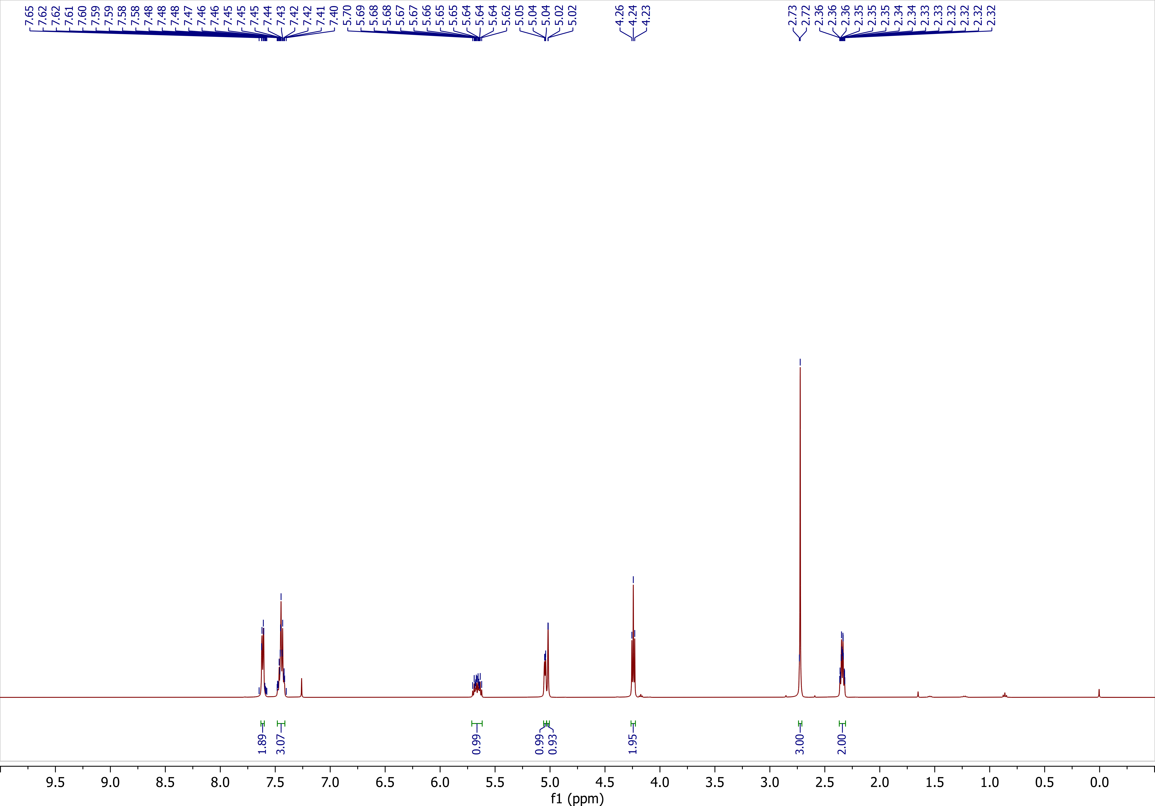
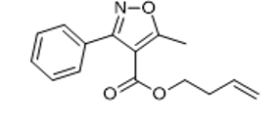

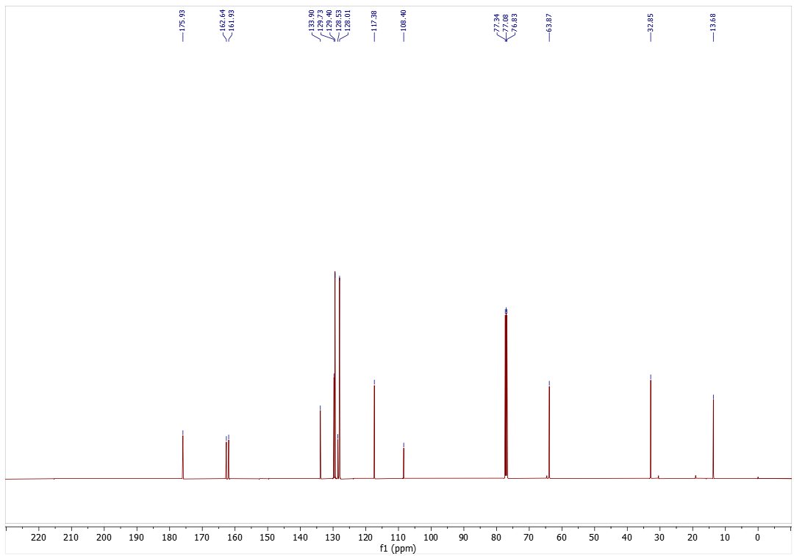
¹³C NMR (126 MHz, CDCl₃) for S1
¹H NMR (500 MHz, CDCl₃) for S2
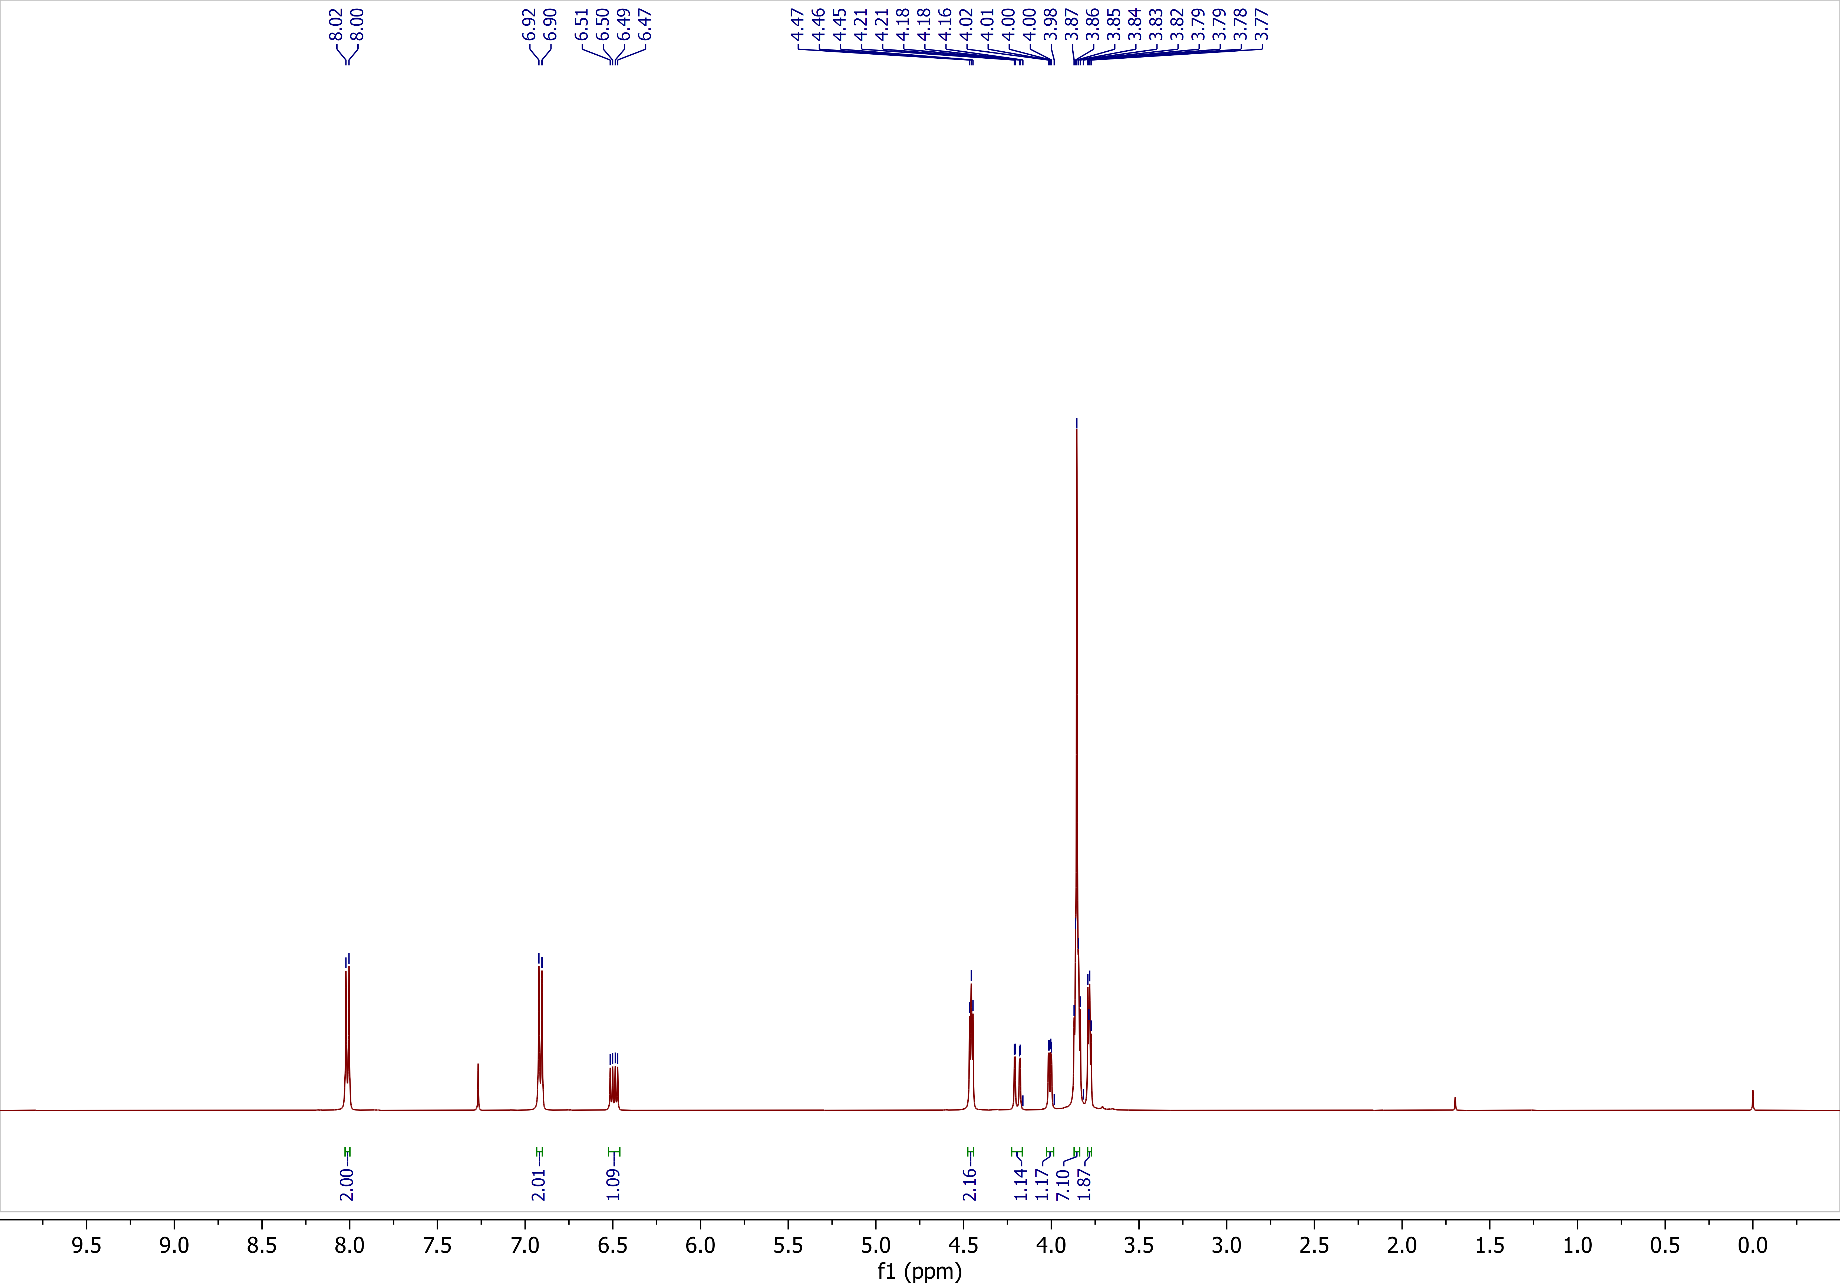
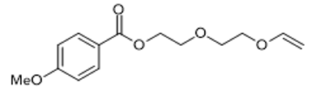

¹³C NMR (126 MHz, CDCl₃) for S2
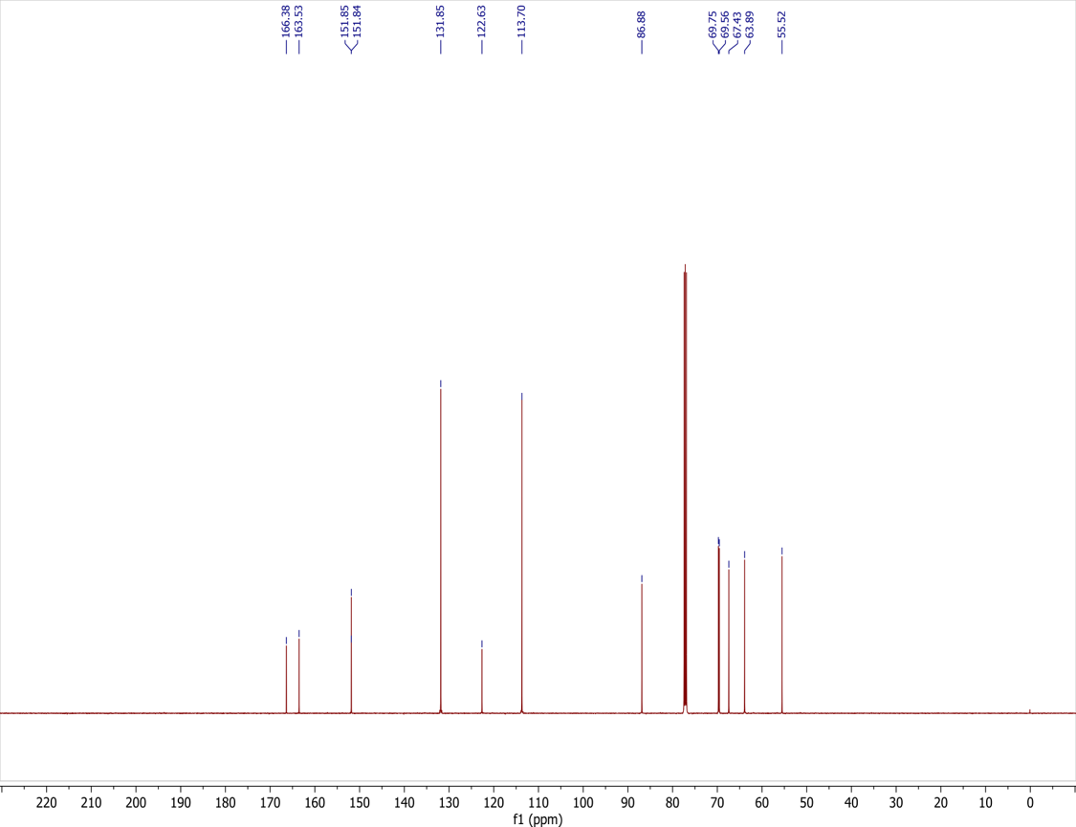

¹H NMR (500 MHz, CDCl₃) for S3
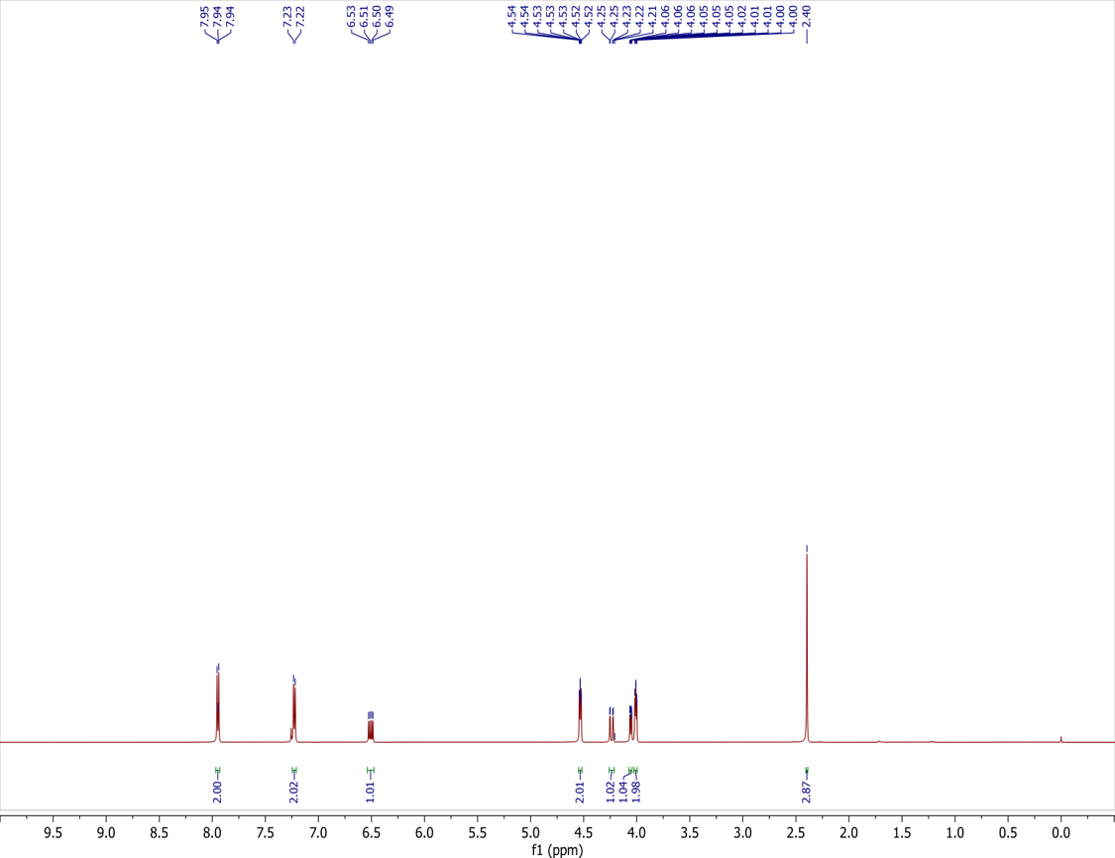
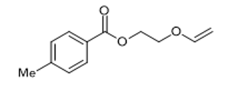

¹³C NMR (126 MHz, CDCl₃) for S3
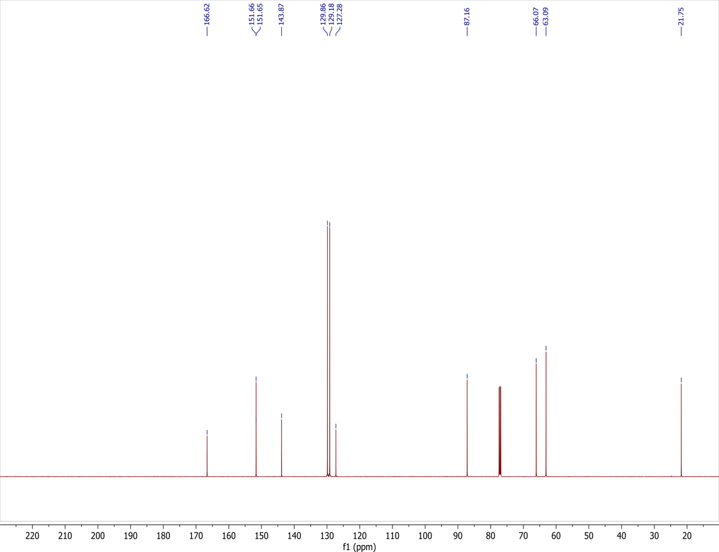
¹H NMR (500 MHz, CDCl₃) for S4
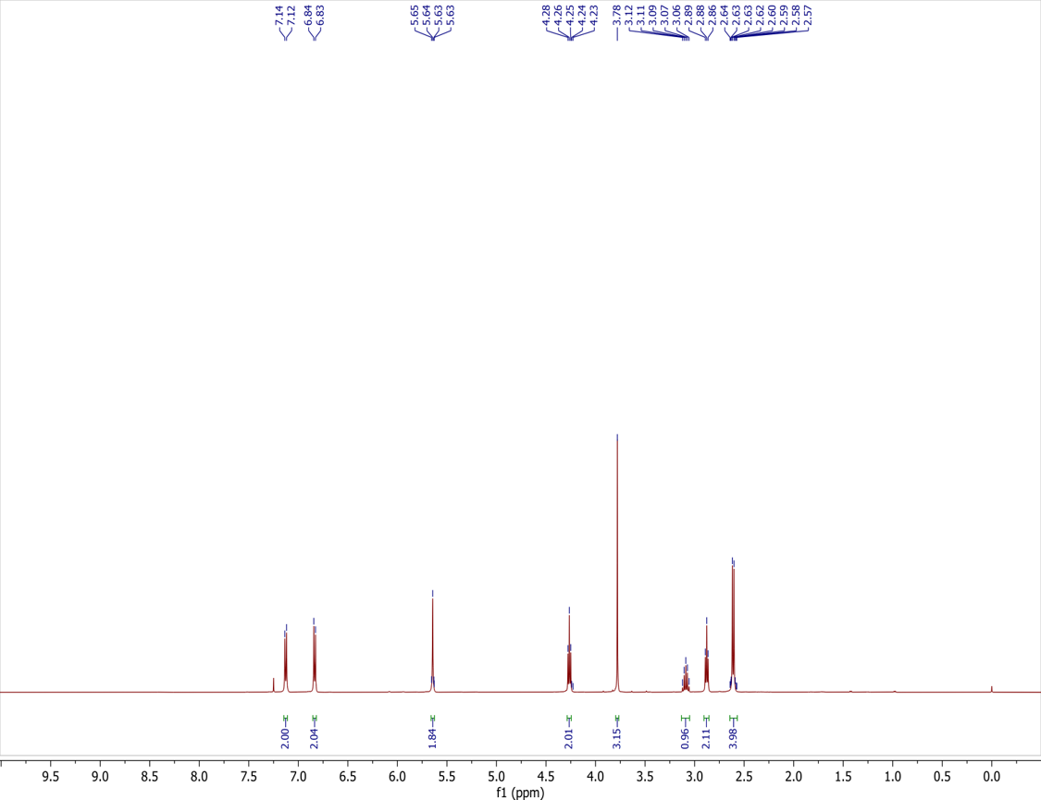
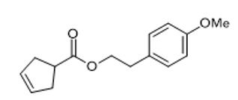

¹³C NMR (126 MHz, CDCl₃) for S4
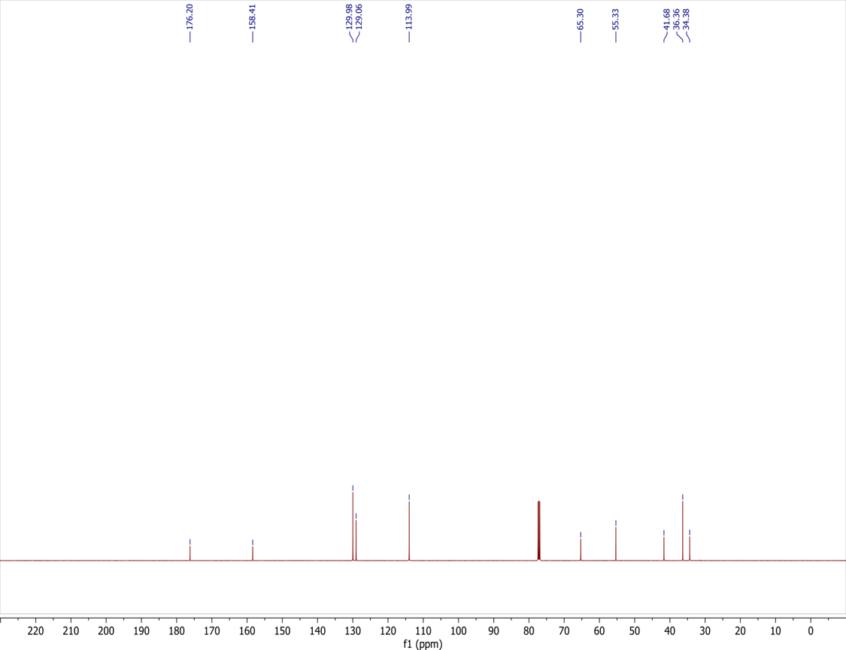

¹H NMR (500 MHz, CDCl₃) for S5
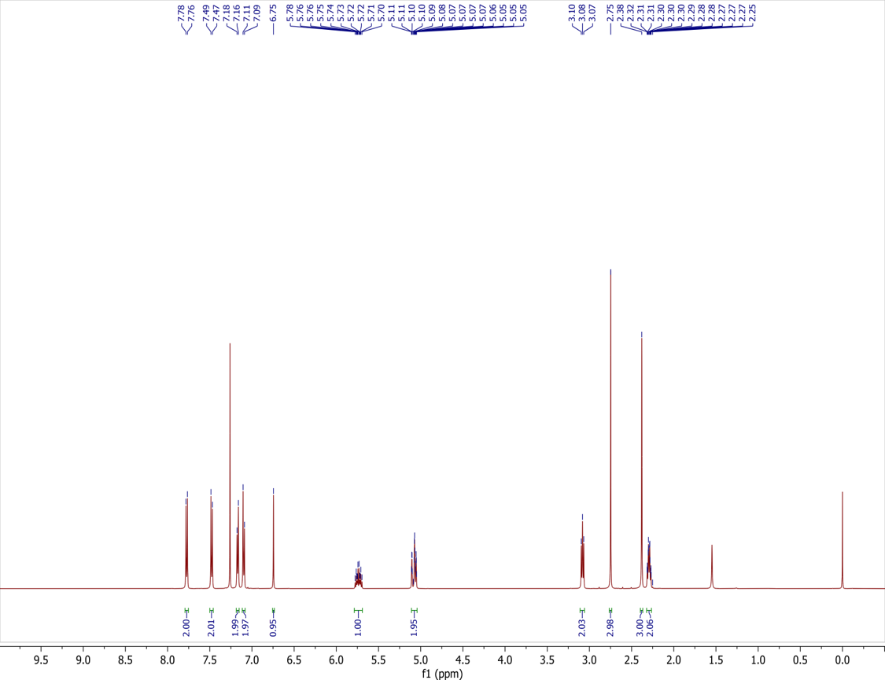
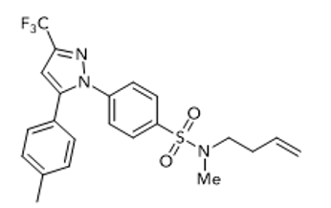

¹³C NMR (126 MHz, CDCl₃) for S5
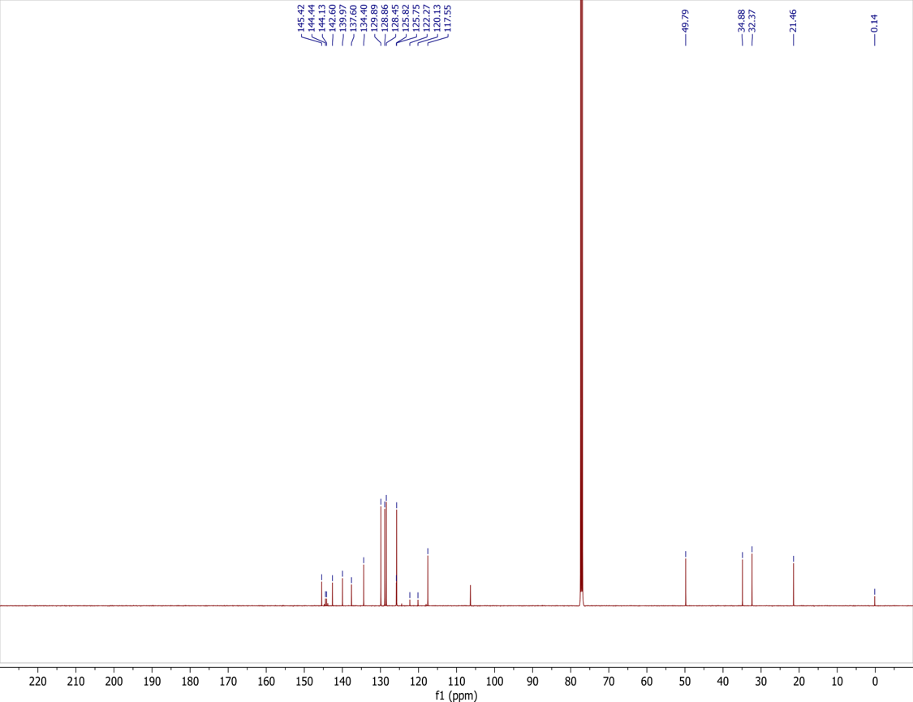

¹⁹F NMR (377 MHz, CDCl₃) for S5
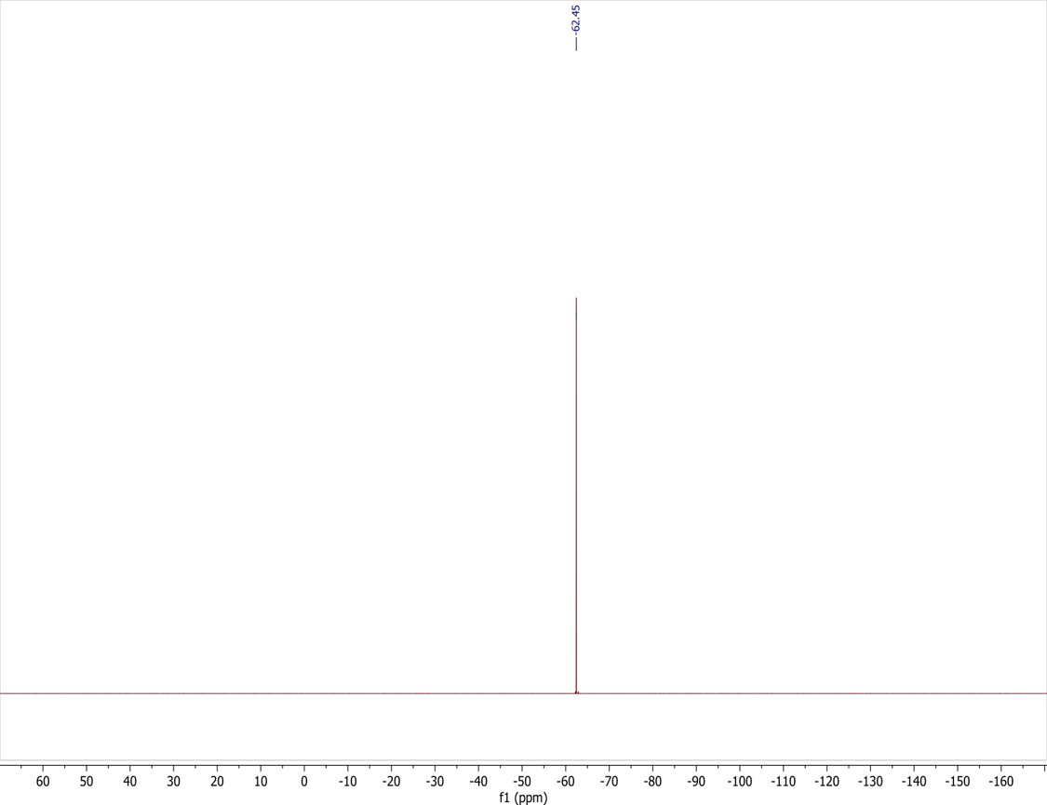
¹H NMR (500 MHz, CDCl₃) for S(VI)-Pro-OH₁
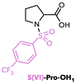
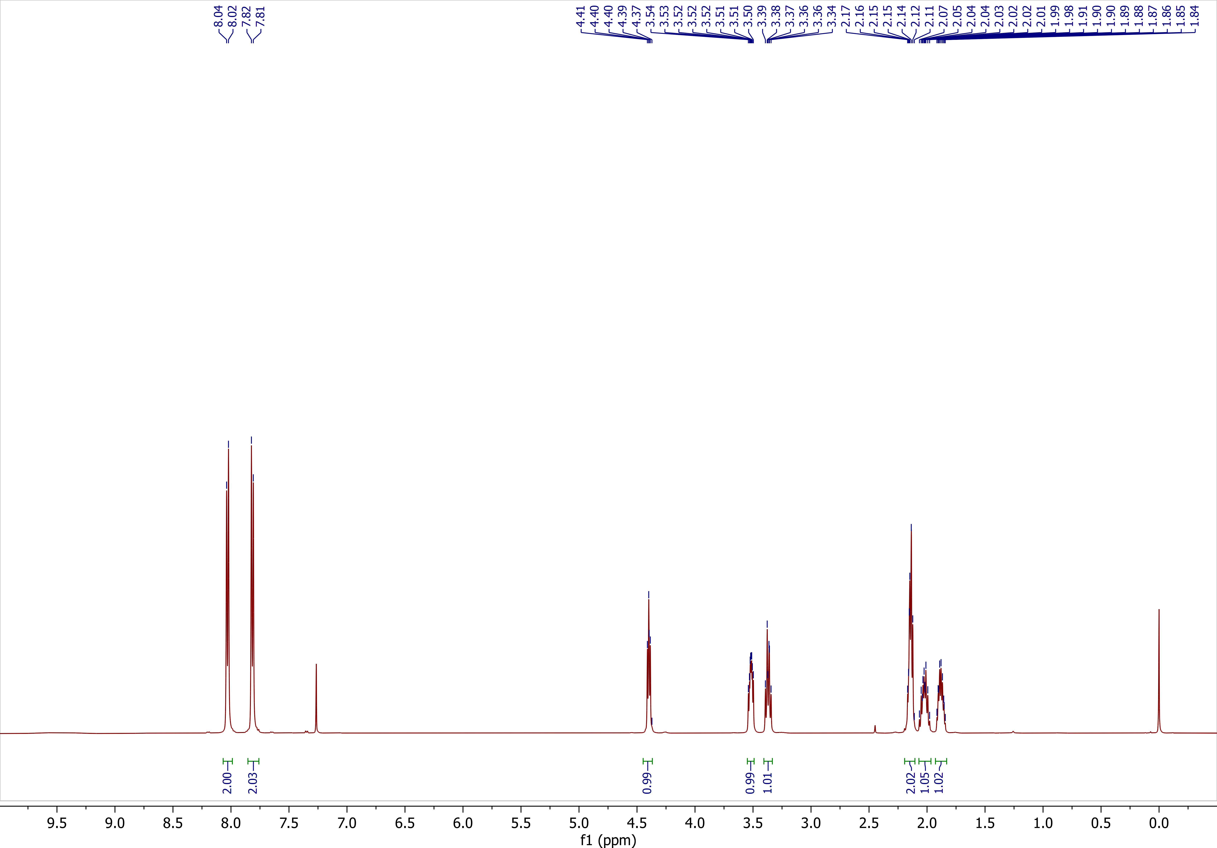
¹³C NMR (126 MHz, CDCl₃) for S(VI)-Pro-OH₁
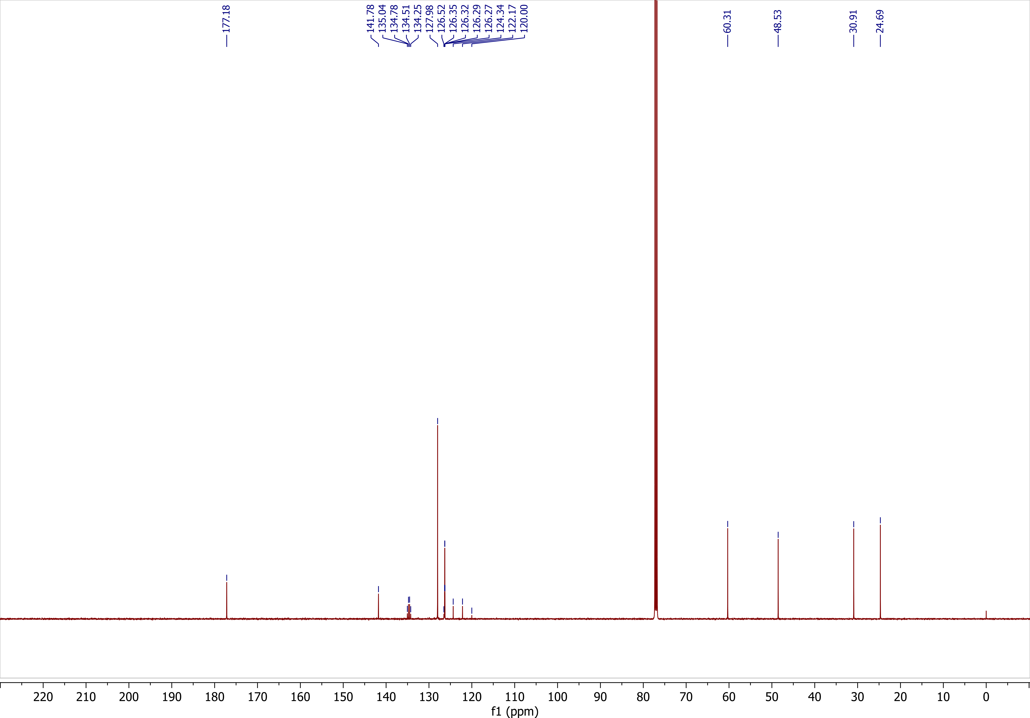
¹⁹F NMR (377 MHz, CDCl₃) for S(VI)-Pro-OH₁
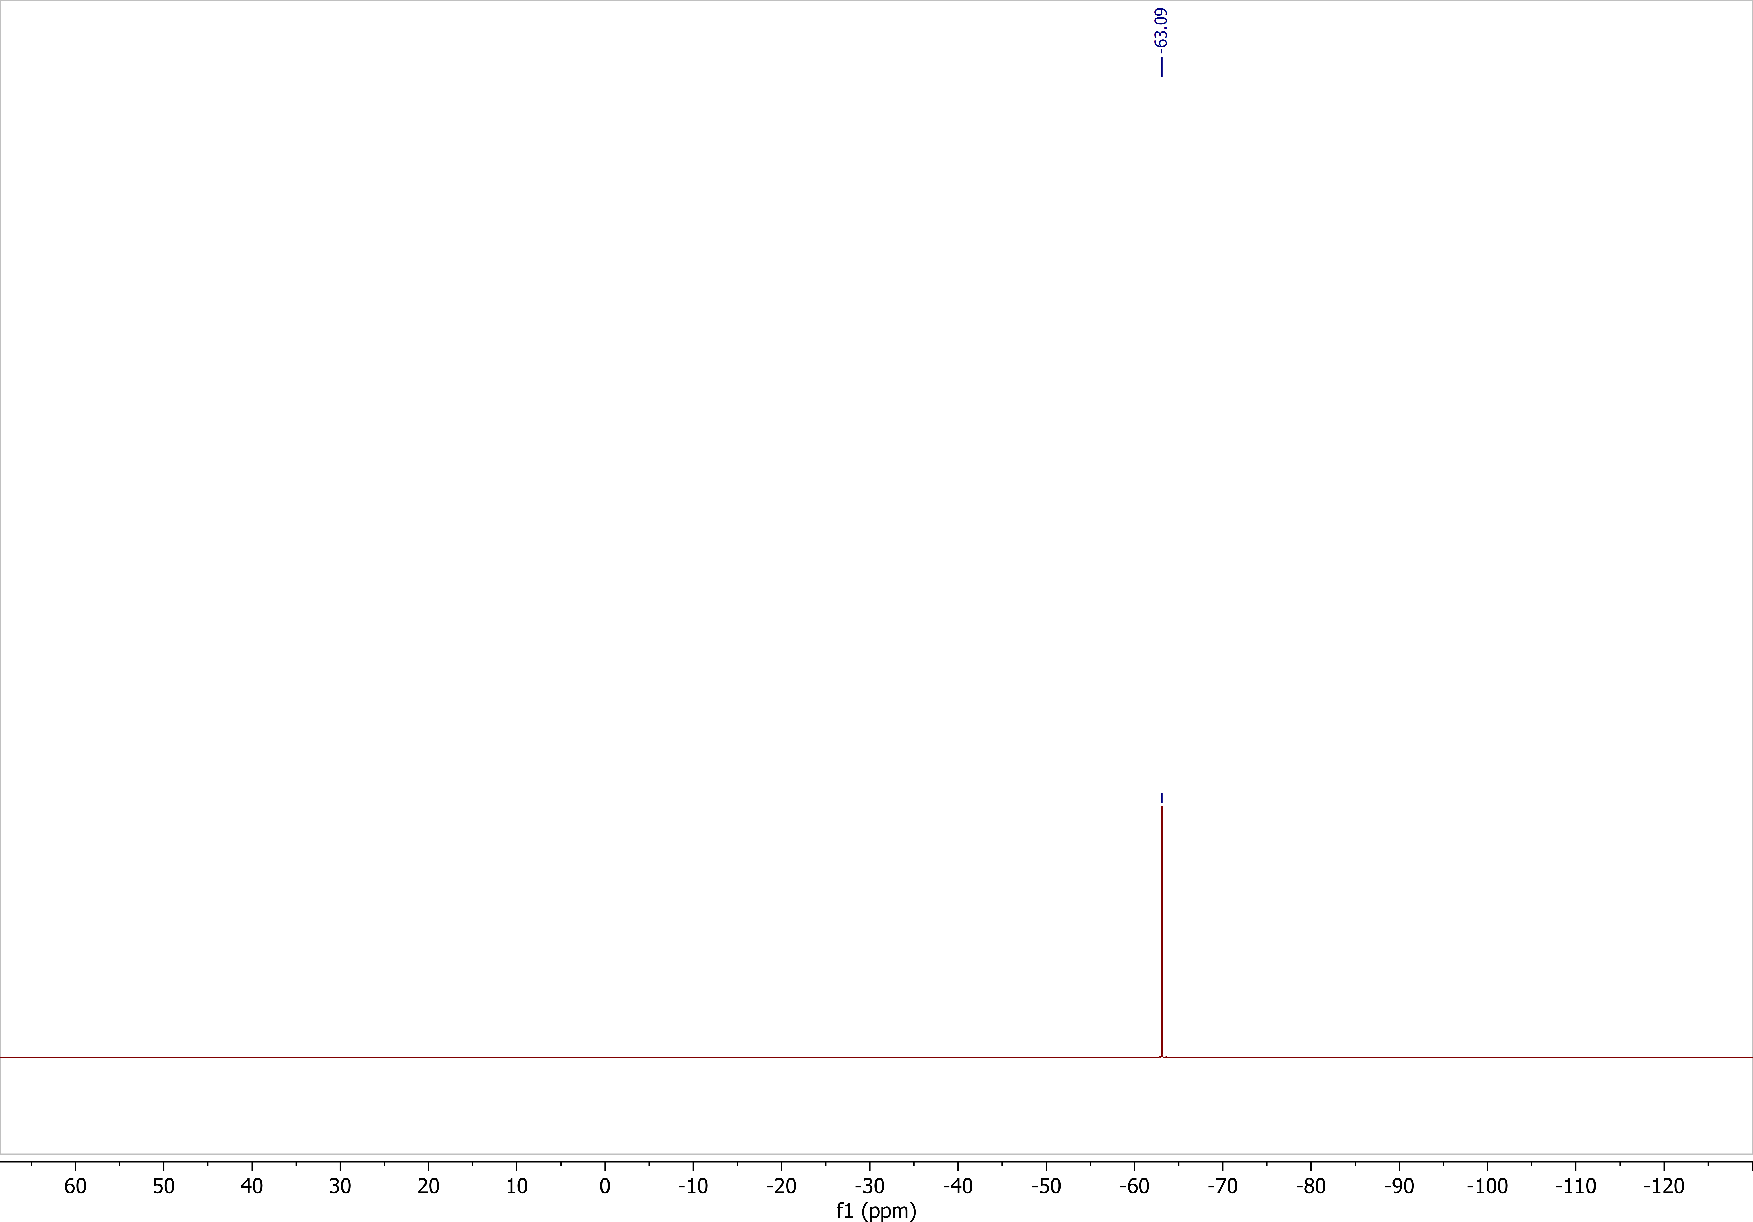
¹H NMR (500 MHz, CDCl₃) for S(VI)-Pro-OH₂
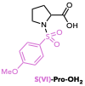
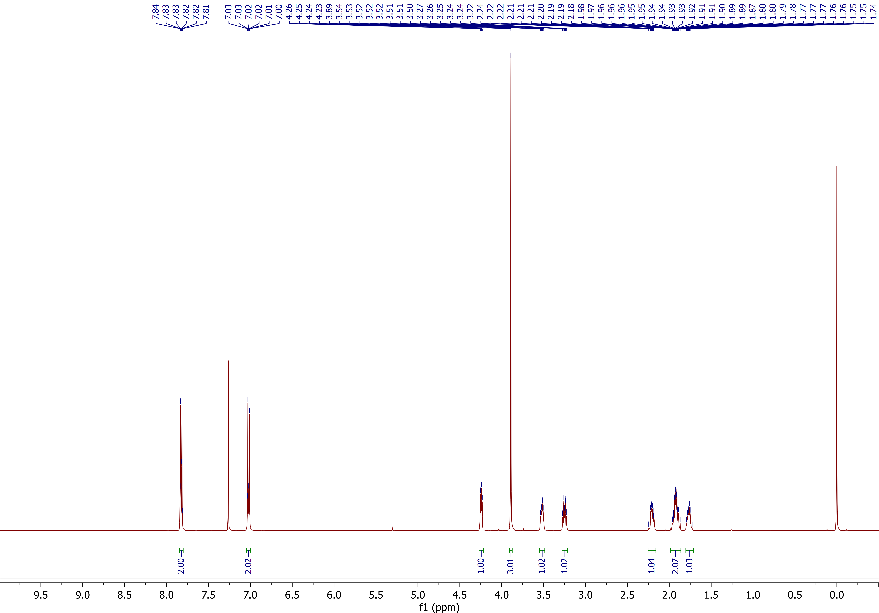
¹³C NMR (126 MHz, CDCl₃) for S(VI)-Pro-OH₂
¹H NMR (500 MHz, CDCl₃) for S(VI)-Pro-OH₃
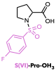
¹³C NMR (126 MHz, CDCl₃) for S(VI)-Pro-OH₃
¹⁹F NMR (377 MHz, CDCl₃) for S(VI)-Pro-OH₃
¹H NMR (500 MHz, Acetone-d₆) for S(VI)-Pro-OH₄
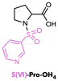
¹³C NMR (126 MHz, Acetone-d₆) for S(VI)-Pro-OH₄
¹H NMR (500 MHz, CDCl₃) for S(VI)-Pro-OH₅
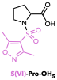
¹³C NMR (126 MHz, CDCl₃) for S(VI)-Pro-OH₅
¹H NMR (500 MHz, CDCl₃) for S(VI)-Pro-OH₆
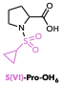
¹³C NMR (126 MHz, CDCl₃) for S(VI)-Pro-OH₆
¹H NMR (500 MHz, CDCl₃) for Ts-Pro-RAE
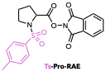
¹³C NMR (126 MHz, CDCl₃) for Ts-Pro-RAE
¹H NMR (500 MHz, CDCl₃) for S(VI)-Pro-RAE₁
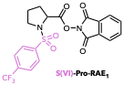
¹³C NMR (126 MHz, CDCl₃) for S(VI)-Pro-RAE₁
¹⁹F NMR (377 MHz, CDCl₃) for S(VI)-Pro-RAE₁
¹H NMR (500 MHz, CDCl₃) for S(VI)-Pro-RAE₂
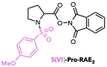
¹³C NMR (126 MHz, CDCl₃) for S(VI)-Pro-RAE₂
¹H NMR (500 MHz, CDCl₃) for S(VI)-Pro-RAE₃
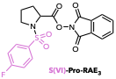
¹³C NMR (126 MHz, CDCl₃) for S(VI)-Pro-RAE₃
¹⁹F NMR (377 MHz, CDCl₃) for S(VI)-Pro-RAE₃
¹H NMR (500 MHz, CDCl₃) for S(VI)-Pro-RAE₄
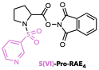
¹³C NMR (126 MHz, CDCl₃) for S(VI)-Pro-RAE₄
¹H NMR (500 MHz, CDCl₃) for S(VI)-Pro-RAE₅
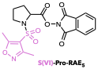
¹³C NMR (126 MHz, CDCl₃) for S(VI)-Pro-RAE₅
¹H NMR (500 MHz, CDCl₃) for S(VI)-Pro-RAE₆
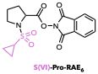
¹³C NMR (126 MHz, CDCl₃) for S(VI)-Pro-RAE₆
¹H NMR (500 MHz, CDCl₃) for Ms-Pro-RAE
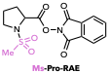
¹³C NMR (126 MHz, CDCl₃) for Ms-Pro-RAE

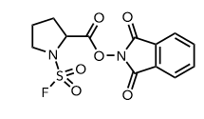
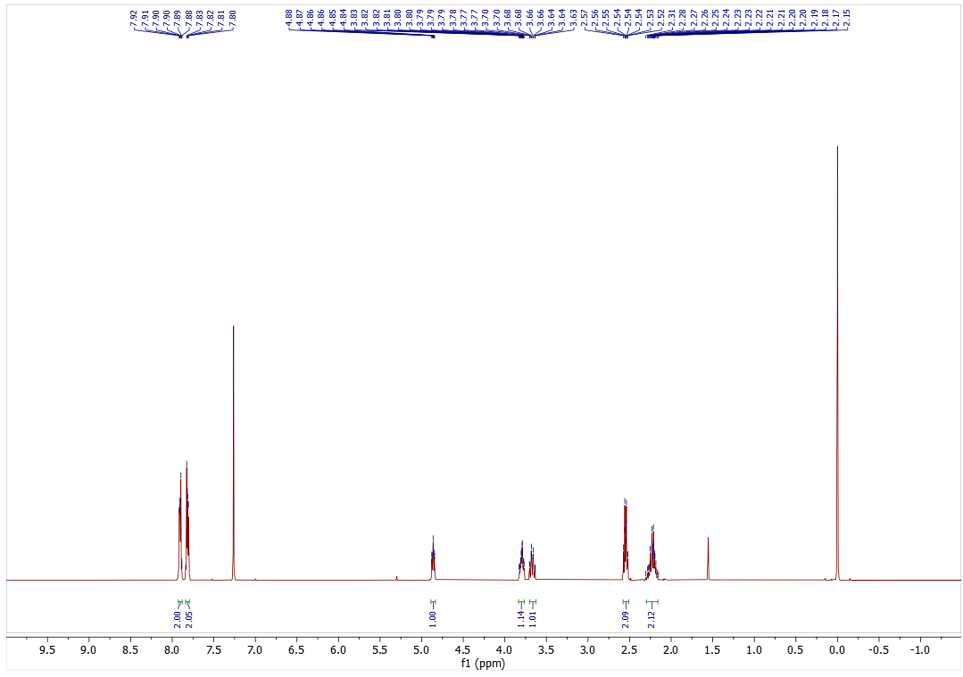
¹H NMR (500 MHz, CDCl₃) for FS-Pro-RAE
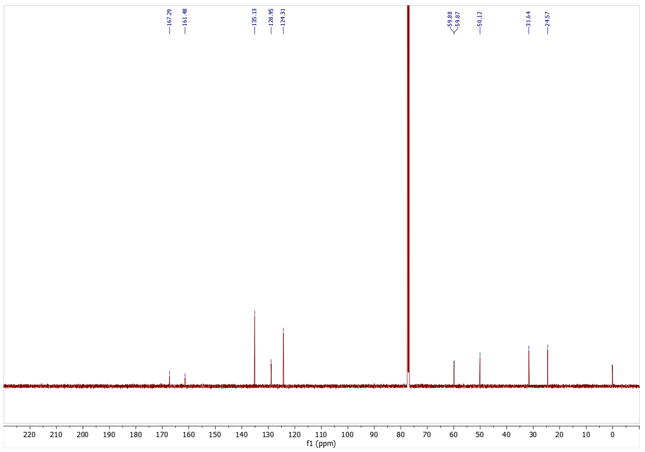
¹³C NMR (126 MHz, CDCl₃) for FS-Pro-RAE
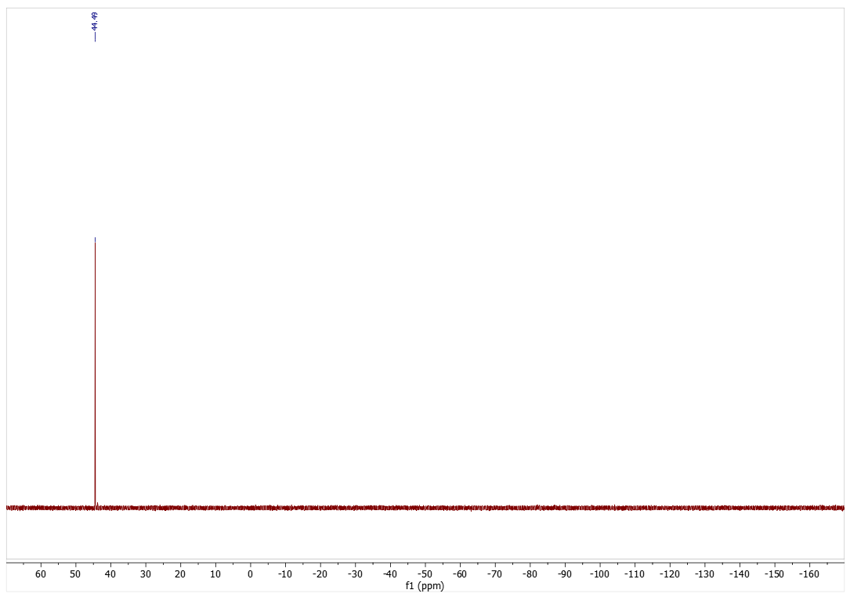
¹⁹F NMR (377 MHz, CDCl₃) for FS-Pro-RAE
¹H NMR (500 MHz, CDCl₃) for Tf-Pro-OBn
¹³C NMR (126 MHz, CDCl₃) for Tf-Pro-OBn
¹⁹F NMR (377 MHz, CDCl₃) for Tf-Pro-OBn
¹H NMR (500 MHz, CDCl₃) for Tf-Pro-OH
¹³C NMR (126 MHz, CDCl₃) for Tf-Pro-OH
¹⁹F NMR (377 MHz, CDCl₃) for Tf-Pro-OH
¹H NMR (400 MHz, CDCl₃) for Tf-Pro-RAE
¹³C NMR (126 MHz, CDCl₃) for Tf-Pro-RAE
¹⁹F NMR (471 MHz, CDCl₃) for Tf-Pro-RAE
¹H NMR (500 MHz, CDCl₃) for S8
¹³C NMR (126 MHz, CDCl₃) for S8
¹H NMR (500 MHz, CDCl₃) for S9
¹³C NMR (126 MHz, CDCl₃) for S9
¹H NMR (500 MHz, CDCl₃) for S10
¹³C NMR (126 MHz, CDCl₃) for S10
¹H NMR (500 MHz, CDCl₃) for S12
¹³C NMR (126 MHz, CDCl₃) for S12
¹⁹F NMR (377 MHz, CDCl₃) for S12
¹H NMR (400 MHz, CDCl₃) for S13
¹³C NMR (126 MHz, CDCl₃) for S13
¹⁹F NMR (377 MHz, CDCl₃) for S13
¹H NMR (400 MHz, CDCl₃) for Df-Pro-OH
¹³C NMR (126 MHz, CDCl₃) for Df-Pro-OH
¹⁹F NMR (377 MHz, CDCl₃) for Df-Pro-OH
¹H NMR (500 MHz, CDCl₃) for Compound 2a
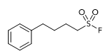
¹³C NMR (126 MHz, CDCl₃) for Compound 2a
¹⁹F NMR (377 MHz, CDCl₃) for Compound 2a
¹H NMR (500 MHz, CDCl₃) for Compound 2b
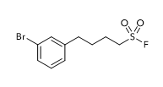
¹³C NMR (126 MHz, CDCl₃) for Compound 2b
¹⁹F NMR (377 MHz, CDCl₃) for Compound 2b
¹H NMR (500 MHz, CDCl₃) for Compound 2c
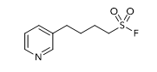
¹³C NMR (126 MHz, CDCl₃) for Compound 2c
¹⁹F NMR (377 MHz, CDCl₃) for Compound 2c
¹H NMR (500 MHz, CDCl₃) for Compound 2d
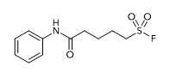
¹³C NMR (126 MHz, CDCl₃) for Compound 2d
¹⁹F NMR (377 MHz, CDCl₃) for Compound 2d
¹H NMR (500 MHz, CDCl₃) for Compound 2e
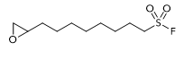
¹³C NMR (126 MHz, CDCl₃) for Compound 2e
¹⁹F NMR (377 MHz, CDCl₃) for Compound 2e
¹H NMR (500 MHz, CDCl₃) for Compound 2f
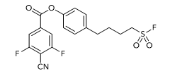
¹³C NMR (126 MHz, CDCl₃) for Compound 2f
¹⁹F NMR (377 MHz, CDCl₃) for Compound 2f
¹H NMR (500 MHz, CDCl₃) for Compound 2g
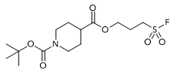
¹³C NMR (126 MHz, CDCl₃) for Compound 2g
¹⁹F NMR (471 MHz, CDCl₃) for Compound 2g
¹H NMR (400 MHz, CDCl₃) for Compound 2h
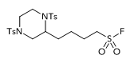
¹³C NMR (126 MHz, CDCl₃) for Compound 2h
¹⁹F NMR (377 MHz, CDCl₃) for Compound 2h
¹H NMR (500 MHz, CDCl₃) for Compound 2i
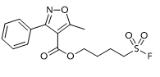
¹³C NMR (126 MHz, CDCl₃) for Compound 2i
¹⁹F NMR (377 MHz, CDCl₃) for Compound 2i
¹H NMR (500 MHz, CDCl₃) for Compound 2j
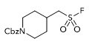
¹³C NMR (126 MHz, CDCl₃) for Compound 2j
¹⁹F NMR (377 MHz, CDCl₃) for Compound 2j
¹H NMR (500 MHz, CDCl₃) for Compound 2k
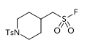
¹³C NMR (126 MHz, CDCl₃) for Compound 2k
¹⁹F NMR (471 MHz, CDCl₃) for Compound 2k
¹H NMR (500 MHz, CDCl₃) for Compound 2l
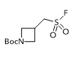
¹³C NMR (126 MHz, CDCl₃) for Compound 2l
¹⁹F NMR (377 MHz, CDCl₃) for Compound 2l
¹H NMR (500 MHz, CDCl₃) for Compound 2m
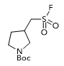
¹³C NMR (126 MHz, CDCl₃) for Compound 2m
¹⁹F NMR (377 MHz, CDCl₃) for Compound 2m
¹H NMR (500 MHz, CDCl₃) for Compound 2n
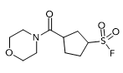
¹³C NMR (126 MHz, CDCl₃) for Compound 2n
¹⁹F NMR (471 MHz, CDCl₃) for Compound 2n
¹H NMR (500 MHz, CDCl₃) for Compound 2o
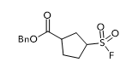
¹³C NMR (126 MHz, CDCl₃) for Compound 2o
¹⁹F NMR (471 MHz, CDCl₃) for Compound 2o
¹H NMR (400 MHz, CDCl₃) for Compound 2p
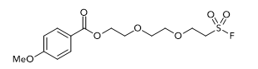
¹³C NMR (126 MHz, CDCl₃) for Compound 2p
¹⁹F NMR (377 MHz, CDCl₃) for Compound 2p
¹H NMR (400 MHz, CDCl₃) for Compound 2q
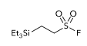
¹³C NMR (126 MHz, CDCl₃) for Compound 2q
¹⁹F NMR (377 MHz, CDCl₃) for Compound 2q
¹H NMR (500 MHz, CDCl₃) for Compound 2r
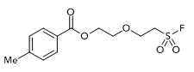
¹³C NMR (126 MHz, CDCl₃) for Compound 2r
¹⁹F NMR (377 MHz, CDCl₃) for Compound 2r
¹H NMR (500 MHz, CDCl₃) for Compound 2s
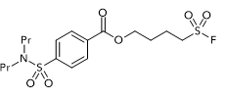
¹³C NMR (126 MHz, CDCl₃) for Compound 2s
¹⁹F NMR (377 MHz, CDCl₃) for Compound 2s
¹H NMR (500 MHz, CDCl₃) for Compound 2t
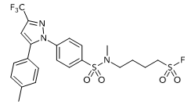
¹³C NMR (126 MHz, CDCl₃) for Compound 2t
¹⁹F NMR (377 MHz, CDCl₃) for Compound 2t
¹H NMR (500 MHz, CDCl₃) for Compound 2u
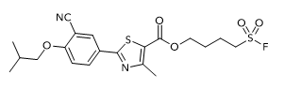
¹³C NMR (126 MHz, CDCl₃) for Compound 2u
¹⁹F NMR (377 MHz, CDCl₃) for Compound 2u
¹H NMR (500 MHz, CDCl₃) for Compound 3a
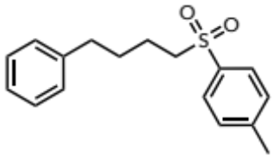
¹³C NMR (126 MHz, CDCl₃) for Compound 3a
¹H NMR (500 MHz, CDCl₃) for Compound 3b
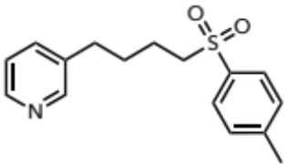
¹³C NMR (126 MHz, CDCl₃) for Compound 3b
¹H NMR (500 MHz, CDCl₃) for Compound 3c
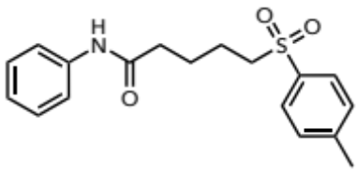
¹³C NMR (126 MHz, CDCl₃) for Compound 3c
¹H NMR (500 MHz, CDCl₃) for Compound 3d
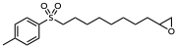
¹³C NMR (126 MHz, CDCl₃) for Compound 3d
¹H NMR (500 MHz, CDCl₃) for Compound 3e
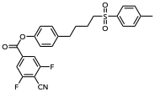
¹³C NMR (126 MHz, CDCl₃) for Compound 3e
¹⁹F NMR (377 MHz, CDCl₃) for Compound 3e
¹H NMR (500 MHz, CDCl₃) for Compound 3f
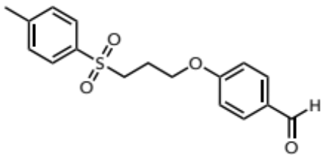
¹³C NMR (126 MHz, CDCl₃) for Compound 3f
¹H NMR (500 MHz, CDCl₃) for Compound 3g
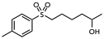
¹³C NMR (126 MHz, CDCl₃) for Compound 3g
¹H NMR (400 MHz, CDCl₃) for Compound 3h
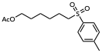
¹³C NMR (126 MHz, CDCl₃) for Compound 3h
¹H NMR (500 MHz, CDCl₃) for Compound 3i
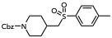
¹³C NMR (126 MHz, CDCl₃) for Compound 3i
¹H NMR (500 MHz, CDCl₃) for Compound 3j
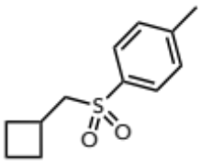
¹³C NMR (126 MHz, CDCl₃) for Compound 3j
¹H NMR (500 MHz, CDCl₃) for Compound 3k
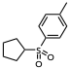
¹³C NMR (126 MHz, CDCl₃) for Compound 3k
¹H NMR (500 MHz, CDCl₃) for Compound 3l
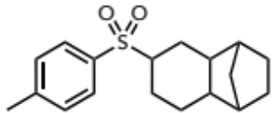
¹³C NMR (126 MHz, CDCl₃) for Compound 3l
¹H NMR (500 MHz, CDCl₃) for Compound 3m
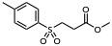
¹³C NMR (126 MHz, CDCl₃) for Compound 3m
¹H NMR (500 MHz, CDCl₃) for Compound 3n
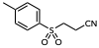
¹³C NMR (126 MHz, CDCl₃) for Compound 3n
¹H NMR (500 MHz, CDCl₃) for Compound 3o
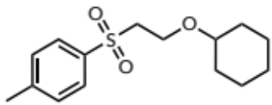
¹³C NMR (126 MHz, CDCl₃) for Compound 3o
¹H NMR (500 MHz, CDCl₃) for Compound 3p
¹³C NMR (126 MHz, CDCl₃) for Compound 3p
¹H NMR (500 MHz, CDCl₃) for Compound 3q
¹³C NMR (126 MHz, CDCl₃) for Compound 3q
¹⁹F NMR (377 MHz, CDCl₃) for Compound 3q
¹H NMR (500 MHz, CDCl₃) for Compound 3r
¹³C NMR (126 MHz, CDCl₃) for Compound 3r
¹H NMR (500 MHz, CDCl₃) for Compound 3s
¹³C NMR (126 MHz, CDCl₃) for Compound 3s
¹⁹F NMR (377 MHz, CDCl₃) for Compound 3s
¹H NMR (500 MHz, CDCl₃) for Compound 3t
¹³C NMR (126 MHz, CDCl₃) for Compound 3t
¹H NMR (500 MHz, CDCl₃) for Compound 3u
¹³C NMR (126 MHz, CDCl₃) for Compound 3u
¹H NMR (500 MHz, CDCl₃) for Compound 3v
¹³C NMR (126 MHz, CDCl₃) for Compound 3v
Crude ¹H NMR (500 MHz, CDCl₃) for Compound 3w (volatile) with 1.0 equiv. CH₂Br₂ as the internal standard
CH₂Br₂
¹H NMR (500 MHz, CDCl₃) for Compound 3x
¹³C NMR (126 MHz, CDCl₃) for Compound 3x
¹H NMR (500 MHz, CDCl₃) for Compound 3y
¹³C NMR (126 MHz, CDCl₃) for Compound 3y
¹H NMR (500 MHz, CDCl₃) for Compound 3z
¹³C NMR (126 MHz, CDCl₃) for Compound 3z
¹⁹F NMR (377 MHz, CDCl₃) for Compound 3z
Comp
¹H NMR (500 MHz, CDCl₃) for Compound 4b
¹³C NMR (126 MHz, CDCl₃) for Compound 4b
¹⁹F NMR (377 MHz, CDCl₃) for Compound 4b
¹H NMR (500 MHz, CDCl₃) for Compound 4c
¹³C NMR (126 MHz, CDCl₃) for Compound 4c
¹⁹F NMR (377 MHz, CDCl₃) for Compound 4c
¹H NMR (500 MHz, CDCl₃) for Compound 4d
¹³C NMR (126 MHz, CDCl₃) for Compound 4d
¹⁹F NMR (377 MHz, CDCl₃) for Compound 4d
¹H NMR (500 MHz, CDCl₃) for Compound 4e
¹³C NMR (126 MHz, CDCl₃) for Compound 4e
¹⁹F NMR (377 MHz, CDCl₃) for Compound 4e
¹H NMR (500 MHz, CDCl₃) for Compound 4f
¹³C NMR (126 MHz, CDCl₃) for Compound 4f
¹⁹F NMR (377 MHz, CDCl₃) for Compound 4f
¹H NMR (500 MHz, CDCl₃) for Compound 4g
¹³C NMR (126 MHz, CDCl₃) for Compound 4g
¹⁹F NMR (471 MHz, CDCl₃) for Compound 4g
¹H NMR (500 MHz, CDCl₃) for Compound 4h
¹³C NMR (126 MHz, CDCl₃) for Compound 4h
¹⁹F NMR (377 MHz, CDCl₃) for Compound 4h
¹¹B NMR (161 MHz, CDCl₃) for Compound 4h
¹H NMR (500 MHz, CDCl₃) for Compound 4i
¹³C NMR (126 MHz, CDCl₃) for Compound 4i
¹⁹F NMR (377 MHz, CDCl₃) for Compound 4i
¹H NMR (500 MHz, CDCl₃) for Compound 4j
¹³C NMR (126 MHz, CDCl₃) for Compound 4j
¹⁹F NMR (377 MHz, CDCl₃) for Compound 4j
¹H NMR (500 MHz, CDCl₃) for Compound 4k
¹³C NMR (126 MHz, CDCl₃) for Compound 4k
¹⁹F NMR (377 MHz, CDCl₃) for Compound 4k
¹H NMR (500 MHz, CDCl₃) for Compound 4l
¹³C NMR (126 MHz, CDCl₃) for Compound 4l
¹⁹F NMR (377 MHz, CDCl₃) for Compound 4l
¹H NMR (400 MHz, CDCl₃) for Compound 4m
¹³C NMR (126 MHz, CDCl₃) for Compound 4m
¹⁹F NMR (377 MHz, CDCl₃) for Compound 4m
¹H NMR (500 MHz, CDCl₃) for Compound 4n
¹³C NMR (126 MHz, CDCl₃) for Compound 4n
¹⁹F NMR (377 MHz, CDCl₃) for Compound 4n
¹H NMR (500 MHz, CDCl₃) for Compound 4o
¹³C NMR (126 MHz, CDCl₃) for Compound 4o
¹⁹F NMR (471 MHz, CDCl₃) for Compound 4o
¹H NMR (500 MHz, CDCl₃) for Compound 4p
¹³C NMR (126 MHz, CDCl₃) for Compound 4p
¹⁹F NMR (471 MHz, CDCl₃) for Compound 4p
¹H NMR (500 MHz, CDCl₃) for Compound 4q
¹³C NMR (126 MHz, CDCl₃) for Compound 4q
¹⁹F NMR (377 MHz, CDCl₃) for Compound 4q
¹H NMR (500 MHz, CDCl₃) for Compound 4r
¹³C NMR (126 MHz, CDCl₃) for Compound 4r
¹⁹F NMR (377 MHz, CDCl₃) for Compound 4r
¹H NMR (500 MHz, CDCl₃) for Compound 5a
¹³C NMR (126 MHz, CDCl₃) for Compound 5a
¹⁹F NMR (471 MHz, CDCl₃) for Compound 5a
¹H NMR (500 MHz, CDCl₃) for Compound 5b
¹³C NMR (126 MHz, CDCl₃) for Compound 5b
¹⁹F NMR (471 MHz, CDCl₃) for Compound 5b
¹H NMR (400 MHz, CDCl₃) for Compound 5c
¹³C NMR (101 MHz, CDCl₃) for Compound 5c
¹⁹F NMR (377 MHz, CDCl₃) for Compound 5c
¹H NMR (500 MHz, CDCl₃) for Compound 5d
¹³C NMR (126 MHz, CDCl₃) for Compound 5d
¹⁹F NMR (377 MHz, CDCl₃) for Compound 5d
¹H NMR (500 MHz, CDCl₃) for Compound 5e
¹³C NMR (126 MHz, CDCl₃) for Compound 5e
¹⁹F NMR (377 MHz, CDCl₃) for Compound 5e
¹H NMR (500 MHz, CDCl₃) for Compound 6
¹³C NMR (126 MHz, CDCl₃) for Compound 6
¹H NMR (500 MHz, CDCl₃) for Compound 7

¹³C NMR (126 MHz, CDCl₃) for Compound 7
¹H NMR (500 MHz, CDCl₃) for Compound 8
¹³C NMR (126 MHz, CDCl₃) for Compound 8
¹H NMR (500 MHz, CDCl₃) for Compound 9
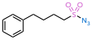
¹³C NMR (126 MHz, CDCl₃) for Compound 9
¹H NMR (500 MHz, CDCl₃) for Compound 10
¹³C NMR (126 MHz, CDCl₃) for Compound 10
¹H NMR (500 MHz, CDCl₃) for Compound 11
¹³C NMR (126 MHz, CDCl₃) for Compound 11
¹H NMR (500 MHz, CDCl₃) for Compound 13
¹³C NMR (126 MHz, CDCl₃) for Compound 13
¹H NMR (500 MHz, CDCl₃) for Compound 15
¹³C NMR (126 MHz, CDCl₃) for Compound 15
¹H NMR (500 MHz, CDCl₃) for Compound 16

¹³C NMR (126 MHz, CDCl₃) for Compound 16
¹H NMR (500 MHz, CDCl₃) for AM3506
¹³C NMR (126 MHz, CDCl₃) for AM3506

¹⁹F NMR (377 MHz, CDCl₃) for AM3506

¹H NMR (500 MHz, CDCl₃) for Compound 21

¹³C NMR (126 MHz, CDCl₃) for Compound 21

¹H NMR (500 MHz, CDCl₃) for Compound 21a

¹³C NMR (126 MHz, CDCl₃) for Compound 21a

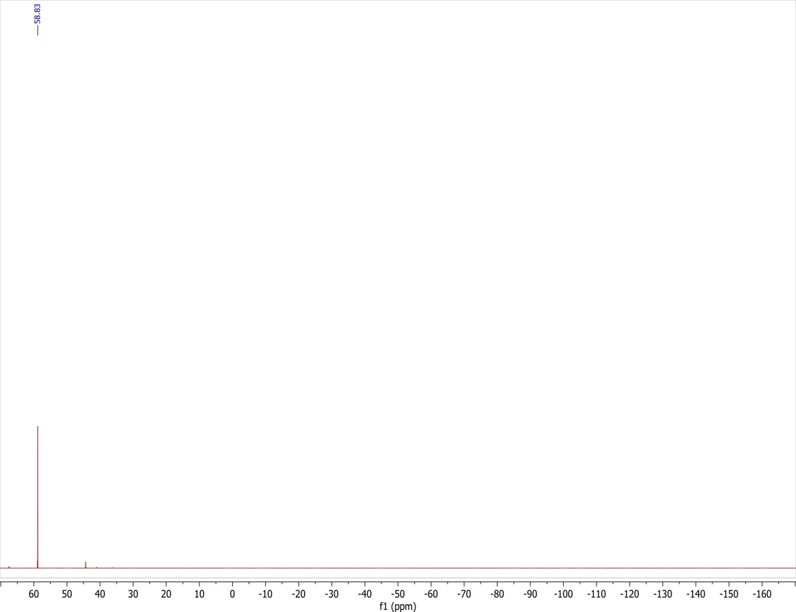
¹⁹F NMR (377 MHz, CDCl₃) for Compound 21a

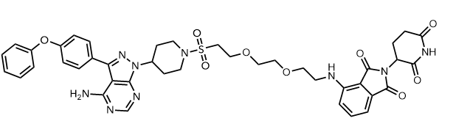
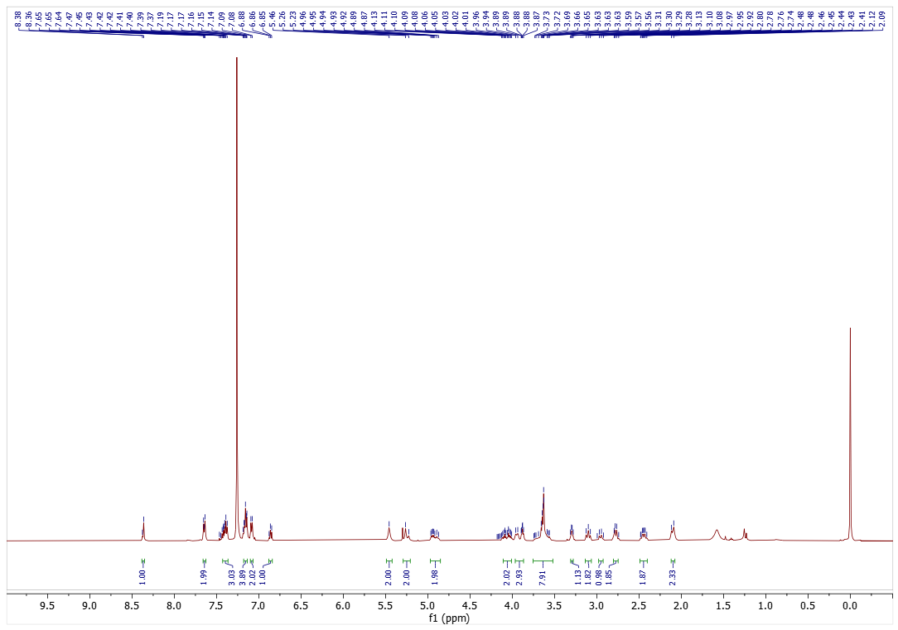
¹H NMR (500 MHz, CDCl₃) for Compound 22
¹³C NMR (126 MHz, CDCl₃) for Compound 22
