Supplemental Materials

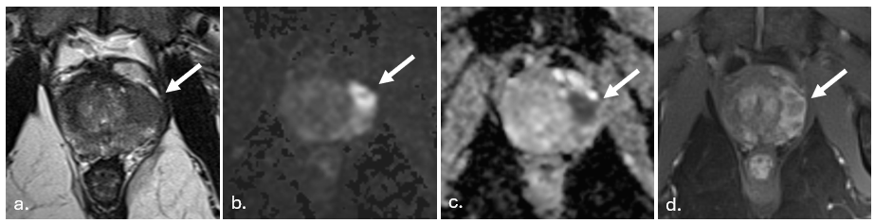
Supplemental Figure 1. 65 year old with PSA of 7.9 ng/mL. All deep learning models and readers identified a lesion with extraprostatic extension (EPE) (arrow). Prostatectomy pathology demonstrated Gleason grade group 3 with EPE in the left anterior and left posterior prostate gland.

