Supplementary Information:

Optimized small scale automated preparation and quality control of [⁶⁸Ga]Ga-DOTA-MGS5 and [¹⁷⁷Lu]Lu-DOTA-MGS5 for clinical application

  - Sven Messerschmidt¹, Taraneh Sadat Zavvar¹, Lisa Pivetta¹, Martin Kraihammer¹, Klaus Faserl², Paul Eichberger³, Clemens Decristoforo¹, Elisabeth von Guggenberg¹ and Emanuel Sporer^{1*}
  - 1 Department of Nuclear Medicine, Medical University of Innsbruck, Austria
2 Protein Core Facility, Institute of Medical Chemistry, Biocenter, Medical University of Innsbruck, Innsbruck, Austria
3 Department of Therapeutic Radiology and Oncology, Medical University of Innsbruck, Innsbruck, Austria
* Corresponding Author: emanuel.sporer@i-med.ac.at

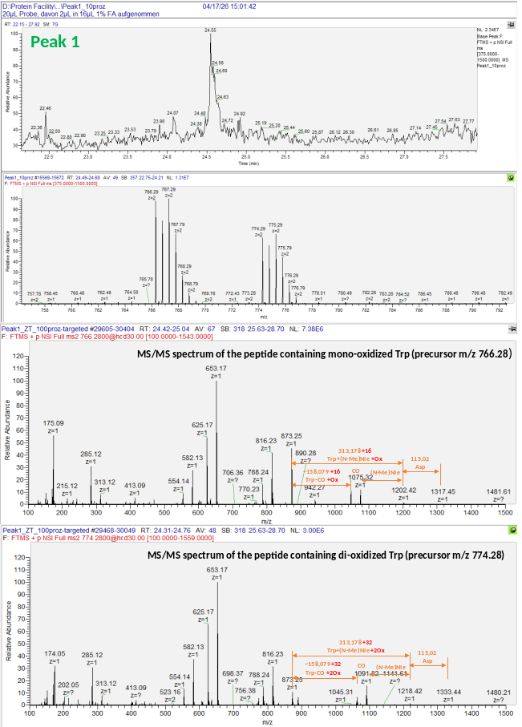

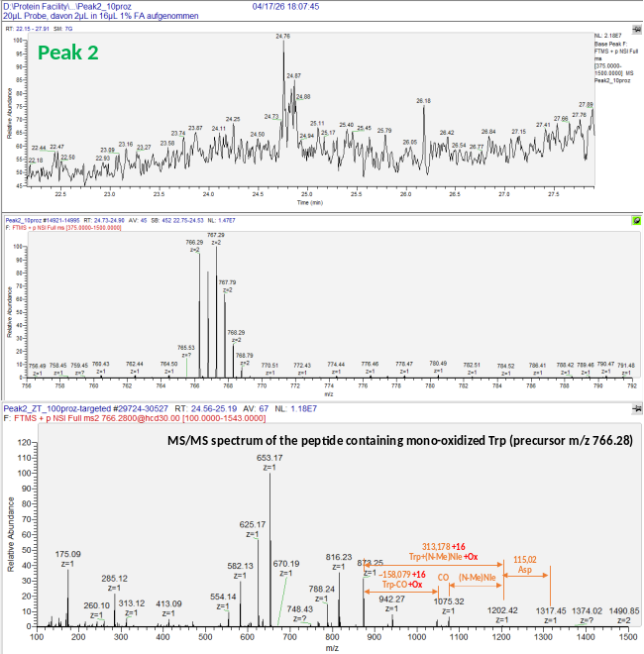

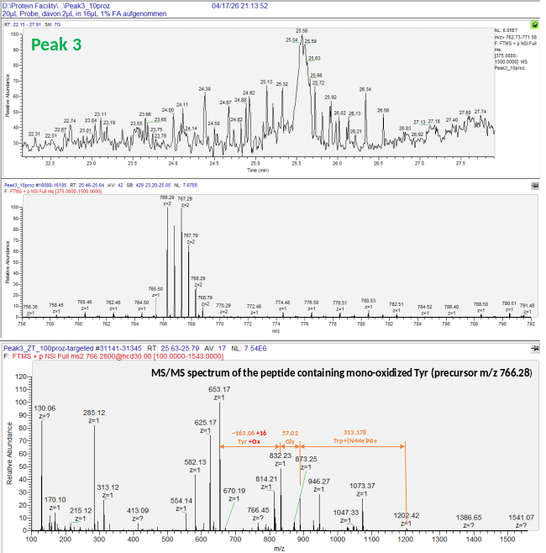

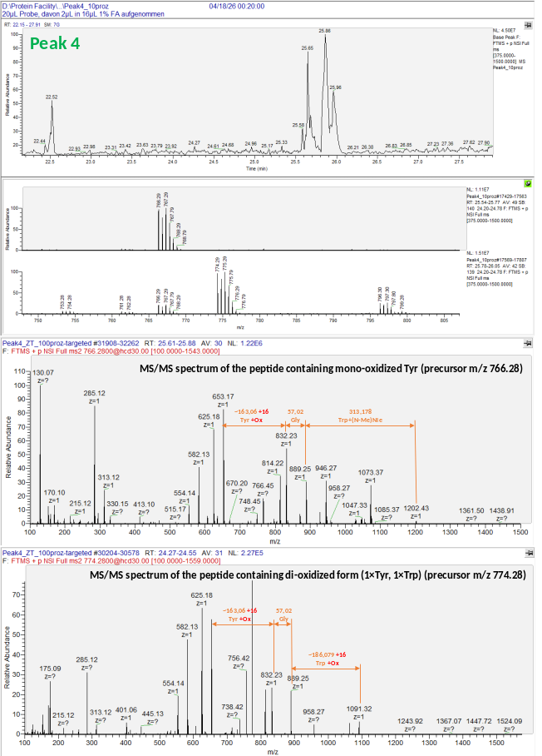

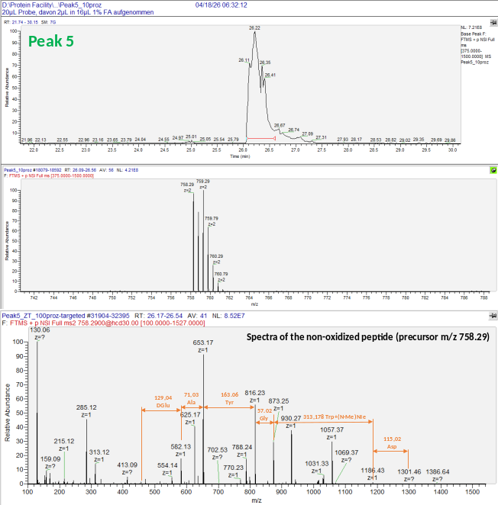
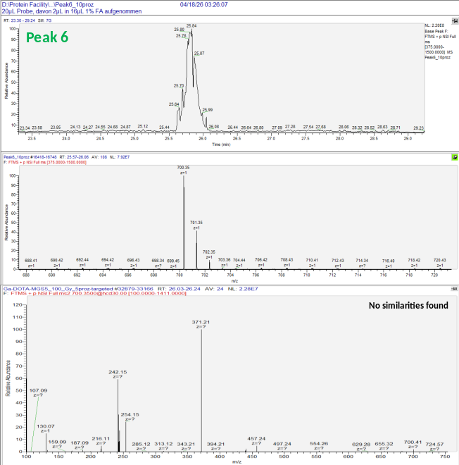

Supplementary Figure 1. LC–MS/MS characterization of Peaks 1 to 6. For each chromatographic peak, the upper panel shows the extracted ion chromatogram (EIC), the second panel displays the corresponding full-scan MS spectrum, and the lower panels present the MS/MS spectra of the selected precursor ions. Sequence-specific fragment ions were used to identify the peptide species and to localize oxidative modifications. Depending on the peak, mono-oxidized and/or di-oxidized tryptophan and tyrosine-containing peptide species were identified.

Supplementary Table 1: Results of mass analysis of test synthesis without gallium-68
Peak | Found mass | Calculated mass
1 | 736.65 | 736.3 [M+H+Na]²⁺ -> DOTA-MGS5
2 | 757.03 | 756.3 [M+2H]²⁺ -> Zn-DOTA-MGS5  756.0 [M+2H]²⁺ -> Cu-DOTA-MGS5
3 | 752.41 | 751.8 [M+2H]²⁺ -> Fe-DOTA-MGS5

Supplementary Table 2: Results of mass analysis of test synthesis without lutetium-177
Peak | Found mass | Calculated mass
1 | 726,63 | 725,3 [M+2H]²⁺ -> DOTA-MGS5
2
3 | 752,28 | 751.8 [M+2H]²⁺ -> Fe-DOTA-MGS5

