Supplemental Section

Supplemental Table 1. Target regions, primer sequences, and probe sequences by parasites for DNA amplification.*

Parasite | Target region | Forward primer sequence (5’ to 3’)  Reverse primer sequence (5’ to 3’)  Probe sequence (5’FAM to 3’)
Ancylostoma duodenale | ITS-2 | GAATGACAGCAAACTCGTTGTTG ATACTAGCCACTGCCGAAACGT ATCGTTTACCGACTTTAG
Ascaris lumbricoides | ITS-1 | TGCACATAAGTACTATTTGCGCGTAT  CCGCCGACTGCTATTACATCA  GAGCCACATAGTAAATT
Cryptosporidium spp. | DNA-J like protein | AACTTCACGTGTGTTTGCCAAT  CCAATCACAGAATCATCAGAATCG  CATATGAAGTTATAGGGATACCAG
Blastocystis spp. | 16s rRNA | AGTAGTCATACGCTCGTCTCAAA  TCTTCGTTACCCGTTACTGC  CGTGTAAATCTTACCATTTAGAGGA
Entamoeba histolytica | 18S rRNA | GTTTGTATTAGTACAAAATGGCCAATTC  TCGTGGCATCCTAACTCACTTAGA  CAATGAATTGAGAAATGACA
Giardia duodenalis | 16S rRNA | CATGCATGCCCGCTCA  AGCGGTGTCCGGCTAGC  AGGACAACGGTTGCAC
Necator americanus | ITS-2 | CTGTTTGTCGAACGGTACTTGC  ATAACAGCGTGCACATGTTGC  CTGTACTACGCATTGTATAC
Strongyloides stercoralis | 18s rRNA | GAATTCCAAGTAAACGTAAGTCATTAGC  TGCCTCTGGATATTGCTCAGTTC  ACACACCGGCCGTCGCTGC
Trichuris trichiura | ITS-1 | TCCGAACGGCGGATCA  CTCGAGTGTCACGTCGTCCTT  TTGGCTCGTAGGTCGTT
Internal Amplification Control (IAC) | Synthetic sequence | CTAACCTTCGTGATGAGCAATCG  GATCAGCTACGTGAGGTCCTAC  TCGATGCACTCCAGTCCTCCT
*ITS = internal transcribed spacer; rRNA = ribosomal RNA

Supplemental Figure 1. LEfSe analysis LDA between the two regions.

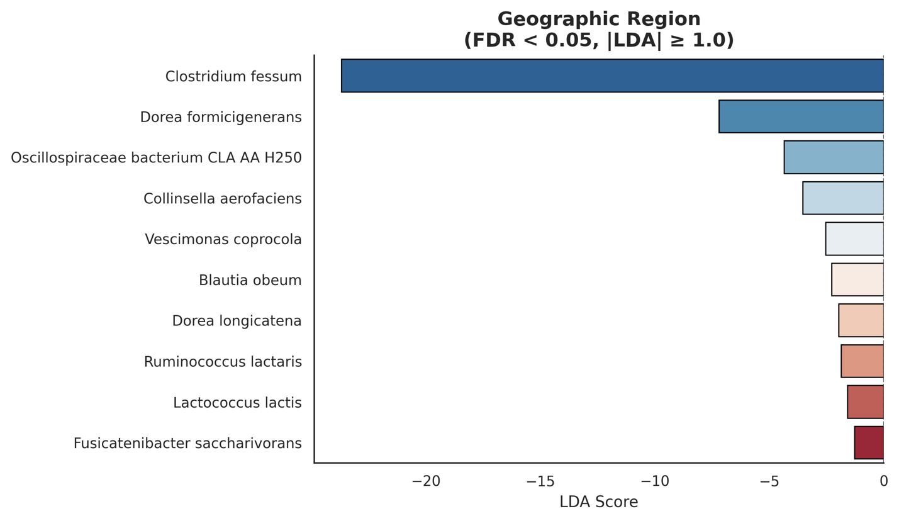

Supplemental Figure 2. Intestinal parasite prevalences (%) and DNA concentration (fg/µl) per Medellín and Ungía.
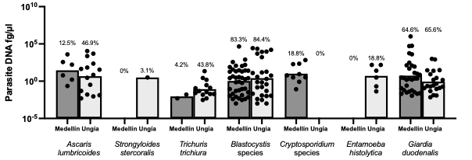
Supplemental Table 2. Differential functional abundance analysis of HUMAnN features.
Functional Feature | p_value | Mean_NEG | Mean_POS | FDR_q_value
RXN-17108: (expasy) Oleoyl-[acyl-carrier-protein] hydrolase [3.1.2.14]|unclassified | 5.44E+10 | 27,206,686,111,111,100 | 10,552,494,615,384,600 | 26,031,771,264,311,500
RXN-10727: (metacyc) myristoyl-ACP hydrolase activity [3.1.2.14]|unclassified | 5.44E+10 | 27,206,686,111,111,100 | 10,552,494,615,384,600 | 26,031,771,264,311,500
RXN66-643: (expasy) Oleoyl-[acyl-carrier-protein] hydrolase [3.1.2.14]|unclassified | 5.44E+10 | 27,206,686,111,111,100 | 10,552,494,615,384,600 | 26,031,771,264,311,500
RXN-9555: (expasy) Oleoyl-[acyl-carrier-protein] hydrolase [3.1.2.14]|unclassified | 5.44E+10 | 27,206,686,111,111,100 | 10,552,494,615,384,600 | 26,031,771,264,311,500
RXN-12973: (expasy) Oleoyl-[acyl-carrier-protein] hydrolase [3.1.2.14]|unclassified | 5.44E+10 | 27,206,686,111,111,100 | 10,552,494,615,384,600 | 26,031,771,264,311,500
RXN-21716: (expasy) Oleoyl-[acyl-carrier-protein] hydrolase [3.1.2.14]|unclassified | 5.44E+10 | 27,206,686,111,111,100 | 10,552,494,615,384,600 | 26,031,771,264,311,500
RXN-21715: (expasy) Oleoyl-[acyl-carrier-protein] hydrolase [3.1.2.14]|unclassified | 5.44E+10 | 27,206,686,111,111,100 | 10,552,494,615,384,600 | 26,031,771,264,311,500
RXN-21714: (expasy) Oleoyl-[acyl-carrier-protein] hydrolase [3.1.2.14]|unclassified | 5.44E+10 | 27,206,686,111,111,100 | 10,552,494,615,384,600 | 26,031,771,264,311,500
RXN-9548: (expasy) Oleoyl-[acyl-carrier-protein] hydrolase [3.1.2.14]|unclassified | 5.44E+10 | 27,206,686,111,111,100 | 10,552,494,615,384,600 | 26,031,771,264,311,500
RXN-9549: (expasy) Oleoyl-[acyl-carrier-protein] hydrolase [3.1.2.14]|unclassified | 5.44E+10 | 27,206,686,111,111,100 | 10,552,494,615,384,600 | 26,031,771,264,311,500
RXN-9550: (expasy) Oleoyl-[acyl-carrier-protein] hydrolase [3.1.2.14]|unclassified | 5.44E+10 | 27,206,686,111,111,100 | 10,552,494,615,384,600 | 26,031,771,264,311,500
RXN-9551: (expasy) Oleoyl-[acyl-carrier-protein] hydrolase [3.1.2.14]|unclassified | 5.44E+10 | 27,206,686,111,111,100 | 10,552,494,615,384,600 | 26,031,771,264,311,500
RXN-21675: (expasy) Oleoyl-[acyl-carrier-protein] hydrolase [3.1.2.14]|unclassified | 5.44E+10 | 27,206,686,111,111,100 | 10,552,494,615,384,600 | 26,031,771,264,311,500
RXN-21706: (expasy) Oleoyl-[acyl-carrier-protein] hydrolase [3.1.2.14]|unclassified | 5.44E+10 | 27,206,686,111,111,100 | 10,552,494,615,384,600 | 26,031,771,264,311,500
3.1.2.14-RXN: (expasy) Oleoyl-[acyl-carrier-protein] hydrolase [3.1.2.14]|unclassified | 5.44E+10 | 27,206,686,111,111,100 | 10,552,494,615,384,600 | 26,031,771,264,311,500
RXN-13011: (expasy) Oleoyl-[acyl-carrier-protein] hydrolase [3.1.2.14]|unclassified | 5.44E+10 | 27,206,686,111,111,100 | 10,552,494,615,384,600 | 26,031,771,264,311,500
RXN-7902: (expasy) Oleoyl-[acyl-carrier-protein] hydrolase [3.1.2.14]|unclassified | 5.44E+10 | 27,206,686,111,111,100 | 10,552,494,615,384,600 | 26,031,771,264,311,500
RXN-21638: (expasy) Oleoyl-[acyl-carrier-protein] hydrolase [3.1.2.14]|unclassified | 5.44E+10 | 27,206,686,111,111,100 | 10,552,494,615,384,600 | 26,031,771,264,311,500
ADENYLYLSULFATE-REDUCTASE-RXN: (expasy) Adenylyl-sulfate reductase [1.8.99.2]|unclassified | 9.37E+10 | 7,903,808,333,333,330 | 16,508,217,692,307,600 | 4,245,652,145,847,340

