Persistent phoQ upregulation and sigma-factor modulation link polymyxin resistance to broader stress responses in Klebsiella pneumoniae ST11
Michelly Maria Pereira e Oliveira¹, Paula Mariana Salgueiro de Souza^{1*}, Patrícia Francisca Gama da Silva¹, Lara Valesca Mendonça da Costa Santos¹, Rodrigo Tenório Gomes Pereira², Márcia Maria Camargo de Morais², Anna Carolina Soares Almeida¹
ORCID iDs: Michelly Maria Pereira e Oliveira, 0009-0004-4287-8193; Paula Mariana Salgueiro de Souza, 0000-0001-7764-0573; Patrícia Francisca Gama da Silva, 0009-0003-8551-3621; Lara Valesca Mendonça da Costa Santos, 0000-0002-4400-6637; Rodrigo Tenório Gomes Pereira, 0009-0003-0875-2442; Márcia Maria Camargo de Morais, 0000-0001-5337-1188; Anna Carolina Soares Almeida, 0000-0001-5536-7262
1 Laboratory of Molecular Microbiology, Department of Biology, Federal Rural University of Pernambuco, Rua Dom Manuel de Medeiros, Dois Irmãos, Recife, Pernambuco 52171-900, Brazil.
2 Laboratory of Microbial Resistance, Institute of Biological Sciences, University of Pernambuco, Rua Arnóbio Marques 310, Santo Amaro, Recife, Pernambuco 50100-130, Brazil.

*Corresponding author: Paula Mariana Salgueiro de Souza, Laboratory of Molecular Microbiology, Department of Biology, Federal Rural University of Pernambuco, Rua Dom Manuel de Medeiros, Dois Irmãos, Recife, Pernambuco 52171-900, Brazil. Tel.: +55 81 3320-6304. E-mail: paulasalgueiro.db@ufrpe.br

SUPPLEMENTARY TABLES

Table S1: Minimum Inhibitory Concentrations (MICs) of Tested Antimicrobials

Antibiotics | Minimal Inibitory Concentration  (MIC mg/mL)
AMP | ≥32 (R)
AMP/SUL | ≥32 (R)
CXM | ≥64 (R)
CFX | ≥64 (R)
CAZ | 16 (R)
CTX | ≥64 (R)
FEP | ≥64 (R)
ERT | ≥8 (R)
IMI | ≥16 (R)
MER | ≥16 (R)
AMC | ≥64 (R)
GEN | ≥16 (R)
CIP | ≥4 (R)
TIG | 4 (R)
POLB | 16 (R)

Table S2: In Silico Detection of Antimicrobial Resistance Genes from Sequence Data
Resistence to antimicrobials | Gene | Action Against antimicrobials | Identity | Database
aminoglycoside antibiotic | AAC(3)-Iie | antibiotic inactivation | 98.95 | CARD/RESFINDER/BIGSdb
aminoglycoside antibiotic | aadA2 | antibiotic inactivation | 99.58 | CARD/RESFINDER
cephalosporin, penam | Escherichia coli ampH beta-lactamase | antibiotic inactivation | 85.71 | CARD
cephalosporin, penam | FosA6 | antibiotic inactivation | 97.84 | CARD/RESFINDER/BIGSdb
fosfomycin | Escherichia coli UhpT with mutation (E350Q) conferring resistance to fosfomycin | antibiotic target alteration | 95.03 | CARD
nitroimidazole antibiotic | msbA | antibiotic efflux | 92.78 | CARD
phenicol antibiotic | catA1 | antibiotic efflux |  | CARD
phenicol antibiotic | catI | antibiotic inactivation | 100.0 | RESFINDER
fluoroquinolone antibiotic | Salmonella enterica gyrA (D87Y) conferring resistance to fluoroquinolones | antibiotic target alteration | 95.67 | CARD/BIGSdb
fluoroquinolone antibiotic | Escherichia coli parC (S80I) conferring resistance to fluoroquinolones | antibiotic target alteration | 94.41 | CARD/BIGSdb
fluoroquinolone antibiotic | parE | antibiotic target alteration |  | CARD/BIGSdb
fluoroquinolone antibiotic | LptD | antibiotic efflux | 99.86 | CARD
fluoroquinolone antibiotic | qacEdelta1 | antibiotic efflux | 100.0 | CARD
aminoglycoside antibiotic, aminocoumarin antibiotic | baeR | antibiotic efflux | 92.05 | CARD
cephalosporin | CTX-M-141 | antibiotic inactivation | 100.0 | CARD/RESFINDER
monobactam, carbapenem, cephalosporin, penam | KPC-2 | antibiotic inactivation | 100.0 | CARD/RESFINDER/BIGSdb
carbapenem, cephalosporin, penam | SHV-11 | antibiotic inactivation | 100.0 | CARD/BIGSdb
cephalosporin, cephamycin, penam | Haemophilus influenzae PBP3 (D350N, S357N) conferring resistance to beta-lactam antibiotics | antibiotic target alteration | 52.37 | CARD
fluoroquinolone antibiotic, aminoglycoside antibiotic, tetracycline antibiotic, rifamycin antibiotic | LAP-2 | antibiotic inactivation | 100.0 | CARD/RESFINDER
fluoroquinolone antibiotic, cephalosporin, glycylcycline, penam, tetracycline antibiotic, rifamycin antibiotic, phenicol antibiotic, triclosan | Escherichia coli marR mutant conferring antibiotic resistance | antibiotic target alteration, antibiotic efflux | 83.33 | CARD
fluoroquinolone antibiotic, monobactam, carbapenem, cephalosporin, glycylcycline, cephamycin, penam, tetracycline antibiotic, rifamycin antibiotic, phenicol antibiotic, triclosan, penem | marA | antibiotic efflux, reduced permeability to antibiotic | 92.74 | CARD
fluoroquinolone antibiotic, tetracycline antibiotic | adeF | antibiotic efflux | 41.71 | CARD
macrolide antibiotic | mphA | antibiotic inactivation | 100.0 | CARD/RESFINDER
macrolide antibiotic, aminoglycoside antibiotic, cephalosporin, tetracycline antibiotic, peptide antibiotic, rifamycin antibiotic | Klebsiella pneumoniae KpnF | antibiotic efflux | 100.0 | CARD
 | Klebsiella pneumoniae KpnE | antibiotic efflux | 99.17 | CARD
macrolide antibiotic, fluoroquinolone antibiotic, penam | CRP | antibiotic efflux | 99.05 | CARD
monobactam, carbapenem, cephalosporin, cephamycin, penam, penem | OmpA | reduced permeability to antibiotic | 99.45 | CARD
 | OmpK37 | reduced permeability to antibiotic | 94.27 | CARD
peptide antibiotic | ArnT | antibiotic target alteration | 99.64 | CARD
peptide antibiotic | eptB | antibiotic target alteration | 99.46 | CARD
sulfonamide antibiotic | sul1 | antibiotic target replacement | 100.0 | CARD/RESFINDER
tetracycline antibiotic | tet(A) | antibiotic efflux | 99.74 | CARD/RESFINDER
aminoglycoside | aph(3')-VIa (aph(3')-VIa_X07753), aph(3')-VI (aph(3')-VI_APPJ01000012) |  |  | RESFINDER
aminoglycoside | aadA2 |  |  | RESFINDER

Table S3: Alterations observed in genes associated with resistance to polymyxins in K. pneumoniae Pol16 strain.
Gene | Protein | Integrity | Amino Acid Change | Affected Protein Domain
pmrA | Transcriptional regulatory protein pmrA - TCS PmrAB | 100% | - | -
pmrB | Histidine kinase - TCS PmrAB | 99.54% | R256G (X) | Histidine kinase
phoP | Transcriptional regulatory protein PhoP - TCS PhoPQ | 99.7% | - | -
phoQ | Histidine kinase - TCS PhoPQ | 99.05% | - | -
crrA | Response regulator transcription factor - TCS CrrAB | 99.86% | - | -
crrB | Histidine kinase - TCS CrrAB | 99.5% | D189E (+);  V237I (+); A11N (X) | Histidine kinase
pmrD | Histidine kinase - Connector | 98.37% | E42G (X) | Pfam
mgrB | PhoP/PhoQ regulator | 57.6% | -70pb | Transmembrane region
rpoD | RNA polymerase sigma factor | 99.73% | - | -
rpoS | RNA polymerase sigma factor | 99.8% | - | -
rpoE | RNA polymerase sigma factor | 100% | - | -
arnA | Bifunctional polymyxin resistance protein ArnA - Operon arn | 96.53% | Q212L (X);  I260L (+);  N448S (+);  E569D (+);  T635K (X);  T656V (X); S661P (X) | Formyl transferase C- terminal; NAD- dependent epimerase/dehydratase
arnB | UDP-4-amino-4-deoxy-L- arabinose-oxoglutarate aminotransferase - Operon arn | 99.21% | - | -
arnC | Undecaprenyl-phosphate 4-deoxy-4-formamido-L-arabinose transferase - Operon arn | 96.54% | -33pb | Transmembrane region
arnD | 4-deoxy-4-formamido-L- arabinose-phosphoundecaprenol deformylase - Operon arn | 98.23% | A25E (X);  K29R (+);  V53I (+); I94L (+) | NodB
arnE | Flippase subunit 4-amino-4- deoxy-L-arabinose- phosfoundecaprenol - Operon arn | 100% | - | -
arnF | Flippase subunit 4-amino-4- deoxy-L-arabinose- phosfoundecaprenol -Operon arn | 99.74% | - | -
arnT | Undecaprenyl phosphate-alpha-4- amino-4-deoxy-L-arabinose arabinosyl transferase -Operon arn | 99.28% | V117I (+);  Q157H (X);  R372K (+); C404S (X) | Glycosyl transferase family
ugd | UDP-glucose 6 dehydrogenase - PmrE | 95.46% | G99A (x); A376V (X) | UDP-glucose/GDP-mannose dehydrogenase C- terminal
eptA | Putative cell division protein - Phosphoethanolamine transferase | 99.45% | Q319R (+) | N-terminal sulphatase
eptB | Phosphoethanolamine transferase specific for the outer Kdo residue of lipopolysaccharide | 99.88% | - | -
hfq | RNA-binding protein | 100% | - | -
lpxM | Lipid biosynthesis acyltransferase A | 99.59% | - | -
rsd | Sigma70 regulator | 99.80% | - | -
rseA | Anti-sigma-E factor | 99.69% | - | -
rseB | Sigma-E factor regulatory protein | 97.18% | -21pb; A18T(X) | -
rseP | Zinc metalloprotease | 99.70% | A282V (+) | PDZ
surA | Chaperone | 99.53% | - | -
degS | Peptidase Do | 83.47% | -171pb | transmembrane region
X: A substitution of an amino acid with a different polarity; +: A substitution of an amino acid with the same polarity.

Table S4: Quantification Cycle Values (Cq) Obtained in RT-qPCR Assays.
ATCC | S/ATB | C/ATB
pmrd | 23,993 | 23,098
pmrb | 26,157 | 26,0488
phoq | 25,272 | 25,713
rpoe | 21,3498 | 20,354
rpos | 23,354 | 22,867
rpod | 28,479 | 31,297
rpoc | 24,8123 | 24,398
Pol16
pmrd | 21,447 | 20,434
pmrb | 27,186 | 25,477
phoq | 24,1503 | 22,748
rpoe | 22,158 | 19,664
rpos | 24,0898 | 20,7538
rpod | 31,3303 | 28,0763
rpoc | 24,125 | 23,578

SUPPLEMENTARY FIGURES

Figure S1: Dissociation-curve and standard curve analyses showing only single peaks and the absence of primer-dimers formation and non specific amplification.

A: rpoD; B: phoQ; C: pmrD; D: pmrB; E: rpoS; F: rpoE
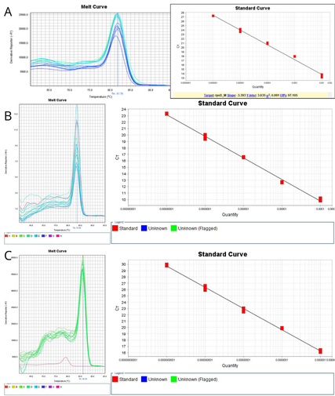

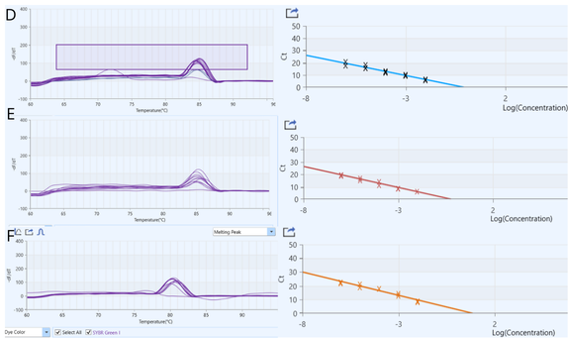

Figure S2: Sequence Alignment of Colistin Resistance-Associated Genes in Target and Reference Isolates
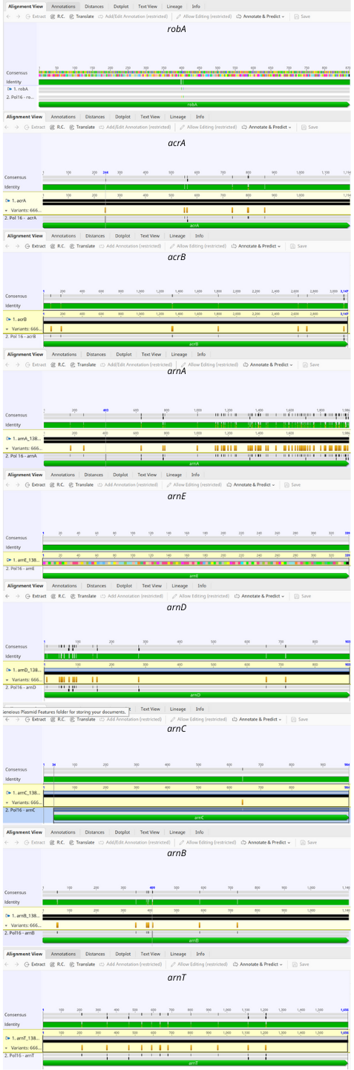

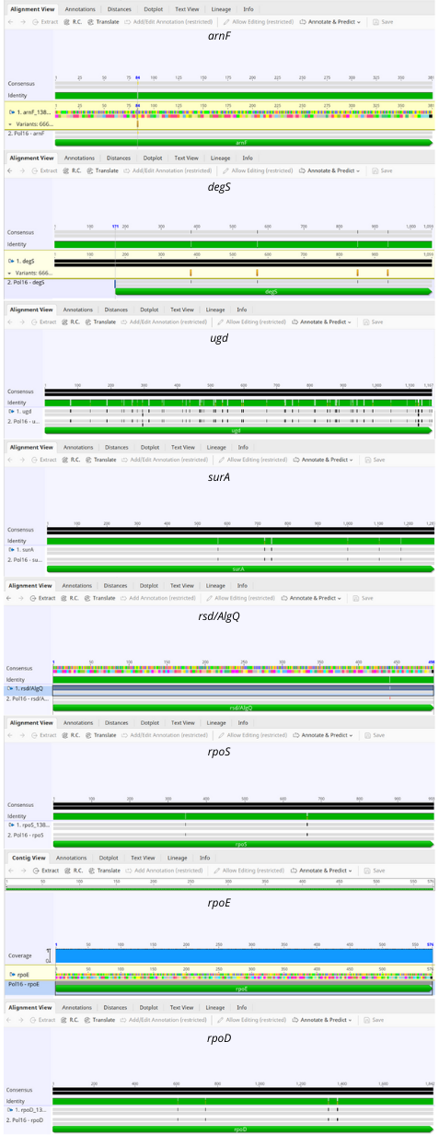
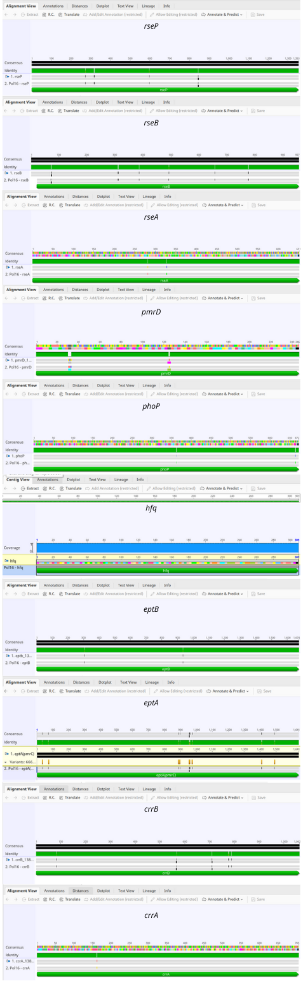
References
Aires, C.A.M., et al. (2016). mgrB Mutations Mediating Polymyxin B Resistance in Klebsiella pneumoniae Isolates from Rectal Surveillance Swabs in Brazil. Antimicrobial Agents and Chemotherapy, 60(11), 6969-6972. https://doi.org/10.1128/AAC.01456-16
Andrade, F.F., et al. (2020). Colistin Update on Its Mechanism of Action and Resistance, Present and Future Challenges. Microorganisms, 8(11), 1716. https://doi.org/10.3390/microorganisms8111716
ECDC. (2023). Antimicrobial resistance surveillance in Europe 2022 - 2020 data. Retrieved from https://www.ecdc.europa.eu/en/publications-data/antimicrobial-resistance-surveillance-europe-2022-2020-data [Accessed 20 March 2023].
Boszczowski, I., et al. (2019). Multidrug-resistant Klebsiella pneumoniae: genetic diversity, mechanisms of resistance to polymyxins and clinical outcomes in a tertiary teaching hospital in Brazil. Revista do Instituto de Medicina Tropical de São Paulo, 61, e29. https://doi.org/10.1590/S1678-9946201961029
Bray, A.S., et al. (2022). MgrB-Dependent Colistin Resistance in Klebsiella pneumoniae Is Associated with an Increase in Host-to-Host Transmission. mBio, 13(2), e03595-21. https://doi.org/10.1128/mBio.03595-21
CDC. (2023). The biggest antibiotic-resistant threats in the U.S. Retrieved from https://www.cdc.gov/drugresistance/biggest-threats.html [Accessed 28 March 2023].
Chen, A.I., et al. (2021). Effects of Regulatory Network Organization and Environment on PmrD Connector Activity and Polymyxin Resistance in Klebsiella pneumoniae and Escherichia coli. Antimicrobial Agents and Chemotherapy, 65(3), e00889-20. https://doi.org/10.1128/AAC.00889-20
Chen, H.D., & Groisman, E.A. (2013). The Biology of the PmrA/PmrB Two-Component System: The Major Regulator of Lipopolysaccharide Modifications. Annual Review of Microbiology, 67(1), 83-112. https://doi.org/10.1146/annurev-micro-092412-155751
Cheung, C.H.P., et al. (2020). Proteomic Investigation of the Signal Transduction Pathways Controlling Colistin Resistance in Klebsiella pneumoniae. Antimicrobial Agents and Chemotherapy, 64(8), e00790-20. https://doi.org/10.1128/AAC.00790-20
Elias, R., Duarte, A., & Perdigão, J. (2021). A Molecular Perspective on Colistin and Klebsiella pneumoniae: Mode of Action, Resistance Genetics, and Phenotypic Susceptibility. Diagnostics, 11(7), 1165. https://doi.org/10.3390/diagnostics11071165
Groisman, E.A., Duprey, A., & Choi, J. (2021). How the PhoP/PhoQ System Controls Virulence and Mg²⁺ Homeostasis: Lessons in Signal Transduction, Pathogenesis, Physiology, and Evolution. Microbiology and Molecular Biology Reviews, 85(3), e00176-20. https://doi.org/10.1128/MMBR.00176-20
Han, J., et al. (2023). The role of PhoP/PhoQ system in regulating stress adaptation response in Escherichia coli O157. Food Microbiology, 112, 104244. https://doi.org/10.1016/j.fm.2023.104244
Hancock, R.E. (1997). Peptide antibiotics. The Lancet, 349(9049), 418-422. https://doi.org/10.1016/S0140-6736(96)06146-5
Helmann, J.D. (1999). Anti-sigma factors. Current Opinion in Microbiology, 2(2), 135-141. https://doi.org/10.1016/S1369-5274(99)80024-5
Helmann, J.D., & Zaher, H., & MacLellan, S.R. (2021). Transcription | Sigma Factors☆. In: J. Jez (Ed.), Encyclopedia of Biological Chemistry III (Third Edition) (pp. 379-382). Oxford: Elsevier. https://doi.org/10.1016/B978-0-12-818731-9.00104-8
Hjort, K., Nicoloff, H., & Andersson, D.I. (2016). Unstable tandem gene amplification generates heteroresistance (variation in resistance within a population) to colistin in Salmonella enterica. Molecular Microbiology, 102(2), 274-289. https://doi.org/10.1111/mmi.13463
Huang, J., et al. (2020). Regulating polymyxin resistance in Gram-negative bacteria: roles of two-component systems PhoPQ and PmrAB. Future Microbiology, 15(6), 445-459. https://doi.org/10.2217/fmb-2020-0043
Jayol, A., et al. (2015). Heteroresistance to Colistin in Klebsiella pneumoniae Associated with Alterations in the PhoPQ Regulatory System. Antimicrobial Agents and Chemotherapy, 59(5), 2780-2784. https://doi.org/10.1128/AAC.00068-15
Li, L., et al. (2023). Roles of two-component regulatory systems in Klebsiella pneumoniae: Regulation of virulence, antibiotic resistance, and stress responses. Microbiological Research, 272, 127374. https://doi.org/10.1016/j.micres.2023.127374
Lonetto, M., Gribskov, M., & Gross, C.A. (1992). The sigma 70 family: sequence conservation and evolutionary relationships. Journal of Bacteriology, 174(12), 3843-3849. https://doi.org/10.1128/jb.174.12.3843-3849.1992
MacNair, C.R., et al. (2018). Overcoming mcr-1 mediated colistin resistance with colistin in combination with other antibiotics. Nature Communications, 9(1), 458. https://doi.org/10.1038/s41467-018-02875-1
Martin, R.M., & Bachman, M.A. (2018). Colonization, Infection, and the Accessory Genome of Klebsiella pneumoniae. Frontiers in Cellular and Infection Microbiology, 8, 4. https://doi.org/10.3389/fcimb.2018.00004
Monedero, V., Revilla-Guarinos, A., & Zúñiga, M. (2017). Physiological Role of Two-Component Signal Transduction Systems in Food-Associated Lactic Acid Bacteria. In: Advances in Applied Microbiology, Vol. 99 (pp. 1-51). Elsevier. https://doi.org/10.1016/bs.aambs.2017.05.001
Olaitan, A.O., Morand, S., & Rolain, J.-M. (2014). Mechanisms of polymyxin resistance: acquired and intrinsic resistance in bacteria. Frontiers in Microbiology, 5, 643. https://doi.org/10.3389/fmicb.2014.00643
Paget, M.S. (2015). Bacterial Sigma Factors and Anti-Sigma Factors: Structure, Function and Distribution. Biomolecules, 5(3), 1245-1265. https://doi.org/10.3390/biom5031245
Paget, M.S., & Helmann, J.D. (2003). The σ70 family of sigma factors. Genome Biology, 4(1), 203. https://doi.org/10.1186/gb-2003-4-1-203
Pinto, D., Liu, Q., & Mascher, T. (2019). ECF σ factors with regulatory extensions: the one‐component systems of the σ universe. Molecular Microbiology, 112(2), 399-409. https://doi.org/10.1111/mmi.14343
Sabnis, A., et al. (2021). Colistin kills bacteria by targeting lipopolysaccharide in the cytoplasmic membrane. eLife, 10, e65836. https://doi.org/10.7554/eLife.65836
Soncini, F.C., Véscovi, E.G., & Groisman, E.A. (1995). Transcriptional autoregulation of the Salmonella typhimurium phoPQ operon. Journal of Bacteriology, 177(15), 4364-4371. https://doi.org/10.1128/jb.177.15.4364-4371.1995
Stojowska-Swędrzyńska, K., et al. (2021). Antibiotic Heteroresistance in Klebsiella pneumoniae. International Journal of Molecular Sciences, 23(1), 449. https://doi.org/10.3390/ijms23010449
Treviño-Quintanilla, L.G., Freyre-González, J.A., & Martínez-Flores, I. (2013). Anti-Sigma Factors in E. coli: Common Regulatory Mechanisms Controlling Sigma Factors Availability. Current Genomics, 14(6), 378-387. https://doi.org/10.2174/1389202914666131217221958
WHO. (2024). Bacterial Priority Pathogens List, 2024: bacterial pathogens of public health importance to guide research, development and strategies to prevent and control antimicrobial resistance. Geneva: World Health Organization. Licence: CC BY-NC-SA 3.0 IGO.
Wösten, M. (1998). Eubacterial sigma-factors. FEMS Microbiology Reviews, 22(3), 127-150. https://doi.org/10.1111/j.1574-6976.1998.tb00365.x
Zeng, X., et al. (2023). Critical role of the RpoE stress response pathway in polymyxin resistance of Escherichia coli. Journal of Antimicrobial Chemotherapy, 78(3), 732-746. https://doi.org/10.1093/jac/dkac419

