Additional file 3. Flow diagrams
How to improve cancer outreach programs in rural areas: insights from a realist evaluation

Figures
Figure A3.1 Flow diagram of included studies 2
Figure A3.2 Flow diagram of participants 3

Figure A3.1 Flow diagram of included studies
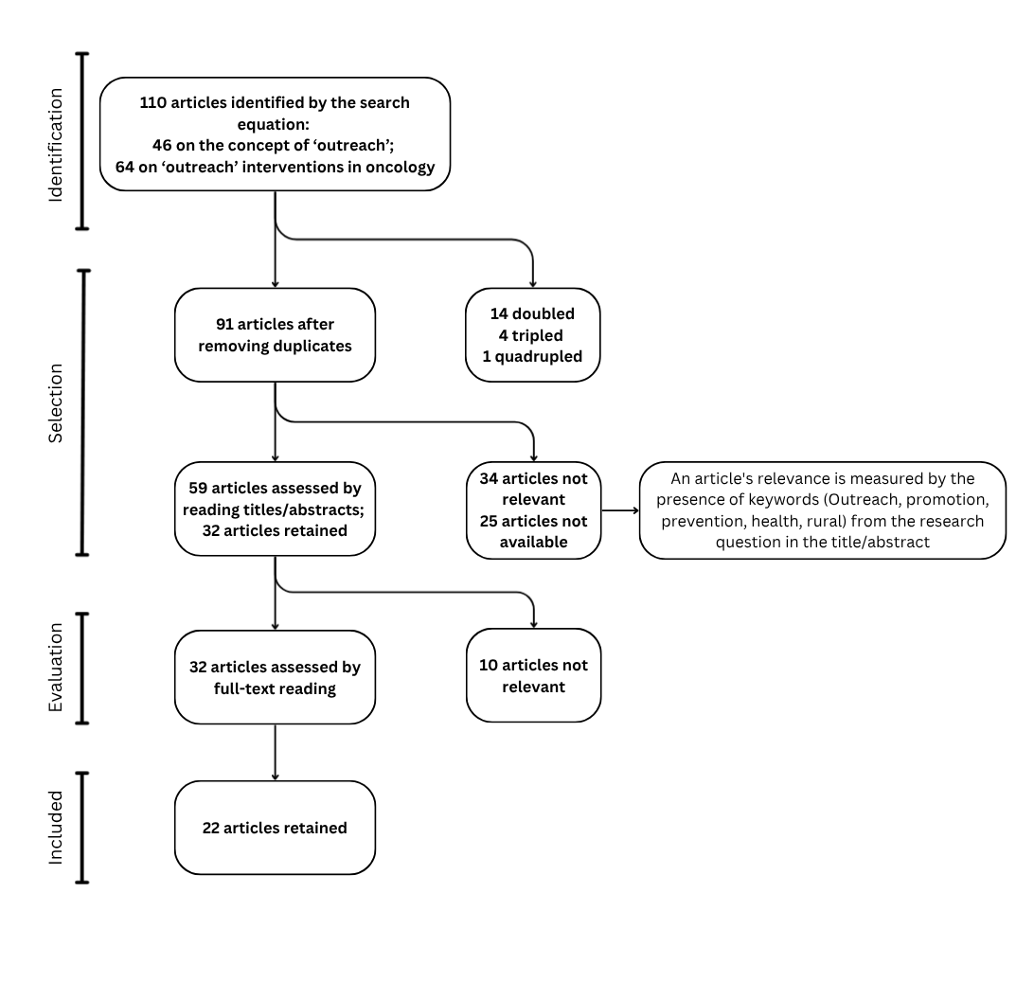
Figure A3.1 : Flow Diagram of realist review, Realist evaluation, Bergo’Bus, France

Figure A3.2 Flow diagram of participants
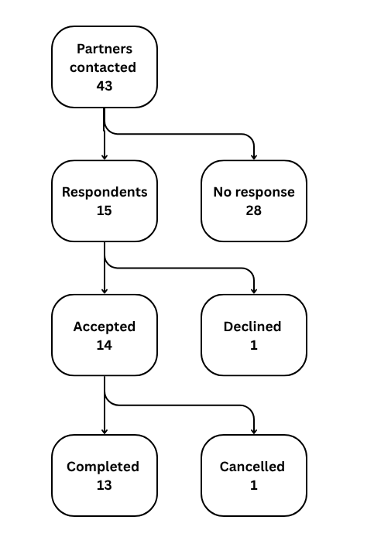
Figure A3.2 : Flow Diagram of interviews, Realist evaluation, Bergo’Bus, France

