Wavelength-Division-Multiplexed Photonic Tensor Core Using Nonvolatile and Volatile Weighting with a General Matrix-Multiply Compiler
Xiaoxuan Ma¹, Nicola Peserico^{2,3}, Ahmed Khaled⁴, Zhimu Guo⁴, Safayat Chowdhury Nirjon³, Jiawei Meng¹, Hamed Dalir², Bhavin J. Shastri⁴ and Volker J. Sorger^{2,3*}
¹Department of Electrical and Computer Engineering, The George Washington University, Washington, DC, 20052, USA. ²Department of Electrical and Computer Engineering, University of Florida, Gainesville, FL, 32611, USA.
³Florida Semiconductor Institute, University of Florida, Gainesville, FL, 32611, USA.
⁴Department of Physics, Engineering Physics and Astronomy, Queens University, Kingston, Ontario, Canada.

*Corresponding author(s). E-mail(s): volker.sorger@ufl.edu;

Contents

S1 Optical spectrum of the SiPh tensor core. 3
S2 Photonic tensor core based on phase change material. 3
S3 Power maps and GeMM results 4
S4 Noise analysis 6
S5 Performance analysis 7
1
2 CONTENTS
S6 MTCNN architecture for generating the mask picture on GW face 8
S7 Emulation of machine learning inference on PTC 11

CONTENTS 3

S1 Optical spectrum of the SiPh tensor core.

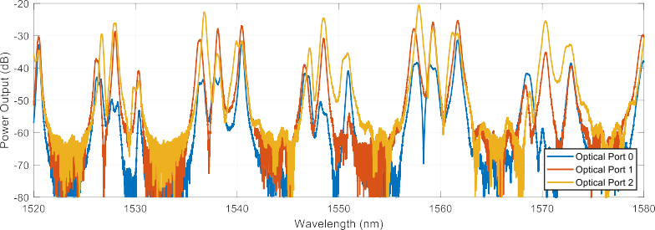
a)
b)

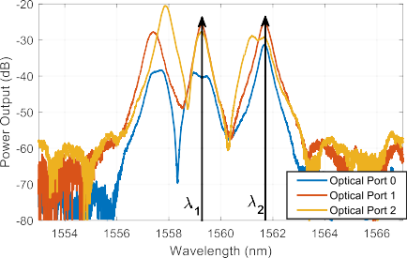
Fig. S1 a, Optical spectrum of the SiPh tensor core, which is measured from optical port 0, 1, and 2, respectively. The FSR of our micro ring resonator is 10 nm. b, Detail of the spectrum and the selected wavelength of the lasers. Wavelength Lambda 1 and 2 are used for the power map measurement

Due to the fault of fabrication, the resonance frequency of micro-ring res-onator in PTC will slightly shift comparing designed frequency. To measure the performance of PTC, the wavelength used for computation should be decided. Fig. S1a shows the spectrum of SiPh tensor core. Due to slightly resonance fre-quency shift of micro-ring resonator, the optical power in different frequency peak and different port are different. To make the measurement easier, the lambda 1 (1559.2 nm) and lambda 2 (1561.8 nm) are selected because the optical power in those two wavelengths is close (Fig. S1b).

S2 Photonic tensor core based on phase change material.
Like the proposed architecture, the Photonic Tensor Core with P-RAM has two rows of microring resonator as WDM. The weight is change to P-RAM. The P-RAM comprise an array of phase change material (GSSe) whose states are individually controlled by on-chip tungsten heaters. The number of GSSe stripes represent the number of bit-1 used for representing the kernel ele-ments. After multiplications, light is detected by a high-speed photodetector, which performs the summation across wavelengths in the linear domain. We

4 CONTENTS
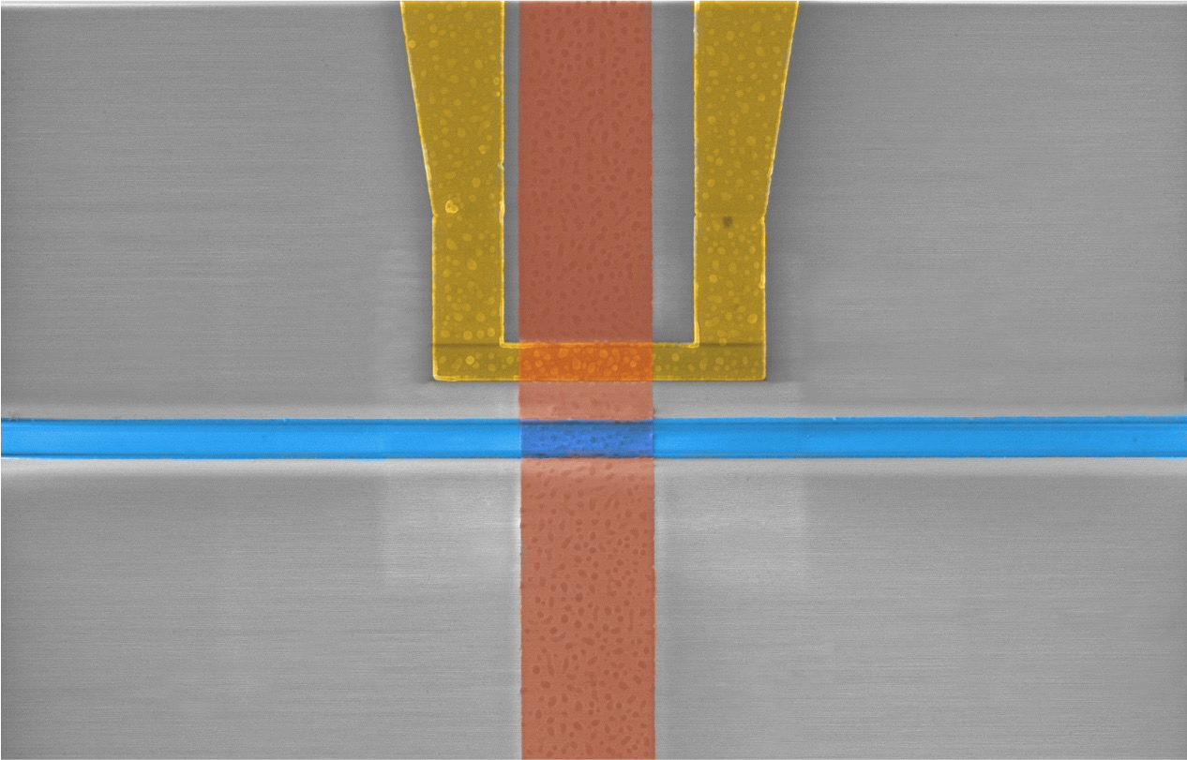
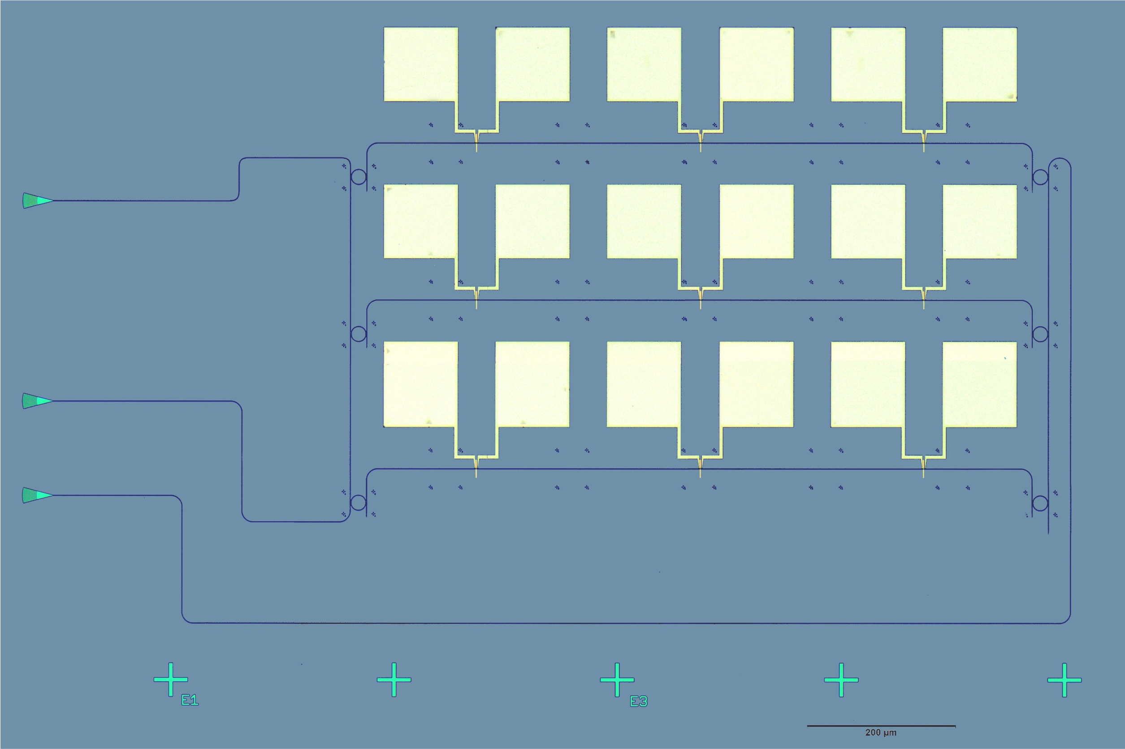
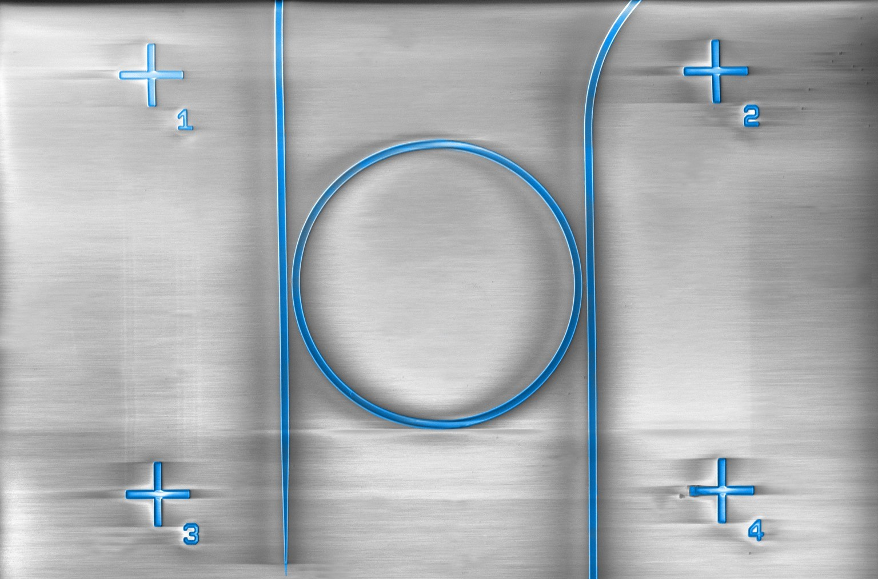
(b)
W Heater
Si WG
PCM 5 um
(a)

Input
Through
(c)
Output
20 um

(d)

0.4
k-crystalline k-amorphous
0.2 dB/um
Ge-Sb-Se

(e) -20

-25
0.3

-30
dBm
0.2
k

-35

0.1
-40

0.0

1140 1290 1433.8 1470 1510 1550 1590
Wavelength(nm)

-45
1 2 3 4 5 6 7 8 9 10 11 12 13 14 15 16
States

Fig. S2 a,microscope image of phase change material based photonic tensor core, which uses GSSe as weight. b-c, SEM picture of micro tungsten heater and micro ring for WDM. d, the absorption coefficient of GSSe. e, Optical power response for a 4-bit photonic memory as a function of digital states.

demonstrated the fabrication of a 13 MVM using 33 photonic random-access memories (P-RAM) (Fig. S2a). Here, we utilize a compact 2 micrometer PCM pads design resulting in an ER of 1.0 dB or 0.2dB (Fig. S2d), which is one of the most area-efficient designs to date. Extending the PCM strip size allows for a) higher ER such as 10dB for 20 micrometers, and b) also enabling multi-state programmability with a single control voltage pulse. Fig. S2e shows the performance of 4 bits P-RAM based on GSSe. When the GSSe wires are writ-ten/SET (switching to crystalline), the optical power transmitted decreases, resulting in discrete power levels for each quantized state. The insertion losses for the multistate memory device with various quantization states are mea-sured, which achieved 16 quantization states for 4bit. Quantization step for a 4-bit photonic memory is 0.75 dB/state, with a total maximum extinction ratio of 12 dB and 16 output power states.

S3 Power maps and GeMM results
The power map of 1 2 kernel is tested based on the S3a. We define a PTC transfer map as the measured output response obtained by sweeping the heater powers applied to the MZI weights for two WDM input channels. The result-ing two-dimensional map captures the combined effects of the MZI transfer
×

CONTENTS 5










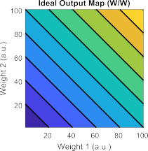
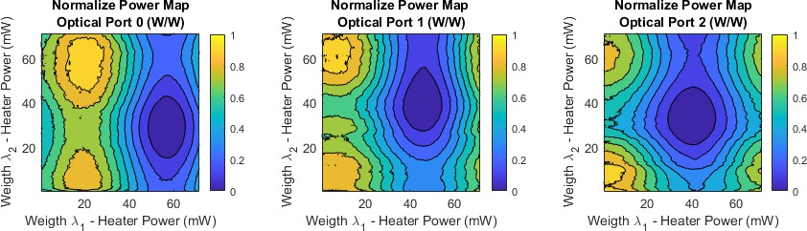
e)
λ₁ + λ₂ λ1
Weight 1
λ1
w1 λ1
+
w2 λ2
λ2
Weight 2
λ2
PTC
b)
a)
c)
d)
Fig. S3 a, Schematic of the SiPh tensor core without on-chip photodiode. b, Ideal output power map. c, The normalized output power map of port 0, port 1, and port 2.

functions, wavelength routing, detector response, and experimental nonideal-ities. A more linear subregion of this map is selected for computation. Two laser beams with different wavelength are injected to the PTC. By tuning the weight for each wavelength, the MAC operation is achieved by the photodiode. S3b shows the shape of ideal output power map. However, due to the non-linear performance of MZI modulator and noise, the measured power map in full voltage range is impossible to be the same as ideal power map (S3c-e). To achieve ideal power map in experiment, a certain voltage range and step size should be specifically selected (S5b).

6 CONTENTS

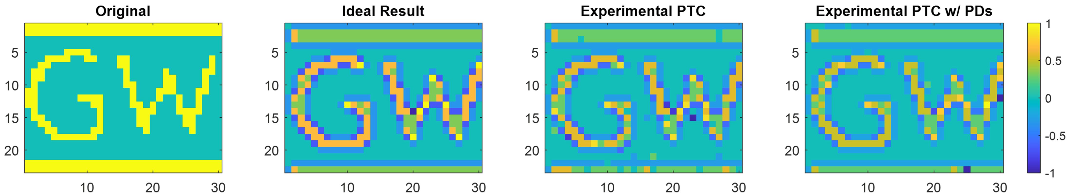


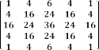
Original Ideal Results PTC Emulation
Results
a
b
Edge Detection – 3 bit
c
d
Error rate 1.1%
e
f
g
h
Blur filter – 5 bit
Error rate 5.05%
i
j
k
l

Error Rate 5.9% Error Rate 2.5%

Fig. S4 a, 3-bit Edge detection kernel b, on a PTC for an input image c, comparing an ideal result (i.e., mathematical edge filter) d, with an emulated PTC results using the MAC performance from figure S3, obtaining an error rate of 1.1%. Similarly, a 5-bit blur filter e along with idea f and PTC-emulated h, results showing, overall, a low error rate (5.05%). i-k, Experimental PTC edge detection result of GW initial. Comparing with ideal result, 5.9% and 2.5% error rate is achieved by off-chip photodiode and on-chip photodiode respectively.

To illustrate the principle of PTC, two different convolutions with dif-ferent kernel are emulated based on photo detector power map Fig. 3e. The result in power map represents the MAC result between two kernel and input image. By selecting the value in power map, the convolution result can be computed. Fig. S4d shows the emulated result of edge detection kernel. The original gray scale picture is converted to binary picture with 83% threshold. The emulated convolution result between the binary picture (input) and 3-bit edge detection kernel shows only 1.1% error rate (Fig. S4d). The 5.05% error can be achieved with 5-bit blur filter kernel (Fig. S4h).

To demonstrate the emulation result, we show the results with and without integrated photodiodes (fig. S4i-l). The experimental results demonstrate good agreement with the ideal one (fig. S4j) computed by Matlab. In this case, the error rate for the PTC without the photodiode is about 5.9%, while the error rate for the PTC with the integrated photodiode is 2.5%.

S4 Noise analysis
The noise of the PTC system with the on-chip photodiode is composited by 3 parts. One is the noise from the photodiode. Based on our measurement,

CONTENTS 7
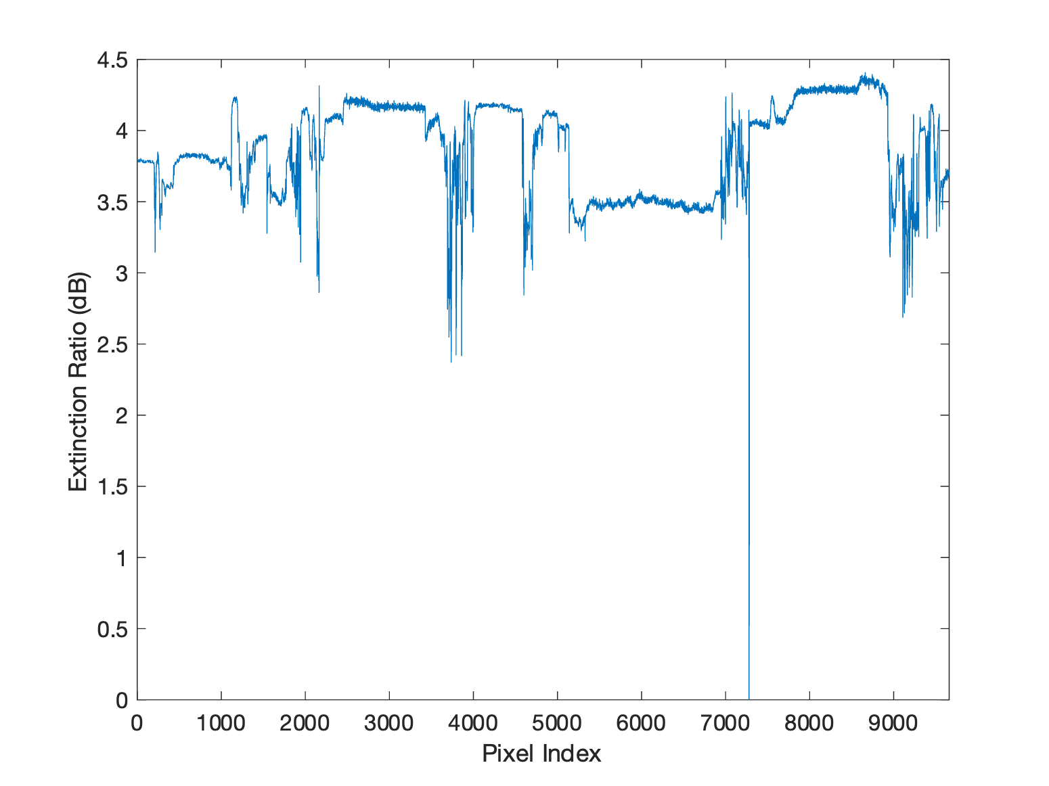

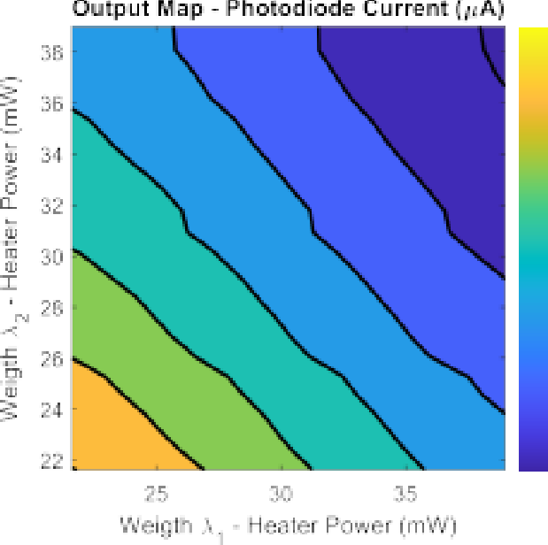
a)
b)
c)

Fig. S5 a, Noise analysis of the on-chip photodiode. b, The detailed power map of photo-diode showing more linear performance, which is used for the emulation and experiment. c The extinction ratio of the MZI changed with different pixel.

the noise of the photodiode is around ±50 nA. Also, the non-linearity of the MZI will cause the power map slightly bended comparing to the ideal output map (Fig. S3b). The bending in the power map will caused the error in the calculated result. But the main noise in our system is caused by the extinction ratio change of the MZI modulator. This change caused by the periodic change
of laser power and the slightly mechanical movement of Input fiber array. The total power change will influence the extinction ration of MZI modulation. The analog digital convertor will introduce the error due to small difference between each optical power levels, the final result of MAC operation will amplify the error causing the different values of pixel comparing to ideal one.

S5 Performance analysis
To calculate the performance of our PTC, Speed=n×m×n×freq [1], for our 3×3 PTC, the speed is 0.32 TOPS under 12 GHz data through put. The total power is determined by:

P = n(Laser + ADC) + nmHeater_{W} _{eigth} + m(TIA + DAC)
The laser power is calculated by
(P_{pd} + ER_{weight})/(1 − Loss),
which is 6.28 uW in our system. The power consumption of 6 bits ADC and DAC with 20 GS/s are 0.136W and 0.07 W respectively [2, 3]. The weights are implemented by heaters. The average power of our heater 0.01W per heater. The efficiency of TIA for photodetector is 9.6e-13 J/bit/ADC [4] . The total power consumption in our system will be 0.9W. The MAC efficiency of our PTC is 0.35 TOPS/W.

8 CONTENTS
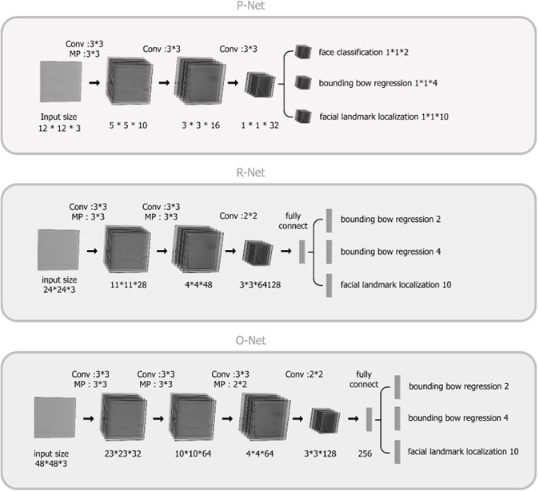

Fig. S6 Architecture of MTCNN, where ”Conv” means convolution and ”MP” means max pooling.

S6 MTCNN architecture for generating the mask picture on GW face
The MTCNN is built by 3 cascaded convolution network which are the proposal network (P-Net), the refine network (R-Net), and the output network (O-Net)[5].

Initial Phase: The Proposal Network (P-Net)
This preliminary level is made up only of convolutional neural networks (FCN). A completely convolutional network, often known as an FCN, does not include a thick layer in its architecture like a conventional neural network (CNN). This is the most important contrast that can be made between the two kinds of networks. Utilizing this Proposal Network allows for the acquisition of can-didate windows in addition to the bounding box regression vectors that are associated with those windows.
Bounding box regression is a typical approach that is used when the goal is to identify an object that belongs to a certain pre-defined class, as is the case here with faces. This method is utilized when the objective is to identify an item that belongs to a particular pre-defined class. As soon as you get the

CONTENTS 9

vectors for the bounding box, the next thing you need to do is do some sort of refinement so that you can merge the overlapping areas. The culmination of this process will be the final outcome, which will consist of all candidate windows that have been improved upon in order to bring the overall number of candidates down.

Second Phase: The Refine Network (R-Net)
Every potential candidate from P-Net is moved forward into the Refine Net-work for additional consideration. Due to the fact that the last stage of the network design consists of a dense layer, it is essential to take note that this network is a CNN and not an FCN like the one that came before it. This is because the thick layer. The R-Net, which also calibrates using bounding box regression and employs non-maximum suppression, often known as NMS, to merge candidates that overlap, reduces the number of candidates even more, bringing the total number of candidates down to an all-time low. The R-Net provides an output that indicates whether or not the input is a face, a vec-tor consisting of four elements that represents the face’s bounding box, and a vector consisting of ten elements that localizes facial landmarks. Additionally, the R-Net provides an output that indicates whether or not the input contains facial landmarks.

Third Phase: The Output Network (O-Net)
This stage is relatively similar to the R-Net; however, the purpose of this Output Network is to offer a more precise description of the face and to output the locations of the five facial landmarks for the eyes, nose, and mouth. This stage is pretty similar to the R-Net.
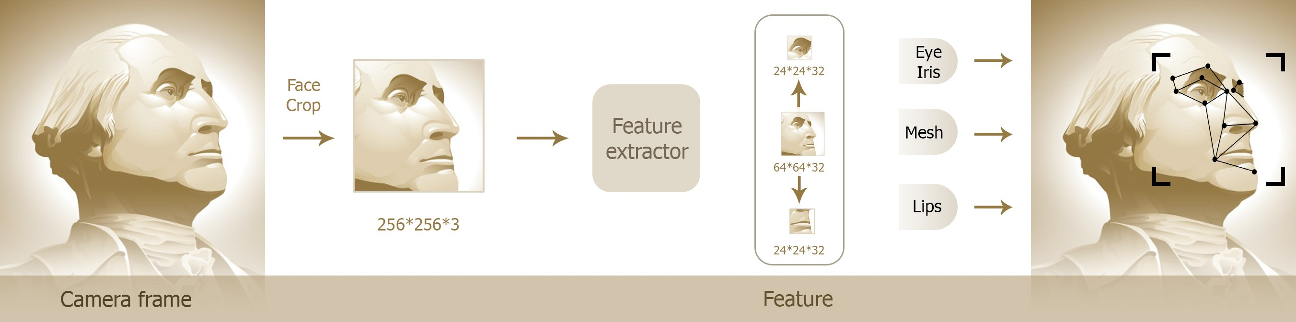
Fig. S7 The responsibilities of the MTCNN to generate the mask picture on GW face, including face classification, boxes with bounds regression, and facial landmark localization

The Three Responsibilities of the MTCNN
The Network is charged with creating three different kinds of outputs: face versus non-face classification, bounding box regression, and facial landmark localization. Each of these three outputs is unique to the Network.

10 CONTENTS

Face classification: this is a binary classification problem that relies on cross-entropy loss:
L^{del} = −(y^{del} − log(P_{i}) + (1 − y^{del})(1 − log(P_{i})))
i
i
i
P_{i} is probability produced by the network. y^{del} is ground truth label y^{del} ∈
i i
{0, 1}.
Boxes with bounds Regression: the learning goal presents a regression chal-
lenge for the learner. The distance that separates each candidate window and the nearest ground truth is measured. Using the Euclidean loss for this particular endeavor:
Lbox = yˆibox − ybox 2
i
i
2
yˆ_{i} is target obtained from network. y^{box} is ground truth coordinate.
i
Facial Landmark localization: the localization of facial landmarks is for-mulated as a regression problem, in which the loss function is Euclidean distance:
Llandmask = yˆilandmask − ylandmask 2
i
i
2
Media-pipe: The Media-Pipe Face Mesh application is a real-time system that can estimate 468 different 3D facial landmarks. For the purpose of infer-ring the 3D facial surface, machine learning (ML) is applied. The technique achieves the real-time speed required for live experiences by making use of lightweight model designs and GPU acceleration throughout the pipeline.
The Facial Transform module, which bridges the gap between face land-mark estimation and useful augmented reality (AR) applications in real-time, is also included in the solution. This module is one of the reasons why the solu-tion is so effective. It does this by first establishing a metric three-dimensional space and then using the locations of facial landmarks on the screen to esti-mate a face transform within that space. Standard 3D primitives were utilized in the construction of the face transform data. These primitives include a face position transformation matrix as well as a triangular face mesh. The Pro-crustes Analysis is a lightweight statistical analysis approach that is utilized to fuel a durable, perform-ant, and portable logic. In addition to the machine learning model inference, the analysis is performed using the CPU and has a little impact on performance and memory.

CONTENTS 11

S7 Emulation of machine learning inference on PTC
Neural networks evaluated on the graphical processing unit (GPU) are expected to achieve maximum testing accuracy due to the resilience of digi-tal hardware to noise, along with the 32-bit weight control bit precision and the ability to implement positive and negative weights. However, this comes at the cost of slower processing and lower energy efficiency compared to pho-tonic hardware. On the other hand, photonic tensor cores offer unparalleled speed and energy efficiency but suffer from weight noise, particularly impact-ing feed-forward layers. Additionally, they face limitations in core size, weight control bit precision, and exclusive support for positive weights in our PTC architecture.

=
𝑌11
𝑌21
×
𝑊22
𝑊21
𝑊12
𝑊11
𝑋21
𝑋11

𝑌11 = 𝑊11 × 𝑋11 + 𝑊12 × 𝑋21
𝑌21 = 𝑊21 × 𝑋11 + 𝑊22 × 𝑋21
Fig. S8 The breakdown of large matrix-vector multiplication operations into smaller ones using GeMM compiler. The smaller matrix-vector multiplication operations are compatible with the size of our PTC.

To reap the benefits of both technologies, we propose a hybrid electronic-photonic approach. Convolutional layers, which are less affected by weight noise, are implemented on the PTC. Meanwhile, for feed-forward layers sus-ceptible to weight noise, we choose GPU implementation. Since the sizes of matrix-vector multiplications may surpass the PTC size, we employ the GeMM compiler to break these operations into smaller sizes as illustrated in Figure S8. Breaking down convolutional operations into smaller sizes is straightforward as they involve the dot product between an image and a kernel matrix.
To validate this approach, we benchmark the inference performance of an emulated convolutional neural network in three scenarios: fully implemented on the GPU, fully implemented on the PTC, and a hybrid electronic-photonic approach. In the latter, convolutional layers are executed on the PTC, while feed-forward layers are processed on the GPU. The convolutional network pipeline is illustrated in Figure S9, operating on the MNIST dataset. For a comprehensive overview, the layer sizes and their implementation options (electronic/photonic) are summarized in Table S1.

12 CONTENTS

Layer number | Name | Kernel/matrix size | Implementation options
1 | Conv1 | 5x5 | electronic/photonic
2 | MaxPool1 | 2x2 | electronic
3 | Conv2 | 5x5 | electronic/photonic
4 | MaxPool2 | 2x2 | electronic
5 | FC1 | 96x50 | electronic/photonic
6 | FC2 | 50x10 | electronic/photonic
Table S1 Breakdown of the convolutional network pipeline. The convolutions in the convolutional layers (Conv) and the matrix-vector multiplications in the fully connected feed-forward layers (FC) can be implemented in the electronic or photonic domain. The max pooling layers (MaxPool) and the nonlinearities can be only implemented in the electronic domain. Conv layers kernels have a stride of 1.

These three networks are benchmarked in terms of the latency of infer-ring one MNIST image, energy consumption per MNIST image inference, and classification accuracy. The overall figure of merit (FOM) for each network is:

FOM =

GPU network
Classification Accuracy Inference Latency × Inference Energy
(1)

This network has all the layers implemented in the electronic domain. It was trained and tested fully on the GPU using the PyTorch machine learning package. Figure S10 illustrates the evolution of testing accuracy with epochs, reaching a final accuracy of 98.49%. Specifics about the training, testing, and GPU can be found in Table S2.
Following this, we input a single MNIST image into the network and mea-sure GPU performance using compute unified device architecture (CUDA) [6] commands. To calculate the inference energy, we multiply latency by the GPU wattage and then determine the Figure of Merit (FOM) using Equation 1. The
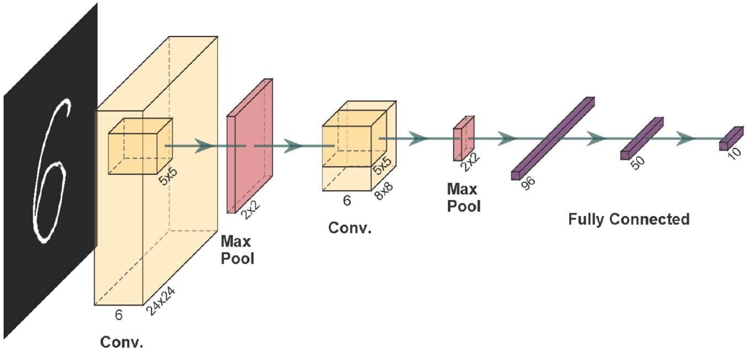
Max
Pool1
Conv2
Max
Pool2
FC1
FC2
Conv1
Fig. S9 Convolutional neural network with two convolutional layers and two fully con-nected layers. It also includes two image max pooling layers to downsample the image.

CONTENTS 13

Parameter | value
Training set size | 60000
Testing set size | 10000
Optimizer | ADAM
Learning rate | 0.001
Batch size | 64
GPU model | GTX 1660TI
GPU power | 120W
Table S2 The specifications of training and testing the GPU network.

results are detailed in Table. S3. It’s important to highlight that the GPU was pre-warmed before measuring image latency to ensure initialization, with ini-tialization time excluded from the measured latency. Additionally, the image was loaded onto the GPU before inference to eliminate communication time between the central processing unit (CPU) and GPU and memory allocation time from the result. Furthermore, we employed CUDA syncing to measure the true GPU latency, excluding scheduling effects from asynchronous GPU operation. This latency measurement was repeated 1000 times and averaged to account for any stochastic hardware noise.

Parameter | Value
Testing accuracy | 98.49%
Inference latency | 48.97 ms
Inference energy | 5.88 J
FOM | 3.42 s⁻¹J⁻¹
Table S3 Inference accuracy, latency, energy, and the FOM of the GPU network.

Hybrid electronic-photonic network
In this network, the convolutional layers operate in the photonic domain, while the remaining layers function in the electronic domain. A network was trained

95

Unconstrained Conv positive All positive
Testing accuracy (%)

90

85

0.0 2.5 5.0 7.5 10.0 12.5
Epochs
Fig. S10 Evolution of network testing accuracy across epochs for different training scenar-ios: unconstrained weights, positive-only weights for convolutional layers, and positive-only weights for all layers.

14 CONTENTS

on the GPU, using the same parameters as the GPU network in Table S3, but with a constraint on the convolutional layer weights to be exclusively positive due to the limitations of our photonic architecture, which cannot accommo-date negative weights. Figure S10 shows the evolution of testing accuracy across epochs, reaching 97.19%, slightly lower than the case of the uncon-strained weight. Subsequently, these positive weights were uploaded to the convolutional layers.








Conv1
GPU
Perform 3 x (3x1 x 3x1 products) Transfer the results back to the CPU

Add bias Apply ReLU MaxPool1

CPU

1 x (28x28) Divides image
to 3x1 vectors
DAC
PTC

(a)
ADC
CPU

Combines results

6 x (12x12)





Conv2
GPU
Perform 3 x (3x1 x 3x1 products) Transfer the results back to the CPU

Add bias Apply ReLU MaxPool2 Perform FC

6 x (12x12)
CPU

Divides image to 3x1 vectors
DAC
PTC

(b)
ADC

CPU

Combines results
Label
“9”

Fig. S11 (a) Diagram illustrating the emulation process of Conv1 layer on PTC, including the addition of bias terms, activation function application, and max pooling on the GPU. (b) Diagram illustrating the emulation process of Conv2 layer on PTC, including the addition of bias terms, activation function application, max pooling, and flattening the resulting feature maps on the GPU.

To emulate the hybrid network’s inference performance, convolutional layer weights were approximated to the nearest value in a 4-bit lookup table that is experimentally extracted from our photonic weights. Additionally, weight noise, randomly sampled from a Gaussian distribution with a variance of 0.4% of the weight value, was added each time an image was inferred to emulate the measured noise in our setup. After incorporating these non-idealities into the convolutional layers, the network inference accuracy slightly decreased to 96.56%. This indicates that the impact of weight noise on the convolutional layers is minimal.

CONTENTS 15

To evaluate the latency and energy consumption of the hybrid network, we analyze the implementation process of convolutional layers on the PTC and feed-forward layers on the GPU. Figure S11a depicts the implementation of the first convolutional layer (Conv1) on the PTC. Initially, the MNIST image is partitioned into 3x1 vectors using a CPU for compatibility with our PTC size. Subsequently, these vectors and kernel weights are transferred to the PTC through digital-to-analog converters (DAC). The PTC then executes convolution operations for each section, and the results are converted to the digital domain using transimpedance amplifiers (TIA) followed by analog-to-digital converters (ADCs). The CPU collects these results, assembling the full convolution result. This process repeats for all six convolution kernels, yielding six feature maps. Finally, the GPU takes over, incorporating bias terms, applying the ReLU activation function, and executing the first non-linear max pooling operation (MaxPool1).
For the second convolutional layer (Conv2), a similar process, as illus-trated in Figure S11b, is employed to convolve six feature maps output from MaxPool1 with six kernels, generating another set of six feature maps. These feature maps undergo processing on the GPU, where bias terms are added, the ReLU activation function is applied, the second non-linear max pooling oper-ation (MaxPool2) is performed, and the values from MaxPool2 are flattened before being fed into the feed-forward layers.
Details regarding the latency and energy consumption of the CPU, PTC, and GPU are available in Appendix S7. The inference time, energy consumption, and FOM for the hybrid network are presented in Table S4.

Parameter | Value
Testing accuracy | 96.56%
Inference latency | 29.83 ms
Inference energy | 3.5535 J
FOM | 9.11 s⁻¹J⁻¹
Table S4 Inference accuracy, latency, energy, and the FOM of the hybrid electronic-photonic network.

PTC network
In this network, both convolutional and feed-forward layers are implemented in the photonic domain. The network was trained on the GPU using parameters identical to those outlined for the GPU network in Table S2. However, a con-straint was imposed on all layer weights to be exclusively positive, reflecting the limitations of our photonic architecture, which cannot accommodate negative weights. Figure S10 illustrates the evolution of testing accuracy across epochs, reaching 94.28%, slightly lower than the case of the unconstrained weight.
Following this, these positively constrained weights were uploaded to the network. To emulate the network’s inference performance, we applied the same bit precision and noise non-idealities to all network layers. However, after

16 CONTENTS

incorporating these non-idealities, the network’s inference accuracy severely decreased to 59.4%. This highlights the substantial impact of weight noise on the feed-forward layers.

FC1
GPU
Perform 3 x (3x1 x 3x1 products) Transfer the results back to the CPU

Add bias Apply ReLU

Flattened feature maps 1x96
CPU
DAC
PTC
ADC
Vector of size 1x50

Divides MVM to 3x1 vectors using GeMM
CPU

(a)
Combines results using GeMM

FC2
GPU
Perform 3 x (3x1 x 3x1 products) Transfer the results back to the CPU

Add bias Apply Sigmoid

Vector of size 1x50
CPU
DAC
PTC
ADC
Label
“9”

Divides MVM to 3x1 vectors using GeMM
CPU

(b)
Combines results using GeMM

Fig. S12 Diagrams illustrating the emulation process of (a) FC1 and (b) FC2 layers on PTC, including the addition of bias terms and activation function application on the GPU.

To evaluate the latency and energy consumption of the PTC network, we examine the process of implementing both the convolutional and feed-forward layers on the PTC. The implementation of Conv1 and Conv2 layers follows the same procedure outlined for the hybrid network in Section S7. However, for the matrix-vector multiplication operations of the feed-forward layers, they were broken down to the size of our PTC using the GeMM compiler in the CPU, as illustrated in Figure S12. Subsequently, these smaller-size operations were fed to the PTC through DACs. The results were then converted to the digital domain using TIAs followed by ADCs, where they were collected by the CPU to assemble the full matrix-vector multiplication result using the GeMM compiler. Finally, the results were passed to the GPU to apply the bias terms and activation functions.
Details regarding the latency and energy consumption of the CPU, PTC, and GPU are provided in Appendix S7. The inference time, energy consumption, and FOM for the PTC network are listed in Table S5.

CONTENTS 17

Parameter | Value
Testing accuracy | 59.4%
Inference latency | 38.7 ms
Inference energy | 3.86 J
FOM | 3.976 s⁻¹J⁻¹
Table S5 Inference accuracy, latency, energy, and the FOM of the PTC network.

Performance comparison



100
Image inference time (ms)
80 40
Inference accuracy (%)
60
40 20

20
0 GPU Hybrid PTC Network type
(a)

0 GPU Hybrid PTC Network type
(b)



6
Image inference energy (J)
8
FOM (s⁻¹J⁻¹)
4 6

2

0 GPU Hybrid PTC Network type
(c)
4
2
0 GPU Hybrid PTC Network type
(d)

Fig. S13 Comparing the (a) Inference accuracy, (b) Inference latency, (c) Inference energy, and (d) Overall FOM for the GPU, hybrid, and PTC networks.

After emulating the inference accuracy, the latency of inferring one image, and the energy consumed in inferring one image on each network, the results are compared in Figure S13. The GPU values include measurement-based latency on the stated hardware platform, whereas the PTC and hybrid latency and energy values are architecture-level projections based on the component and processing assumptions. As shown, the GPU network achieves the best inference accuracy, benefiting from unconstrained and noise-free weights. How-ever, it is the slowest due to its fully electronic nature. On the other hand, the hybrid and PTC networks demonstrate superior speed, with their con-volutional or all layers implemented in the photonic domain, respectively. Nevertheless, the inference accuracy of the PTC network is the lowest, given

18 CONTENTS

the sensitivity of the feed-forward layer weights to noise. Surprisingly, the hybrid network is slightly faster than the PTC network, attributed to the small size of our PTC, causing significant latency overhead in breaking down the matrix-vector multiplication in the feed-forward layers to fit the PTC size.
By combining the strengths of both the GPU and PTC networks, the hybrid network achieves inference accuracy close to that of the GPU network since the noise has little impact on the convolutional layer weights. Simultaneously, convolutional layers benefit from the low latency in photonics, resulting in the highest FOM. This underscores the potential of hybrid electronic-photonic neural networks.

Latency and energy calculations of PTC-based and hybrid electronic-photonic neural networks

Hybrid electronic-photonic network
To assess latency and energy consumption, we examine the emulation of con-volutional (Conv) layers while implementing the max pooling (MaxPool) and fully connected feed-forward layers (FC) on the graphical processing unit (GPU), as detailed in the following subsections.

Conv1 and MaxPool1 layers
The emulation flow, illustrated in Fig. S11a, is detailed as follows:
- Step 1: The central processing unit (CPU) decomposes each convolution operation into a 3x1 by 3x1 vector dot product operation, matching the size of our photonic tensor core (PTC). Utilizing 5x5 kernels, six feature maps are generated from the input MNIST image. For each feature map, M ² convolutions, each sized 5x5, are executed on the 28x28 MNIST image, where M represents the output feature maps’ dimension (in this case, M = 24). To adapt to our PTC, each 5x5 section of the input image is broken down into sets of 3x1 by 3x1 vector dot products. Padding involves appending two zeros to the 5x5=25 numbers, resulting in a size of 27 that is divisible by 3. Thus, each 5x5 image section, intended for convolution with a 5x5 kernel, breaks down into 9 sets of 3x1 by 3x1 vector dot products. This step was implemented and timed on the CPU, and the energy consumption was calculated by multiplying the latency with CPU power, and the resultant values are detailed in Table. S6. To compute the total time and energy for breaking down all 5x5 image sections, we multiply by the number of convolutions F_{in}M ², where F_{in} represents the number of input feature maps and here it is equal to 1 because the input consists of one MNIST image with one channel.
- Step 2: The PTC executes three parallel 3x1 by 3x1 vector dot product oper-
ations by employing digital-to-analog converters (DAC) to upload vectors for multiplication onto the PTC modulators and laser input modulators.

CONTENTS 19

Parameter | Value
CPU model | Intel Core-I7 9750H
CPU power | 45W
tbreak | 8.17 µs
Ebreak | 368 µJ
Table S6 The details of breaking 5x5 convolutions to 3x1 by 3x1 dot products on CPU, where t_{break} and E_{break} are the latency and energy consumption of the CPU, respectively.

The results are then collected on the CPU through transimpedance ampli-fiers (TIA) on photodetectors (PD), followed by analog-to-digital converters (ADC). Key specifications for these components can be found in Table. S7. The time and energy required to infer one image using this step can be cal-culated using the equations outlined in Equation 2. This process effectively utilizes the PTC’s parallel processing capabilities, enhancing the efficiency of vector dot product operations.

tPTC =
FinFoutNM 2
3 tproduct, (2a)

EPTC = FinFoutNM 2Eproduct, (2b)

where:

tproduct = tDAC + tMOD + tTIA + tADC, (2c)
Eproduct = 3ELaser + 6EDAC + 6EMOD + ETIA + EADC, (2d)

where F_{out} represents the number of output feature maps in this convolu-tional layer, while N indicates the number of 3x1 by 3x1 vector dot products involved in convolving one 5x5 image section with a 5x5 kernel. The param-eters t_{P} _{T} _{C} and E_{P} _{T} _{C} denote the time and energy required for the dot products to pass the entire image through the photonic part of Conv1. Addi-tionally, t_{product} and E_{product} represent the time and energy required for one dot product. The time of light propagation is not included in t_{product} as it is negligible compared to the latency of electro-optic components. The terms t_{DAC}, t_{MOD}, t_{T} _{IA}, and t_{ADC} correspond to the times needed for one sam-ple of data through the DAC, modulator (MOD), TIA with PD, and ADC. Similarly, E_{DAC}, E_{MOD}, E_{T} _{IA}, and E_{ADC} denote the energies required for one sample of data through the DAC, MOD, TIA with PD, and ADC. These parameters are detailed in Table. S7, and the results of the photonic part of Conv1 are presented in Table. S8. It’s noteworthy that each PTC 3x1 by 3x1 vector dot product involves 6 MODs, 3 for each input laser at each wavelength, and 3 for the weights. Additionally, there are 6 DACs, one for each MOD.
- Step 3: The convolution result is compiled using a CPU. Each convolu-
tion of a 5x5 image section yields 9 scalars, as previously mentioned, and these scalars are summed to produce one convolution result. This process

20 CONTENTS

Device | Speed | Power
Laser | Continuous wave | 10 µW
DAC [7] | 20 GHz | 140 mW
MOD [8] | 20 GHz | 4 mW
PD and TIA [9] | 20 GHz | 40 mW
ADC [10] | 20 GHz | 70 mW
Table S7 The specifications of the PTC setup components.

Parameter | Value
Fin | 1
Fout | 6
N | 9
M | 24
tPTC | 2.1 µs
EPTC | 3.45 µJ
Table S8 The parameters and results of PTC in performing the linear part of Conv1.

is repeated F_{out}M ² times to encompass all the pixels of the output feature maps. The time taken for this step on the CPU and the corresponding energy consumption, derived by multiplying time by CPU power, are presented in Table. S9.
- Step 4: The obtained result is subsequently forwarded to the GPU, where
the ReLU activation, addition of a bias, and MaxPool1 layer are applied. The GPU execution time is measured, and the energy consumed is computed using the same methodology as outlined in Section S7. The corresponding results are detailed in Table. S9.

Parameter | Value
tcombine | 53 µs
Ecombine | 2.4 mJ
tGPU | 8.5 ms
EGPU | 1 J
Table S9 The time t_{combine} and energy consumed E_{combine} to combine dot product results on the CPU, and the time t_{GP} _{U} and energy consumed E_{GP} _{U} to perform ReLU, bias addition and MaxPool1.

Finally, we summarize the results of Conv1 layer in Table. S10.

Conv2, MaxPool2 and the feed-forward layers
The emulation flow is the same as the previous section, with the only alter-ations being in Step 1, where six input feature maps are broken down instead of one input image. Additionally, the flattening of the output feature maps and the feed-forward layers are incorporated into the GPU, as illustrated in Fig. S11b. A summary of the results can be found in Table. S11.
Having emulated all the parts of the network, we can now calculate the total inference time, and energy consumption as shown in Table. S12.

CONTENTS 21

Parameter | Value
tbreak | 8.17 µs
Ebreak | 368 µJ
tPTC | 2.1 µs
EPTC | 3.45 µJ
tcombine | 53 µs
Ecombine | 2.4 mJ
Total time of Conv1 | 63.27 µs
Total energy of Conv1 | 2.77145 mJ
tGPU | 8.5 ms
EGPU | 1 J
Total time of Conv1 + GPU operations | 8.56327 ms
Total energy of Conv1 + GPU operations | 1.00277 J
Table S10 Summary of Conv1 and GPU operations emulation results.

Parameter | Value
Fin | 6
Fout | 6
N | 9
M | 8
tbreak | 5.8 µs
Ebreak | 260 µJ
tPTC | 1.38 µs
EPTC | 1.87 µJ
tcombine | 11 µs
Ecombine | 495.3 µJ
Total time of Conv2 | 18.18 µs
Total energy of Conv2 | 757.17 µJ
tGPU | 21.25 ms
EGPU | 2.55 J
Total time of Conv2 + GPU operations | 21.26818 ms
Total energy of Conv2 + GPU operations | 2.55075 J
Table S11 Summary of Conv2 and GPU operations emulation results.

Parameter | Value
Inference latency | 29.83 ms
Inference energy | 3.5535 J
Table S12 Total inference time and energy consumption of the hybrid electronic-photonic network.

PTC network
In this network, both the convolutional and feed-forward layers are imple-mented in the photonic domain as explained in the following subsections.

Conv and MaxPool layers
Given the use of PTC for Conv layers, the Conv1 and MaxPool1 latency and energy consumption remain consistent with Section S7. However, for Conv2 and MaxPool2, the process aligns with Section S7, with the exception that

22 CONTENTS

the fully connected feed-forward layers are not executed on the GPU. This modification impacts the total time and energy for this segment of the network. The updated results can be found in Table. S13.

tGPU | 8.17 ms
EGPU | 0.98 J
Total time for Conv2 + GPU operations | 8.18818 ms
Total energy for Conv2 + GPU operations | 0.98075 J
Table S13 The latency and energy consumption of Conv2 and GPU operations.

FC layers
The emulation flow for FC1 and FC2 layers, illustrated in Fig. S12, is as follows:
- Step 1: The matrix-vector multiplication is decomposed into 3x1 by 3x1 vector dot products using the general matrix multiply (GeMM) compiler. This step is timed on the CPU, and energy is calculated using the CPU power.
- Step 2: The 3x1 by 3x1 vector dot products are executed on the PTC, fol-
lowing the approach described in Section S7. The time and energy consumed in the PTC can be calculated using Equation 3:

tPTC =
N
3 tproduct, (3a)

EPTC = NEproduct, (3b)

where N is the number of 3x1 by 3x1 dot products, and t_{P} _{T} _{C} and E_{P} _{T} _{C} represent the time and energy required for the dot products involved in the full matrix-vector multiplication.
- Step 3: The final result vector is assembled from the results of the small 3x1
by 3x1 vector dot products. This assembly is also performed on the CPU.
- Step 4: The result vector is then forwarded to the GPU to undergo the activation function.
The time and energy results for FC1 and FC2 are listed in Tables S14 and S15 respectively.
Having emulated all the parts of the network, we can now calculate the total inference time and energy consumption as listed in Table. S16.

References
- Feldmann, J., Youngblood, N., Karpov, M., Gehring, H., Li, X., Stappers, M., Gallo, M.L., Fu, X., Lukashchuk, A., Raja, A.S., Liu, J., Wright, C.D., Sebastian, A., Kippenberg, T.J., Pernice, W.H.P., Bhaskaran, H.: Parallel convolutional processing using an integrated photonic tensor core. Nature 589 (2021). https://doi.org/10.1038/s41586-020-03070-1

CONTENTS 23

Parameter | Value
N | 1632
tbreak | 1 ms
Ebreak | 44.8 mJ
tPTC | 0.11 µs
EPTC | 0.147 µJ
tcombine | 4.68 ms
Ecombine | 0.21 J
tGPU | 6 ms
EGPU | 0.7257 J
Total time | 11.68 ms
Total energy | 0.9805 J
Table S14 The latency and energy consumption of FC1 and GPU operations.

Parameter | Value
N | 200
tbreak | 0.17 ms
Ebreak | 7.65 mJ
tPTC | 13.3 ns
EPTC | 18 nJ
tcombine | 0.6 ms
Ecombine | 27.2 mJ
tGPU | 6 ms
EGPU | 0.7215 J
Total time | 6.77 ms
Total energy | 0.75635 J
Table S15 The latency and energy consumption of FC2 and GPU operations.

Parameter | Value
Inference latency | 35.2 ms
Inference energy | 3.72037 J
Table S16 Total inference time and energy consumption of the PTC network.

- Chen, V.H.-C., Pileggi, L.: A 69.5 mw 20 gs/s 6b time-interleaved adc with embedded time-to-digital calibration in 32 nm cmos soi. IEEE Journal of Solid-State Circuits 49(12), 2891–2901 (2014)
- Kim, S.-N., Kim, W.-C., Seo, M.-J., Ryu, S.-T.: A 65-nm cmos 6-bit 20
gs/s time-interleaved dac with full-binary sub-dacs. IEEE Transactions on Circuits and Systems II: Express Briefs 65(9), 1154–1158 (2018)
- Li, H., Balamurugan, G., Jaussi, J., Casper, B.: A 112 gb/s pam4 linear tia with 0.96 pj/bit energy efficiency in 28 nm cmos. In: ESSCIRC 2018-IEEE 44th European Solid State Circuits Conference (ESSCIRC), pp. 238–241 (2018). IEEE
- Zhang, K., Zhang, Z., Li, Z., Qiao, Y.: Joint face detection and alignment

24 CONTENTS

using multitask cascaded convolutional networks. IEEE Signal Process-ing Letters 23(10), 1499–1503 (2016). https://doi.org/10.1109/LSP.2016.
2603342
- Sanders, J., Kandrot, E.: CUDA by Example: An Introduction to General-Purpose GPU Programming. Addison-Wesley Professional, ??? (2010).
Google-Books-ID: 49OmnOmTEtQC
- Kim, S.-N., Kim, W.-C., Seo, M.-J., Ryu, S.-T.: A 65-nm CMOS 6-
Bit 20 GS/s Time-Interleaved DAC With Full-Binary Sub-DACs. IEEE Transactions on Circuits and Systems II: Express Briefs 65(9), 1154–1158 (2018). https://doi.org/10.1109/TCSII.2018.2809965. Conference Name: IEEE Transactions on Circuits and Systems II: Express Briefs. Accessed 2024-01-24
- Ding, J., Chen, H., Yang, L., Zhang, L., Ji, R., Tian, Y., Zhu, W., Lu, Y., Zhou, P., Min, R., Yu, M.: Ultra-low-power carrier-depletion Mach-Zehnder silicon optical modulator. Optics Express 20(7), 7081–7087 (2012). https://doi.org/10.1364/OE.20.007081. Publisher: Optica Publishing Group. Accessed 2024-01-08
- Xuan, Z., Ding, R., Liu, Y., Baehr-Jones, T., Hochberg, M., Aflatouni, F.: A Low-Power Hybrid-Integrated 40-Gb/s Optical Receiver in Silicon. IEEE Transactions on Microwave Theory and Techniques 66(1), 589–595 (2018). https://doi.org/10.1109/TMTT.2017.2712144. Accessed 2023-12-
27
- Chen, V.H.-C., Pileggi, L.: A 69.5 mW 20 GS/s 6b Time-Interleaved ADC With Embedded Time-to-Digital Calibration in 32 nm CMOS SOI. IEEE Journal of Solid-State Circuits 49(12), 2891–2901 (2014). https://doi.org/ 10.1109/JSSC.2014.2364043. Conference Name: IEEE Journal of Solid-State Circuits. Accessed 2024-01-24

