Supplementary Material for
Co-seismic and Post-seismic Seismic Velocity Changes Along the Sagaing Fault Following the 28 March 2025 Mw 7.7 Myanmar Earthquake: Insights from Ambient Noise Interferometry and Volumetric Strain Modelling
Akshita¹, Ashwani Kant Tiwari¹*, Utkarsh Atul Deshmukh¹, Tuna Eken²
¹ Department of Earth and Environmental Sciences, Indian Institute of Science Education and Research, Bhopal, India
² Department of Geophysical Engineering, Faculty of Mines, Istanbul Technical University, Istanbul, Türkiye
Corresponding Author: Ashwani Kant Tiwari (aktiwari@iiserb.ac.in)

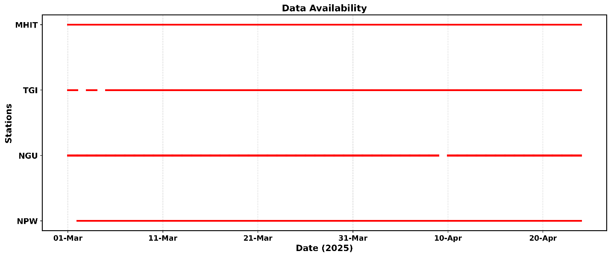

Figure S1: Seismic data availability for stations NPW, TGI, NGU, and MHIT.

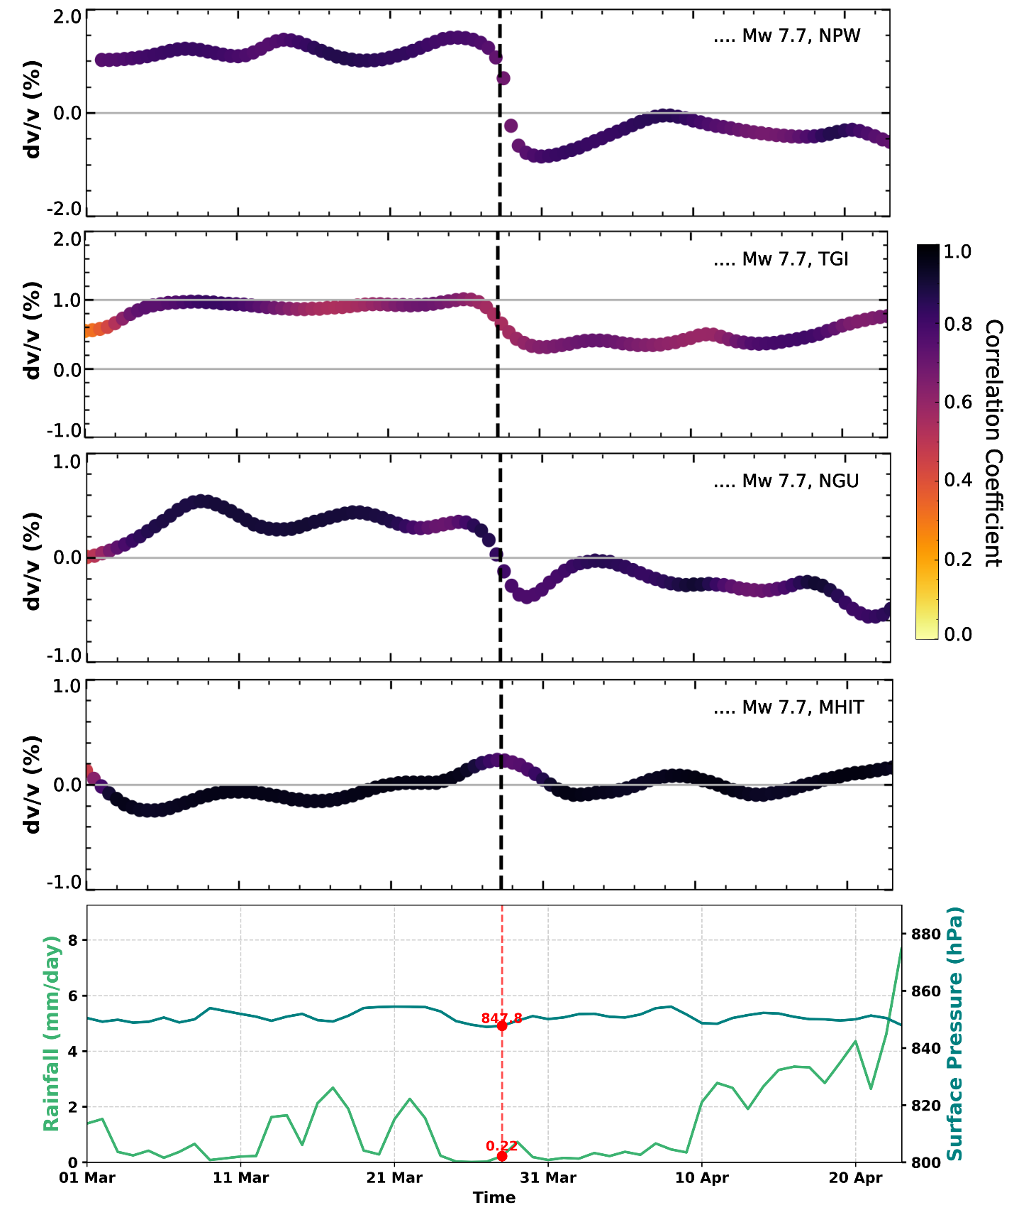

Figure S2: Time series of temporal dv/v (%) at four stations (NPW, TGI, NGU, and MHIT) are shown, with the vertical dashed line marking the occurrence of the Mw 7.7 earthquake. Color indicates the correlation coefficient of the measurements. The lower panel shows rainfall (mm/day) and surface pressure (hPa) over the same period.

