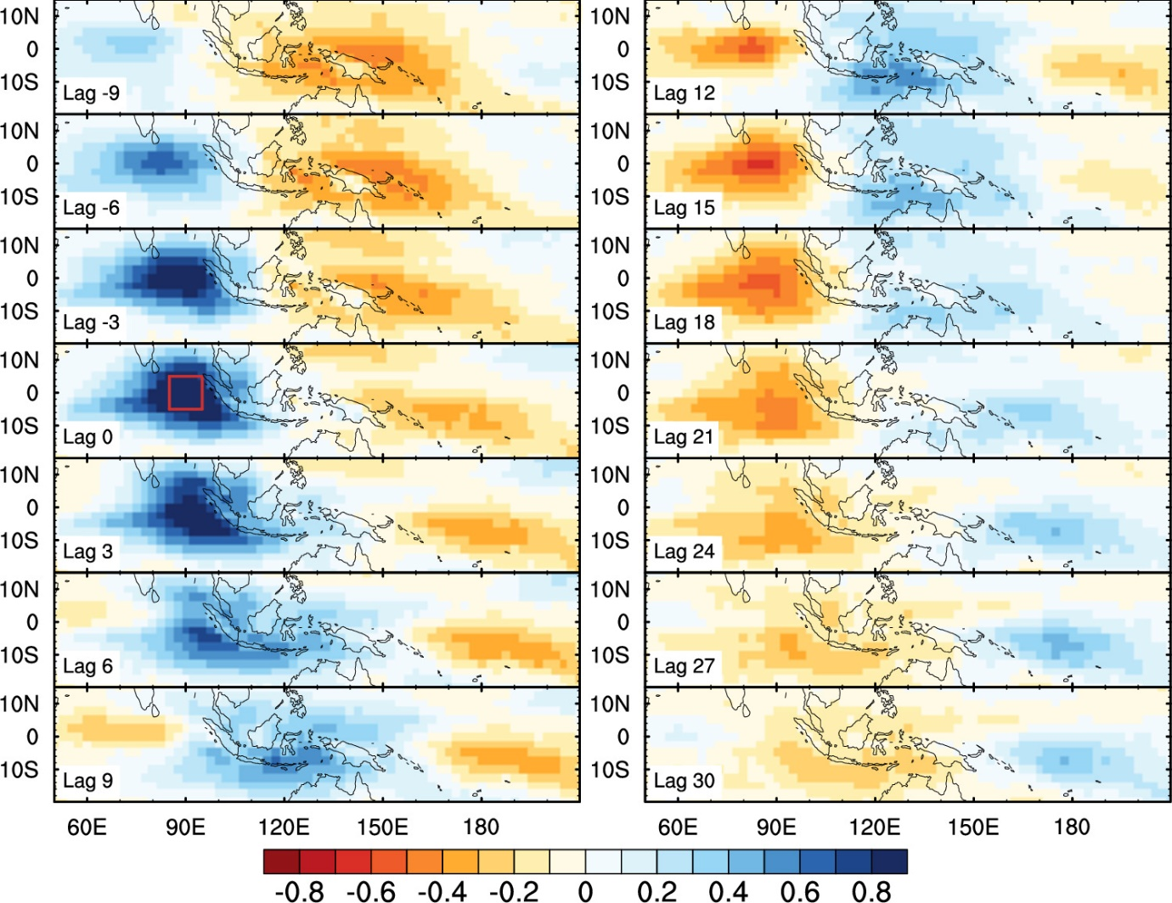
Supplementary Figure 1 Lag‐regression diagnostic for observational MJO propagation during boreal winter for the period of 1979–2018. Spatial distributions of lag-regression coefficients of 20–100-day bandpass-filtered OLR anomalies onto the area-averaged OLR anomalies over the reference IO (red square at lag 0; 5°S–5°N, 85–95°E) where the equatorial MJO convective envelopes initiate and propagate toward the WP.

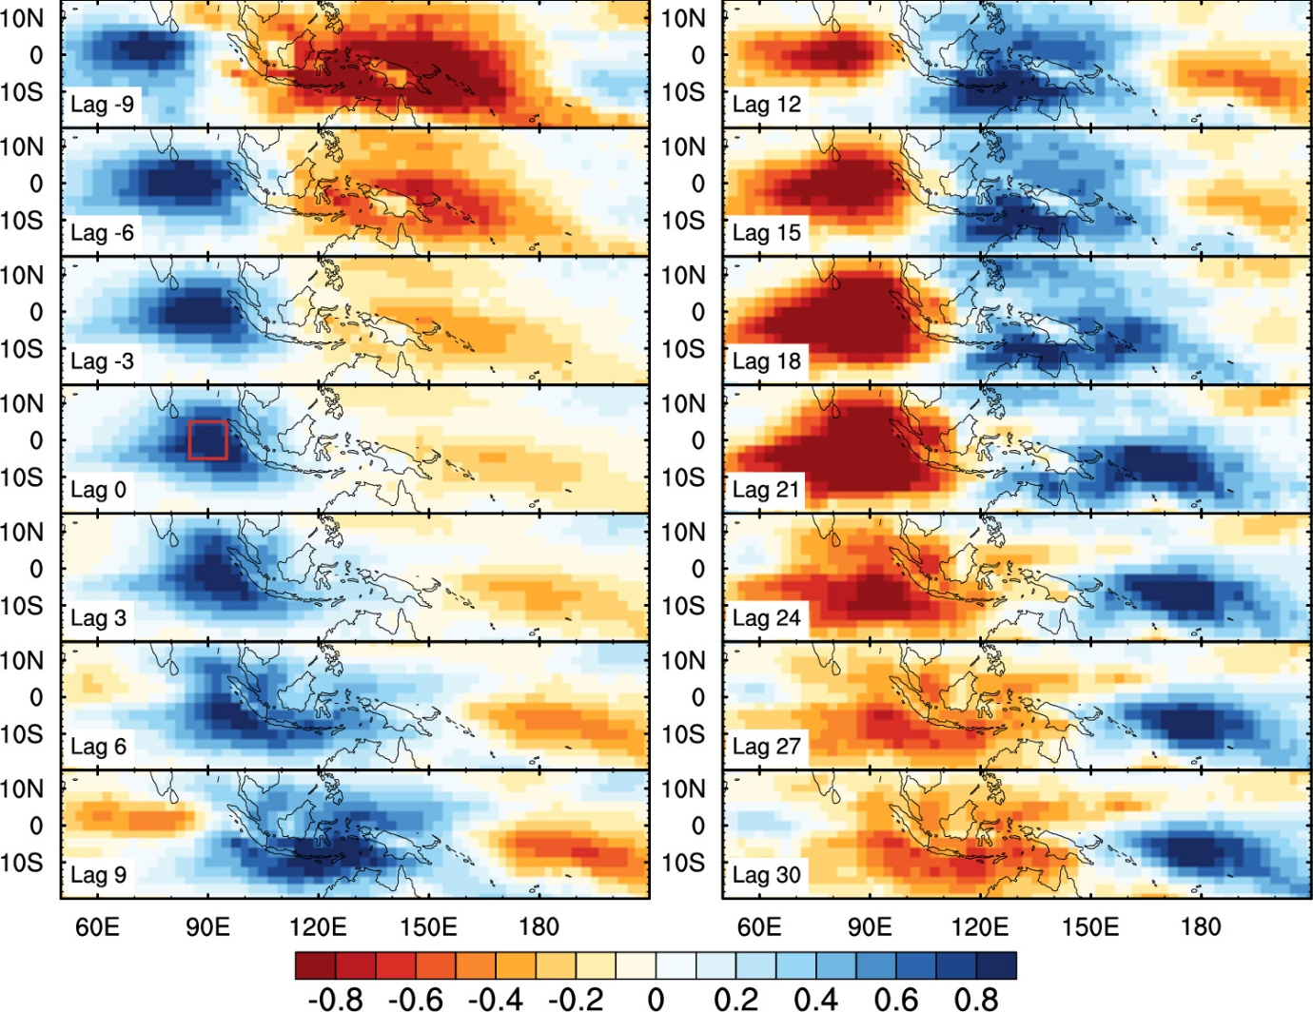
Supplementary Figure 2 Amplified MJO signal during boreal winter for the period of 1979–2018. Same as Supplementary Figure 1 except for the lag-regression coefficients normalized by the maximum value within the analysis domain (30°S–30°N, 50°E–150°W).
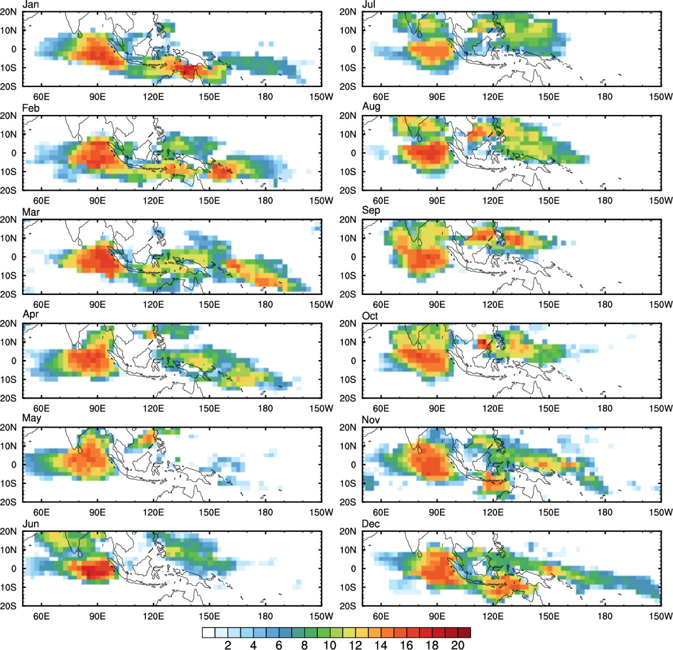
Supplementary Figure 3 Monthly observational pathways of MJO propagation. Spatial distributions of monthly lag-accumulated occurrences of MJO-related convection from 9-lead to 27-lag days during the period of 1979–2018.

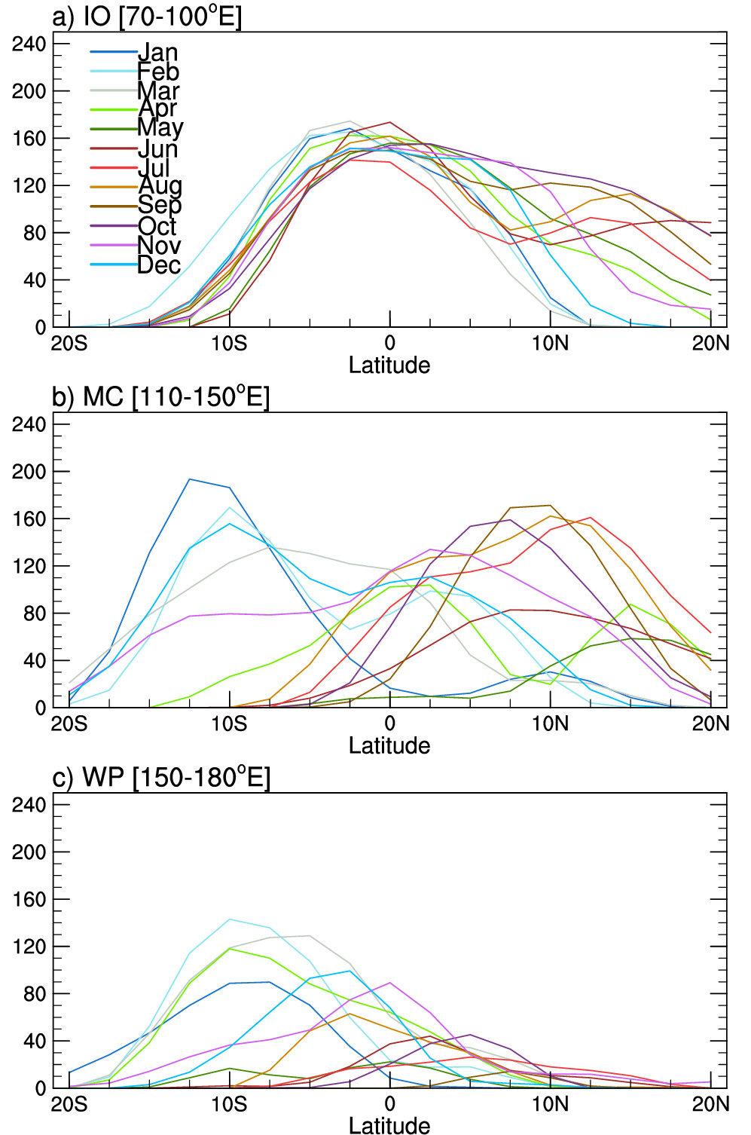
Supplementary Figure 4 Monthly latitudinal peaks of observational MJO-related convection over the IO, MC, and WP. Monthly lag-accumulated occurrences of MJO-related convection longitudinally integrated over the (a) IO (70–100°E), (b) MC (110–150°E), and (c) WP (150–180°E).

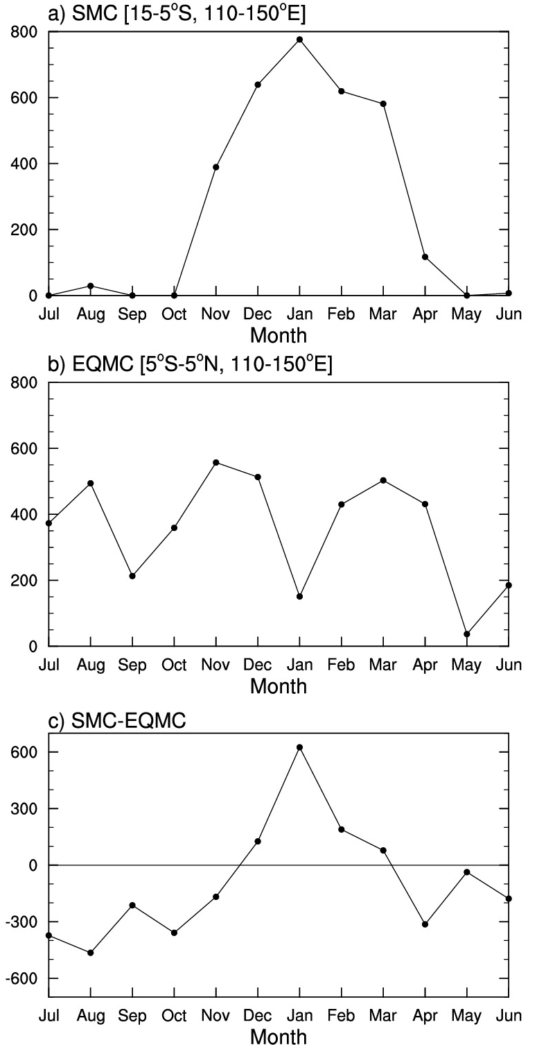
Supplementary Figure 5 Seasonality of observational MJO-related convection over the MC (110–150°E). Monthly lag-accumulated occurrences of MJO-related convection integrated over the (a) southern MC (SMC; 15–5°S, 110–150°E) and (b) equatorial MC (EQMC; 5°S–5°N, 110–150°E), and (c) their difference (SMC-EQMC) defined as the MC detour index.

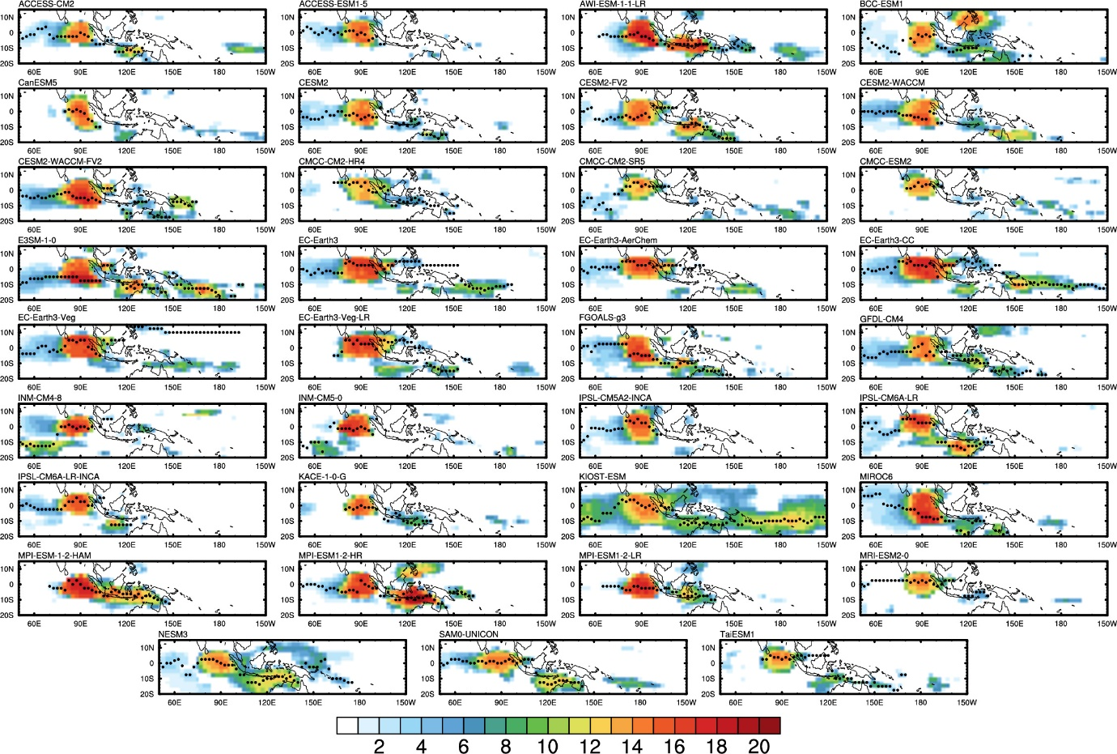
Supplementary Figure 6 MJO propagation behavior in the 35 CMIP6 historical simulations during boreal winter. Spatial distributions of lag-accumulated occurrences (shading) of MJO-related convection from 9-lead to 27-lag days with the latitudes (black dots) where the most frequent MJO-related convection occurs.
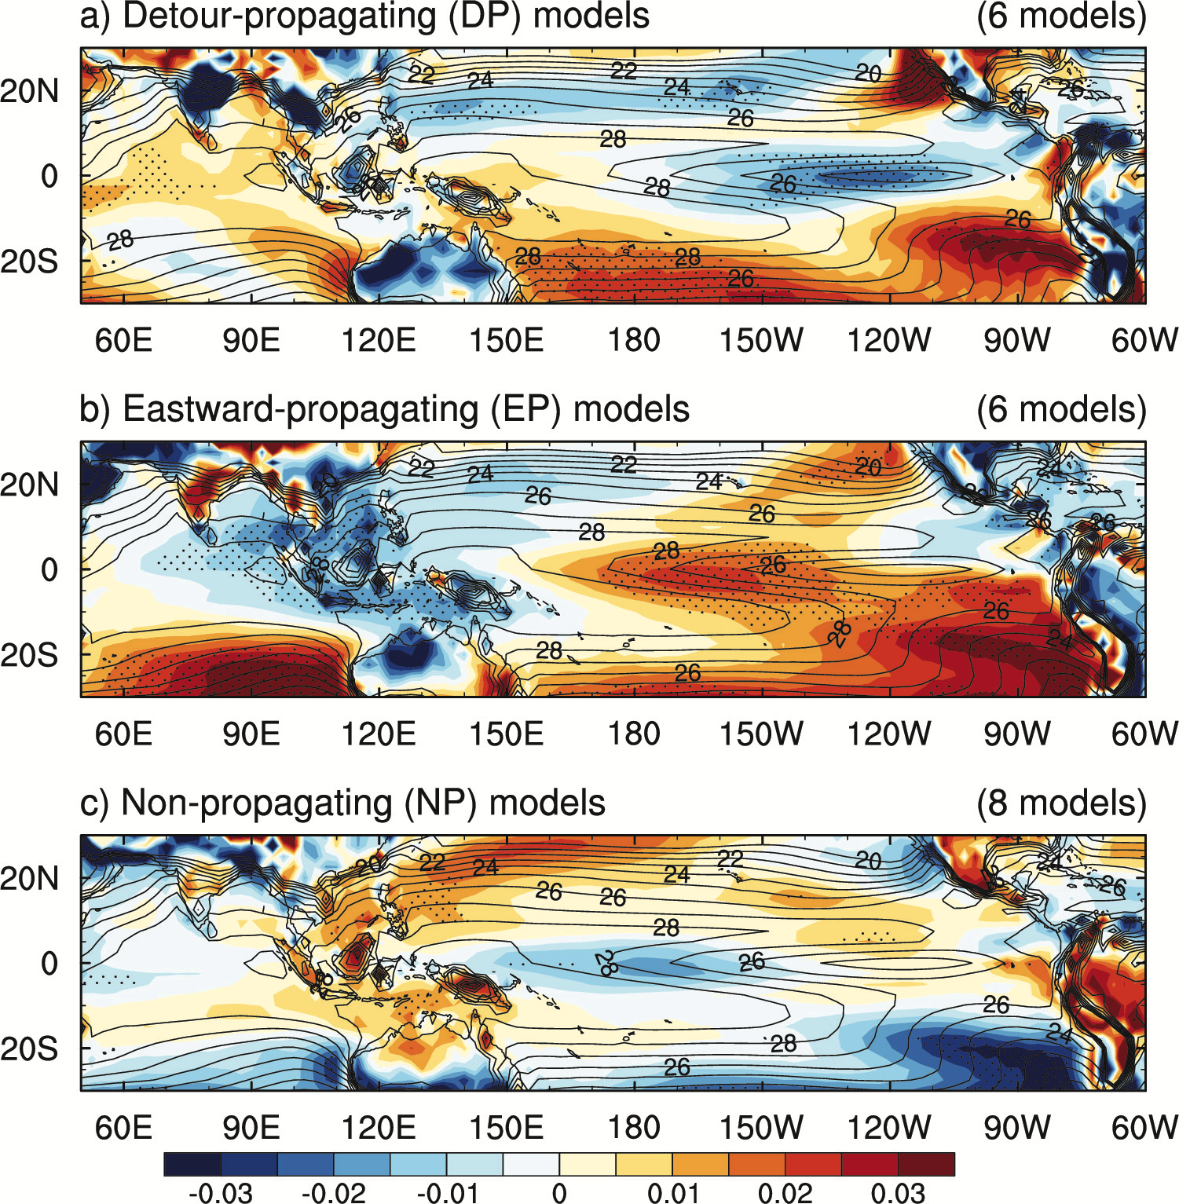
Supplementary Figure 7 Background fields of surface temperature anomalies from the CMIP6 MME based on the success of eastward propagation and southward detour. Composite maps of normalized surface temperature anomalies (shading) by the area-average over the tropical region (10°S–10°N, 40°E–80°W) in the (a) detour-propagating models (DP models; 6 models), (b) eastward-propagating models (EP models; 6 models), and (c) non-propagating models (NP models; 8 models). The contours indicate the 35 CMIP6 MME climatology of surface temperature. The dots denote the statistical significance at the 90% confidence level.

Table S1. CMIP6 models for histroical simulations (1975–2014) utilized in this study. The r1i1p1f1 ensemble member is used for all models. All model outputs are interpolated onto a common 2.5° × 2.5° grid prior to analysis.
No. | Model | Institution ID | Native nominal resolution
1 | ACCESS-CM2 | CSIRO-ARCCSS | 250 km
2 | ACCESS-ESM1-5 | CSIRO | 250 km
3 | AWI-ESM-1-1-LR | AWI | 250 km
4 | BCC-ESM1 | BCC | 250 km
5 | CanESM5 | CCCma | 500 km
6 | CESM2 | NCAR | 100 km
7 | CESM2-FV2 | NCAR | 250 km
8 | CESM2-WACCM | NCAR | 100 km
9 | CESM2-WACCM-FV2 | NCAR | 250 km
10 | CMCC-CM2-HR4 | CMCC | 100 km
11 | CMCC-CM2-SR5 | CMCC | 100 km
12 | CMCC-ESM2 | CMCC | 100 km
13 | E3SM-1-0 | E3SM-Project / LLNL / UCI / UCSB | 100 km
14 | EC-Earth3 | EC-Earth-Consortium | 100 km
15 | EC-Earth3-AerChem | EC-Earth-Consortium | 100 km
16 | EC-Earth3-CC | EC-Earth-Consortium | 100 km
17 | EC-Earth3-Veg | EC-Earth-Consortium | 100 km
18 | EC-Earth3-Veg-LR | EC-Earth-Consortium | 250 km
19 | FGOALS-g3 | CAS | 250 km
20 | GFDL-CM4 | NOAA-GFDL | 100 km
21 | INM-CM4-8 | INM | 100 km
22 | INM-CM5-0 | INM | 100 km
23 | IPSL-CM5A2-INCA | IPSL | 500 km
24 | IPSL-CM6A-LR | IPSL | 250 km
25 | IPSL-CM6A-LR-INCA | IPSL | 250 km
26 | KACE-1-0-G | NIMS-KMA | 250 km
27 | KIOST-ESM | KIOST | 250 km
28 | MIROC6 | MIROC | 250 km
29 | MPI-ESM-1-2-HAM | HAMMOZ-Consortium | 250 km
30 | MPI-ESM1-2-HR | MPI-M / DWD / DKRZ | 100 km
31 | MPI-ESM1-2-LR | MPI-M / AWI / DKRZ / DWD | 250 km
32 | MRI-ESM2-0 | MRI | 100 km
33 | NESM3 | NUIST | 250 km
34 | SAM0-UNICON | SNU | 100 km
35 | TaiESM1 | AS-RCEC | 100 km
Note: Model and resolution information is based on the CMIP6 Controlled Vocabularies maintained by WCRP-CMIP, particularly the CMIP6_source_id metadata (https://github.com/WCRP-CMIP/CMIP6_CVs; accessed 2 September 2026). Native nominal resolution refers to the atmospheric component of each model.

