Morphological and genetic variability of Vitellaria paradoxa C.F. Gaertn populations across a climate gradient in Benin (West Africa)

Genetic Resources and Crop Evolution
Borec Missinmahu Ignace GBEHOU^{1*}, Séverin Biaou¹, Thierry Dèhouégnon Houehanou^{1,3}, Georges Alex Agonvonon², Gérard Nounagnon Gouwakinnou^{1,3} Chinwe Ifejika Speranza²
¹Research Unit of Biodiversity Conservation at the Interface People, Land Use and Climate Change, Laboratory of Ecology, Botany and Plant Biology, University of Parakou, Benin
²Land Systems and Sustainable Land Management Unit, Institute of Geography, University of Bern, Bern, Switzerland
³Department of Natural Resources Management, Faculty of Agronomy, University of Parakou, Republic of Benin
Online Resource 1 Populations and geographic location parameters of shea tree individuals sampled in this study
Climate zones | Populations | Number of trees sampled | GPS coordinates | Total number of leaves collected
ZS | Pehunco | 10 | 10.28447 N  1.681184 E | 432
ZS | Boukoumbé | 10 | 10.25684 N  1.268399 E | 432
ZS | Tanguiéta | 10 | 10.4739528 N  1.0294053 E | 432
ZS | Matéri | 10 | 10.7238213 N  1.1786888 E | 432
ZS | Banikoara | 10 | 11.038083 N  2.220101 E | 432
ZS | Malanville | 10 | 11.7465012 N  3.2832363 E | 432
ZS | Karimama | 08 | 12.077842 N  3.1768271 E | 432
ZS | Sègbana | 10 | 10.9313177 N  3.5343283 E | 432
ZS | Kandi | 10 | 10.8495738 N  2.8104667 E | 432
ZS | Bembèrèkè | 10 | 10.2974845 N  2.7002532 E | 432
ZS | Kalalé | 10 | 9.8410533 N  2.9854667 E | 432
ZSG | Dassa | 10 | 7.820244 N  2.2435483 E | 240
ZSG | Savalou | 10 | 8.0386372 N  1.9821975 E | 240
ZSG | Bassila | 10 | 8.987595 N  1.68806 E | 240
ZSG | Djougou | 10 | 9.7675382 N  1.5940571 E | 240
ZSG | Parakou | 10 | 9.3212417 N  2.6827427 E | 240
ZSG | Savè | 10 | 8.0064165 N  2.4267618 E | 240
ZG | Kétou | 10 | 7.471523 N  2.5026966 E | 80
ZG | Djidja | 10 | 7.370012 N  1.911123 E | 80
Total | 19 | 188 | - | 752
SZ = Sudanian zone; SGZ = Sudano-Guinean zone; GZ = Guinean zone

Online Resource 2 Codes and names of the climatic and environmental variables used
Codes | Signification | Codes | Signification
bio 1 | Average annual temperature | bio 12 | Total annual precipitation
bio 2 | Average daily temperature range | bio 13 | Precipitation in the wettest month
bio 5 | Maximum temperature of the hottest month | Soil | Soil
bio 6 | Minimum temperature of the coldest month | Elev | Elevation

MFT | Overall values | SZ | SGZ | GZ | Overall p-value
Mean (Standard deviation)
Leaf morphology
LL | 16.70(3.28) | 16.39(3.29) ª | 16.94(3.21) ^{b} | 17.57(3.25) ^{b} | <0.01**
LW | 6.32(1.31) | 6.22(1.30) ª | 6.49(1.33) ^{ab} | 6.33(1.25) ª | 0.02*
PEL | 6.37(1.52) | 6.17(1.47) ª | 6.42(1.40) ^{b} | 7.28(1.79) ^{c} | <0.001***
Functional traits
LM | 1.00(0.42) | 0.97(0.41) ª | 1.05(0.44) ª | 1.02(0.43) ª | 0.04*
LA | 26.57(11.27) | 26.26(11.76) ª | 26.78(10.23) ª | 27.61(11 .63) ª | 0.10
SLA | 28.31(11.10) | 28.23(9.55) ª | 27.59(11.46) ª | 30.91(16.34) ª | 0.14
LMA | 0.04(0.06) | 0.04(0.05) ª | 0.04(0.07) ª | 0.04 (0.01) ª | 0.11
AGB | 547.90(366.61) | 709.27(377.59) ª | 355.42(216.56) ^{b} | 253.99(135.37) ^{b} | <0.001***
Online Resource 3 Descriptive analysis and significance of morphological and functional traits by climate zone

MFT = morphological and functional traits; SZ = Sudanian zone; SGZ = Sudano-Guinean zone; GZ = Guinean zone; LL = leaf length (cm); LW = leaf width (cm); PEL = petiole length (cm); LM = leaf mass (g); LA = Leaf area (cm²); SLA = Specific leaf area (cm²/g); LMA = leaf mass per area (g/cm²); AGB = Above-ground biomass (kg/tree)

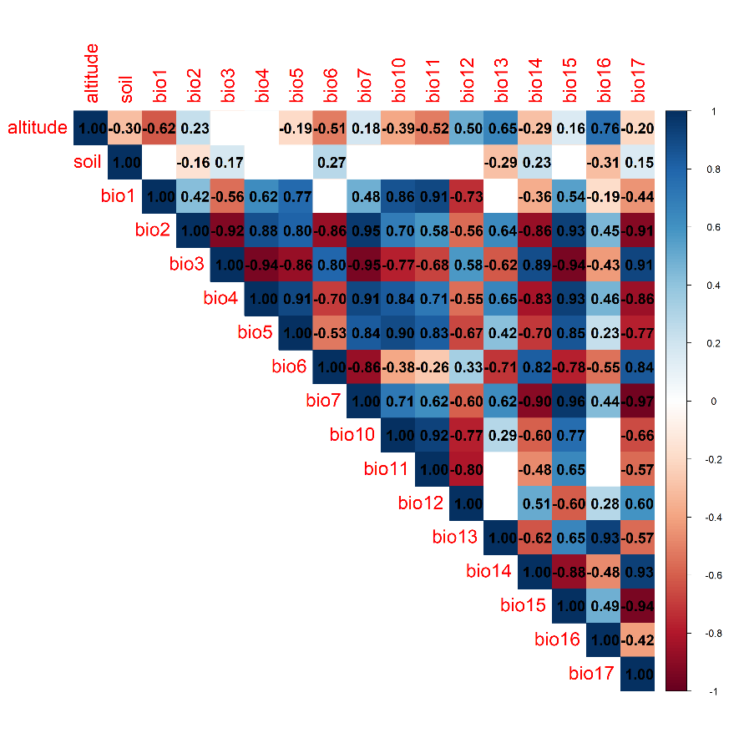

Online Resource 4 Spearman correlation matrix showing the relationship between climate and environmental variables with values closest to 1 indicating a strong positive correlation, of -1 indicating a strong negative correlation and 0 indicating no strong correlation between variables

