Supplemental Material
Supporting Figures, Tables, and Descriptive Statistics
This supplemental material includes tables and figures showing relevant survey questions, distributions of the variables used in the analyses, descriptive statistics of the sociodemographic and weight status variables, prevalence of food noise by number of items endorsed, scree plot after the factor analysis, and the results of the logistic regression examining correlates of food noise for each of its three operational criteria.
Survey questions related to food noise and GLP-1 use:

FOOD NOISE ITEMS
Please answer these questions by reflecting on your thoughts over the last 2 weeks.

GRID ITEMS:
- I find myself constantly thinking about food throughout the day.
- My thoughts about food feel uncontrollable.
- I spend too much time thinking about food.
- My thoughts about food have negative effects on me and/or my life.
- My thoughts about food distract me from what I need to do.

RESPONSE OPTIONS:
- Strongly disagree
- Disagree
- Neither agree nor disagree
- Agree
- Strongly agree

Are you currently taking any GLP-1 medications (e.g., Ozempic, Wegovy, Zepbound)?
RESPONSE OPTIONS
- Yes
- No

Table S1. Weighted descriptive statistics of the sociodemographic and weight status variables

Descriptive statistics | Fall 2025 Wave  N = 3,646
 | % | N
Age
18-29 | 11.39 | 415
30-44 | 34.79 | 1,269
45-59 | 23.73 | 865
60+ | 30.09 | 1,097
Gender
Male | 46.10 | 1,681
Female | 53.90 | 1,965
Ethnicity
Whites | 63.24 | 2,306
Black | 11.97 | 436
Other/2+races | 8.33 | 304
Hispanic | 16.46 | 600
Education
No high school diploma | 3.86 | 141
High school graduate | 28.60 | 1,043
Some college | 30.52 | 1,113
Bachelor’s degree or higher | 37.02 | 1,349
Income*
<$30,000 | 21.97 | 801
$30,000 - $59,999 | 23.73 | 865
$60,000 - $99,999 | 25.62 | 934
>$100,000 | 28.68 | 1,046
Prior mental health
Underweight | 1.71 | 62
Normal weight | 26.88 | 976
Overweight | 30.90 | 1,122
Obesity class I | 19.18 | 696
Obesity class II | 9.49 | 345
Obesity class III | 11.83 | 430

Table S2. Prevalence of food noise by # of items endorsed
Population | Criterion 0.1 | Criterion 0.2 | Criterion 1 | Criterion 2
# of items endorsed as agree or higher | 1 | 2 | 3 | 4
U.S. adults | 24.98% | 14.71% | 9.46% | 6.12%
Adults with obesity | 31.80% | 20.16% | 13.67% | 9.86%
Adults without obesity | 20.17% | 10.70% | 6.40% | 3.46%

Figure S1. Histograms of different food noise items

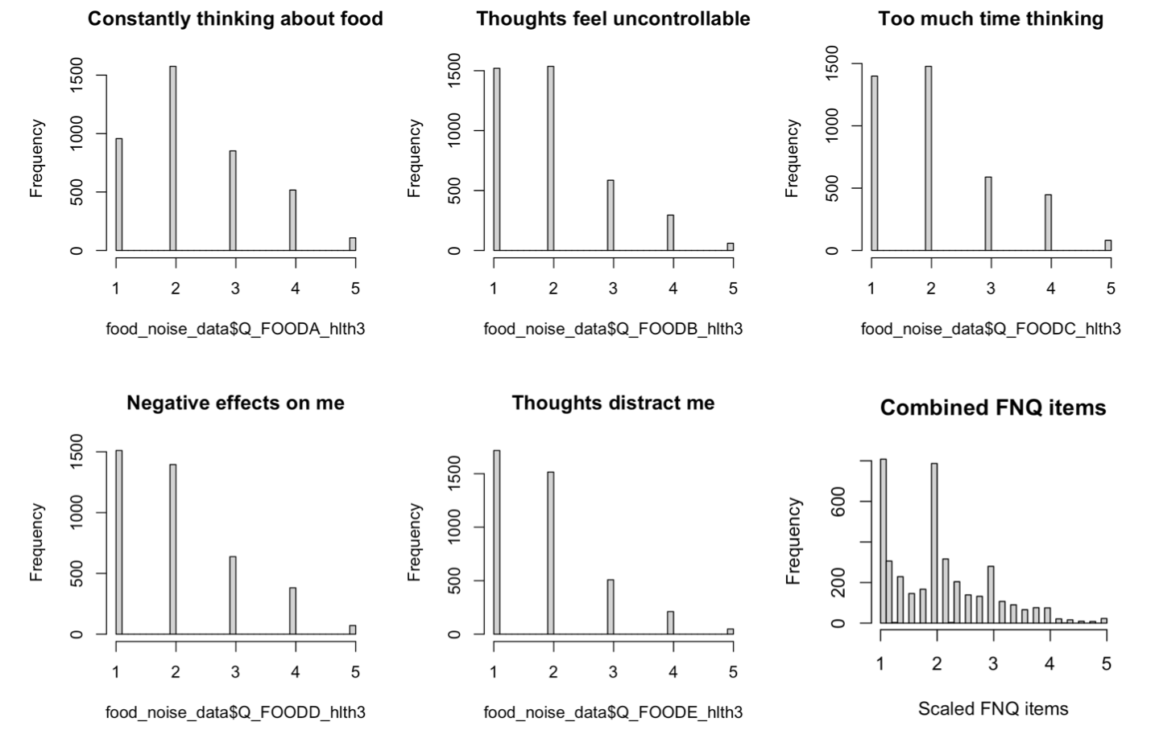

Figure S2. Likert plot of all food noise items

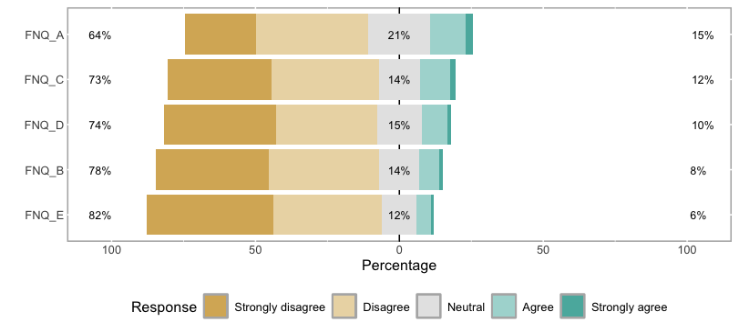

Figure S3. Likert plot of all food noise items by gender

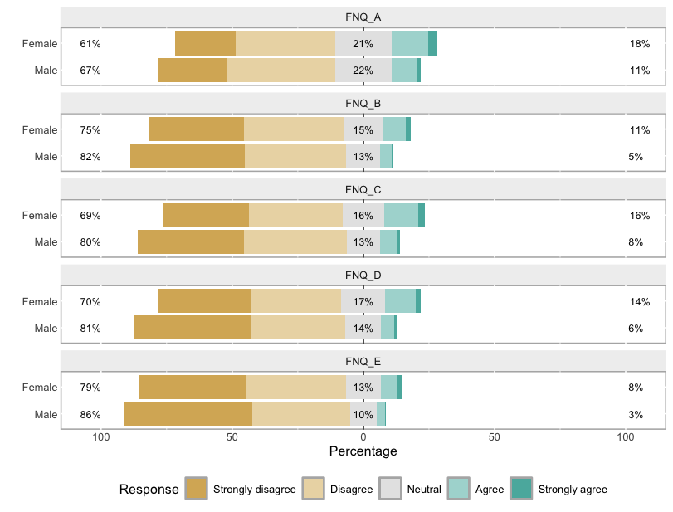

Figure S4. Histograms of different food noise items by gender

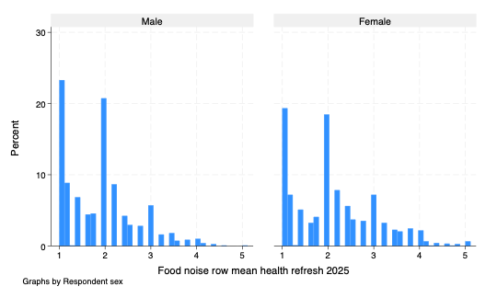

Figure S5. Likert plot of all food noise items by age

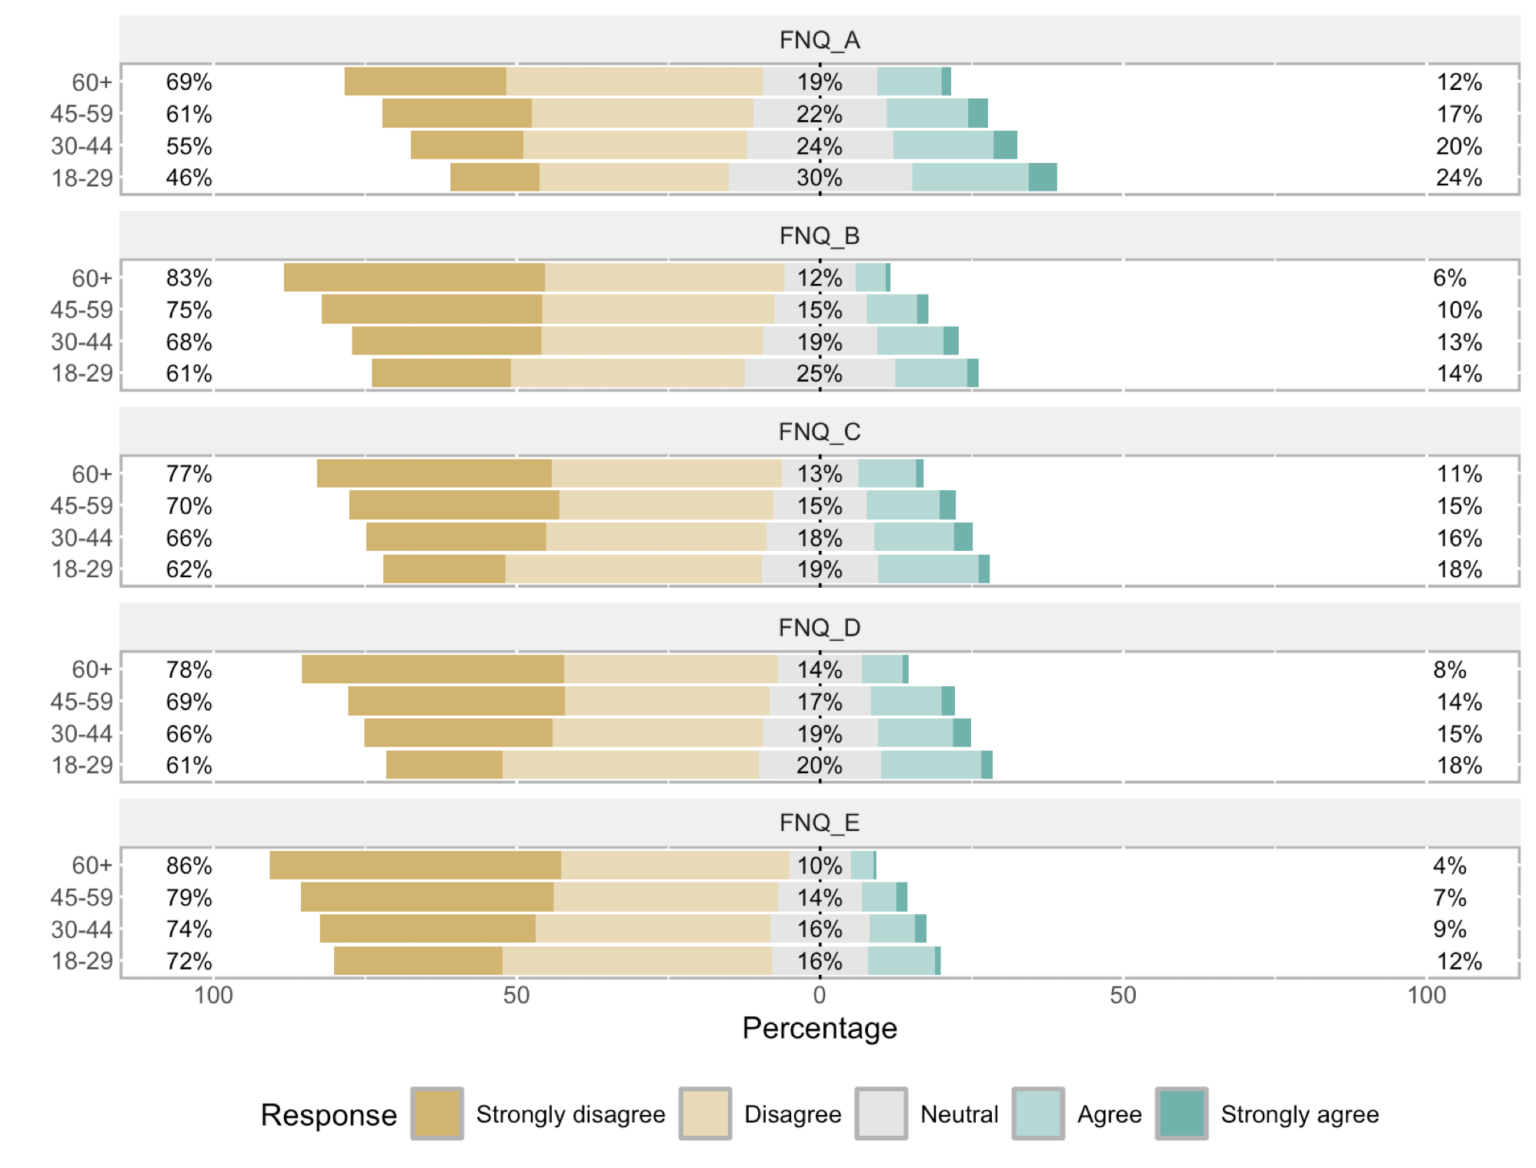

Figure S6. Histograms of different food noise items by age

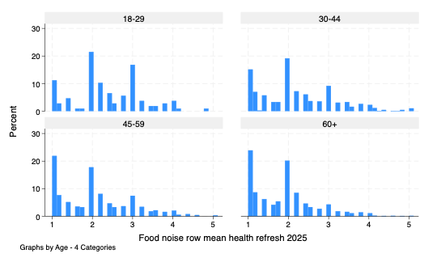

Figure S7. Likert plot of all food noise items by race/ethnicity

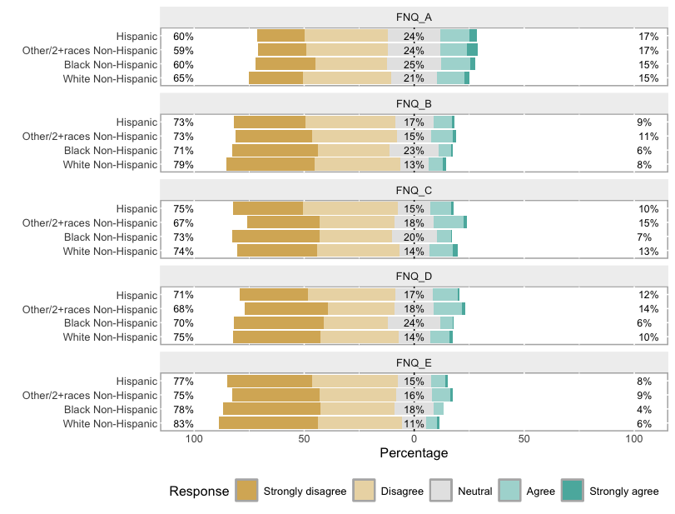

Figure S8. Histograms of different food noise items by race/ethnicity

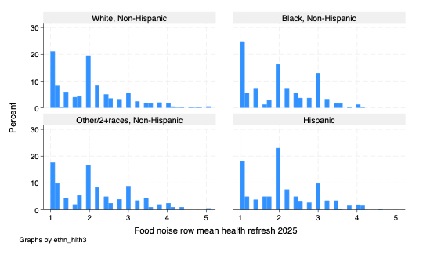

Figure S9. Likert plot of all food noise items by education

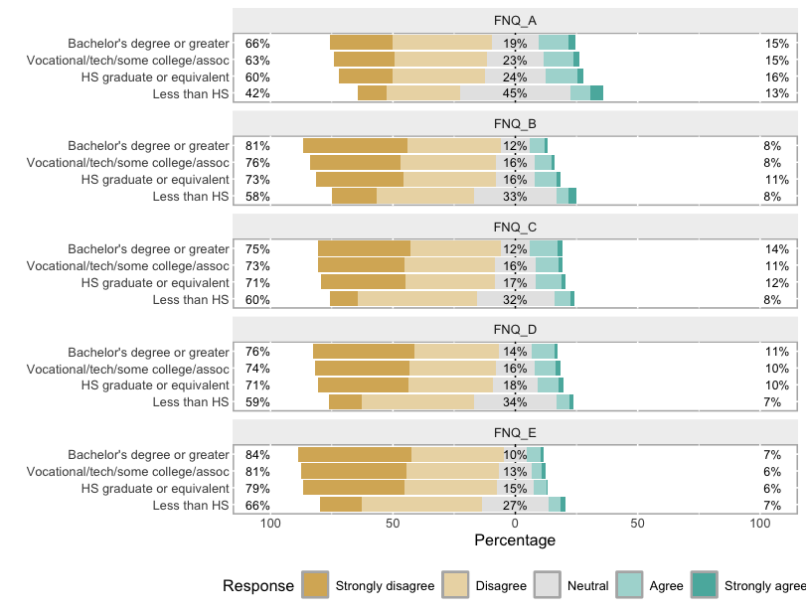

Figure S10. Histograms of different food noise items by education

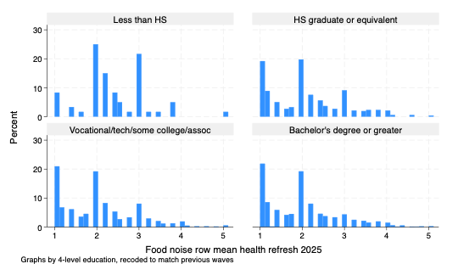

Figure S11. Bartless plot for the EFA analysis
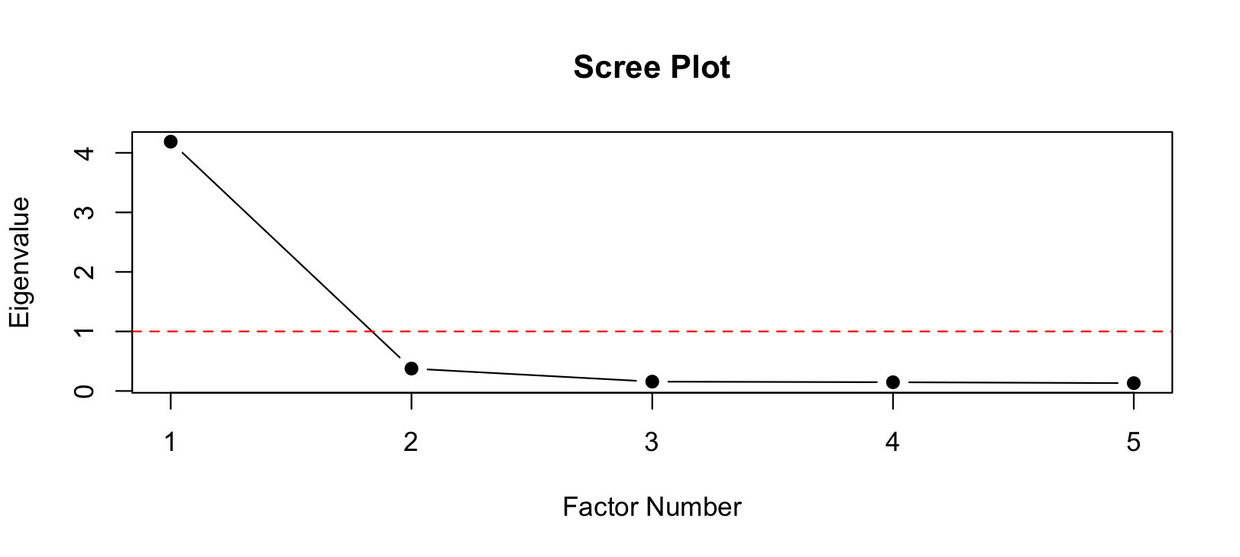
Figure S12. Distribution of mean food noise scores (1-5)

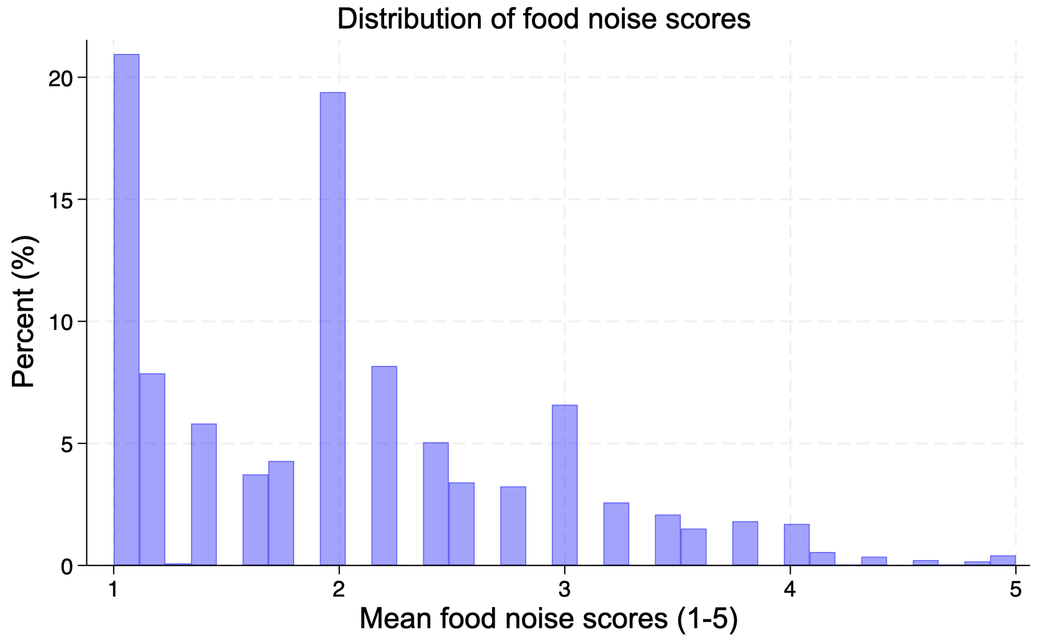

Figure S13. Results of the logistic regression examining correlates of food noise for each of its three operational criteria.
