SUPPLEMENTARY MATERIAL
1 - Charge change | 2 - Polarity change | 3 - Aromatic change | 4 - No change
D405N | E484A | F490S | S477N
E484K | G446S | F486P | V445P
K417N | G496S | N501Y | -
K417T | G339D | S375F | -
N440K | G339H | S371F | -
N460K | L452R | Y505H | -
R408S | S371L | - | -
Q493R | S373P | - | -
Q498R | - | - | -
T478K | - | - | -
T487K | - | - | -

Table S1 Class labels assigned to the mutant and wild-type (WT) systems. Mutants and the WT were classified according to the type of amino acid substitution based on the physicochemical properties of the substituted side chains
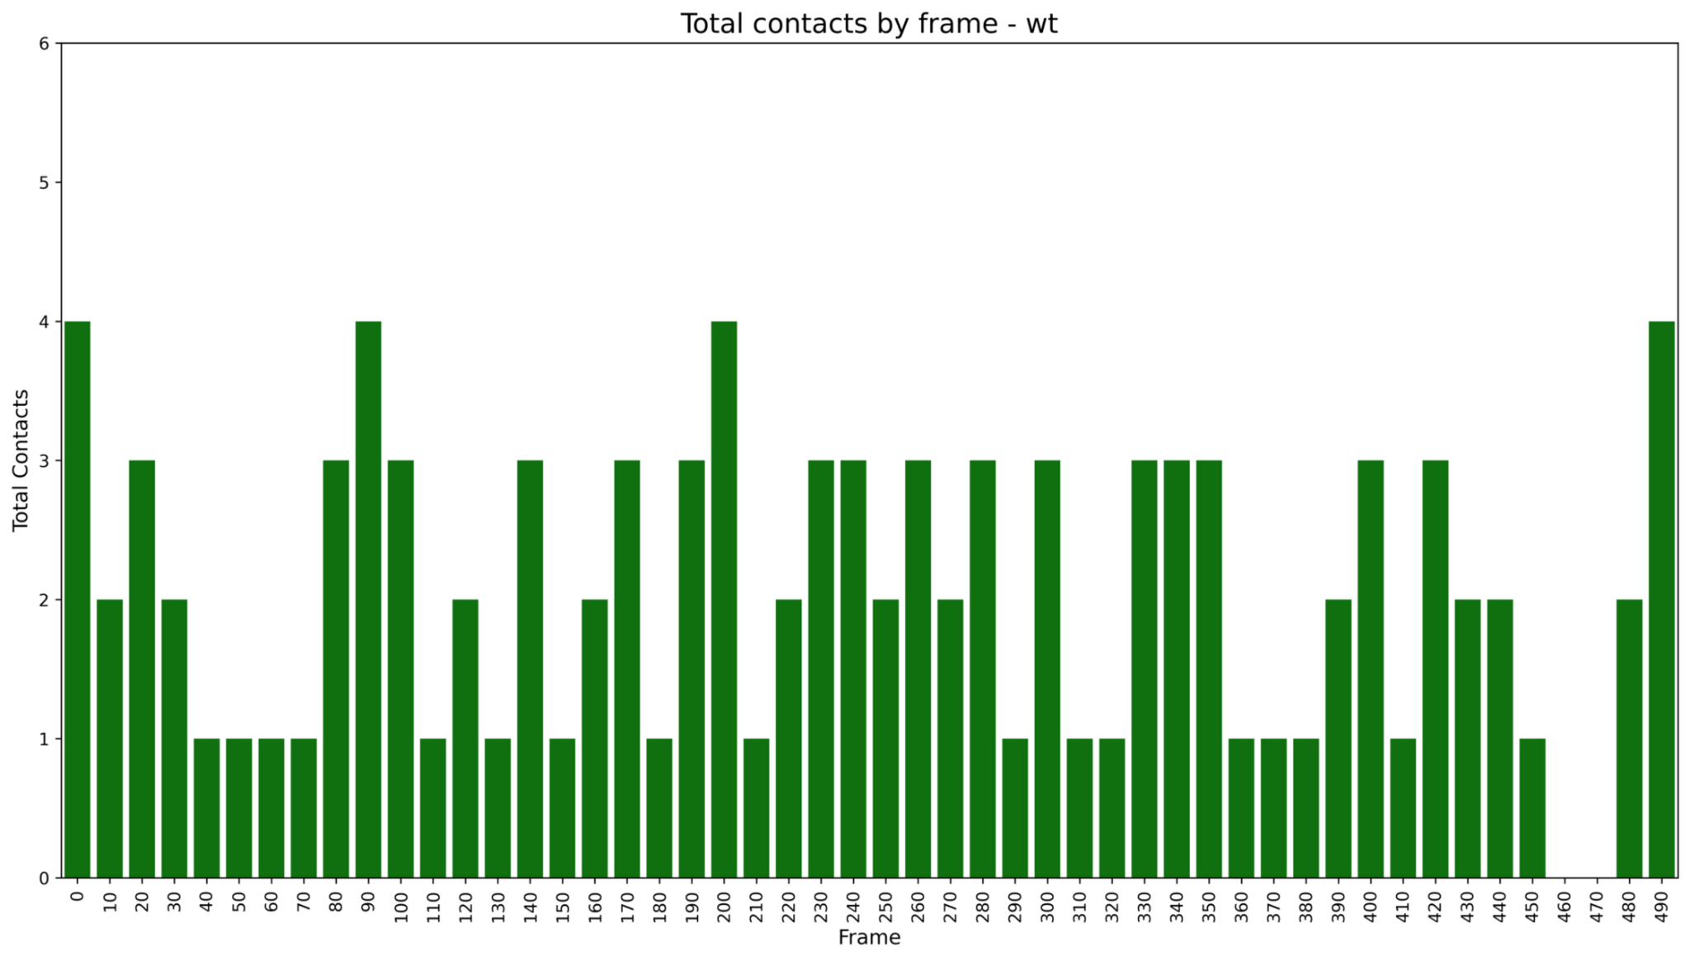Figure S1 Total contacts during the 50 ns trajectory, sampled every 10 frames, for the Wild-Type (WT) system. The WT exhibited fluctuations in the number of contacts throughout the trajectory, including a reduction near the end of the simulation

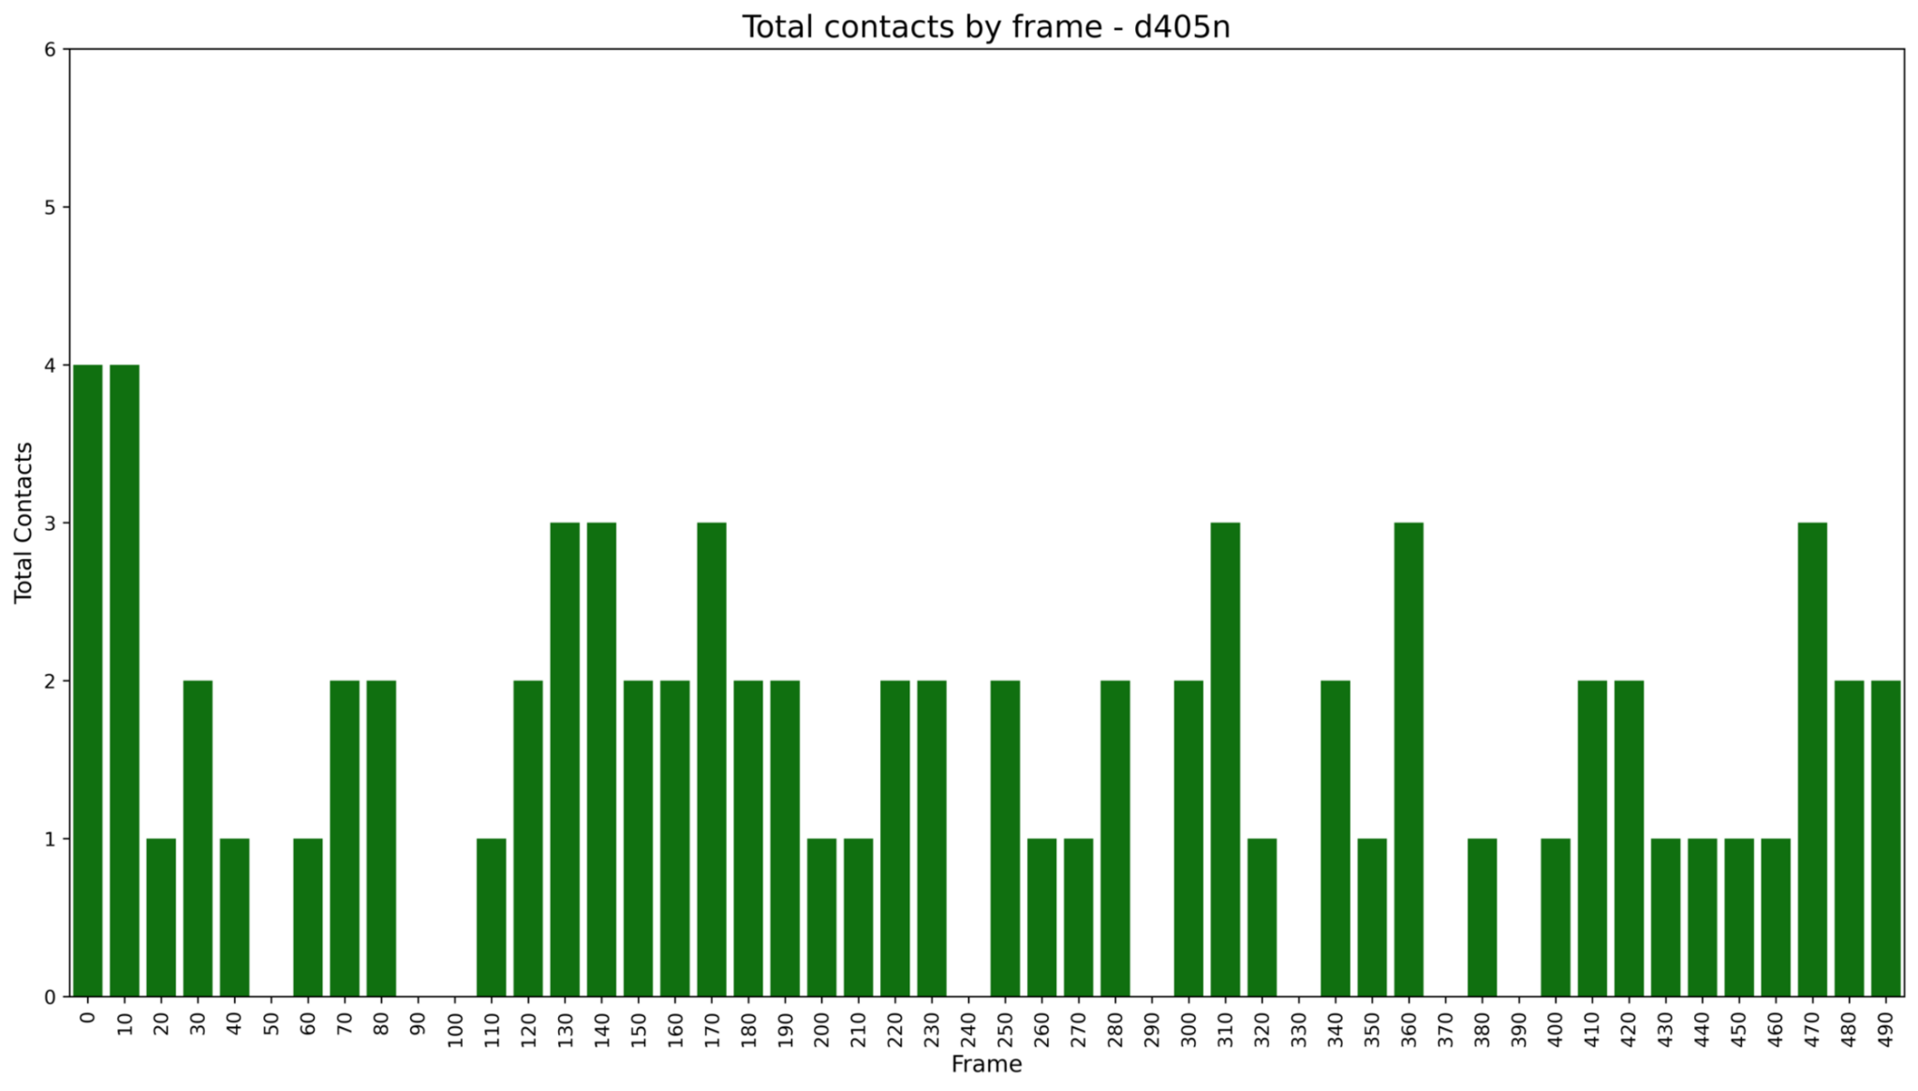Figure S2 Total contacts during the 50 ns trajectory, sampled every 10 frames, for the D405N mutant. Compared with the WT, D405N exhibited fewer contacts and lower variability throughout the trajectory

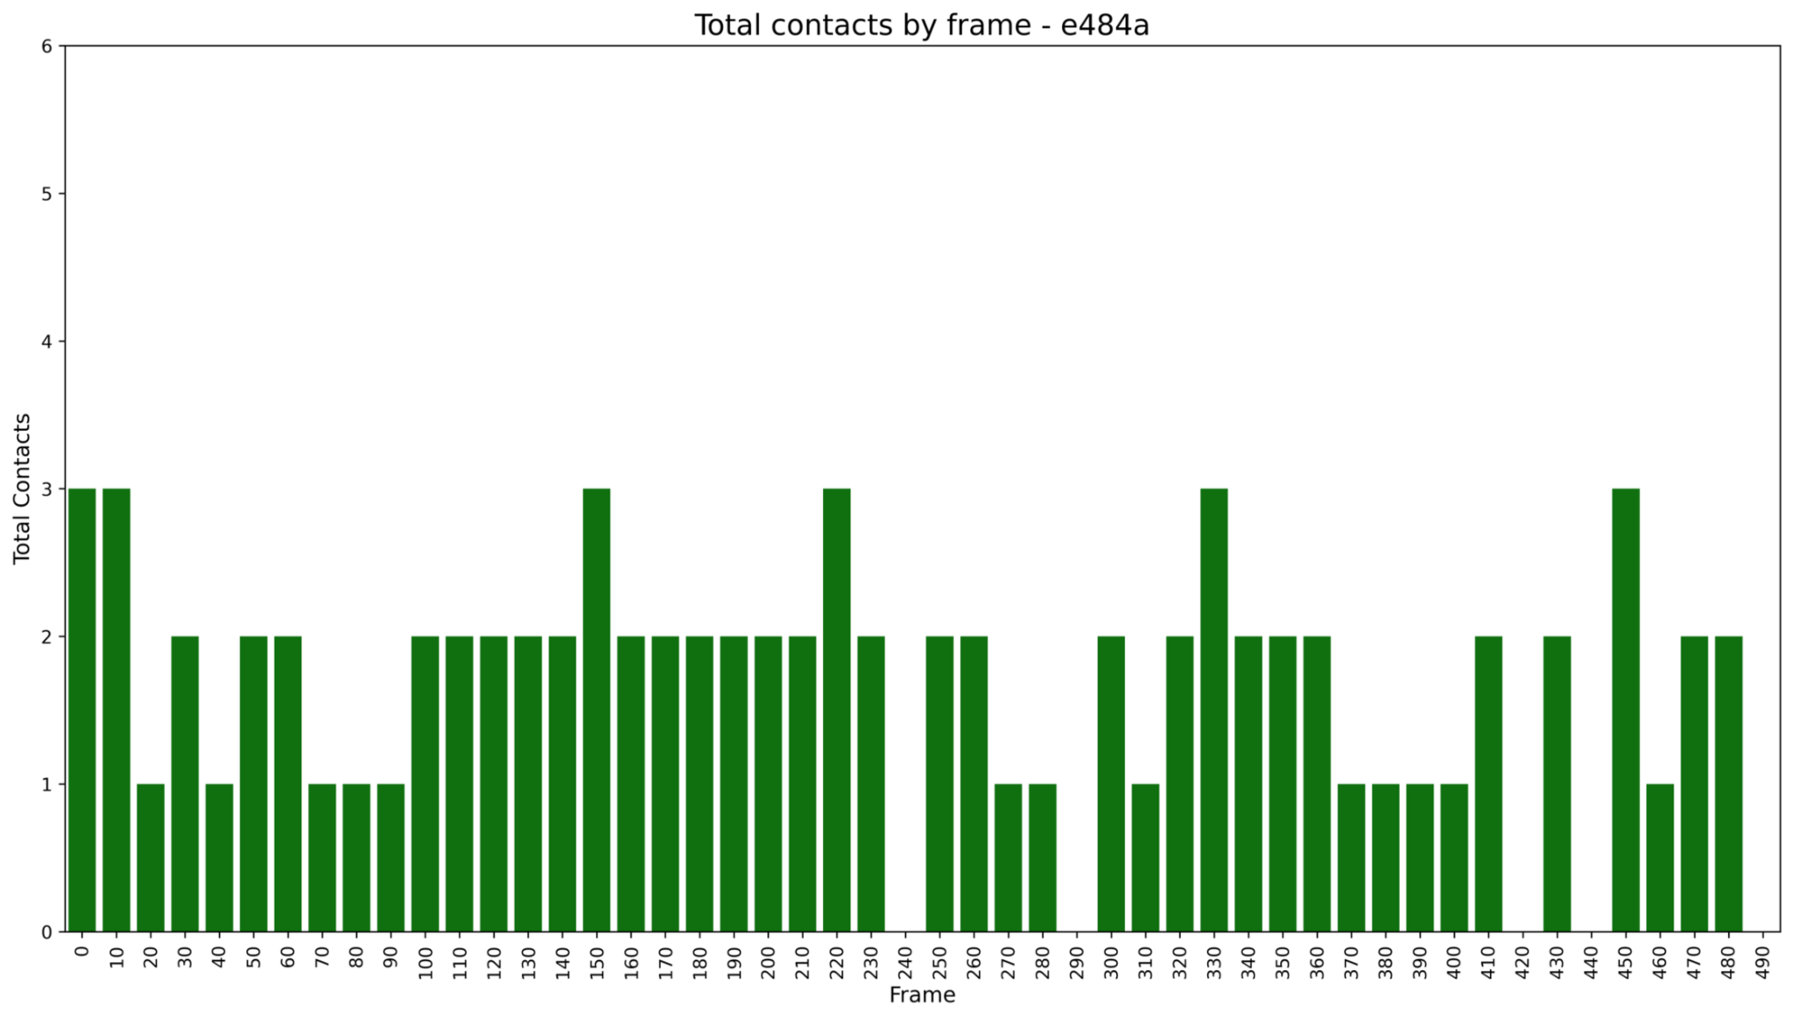Figure S3 Total contacts during the 50 ns trajectory, sampled every 10 frames, for the E484A mutant. E484A exhibited brief contact-free intervals (<1 ns) at multiple time points but maintained low overall variability, with at least two contacts for approximately 13 ns Near the end of the trajectory, contacts persisted for ~2 ns before being lost during the final frames

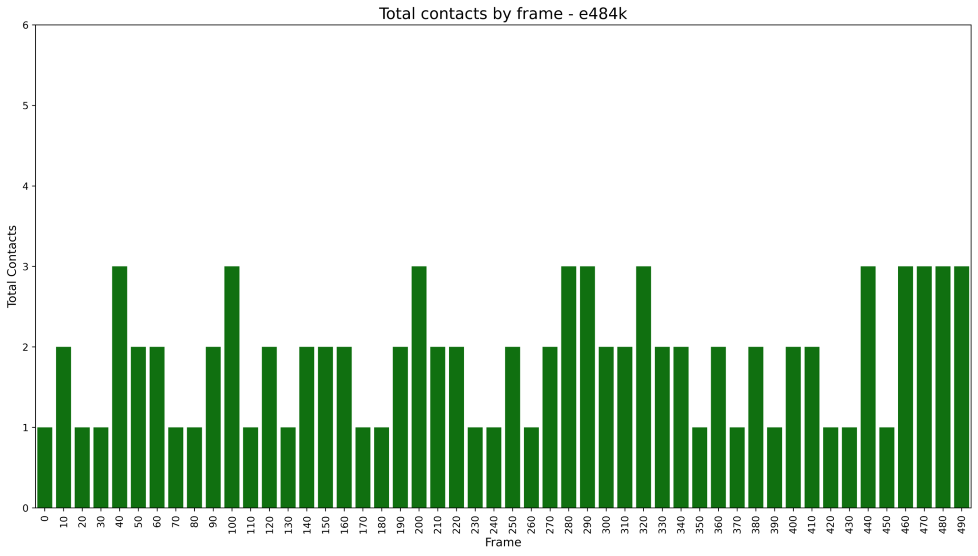Figure S4 Total contacts during the 50 ns trajectory, sampled every 10 frames, for the E484K mutant. Compared with the WT, E484K eliminated the contact-free interval by maintaining three contacts for ~3 ns The mutant also exhibited lower variability throughout most of the trajectory, maintaining at least two contacts at several time points, although contact losses were still observed, but without contact-free interval

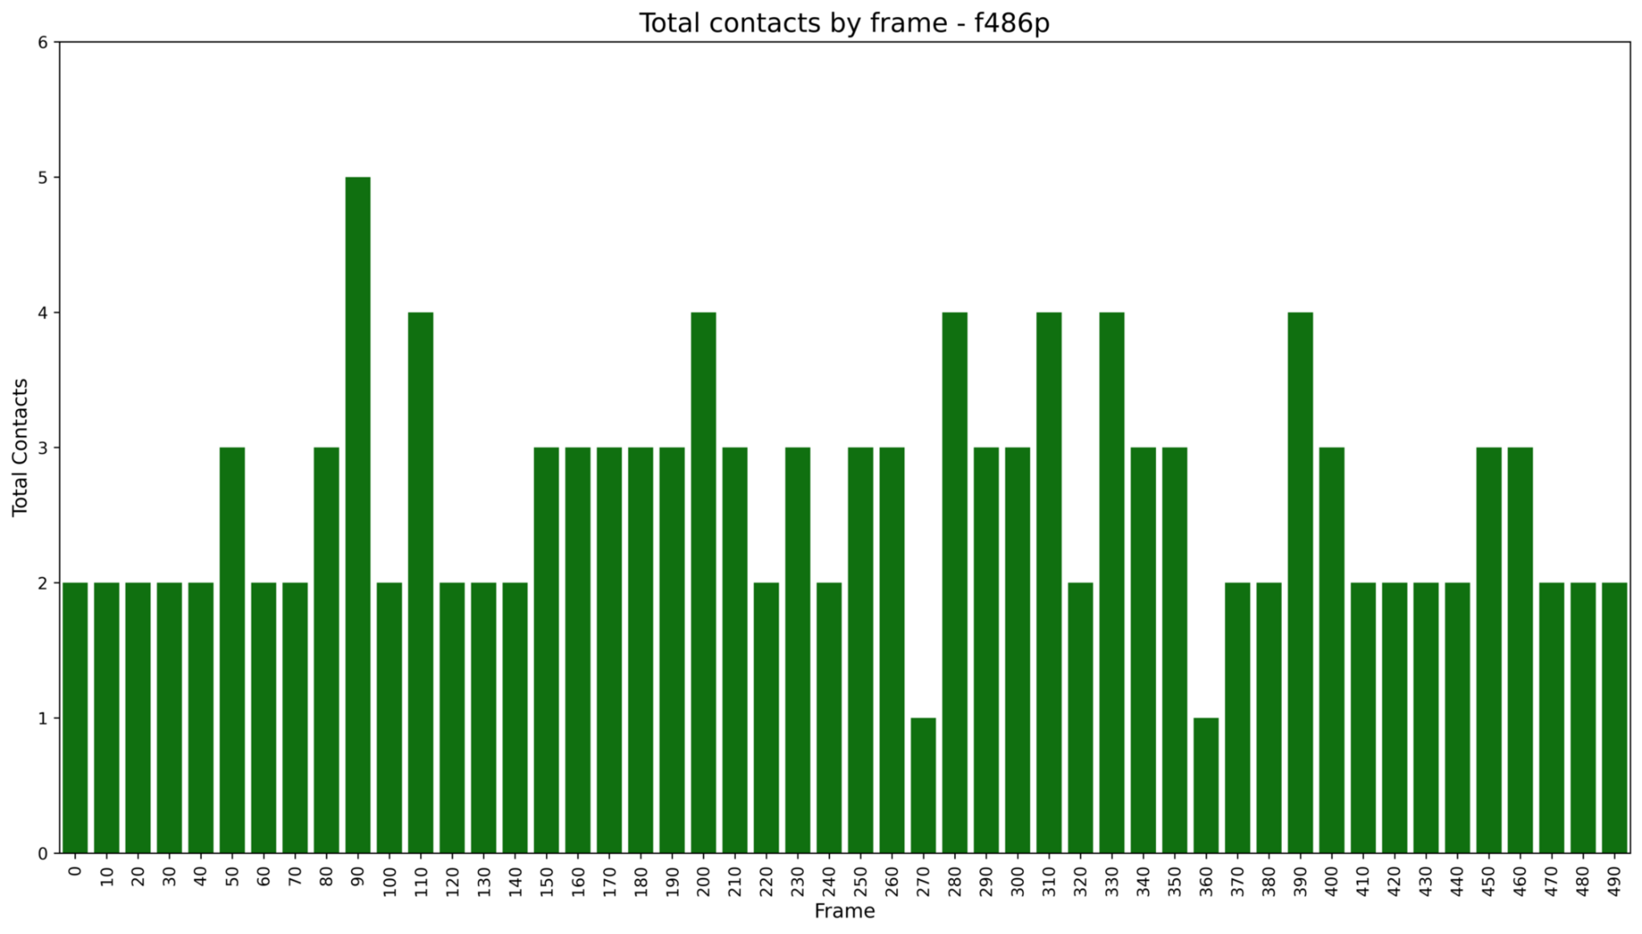
Figure S5 Total contacts during the 50 ns trajectory, sampled every 10 frames, for the F486P mutant. F486P exhibited a longer residence time of multiple contacts, maintaining at least two contacts throughout the trajectory and eliminating the contact-free interval observed in the WT

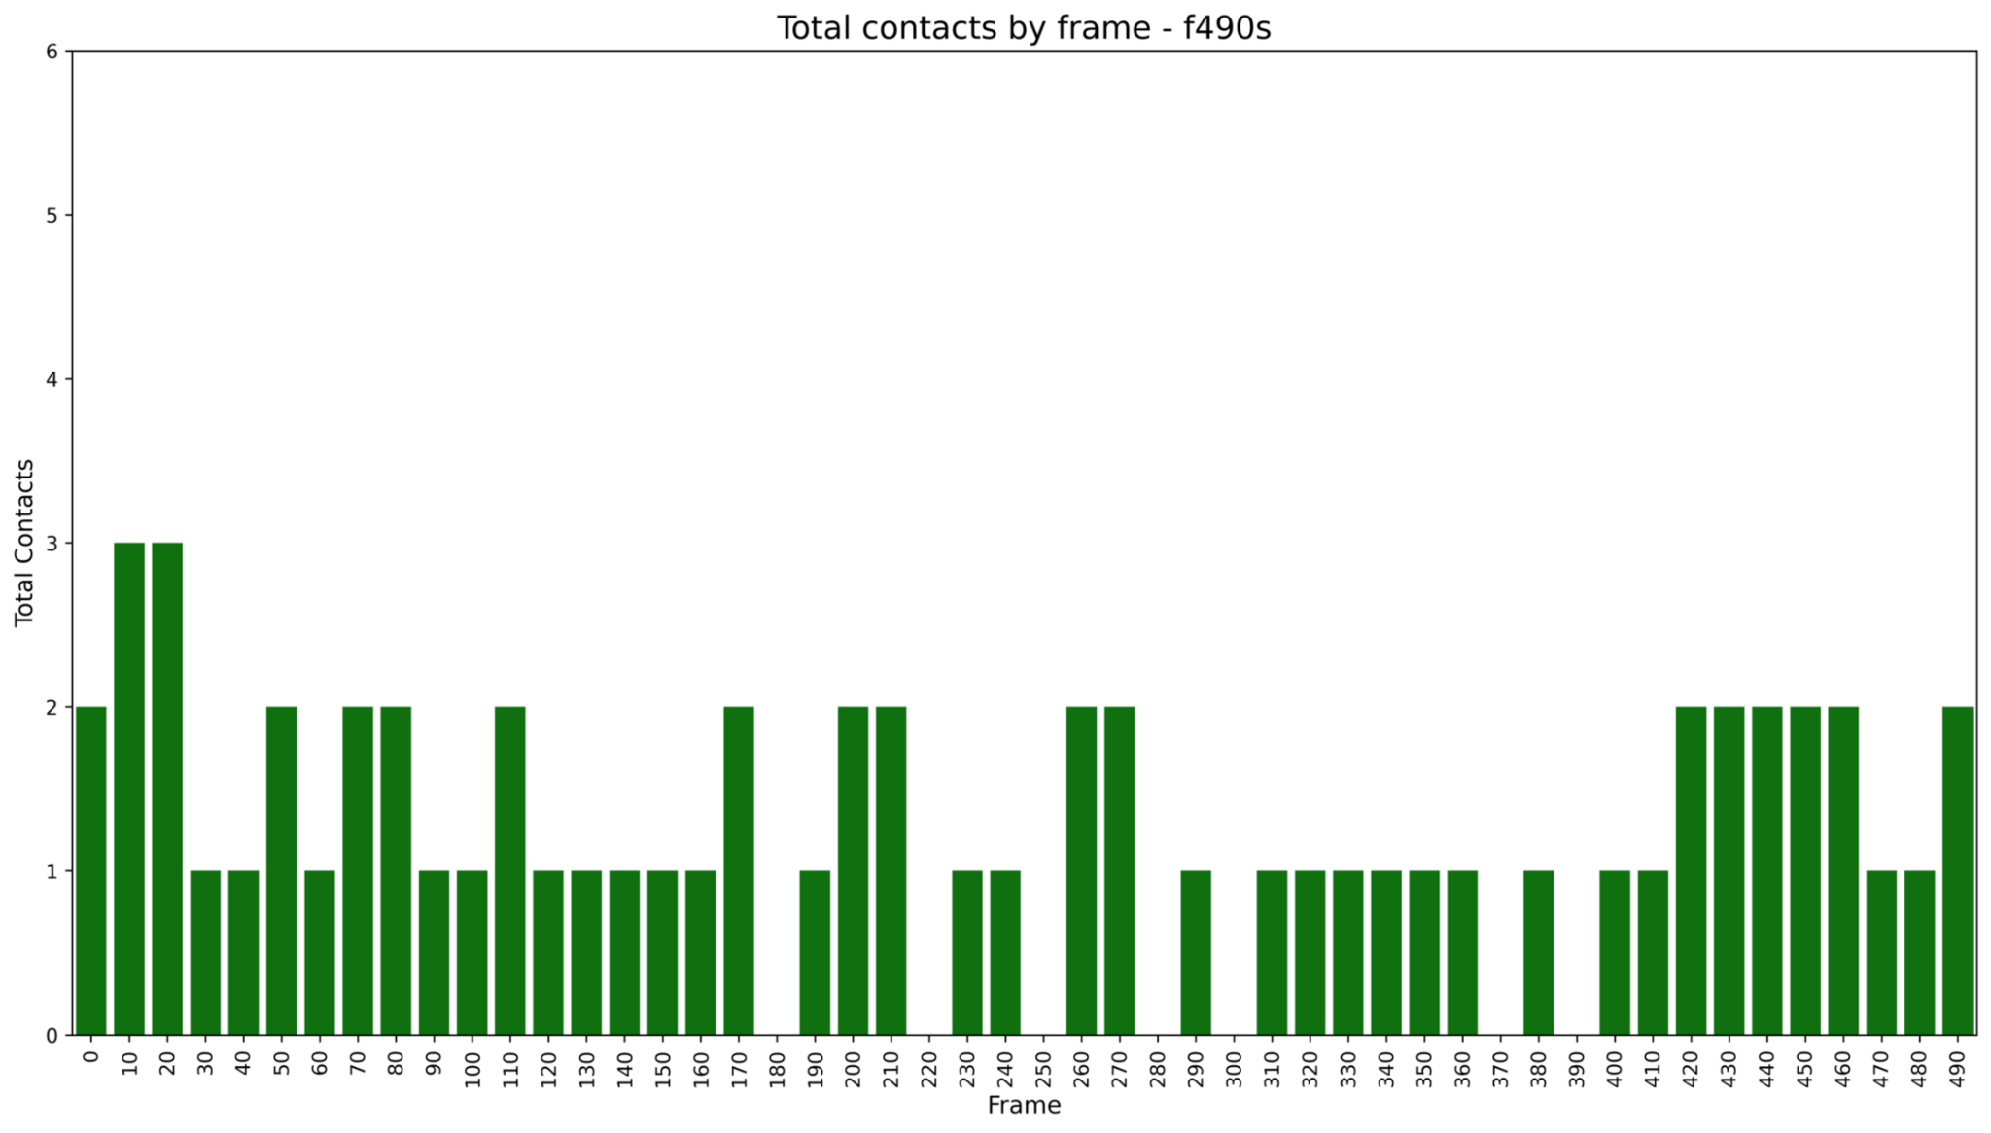Figure S6 Total contacts during the 50 ns trajectory, sampled every 10 frames, for the F490S mutant. F490S exhibited an overall reduction in contacts, showing contact-free intervals, but maintained at least one contact during most of the trajectory and ending with approximately one contact for the final ~10 ns

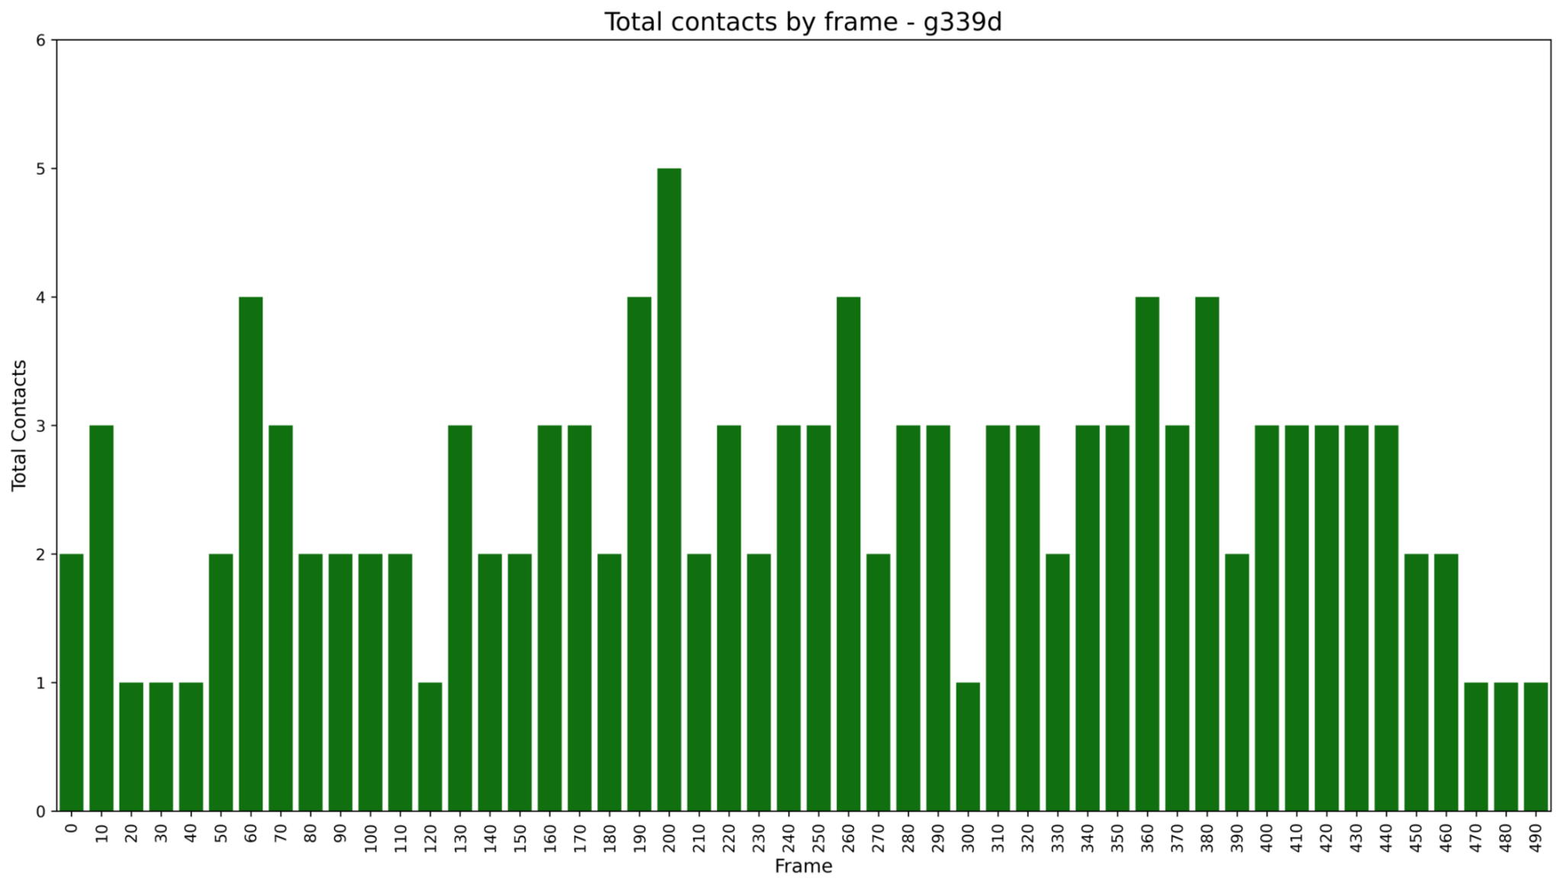
Figure S7 Total contacts during the 50 ns trajectory, sampled every 10 frames, for the G339D mutant. G339D maintained at least two contacts throughout most of the trajectory and three contacts from the middle to the end of the simulation, with only minor fluctuations lasting ~1–2 ns. During the final ~4 ns, the number of contacts decreased, reaching a single contact during the last ~2 ns. Overall, G339D exhibited a greater number of contacts than the WT

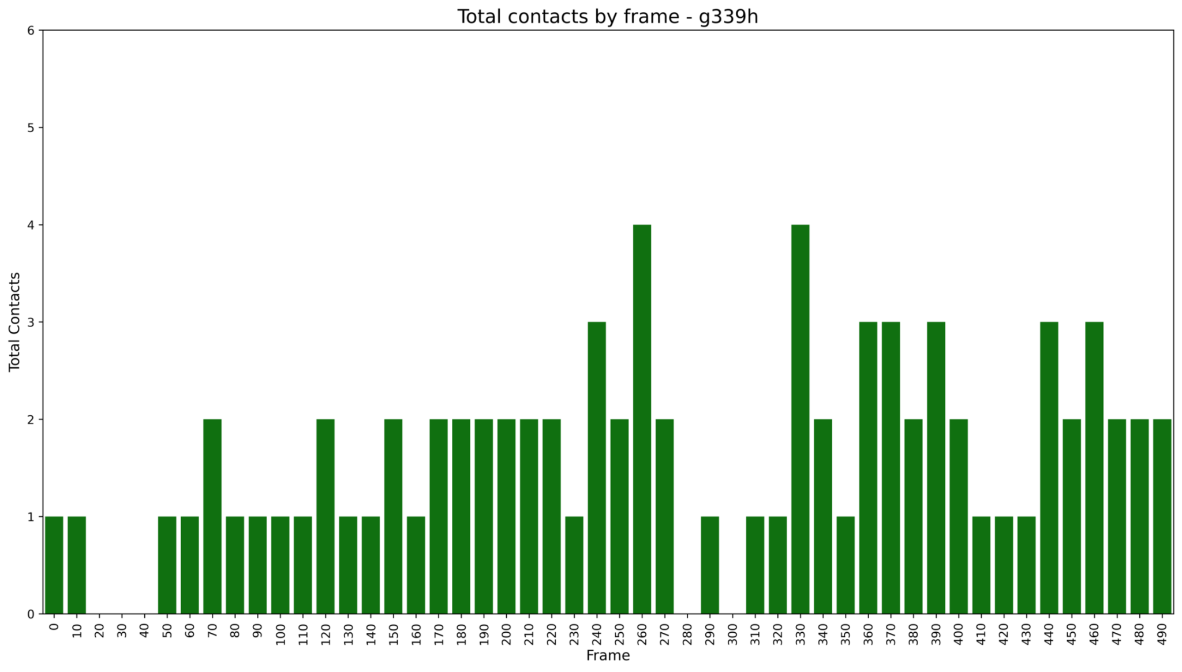
Figure S8 Total contacts during the 50 ns trajectory, sampled every 10 frames, for the G339H mutant. G339H exhibited a reduction in contacts, including an initial contact-free interval of approximately 2 ns. Thereafter, at least one contact was maintained throughout the trajectory, increasing to two contacts during the final ~5 ns

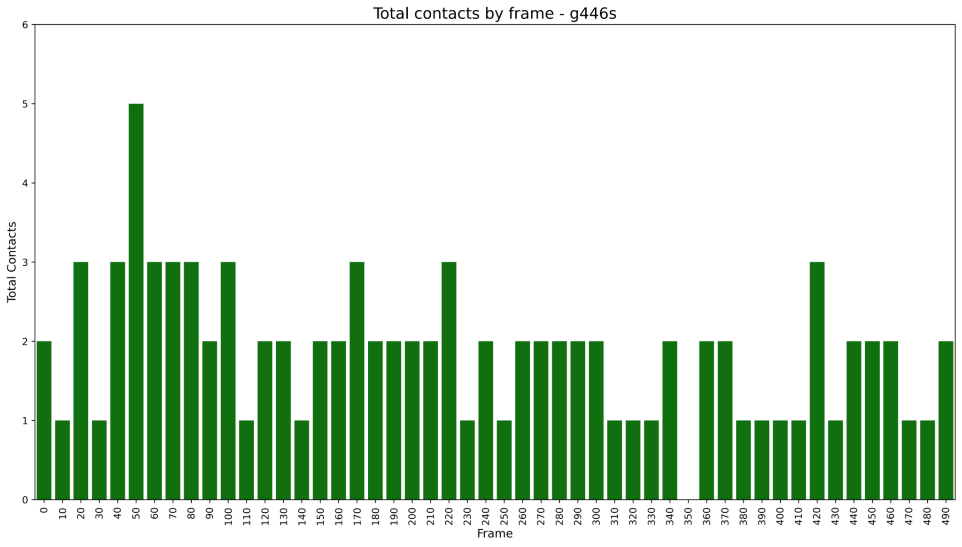
Figure S9 Total contacts during the 50 ns trajectory, sampled every 10 frames, for the G446S mutant. G446S exhibited a stable contact profile, maintaining at least two contacts from the beginning to the middle of the trajectory and between approximately 4 and 7 ns

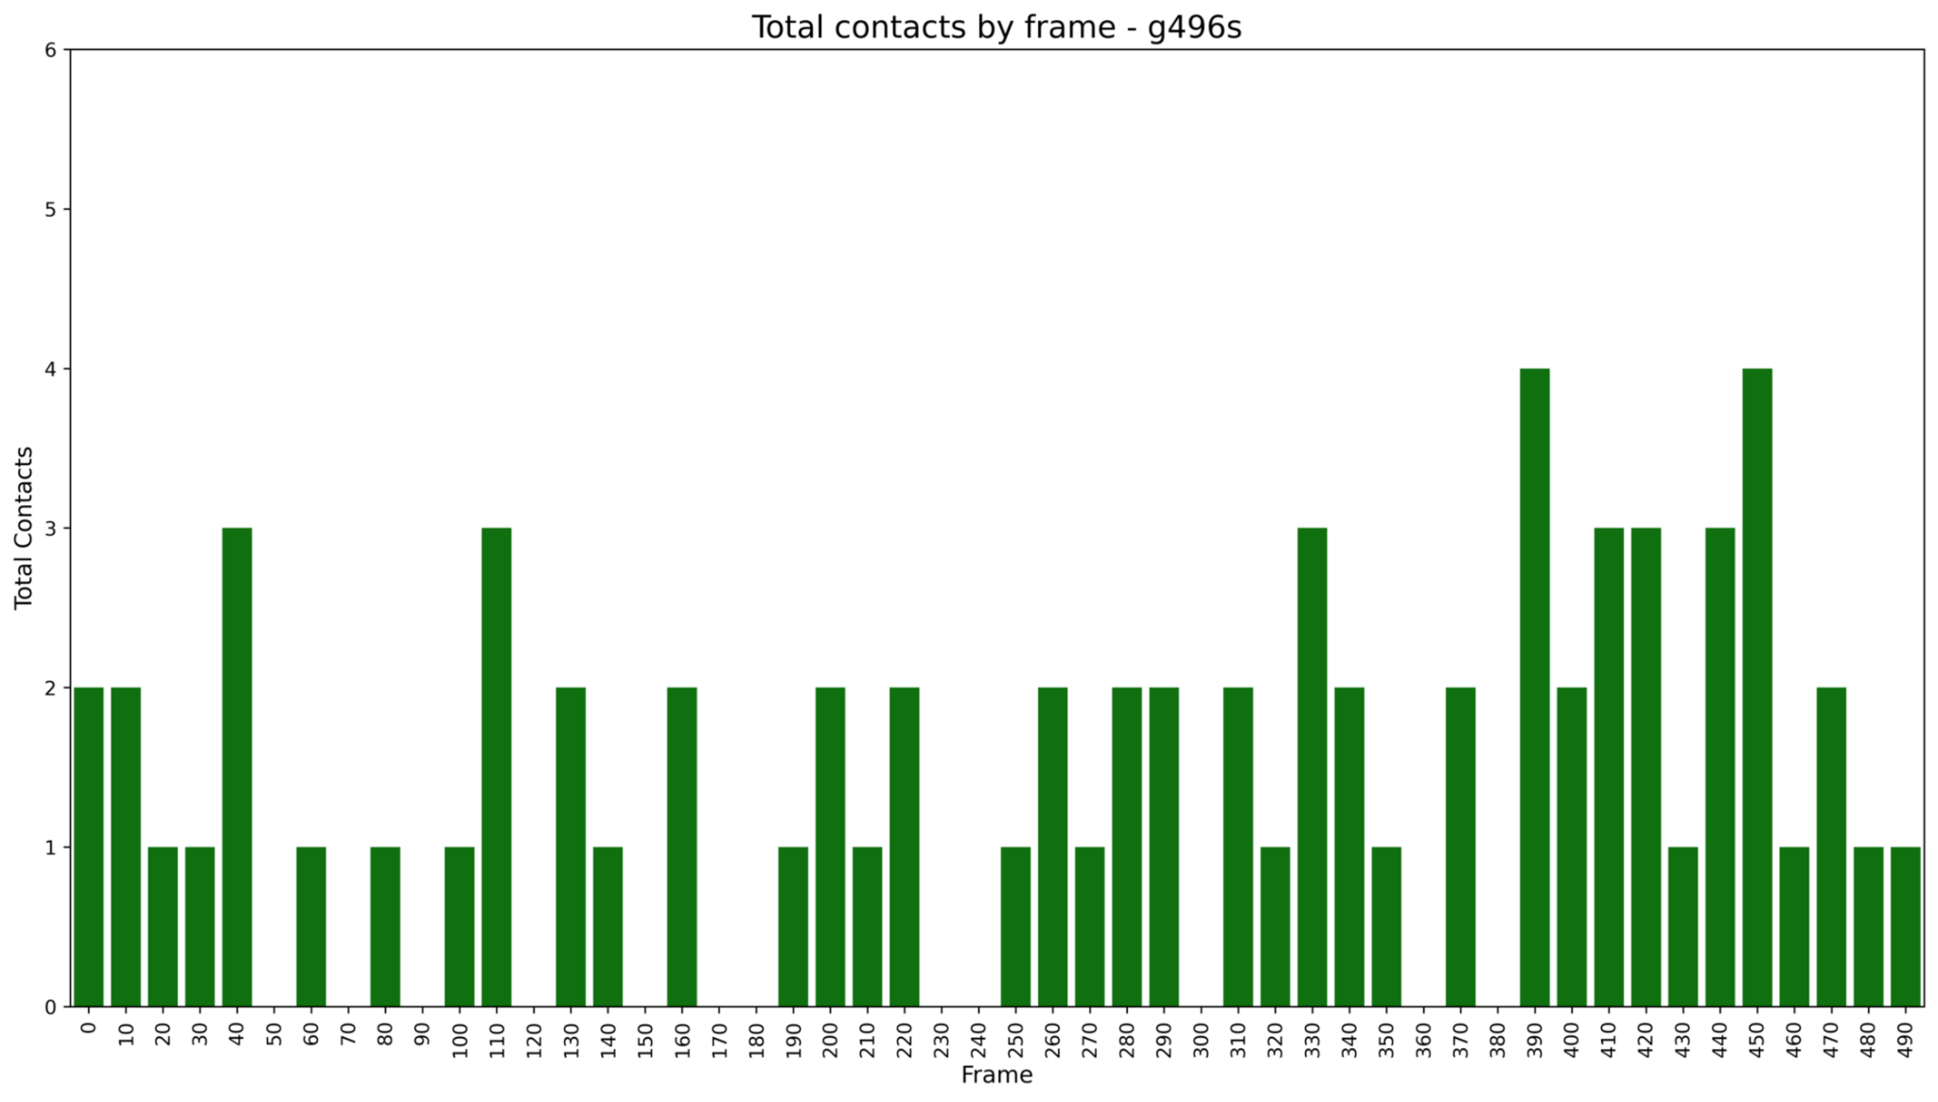
Figure S10 Total contacts during the 50 ns trajectory, sampled every 10 frames, for the G496S mutant. G496S exhibited brief reductions in contacts (~1 ns) at several time points. The mutant maintained two contacts for approximately 2 ns during different portions of the trajectory and at least one contact during the final ~10 ns, fluctuating between one and three contacts

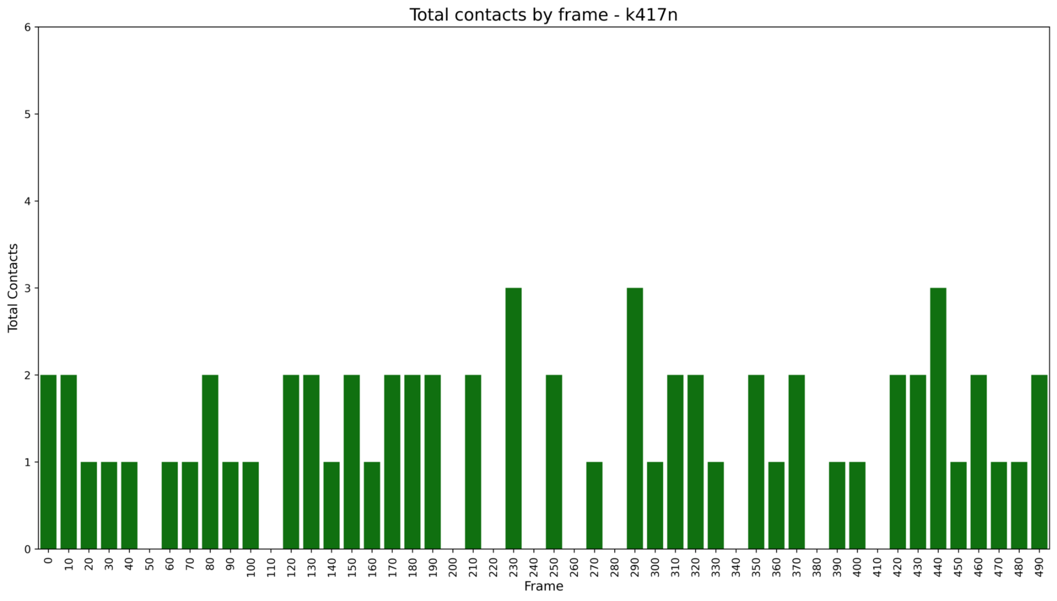
Figure S11 Total contacts during the 50 ns trajectory, sampled every 10 frames, for the K417N mutant. K417N exhibited fewer contacts than the WT, maintaining a single contact for periods of approximately 4 ns or longer and fluctuating primarily between one and two contacts throughout the trajectory

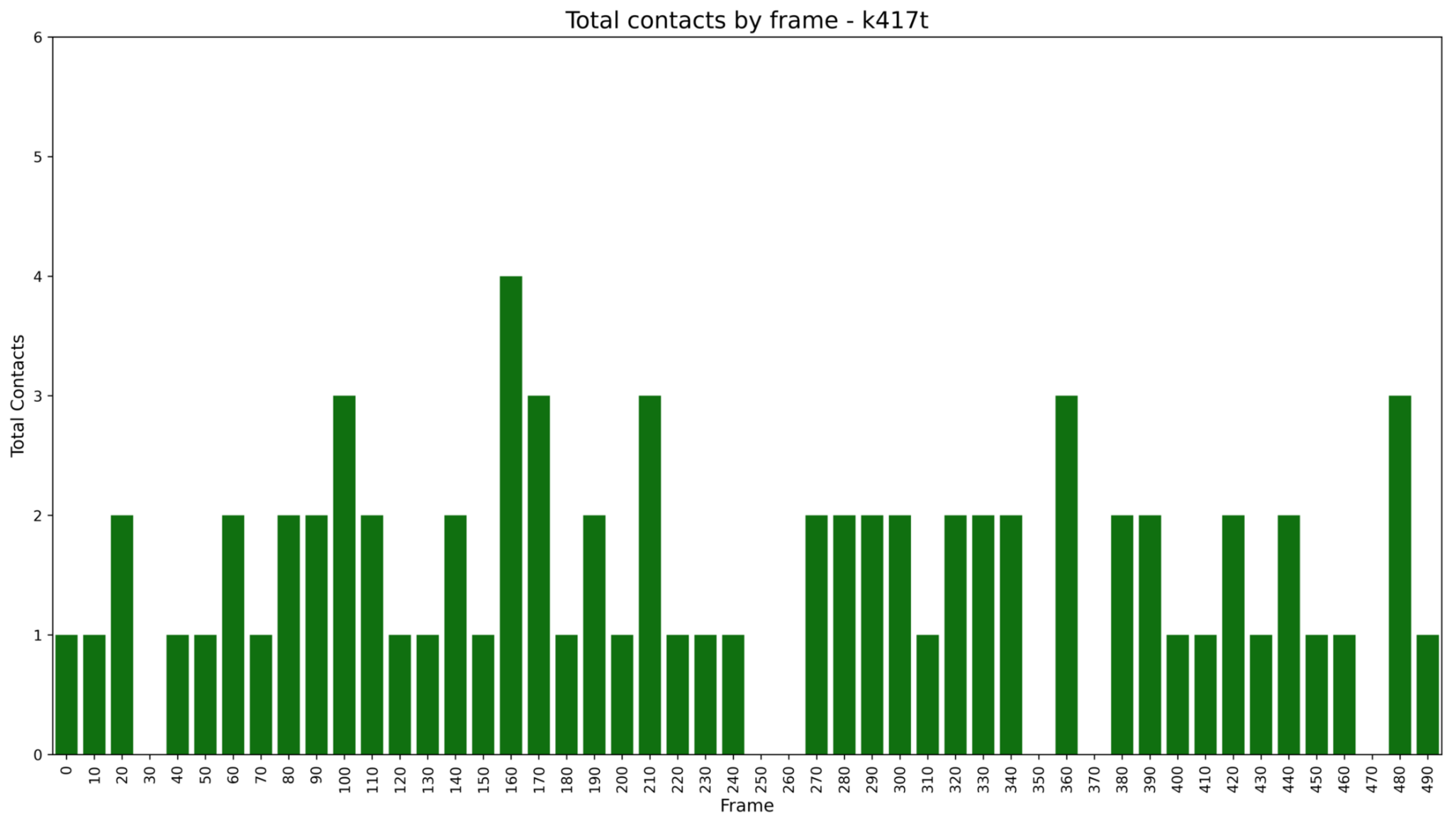
Figure S12 Total contacts during the 50 ns trajectory, sampled every 10 frames, for the K17T mutant. K417T exhibited brief contact losses (generally ≤1 ns) while maintaining at least one contact throughout most of the trajectory. The number of contacts fluctuated between one and three for approximately 20 ns and again during the final ~10 ns despite intermittent contact losses

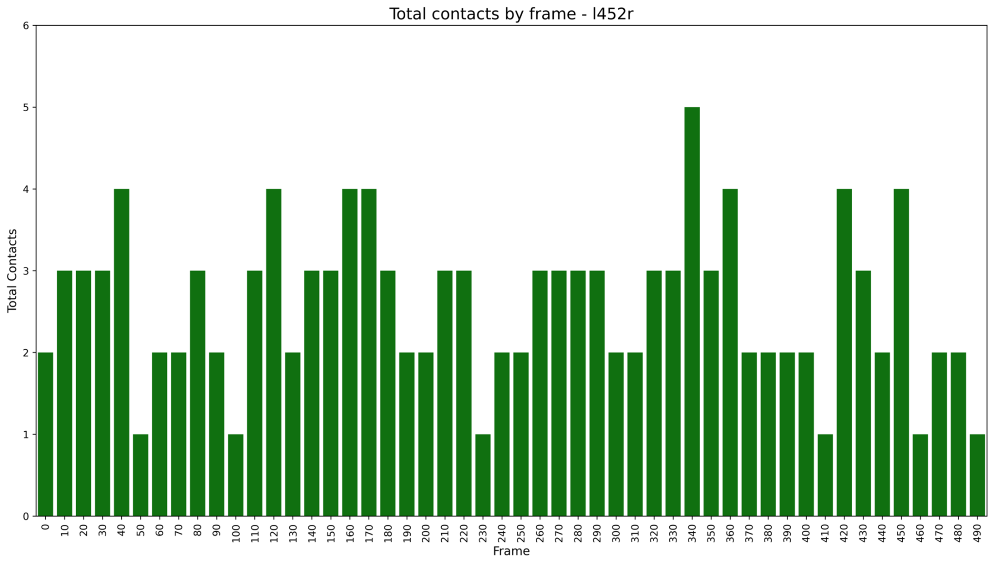
Figure S13 Total contacts during the 50 ns trajectory, sampled every 10 frames, for the L452R mutant. L452R exhibited an overall increase in contacts, fluctuating primarily between two and three contacts throughout most of the trajectory. Individual contact states persisted for at least ~2 ns, resulting in a stable profile with at least two contacts during most of the simulation

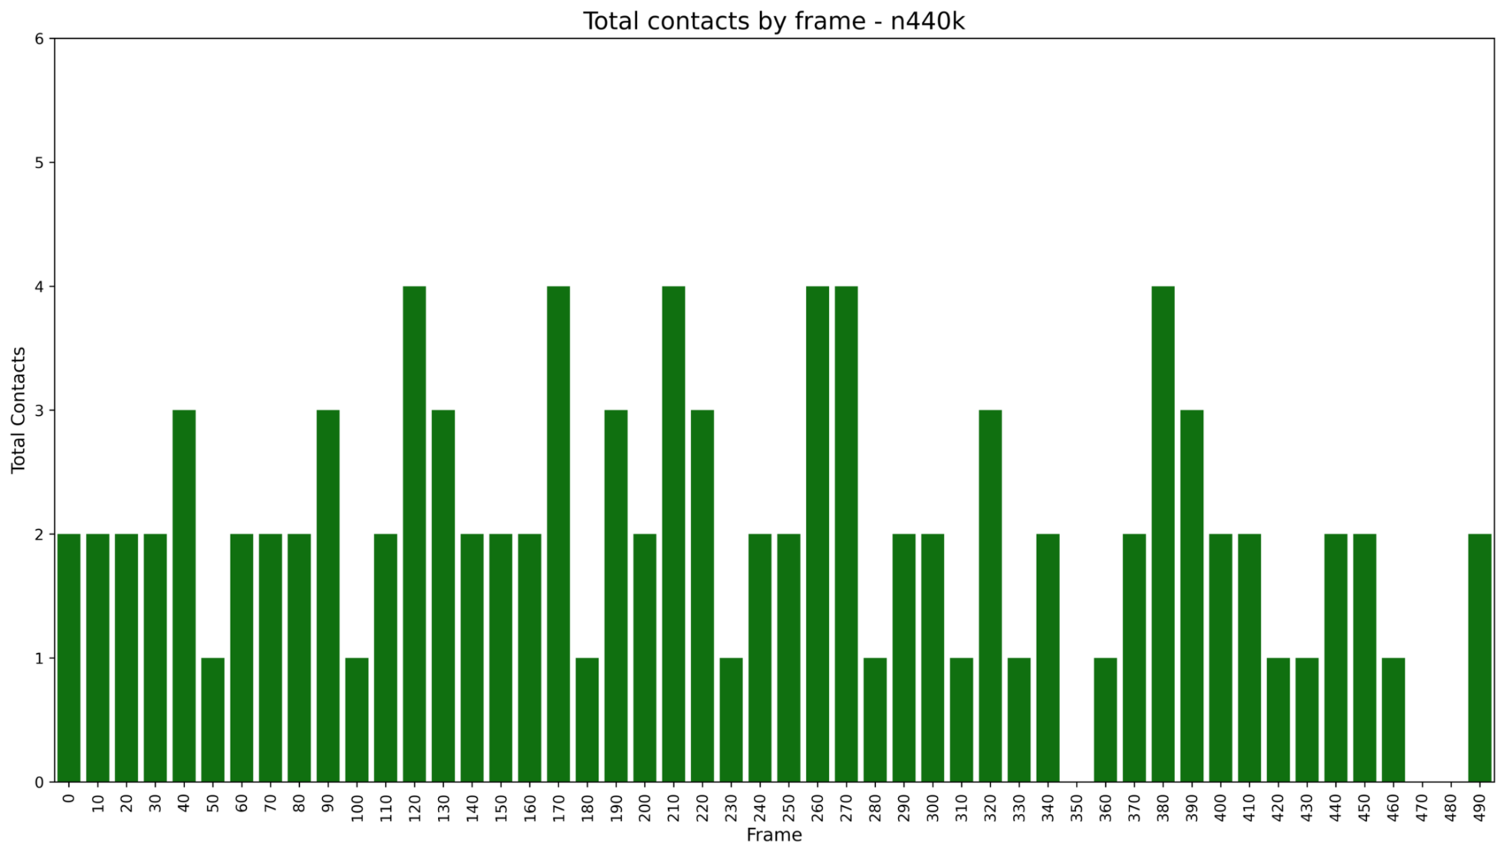
Figure S14 Total contacts during the 50 ns trajectory, sampled every 10 frames, for the N440K mutant. N440K exhibited reduced contacts and a contact-free interval of approximately 1 ns near the end of the trajectory, resembling the pattern observed for the WT

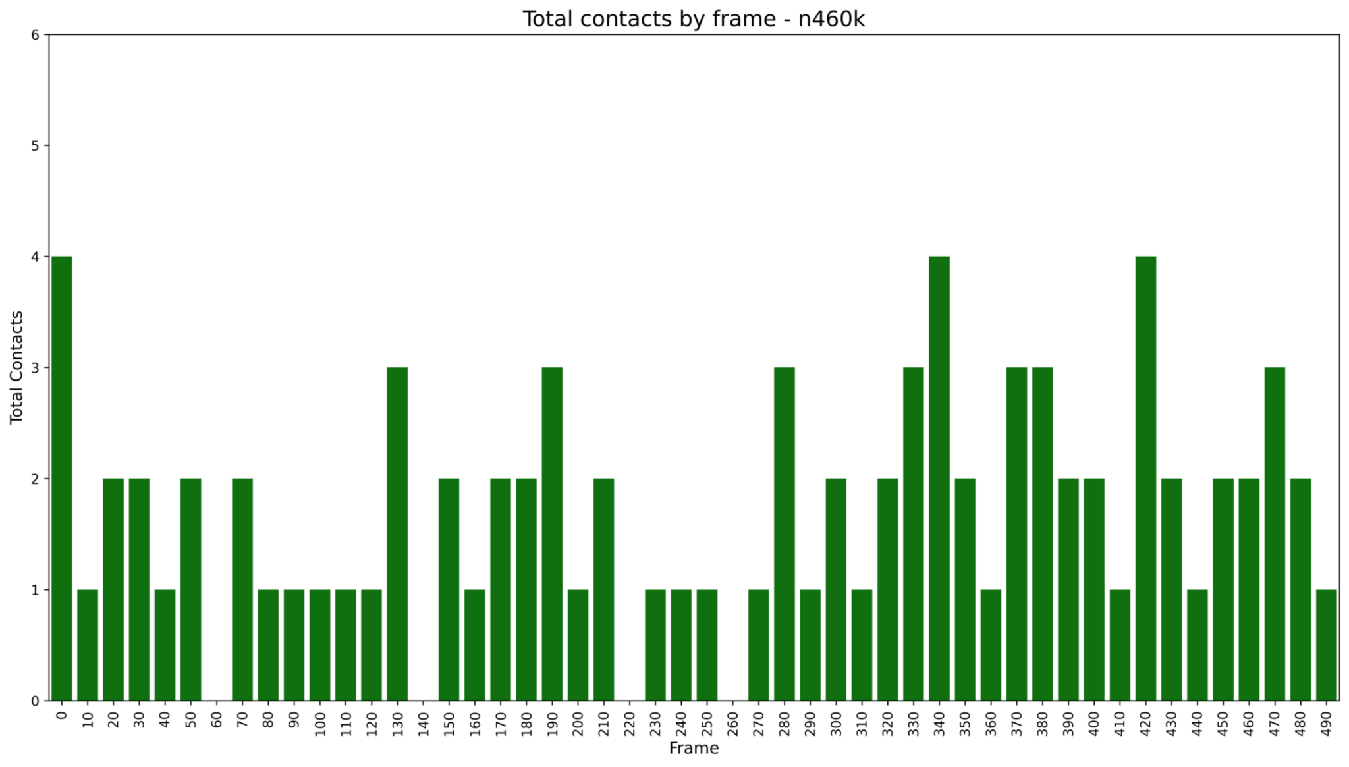
Figure S15 Total contacts during the 50 ns trajectory, sampled every 10 frames, for the N460K mutant. N460K exhibited occasional contact losses while maintaining at least one to two contacts throughout most of the trajectory. From the middle to the end of the simulation, the mutant maintained at least one contact for approximately 22 ns and two contacts for approximately 3 ns

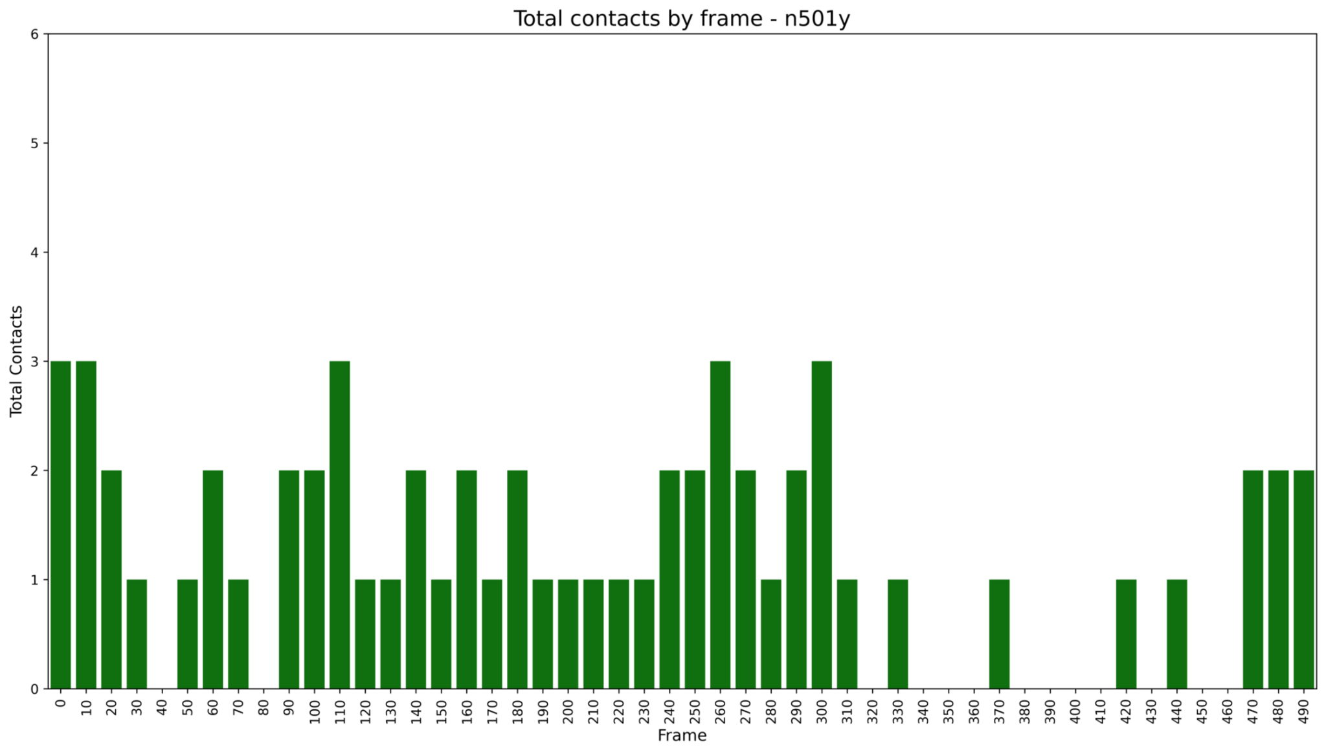
Figure S16 Total contacts during the 50 ns trajectory, sampled every 10 frames, for the N501Y mutant. N501Y exhibited a marked reduction in contacts for approximately 2–3 ns near the end of the trajectory. From the middle to the end of the simulation, the mutant maintained at least one contact, with intermittent increases to two contacts

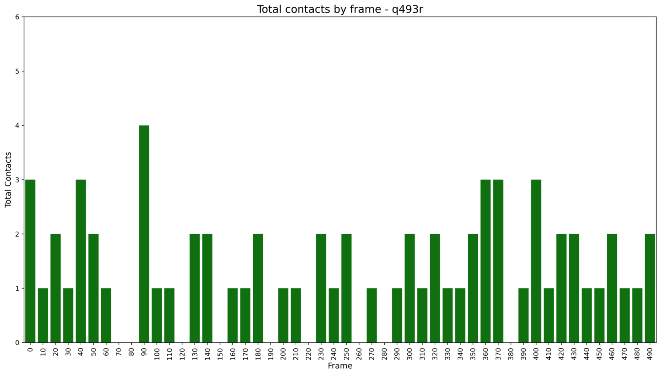
Figure S17 Total contacts during the 50 ns trajectory, sampled every 10 frames, for the Q493R mutant. Q493R exhibited fewer contacts than the WT, maintaining at least one contact throughout the trajectory with intermittent increases to two contacts for approximately 6 ns at different time points.

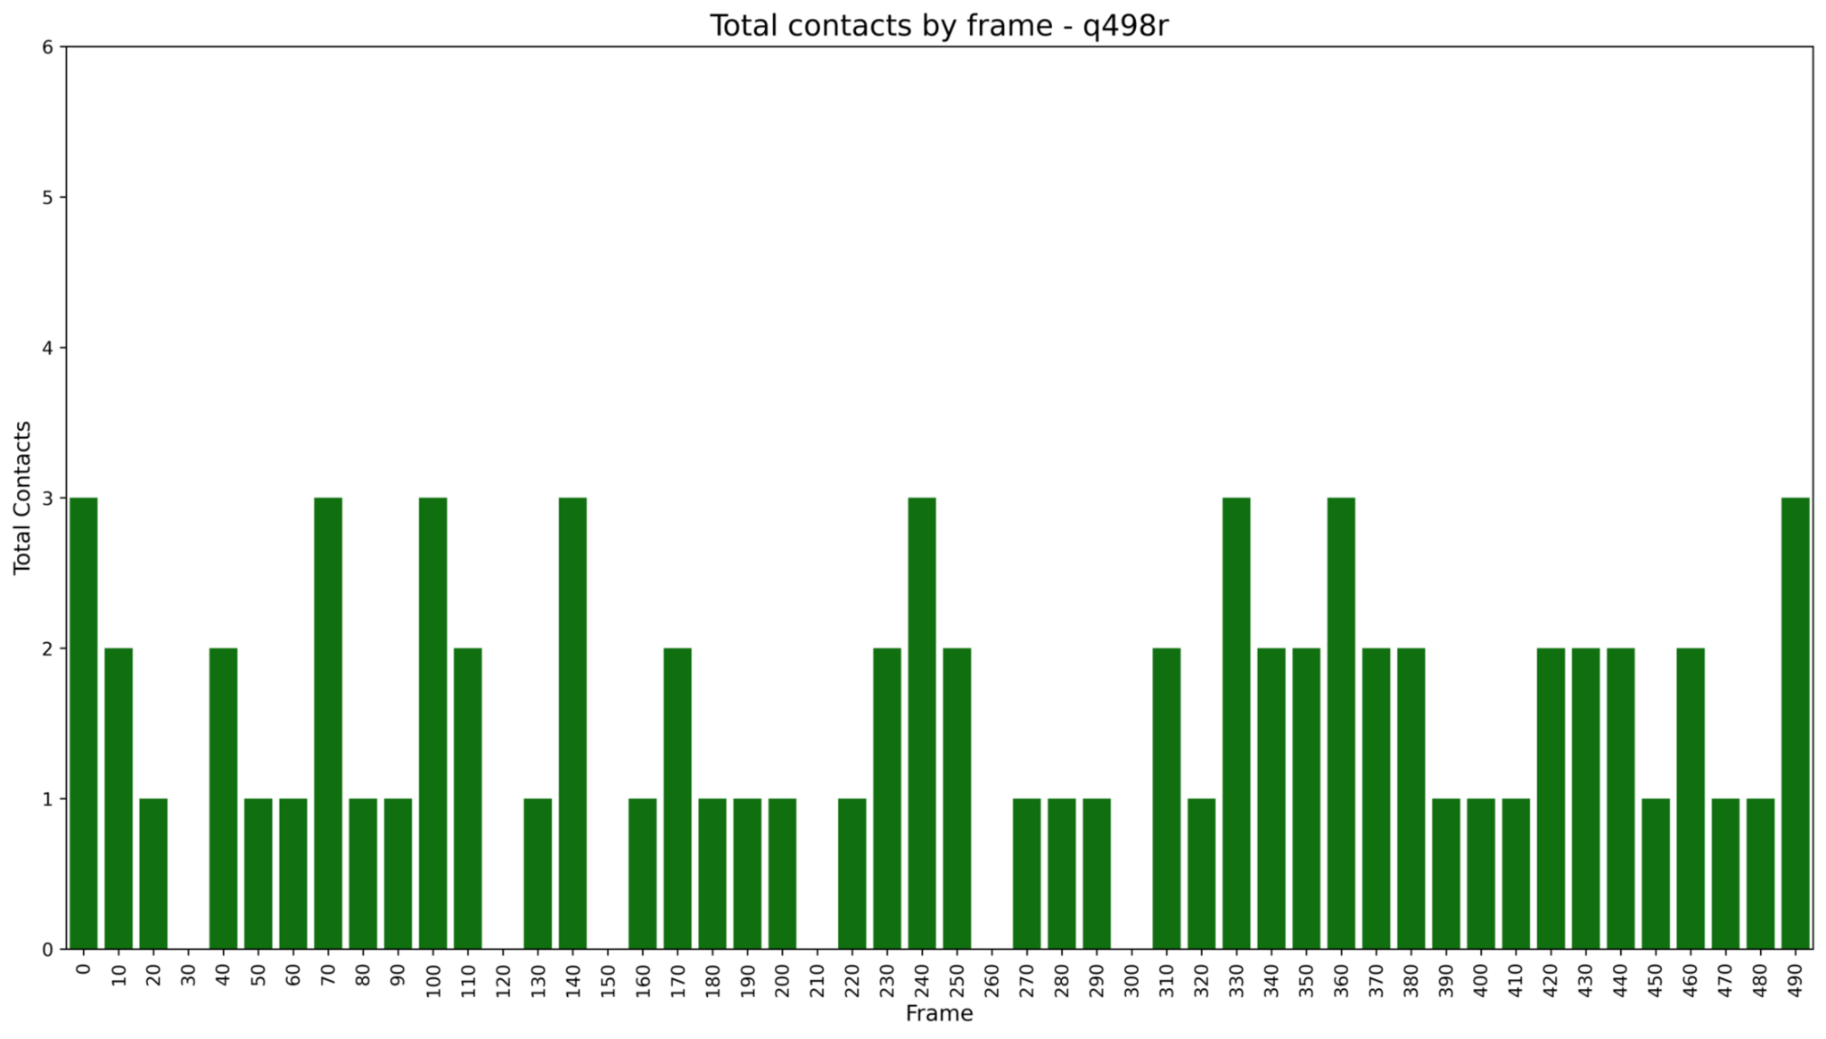
Figure S18 Total contacts during the 50 ns trajectory, sampled every 10 frames, for the Q498R mutant. Q498R exhibited fewer contacts than the WT while maintaining at least one contact throughout the trajectory

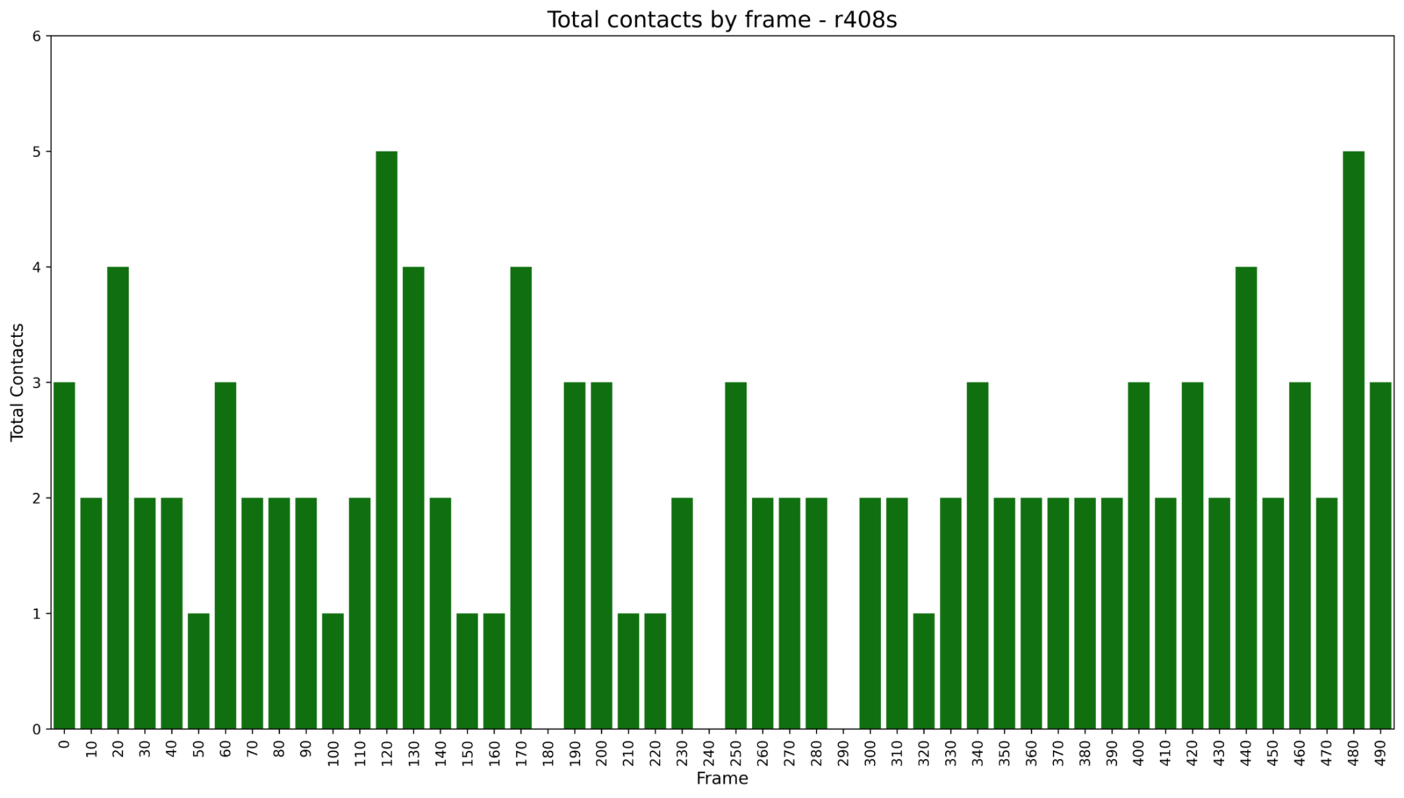
Figure S19 Total contacts during the 50 ns trajectory, sampled every 10 frames, for the R408S mutant. R408S maintained at least two contacts throughout most of the simulation, with intermittent increases to three or more contacts

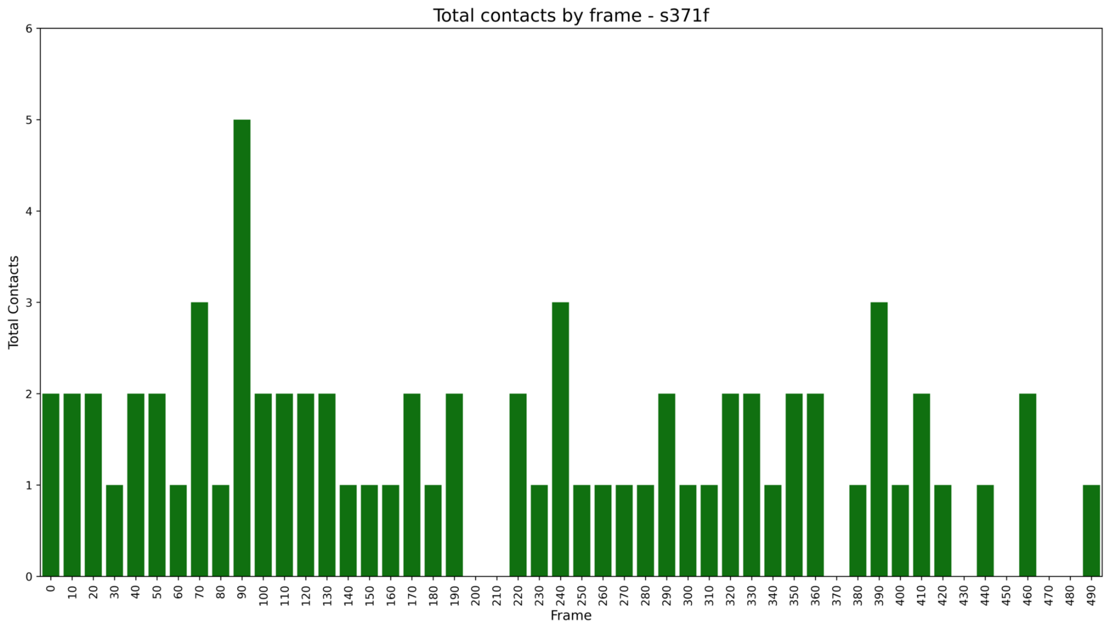
Figure S20 Total contacts during the 50 ns trajectory, sampled every 10 frames, for the S371F mutant. S371F exhibited more frequent contact losses, including brief contact-free intervals (~1 ns) at some time points, including the end of the trajectory

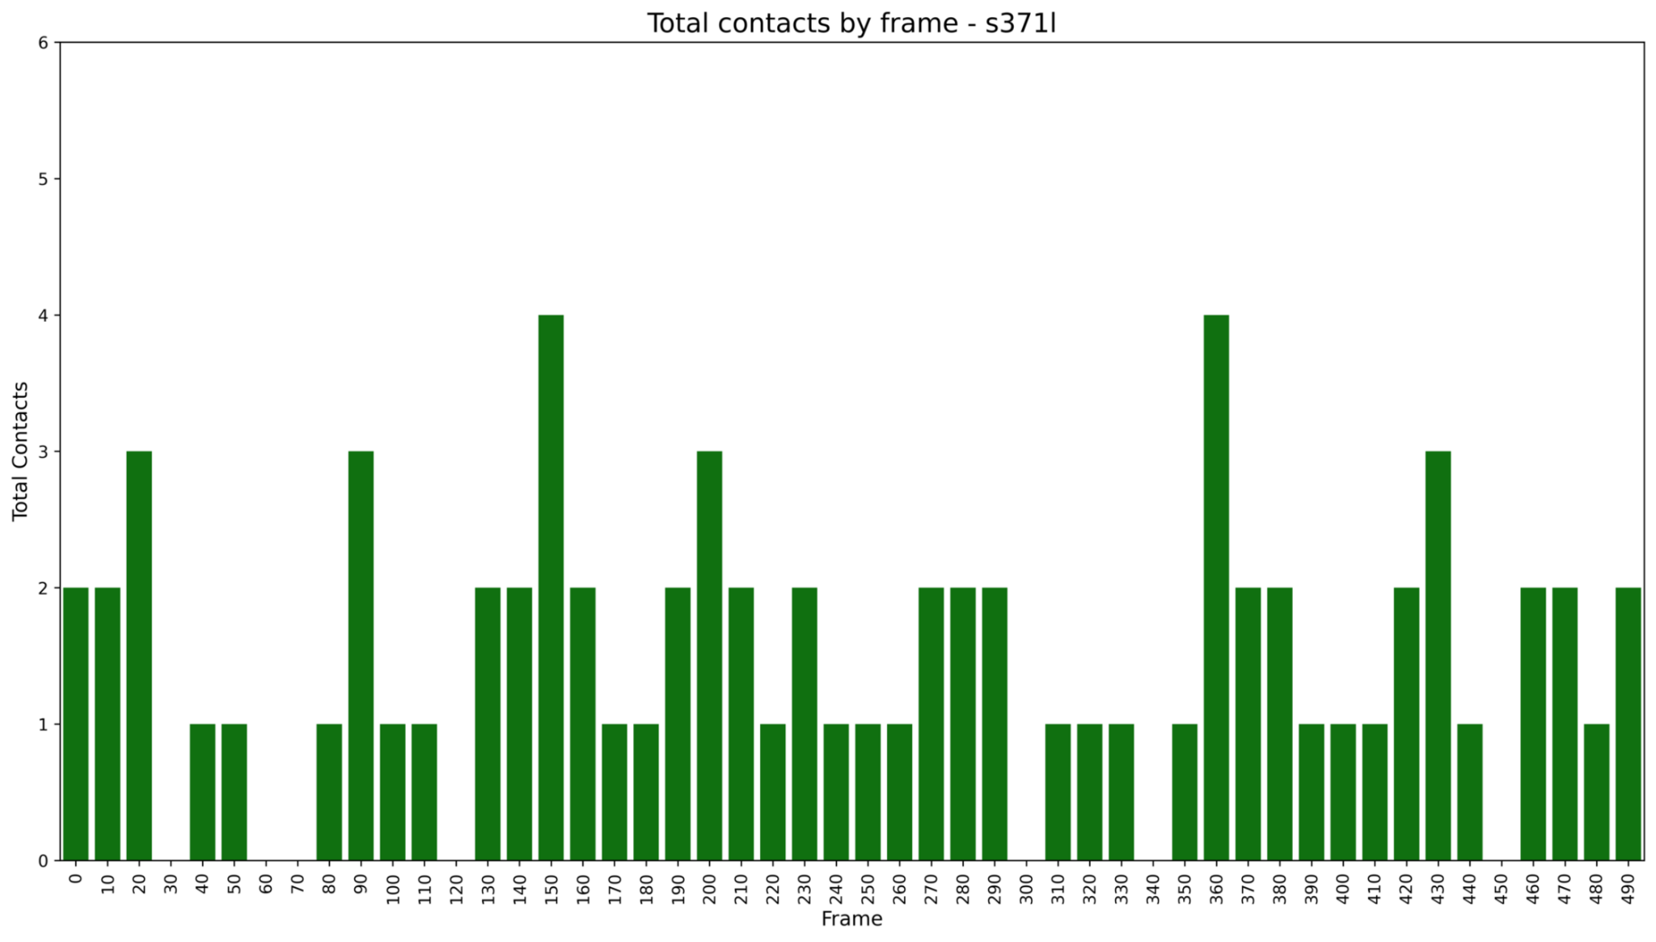
Figure S21 Total contacts during the 50 ns trajectory, sampled every 10 frames, for the S371L mutant. S371L exhibited fewer contacts overall, maintaining at least one contact throughout the trajectory with intermittent increases to two contacts lasting approximately 1–3 ns

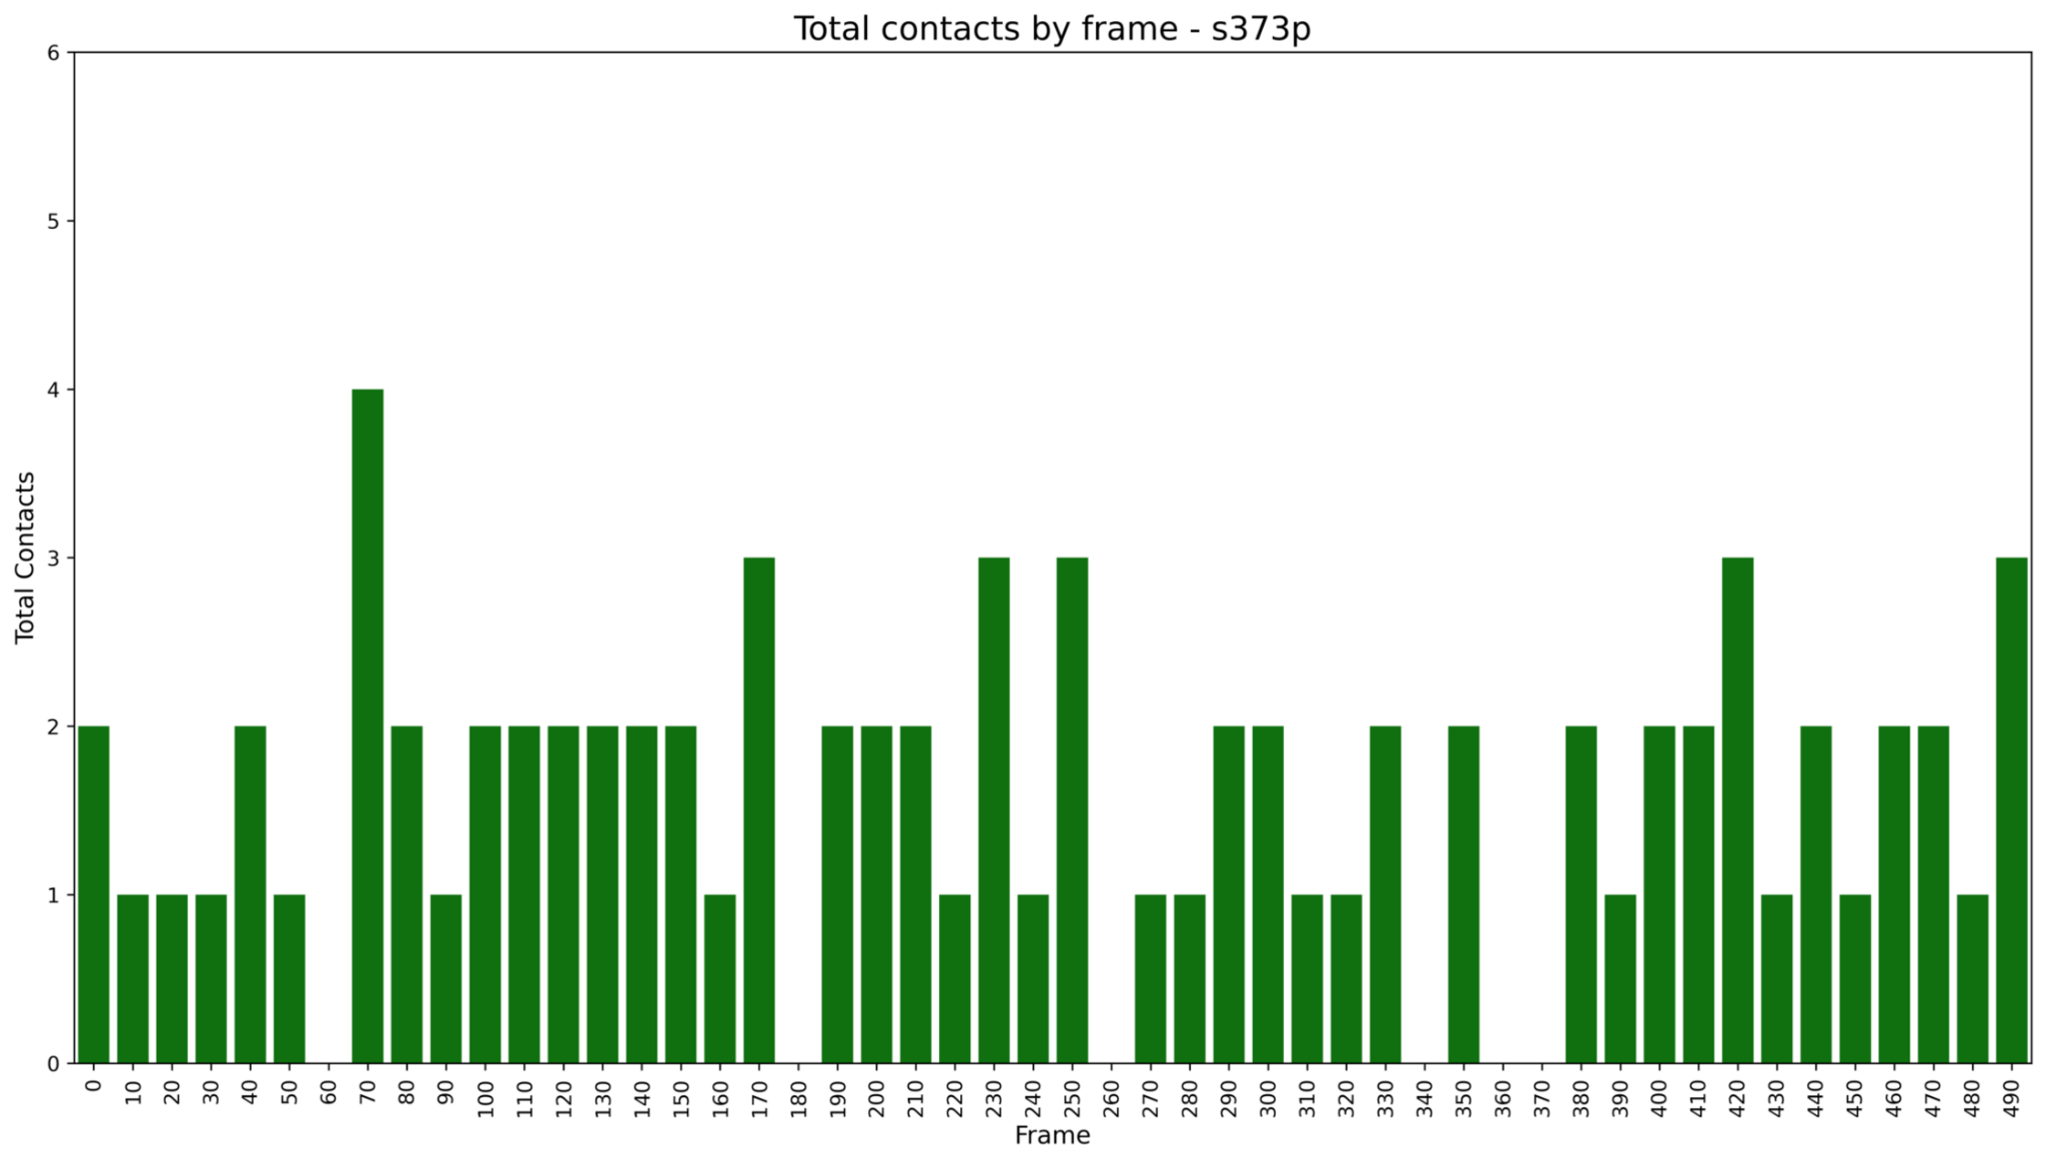
Figure S22 Total contacts during the 50 ns trajectory, sampled every 10 frames, for the S373P mutant. S373P exhibited occasional contact losses while maintaining at least one contact throughout the trajectory. The mutant maintained one contact for approximately 5 ns at the beginning, ~2 ns during the middle, and ~1–2 ns near the end of the simulation, with intermittent increases to two contacts

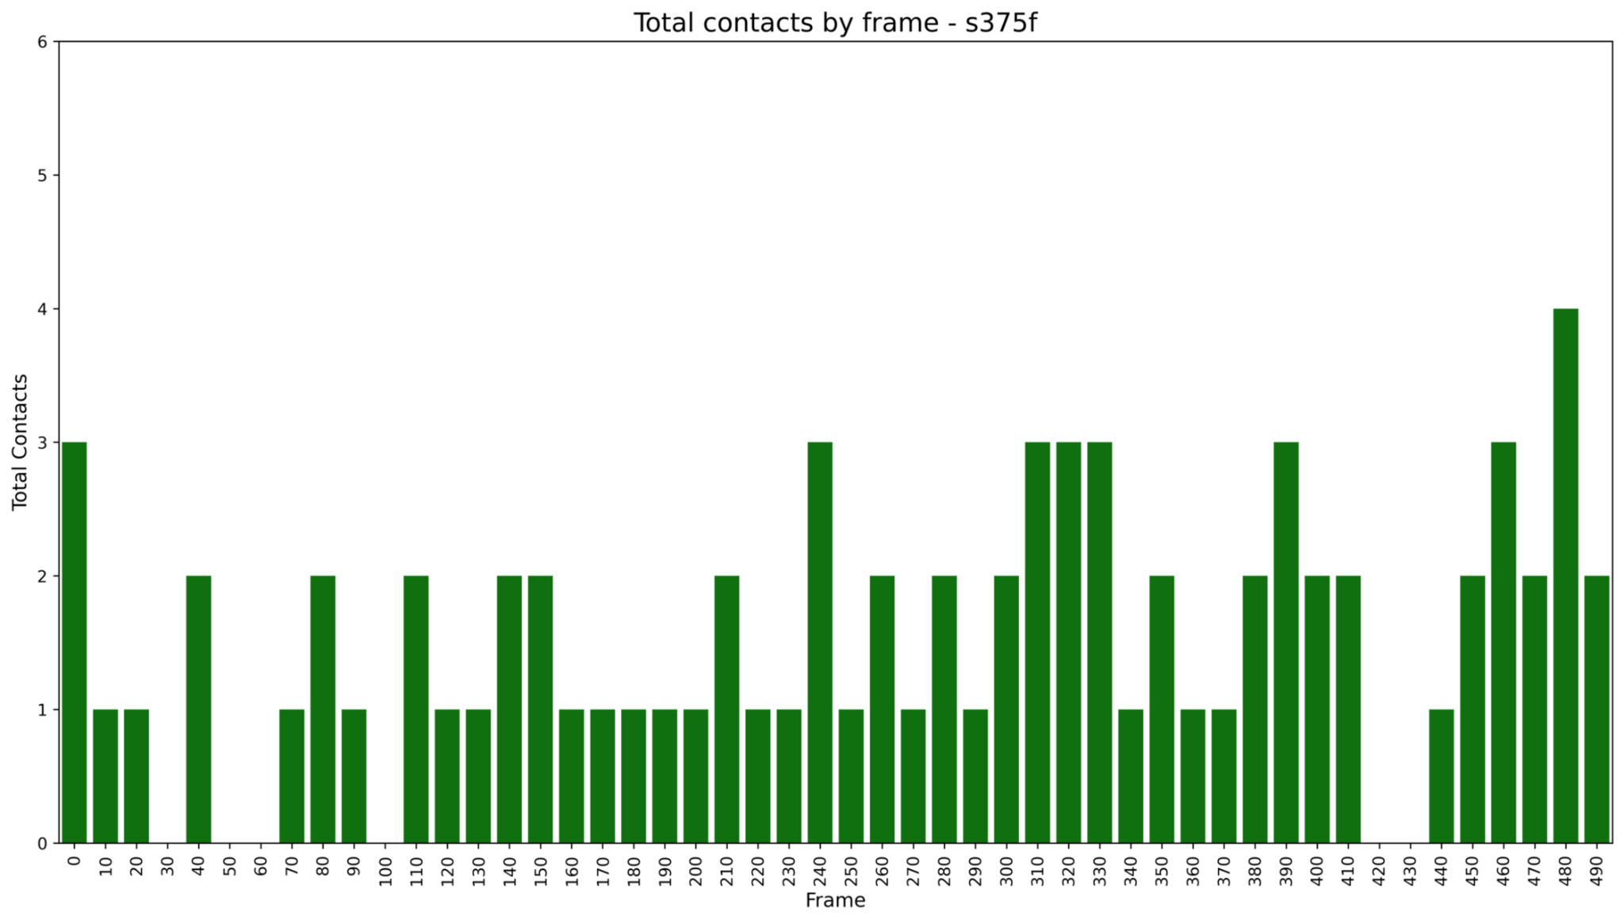
Figure S23 Total contacts during the 50 ns trajectory, sampled every 10 frames, for the S375F mutant. S375F exhibited fewer contacts overall, maintaining one contact throughout most of the trajectory. Transient increases to three contacts were observed for approximately 2 ns in the middle of the simulation and to two contacts for approximately 4 ns near the end

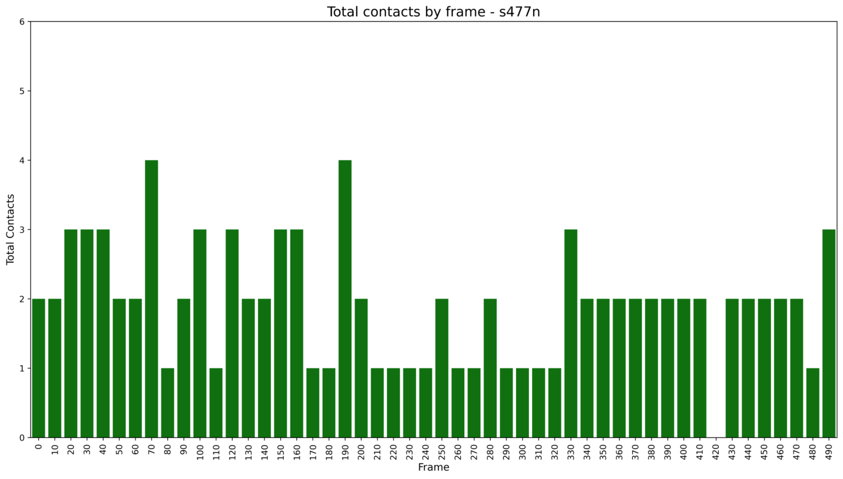
Figure S24 Total contacts during the 50 ns trajectory, sampled every 10 frames, for the S477N mutant. S477N exhibited greater contact stability with limited variability. Additional contacts were observed at the beginning of the trajectory, brief contact-free intervals (<1 ns) occurred near the end, and at least two contacts was maintained throughout the final portion of the simulation

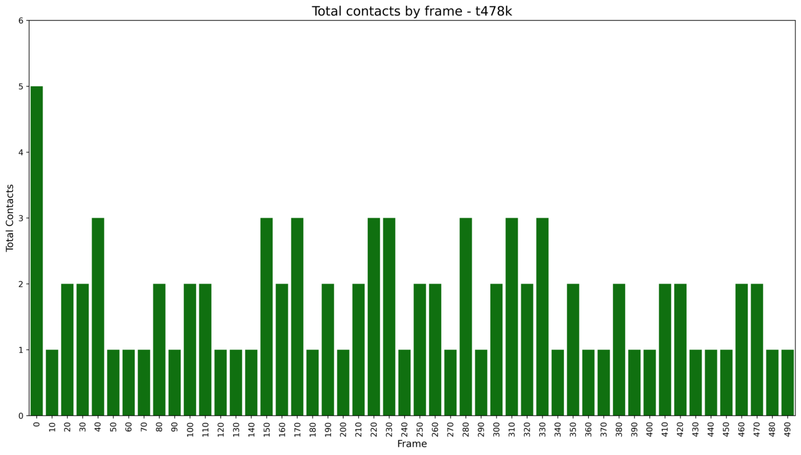
Figure S25 Total contacts during the 50 ns trajectory, sampled every 10 frames, for the T478K mutant. T478K maintained 1 contact throughout the entire trajectory with intermittent increases to two contacts

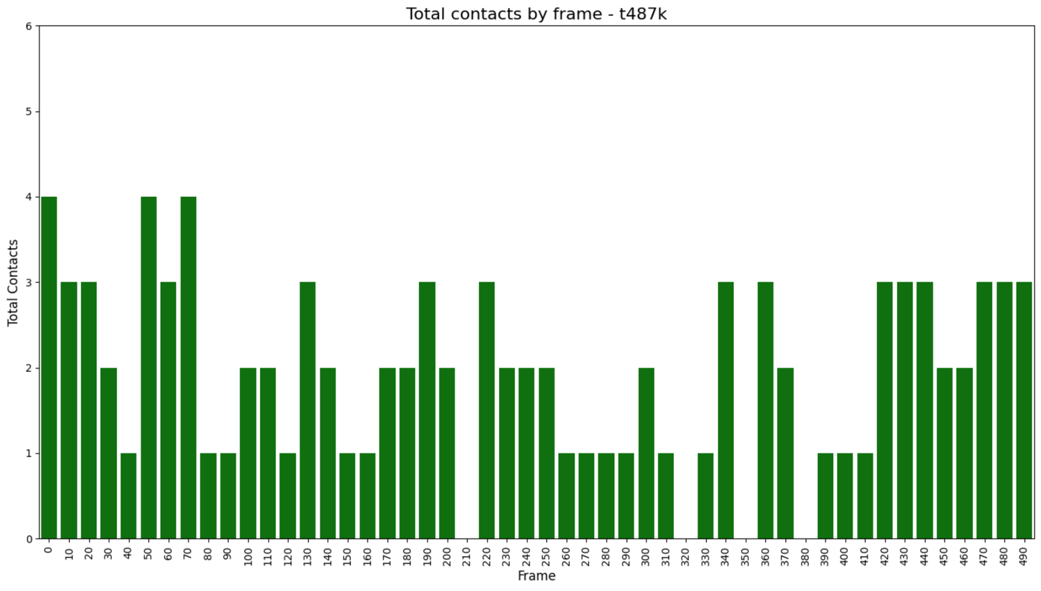
Figure S26 Total contacts during the 50 ns trajectory, sampled every 10 frames, for the T487K mutant. T487K exhibited alternating contact gains and losses throughout the trajectory. The mutant maintained approximately three contacts for ~2 ns at several time points and two contacts for approximately 2 ns during the beginning, middle, and end of the simulation. During the final ~7 ns, the number of contacts fluctuated between two and three

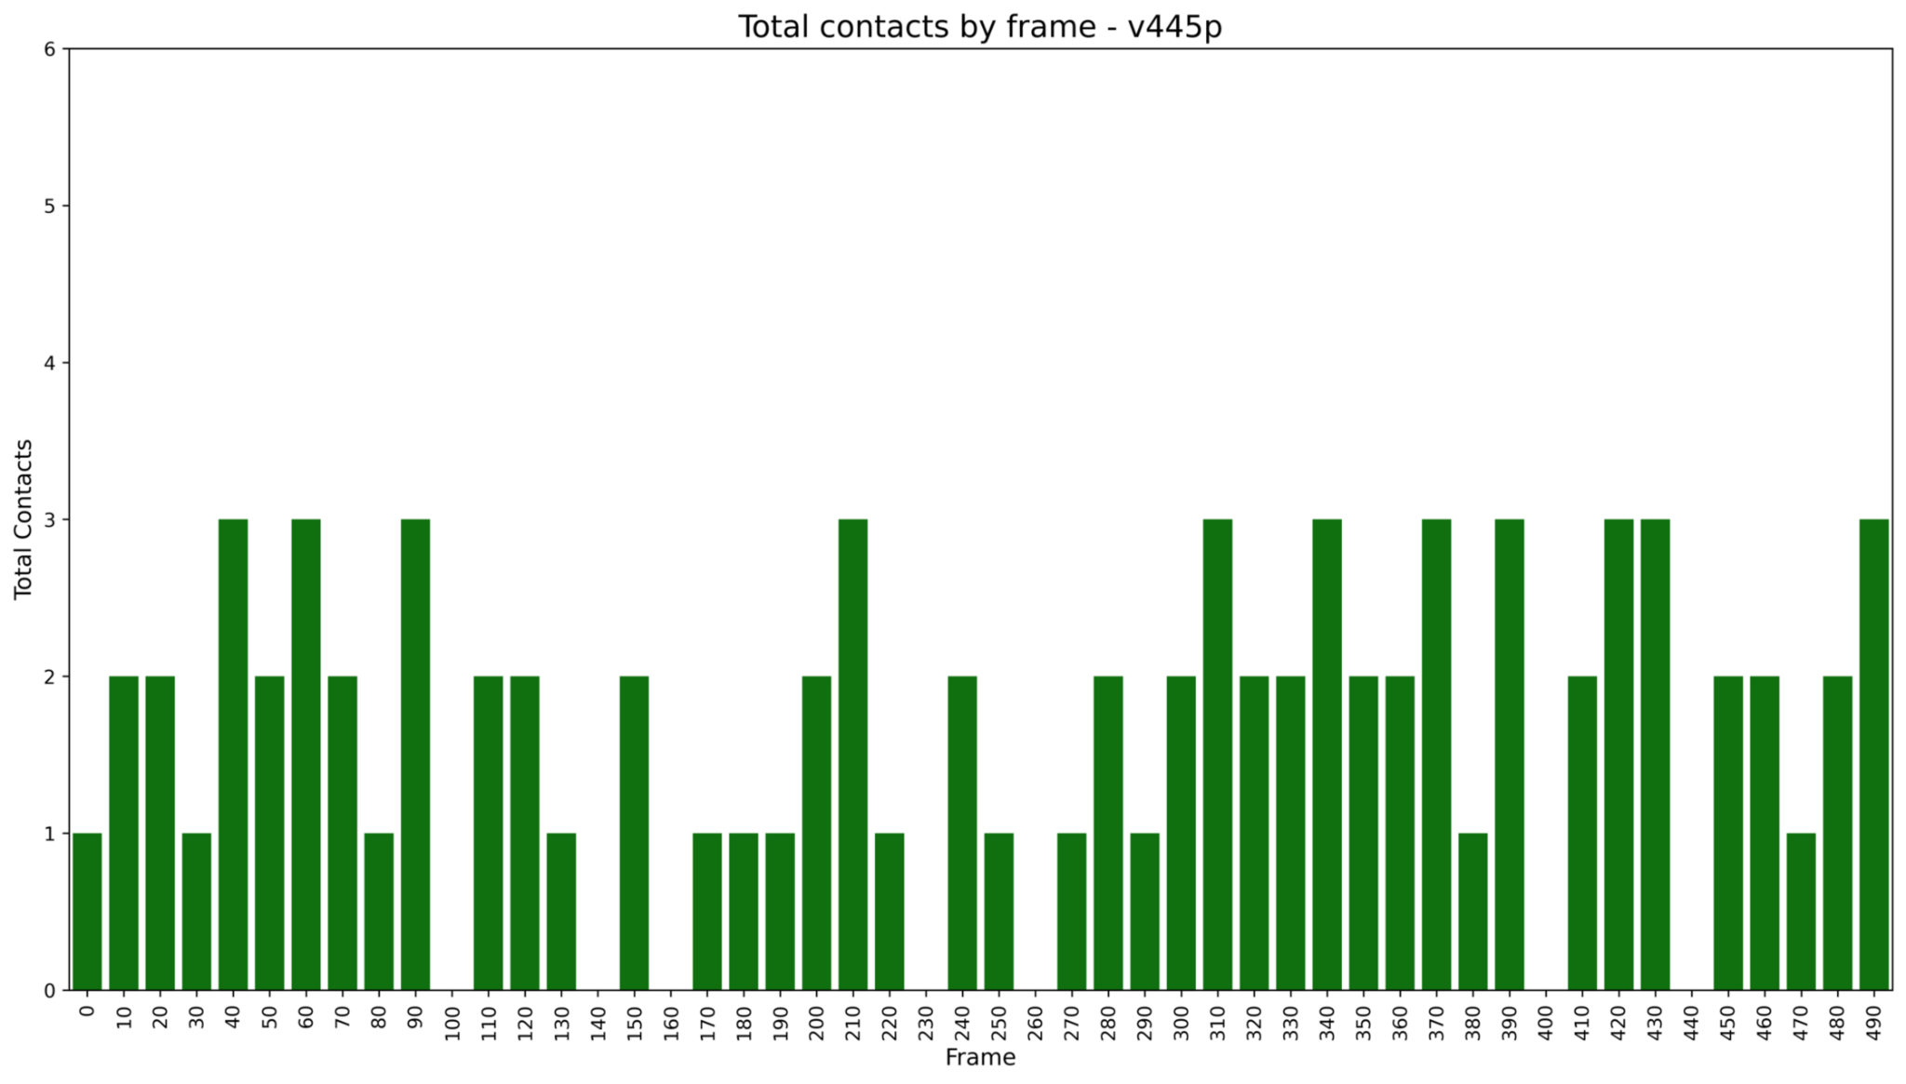
Figure S27 Total contacts during the 50 ns trajectory, sampled every 10 frames, for the V445P mutant. V445P fluctuated between one and two contacts and presented contact-free intervals of approximately 1 ns at the beginning, middle, and end of the simulation

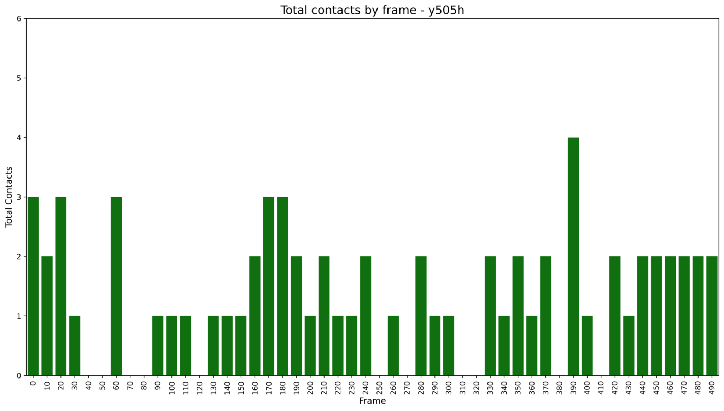
Figure S28 Total contacts during the 50 ns trajectory, sampled every 10 frames, for the Y505H mutant. Y505H exhibited fewer contacts overall, fluctuating between one and two contacts and maintaining two contacts for approximately 5 ns at the end of the trajectory

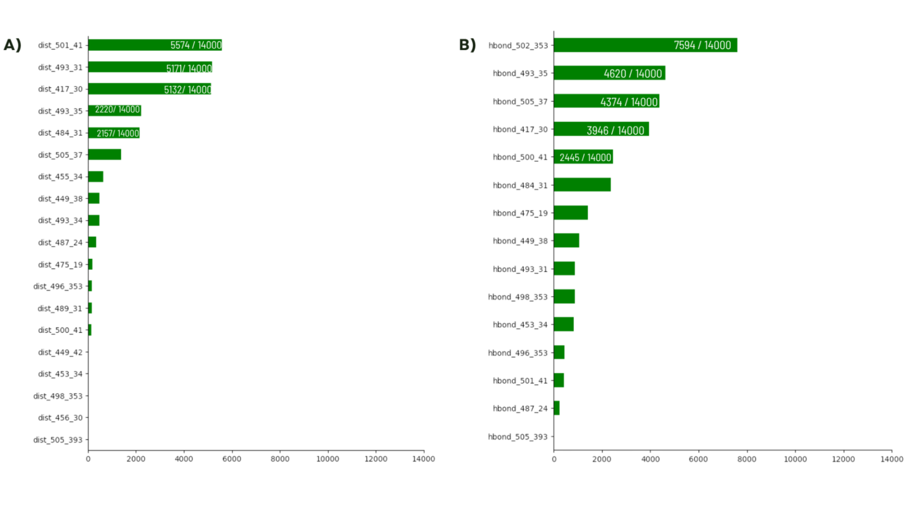
Figure S29 Frequency of contacts and hydrogen bonds (hbs) through the dataset. A) Total number of contacts baked on interaction distances. Distances ≤3.5 Å were counted as one contact. Residue pairs 501-41, 493-31 and 417-30 showed the highest contact frequencies. B) Total number of hydrogen bonds. Residue pairs 502-353, 493-35 and 505-37 exhibited the highest hydrogen-bond frequencies

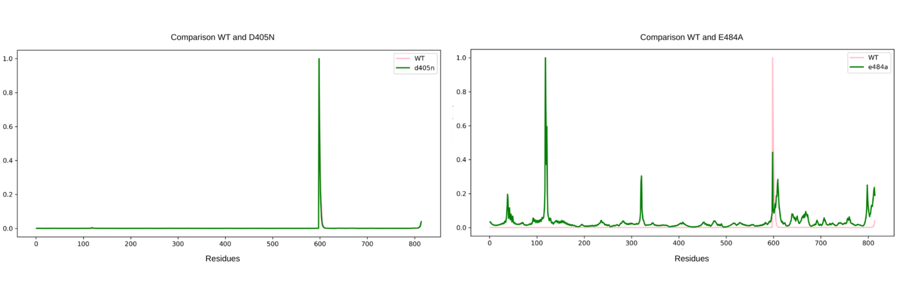
Figure S30 Root-mean-square fluctuation (RMSF) profiles of Cα atoms across residues for the D405N and E484A mutants. The WT (pink) exhibited a predominantly uniform fluctuation profile with a single dominant peak. D405N showed a WT-like fluctuation pattern with a similar dominant peak. In contrast, E484A exhibited increased fluctuations across both the RBD and ACE2, indicating increased local mobility

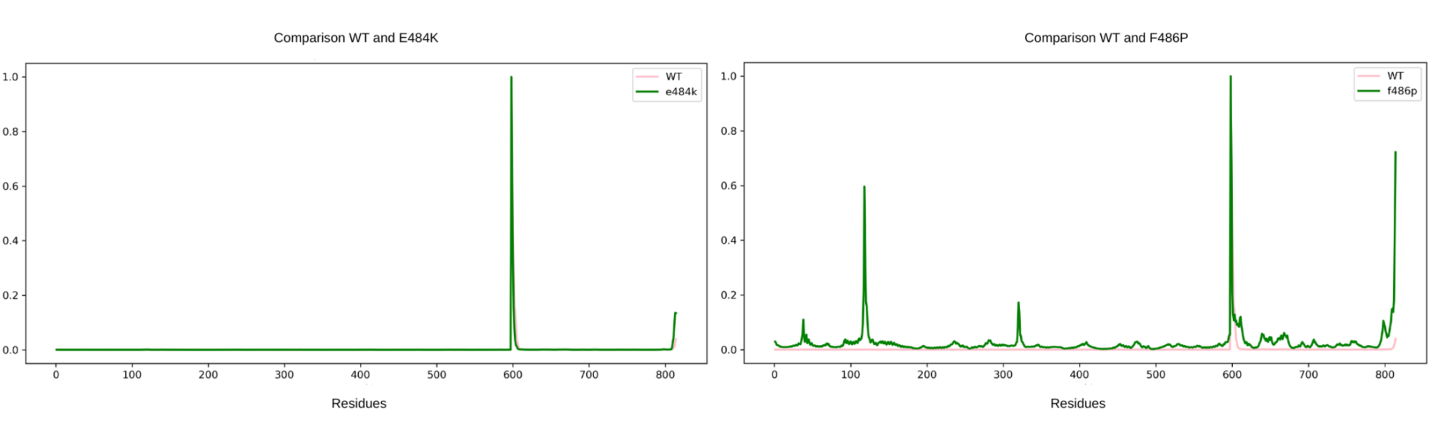
Figure S31 RMSF profiles of Cα atoms across residues for the E484K and F486P mutants. E484K exhibited a WT-like fluctuation profile characterized by a predominantly uniform pattern with a single dominant peak. F486P displayed fluctuations across residues similar to those observed for E484A, although with lower amplitudes

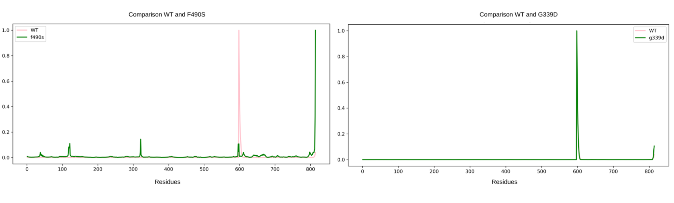
Figure S32 RMSF profiles of Cα atoms across residues for the F490S and G339D mutants. F490S exhibited slight deviations from the WT, with localized fluctuations in specific regions. G339D maintained a WT-like fluctuation profile characterized by a predominantly uniform pattern with a single dominant peak

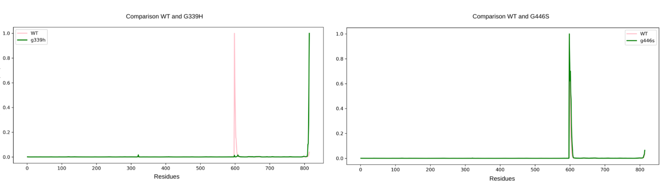Figure S33 RMSF profiles of Cα atoms across residues for the G339H and G446S mutants. G339H exhibited an overall uniform fluctuation profile with only two localized short fluctuations. G446S maintained a WT-like fluctuation profile with a predominantly uniform pattern and a single dominant peak
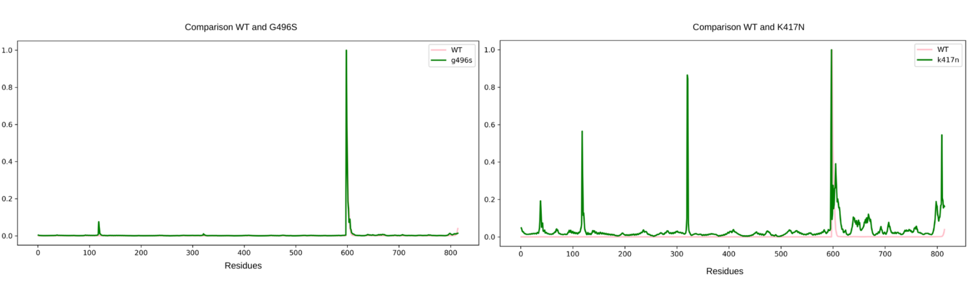Figure S34 RMSF profiles of Cα atoms across residues for the G496S and K417N mutants. G496S maintained a WT-like fluctuation profile characterized by a predominantly uniform pattern with a single dominant peak. In contrast, K417N exhibited increased fluctuations across both the RBD and ACE2, indicating greater structural flexibility

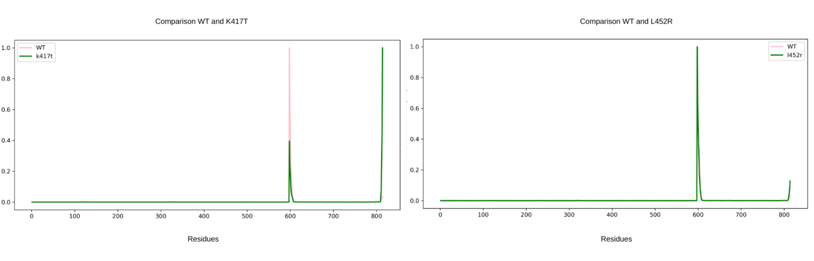Figure S35 RMSF profiles of Cα atoms across residues for the K417T and L452R mutants. Both mutants maintained WT-like fluctuation profiles characterized by predominantly uniform patterns with a single dominant peak

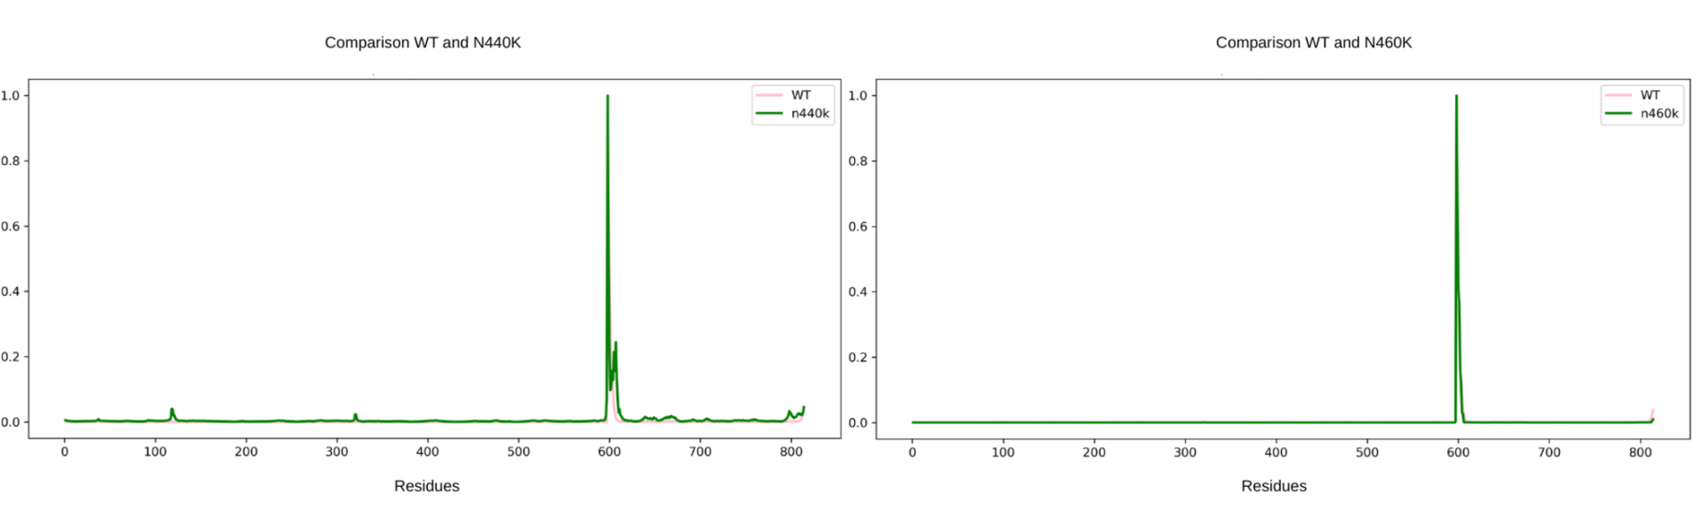Figure S36 RMSF profiles of Cα atoms across residues for the N440K and N460K mutants. N440K exhibited slight deviations from the WT, with localized fluctuations in the RBD. N460K maintained a WT-like fluctuation profile characterized by a predominantly uniform pattern with a single dominant peak

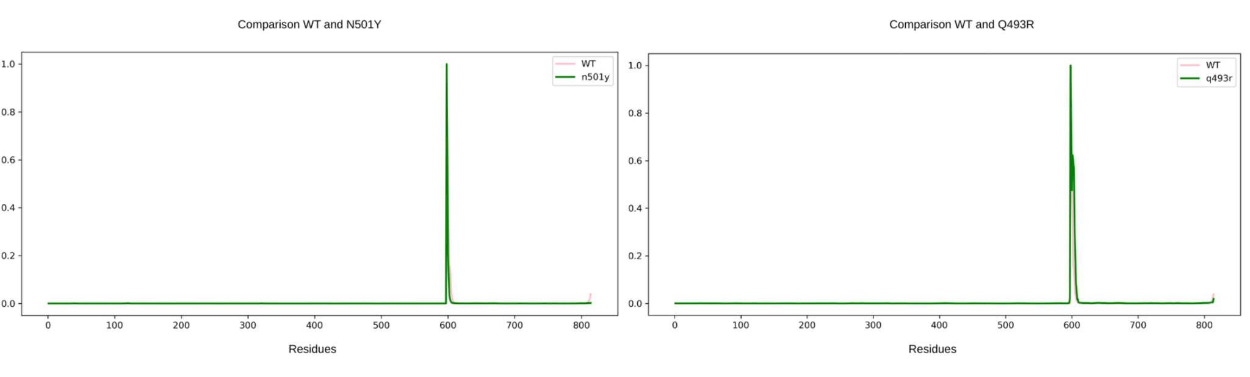Figure S37 RMSF profiles of Cα atoms across residues for the N501Y and Q493R mutants. Both mutants maintained WT-like fluctuation profiles characterized by predominantly uniform patterns with a single dominant peak

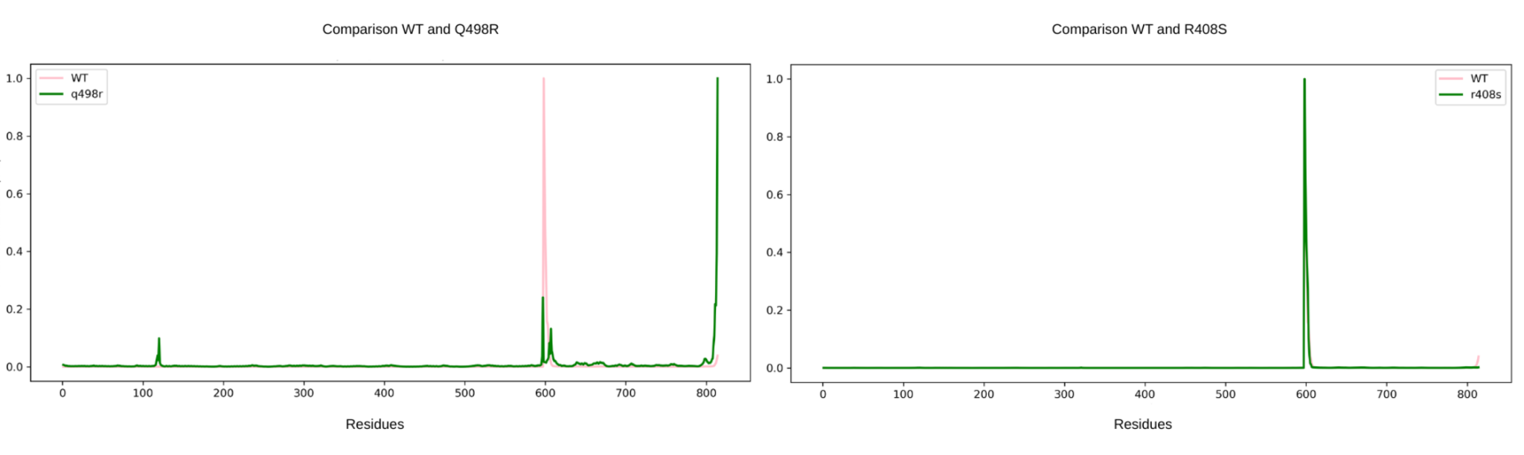Figure S38 RMSF profiles of Cα atoms across residues for the Q498R and R408S mutants. Q498R exhibited some fluctuations within the RBD. R408S maintained a WT-like fluctuation profile characterized by a predominantly uniform pattern with a single dominant peak
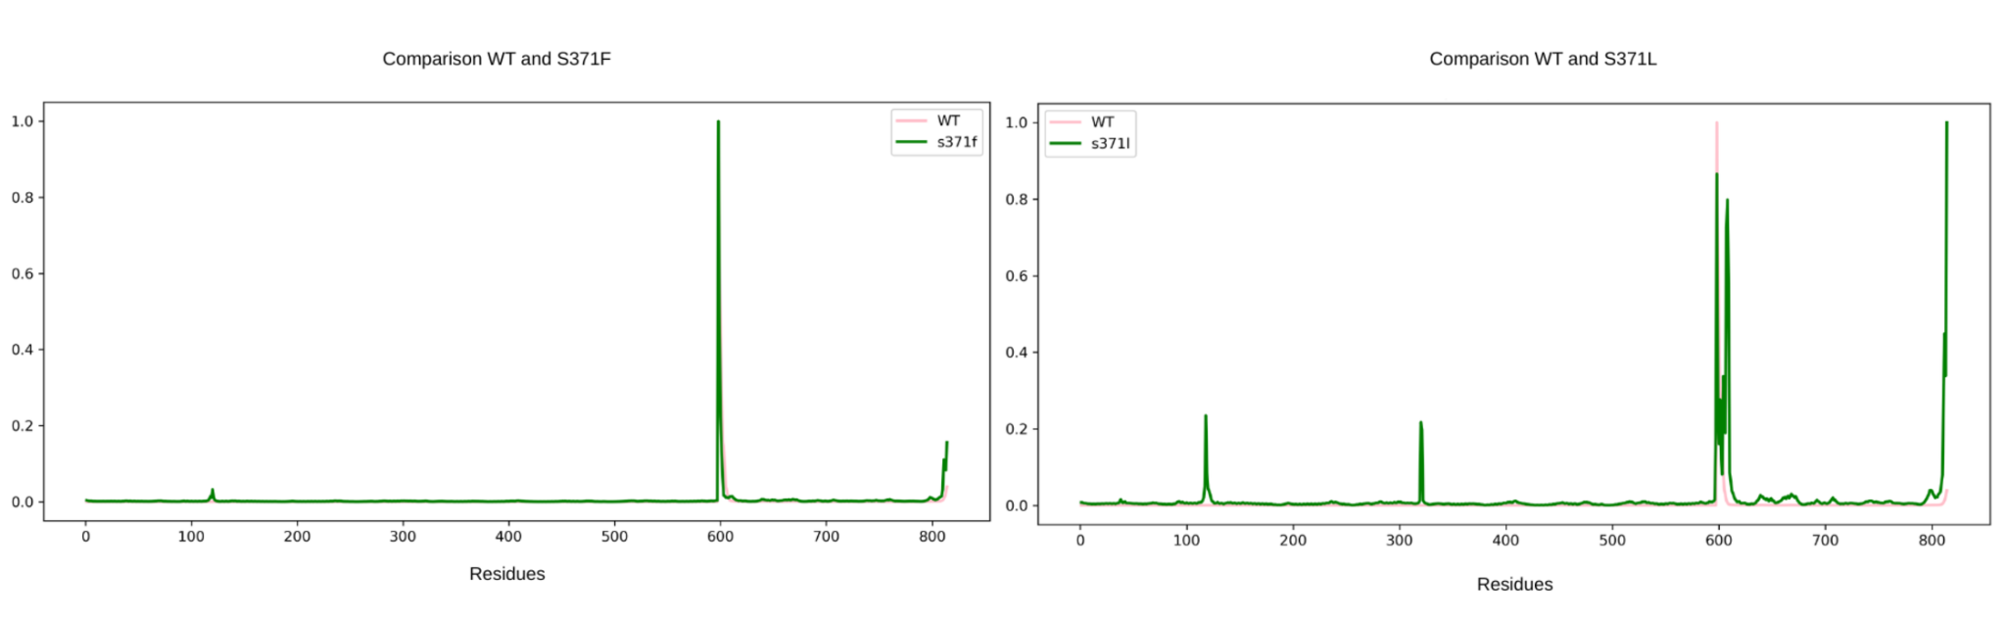Figure S39 RMSF profiles of Cα atoms across residues for the S371F and S371L mutants. S371F maintained a WT-like fluctuation profile characterized by a predominantly uniform pattern with a single dominant peak. In contrast, S371L exhibited increased fluctuations across both ACE2 and the receptor-binding domain (RBD)

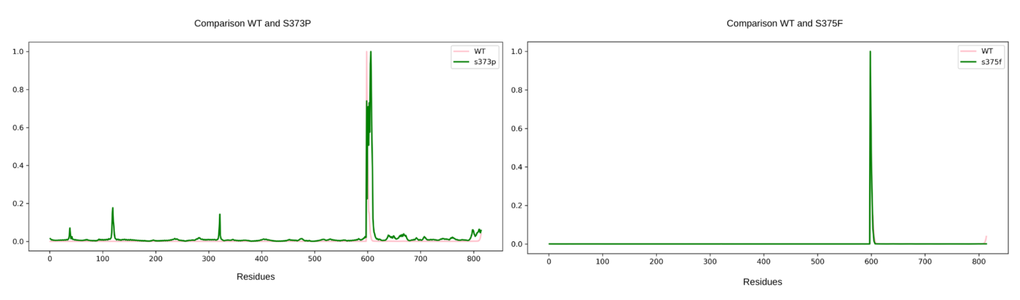Figure S40 RMSF profiles of Cα atoms across residues for the S373P and S375F mutants. S373P exhibited increased fluctuations across both ACE2 and RBD. S375F maintained a WT-like fluctuation profile characterized by a predominantly uniform pattern with a single dominant peak

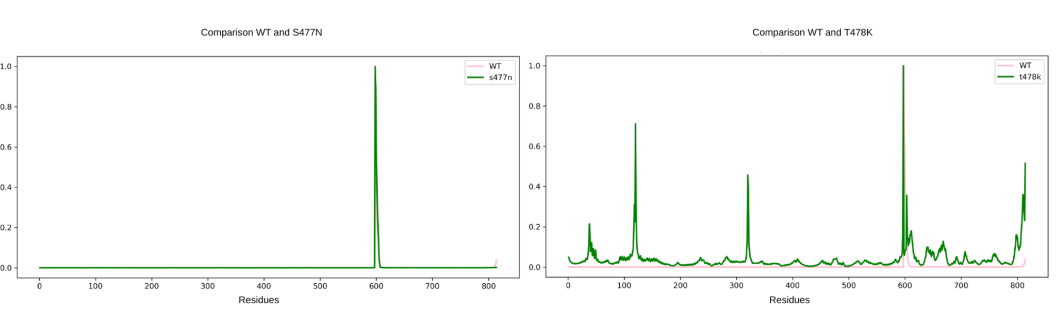Figure S41 RMSF profiles of Cα atoms across residues for the S477N and T478K mutants. S477N maintained a WT-like fluctuation profile characterized by a predominantly uniform pattern with a single dominant peak. In contrast, T478K exhibited increased fluctuations across both ACE2 and the RBD, indicating greater structural flexibility

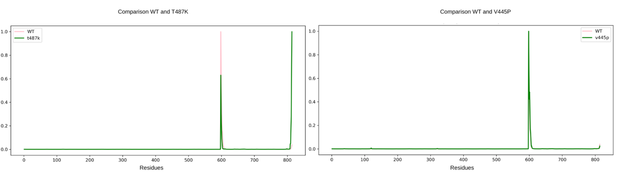Figure S42 RMSF profiles of Cα atoms across residues for the T487K and V445P mutants. Both mutants maintained WT-like fluctuation profiles characterized by predominantly uniform patterns with a single dominant peak

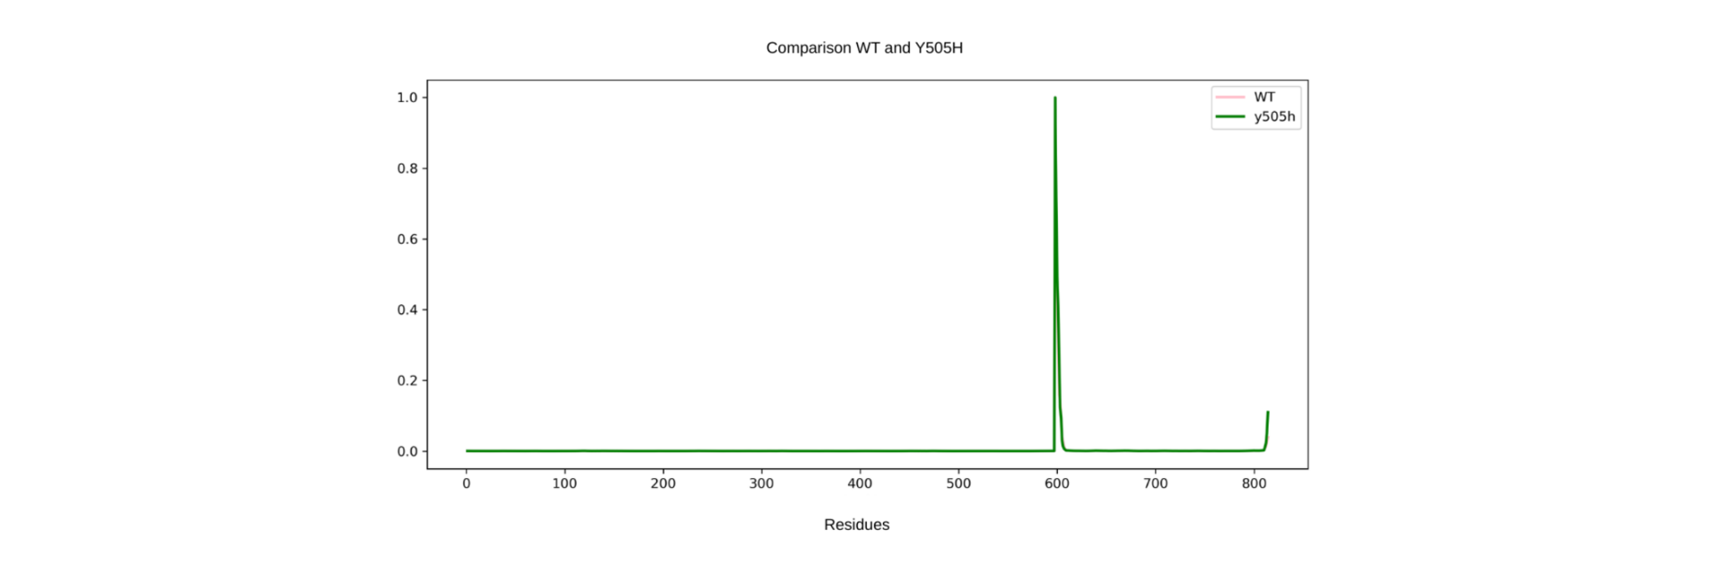Figure S43 RMSF profiles of Cα atoms across residues for the Y505H mutant. Y505H maintained a WT-like fluctuation profile characterized by a predominantly uniform pattern with a single dominant peak
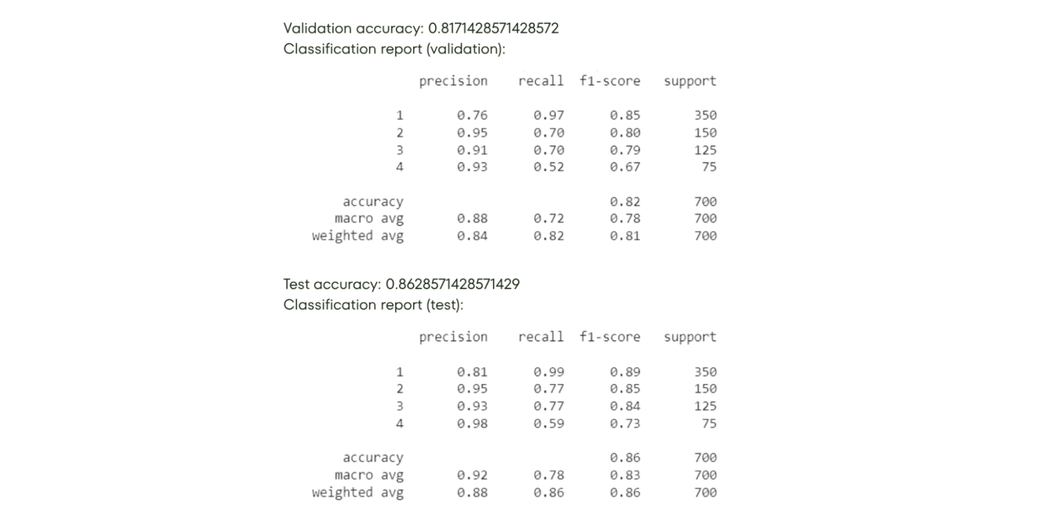

Figure S44 Performance of the Random Forest classification model. The model achieved a validation accuracy of 0.82 and a test accuracy of 0.86. Classification reports for the validation and test sets are shown, including precision, recall, F1-score, and support for each class. Overall, the model demonstrated strong predictive performance, with weighted F1-scores of 0.81 for the validation set and 0.86 for the test set

