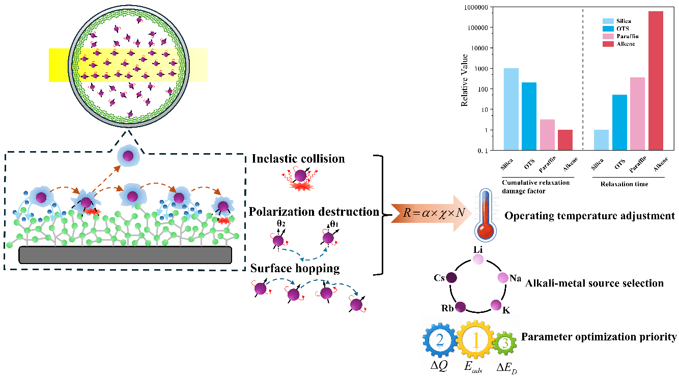
This work focuses on anti-relaxation coatings for alkali metal vapor cells in quantum sensing instruments. We analyzed the wall-collision relaxation mechanism by decomposing the long-range dynamics into three sub-stages : Inelastic collision, Hyperfine polarization destruction, and Surface hopping, which are quantified by adsorption energy, charge migration, and diffusion energy barrier based on first-principles calculations. A cumulative relaxation damage factor is established by integrating these parameters via a product-type functional form, enabling effective material evaluation, alkali-metal source selection, and operating temperature optimization. This work aims to provide a unified theoretical framework for rational coating design and drive performance breakthroughs in quantum sensors.

