Pedodiversity as a Key Element of Geological Heritage in the Shouf Jezzine Geopark Project Lebanon
BOU GHOSN SALAMEH Reine^{1,2,3*}; AYADI MAASRI Soumaya^{1,2}; HASSOUN Georges³; ABBOUD Maher²; ERRAMI Ezzoura⁴
¹Association for Community and Environment (ACE), Baabda, Lebanon
²Laboratoire E2D, UR-EGP, Centre d’Analyses et de Recherche, Faculté des Sciences, Université Saint-Joseph, Beyrouth 1104 2020, Lebanon
³Environment and Natural Resources department, Faculty of Agronomy and Veterinary Sciences, Lebanese University, Dekwaneh, Lebanon
⁴LGG, Faculty of Sciences, Chouaïb Doukkali University, El Jadida, Morocco
*Correspondence: reinebgsalameh@ace4ce.org

Annex 1
Digitized profiles of fifteen soil pedons in AutoCAD showing horizon variability and characteristics
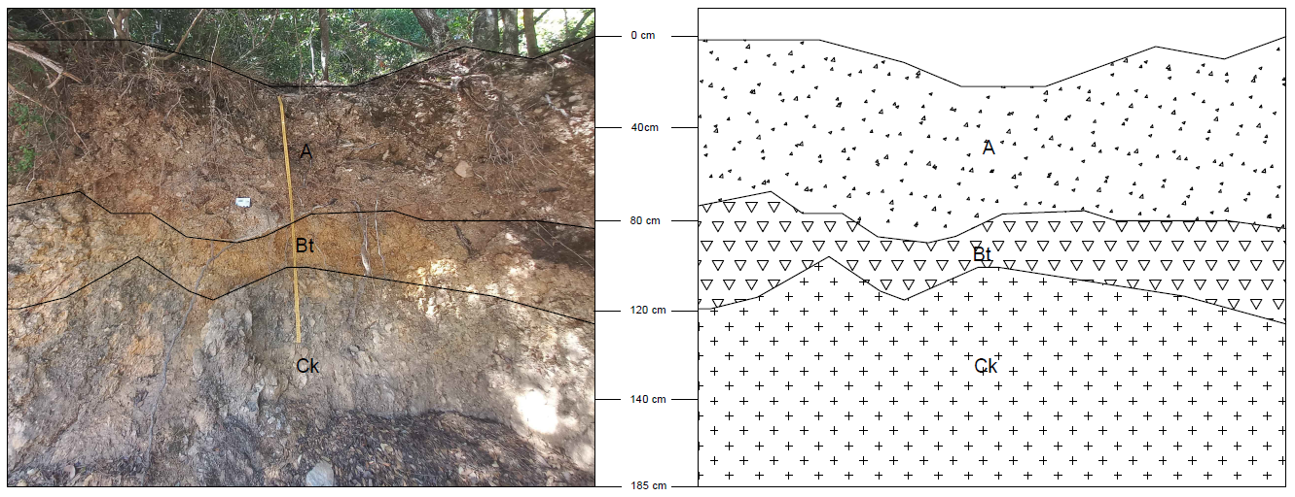

Figure 1: Aazour - Quercus calliprinos

Site | Aazour
GPS Coordinates | 33.5623 N, 35.53087 E
Altitude (m) | 796
Human Influence | None
Land Use (Tree) | Quercus calliprinos
Main Landform Hierarchy | L (Flat Terrain)
Horizon Depth (cm) | Soil Type | Color (Dry) | Soil Odor Classification | Horizon Boundary Classification | Rock Fragments & Artefacts (% Volume) | Rock Fragment Types | Rock Fragment Shape | Rock Fragment Alteration | Carbonate Reaction | Mineral Concentration | Root Abundance | Root Diameter
0-80 (A) | Silty Clay | 10YR 4/3 | N: None detected | C: Clear | 2% F (Low, 2-5%) | M (Medium gravel, 6-20 mm) | S (Sub-rounded) | F (Fresh or slightly altered) | Extremely calcareous | N (None, 0%) | V (Very few) | VF (Very fine, <0.5 mm)
80-115 (Bt) | Silty Clay Loam | 7.5YR 5/4 | N: None detected | C: Clear | 20% M (Numerous, 15-40%) | M (Medium gravel, 6-20 mm) | S (Sub-rounded) | F (Fresh or slightly altered) | Extremely calcareous | N (None, 0%) | N (None) | -
115-185 (Ck) | Silty | 5Y 6/3 | N: None detected | C: Clear | 20% M (Numerous, 15-40%) | C (Coarse gravel, 20-60 mm) | S (Sub-rounded) | F (Fresh or slightly altered) | Extremely calcareous | N (None, 0%) | N (None) | -

Soil Classification (WRB): Calcic Luvisol
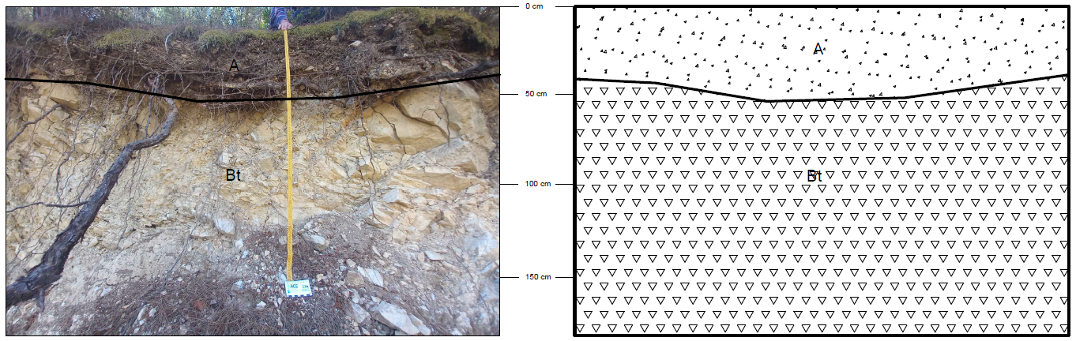
Figure 2: Aazour – Pinus brutia

Site | Aazour
GPS Coordinates | 33.8418 N, 35.74669 E
Altitude (m) | 776
Human Influence | None
Land Use (Tree) | Pinus brutia
Main Landform Hierarchy | L (Flat Terrain)

Horizon Depth (cm) | Soil Type | Color (Dry) | Soil Odor Classification | Horizon Boundary Classification | Rock Fragments & Artefacts (% Volume) | Rock Fragment Types | Rock Fragment Shape | Rock Fragment Alteration | Carbonate Reaction | Mineral Concentration | Root Abundance | Root Diameter
0–60 (A) | Sandy Loam | 5Y 4/2 | N: None detected | C: Clear | 12% C (Common, 5–15%) | M (Medium gravel, 6–20 mm)+ MC mix | A (Angular) | F (Fresh or slightly altered) | Extremely calcareous | N (None, 0%) | V (Very few) | F (Fine)
60–150 (Bt) | Sandy Loam | 10YR 5/3 | N: None detected | C: Clear | >50% A (Abundant, 40–80%) | C (Coarse gravel, ~35 mm) + MC mix | A (Angular) | F (Fresh or slightly altered) | Extremely calcareous | N (None, 0%) | N (None) | –
Soil Classification (WRB): Haplic cambisol
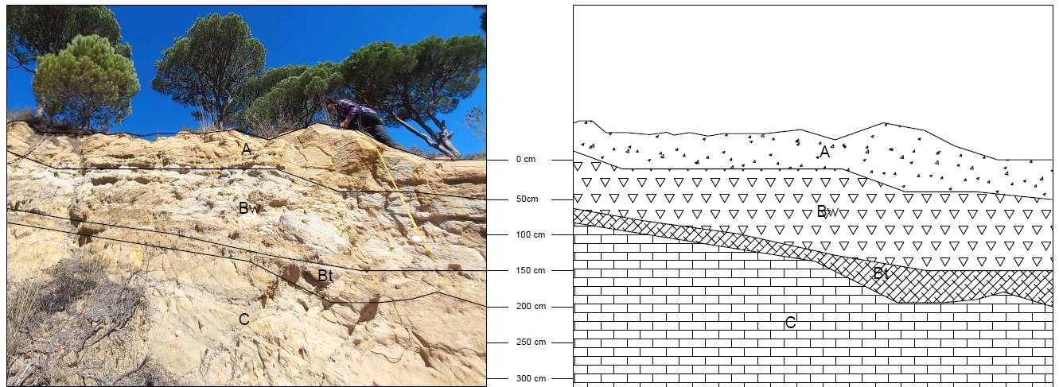
Figure 3: Homsiyeh - Pinus pinea

Site | Homsiyeh
GPS Coordinates | 33.54798 N, 35.55316 E
Altitude (m) | 959
Human Influence | None
Land Use (Tree) | Pinus pinea
Main Landform Hierarchy | Slope

Horizon Depth (cm) | Soil Type | Color (Dry) | Soil Odor Classification | Horizon Boundary Classification | Rock Fragments & Artefacts (% Volume) | Mineral Concentration (% Volume) | Types of Mineral Concentrations | Mineral Concentration Size | Mineral Concentration Shape | Mineral Concentration Hardness | Carbonate Reaction | Root Abundance | Root Diameter
0–40 (A) | Loamy Sand | 10YR 3/2 | N: None detected | C: Clear | N (None, 0%) | 95% D (Dominant >80%) | C (Concretion) | F, M, C (Fine 2–6 mm; Medium 6–20 mm; Coarse >20 mm) | I (Irregular), A (Angular) | B (Both hard and soft) | Slightly calcareous | N (None) | –
40–150 (Bw) | Loamy Sand | 2.5Y 5/2 | N: None detected | C: Clear | N (None, 0%) | >80% D (Dominant) | C (Concretion) | C (Coarse >20 mm) | I (Irregular), A (Angular) | B (Both hard and soft) | Slightly calcareous | N (None) | –
150–180 (Bt) | Loamy Sand | 7.5YR 5/6 | N: None detected | C: Clear | N (None, 0%) | 80% D (Dominant >80%) | C (Concretion) | F, M, C | I (Irregular), A (Angular) | B (Both hard and soft) | Slightly calcareous | N (None) | –
180–310 (C) | Sandy Loam | 10YR 6/4 | N: None detected | C: Clear | N (None, 0%) | 90% D (Dominant >80%) | C (Concretion) | F, M, C | I (Irregular), A (Angular) | B (Both hard and soft) | Moderately calcareous | N (None) | –
Soil Classification (WRB): Haplic cambisol
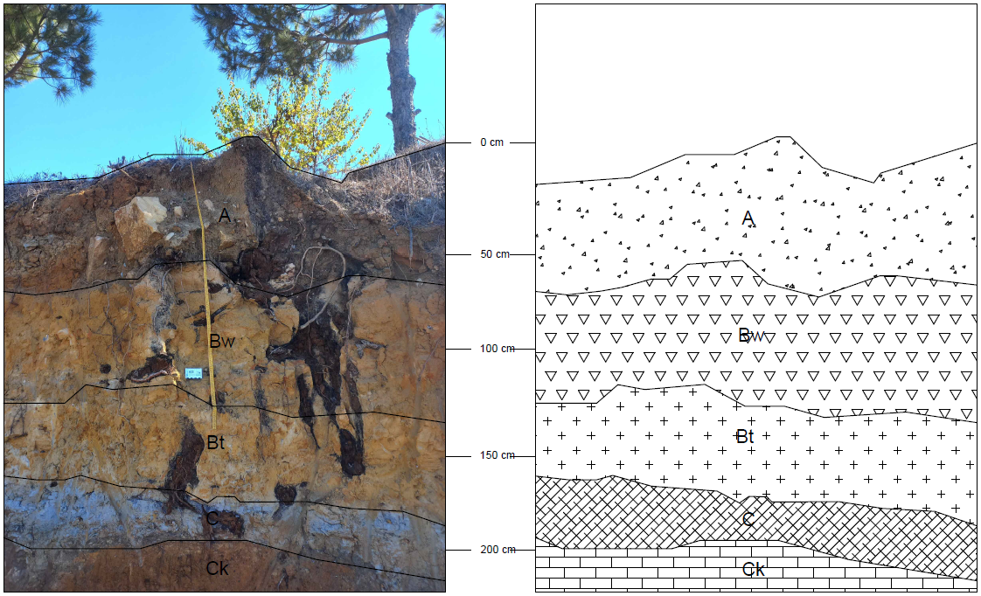

Figure 4: Sabbah - Pinus pinea

Site | Sabbah
GPS Coordinates | 33.56643 N, 35.56372 E
Altitude (m) | 1014
Human Influence | None
Land Use (Tree) | Pinus pinea
Main Landform Hierarchy | L (Flat Terrain)
Horizon Depth (cm) | Soil Type | Color (Dry) | Soil Odor Classification | Horizon Boundary Classification | Rock Fragments & Artefacts (% Volume) | Rock Fragment Types | Rock Fragment Shape | Rock Fragment Alteration | Carbonate Reaction | Mineral Concentration | Root Abundance | Root Diameter
0-60 (A) | Sandy Loam | 5YR 4/3 | N: None detected | C: Clear | 5% C (Common, 5-15%) | C (Coarse gravel, 20-60 mm) | A (Angular) | F (Fresh or slightly altered) | Lightly calcareous | N (None, 0%) | N (None) | -
60-140 (Bw) | Sandy Loam | 7.5YR 4/4 | N: None detected | C: Clear | N (None, 0%) | - | - | - | Lightly calcareous | 80% D (Dominant >80%)  C (Concretion)  I (Irregular), A (Angular)  B (Both hard and soft) | N (None) | -
140-185 (Bt) | Sandy Clay Loam | 10YR 5/2 | N: None detected | C: Clear | N (None, 0%) | - | - | - | Lightly calcareous | 95% D (Dominant >80%)  C (Concretion)  I (Irregular), A (Angular)  B (Both hard and soft) | N (None) | -
185-200 (C) | Sandy Loam | 2.5Y 6/3 | N: None detected | C: Clear | N (None, 0%) | - | - | - | Lightly calcareous | 40% A (Abundant, 40-80%)  S (Soft Segregation)  I (Irregular), A (Angular)  H (Hard, cannot be broken by hand) | N (None) | -
200-240 (Ck) | Sandy Loam | 5YR 5/4 | N: None detected | C: Clear | N (None, 0%) | - | - | - | Lightly calcareous | N (None, 0%) | N (None) | -
Soil Classification (WRB): Calcic Cambisol

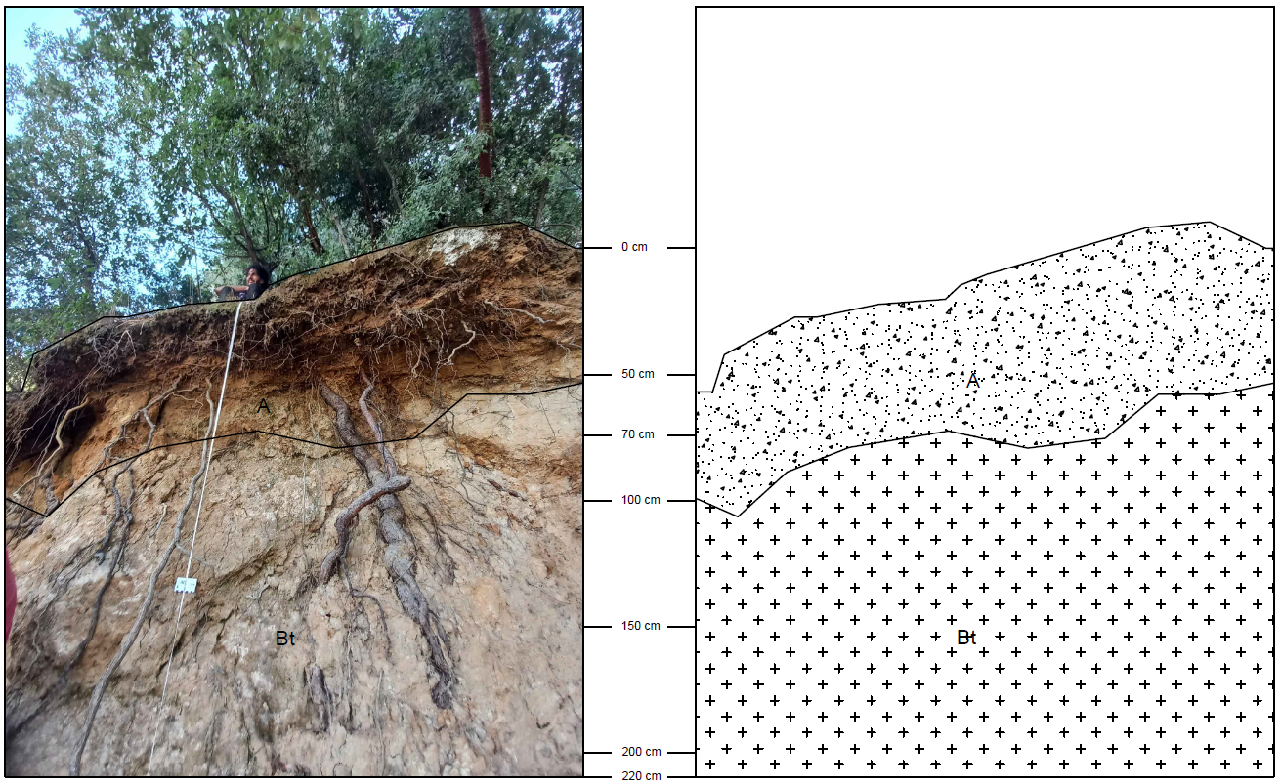

Figure 5: Bkassine – Quercus calliprinos

Site | Bkassine
GPS Coordinates | 33.55801 N, 35.57772 E
Altitude (m) | 762
Human Influence | None
Land Use (Tree) | Quercus calliprinos
Main Landform Hierarchy | Slope

Horizon Depth (cm) | Soil Type | Color (Dry) | Soil Odor Classification | Horizon Boundary Classification | Rock Fragments & Artefacts (% Volume) | Rock Fragment Types | Rock Fragment Shape | Rock Fragment Alteration | Carbonate Reaction | Mineral Concentration | Mineral Concentration Type | Mineral Concentration Characteristics (Size / Shape / Hardness) | Root Abundance | Root Diameter
0–70 (A) | Sandy loam | 5YR 3/2 | N: None detected | C: Clear | N: None (0%) | – | – | – | Moderate calcareous | N: None (0%) | – | – | V: Very few (3%) | VF: Very fine (<0.5 mm)
70–220 (Bt) | Sandy clay loam | 7.5YR 5/6 | N: None detected | C: Clear | N: None (0%) | – | – | – | Not specified | 95% D: Dominant (>80%) | C: Concretion | Size: F (2–6 mm) & C (>20 mm) Shape: I (Irregular), A (Angular) Hardness: B (Both hard & soft) | N: None | –
Soil Classification (WRB): Dystric cambisol

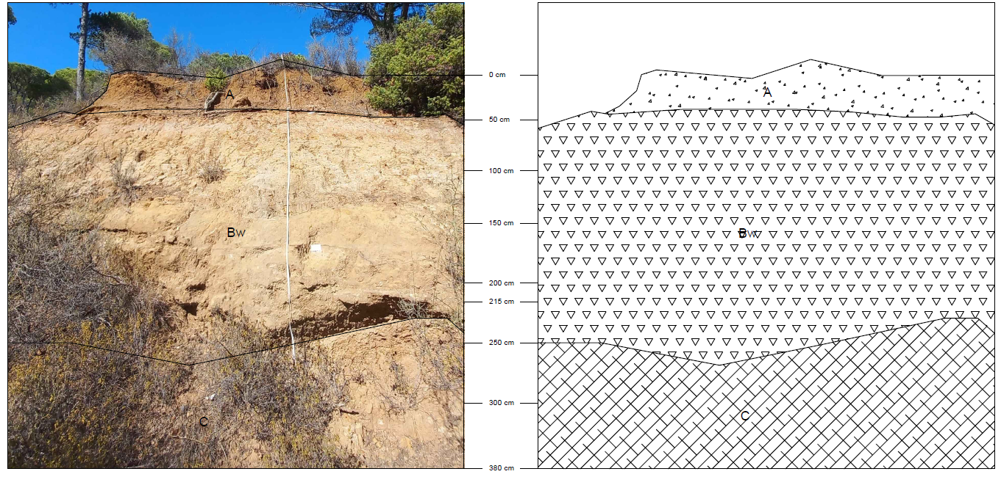

Figure 6: Bkassine – Pinus pinea

Site | Bkassine
GPS Coordinates | 33.56090 N 35.57063 E
Altitude (m) | 877
Human Influence | None
Land Use (Tree) | Pinus pinea
Main Landform Hierarchy | Slope

Horizon Depth (cm) | Soil Type | Color (Dry) | Soil Odor Classification | Horizon Boundary Classification | Rock Fragments & Artefacts (% Volume) | Rock Fragment Types | Rock Fragment Shape | Rock Fragment Alteration | Carbonate Reaction | Mineral Concentration | Mineral Concentration Type | Mineral Concentration Characteristics (Size / Shape / Hardness) | Root Abundance | Root Diameter
0–50 (A) | Sandy clay loam | 10YR 4/3 | N: None detected | C: Clear | N: None (0%) | – | – | – | Moderately calcareous | N: None (0%) | – | – | V: Very few | VF: Very fine (<0.5 mm)
50–215 (Bw) | Sandy loam | 10YR 6/3 | N: None detected | C: Clear | N: None (0%) | – | – | – | Moderately calcareous | 95% D: Dominant (>80%) | C: Concretion | Size: C (>20 mm) Shape: A (Angular), F (Platy) Hardness: H (Hard; cannot be broken by fingers) | N: None | –
215–430 (C) | Sandy loam | 10YR 6/3 | N: None detected | C: Clear | N: None (0%) | – | – | – | Slightly calcareous | N: None (0%) | – | – | N: None | –
Soil Classification (WRB): Haplic cambisol
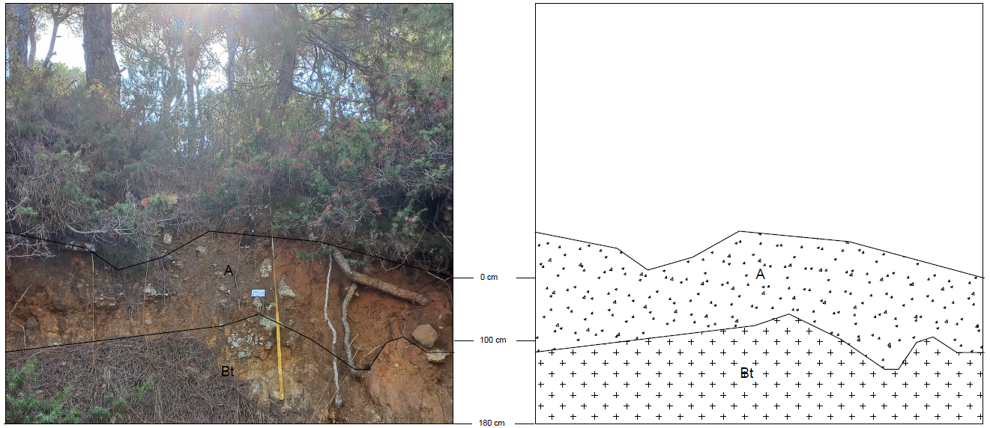

Figure 7: Bkassine – Pinus brutia

Site | Bkassine
GPS Coordinates | 33.55392 N 35.56861 E
Altitude (m) | 931
Human Influence | None
Land Use (Tree) | Pinus brutia
Main Landform Hierarchy | L (Flat Terrain)

Horizon Depth (cm) | Soil Type | Color (Dry) | Soil Odor Classification | Horizon Boundary Classification | Rock Fragments & Artefacts (% Volume) | Carbonate Reaction | Mineral Concentration (Volume %) | Mineral Concentration Type | Mineral Concentration Characteristics (Size / Shape / Hardness) | Root Abundance | Root Diameter
0–100 (A) | Clay loam | 7.5YR 4/4 | N: None detected | C: Clear | N: None (0%) | Moderately calcareous | N: None (0%) | – | – | V: Very few | F: Fine
100–180 (Bt) | Sandy clay loam | 10YR 5/3 | N: None detected | C: Clear | N: None (0%) | Slightly calcareous | 50% A: Abundant (40–80%) | C: Concretion | Size: M (Medium, 6–20 mm) and C (>20 mm) Shape: I (Irregular) and A (Angular) Hardness: S (Soft; can be broken between thumb and forefinger) | N: None | –
Soil Classification (WRB): Haplic luvisol

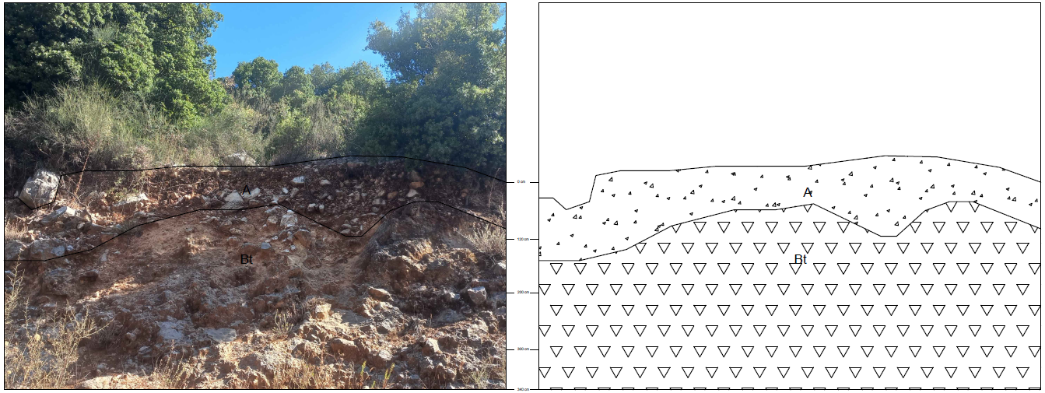
Figure 8: Niha – Quercus calliprinos

Site | Niha
GPS Coordinates | 33.59790N 35.62985E
Altitude (m) | 1078
Human Influence | None
Land Use (Tree) | Quercus calliprinos
Main Landform Hierarchy | Slope

Horizon Depth (cm) | Soil Type | Color (Dry) | Soil Odor Classification | Horizon Boundary Classification | Rock Fragments & Artefacts (% Volume) | Rock Fragment Characteristics (Type / Combination / Shape / Weathering) | Carbonate Reaction | Mineral Concentration (Volume %) | Mineral Concentration Type | Mineral Concentration Characteristics (Size / Shape / Hardness) | Root Abundance
0–120 (A) | Sandy loam | 10YR 4/3 | N: None detected | C: Clear | 10% C: Common (5–15%) | Types: M (Medium gravel, 6–20 mm) & C (Coarse gravel, 20–60 mm) Combination: MC (Medium & coarse gravel / artefacts) Shape: A (Angular) Weathering: F (Fresh or slightly weathered) | Strongly calcareous | N: None (0%) | – | – | N: None
120–340 (Bt) | Sandy loam | 7.5YR 5/4 | N: None detected | C: Clear | N: None (0%) | – | Extremely calcareous | 10% C: Common (2–15%) | SC: Soft concretion | Size: F (Fine, 2–6 mm) & M (Medium, 6–20 mm) Shape: I (Irregular) & A (Angular) Hardness: S (Soft; can be broken between thumb and forefinger) | N: None
Soil Classification (WRB): Haplic cambisol

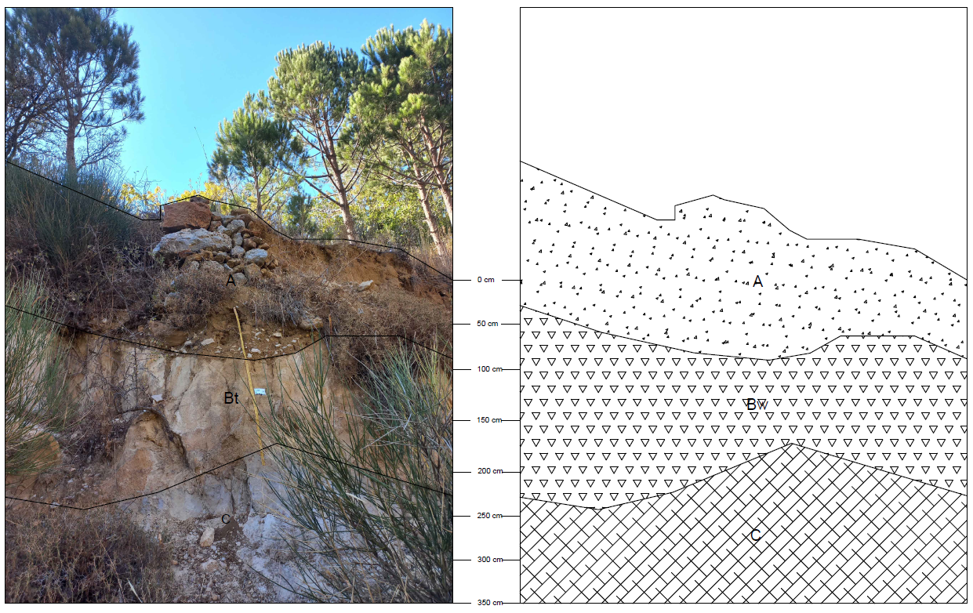

Figure 9: Niha – Pinus pinea

Site | Niha
GPS Coordinates | 33.58593 N 35.63383 E
Altitude (m) | 1104
Human Influence | None
Land Use (Tree) | Pinus pinea
Main Landform Hierarchy | L (Flat Terrain)

Horizon Depth (cm) | Soil Type | Color (Dry) | Soil Odor Classification | Horizon Boundary Classification | Rock Fragments & Artefacts (% Volume) | Carbonate Reaction | Mineral Concentration (Volume %) | Mineral Concentration Type | Mineral Concentration Characteristics (Size / Shape / Hardness) | Root Abundance
0–120 (A) | Sandy loam | 5Y 6/3 | N: None detected | C: Clear | N: None (0%) | Moderately calcareous | N: None (0%) | – | – | N: None
120–200 (Bw) | Sandy loam | 5YR 4/4 | N: None detected | C: Clear | N: None (0%) | Slightly calcareous | 90% D: Dominant (>80%) | C: Concretion | Size: M (Medium, 6–20 mm) & C (Coarse, >20 mm) Shape: I (Irregular) & A (Angular) Hardness: B (Both hard and soft) | N: None
200–340 (C) | Sandy clay loam | 2.5Y 6/4 | N: None detected | C: Clear | N: None (0%) | Slightly calcareous | 80% A: Abundant (40–80%) | C: Concretion | Size: M (Medium, 6–20 mm) & C (Coarse, >20 mm) Shape: I (Irregular) & A (Angular) Hardness: B (Both hard and soft) | N: None
Soil Classification (WRB): Haplic cambisol

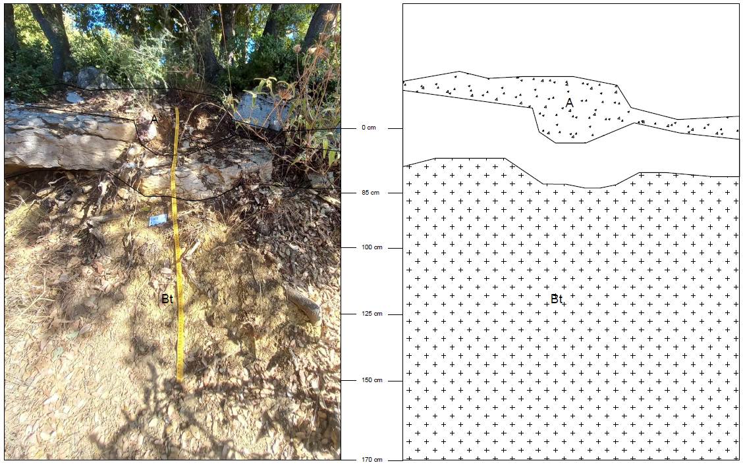

Figure 10: Dalboun – Quercus calliprinos

Site | Dalboun
GPS Coordinates | 33.68877 N 35.66840 E
Altitude (m) | 1132
Human Influence | None
Land Use (Tree) | Quercus calliprinos
Main Landform Hierarchy | L (Flat Terrain)

Horizon Depth (cm) | Soil Type | Color (Dry) | Soil Odor Classification | Horizon Boundary Classification | Rock Fragments & Artefacts (% Volume) | Rock Fragment Shape | Carbonate Reaction | Mineral Concentration (Volume %) | Mineral Concentration Type | Mineral Concentration Characteristics (Size / Shape / Hardness) | Root Abundance
0–85 (A) | Sandy loam | 10YR 5/3 | N: None detected | C: Clear | 2% V: Very few (0–2%) | A: Angular | Moderately calcareous | N: None (0%) | – | – | V: Very few (<0.5 mm)
85–170 (Bt) | Sandy loam | 5YR 4/3 | N: None detected | C: Clear | N: None (0%) | A: Angular | Extremely calcareous | 20% M: Many (15–40%) | SC: Soft concretion | Size: F (Fine, 2–6 mm) Shape: I (Irregular) & A (Angular) Hardness: S (Soft, breakable between thumb and forefinger) | N: None
Soil Classification (WRB): Haplic cambisol

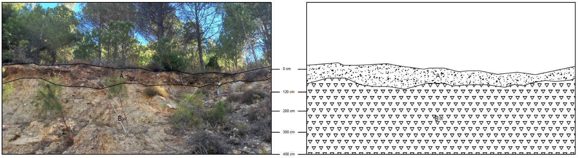

Figure 11: Mokhtara – Pinus brutia and Pinus pinea

Site | Mokhtara
GPS Coordinates | 33.65284 N 35.62561 E
Altitude (m) | 813
Human Influence | None
Land Use (Tree) | Pinus brutia and Pinus pinea
Main Landform Hierarchy | Slope

Horizon Depth (cm) | Soil Type | Color (Dry) | Soil Odor Classification | Horizon Boundary Classification | Rock Fragments & Artefacts (% Volume) | Rock Fragment Shape | Carbonate Reaction | Mineral Concentration (Volume %) | Mineral Concentration Type | Mineral Concentration Characteristics (Size / Shape / Hardness) | Root Abundance
0–120 (A) | Sandy loam | 7.5YR 4/4 | N: None detected | C: Clear | 10% C: Common (5–15%) | A: Angular | Extremely calcareous | N: None (0%) | – | – | N: None
120–340 (Bw) | Sandy clay loam | 10YR 6/3 | N: None detected | C: Clear | N: None (0%) | – | Extremely calcareous | 10% C: Common (2–15%) | C: Concretion | Size: M (Medium, 6–20 mm) & C (Coarse, >20 mm) Shape: I (Irregular) & A (Angular) Hardness: H (Hard, cannot be broken by hand) | N: None
Soil Classification (WRB): Calcic cambisol

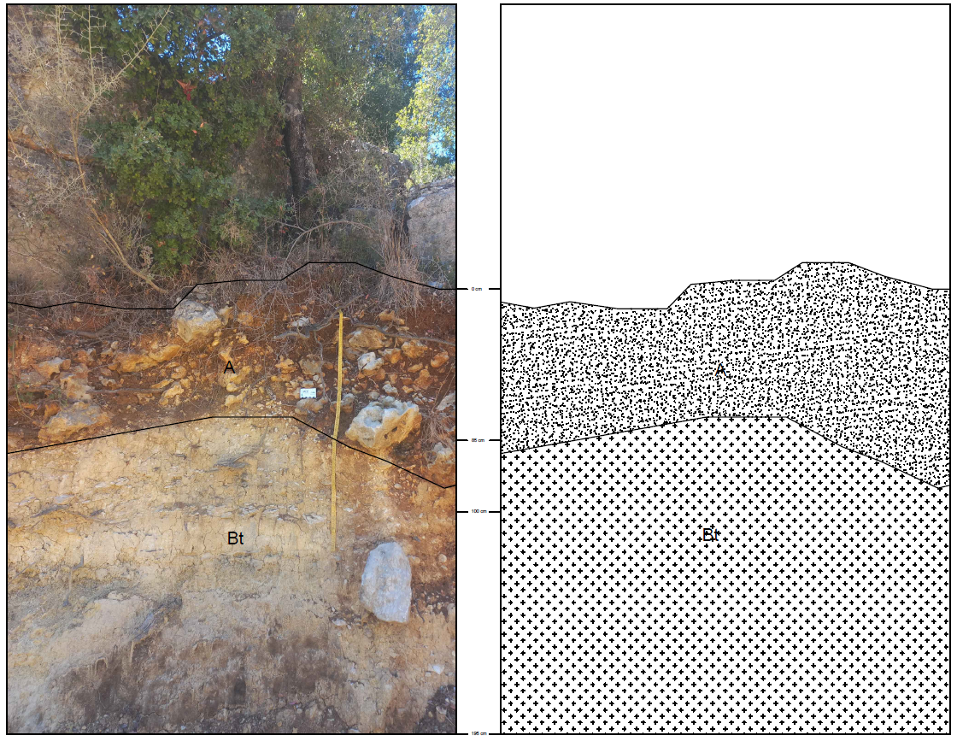

Figure 12: Baadaran – Quercus calliprinos

Site | Baadaran
GPS Coordinates | 33.62906 N 35.61875 E
Altitude (m) | 987
Human Influence | None
Land Use (Tree) | Quercus calliprinos
Main Landform Hierarchy | L (Flat Terrain)

Horizon Depth (cm) | Soil Type | Color (Dry) | Soil Odor Classification | Horizon Boundary Classification | Rock Fragments & Artefacts (% Volume) | Rock Fragment Shape | Carbonate Reaction | Mineral Concentration (Volume %) | Mineral Concentration Type | Mineral Concentration Characteristics (Size / Shape / Hardness) | Root Abundance
0–85 (A) | Sandy clay loam | 5Y 4/2 | N: None detected | C: Clear | 5% F: Few (2–5%) | A: Angular | Strongly calcareous | N: None (0%) | – | – | V: Very few
85–195 (Bt) | Sandy loam | 7.5YR 5/4 | N: None detected | C: Clear | N: None (0%) | – | Extremely calcareous | 10% C: Common (2–15%) | SC: Soft concretion | Size: M (Medium, 6–20 mm) & C (Coarse, >20 mm) Shape: I (Irregular) & A (Angular) Hardness: B (Hard & soft) | N: None
Soil Classification (WRB): Haplic luvisol

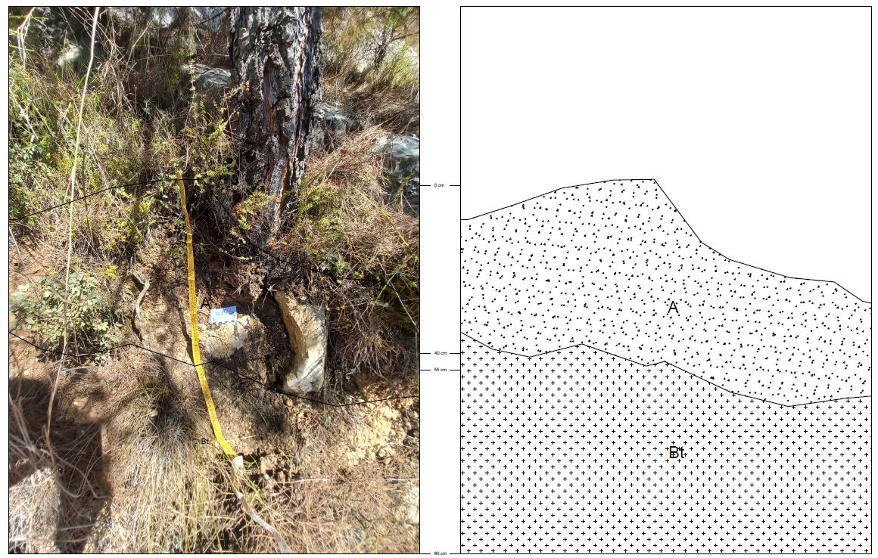

Figure 13: Baadaran – Pinus brutia

Site | Baadaran
GPS Coordinates | 33.62964 N, 35.61330 E
Altitude (m) | 992
Human Influence | None
Land Use (Tree) | Pinus brutia
Main Landform Hierarchy | L (Flat terrain)
Horizon Depth (cm) | Soil Type | Color (Dry) | Soil Odor Classification | Horizon Boundary Classification | Rock Fragments & Artefacts (% Volume) | Rock Fragment Types | Rock Fragment Shape | Rock Fragment Alteration | Carbonate Reaction | Mineral Concentration | Root Abundance | Root Diameter
0-55 (A) | Sandy Loam | 5YR 3/2 | N: None detected | C: Clear | 5% F (Few, 2-5%) | F (Fine gravel, 2-6 mm) & M (Medium gravel, 6-20 mm) | A (Angular) | F (Fresh or slightly altered) | Extremely calcareous | N (None, 0%) | V (Very few) | F (Fine)
55-80 (Bt) | Sandy Clay Loam | 10YR 5/3 | N: None detected | C: Clear | N (None, 0%) | - | - | - | Extremely calcareous | 10% C (Common, 2-15%)  SC (Soft concretion)  I (Irregular), A (Angular)  S (Soft, can be broken between thumb and index) | N (None) | -

Soil Classification (WRB): Haplic cambisol

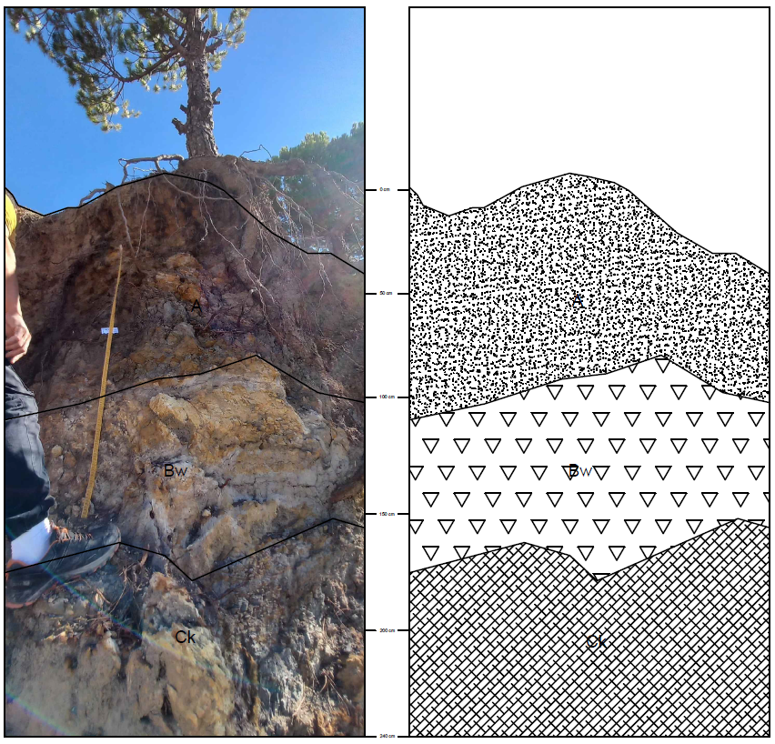

Figure 14: Mrusti – Pinus pinea

Site | Mrusti
GPS Coordinates | 33.63274 N 35.65208 E
Altitude (m) | 1303
Human Influence | None
Land Use (Tree) | Pinus pinea
Main Landform Hierarchy | Slope

Horizon Depth (cm) | Soil Type | Color (Dry) | Soil Odor Classification | Horizon Boundary Classification | Rock Fragments & Artefacts (% Volume) | Rock Fragment Shape | Carbonate Reaction | Mineral Concentration (Volume %) | Mineral Concentration Type | Mineral Concentration Characteristics (Size / Shape / Hardness) | Root Abundance
0–100 (A) | Clay | 5YR 4/4 | N: None detected | C: Clear | N: None (0%) | – | Slightly calcareous | N: None (0%) | – | – | N: None
100–150 (Bw) | Sandy | 10YR 6/4 | N: None detected | C: Clear | 10% C: Common (2–15%) | I & A: Irregular & Angular | Slightly calcareous | 10% C: Common (2–15%) | SC: Soft concretion | Size: M (Medium, 6–20 mm) Shape: I (Irregular) & A (Angular) Hardness: S (Soft, can be broken between thumb & index) | N: None
150–240 (Ck) | Sandy loam | 10YR 2/1 | S: Sulfurous | C: Clear | 20% M: Many (15–40%) | I & A: Irregular & Angular | Slightly calcareous | 20% M: Many (15–40%) | C: Concretion | Size: F (Fine, 2–6 mm), M (Medium, 6–20 mm) & C (Coarse, >20 mm) Shape: I (Irregular) & A (Angular) Hardness: H (Hard, cannot be broken with fingers) | N: None
Soil Classification (WRB): Dystric cambisol

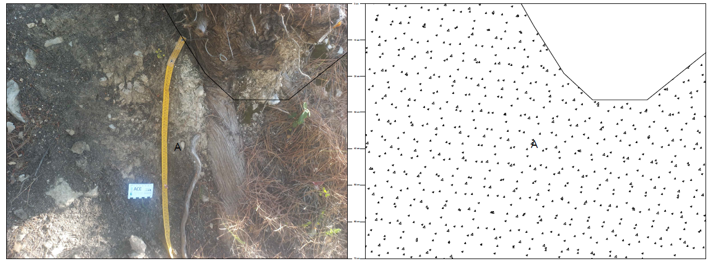

Figure 15: Bater – Pinus brutia

Site | Bater
GPS Coordinates | 33.59879 N 35.61926 E
Altitude (m) | 1303
Human Influence | None
Land Use (Tree) | Pinus brutia
Main Landform Hierarchy | L (Flat terrain)

Horizon Depth (cm) | Soil Type | Color (Dry) | Soil Odor Classification | Horizon Boundary Classification | Rock Fragments & Artefacts (% Volume) | Rock Fragment Shape | Carbonate Reaction | Mineral Concentration (Volume %) | Mineral Concentration Type | Mineral Concentration Characteristics (Size / Shape / Hardness) | Root Abundance
0–70 (A) | Sandy clay loam | 7.5YR 4/4 | N: None detected | C: Clear | N: None (0%) | – | Extremely calcareous | N: None (0%) | – | – | V: Very few, F: Fine
Soil Classification (WRB): Haplic luvisol

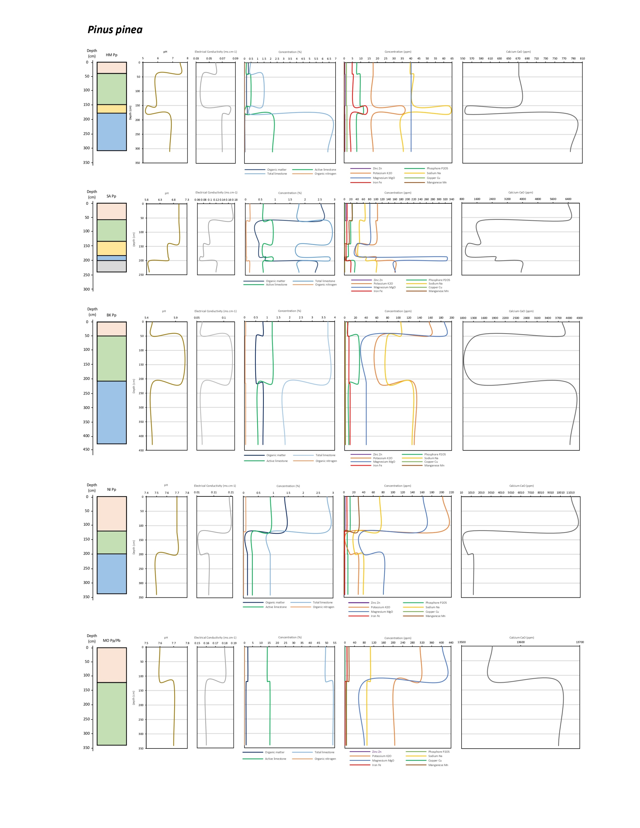
Annex 2
Physicochemical variation with depth in fifteen soil pedons across three forest species at all study sites

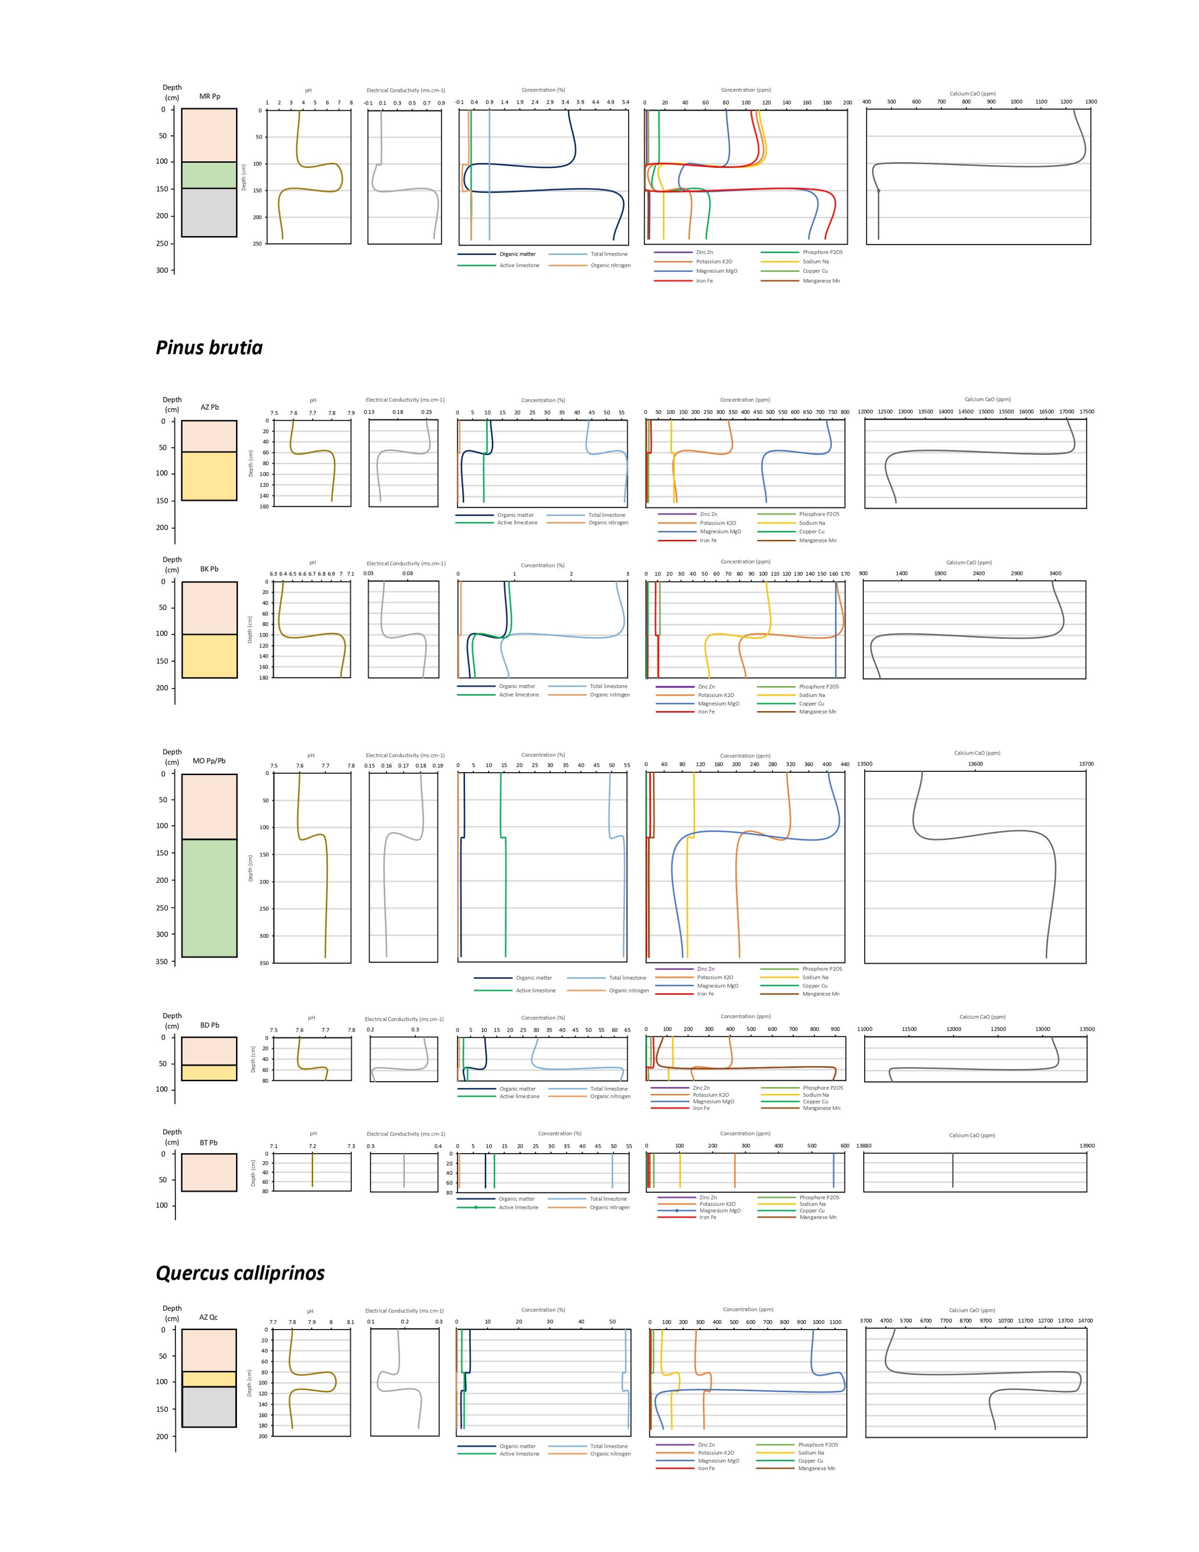

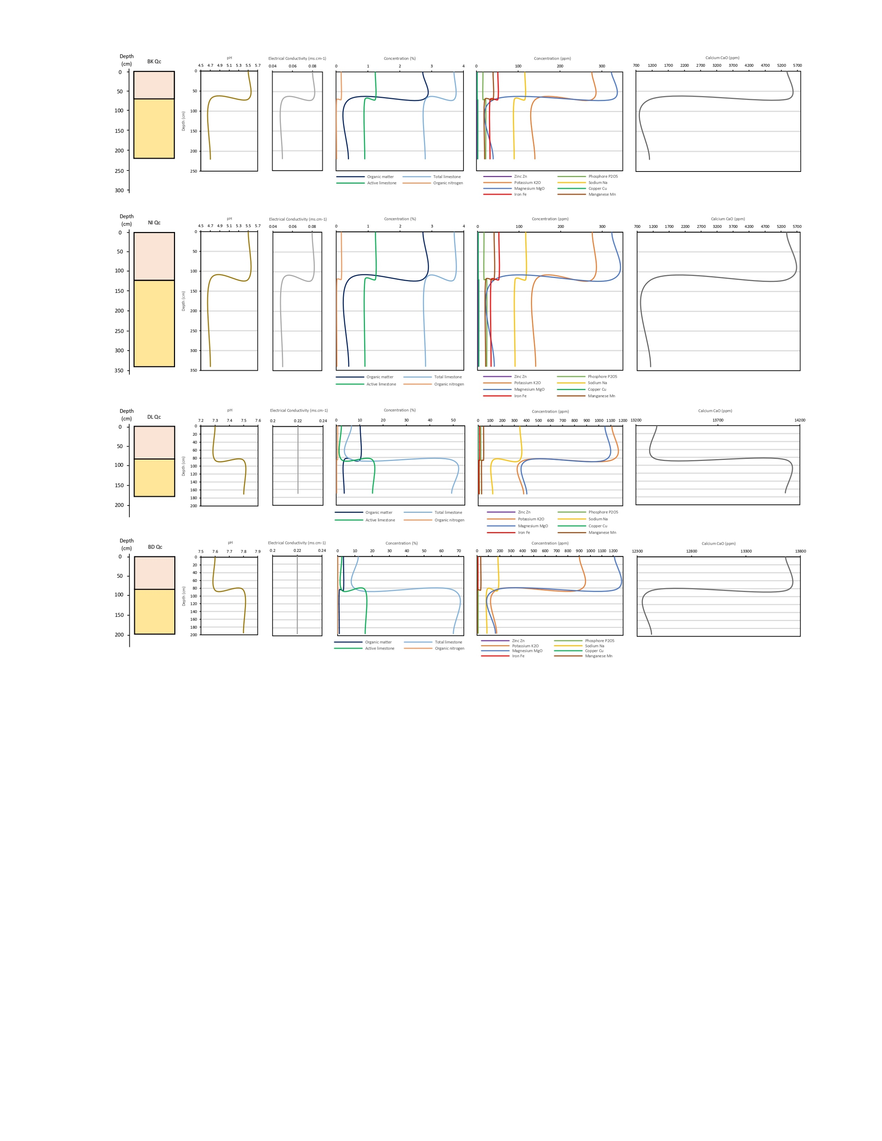

Annex 3
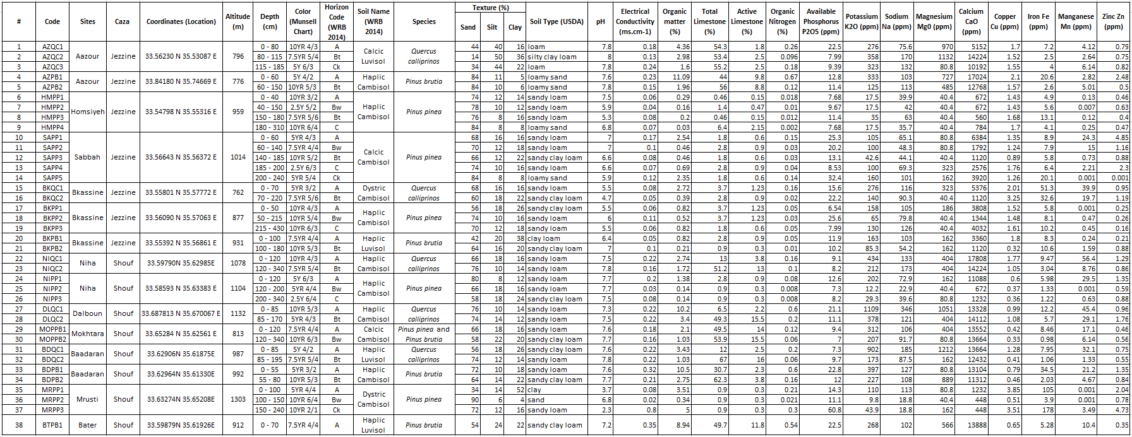
Physico-chemical analysis results of the 38 collected soil samples

