GIANT CALCIFIC INSERTIONAL ACHILLES TENDINOPATHY ASSOCIATED WITH DIABETES MELLITUS: A CLINICAL AND SURGICAL CASE REPORT

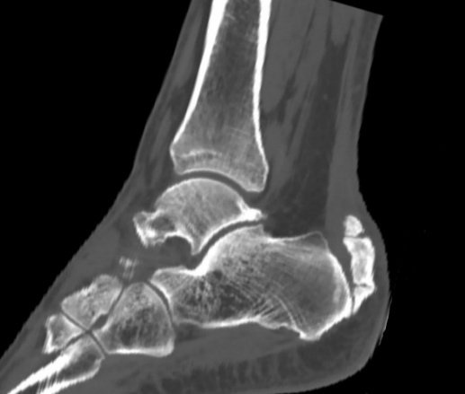
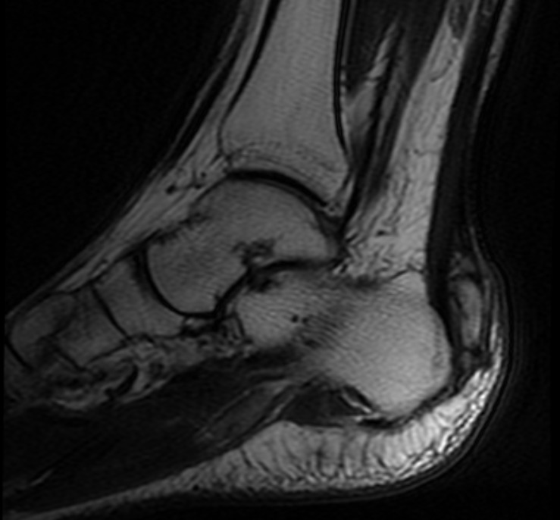
Fig-1: Preoperative Imagıng.

B
A
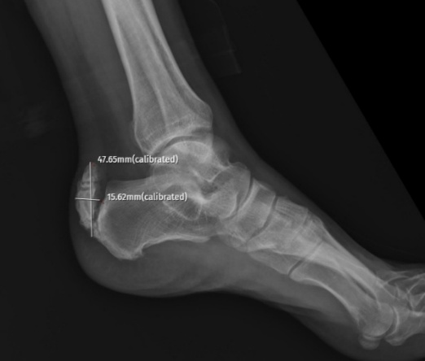
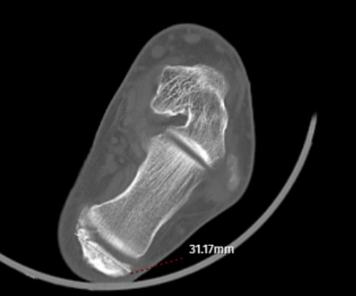

D
C

A) CT scan demonstrating calcific deposits within the Achilles tendon
B) T2-weighted MRI
C) Lateral X-ray, demonstrating the calsific lesion’s length and thickness
D) CT scan, demonstrating the calsific lesion’s width

FİG-2: INTRAOPERATIVE IMAGING
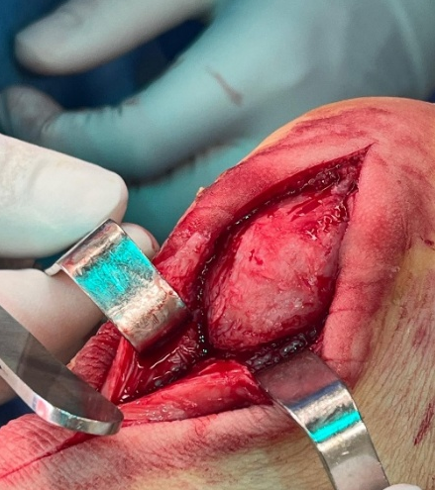
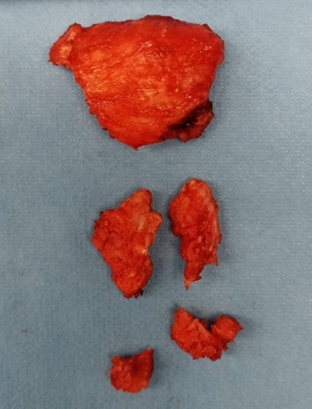
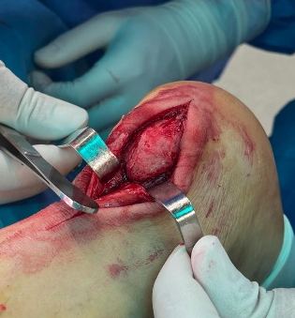
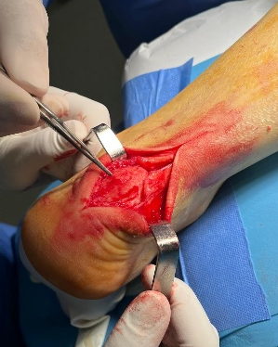
D
C
B
A

A) Exposure of the giant calcific lesion through a posteromedial incision
B) Insizion of Achilles Tendon
C) Exposure of the giant calcific lesion, different angle
D) Resected calcific lesion at the Achilles tendon insertion site

FİG-3: POSTOPERATIVE IMAGING

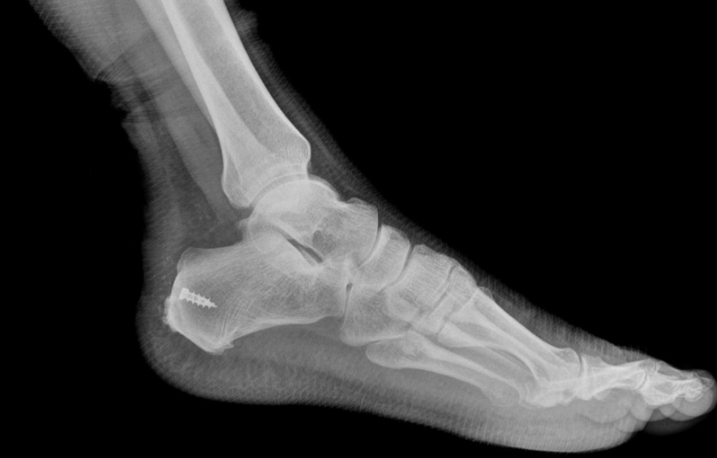
A) The Achilles tendon was reattached using suture anchors, No calcific lesion remained
A

