Supplementary Materials

Supplementary Figures ligands

- Supplementary Figure S1. Overall age-adjusted mortality rate (AAMR) forecasts for tobacco-associated ischemic heart disease mortality among adults aged ≥25 years in the United States, 2025–2035. Historical (1999–2024) and ARIMA forecasted (2025–2035) age-adjusted mortality rates per 100,000 population are shown with 95% confidence intervals.
- Supplementary Figure S2. Sex-specific age-adjusted mortality rate (AAMR) forecasts for tobacco-associated ischemic heart disease mortality among adults aged ≥25 years in the United States, 2025–2035. Historical (1999–2024) and ARIMA forecasted (2025–2035) age-adjusted mortality rates per 100,000 population for males and females are shown with 95% confidence intervals.
- Supplementary Figure S3. Age-specific crude mortality rate (CMR) forecasts for tobacco-associated ischemic heart disease mortality in the United States, 2025–2035. Historical (1999–2024) and ARIMA forecasted (2025–2035) crude mortality rates per 100,000 population are presented by age group with 95% confidence intervals.
- Supplementary Figure S4. Census region-specific age-adjusted mortality rate (AAMR) forecasts for tobacco-associated ischemic heart disease mortality among adults aged ≥25 years in the United States, 2025–2035. Historical (1999–2024) and ARIMA forecasted (2025–2035) age-adjusted mortality rates per 100,000 population are presented by U.S. Census region with 95% confidence intervals.
- Supplementary Figure S5. Race-specific age-adjusted mortality rate (AAMR) forecasts for tobacco-associated ischemic heart disease mortality among adults aged ≥25 years in the United States, 2025–2035. Historical (1999–2024) and ARIMA forecasted (2025–2035) age-adjusted mortality rates per 100,000 population are presented by race/ethnicity with 95% confidence intervals.
- Supplementary Figure S6. Urbanization-specific age-adjusted mortality rate (AAMR) forecasts for tobacco-associated ischemic heart disease mortality among adults aged ≥25 years in the United States, 2021–2035. Historical (1999–2020) and ARIMA forecasted (2021–2035) age-adjusted mortality rates per 100,000 population are presented by urban–rural classification with 95% confidence intervals.
- Supplementary Figure S7. Place-of-death forecasts for tobacco-associated ischemic heart disease mortality in the United States, 2025–2035. Historical (1999–2024) and ARIMA forecasted (2025–2035) annual deaths are presented by place of death with 95% confidence intervals.

Supplementary Tables ligans

- Table S1. Age-Adjusted Mortality Rates for Tobacco-Associated Ischemic Heart Disease per 100,000 Adults Aged ≥25 Years in the United States, Stratified by Sex and Race/Ethnicity, 1999–2024.
- Table S2. Overall and Sex-Stratified Age-Adjusted Mortality Rates (AAMRs) for Tobacco-Associated Ischemic Heart Disease Among Adults Aged ≥25 Years in the United States, 1999–2024.
- Table S3. Age Group–Stratified Crude Mortality Rates (CMRs) for Tobacco-Associated Ischemic Heart Disease Among Adults Aged ≥25 Years in the United States, 1999–2024.
- Table S4. Race/Ethnicity-Stratified Age-Adjusted Mortality Rates (AAMRs) for Tobacco-Associated Ischemic Heart Disease Among Adults Aged ≥25 Years in the United States, 1999–2024.
- Table S5. Census Region–Stratified Age-Adjusted Mortality Rates (AAMRs) for Tobacco-Associated Ischemic Heart Disease Among Adults Aged ≥25 Years in the United States, 1999–2024.
- Table S6. Urbanization Level–Stratified Age-Adjusted Mortality Rates (AAMRs) for Tobacco-Associated Ischemic Heart Disease Among Adults Aged ≥25 Years in the United States, 1999–2020.
- Table S7. Distribution of Place of Death Among Decedents With Tobacco-Associated Ischemic Heart Disease in Adults Aged ≥25 Years in the United States, 1999–2023.
- Table S8. ARIMA Forecasts of Age-Adjusted Mortality Rates (AAMRs) for Tobacco-Associated Ischemic Heart Disease Among Adults Aged ≥25 Years in the United States, Overall and Stratified by Sex, 2025–2035.
- Table S9. Forecasted Crude Mortality Rates for Tobacco-Associated Ischemic Heart Disease, Stratified by Age Group, Among Adults Aged ≥25 Years in the United States, 2025–2035.
- Table S10. ARIMA Forecasts of Age-Adjusted Mortality Rates (AAMRs) for Tobacco-Associated Ischemic Heart Disease, Stratified by Census Region, Among Adults Aged ≥25 Years in the United States, 2025–2035.
- Table S11. ARIMA Forecasts of Age-Adjusted Mortality Rates (AAMRs) for Tobacco-Associated Ischemic Heart Disease, Stratified by Race and Ethnicity, Among Adults Aged ≥25 Years in the United States, 2025–2035.
- Table S12. ARIMA Forecasts of Age-Adjusted Mortality Rates (AAMRs) for Tobacco-Associated Ischemic Heart Disease, Stratified by Urbanization Level, Among Adults Aged ≥25 Years in the United States, 2025–2035.
- Table S13. ARIMA Forecasts of Age-Adjusted Mortality Rates (AAMRs) for Tobacco-Associated Ischemic Heart Disease, Stratified by Place of Death, Among Adults Aged ≥25 Years in the United States, 2025–2035.

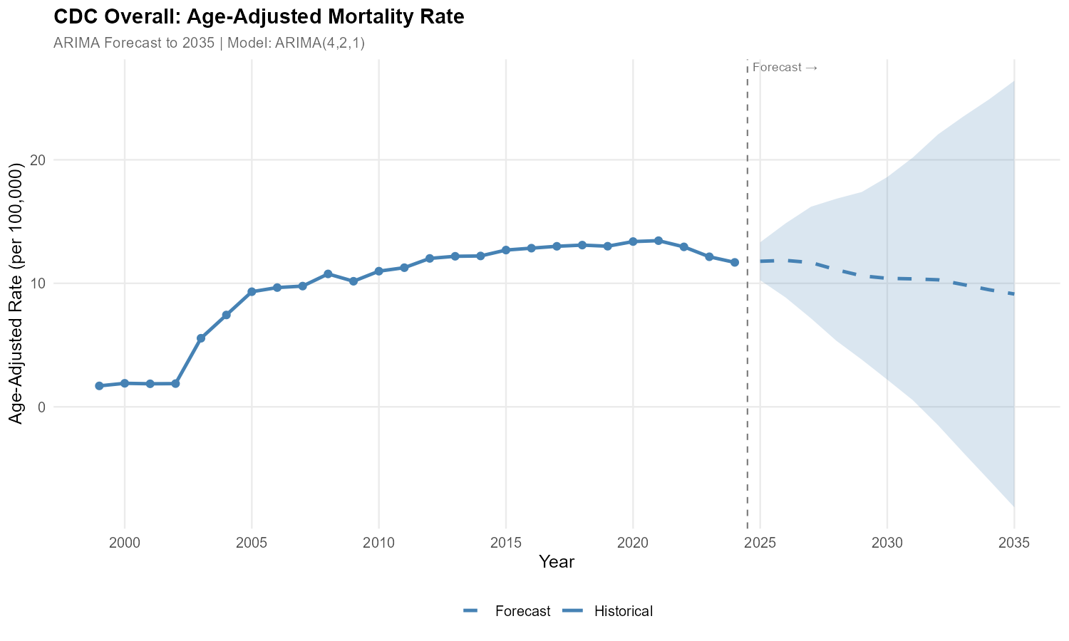
Supplementary Figure S1. Overall age-adjusted mortality rate (AAMR) forecasts for tobacco-associated ischemic heart disease mortality among adults aged ≥25 years in the United States, 2025–2035. Historical (1999–2024) and ARIMA forecasted (2025–2035) age-adjusted mortality rates per 100,000 population are shown with 95% confidence intervals.

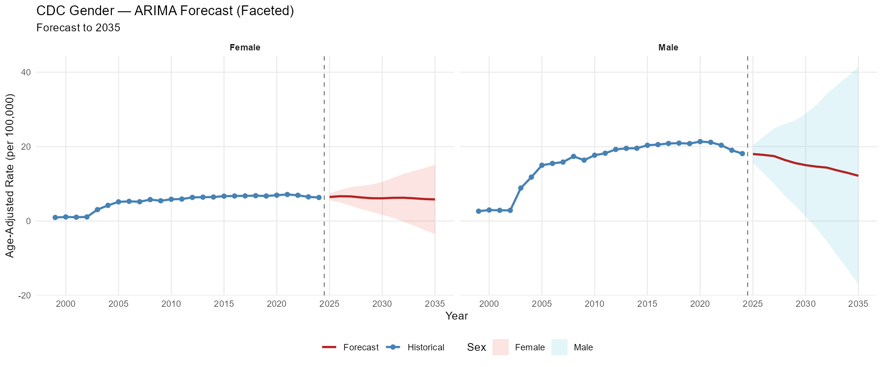
Supplementary Figure S2. Sex-specific age-adjusted mortality rate (AAMR) forecasts for tobacco-associated ischemic heart disease mortality among adults aged ≥25 years in the United States, 2025–2035. Historical (1999–2024) and ARIMA forecasted (2025–2035) age-adjusted mortality rates per 100,000 population for males and females are shown with 95% confidence intervals.

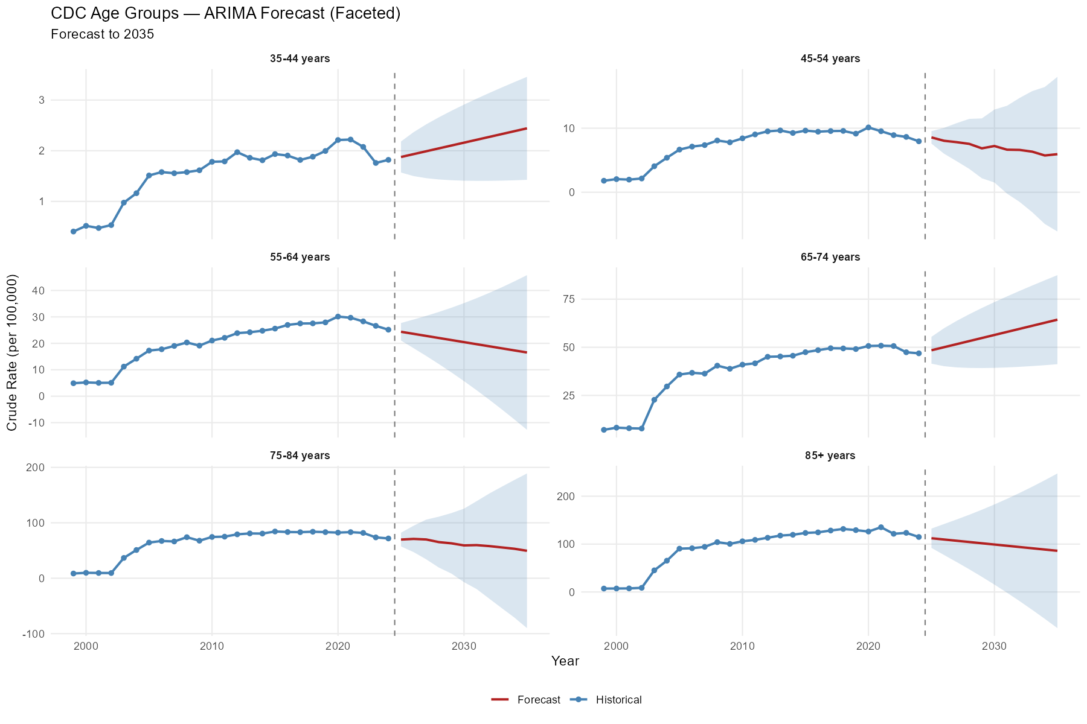
Supplementary Figure S3. Age-specific crude mortality rate (CMR) forecasts for tobacco-associated ischemic heart disease mortality in the United States, 2025–2035. Historical (1999–2024) and ARIMA forecasted (2025–2035) crude mortality rates per 100,000 population are presented by age group with 95% confidence intervals.

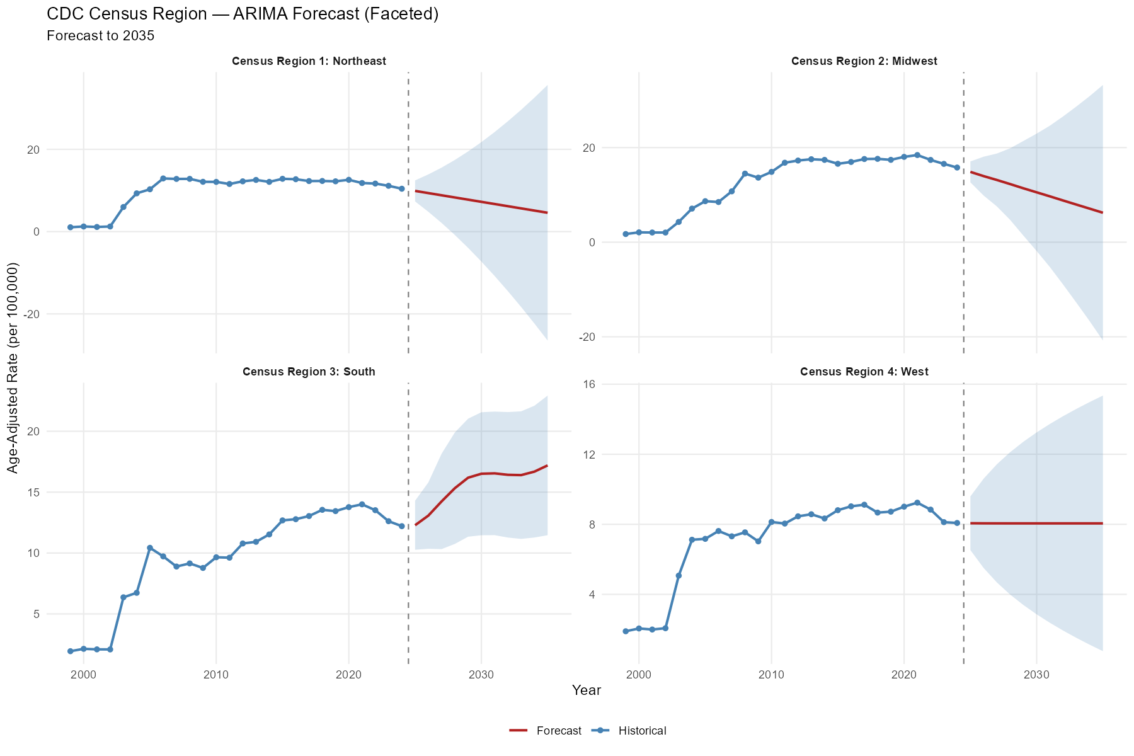Supplementary Figure S4. Census region-specific age-adjusted mortality rate (AAMR) forecasts for tobacco-associated ischemic heart disease mortality among adults aged ≥25 years in the United States, 2025–2035. Historical (1999–2024) and ARIMA forecasted (2025–2035) age-adjusted mortality rates per 100,000 population are presented by U.S. Census region with 95% confidence intervals.

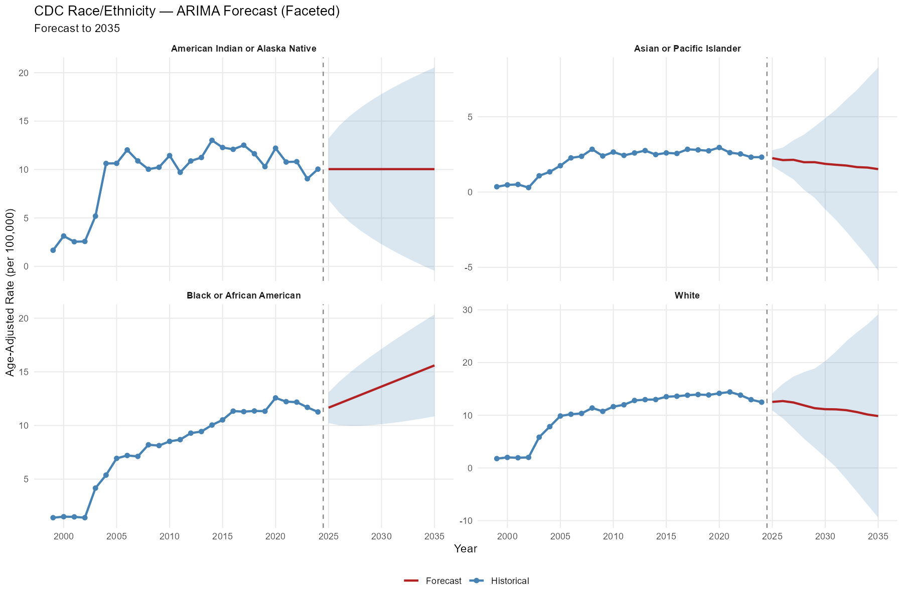Supplementary Figure S5. Race-specific age-adjusted mortality rate (AAMR) forecasts for tobacco-associated ischemic heart disease mortality among adults aged ≥25 years in the United States, 2025–2035. Historical (1999–2024) and ARIMA forecasted (2025–2035) age-adjusted mortality rates per 100,000 population are presented by race/ethnicity with 95% confidence intervals.

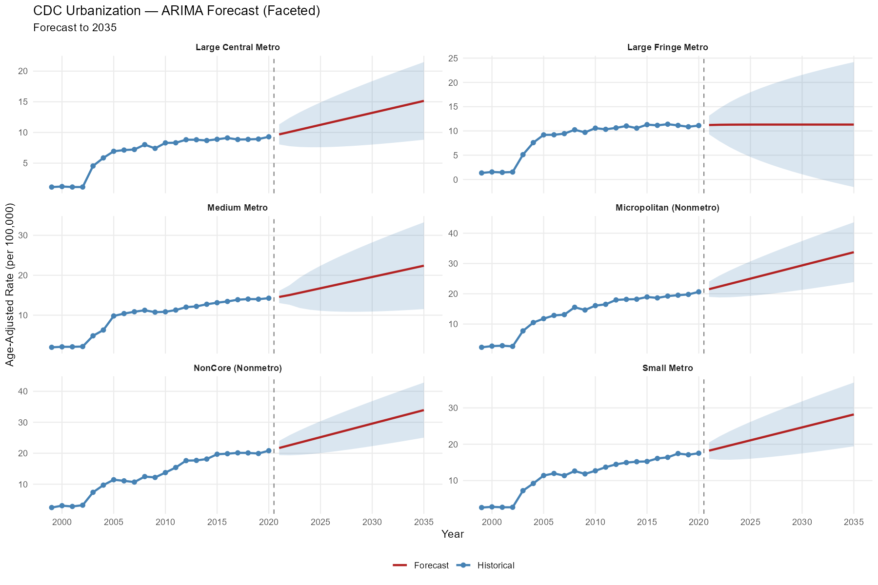
Supplementary Figure S6. Urbanization-specific age-adjusted mortality rate (AAMR) forecasts for tobacco-associated ischemic heart disease mortality among adults aged ≥25 years in the United States, 2021–2035. Historical (1999–2020) and ARIMA forecasted (2021–2035) age-adjusted mortality rates per 100,000 population are presented by urban–rural classification with 95% confidence intervals.

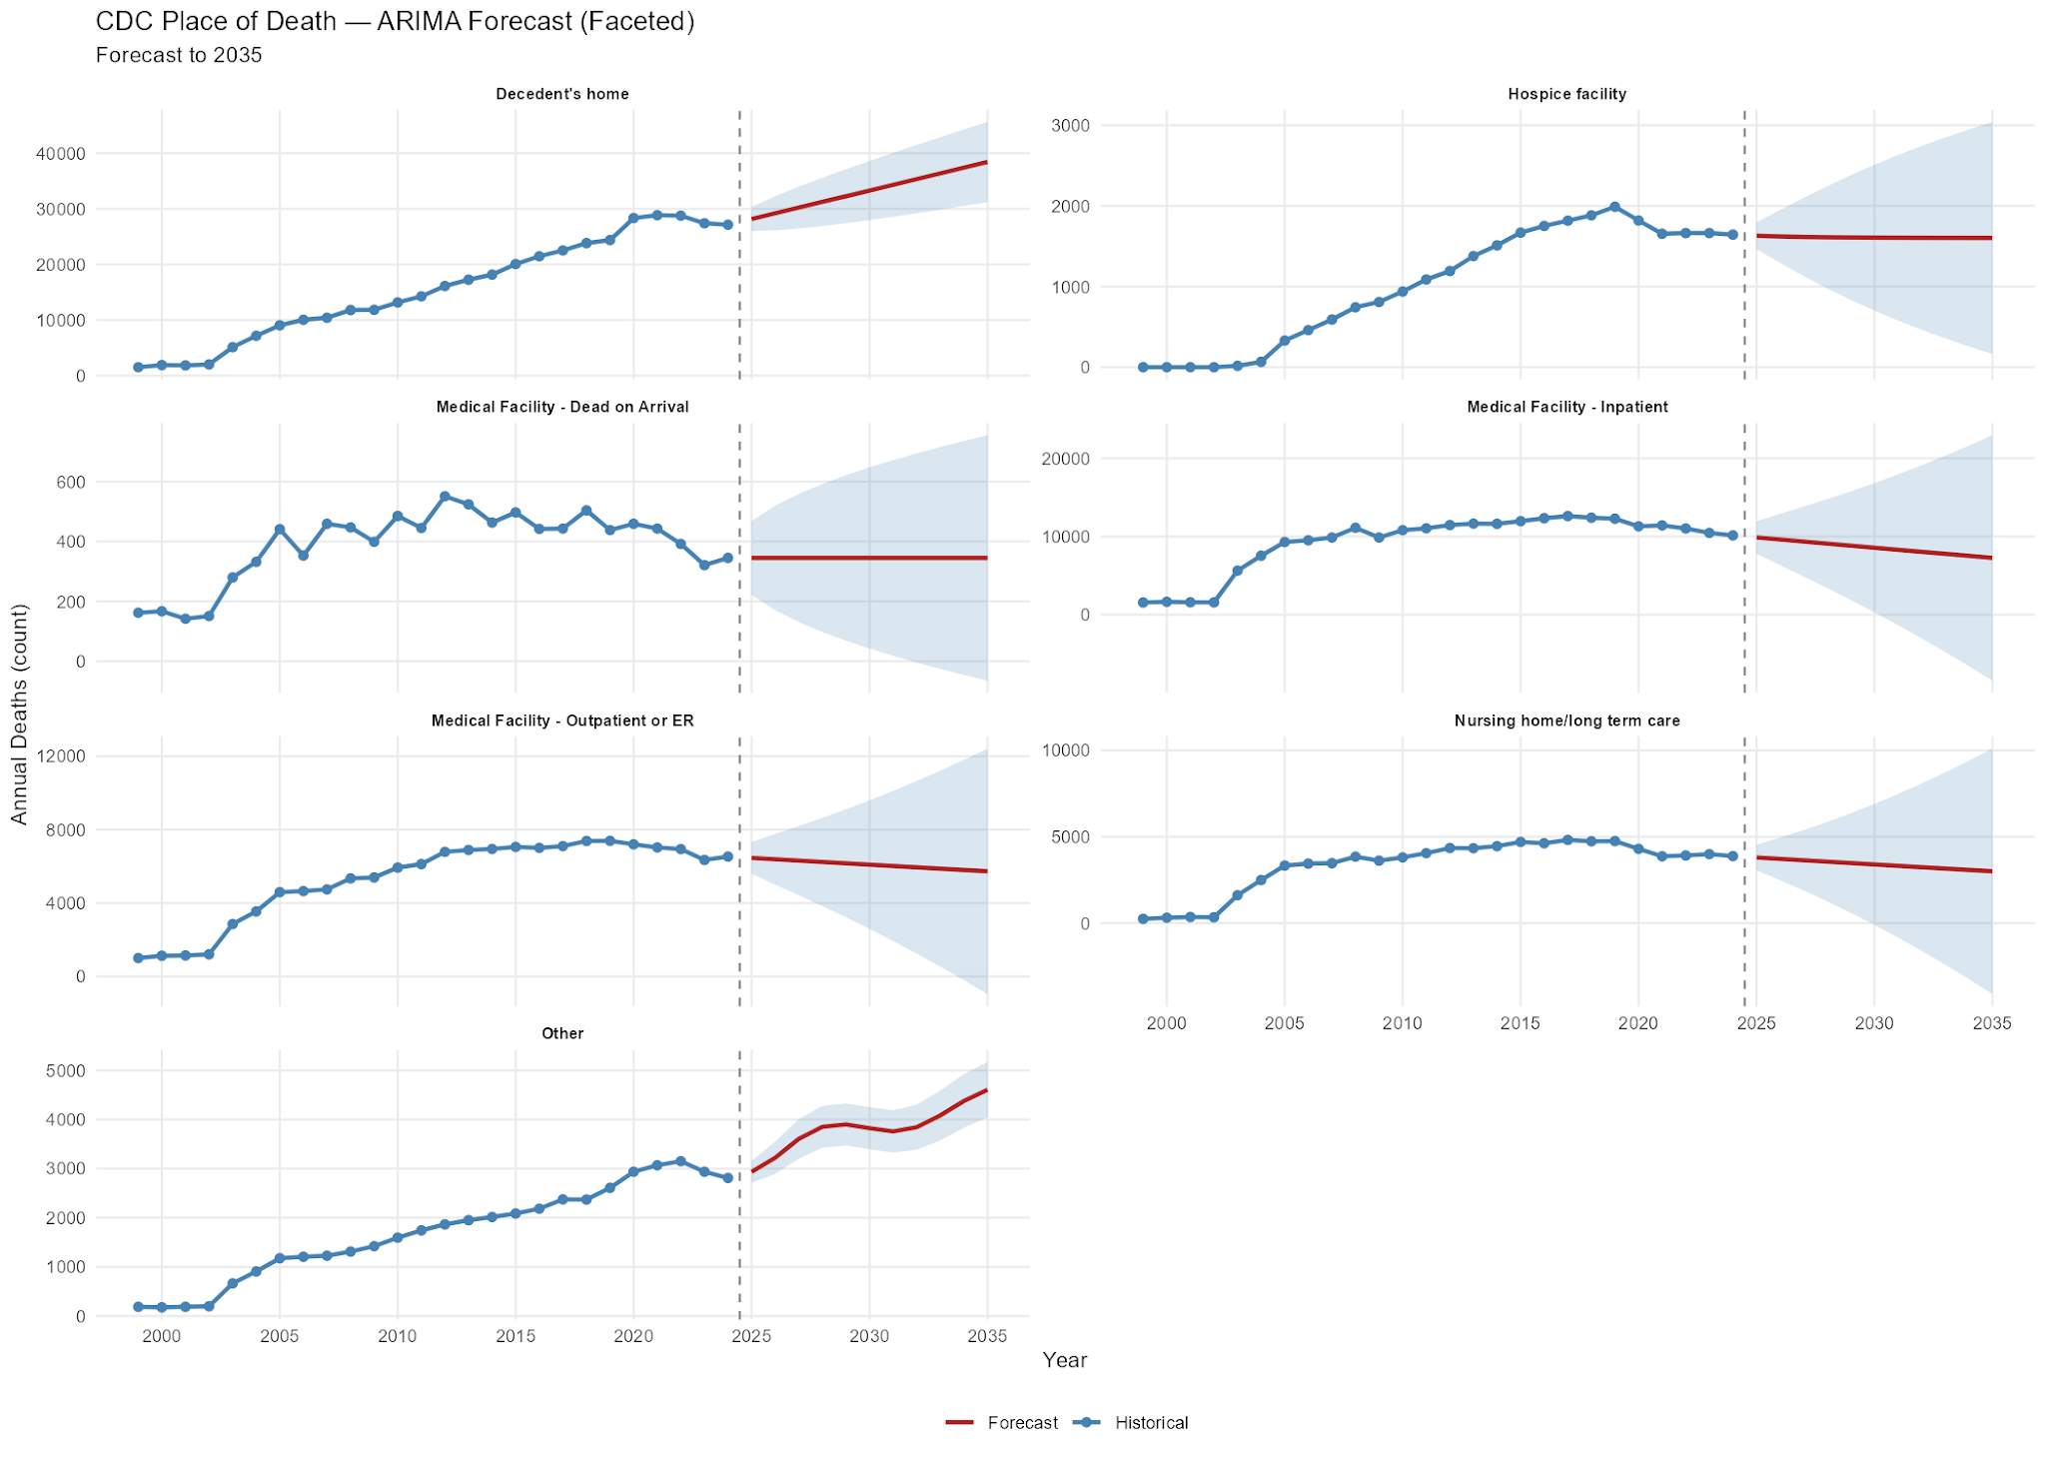
Supplementary Figure S7. Place-of-death forecasts for tobacco-associated ischemic heart disease mortality in the United States, 2025–2035. Historical (1999–2024) and ARIMA forecasted (2025–2035) annual deaths are presented by place of death with 95% confidence intervals.

Table S1. Age-Adjusted Mortality Rates for Tobacco-Associated Ischemic Heart Disease per 100,000 Adults Aged ≥25 Years in the United States, Stratified by Sex and Race/Ethnicity, 1999–2024
Year | Deaths | Female | Male | White | Black or African American | Asian or Pacific Islander | American Indian or Alaska Native
1999 | 4669 | 1480 | 3189 | 4258 | 359 | 27 | 25
2000 | 5329 | 1708 | 3621 | 4848 | 394 | 37 | 50
2001 | 5255 | 1648 | 3607 | 4770 | 395 | 42 | 48
2002 | 5482 | 1780 | 3702 | 5014 | 392 | 28 | 48
2003 | 16210 | 5135 | 11075 | 14889 | 1122 | 100 | 99
2004 | 22090 | 7140 | 14950 | 20290 | 1485 | 123 | 192
2005 | 28262 | 8920 | 19342 | 25905 | 1971 | 182 | 204
2006 | 29825 | 9344 | 20481 | 27229 | 2117 | 238 | 241
2007 | 30858 | 9315 | 21543 | 28214 | 2144 | 269 | 231
2008 | 34690 | 10525 | 24165 | 31606 | 2533 | 326 | 225
2009 | 33472 | 10124 | 23348 | 30332 | 2596 | 307 | 237
2010 | 36746 | 10980 | 25766 | 33353 | 2780 | 337 | 276
2011 | 38768 | 11360 | 27408 | 35189 | 2973 | 343 | 263
2012 | 42339 | 12496 | 29843 | 38378 | 3282 | 378 | 301
2013 | 43986 | 12892 | 31094 | 39746 | 3479 | 430 | 331
2014 | 45215 | 13219 | 31996 | 40605 | 3806 | 413 | 391
2015 | 48070 | 13982 | 34088 | 43061 | 4141 | 469 | 399
2016 | 49815 | 14451 | 35364 | 44303 | 4627 | 484 | 401
2017 | 51690 | 14835 | 36855 | 45905 | 4788 | 562 | 435
2018 | 53108 | 15279 | 37829 | 47191 | 4917 | 573 | 427
2019 | 53830 | 15403 | 38427 | 47785 | 5057 | 588 | 400
2020 | 56373 | 16083 | 40290 | 49435 | 5777 | 677 | 484
2021 | 56351 | 16283 | 40068 | 49475 | 5599 | 560 | 394
2022 | 55877 | 16344 | 39533 | 48923 | 5639 | 572 | 417
2023 | 53147 | 15466 | 37681 | 46340 | 5566 | 546 | 364
2024 | 52510 | 15545 | 36965 | 45611 | 5533 | 585 | 432

Table S2. Overall and Sex-Stratified Age-Adjusted Mortality Rates (AAMRs) for Tobacco-Associated Ischemic Heart Disease Among Adults Aged ≥25 Years in the United States, 1999–2024
Year | Overall | Female | Male
1999 | 1.7 (1.65-1.74) | 0.96 (0.91–1.01) | 2.65 (2.55–2.74)
2000 | 1.90 (1.85-1.96) | 1.10 (1.05–1.15) | 2.96 (2.86–3.06)
2001 | 1.87 (1.81-1.92) | 1.04 (0.99–1.09) | 2.88 (2.79–2.98)
2002 | 1.88 (1.83-1.93) | 1.1 (1.05–1.15) | 2.88 (2.79–2.97)
2003 | 5.55 (5.47-5.64) | 3.07 (2.98–3.15) | 8.87 (8.70–9.04)
2004 | 7.44 (7.34-7.54) | 4.22 (4.12–4.31) | 11.80 (11.61–12)
2005 | 9.32 (9.21-9.43) | 5.16 (5.06–5.27) | 15 (14.79–15.22)
2006 | 9.66 (9.55-9.77) | 5.3 (5.19–5.46) | 15.49 (15.27–15.70)
2007 | 9.77 (9.66-9.88) | 5.2 (5.089–5.30) | 15.85 (15.63–16.06)
2008 | 10.76 (10.65-10.88) | 5.77 (5.66–5.888) | 17.38 (17.15–17.6)
2009 | 10.17 (10.06-10.28) | 5.45 (5.35–5.56) | 16.37 (16.16–16.59)
2010 | 10.98 (10.87-11.1) | 5.85 (5.74–5.96) | 17.69 (17.47–17.91)
2011 | 11.27 (11.15-11.38) | 5.91 (5.80–6.02) | 18.23 (18.01–18.45)
2012 | 12.02 (11.90-12.13) | 6.36 (6.26–6.47) | 19.26 (19.03–19.48)
2013 | 12.19 (12.07-12.30) | 6.42 (6.31–6.54) | 19.54 (19.32–19.76)
2014 | 12.22 (12.10-12.33) | 6.46 (6.35–6.57) | 19.57 (19.35–19.79)
2015 | 12.69 (12.58-12.81) | 6.69 (6.58–6.80) | 20.37 (20.15–20.59)
2016 | 12.85 (12.73-12.96) | 6.74 (6.63–6.85) | 20.56 (20.34–20.78)
2017 | 13 (12.89-13.11) | 6.76 (6.65–6.87) | 20.86 (20.64–21.07)
2018 | 13.1 (12.98-13.21) | 6.82 (6.71–6.93) | 20.95 (20.73–21.16)
2019 | 13.00 (12.89-13.12) | 6.73 (6.63–6.84) | 20.82 (20.61–21.03)
2020 | 13.38 (13.27-13.49) | 6.95 (6.84–7.06) | 21.36 (21.14–21.57)
2021 | 13.45 (13.34-13.57) | 7.14 (7.03–7.25) | 21.18 (20.96–21.39)
2022 | 12.95 (12.84-13.06) | 6.92 (6.82–7.03) | 20.38 (20.18–20.59)
2023 | 12.15 (12.05-12.26) | 6.5 (6.39–6.60) | 19.04 (18.84–19.24)
2024 | 11.69 (11.59-11.8) | 6.34 (6.24–6.44) | 18.13 (17.95–18.32)

Table S3. Age Group–Stratified Crude Mortality Rates (CMRs) for Tobacco-Associated Ischemic Heart Disease Among Adults Aged ≥25 Years in the United States, 1999–2024
Year | Age 35-44 Years | Age 45-54 Years | Age 55-64 Years | Age 65-74 Years | Age 75-84 Years | Age 85+ Years
1999 | 0.41 (0.35–0.47) | 1.8 (1.66–1.93) | 4.91 (4.63–5.19) | 7.14 (6.75–7.53) | 8.51 (7.99–9.02) | 7.126 (6.314–7.937)
2000 | 0.52 (0.45–0.59) | 2.05 (1.90–2.19) | 5.22 (4.93–5.50) | 8.27 (7.85–8.68) | 9.81 (9.25–10.36) | 7.218 (6.409–8.026)
2001 | 0.48 (0.41–0.54) | 1.97 (1.83–2.12) | 5.05 (4.77–5.33) | 7.96 (7.56–8.37) | 9.48 (8.94–10.02) | 7.443 (6.629–8.258)
2002 | 0.53 (0.47–0.60) | 2.15 (2–2.29) | 5.09 (4.82–5.36) | 7.82 (7.41–8.22) | 9.39 (8.86–9.93) | 8.629 (7.758–9.500)
2003 | 0.98 (0.88–1.07) | 4.06 (3.86–4.25) | 11.2 (10.89–11.59) | 22.73 (22.05–23.42) | 36.67 (35.62–37.71) | 45.162 (43.191–47.133)
2004 | 1.16 (1.06–1.26) | 5.39 (5.17–5.61) | 14.18 (13.75–14.61) | 29.66 (28.88–30.44) | 50.97 (49.74–52.2) | 65.334 (62.984–67.684)
2005 | 1.51 (1.4–1.63) | 6.66 (6.41–6.91) | 17.26 (16.8–17.73) | 35.84 (34.99–36.69) | 64.32 (62.94–65.69) | 90.448 (87.727–93.169)
2006 | 1.58 (1.46–1.7) | 7.13 (6.88–7.38) | 17.76 (17.3–18.22) | 36.75 (35.89–37.61) | 67.25 (65.85–68.66) | 91.308 (88.623–93.993)
2007 | 1.56 (1.44–1.67) | 7.36 (7.11–7.61) | 19.02 (18.55–19.49) | 36.32 (35.48–37.16) | 66.34 (64.94–67.73) | 94.235 (91.555–96.915)
2008 | 1.58 (1.46–1.7) | 8.08 (7.82–8.35) | 20.33 (19.85–20.81) | 40.47 (39.60–41.34) | 74.05 (72.58–75.53) | 104.045 (101.271–106.818)
2009 | 1.62 (1.49–1.74) | 7.79 (7.53–8.048) | 19.13 (18.67–19.59) | 38.85 (38.02–39.69) | 67.74 (66.32–69.15) | 100.423 (97.742–103.104)
2010 | 1.78 (1.65–1.91) | 8.42 (8.15–8.69) | 21.06 (20.59–21.53) | 40.98 (40.13–41.83) | 74.48 (73–75.96) | 105.872 (103.151–108.593)
2011 | 1.79 (1.66–1.92) | 9.03 (8.75–9.31) | 22.09 (21.61–22.56) | 41.67 (40.83–42.52) | 75.03 (73.55–76.51) | 108.76 (106.07–111.46)
2012 | 1.97 (1.84–2.11) | 9.51 (9.22–9.8) | 23.87 (23.38–24.36) | 45.07 (44.22–45.92) | 79.19 (77.68–80.71) | 113.23 (110.51–115.94)
2013 | 1.86 (1.73–1.99) | 9.65 (9.36–9.94) | 24.19 (23.71–24.68) | 45.23 (44.40–46.06) | 80.84 (79.32–82.36) | 117.75 (115.01–120.49)
2014 | 1.81 (1.68–1.94) | 9.26 (8.97–9.54) | 24.76 (24.28–25.25) | 45.61 (44.79–46.42) | 80.58 (79.07–82.08) | 119.44 (116.71–122.17)
2015 | 1.93 (1.8–2.07) | 9.63 (9.33–9.92) | 25.58 (25.09–26.07) | 47.45 (46.64–48.26) | 84.33 (82.81–85.86) | 123.28 (120.54–126.03)
2016 | 1.91 (1.77–2.04) | 9.46 (9.17–9.75) | 26.97 (26.47–27.47) | 48.51 (47.70–49.32) | 83.41 (81.91–84.91) | 124.49 (121.75–127.23)
2017 | 1.82 (1.69–1.95) | 9.56 (9.26–9.85) | 27.52 (27.01–28.02) | 49.52 (48.72–50.32) | 83.12 (81.65–84.59) | 128.33 (125.57–131.09)
2018 | 1.88 (1.75–2.02) | 9.58 (9.28–9.88) | 27.55 (27.05–28.05) | 49.41 (48.62–50.20) | 83.89 (82.45–85.34) | 131.58 (128.8–134.36)
2019 | 2 (1.86–2.13) | 9.15 (8.85–9.44) | 27.93 (27.43–28.43) | 49.09 (48.32–49.87) | 83.19 (81.78–84.61) | 129.18 (126.44–131.92)
2020 | 2.21 (2.07–2.35) | 10.12 (9.81–10.43) | 30.13 (29.61–30.65) | 50.69 (49.92–51.46) | 82.33 (80.94–83.71) | 126.22 (123.52–128.92)
2021 | 2.22 (2.08–2.36) | 9.53 (9.23–9.83) | 29.69 (29.17–30.21) | 50.84 (50.08–51.6) | 83.20 (81.8–84.61) | 135.2 (132.25–138.14)
2022 | 2.08 (1.94–2.21) | 8.92 (8.63–9.21) | 28.31 (27.80–28.82) | 50.66 (49.90–51.42) | 81.78 (80.44–83.12) | 121.48 (118.8–124.16)
2023 | 1.76 (1.64–1.88) | 8.64 (8.36–8.93) | 26.62 (26.13–27.12) | 47.42 (46.7–48.15) | 73.70 (72.46–74.95) | 123.47 (120.70–126.24)
2024 | 1.82 (1.7–1.94) | 7.96 (7.68–8.23) | 25.16 (24.68–25.64) | 46.86 (46.15–47.58) | 71.77 (70.57–72.96) | 114.81 (112.19–117.43)

Table S4. Race/Ethnicity-Stratified Age-Adjusted Mortality Rates (AAMRs) for Tobacco-Associated Ischemic Heart Disease Among Adults Aged ≥25 Years in the United States, 1999–2024
Year | White | Black or African American | Asian or Pacific Islander | American Indian or Alaska Native
1999 | 1.77 (1.72–1.82) | 1.41 (1.26–1.56) | 0.35 (0.23–0.52) | 1.67 (1.04–2.52)
2000 | 2 (1.94–2.05) | 1.5 (1.35–1.65) | 0.48 (0.33–0.69) | 2.14 (2.28–4.21)
2001 | 1.93 (1.88–1.99) | 1.48 (1.33–1.63) | 0.50 (0.36–0.69) | 2.55 (1.84–3.44)
2002 | 2. (1.96–2.06) | 1.41 (1.27–1.55) | 0.3 (0.19–0.44) | 2.58 (1.86–3.49)
2003 | 5.84 (5.74–5.93) | 4.17 (3.92–4.41) | 1.08 (0.86–1.30) | 5.19 (4.16–6.41)
2004 | 7.84 (7.73–7.95) | 5.38 (5.1–5.66) | 1.34 (1.09–1.59) | 10.63 (9.–12.26)
2005 | 9.86 (9.74–9.98) | 6.94 (6.62–7.25) | 1.75 (1.48–2.01) | 10.64 (9.05–12.23)
2006 | 10.19 (10.07–10.32) | 7.21 (6.89–7.52) | 2.27 (1.97–2.57) | 12.03 (10.39–13.67)
2007 | 10.34 (10.22–10.47) | 7.12 (6.81–7.43) | 2.37 (2.08–2.67) | 10.89 (9.36–12.42)
2008 | 11.38 (11.25–11.51) | 8.2 (7.87–8.530) | 2.84 (2.52–3.16) | 10.03 (8.61–11.46)
2009 | 10.74 (10.62–10.86) | 8.13 (7.81–8.45) | 2.39 (2.12–2.67) | 10.24 (8.81–11.66)
2010 | 11.64 (11.51–11.76) | 8.52 (8.19–8.85) | 2.66 (2.36–2.95) | 11.44 (9.98–12.90)
2011 | 11.99 (11.86–12.11) | 8.68 (8.36–9.01) | 2.43 (2.17–2.7) | 9.71 (8.45–10.98)
2012 | 12.80 (12.67–12.93) | 9.29 (8.96–9.62) | 2.594 (2.33–2.86) | 10.88 (9.56–12.21)
2013 | 12.96 (12.83–13.09) | 9.44 (9.11–9.76) | 2.753 (2.49–3.02) | 11.24 (9.95–12.54)
2014 | 12.98 (12.86–13.11) | 10.04 (9.71–10.37) | 2.489 (2.24–2.74) | 13.02 (11.65–14.39)
2015 | 13.52 (13.39–13.65) | 10.52 (10.19–10.85) | 2.6 (2.36–2.84) | 12.28 (10.99–13.56)
2016 | 13.61 (13.48–13.74) | 11.34 (11.01–11.68) | 2.56 (2.33–2.8) | 12.09 (10.84–13.34)
2017 | 13.81 (13.68–13.93) | 11.29 (10.96–11.62) | 2.84 (2.6–3.08) | 12.52 (11.27–13.76)
2018 | 13.93 (13.80–14.06) | 11.36 (11.03–11.68) | 2.8 (2.57–3.03) | 11.63 (10.47–12.79)
2019 | 13.85 (13.73–13.98) | 11.33 (11.01–11.65) | 2.74 (2.51–2.96) | 10.3 (9.24–11.35)
2020 | 14.16 (14.04–14.29) | 12.57 (12.24–12.91) | 2.96 (2.73–3.18) | 12.21 (11.07–13.34)
2021 | 14.42 (14.29–14.55) | 12.22 (11.89–12.56) | 2.62 (2.40–2.85) | 10.78 (9.69–11.96)
2022 | 13.82 (13.7–13.95) | 12.18 (11.85–12.51) | 2.53 (2.32–2.75) | 10.81 (9.77–11.95)
2023 | 12.96 (12.84–13.08) | 11.69 (11.38–12.01) | 2.32 (2.13–2.52) | 9.05 (8.12–10.06)
2024 | 12.48 (12.37–12.6) | 11.27 (10.96–11.57) | 2.32 (2.13–2.52) | 10.04 (9.1–11.07)

Table S5. Census Region–Stratified Age-Adjusted Mortality Rates (AAMRs) for Tobacco-Associated Ischemic Heart Disease Among Adults Aged ≥25 Years in the United States, 1999–2024
Census Region | Year | Age Adjusted Rate (95% CI)
Northeast | 1999 | 1.06 (0.97–1.14)
Northeast | 2000 | 1.24 (1.15–1.34)
Northeast | 2001 | 1.13 (1.04–1.21)
Northeast | 2002 | 1.24 (1.15–1.34)
Northeast | 2003 | 5.98 (5.79–6.18)
Northeast | 2004 | 9.30 (9.06–9.55)
Northeast | 2005 | 10.29 (10.04–10.59)
Northeast | 2006 | 12.93 (12.64–13.21)
Northeast | 2007 | 12.81 (12.52–13.09)
Northeast | 2008 | 12.82 (12.54–13.10)
Northeast | 2009 | 12.12 (11.84–12.38)
Northeast | 2010 | 12.08 (11.81–12.35)
Northeast | 2011 | 11.58 (11.31–11.84)
Northeast | 2012 | 12.22 (11.95–12.49)
Northeast | 2013 | 12.56 (12.29–12.83)
Northeast | 2014 | 12.09 (11.83–12.36)
Northeast | 2015 | 12.83 (12.57–13.1)
Northeast | 2016 | 12.73 (12.47–13)
Northeast | 2017 | 12.29 (12.03–12.55)
Northeast | 2018 | 12.31 (12.05–12.56)
Northeast | 2019 | 12.22 (11.97–12.48)
Northeast | 2020 | 12.59 (12.33–12.85)
Northeast | 2021 | 11.81 (11.57–12.06)
Northeast | 2022 | 11.68 (11.44–11.93)
Northeast | 2023 | 11.13 (10.9–11.37)
Northeast | 2024 | 10.42 (10.2–10.65)
Midwest | 1999 | 1.73 (1.62–1.83)
Midwest | 2000 | 2.08 (1.97–2.19)
Midwest | 2001 | 2.05 (1.94–2.16)
Midwest | 2002 | 2.04 (1.93–2.15)
Midwest | 2003 | 4.29 (4.13–4.44)
Midwest | 2004 | 7.10 (6.90–7.30)
Midwest | 2005 | 8.67 (8.45–8.89)
Midwest | 2006 | 8.49 (8.28–8.71)
Midwest | 2007 | 10.75 (10.51–10.99)
Midwest | 2008 | 14.5 (14.22–14.78)
Midwest | 2009 | 13.64 (13.37–13.91)
Midwest | 2010 | 14.87 (14.59–15.14)
Midwest | 2011 | 16.8 (16.51–17.09)
Midwest | 2012 | 17.26 (16.97–17.56)
Midwest | 2013 | 17.54 (17.25–17.84)
Midwest | 2014 | 17.40 (17.11–17.69)
Midwest | 2015 | 16.57 (16.29–16.86)
Midwest | 2016 | 16.96 (16.68–17.25)
Midwest | 2017 | 17.58 (17.3–17.87)
Midwest | 2018 | 17.62 (17.34–17.90)
Midwest | 2019 | 17.41 (17.13–17.69)
Midwest | 2020 | 18.04 (17.76–18.32)
Midwest | 2021 | 18.43 (18.14–18.72)
Midwest | 2022 | 17.39 (17.12–17.67)
Midwest | 2023 | 16.56 (16.29–16.83)
Midwest | 2024 | 15.78 (15.52–16.04)
South | 1999 | 1.94 (1.85–2.03)
South | 2000 | 2.13 (2.042–2.22)
South | 2001 | 2.09 (2–2.18)
South | 2002 | 2.08 (2–2.17)
South | 2003 | 6.37 (6.21–6.52)
South | 2004 | 6.73 (6.58–6.89)
South | 2005 | 10.43 (10.24–10.62)
South | 2006 | 9.73 (9.54–9.91)
South | 2007 | 8.89 (8.72–9.07)
South | 2008 | 9.15 (8.98–9.32)
South | 2009 | 8.78 (8.61–8.95)
South | 2010 | 9.65 (9.48–9.83)
South | 2011 | 9.61 (9.45–9.79)
South | 2012 | 10.79 (10.61–10.97)
South | 2013 | 10.92 (10.74–11.1)
South | 2014 | 11.53 (11.34–11.71)
South | 2015 | 12.68 (12.49–12.87)
South | 2016 | 12.78 (12.59–12.97)
South | 2017 | 13.04 (12.85–13.22)
South | 2018 | 13.55 (13.36–13.74)
South | 2019 | 13.44 (13.26–13.63)
South | 2020 | 13.77 (13.59–13.96)
South | 2021 | 14 (13.81–14.19)
South | 2022 | 13.52 (13.34–13.7)
South | 2023 | 12.61 (12.44–12.79)
South | 2024 | 12.21 (12.04–12.38)
West | 1999 | 1.89 (1.78–2.01)
West | 2000 | 2.05 (1.94–2.17)
West | 2001 | 1.99 (1.88–2.11)
West | 2002 | 2.07 (1.95–2.18)
West | 2003 | 5.07 (4.89–5.25)
West | 2004 | 7.12 (6.91–7.33)
West | 2005 | 7.17 (6.96–7.38)
West | 2006 | 7.62 (7.41–7.83)
West | 2007 | 7.32 (7.11–7.52)
West | 2008 | 7.54 (7.33–7.75)
West | 2009 | 7.03 (6.83–7.22)
West | 2010 | 8.13 (7.92–8.35)
West | 2011 | 8.04 (7.84–8.25)
West | 2012 | 8.46 (8.25–8.66)
West | 2013 | 8.58 (8.37–8.78)
West | 2014 | 8.33 (8.13–8.53)
West | 2015 | 8.81 (8.60–9.01)
West | 2016 | 9.03 (8.82–9.23)
West | 2017 | 9.12 (8.92–9.32)
West | 2018 | 8.67 (8.48–8.86)
West | 2019 | 8.72 (8.53–8.91)
West | 2020 | 9.01 (8.82–9.20)
West | 2021 | 9.24 (9.04–9.44)
West | 2022 | 8.84 (8.65–9.03)
West | 2023 | 8.12 (7.95–8.31)
West | 2024 | 8.078 (7.90–8.26)

Table S6. Urbanization Level–Stratified Age-Adjusted Mortality Rates (AAMRs) for Tobacco-Associated Ischemic Heart Disease Among Adults Aged ≥25 Years in the United States, 1999–2020
Year | Large Central Metro | Large Fringe Metro | Medium Metro | Small Metro | Micropolitan (Nonmetro | NonCore (Nonmetro)
1999 | 1.11 (1.03–1.18) | 1.34 (1.25–1.43) | 1.96 (1.85–2.08) | 2.58 (2.39–2.78) | 2.32 (2.14–2.49) | 2.46 (2.25–2.67)
2000 | 1.19 (1.12–1.27) | 1.55 (1.45–1.64) | 2.08 (1.96–2.2) | 2.77 (2.57–2.97) | 2.71 (2.52–2.9) | 3.06 (2.83–3.29)
2001 | 1.11 (1.04–1.19) | 1.46 (1.37–1.55) | 2.08 (1.97–2.20) | 2.66 (2.47–2.85) | 2.85 (2.65–3.044) | 2.81 (2.59–3.03)
2002 | 1.11 (1.04–1.18) | 1.53 (1.44–1.63) | 2.15 (2.03–2.27) | 2.66 (2.47–2.85) | 2.63 (2.44–2.81) | 3.22 (2.99–3.45)
2003 | 4.54 (4.39–4.69) | 5.11 (4.94–5.29) | 4.84 (4.66–5.01) | 7.23 (6.92–7.54) | 7.73 (7.41–8.05) | 7.38 (7.03–7.73)
2004 | 5.86 (5.7–6.03) | 7.59 (7.38–7.8) | 6.29 (6.09–6.48) | 9.2 (8.85–9.55) | 10.49 (10.12–10.86) | 9.7 (9.31–10.11)
2005 | 6.94 (6.76–7.12) | 9.19 (8.97–9.41) | 9.81 (9.56–10.05) | 11.39 (11–11.77) | 11.79 (11.4–12.17) | 11.44 (11.01–11.87)
2006 | 7.14 (6.95–7.32) | 9.21 (8.98–9.43) | 10.41 (10.16–10.66) | 11.97 (11.58–12.36) | 12.85 (12.44–13.25) | 11.09 (10.67–11.51)
2007 | 7.23 (7.05–7.41) | 9.45 (9.22–9.67) | 10.86 (10.61–11.11) | 11.36 (10.98–11.74) | 13.11 (12.7–13.51) | 10.68 (10.27–11.09)
2008 | 8.02 (7.83–8.21) | 10.24 (10.01–10.46) | 11.23 (10.98–11.49) | 12.63 (12.23–13.02) | 15.54 (15.1–15.97) | 12.46 (12.02–12.9)
2009 | 7.41 (7.23–7.59) | 9.71 (9.49–9.93) | 10.76 (10.51–11) | 11.84 (11.46–12.22) | 14.63 (14.21–15.05) | 12.19 (11.75–12.62)
2010 | 8.31 (8.12–8.49) | 10.57 (10.35–10.80) | 10.85 (10.61–11.09) | 12.69 (12.3–13.08) | 16.08 (15.64–16.51) | 13.75 (13.29–14.21)
2011 | 8.32 (8.14–8.51) | 10.33 (10.11–10.55) | 11.29 (11.04–11.53) | 13.69 (13.29–14.09) | 16.52 (16.07–16.96) | 15.4 (14.91–15.88)
2012 | 8.82 (8.63–9.01) | 10.63 (10.41–10.85) | 12.02 (11.77–12.27) | 14.46 (14.05–14.87) | 17.97 (17.51–18.42) | 17.62 (17.1–18.13)
2013 | 8.82 (8.63–9.01) | 11.02 (10.8–11.24) | 12.2 (11.95–12.45) | 14.96 (14.54–15.37) | 18.15 (17.7–18.61) | 17.68 (17.17–18.2)
2014 | 8.69 (8.51–8.88) | 10.57 (10.36–10.79) | 12.74 (12.49–12.99) | 15.19 (14.78–15.6) | 18.21 (17.75–18.66) | 18.13 (17.61–18.65)
2015 | 8.89 (8.71–9.08) | 11.3 (11.08–11.52) | 13.13 (12.87–13.38) | 15.26 (14.85–15.67) | 18.94 (18.48–19.41) | 19.68 (19.14–20.22)
2016 | 9.11 (8.93–9.3) | 11.15 (10.94–11.37) | 13.44 (13.19–13.697) | 16.09 (15.67–16.5) | 18.63 (18.18–19.09) | 19.85 (19.31–20.39)
2017 | 8.86 (8.68–9.03) | 11.39 (11.17–11.60) | 13.88 (13.62–14.134) | 16.39 (15.98–16.81) | 19.23 (18.77–19.69) | 20.12 (19.58–20.67)
2018 | 8.88 (8.70–9.06) | 11.14 (10.93–11.35) | 14.04 (13.78–14.290) | 17.44 (17.02–17.86) | 19.52 (19.06–19.98) | 20.1 (19.56–20.64)
2019 | 8.93 (8.75–9.11) | 10.86 (10.65–11.06) | 14.01 (13.76–14.263) | 17.11 (16.7–17.53) | 19.78 (19.32–20.24) | 19.92 (19.38–20.46)
2020 | 9.3 (9.12–9.47) | 11.11 (10.90–11.31) | 14.26 (14.01–14.510) | 17.52 (17.1–17.94) | 20.64 (20.17–21.11) | 20.82 (20.27–21.37)

Table S7. Distribution of Place of Death Among Decedents With Tobacco-Associated Ischemic Heart Disease in Adults Aged ≥25 Years in the United States, 1999–2023
Place of Death | Deaths
Medical Facility - Inpatient | 241711
Medical Facility - Outpatient or ER | 138277
Medical Facility - Dead on Arrival | 10085
Medical Facility - Status unknown | 80
Decedent's home | 404286
Hospice facility | 26680
Nursing home/long term care | 87656
Other | 44345
Place of death unknown | 825

Table S8. ARIMA Forecasts of Age-Adjusted Mortality Rates (AAMRs) for Tobacco-Associated Ischemic Heart Disease Among Adults Aged ≥25 Years in the United States, Overall and Stratified by Sex, 2025–2035
Group | Year | Point Estimate | Lower CI | Upper CI
Female | 2025 | 6.4753 | 5.5961 | 7.3546
Female | 2026 | 6.6709 | 4.9979 | 8.344
Female | 2027 | 6.6232 | 4.1293 | 9.1171
Female | 2028 | 6.345 | 3.2253 | 9.4646
Female | 2029 | 6.13 | 2.4617 | 9.7984
Female | 2030 | 6.1135 | 1.6803 | 10.5468
Female | 2031 | 6.2405 | 0.9067 | 11.5743
Female | 2032 | 6.262 | -0.1439 | 12.668
Female | 2033 | 6.1124 | -1.2681 | 13.4929
Female | 2034 | 5.9144 | -2.4093 | 14.2381
Female | 2035 | 5.818 | -3.495 | 15.1311
Male | 2025 | 18.0181 | 15.5624 | 20.4737
Male | 2026 | 17.7875 | 12.8723 | 22.7028
Male | 2027 | 17.4633 | 9.9869 | 24.9398
Male | 2028 | 16.4378 | 6.7796 | 26.096
Male | 2029 | 15.5939 | 4.1227 | 27.0651
Male | 2030 | 15.0229 | 1.1553 | 28.8905
Male | 2031 | 14.6378 | -1.9064 | 31.182
Male | 2032 | 14.3732 | -5.4331 | 34.1795
Male | 2033 | 13.6043 | -9.369 | 36.5777
Male | 2034 | 12.9351 | -13.1055 | 38.9756
Male | 2035 | 12.1687 | -17.0948 | 41.4321
Overall | 2025 | 11.7857 | 10.2495 | 13.3219
Overall | 2026 | 11.8537 | 8.8529 | 14.8544
Overall | 2027 | 11.6814 | 7.1594 | 16.2035
Overall | 2028 | 11.0966 | 5.3427 | 16.8505
Overall | 2029 | 10.6067 | 3.8169 | 17.3966
Overall | 2030 | 10.4027 | 2.1991 | 18.6063
Overall | 2031 | 10.3601 | 0.5444 | 20.1758
Overall | 2032 | 10.2844 | -1.496 | 22.0648
Overall | 2033 | 9.8928 | -3.7328 | 23.5184
Overall | 2034 | 9.4812 | -5.925 | 24.8874
Overall | 2035 | 9.1323 | -8.1407 | 26.4053

Table S9.Forecasted Crude Mortality Rates for Tobacco-Associated Ischemic Heart Disease, Stratified by Age Group, Among Adults Aged ≥25 Years in the United States, 2025–2035
Group | Year | Point Estimate | Lower CI | Upper CI
35-44 years | 2025 | 1.8766 | 1.5701 | 2.183
35-44 years | 2026 | 1.9331 | 1.4997 | 2.3665
35-44 years | 2027 | 1.9897 | 1.4589 | 2.5205
35-44 years | 2028 | 2.0462 | 1.4333 | 2.6591
35-44 years | 2029 | 2.1028 | 1.4176 | 2.788
35-44 years | 2030 | 2.1594 | 1.4087 | 2.91
35-44 years | 2031 | 2.2159 | 1.4051 | 3.0267
35-44 years | 2032 | 2.2725 | 1.4057 | 3.1392
35-44 years | 2033 | 2.329 | 1.4097 | 3.2484
35-44 years | 2034 | 2.3856 | 1.4165 | 3.3547
35-44 years | 2035 | 2.4422 | 1.4258 | 3.4585
45-54 years | 2025 | 8.5644 | 7.592 | 9.5368
45-54 years | 2026 | 8.0355 | 6.0184 | 10.0525
45-54 years | 2027 | 7.82 | 4.8508 | 10.7892
45-54 years | 2028 | 7.5519 | 3.6504 | 11.4534
45-54 years | 2029 | 6.8558 | 2.1841 | 11.5275
45-54 years | 2030 | 7.2161 | 1.5189 | 12.9134
45-54 years | 2031 | 6.6438 | -0.2161 | 13.5038
45-54 years | 2032 | 6.6077 | -1.5116 | 14.727
45-54 years | 2033 | 6.3365 | -3.1195 | 15.7925
45-54 years | 2034 | 5.739 | -4.959 | 16.4371
45-54 years | 2035 | 5.9444 | -6.133 | 18.0218
55-64 years | 2025 | 24.3765 | 21.0638 | 27.6892
55-64 years | 2026 | 23.593 | 18.1646 | 29.0213
55-64 years | 2027 | 22.8095 | 15.2313 | 30.3876
55-64 years | 2028 | 22.0259 | 12.1868 | 31.8651
55-64 years | 2029 | 21.2424 | 9.013 | 33.4719
55-64 years | 2030 | 20.4589 | 5.7066 | 35.2112
55-64 years | 2031 | 19.6754 | 2.2693 | 37.0815
55-64 years | 2032 | 18.8919 | -1.2957 | 39.0794
55-64 years | 2033 | 18.1084 | -4.9843 | 41.201
55-64 years | 2034 | 17.3248 | -8.7928 | 43.4425
55-64 years | 2035 | 16.5413 | -12.7172 | 45.7999
65-74 years | 2025 | 48.453 | 41.4813 | 55.4247
65-74 years | 2026 | 50.042 | 40.1825 | 59.9015
65-74 years | 2027 | 51.631 | 39.5556 | 63.7064
65-74 years | 2028 | 53.22 | 39.2765 | 67.1635
65-74 years | 2029 | 54.809 | 39.2197 | 70.3983
65-74 years | 2030 | 56.398 | 39.3208 | 73.4752
65-74 years | 2031 | 57.987 | 39.5415 | 76.4325
65-74 years | 2032 | 59.576 | 39.857 | 79.295
65-74 years | 2033 | 61.165 | 40.2498 | 82.0802
65-74 years | 2034 | 62.754 | 40.7074 | 84.8006
65-74 years | 2035 | 64.343 | 41.2204 | 87.4656
75-84 years | 2025 | 69.7824 | 57.3965 | 82.1683
75-84 years | 2026 | 70.9549 | 47.1516 | 94.7582
75-84 years | 2027 | 69.9479 | 34.1335 | 105.7624
75-84 years | 2028 | 65.1902 | 19.3176 | 111.0628
75-84 years | 2029 | 62.9809 | 8.4052 | 117.5567
75-84 years | 2030 | 59.2418 | -7.0661 | 125.5497
75-84 years | 2031 | 59.7571 | -19.5005 | 139.0147
75-84 years | 2032 | 57.9868 | -36.7797 | 152.7533
75-84 years | 2033 | 55.5834 | -53.9891 | 165.1558
75-84 years | 2034 | 53.1771 | -70.9549 | 177.309
75-84 years | 2035 | 49.5015 | -90.0675 | 189.0705
85+ years | 2025 | 112.1866 | 92.0309 | 132.3422
85+ years | 2026 | 109.5661 | 77.2154 | 141.9169
85+ years | 2027 | 106.9457 | 62.5161 | 151.3754
85+ years | 2028 | 104.3253 | 47.3908 | 161.2598
85+ years | 2029 | 101.7049 | 31.689 | 171.7208
85+ years | 2030 | 99.0844 | 15.3642 | 182.8047
85+ years | 2031 | 96.464 | -1.5928 | 194.5208
85+ years | 2032 | 93.8436 | -19.1759 | 206.8631
85+ years | 2033 | 91.2232 | -37.3728 | 219.8191
85+ years | 2034 | 88.6027 | -56.1684 | 233.3739
85+ years | 2035 | 85.9823 | -75.5471 | 247.5118

Table S10. ARIMA Forecasts of Age-Adjusted Mortality Rates (AAMRs) for Tobacco-Associated Ischemic Heart Disease, Stratified by Census Region, Among Adults Aged ≥25 Years in the United States, 2025–2035
Group | Year | Point Estimate | Lower CI | Upper CI
Census Region 1: Northeast | 2025 | 9.892 | 7.3377 | 12.4463
Census Region 1: Northeast | 2026 | 9.361 | 4.8187 | 13.9033
Census Region 1: Northeast | 2027 | 8.83 | 2.106 | 15.5541
Census Region 1: Northeast | 2028 | 8.2991 | -0.8198 | 17.4179
Census Region 1: Northeast | 2029 | 7.7681 | -3.9513 | 19.4874
Census Region 1: Northeast | 2030 | 7.2371 | -7.2774 | 21.7516
Census Region 1: Northeast | 2031 | 6.7061 | -10.7875 | 24.1997
Census Region 1: Northeast | 2032 | 6.1751 | -14.4718 | 26.822
Census Region 1: Northeast | 2033 | 5.6441 | -18.3218 | 29.6101
Census Region 1: Northeast | 2034 | 5.1131 | -22.3301 | 32.5564
Census Region 1: Northeast | 2035 | 4.5822 | -26.49 | 35.6543
Census Region 2: Midwest | 2025 | 14.8616 | 12.6538 | 17.0694
Census Region 2: Midwest | 2026 | 13.9667 | 9.8594 | 18.0741
Census Region 2: Midwest | 2027 | 13.1499 | 7.5571 | 18.7427
Census Region 2: Midwest | 2028 | 12.284 | 4.7138 | 19.8541
Census Region 2: Midwest | 2029 | 11.3921 | 1.3844 | 21.3997
Census Region 2: Midwest | 2030 | 10.541 | -1.8709 | 22.9529
Census Region 2: Midwest | 2031 | 9.6881 | -5.2622 | 24.6383
Census Region 2: Midwest | 2032 | 8.8112 | -8.9737 | 26.5961
Census Region 2: Midwest | 2033 | 7.9459 | -12.8 | 28.6917
Census Region 2: Midwest | 2034 | 7.09 | -16.7042 | 30.8841
Census Region 2: Midwest | 2035 | 6.2231 | -20.7993 | 33.2454
Census Region 3: South | 2025 | 12.2815 | 10.2698 | 14.2931
Census Region 3: South | 2026 | 13.0728 | 10.3498 | 15.7957
Census Region 3: South | 2027 | 14.2384 | 10.3221 | 18.1548
Census Region 3: South | 2028 | 15.3251 | 10.7486 | 19.9016
Census Region 3: South | 2029 | 16.1861 | 11.3409 | 21.0314
Census Region 3: South | 2030 | 16.511 | 11.4604 | 21.5616
Census Region 3: South | 2031 | 16.5419 | 11.4675 | 21.6164
Census Region 3: South | 2032 | 16.4241 | 11.2719 | 21.5762
Census Region 3: South | 2033 | 16.3989 | 11.1622 | 21.6356
Census Region 3: South | 2034 | 16.6838 | 11.2731 | 22.0945
Census Region 3: South | 2035 | 17.1977 | 11.4634 | 22.932
Census Region 4: West | 2025 | 8.0614 | 6.53 | 9.5928
Census Region 4: West | 2026 | 8.0562 | 5.5053 | 10.6071
Census Region 4: West | 2027 | 8.0545 | 4.6799 | 11.429
Census Region 4: West | 2028 | 8.0539 | 3.9896 | 12.1183
Census Region 4: West | 2029 | 8.0537 | 3.3916 | 12.7158
Census Region 4: West | 2030 | 8.0537 | 2.8594 | 13.2479
Census Region 4: West | 2031 | 8.0536 | 2.3762 | 13.7311
Census Region 4: West | 2032 | 8.0536 | 1.9306 | 14.1766
Census Region 4: West | 2033 | 8.0536 | 1.5153 | 14.5919
Census Region 4: West | 2034 | 8.0536 | 1.1249 | 14.9824
Census Region 4: West | 2035 | 8.0536 | 0.7552 | 15.352

Table S11. ARIMA Forecasts of Age-Adjusted Mortality Rates (AAMRs) for Tobacco-Associated Ischemic Heart Disease, Stratified by Race and Ethnicity, Among Adults Aged ≥25 Years in the United States, 2025–2035
Group | Year | Point Estimate | Lower CI | Upper CI
American Indian or Alaska Native | 2025 | 10.043 | 6.8799 | 13.2061
American Indian or Alaska Native | 2026 | 10.043 | 5.5697 | 14.5163
American Indian or Alaska Native | 2027 | 10.043 | 4.5644 | 15.5216
American Indian or Alaska Native | 2028 | 10.043 | 3.7169 | 16.3691
American Indian or Alaska Native | 2029 | 10.043 | 2.9702 | 17.1158
American Indian or Alaska Native | 2030 | 10.043 | 2.2951 | 17.7909
American Indian or Alaska Native | 2031 | 10.043 | 1.6743 | 18.4117
American Indian or Alaska Native | 2032 | 10.043 | 1.0965 | 18.9895
American Indian or Alaska Native | 2033 | 10.043 | 0.5538 | 19.5322
American Indian or Alaska Native | 2034 | 10.043 | 0.0405 | 20.0455
American Indian or Alaska Native | 2035 | 10.043 | -0.4477 | 20.5337
Asian or Pacific Islander | 2025 | 2.25 | 1.7178 | 2.7822
Asian or Pacific Islander | 2026 | 2.1218 | 1.2887 | 2.9548
Asian or Pacific Islander | 2027 | 2.14 | 0.8427 | 3.4374
Asian or Pacific Islander | 2028 | 1.9801 | 0.147 | 3.8133
Asian or Pacific Islander | 2029 | 1.9826 | -0.3795 | 4.3448
Asian or Pacific Islander | 2030 | 1.8713 | -1.1529 | 4.8956
Asian or Pacific Islander | 2031 | 1.811 | -1.8447 | 5.4667
Asian or Pacific Islander | 2032 | 1.7593 | -2.6261 | 6.1448
Asian or Pacific Islander | 2033 | 1.6553 | -3.4721 | 6.7826
Asian or Pacific Islander | 2034 | 1.6253 | -4.2862 | 7.5368
Asian or Pacific Islander | 2035 | 1.5212 | -5.2255 | 8.2679
Black or African American | 2025 | 11.6593 | 10.2274 | 13.0912
Black or African American | 2026 | 12.0536 | 10.0285 | 14.0786
Black or African American | 2027 | 12.4478 | 9.9677 | 14.928
Black or African American | 2028 | 12.8421 | 9.9783 | 15.706
Black or African American | 2029 | 13.2364 | 10.0345 | 16.4383
Black or African American | 2030 | 13.6307 | 10.1232 | 17.1381
Black or African American | 2031 | 14.025 | 10.2365 | 17.8135
Black or African American | 2032 | 14.4192 | 10.3692 | 18.4693
Black or African American | 2033 | 14.8135 | 10.5178 | 19.1093
Black or African American | 2034 | 15.2078 | 10.6797 | 19.7359
Black or African American | 2035 | 15.6021 | 10.8529 | 20.3512
White | 2025 | 12.5376 | 10.9127 | 14.1625
White | 2026 | 12.6937 | 9.4187 | 15.9687
White | 2027 | 12.4247 | 7.4984 | 17.3511
White | 2028 | 11.8734 | 5.5485 | 18.1984
White | 2029 | 11.3428 | 3.826 | 18.8597
White | 2030 | 11.1488 | 2.021 | 20.2766
White | 2031 | 11.1211 | 0.1773 | 22.0648
White | 2032 | 10.9604 | -2.1384 | 24.0592
White | 2033 | 10.603 | -4.5504 | 25.7563
White | 2034 | 10.1406 | -7.0181 | 27.2993
White | 2035 | 9.8463 | -9.4418 | 29.1344

Table S12. ARIMA Forecasts of Age-Adjusted Mortality Rates (AAMRs) for Tobacco-Associated Ischemic Heart Disease, Stratified by Urbanization Level, Among Adults Aged ≥25 Years in the United States, 2025–2035
Urbanization | Year | Point Estimate | Lower CI | Upper CI
Large Central Metro | 2021 | 9.6871 | 8.0537 | 11.3205
Large Central Metro | 2022 | 10.0772 | 7.7673 | 12.3871
Large Central Metro | 2023 | 10.4673 | 7.6382 | 13.2963
Large Central Metro | 2024 | 10.8574 | 7.5907 | 14.1241
Large Central Metro | 2025 | 11.2475 | 7.5952 | 14.8998
Large Central Metro | 2026 | 11.6376 | 7.6367 | 15.6385
Large Central Metro | 2027 | 12.0277 | 7.7062 | 16.3491
Large Central Metro | 2028 | 12.4178 | 7.7979 | 17.0376
Large Central Metro | 2029 | 12.8079 | 7.9078 | 17.7079
Large Central Metro | 2030 | 13.198 | 8.0328 | 18.3631
Large Central Metro | 2031 | 13.588 | 8.1708 | 19.0053
Large Central Metro | 2032 | 13.9781 | 8.32 | 19.6363
Large Central Metro | 2033 | 14.3682 | 8.4791 | 20.2574
Large Central Metro | 2034 | 14.7583 | 8.6469 | 20.8698
Large Central Metro | 2035 | 15.1484 | 8.8225 | 21.4744
Large Fringe Metro | 2021 | 11.219 | 9.2995 | 13.1385
Large Fringe Metro | 2022 | 11.2694 | 7.8888 | 14.65
Large Fringe Metro | 2023 | 11.292 | 6.6568 | 15.9273
Large Fringe Metro | 2024 | 11.3022 | 5.5855 | 17.019
Large Fringe Metro | 2025 | 11.3068 | 4.6429 | 17.9708
Large Fringe Metro | 2026 | 11.3089 | 3.8003 | 18.8175
Large Fringe Metro | 2027 | 11.3098 | 3.0358 | 19.5839
Large Fringe Metro | 2028 | 11.3102 | 2.333 | 20.2875
Large Fringe Metro | 2029 | 11.3104 | 1.6801 | 20.9408
Large Fringe Metro | 2030 | 11.3105 | 1.0681 | 21.5529
Large Fringe Metro | 2031 | 11.3105 | 0.4904 | 22.1307
Large Fringe Metro | 2032 | 11.3106 | -0.058 | 22.6791
Large Fringe Metro | 2033 | 11.3106 | -0.5812 | 23.2024
Large Fringe Metro | 2034 | 11.3106 | -1.0824 | 23.7036
Large Fringe Metro | 2035 | 11.3106 | -1.5641 | 24.1853
Medium Metro | 2021 | 14.57 | 13.0471 | 16.0929
Medium Metro | 2022 | 15.0492 | 12.6114 | 17.487
Medium Metro | 2023 | 15.6142 | 11.7979 | 19.4305
Medium Metro | 2024 | 16.1791 | 11.364 | 20.9943
Medium Metro | 2025 | 16.7441 | 11.1043 | 22.3839
Medium Metro | 2026 | 17.309 | 10.9507 | 23.6674
Medium Metro | 2027 | 17.874 | 10.8704 | 24.8776
Medium Metro | 2028 | 18.4389 | 10.8448 | 26.0331
Medium Metro | 2029 | 19.0039 | 10.8619 | 27.1459
Medium Metro | 2030 | 19.5689 | 10.9136 | 28.2241
Medium Metro | 2031 | 20.1338 | 10.994 | 29.2736
Medium Metro | 2032 | 20.6988 | 11.0989 | 30.2986
Medium Metro | 2033 | 21.2637 | 11.2249 | 31.3026
Medium Metro | 2034 | 21.8287 | 11.3692 | 32.2881
Medium Metro | 2035 | 22.3936 | 11.5299 | 33.2574
Small Metro | 2021 | 18.2333 | 15.9691 | 20.4975
Small Metro | 2022 | 18.9447 | 15.7426 | 22.1467
Small Metro | 2023 | 19.656 | 15.7343 | 23.5777
Small Metro | 2024 | 20.3673 | 15.8389 | 24.8957
Small Metro | 2025 | 21.0787 | 16.0158 | 26.1416
Small Metro | 2026 | 21.79 | 16.2439 | 27.3361
Small Metro | 2027 | 22.5013 | 16.5108 | 28.4919
Small Metro | 2028 | 23.2127 | 16.8085 | 29.6168
Small Metro | 2029 | 23.924 | 17.1314 | 30.7166
Small Metro | 2030 | 24.6353 | 17.4753 | 31.7954
Small Metro | 2031 | 25.3467 | 17.8371 | 32.8562
Small Metro | 2032 | 26.058 | 18.2146 | 33.9014
Small Metro | 2033 | 26.7693 | 18.6056 | 34.933
Small Metro | 2034 | 27.4807 | 19.0088 | 35.9525
Small Metro | 2035 | 28.192 | 19.4228 | 36.9612
Micropolitan (Nonmetro) | 2021 | 21.5126 | 18.9638 | 24.0615
Micropolitan (Nonmetro) | 2022 | 22.3852 | 18.7806 | 25.9899
Micropolitan (Nonmetro) | 2023 | 23.2579 | 18.8431 | 27.6726
Micropolitan (Nonmetro) | 2024 | 24.1305 | 19.0328 | 29.2282
Micropolitan (Nonmetro) | 2025 | 25.0031 | 19.3037 | 30.7025
Micropolitan (Nonmetro) | 2026 | 25.8757 | 19.6323 | 32.1191
Micropolitan (Nonmetro) | 2027 | 26.7483 | 20.0047 | 33.4919
Micropolitan (Nonmetro) | 2028 | 27.621 | 20.4117 | 34.8302
Micropolitan (Nonmetro) | 2029 | 28.4936 | 20.847 | 36.1401
Micropolitan (Nonmetro) | 2030 | 29.3662 | 21.306 | 37.4263
Micropolitan (Nonmetro) | 2031 | 30.2388 | 21.7852 | 38.6924
Micropolitan (Nonmetro) | 2032 | 31.1114 | 22.282 | 39.9409
Micropolitan (Nonmetro) | 2033 | 31.984 | 22.7941 | 41.174
Micropolitan (Nonmetro) | 2034 | 32.8567 | 23.3198 | 42.3936
Micropolitan (Nonmetro) | 2035 | 33.7293 | 23.8576 | 43.6009
NonCore (Nonmetro) | 2021 | 21.6952 | 19.3989 | 23.9916
NonCore (Nonmetro) | 2022 | 22.5695 | 19.322 | 25.817
NonCore (Nonmetro) | 2023 | 23.4437 | 19.4664 | 27.4211
NonCore (Nonmetro) | 2024 | 24.318 | 19.7253 | 28.9106
NonCore (Nonmetro) | 2025 | 25.1922 | 20.0574 | 30.3269
NonCore (Nonmetro) | 2026 | 26.0664 | 20.4416 | 31.6913
NonCore (Nonmetro) | 2027 | 26.9407 | 20.8651 | 33.0162
NonCore (Nonmetro) | 2028 | 27.8149 | 21.3199 | 34.3099
NonCore (Nonmetro) | 2029 | 28.6891 | 21.8002 | 35.5781
NonCore (Nonmetro) | 2030 | 29.5634 | 22.3017 | 36.825
NonCore (Nonmetro) | 2031 | 30.4376 | 22.8216 | 38.0537
NonCore (Nonmetro) | 2032 | 31.3119 | 23.3571 | 39.2666
NonCore (Nonmetro) | 2033 | 32.1861 | 23.9066 | 40.4656
NonCore (Nonmetro) | 2034 | 33.0603 | 24.4683 | 41.6524
NonCore (Nonmetro) | 2035 | 33.9346 | 25.0409 | 42.8282

Table S13. ARIMA Forecasts of Age-Adjusted Mortality Rates (AAMRs) for Tobacco-Associated Ischemic Heart Disease, Stratified by place of death, Among Adults Aged ≥25 Years in the United States, 2025–2035
Group | Year | Point Estimate | Lower CI | Upper CI
Decedent's home | 2025 | 28171.88 | 25998.2419 | 30345.5181
Decedent's home | 2026 | 29197.76 | 26123.7715 | 32271.7485
Decedent's home | 2027 | 30223.64 | 26458.7884 | 33988.4916
Decedent's home | 2028 | 31249.52 | 26902.2438 | 35596.7962
Decedent's home | 2029 | 32275.4 | 27414.9975 | 37135.8025
Decedent's home | 2030 | 33301.28 | 27976.9758 | 38625.5842
Decedent's home | 2031 | 34327.16 | 28576.2542 | 40078.0658
Decedent's home | 2032 | 35353.04 | 29205.0631 | 41501.0169
Decedent's home | 2033 | 36378.92 | 29858.0057 | 42899.8343
Decedent's home | 2034 | 37404.8 | 30531.1528 | 44278.4472
Decedent's home | 2035 | 38430.68 | 31221.538 | 45639.822
Hospice facility | 2025 | 1630.4608 | 1463.147 | 1797.7747
Hospice facility | 2026 | 1621.2954 | 1294.6181 | 1947.9727
Hospice facility | 2027 | 1615.0908 | 1130.9956 | 2099.186
Hospice facility | 2028 | 1610.8905 | 977.0454 | 2244.7356
Hospice facility | 2029 | 1608.0471 | 833.9929 | 2382.1013
Hospice facility | 2030 | 1606.1222 | 701.5433 | 2510.7012
Hospice facility | 2031 | 1604.8192 | 578.8072 | 2630.8312
Hospice facility | 2032 | 1603.9371 | 464.7211 | 2743.153
Hospice facility | 2033 | 1603.3399 | 358.2348 | 2848.4451
Hospice facility | 2034 | 1602.9357 | 258.3889 | 2947.4825
Hospice facility | 2035 | 1602.662 | 164.3405 | 3040.9836
Medical Facility - Dead on Arrival | 2025 | 345 | 221.5123 | 468.4877
Medical Facility - Dead on Arrival | 2026 | 345 | 170.362 | 519.638
Medical Facility - Dead on Arrival | 2027 | 345 | 131.113 | 558.887
Medical Facility - Dead on Arrival | 2028 | 345 | 98.0246 | 591.9754
Medical Facility - Dead on Arrival | 2029 | 345 | 68.8731 | 621.1269
Medical Facility - Dead on Arrival | 2030 | 345 | 42.5181 | 647.4819
Medical Facility - Dead on Arrival | 2031 | 345 | 18.2822 | 671.7178
Medical Facility - Dead on Arrival | 2032 | 345 | -4.276 | 694.276
Medical Facility - Dead on Arrival | 2033 | 345 | -25.4631 | 715.4631
Medical Facility - Dead on Arrival | 2034 | 345 | -45.5024 | 735.5024
Medical Facility - Dead on Arrival | 2035 | 345 | -64.5624 | 754.5624
Medical Facility - Inpatient | 2025 | 9880.6508 | 7811.9284 | 11949.3731
Medical Facility - Inpatient | 2026 | 9618.3015 | 6334.3146 | 12902.2885
Medical Facility - Inpatient | 2027 | 9355.9523 | 4886.1585 | 13825.7461
Medical Facility - Inpatient | 2028 | 9093.6031 | 3407.8971 | 14779.3091
Medical Facility - Inpatient | 2029 | 8831.2538 | 1881.9127 | 15780.595
Medical Facility - Inpatient | 2030 | 8568.9046 | 302.0124 | 16835.7969
Medical Facility - Inpatient | 2031 | 8306.5554 | -1333.773 | 17946.8837
Medical Facility - Inpatient | 2032 | 8044.2061 | -3025.6084 | 19114.0206
Medical Facility - Inpatient | 2033 | 7781.8569 | -4772.8346 | 20336.5484
Medical Facility - Inpatient | 2034 | 7519.5077 | -6574.4119 | 21613.4273
Medical Facility - Inpatient | 2035 | 7257.1584 | -8429.1365 | 22943.4534
Medical Facility - Outpatient or ER | 2025 | 6459.8305 | 5593.1076 | 7326.5534
Medical Facility - Outpatient or ER | 2026 | 6386.6611 | 5006.349 | 7766.9731
Medical Facility - Outpatient or ER | 2027 | 6313.4916 | 4429.7962 | 8197.187
Medical Facility - Outpatient or ER | 2028 | 6240.3221 | 3838.9684 | 8641.6759
Medical Facility - Outpatient or ER | 2029 | 6167.1527 | 3226.7469 | 9107.5584
Medical Facility - Outpatient or ER | 2030 | 6093.9832 | 2590.711 | 9597.2555
Medical Facility - Outpatient or ER | 2031 | 6020.8137 | 1930.1608 | 10111.4667
Medical Facility - Outpatient or ER | 2032 | 5947.6443 | 1245.1224 | 10650.1661
Medical Facility - Outpatient or ER | 2033 | 5874.4748 | 535.9473 | 11213.0024
Medical Facility - Outpatient or ER | 2034 | 5801.3054 | -196.8682 | 11799.4789
Medical Facility - Outpatient or ER | 2035 | 5728.1359 | -952.7691 | 12409.0409
Nursing home/long term care | 2025 | 3800.7334 | 3062.5837 | 4538.883
Nursing home/long term care | 2026 | 3720.4667 | 2486.8705 | 4954.063
Nursing home/long term care | 2027 | 3640.2001 | 1892.0826 | 5388.3176
Nursing home/long term care | 2028 | 3559.9335 | 1263.7278 | 5856.1391
Nursing home/long term care | 2029 | 3479.6668 | 599.2282 | 6360.1054
Nursing home/long term care | 2030 | 3399.4002 | -101.2061 | 6900.0065
Nursing home/long term care | 2031 | 3319.1335 | -836.5545 | 7474.8216
Nursing home/long term care | 2032 | 3238.8669 | -1605.5788 | 8083.3127
Nursing home/long term care | 2033 | 3158.6003 | -2407.0271 | 8724.2276
Nursing home/long term care | 2034 | 3078.3336 | -3239.7067 | 9396.374
Nursing home/long term care | 2035 | 2998.067 | -4102.5078 | 10098.6418
Other | 2025 | 2934.5281 | 2711.5437 | 3157.5126
Other | 2026 | 3219.9984 | 2891.2216 | 3548.7752
Other | 2027 | 3606.3412 | 3203.4152 | 4009.2673
Other | 2028 | 3851.1757 | 3424.6043 | 4277.7471
Other | 2029 | 3899.2958 | 3472.0679 | 4326.5236
Other | 2030 | 3822.9982 | 3395.5633 | 4250.4331
Other | 2031 | 3757.4087 | 3325.8177 | 4188.9997
Other | 2032 | 3843.3113 | 3385.0723 | 4301.5502
Other | 2033 | 4081.763 | 3574.7881 | 4588.738
Other | 2034 | 4378.1924 | 3831.8939 | 4924.4908
Other | 2035 | 4605.5671 | 4041.6627 | 5169.4715

