Extremophile-derived Bacillus licheniformis metabolites selectively remodel macrophage bioenergetics following exposure to Mycobacterium tuberculosis-derived metabolites
Kudakwashe Nyambo^{1,2}*, Rosette R.D Feuze^{1,2,4}, Hamond Motsi³, Ephifania Geza⁷, Brendon Maan^{1,2}, Idah Sithole Niang⁵, Marshall Keyster⁴, Ashwil Klein⁴, Gerald Maarman^{2,6}, Lucinda Baatjies^{1,2}, and Vuyo Mavumengwana^{1,2}*
¹South African Medical Research Council Centre for Tuberculosis Research; Division of Molecular Biology and Human Genetics, Faculty of Medicine and Health Sciences, Stellenbosch University, Cape Town
² Biomedical Research Institute (BMRI), Faculty of Medicine and Health Sciences, Stellenbosch University, Cape Town, South Africa; KN: knyambo@sun.ac.za; LB: lbaatjies@sun.ac.za; VM: vuyom@sun.ac.za
³Department of Soil Science, Faculty of Agrisciences, Stellenbosch University, Private Bag X1, Matieland, Stellenbosch, 7602, South Africa. HM: 23998008@sun.ac.za
⁴Department of Biotechnology, University of Western Cape, Bellville, Cape Town, South Africa; R.R.D.F: 4072621@myuwc.ac.za; MK: mkeyster@uwc.ac.za; AK: aklein@uwc.ac.za5
⁵Department of Biotechnology and Biochemistry, University of Zimbabwe, B064, Mount Pleasant, Harare, Zimbabwe; ISN:sitholeidah2015@gmail.com
⁶CARMA: Centre for Cardio-Metabolic Research in Africa, Division of Medical Physiology, Department of Biomedical Sciences, Faculty of Medicine & Health Science, Stellenbosch University, Cape Town, 8000, South Africa; GM: gmaarman@sun.ac.za
⁷Computational Biology Division, Department of Integrative Biomedical Sciences, Faculty of Health Sciences, University of Cape Town, Observatory, 7925, South Africa; EG: ephie.geza@uct.ac.za
* Corresponding author.
Email address: vuyom@sun.ac.za; knyambo@sun.ac.za

Table S1. Characteristics of the identified MAGs from the soil and from the Bacillus enrichments
MAG ID | Completeness ($\%$) | Contamination ($\%$) | Genome size (Mbp) | Taxonomy
bin.3 | 100 | 0.1 | 3.23 | Clostridium perfringens
bin.2 | 98.7 | 3.9 | 3.42 | Bacillus coagulans
bin.1 | 99.3 | 8.9 | 4.90 | Bacillus amyloliquefaciens
bin.001 | 100 | 1.4 | 4.21 | Peribacillus simplex
bin.002 | 100 | 0.7 | 5.90 | Bacillus licheniformis

Table S2. Antimicrobial Resistance Genes of B. licheniformis SAMN36381076 MAG
AMR Mechanism | Genes | Product | Antibiotics class
Antibiotic inactivation enzyme | CatA family | Chloramphenicol O-acetyltransferase (EC 2.3.1.28) CatA superfamily | Phenicol antibiotics
Antibiotic inactivation enzyme | FosB, | Fosfomycin resistance protein FosB | Fosfomycin
Antibiotic target modifying enzyme | RlmA(II) | 23S rRNA (guanine(748)-N(1))-methyltransferase (EC 2.1.1.188) | Macrolides, Lincosamides
Antibiotic target protection protein | BcrC | Undecaprenyl-diphosphatase BcrC (EC 3.6.1.27), | Peptide antibiotics  conveys bacitracin
Antibiotic target replacement protein | fabL | Enoyl-[acyl-carrier-protein] reductase [NADPH] (EC 1.3.1.104), FabL | Triclosan
Efflux pump conferring antibiotic resistance | BceA, | Bacitracin export ATP-binding protein BceA | Peptide antibiotics (bacitracin)
Efflux pump conferring antibiotic resistance | BceB | Bacitracin export permease protein BceB | Peptide antibiotics (bacitracin)
Efflux pump conferring antibiotic resistance | EbrA | Multidrug resistance protein EbrA | Multiple antibiotic resistance
Efflux pump conferring antibiotic resistance | EbrB | Multidrug resistance protein EbrB | Multiple antibiotic resistance
Efflux pump conferring antibiotic resistance | YkkCD | Broad-specificity multidrug efflux pump YkkC | Tetracyclines, aminoglycosides, phenicol antibiotics
Gene conferring resistance via absence | gidB | 16S rRNA (guanine(527)-N(7))-methyltransferase (EC 2.1.1.170) | Aminoglycosides  (streptomycin)
Protein altering cell wall charge conferring antibiotic resistance | GdpD | Glycerophosphoryl diester phosphodiesterase (EC 3.1.4.46) | Peptide antibiotics  (daptomycin)
 | MprF | L-O lysylphosphatidylglycerol synthase (EC 2.3.2.3) | Peptide antibiotics  (daptomycin, defensin)
 | PgsA | CDP-diacylglycerol--glycerol-3-phosphate 3-phosphatidyltransferase (EC 2.7.8.5) | Peptide antibiotics (daptomycin)

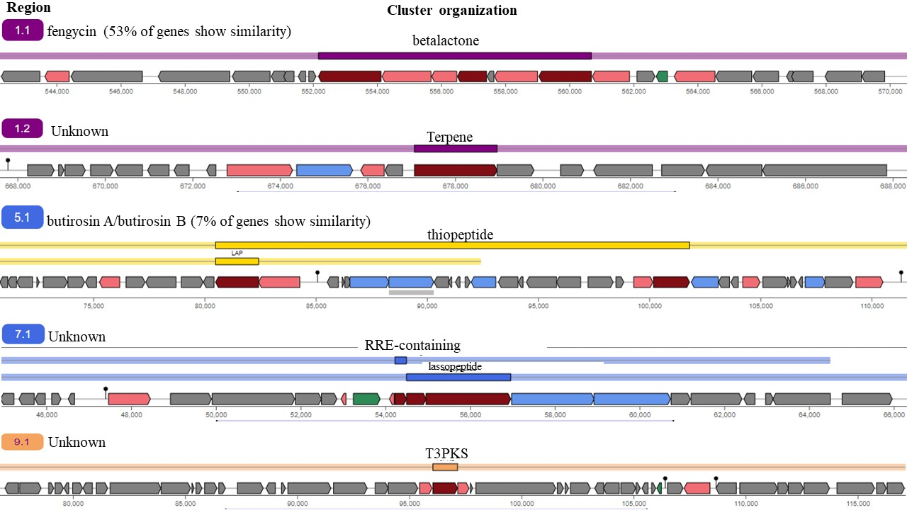

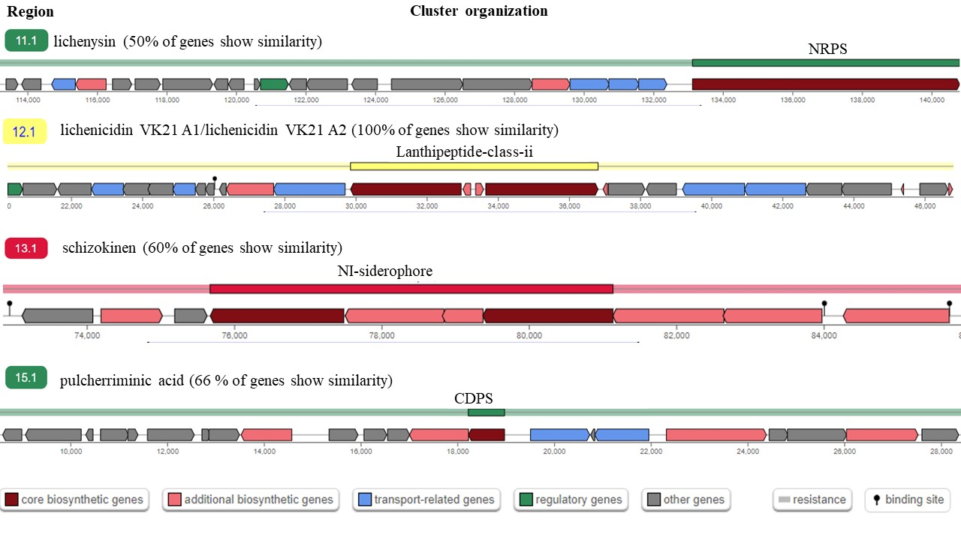
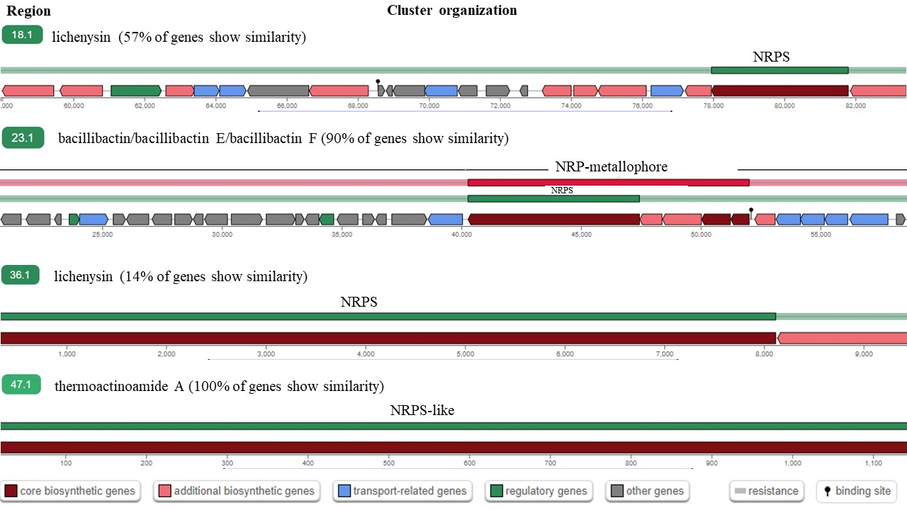
Figure S1. Predicted BGC encoded in B. licheniformis SAMN36381076 MAG by antiSMASH. Fengycin, butirosin A, 3 unknown metabolites were predicted with core biosynthetic genes, lichenysin, bacillibactin/bacillibactin E/bacillibactin F, thermoactinoamide A, lichenicidin VK21 A1/ Lichenicidin VK21 A2, schizokinen, and pulcherriminic acid were predicted with core biosynthetic genes.

Figure S2. Putative redox functionality within the tailings niche. A. Annotation for MAGs from the tailings soil (B. coagulans (bin.2), B. amyloliquefaciens (bin.1), and C. perfringens (bin3)).
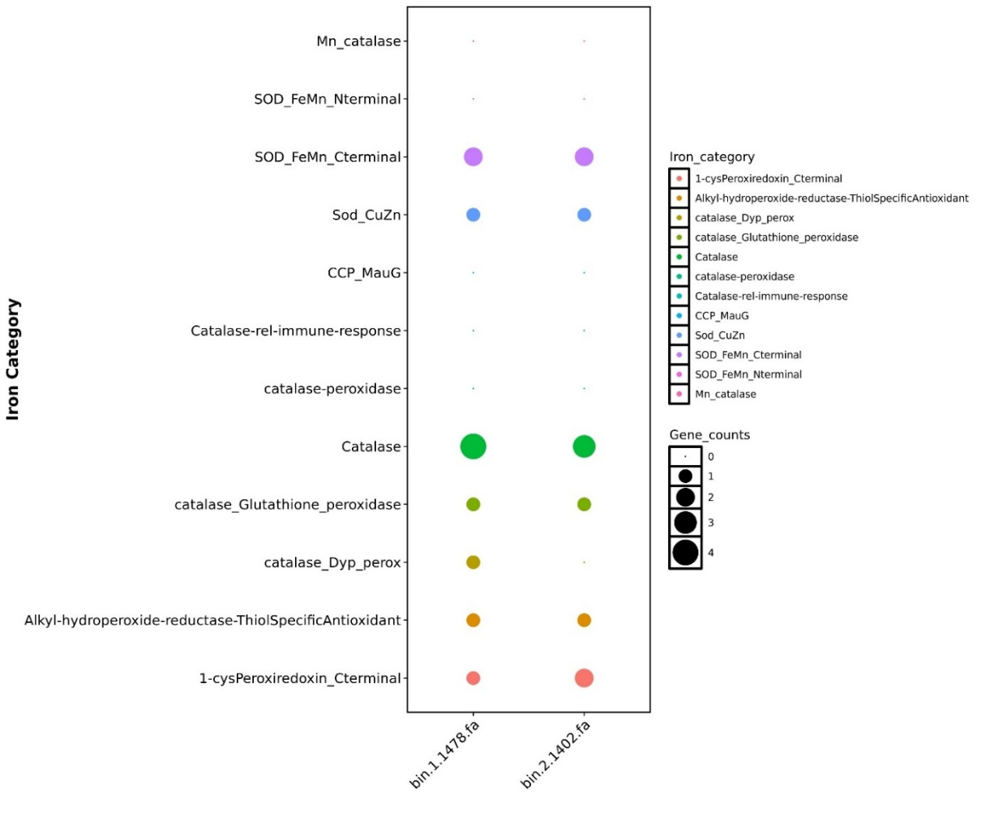
Figure S3. Putative redox functionality within the tailings niche. Annotated functionality for culturable bacteria (B. licheniformis SAMN36381076 (bin.2.1478) and B. simplex SAMN36381075 MAG (bin.1.1402)).

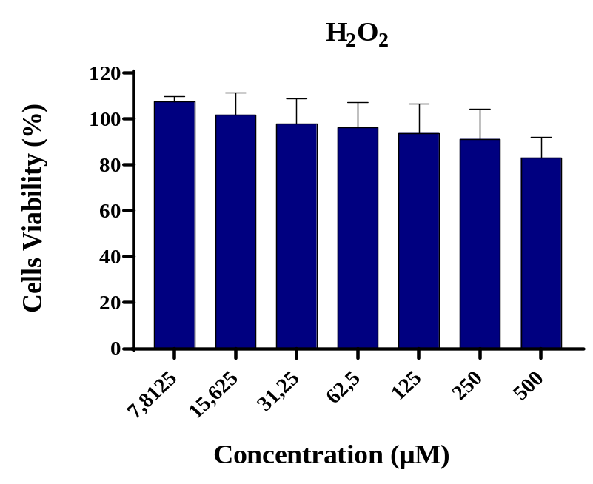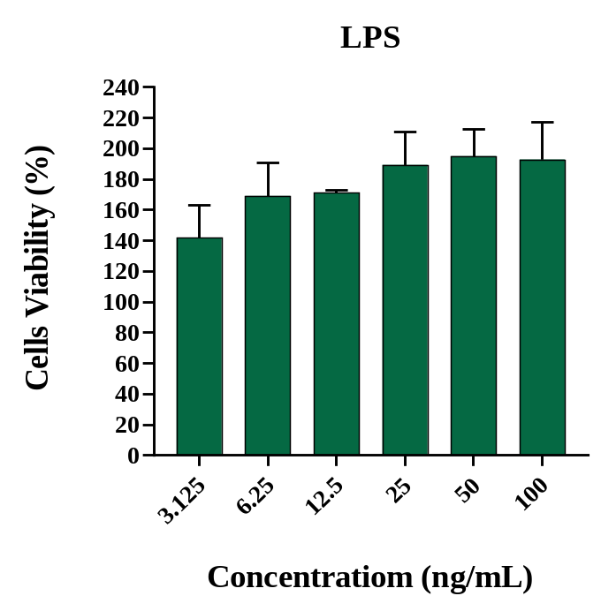

Figure S4. Percentage of cell viability of Raw 264.7 macrophages after 24 hours of treatment with M. tuberculosis H37Rv (D1), and B. licheniformis OM182835 (BLM) semi-purified metabolites (A), Hydrogen peroxide “H₂O₂” (B), Lipopolysaccharide “LPS” (C).

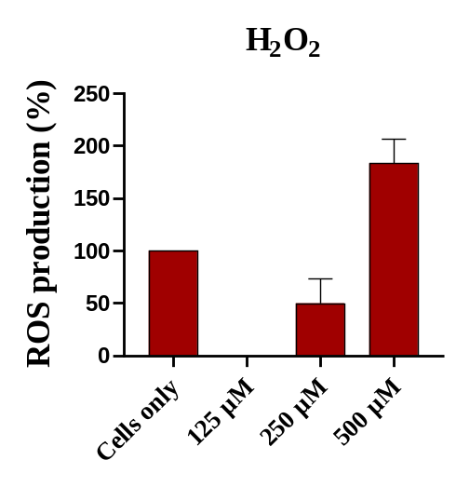

Figure S5. Reactive Oxygen Species (ROS) production in Raw 264.7 macrophages after 24 hours of treatment with H₂O₂.

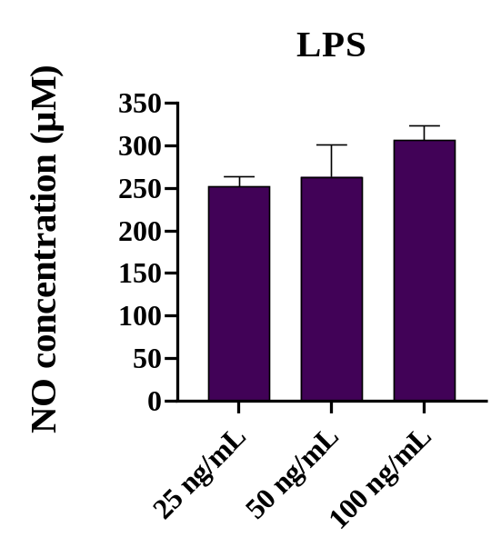
Figure S6. Nitric Oxide accumulation of Raw 264.7 macrophages after lipopolysaccharide (LPS) treatment for 24 hours.

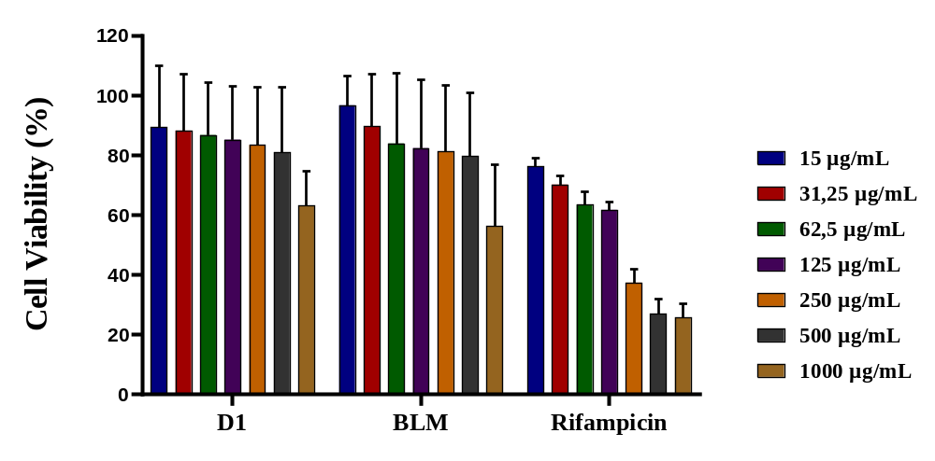

Figure S7. Cell viability assay to determine the lowest concentration used in the treatment assays.

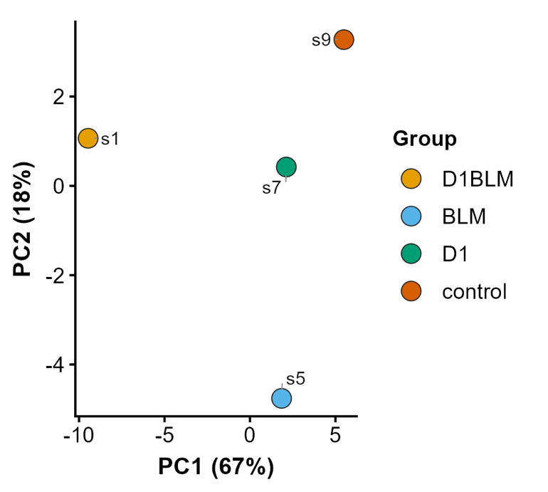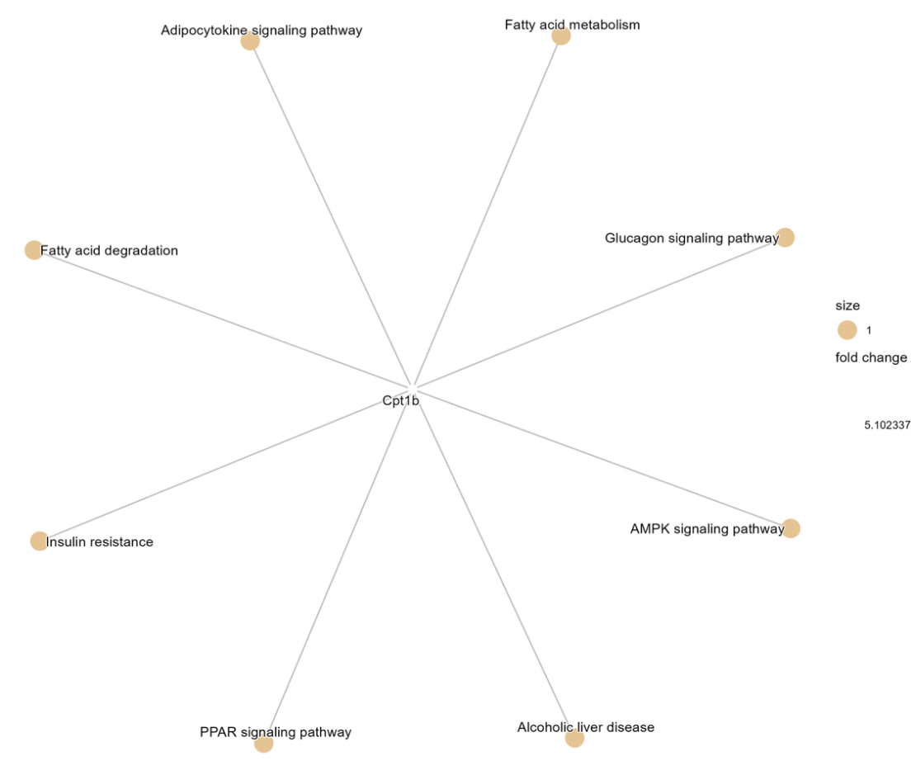
B
A

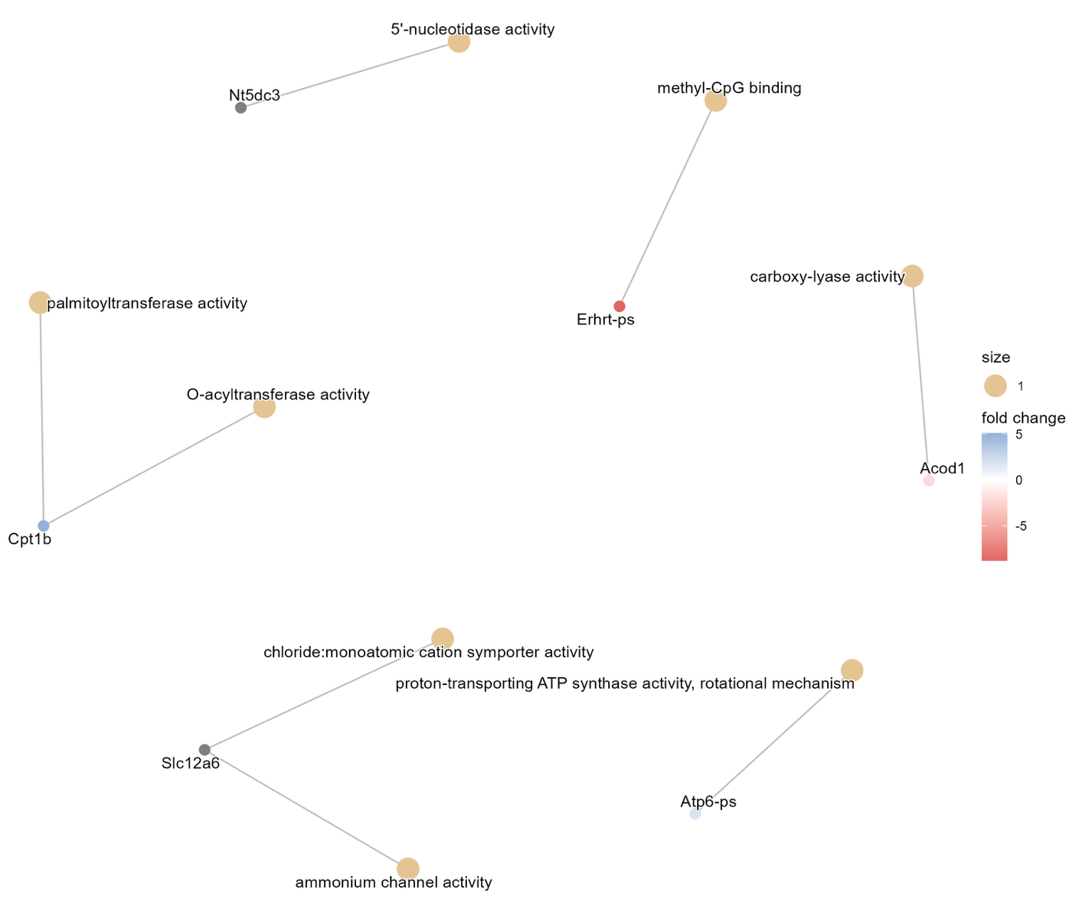
C
Figure S8. The differential expression landscape of Raw 264.7 macrophage cells exposed to semi-purified metabolites from M. tuberculosis (D1) after 2 hours. A. Principal Component Analysis (PCA) showing variance in expression patterns. B. Differential expression of profile centered on cptr1b transcript (control vs D1). D. Enrichment pathway analysis according to Gene Ontology (control vs D1).
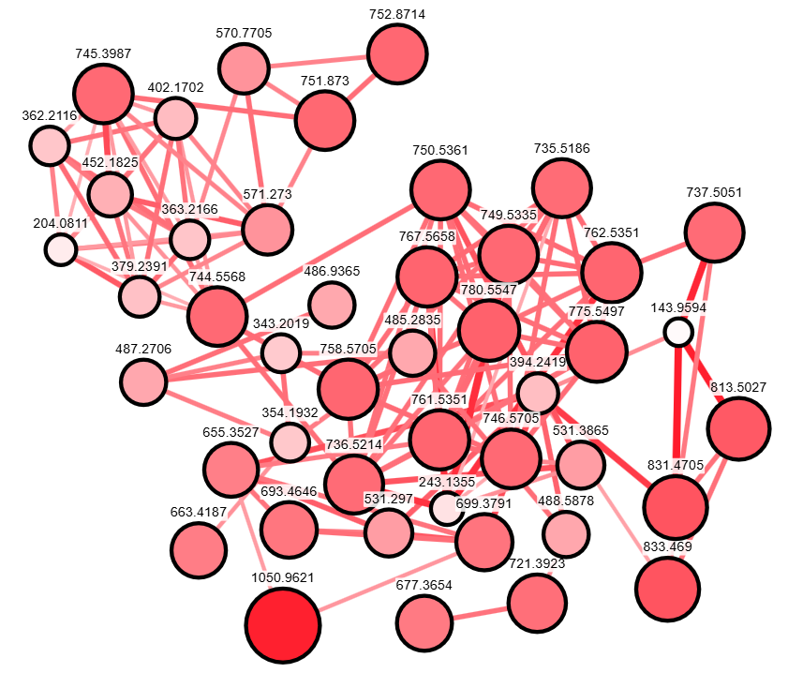
Lichenysin A
Figure S9. Feature-Based Molecular Networking (FBMN) for metabolites derived from B. licheniformis OM182835 (BLM).
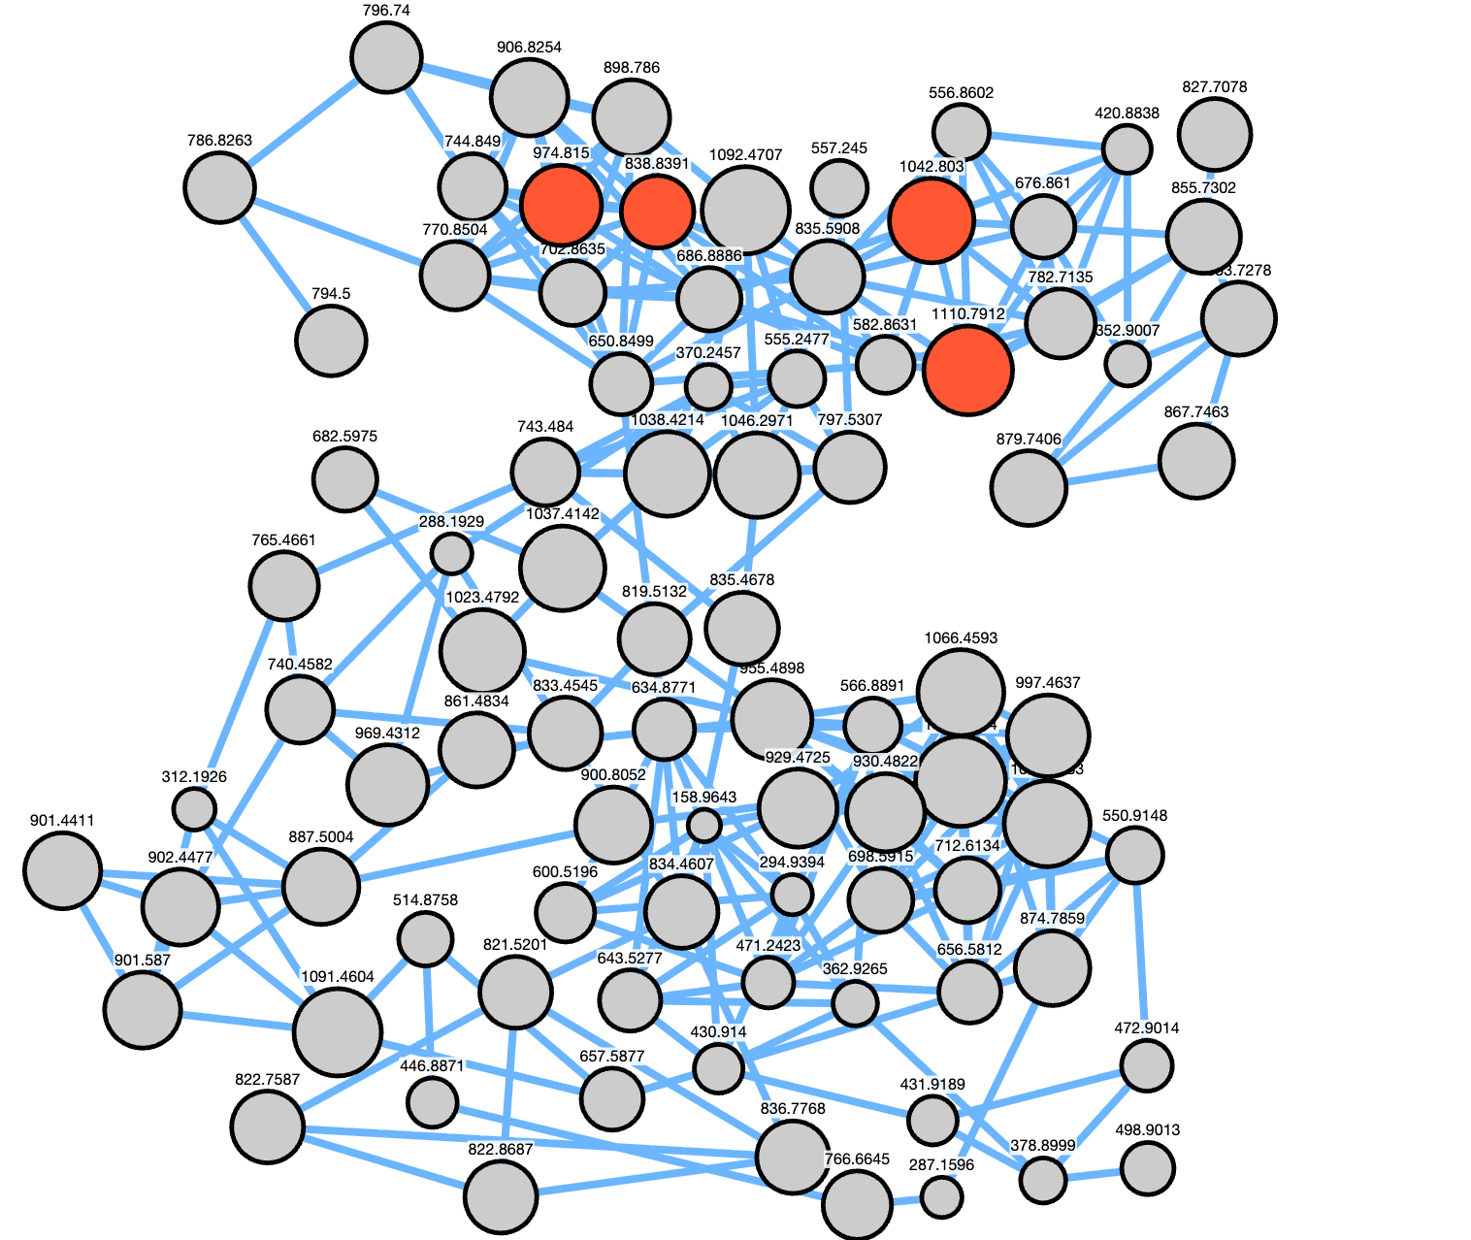
Figure S10. Feature-Based Molecular Networking (FBMN) for metabolites derived from M. tuberculosis H37Rv (D1).
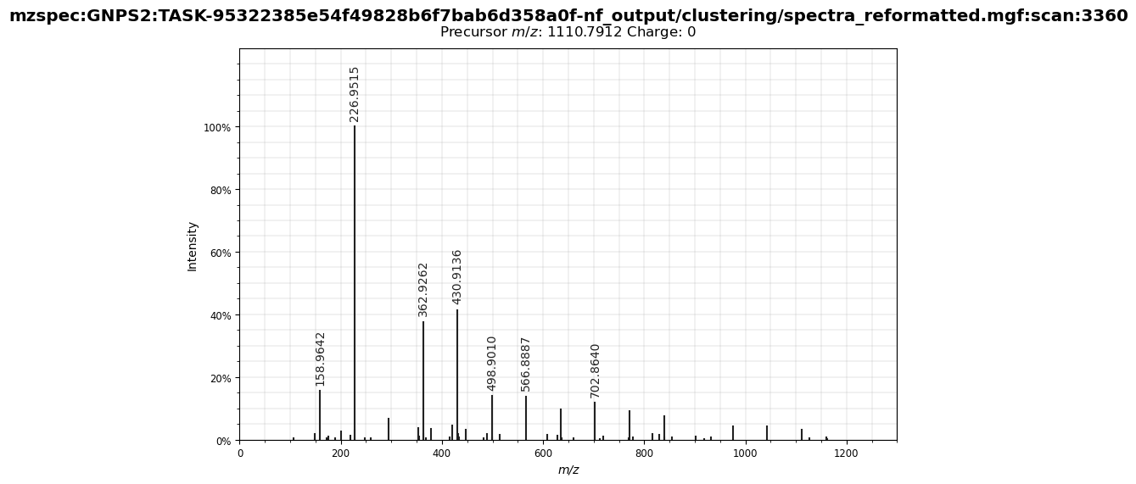
Figure S11. MS/MS fragmentation spectrum of precursor m/z 1110.7912.

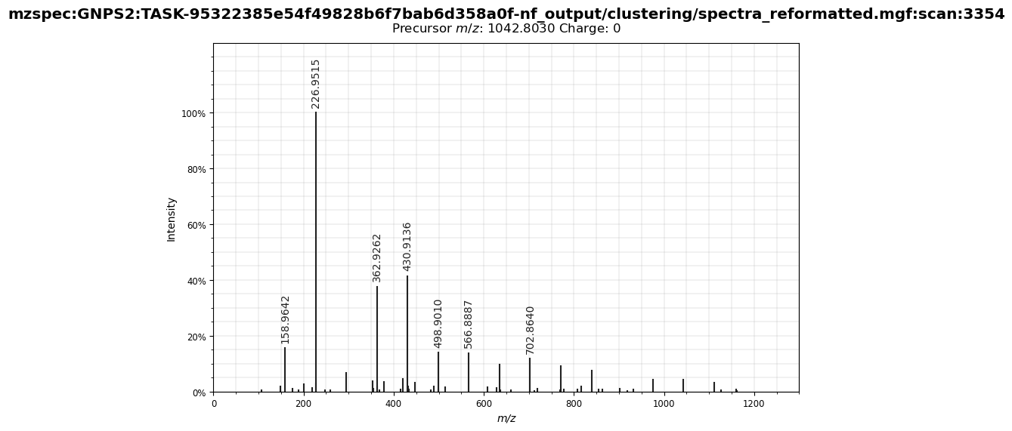
Figure S12. MS/MS fragmentation spectrum of precursor m/z 1042.8030.

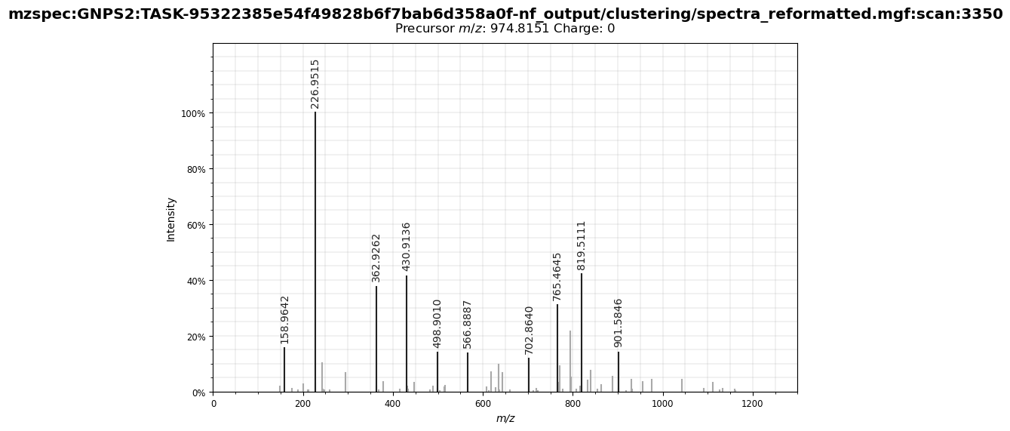
Figure S13. MS/MS fragmentation spectrum of precursor m/z 974.8150.

