Supplementary Materials for
Volcanic-affinity compositional shifts obscure chemical weathering signals in black shales
The Supplementary Materials file includes:
Supplementary Notes (1–5)
Supplementary Figures (S1–S6)
Supplementary Tables (1–5)
Separate machine-readable files supplied with the submission:
Supplementary Data 1: Targeted 1,546-sample literature-curated black-shale cohort, provenance, geological context, harmonised source fields and row-level quality-control metadata. Derived A–CN–K/posterior fields are supplied in Supplementary Data 2; CIA-family/${\text{R}}_{\text{CIA}}$ fields are supplied in Supplementary Data 3. Actual archive file: Supplementary_Data_1_Main_Cohort_and_Provenance.zip.
Supplementary Data 2: ${\text{M}}_{\text{0}}$/${\text{M}}_{\text{1}}$/${\text{M}}_{\text{2}}$ model-support libraries, A–CN–K and ilr analytical compositions, posterior outputs and parameters, plotting-domain source data and materials for sample-level numerical replay. Actual archive file: Supplementary_Data_2_Endmember_Libraries_and_Posterior.zip.
Supplementary Data 3: CIA-family indices, sample-level ${\text{R}}_{\text{CIA}}$ outputs, baseline and threshold sensitivities, bootstrap outputs, figure membership and data dictionaries. Actual archive file: Supplementary_Data_3_CIA_${\text{R}}_{\text{CIA}}$_and_Robustness.xlsx.
Supplementary Data 4: J10025 quantitative X-ray diffraction (XRD) phase estimates and total organic carbon (TOC) records, mineral-phase dictionary, ${\text{VMI}}_{\text{XRD}}$ calculation, depth metadata, selected-sample identifier crosswalk, quality-control fields and interpretive scope. Actual archive file: Supplementary_Data_4_J10025_XRD_and_TOC.xlsx.
Supplementary Data 5: Targeted scanning electron microscopy–energy-dispersive X-ray spectroscopy (SEM–EDS) point classes, OSI–TOC outputs, grouped out-of-fold (OOF) predictions and Shapley additive explanations (SHAP) values, figure source data, computational validation materials and the posterior-emulator deployment package. Actual archive file: Supplementary_Data_5_SEM_EDS_OSI_TOC_ML_SHAP_and_Deployment.zip.
Supplementary Notes
Supplementary Note 1: Data compilation, cohort definition and analytical subsets
This Note supplements the main-text description of the data architecture and major-element processing with details of cohort eligibility, curation metadata, field-level provenance and boundary-test implementation. Analysis-specific populations and denominators are summarised in Supplementary Table 1.
Eligibility required a DOI-aware published or reference-like source, shale or mudstone context, exclusion of explicit hard-rock and pure-tuff records, TOC availability, valid A–CN–K coordinates, complete posterior fields, a valid ${\text{M}}_{\text{0}}$/${\text{M}}_{\text{1}}$/${\text{M}}_{\text{2}}$ label and explicit evidence metadata. Records labelled no volcanic evidence, proxy-only or metal-anomaly evidence were excluded. Strong evidence comprised ash, tuff, tuffaceous, bentonite/bentonitic, volcaniclastic, volcanic-event, tephra or non-regional hydrothermal wording; regional volcanic/hydrothermal unit and other target-unit evidence were classified as moderate. These categories summarise literature wording at heterogeneous evidence levels and do not provide independent sample-level measurements of volcanic abundance.
Curation fields comprise reference, doi_or_url, basin, formation, member, site, sample, age, period, lithology, facies, volcanic_evidence_strength, volcanic_evidence_basis, volcanic_evidence_source_field, volcanic_evidence_type, match_basis, data_tier, qc_flag, ack_sum and ack_valid, together with source identifiers. Supplementary Data 1 provides sample identities, provenance, harmonised source fields and row-level quality-control metadata; derived A–CN–K/posterior and CIA-family/${\text{R}}_{\text{CIA}}$ fields are supplied in Supplementary Data 2 and 3, respectively.
Oxide concentrations were interpreted as grams per 100 g of sample before molar conversion.
In the phosphate-corrected-first sensitivity, phosphate subtraction was set to zero for the single record lacking ${\text{P}}_{\text{2}}{\text{O}}_{\text{5}}$ before application of the Na cap. High-phosphate and high-Ca exclusions were evaluated separately, and uncapped total $\text{CaO}$ was used only in the carbonate-sensitive boundary test. Loss-on-ignition coverage was incomplete, and neither ${\text{CaO}}^{\text{∗}}$ route resolves sample-specific Ca hosts.
Supplementary Note 2: Model-support geometry and posterior compositional-exposure ranking
Additional documentation of the main-text posterior method covers scored-row validation, upstream support cleaning, the distinction between recovered base domains and frozen inference arrays, realised bandwidths, local uncertainty summaries and numerical replay.
Scored rows were accepted only when A, CN and K were finite, non-negative, bounded between zero and one and summed to within 0.01 of unity. Finite zeros were replaced by ${\text{10}}^{\text{−9}}$, after which rows were reclosed to unit sum. For upstream support cleaning, non-finite or non-positive A/CN/K rows were excluded; retained components were floored within each group to the greater of ${\text{10}}^{\text{−8}}$ and 0.5 times its first positive percentile, closed and ilr-transformed. Robust covariance with 75% support was iterated up to eight times, after which the empirical 97.5% robust-Mahalanobis cutoff was applied.
The cleaning audit recorded ${\text{M}}_{\text{0}}$ 2,471 → 2,219 with A/CN/K floors of 0.222, 0.00169 and 0.00429 and a $\text{robust-}{\text{MD}}^{\text{2}}$ cutoff of 96.70039743; mafic–intermediate 115,523 → 112,459 with floors of 0.182, 0.0764 and 0.000972 and a cutoff of 54.47417209; and felsic 48,993 → 47,697 with floors of 0.208, 0.00982 and 0.00725 and a cutoff of 209.15059786. These values describe recovered base-domain cleaning. The authoritative frozen inference table subsequently class-labelled 128 fresh-shale rows as ${\text{M}}_{\text{1}}$ and 2,091 as ${\text{M}}_{\text{2}}$, yielding the replay-exact arrays of 112,587 and 49,788. From these frozen arrays, each ${\text{M}}_{\text{1}}$/${\text{M}}_{\text{2}}$ simulation independently sampled a reference-like row and an affinity-specific row, drew f uniformly on [0,1), and formed their convex combination with weights 1−f and f in closed A–CN–K composition space. Components were floored at ${\text{10}}^{\text{−9}}$, reclosed and then ilr-transformed. ${\text{M}}_{\text{0}}$ resampled the reference-like array with f=0. A single random sequence with seed 20260427 was used in ${\text{M}}_{\text{0}}$→${\text{M}}_{\text{1}}$→${\text{M}}_{\text{2}}$ order. The 180,000 draws per model describe simulated compositions, distinct from the support-array row counts. The verified draw_mixture_cloud and run_ptd_kdtree functions are supplied in Supplementary Data 2, verified_inference_source.py.
Across the 44,558 A–CN–K-valid scoring rows, the realised bandwidths were 0.0500000000000000 for ${\text{M}}_{\text{0}}$, 0.06256913768284394 for ${\text{M}}_{\text{1}}$ and 0.05812579127550185 for ${\text{M}}_{\text{2}}$. Stored medians and nominal 95% limits were probability-weighted combinations of the within-${\text{M}}_{\text{1}}$/${\text{M}}_{\text{2}}$ local weighted quantiles rather than quantiles of a pooled distribution containing an ${\text{M}}_{\text{0}}$ point mass. These summaries do not imply 95% coverage of the full posterior. The historical fields f_volc_ci95_lo and f_volc_ci95_hi serve as operational quality metadata. The historical bandwidth set included inherited valid A–CN–K coordinates where raw core oxide fields were incomplete. It is therefore distinct from the 26,522 unique records with complete ${\text{Al}}_{\text{2}}{\text{O}}_{\text{3}}$, $\text{CaO}$, ${\text{Na}}_{\text{2}}\text{O}$ and ${\text{K}}_{\text{2}}\text{O}$ fields and from the independently curated 1,546-sample analytical cohort. The local-quantile weights are P_${\text{M}}_{\text{1}}$ and P_${\text{M}}_{\text{2}}$ as stored, without renormalising their sum to one.
The archived identifier-matched replay from the frozen arrays and posterior parameters reproduced all 1,546 posterior values to machine precision; those historical full-cohort metrics are reported in Supplementary Table 2. The supplied validate_posterior_archive.py checks stored output consistency rather than independently generating posterior values; validate_frozen_start_subset.py provides a separate entry point for a nine-sample verification from the frozen arrays. The recovered cleaner documents base-domain construction, but the visible generator would omit the 128 and 2,091 fresh-shale rows added to the frozen ${\text{M}}_{\text{1}}$ and ${\text{M}}_{\text{2}}$ inference arrays. The exact historical mapping version and raw precursor inputs required to regenerate final_endmember_plot_points.csv were not recovered. The frozen arrays are therefore the bounded upstream starting point for sample-level inference. Posterior $\text{E}\text{[}{\text{f}}_{\text{volc}}\text{]}$ remains a model-derived compositional-exposure ranking, not volcanic abundance or a direct material fraction.
Supplementary Note 3: Weathering-index responses and construction of the ${\text{R}}_{\text{CIA}}$ reference-baseline screen
Supplementary documentation of the main-text weathering-statistics and ${\text{R}}_{\text{CIA}}$ methods covers sensitivity populations, composition-aware diagnostics, exact baseline coordinates, endpoint handling and baseline-classification robustness.
The phosphate-corrected-first CIA sensitivity used 1,000 bootstrap replicates with seed 20260628. Additional checks comprised high-Ca and high-phosphate exclusions, reference-study-level grouped bootstrap resampling, group-median analyses, leave-one-reference-study-out tests and sequential compositional controls. Definitions, denominators and outputs are reported in Supplementary Fig. S3, Supplementary Table 3 and Supplementary Data 3.
For the archived phosphate-corrected-first implementation, CIA–exposure alignment was compared with 5,000 random directions in centred-log-ratio A–CN–K space using a two-sided empirical P value; the associated rank residualisation conditioned on both ilr coordinates.
For the ${\text{M}}_{\text{0}}$-only reference coordinate, the centre was $\left({\text{ilr}}_{\text{1}}\text{,}{\text{ilr}}_{\text{2}}\right)\text{=}\left(\text{1.758797366650168,0.08711466948093365}\right)$, and the signed ${\text{PC}}_{\text{1}}$ $\text{loading}\text{=}\left(\text{0.796968706825736,−0.6040205959572191}\right)$. Its sign was selected so that $\text{corr}\left({\text{PC}}_{\text{1}}\text{,}{\text{M}}_{\text{0}} {\text{ilr}}_{\text{1}}\right)\text{=+0.9629768575290013}$. Sorted duplicate coordinate values were averaged before interpolation. Constant nearest-endpoint prediction used CIA values of 42.6843486949 below and 66.0863846164 above the fitted range; six samples fell below the fitted range and none above, and all were retained. The residual centre, MAD and robust scale used for standardisation are reported in Supplementary Table 3. The raw LOWESS curve differs from the residual-centred reference baseline by the ${\text{M}}_{\text{0}}$ residual median. Accordingly, zero ${\text{R}}_{\text{CIA}}$ corresponds to LOWESS plus that centre, and positive/negative values denote positions above/below this centred reference. This is the algebraically equivalent definition given in Methods.
Threshold perturbations shifted both departure cutoffs by $\text{ΔMAD}$ from −0.50 to +0.50 in 0.05 steps. LOWESS variants crossed fractions 0.25, 0.35 and 0.45 with robustness iterations of 0 and 3 and recalculated the ${\text{M}}_{\text{0}}$ residual centre, MAD and scale. In each of 500 bootstrap replicates using seed 20260723, 733 ${\text{M}}_{\text{0}}$ rows were resampled with replacement, centred-unscaled PCA was refitted, ${\text{PC}}_{\text{1}}$ was sign-aligned to the primary loading by a positive dot product, all samples were projected, LOWESS was refitted and the residual centre, MAD and scale were recalculated from the resampled ${\text{M}}_{\text{0}}$ rows. Exact-agreement outputs are retained in Supplementary Table 3, with sample-level assignments in Supplementary Data 3. ${\text{R}}_{\text{CIA}}$ is a signed, standardised baseline departure and is not corrected CIA or reconstructed pre-overprint weathering intensity.
Supplementary Note 4: Primary OSI–TOC analysis and loading-stability audit
Details of the seven-proxy construction audit, loading orientation, quality-control tiers, dilution and influence screens and same-sample regression specifications supplement the concise OSI–TOC description in the main text.
For the loading and construction-stability audit, the seven ratios listed in Supplementary Table 4 were calculated for records with positive ${\text{Al}}_{\text{2}}{\text{O}}_{\text{3}}$ and retained only when the resulting values were positive and finite before ${\text{log}}_{\text{10}}$ transformation. The ratios were z-standardised using population standard deviations (ddof = 0), without winsorisation or median imputation. All seven were finite in 673 records. Leverage was $\text{h=}\sum_{\text{j}}{{\text{z}}_{\text{j}}^{\text{2}}}$; excluding 21 records above ${\text{χ}}_{\text{7,0.995}}^{\text{2}}\text{=20.27773987496262}$ left 652 cases for PCA. ${\text{PC}}_{\text{1}}$ explained 47.667062% of the variance and was multiplied by −1 to orient its loadings towards jointly higher redox/productivity proxy values without using TOC, posterior, carbonate or weathering variables. Leave-one-proxy-out PCA used ${\text{χ}}_{\text{6,0.995}}^{\text{2}}\text{=18.547584178511087}$; the resulting loading-stability audit is displayed in Supplementary Fig. S5b. The transformations and linear projection take the following form; the primary 673-case downstream score uses its own archived parameter vectors specified below:
$${\text{x}}_{\text{j}}\text{=}{\text{log}}_{\text{10}}\left({\text{ratio}}_{\text{j}}\right)$$
$\text{OSI=}\sum_{\text{j}}{{\text{λ}}_{\text{j}}}\frac{{\text{x}}_{\text{j}}\text{−}{\text{μ}}_{\text{j}}}{{\text{σ}}_{\text{j}}}$.
For the primary 673-case downstream OSI score, the exact loading, mean and population-standard-deviation vectors are supplied in Supplementary Data 5, B_OSI_TOC/OSI_673_exact_parameters.csv. Supplementary Table 4 summarises the separate 652-case loading and construction-stability audit; its displayed loadings are not the primary score parameters.
The exact analysis-tier sequence and paired model-complete populations are reported in Supplementary Table 4; the archived tier rules follow.
The primary analysis assigned tiers before model-complete filtering: raw positive complete case, $\text{n}\text{=673;}$ QC-cleaned, $\text{n}\text{=508;}$ dilution-sensitive-cleaned, $\text{n}\text{=434;}$ and strict-cleaned, $\text{n}\text{=406.}$ QC-cleaned required qc_flag = ok, complete pmax, entropy, f_volc_ci95_lo, f_volc_ci95_hi and ptd_uncertainty_score fields, and ptd_uncertainty_score strictly below the archived ${\text{Q}}_{\text{90}}$ of 2.401188707280832. On QC-cleaned rows, dilution flags used ${\text{Q}}_{\text{3}}\text{+3IQR}$ cutoffs of 31.500941214893878 for CaO_anhydrous_norm, 1.6466445321174925 for $\text{CaO/A}{\text{l}}_{\text{2}}{\text{O}}_{\text{3}}\text{,}$ 21.901998036963516 for $\text{Si}{\text{O}}_{\text{2}}\text{/A}{\text{l}}_{\text{2}}{\text{O}}_{\text{3}}$ and 23.206314627135914 for $\text{Zr/A}{\text{l}}_{\text{2}}{\text{O}}_{\text{3}}\text{;}$ exceeding any cutoff triggered exclusion from the dilution-sensitive tier. High influence required at least two of the following criteria: $\text{Cook’s}\text{D}\text{>}\frac{\text{4}}{\text{n}}\text{,}$ $\text{|externally studentised residual|>3}$ and ${\text{max}}_{\text{j}}\text{|}{\text{DFBETAS}}_{\text{j}}\text{|>}\frac{\text{2}}{\sqrt{\text{n}}}\text{.}$ Strict cleaning was dilution-sensitive cleaning plus removal of high-influence rows. For $\text{n}\text{=508,}$ $\frac{\text{4}}{\text{n}}\text{=0.007874015748031496}$ and $\frac{\text{2}}{\sqrt{\text{n}}}\text{=0.08873565094161139;}$ for $\text{n}\text{=434,}$ they are 0.009216589861751152 and 0.09600307214746386. The ci95 fields contain the probability-weighted local-quantile summaries defined in Note 2. Their use with pmax, entropy and ptd_uncertainty_score is operational QC within the archived implementation, not an independently calibrated 95% uncertainty guarantee.
TOC was modelled as ${\text{log}}_{\text{10}}\left(\text{TOC+1}\right)$. The OSI-only baseline was specified as
$$\text{1+bs}\left(\text{OSI,df=4,degree=3,include_intercept=False}\right)$$
and fitted to ${\text{log}}_{\text{10}}\left(\text{TOC+1}\right)$. Within each analytical tier, this baseline was compared with an extended model containing posterior $\text{E}\text{[}{\text{f}}_{\text{volc}}\text{]}$ on exactly the same samples. Model-comparison results are reported in Supplementary Table 4 and Supplementary Fig. S5.
Supplementary Note 5: Posterior emulation, grouped-OOF evaluation, held-out SHAP and deployment
Feature conventions, benchmark hyperparameters, reproducibility tests and deployment safeguards are documented here to supplement the main-text grouped-OOF and held-out-SHAP methods.
The archived ${\text{K}}_{\text{2}}\text{O}$/${\text{Al}}_{\text{2}}{\text{O}}_{\text{3}}$ and ${\text{Na}}_{\text{2}}\text{O}$/${\text{Al}}_{\text{2}}{\text{O}}_{\text{3}}$ predictors are wt/wt oxide ratios. For all 1,546 training samples, the Fe/Al predictor is a molar cation ratio: elemental Fe in the linked DM-SED source records was converted to ${\text{Fe}}_{\text{2}}{\text{O}}_{\text{3T}}$-equivalent wt.%, and the archived raw-oxide converter reproduces the frozen feature values. Raw deployment therefore requires explicitly harmonised total Fe as ${\text{Fe}}_{\text{2}}{\text{O}}_{\text{3}}$-equivalent input on the same mass basis as the other oxides; it does not automatically interpret or convert other Fe reporting conventions.
ExtraTrees used 320 trees, unlimited depth, minimum leaf size 2, max_features = 1.0, no bootstrap and seed 20260528. RandomForest used 280 trees, unlimited depth, minimum leaf size 2 and seed 20260528. Ridge used median imputation, standardisation and α = 1. XGBoost used 500 trees, learning rate 0.03, maximum depth 3, subsample 0.85, column subsample 0.85, λ = 1, the squared-error objective, histogram tree method, CPU execution and seed 20260528. Benchmark and feature-set results are retained in Supplementary Table 4.
TreeExplainer used tree_path_dependent perturbation. The archived reproducibility checks reran all three grouped designs and compared fold assignments, OOF predictions and pooled metrics; they also tested SHAP additivity, pooled importance, feature-family shares, fold-rank stability and top-k overlap. Exact replay outcomes are reported in Supplementary Table 4 and Supplementary Data 5.
The archived value of 0.25 is fixed for the reported comparison of reference posterior scores and OOF predictions. Its original selection rationale cannot be established from the available historical record, which does not demonstrate whether it was prespecified or optimised. This operating point is distinct from the historical reporting bin high ≥0.20 in Supplementary Table 2.
Supplementary Data 5 supplies the trained full-data ExtraTrees refit, feature schema, direct-feature and raw-major-oxide input modes, dependency specifications, domain flags and software tests. The deployment object is model/posterior_emulator_extratrees_v1.joblib (model identifier posterior_emulator_extratrees_v1; schema version 1.0.0; SHA-256 9fb3c9db2cb732a9925d08ee20fa81af1833b9fd7ff00a322c6baeeeb217dcc9). The isolated archived environment used Python 3.12.13, numpy 2.4.6, pandas 3.0.3, scipy 1.17.1, scikit-learn 1.8.0 and joblib 1.5.3; all 11 packaged tests passed in that archived validation. A separate verification reran these tests and checked raw/direct feature equivalence against the linked elemental source records.
A marginal warning is emitted outside a feature’s training ${\text{P}}_{\text{1}}\text{–}{\text{P}}_{\text{99}}$ interval or at $\text{|}{\text{z}}_{\text{robust}}\text{|>4}$, and a hard warning is emitted outside the training minimum–maximum range. Manual inspection is required when any marginal or hard warning is present or when two or more predictors are median-imputed. A row with one imputed predictor and no domain warning is retained with the imputed field reported. These rules implement evidence-quality review rather than automatic rejection and do not establish joint multivariate in-domain status.

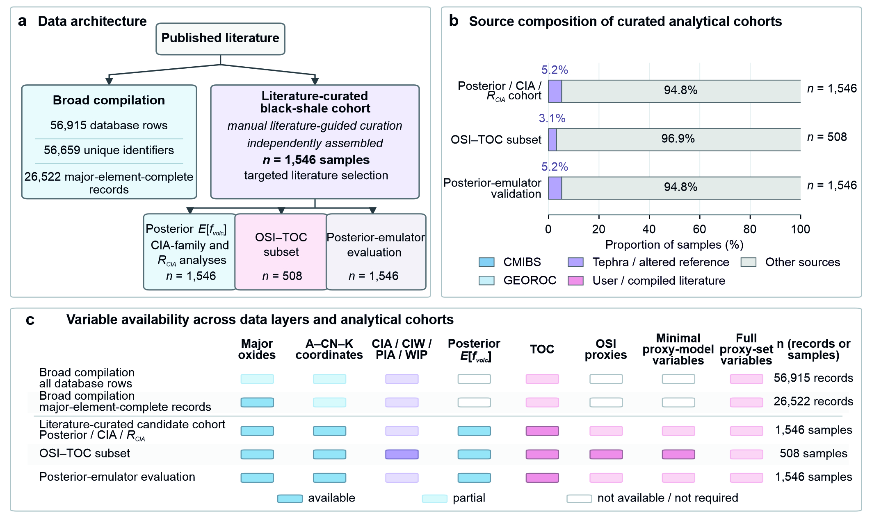
Supplementary Fig. S1 | Data architecture, literature-curated black-shale cohort and variable availability. a, Parallel data layers: the broad compilation (56,915 rows, 56,659 unique identifiers and 26,522 major-element-complete records) and independently assembled literature-guided cohort $\left(\text{n}\text{=1,546}\right)$, with analysis-specific subsets. b, Sources contributing to the posterior/CIA/${\text{R}}_{\text{CIA}}$, OSI–TOC and posterior-emulator grouped-OOF populations. c, Availability of major oxides, A–CN–K coordinates, CIA-family indices, posterior $\text{E}\text{[}{\text{f}}_{\text{volc}}\text{]}$, TOC, OSI and emulator variables. Denominators distinguish database records from unique samples; each grouped-OOF entry is one prediction for a sample withheld with its complete grouping unit.
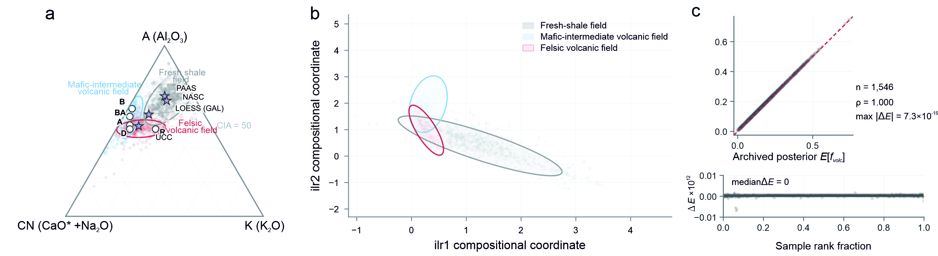
Supplementary Fig. S2 | Model-support geometry and sample-level posterior replay. a, ${\text{M}}_{\text{0}}$/reference-like, ${\text{M}}_{\text{1}}$/mafic–intermediate-affinity and ${\text{M}}_{\text{2}}$/felsic-affinity support arrays in A–CN–K space, with reference-shale compositions. The arrays define model-based compositional domains, not verified provenance populations. b, Descriptive 85% envelopes in ilr space; these are not posterior inclusion boundaries. c, Numerical replay with the supplied support arrays and posterior parameters reproduced archived values for all 1,546 samples (Spearman’s $\text{ρ}\text{=1.000}$; maximum $\text{|Δ}\text{E}\text{|=7.30×}{\text{10}}^{\text{−15}}$).
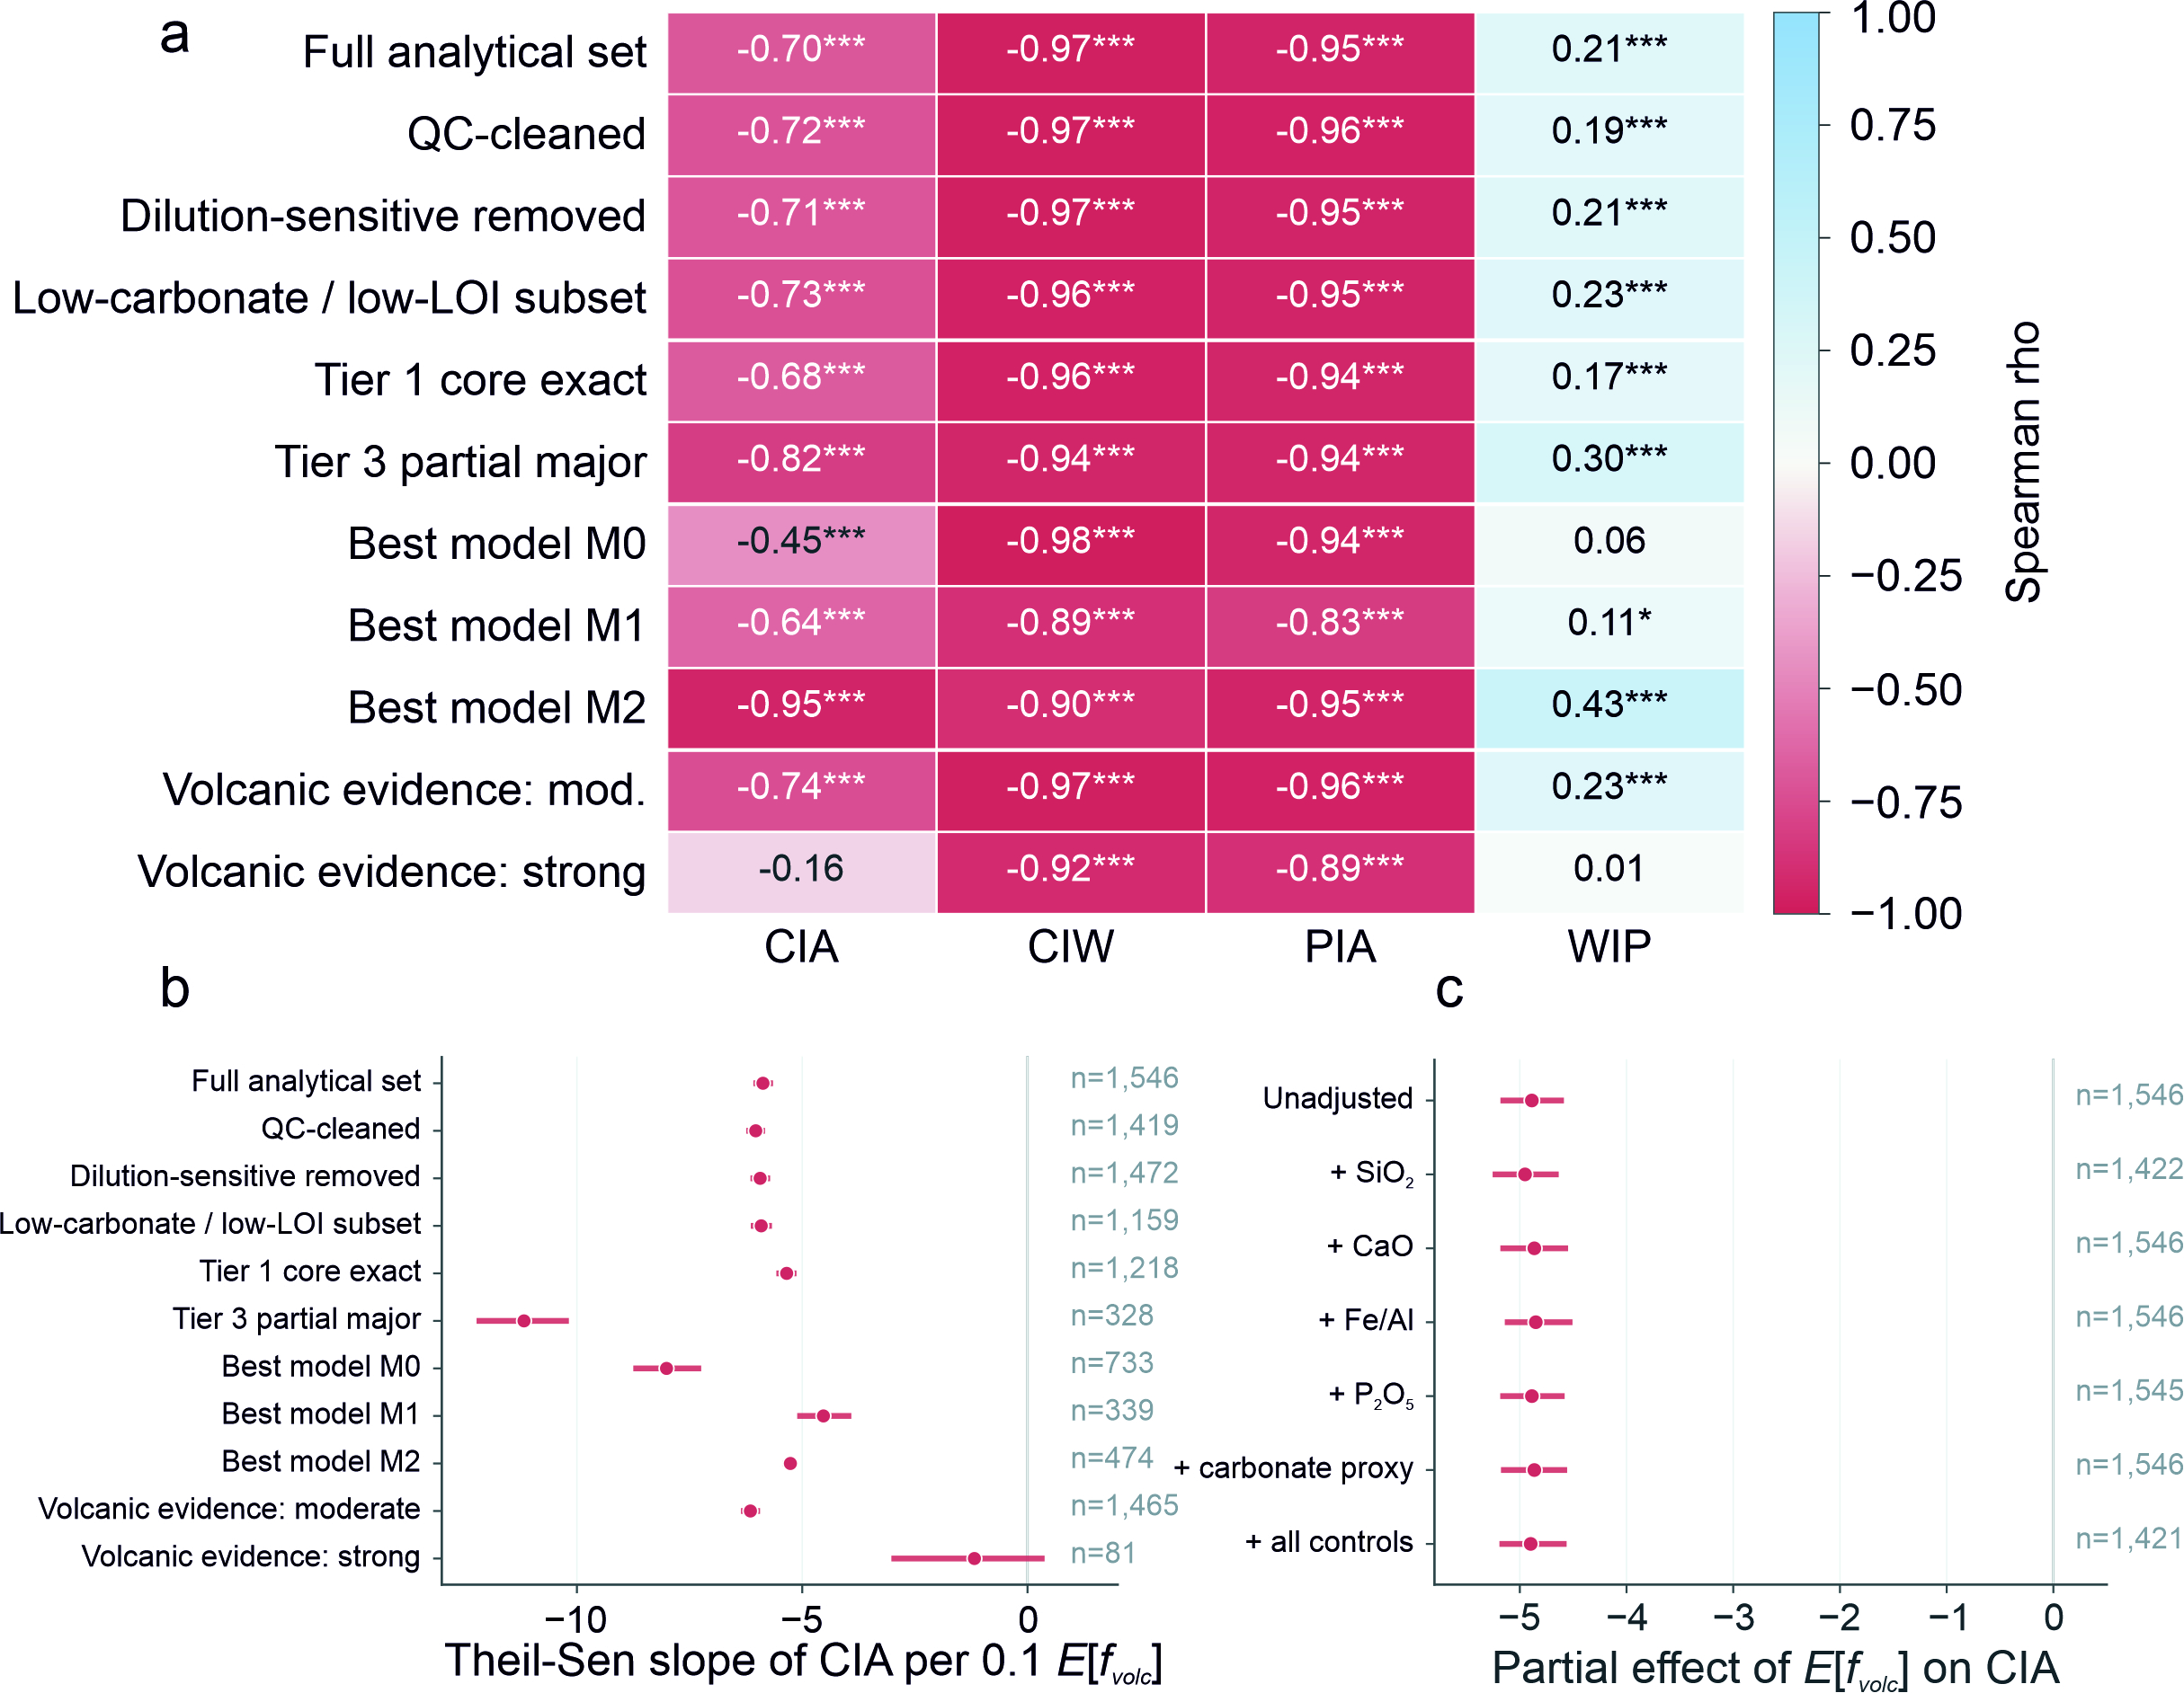
Supplementary Fig. S3 | Subset stability and sequential compositional diagnostics of weathering-index responses. a, Spearman correlations of CIA, CIW, PIA and WIP with posterior compositional exposure across the full cohort and specified subsets. b, CIA Theil–Sen slopes per 0.1 posterior exposure across the same subsets; labels give analysis-specific denominators. c, CIA–exposure estimates after sequential adjustment for the displayed compositional covariates. Evidence-strength categories are curation metadata, not provenance assignments; adjusted estimates are descriptive, not causal. The primary full-cohort four-index response is in Fig. 2a. In the literature-coded strong-evidence subset (n=81), CIA and WIP are explicit weak-association exceptions (ρ=−0.161 and +0.015), whereas CIW and PIA remain strongly negative (ρ=−0.922 and −0.886). No direct between-subset significance or sample-level abundance validation is implied. Asterisks indicate unadjusted Spearman-correlation P values: *P < 0.05, **P < 0.01 and ***P < 0.001. Horizontal bars show 95% confidence intervals (Theil–Sen intervals in b; percentile-bootstrap intervals in c).
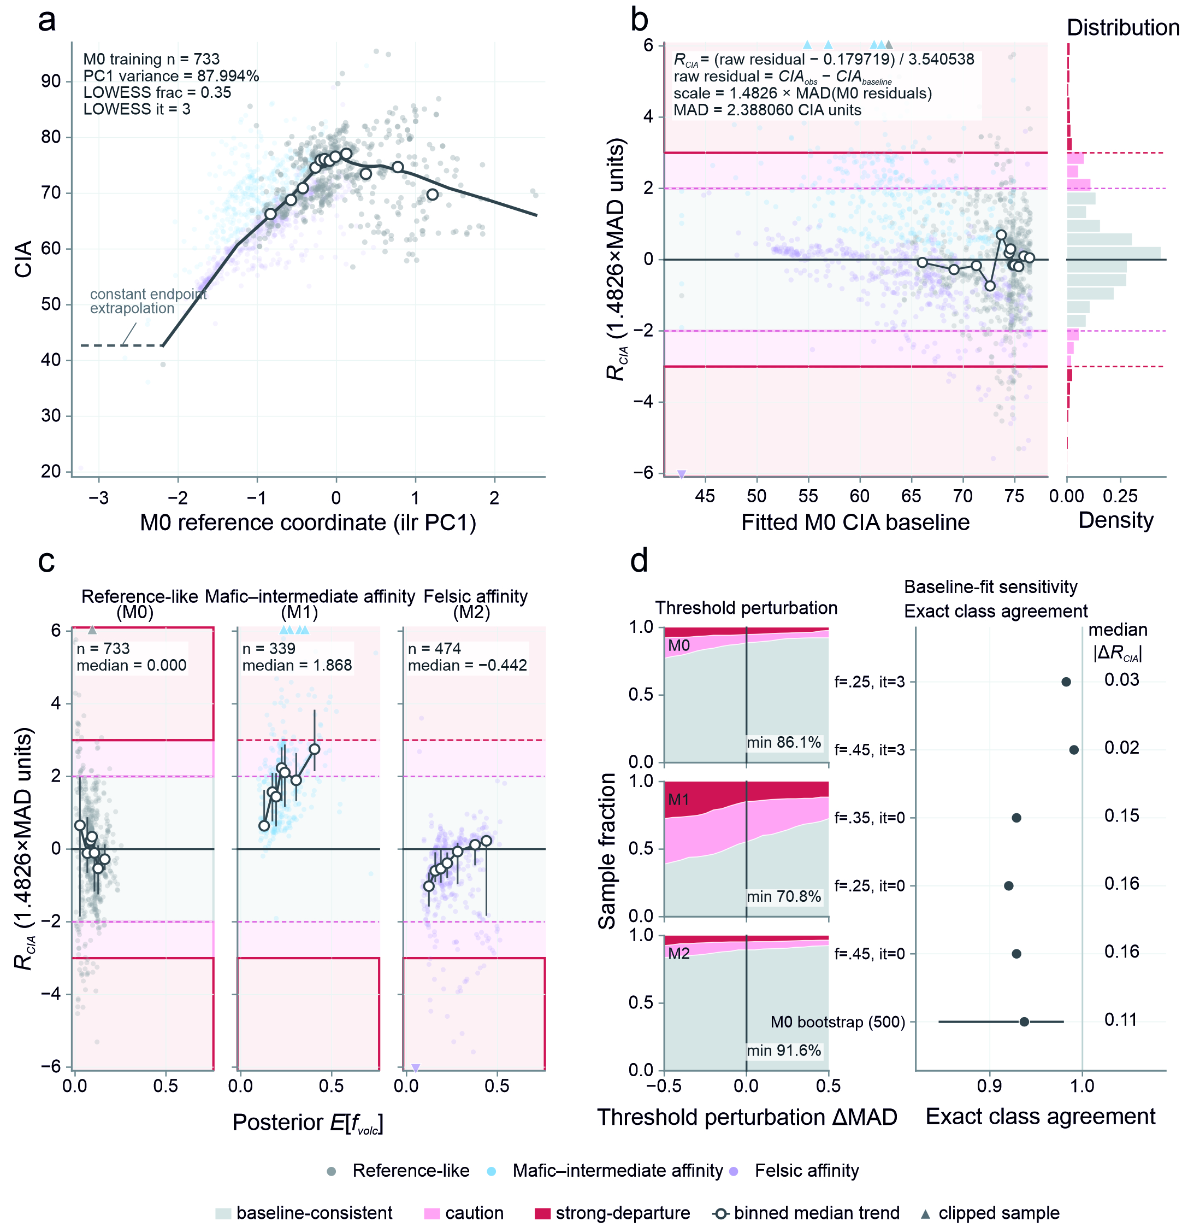
Supplementary Fig. S4 | Construction and sensitivity of the ${\text{R}}_{\text{CIA}}$ reference-baseline departure screen. a, ${\text{M}}_{\text{0}}$-only ilr-${\text{PC}}_{\text{1}}$ coordinate and raw robust LOWESS CIA curve. The 87.994231% variance value pertains only to this ${\text{M}}_{\text{0}}$ reference coordinate. b, Distribution of signed, standardised CIA departures: positive and negative ${\text{R}}_{\text{CIA}}$ values place observed CIA above and below the residual-centred reference baseline (raw LOWESS plus the ${\text{M}}_{\text{0}}$ residual median), respectively. The raw curve in panel a differs from this standardised zero reference. Bands denote baseline-consistent ($\text{|}{\text{R}}_{\text{CIA}}\text{|<2}$), caution ($\text{2≤|}{\text{R}}_{\text{CIA}}\text{|<3}$) and strong-departure ($\text{|}{\text{R}}_{\text{CIA}}\text{|≥3}$) states. c, Class-stratified posterior–${\text{R}}_{\text{CIA}}$ relationships for ${\text{M}}_{\text{0}}$, ${\text{M}}_{\text{1}}$ and ${\text{M}}_{\text{2}}$, distinct from the full-cohort space in Fig. 3a. d, Band-assignment sensitivity to thresholds, LOWESS settings and 500 ${\text{M}}_{\text{0}}$ PCA–LOWESS bootstrap refits. All 1,546 samples were projected; clipped symbols remain analysed. In c, open circles and vertical bars show equal-count-bin medians and interquartile ranges. In the bootstrap row of d, the point and horizontal bar show the median and 95% percentile interval across 500 refits.
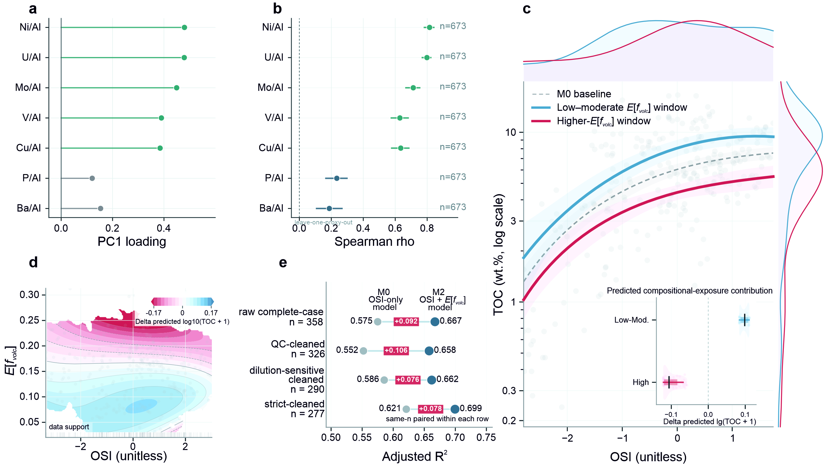
Supplementary Fig. S5 | Organic-sediment index loading audit and primary contextual OSI-conditioned total organic carbon (TOC) analysis. a, Leverage-screened ${\text{PC}}_{\text{1}}$-loading audit on 652 retained cases from 673 seven-proxy-complete records. b, Leave-one-proxy-out loading stability on the common complete-case population. c, OSI–TOC relationships across posterior-exposure windows in the primary archived contextual analysis. d, Posterior-exposure contribution to predicted ${\text{log}}_{\text{10}}\left(\text{TOC+1}\right)$ within the supported predictor space. e, Same-n adjusted-${\text{R}}^{\text{2}}$ comparisons of OSI-only and OSI + posterior-exposure models. Panels a–b audit loading and construction; panels c–e use analysis-specific complete-case subsets within the primary 673-case OSI lineage. The fitted contribution changes sign across the sampled range and is a non-linear conditional association. This independent contextual module does not assess ${\text{R}}_{\text{CIA}}$ fidelity or validate volcanic fertilisation, provenance or the posterior model. Horizontal bars in b show bootstrap 95% confidence intervals. In c, shaded ribbons show 95% confidence intervals from HC3 robust covariance; inset ticks, thick bars and thin bars denote the median, interquartile range and 10th–90th percentile range of predicted contributions across the displayed OSI grid.
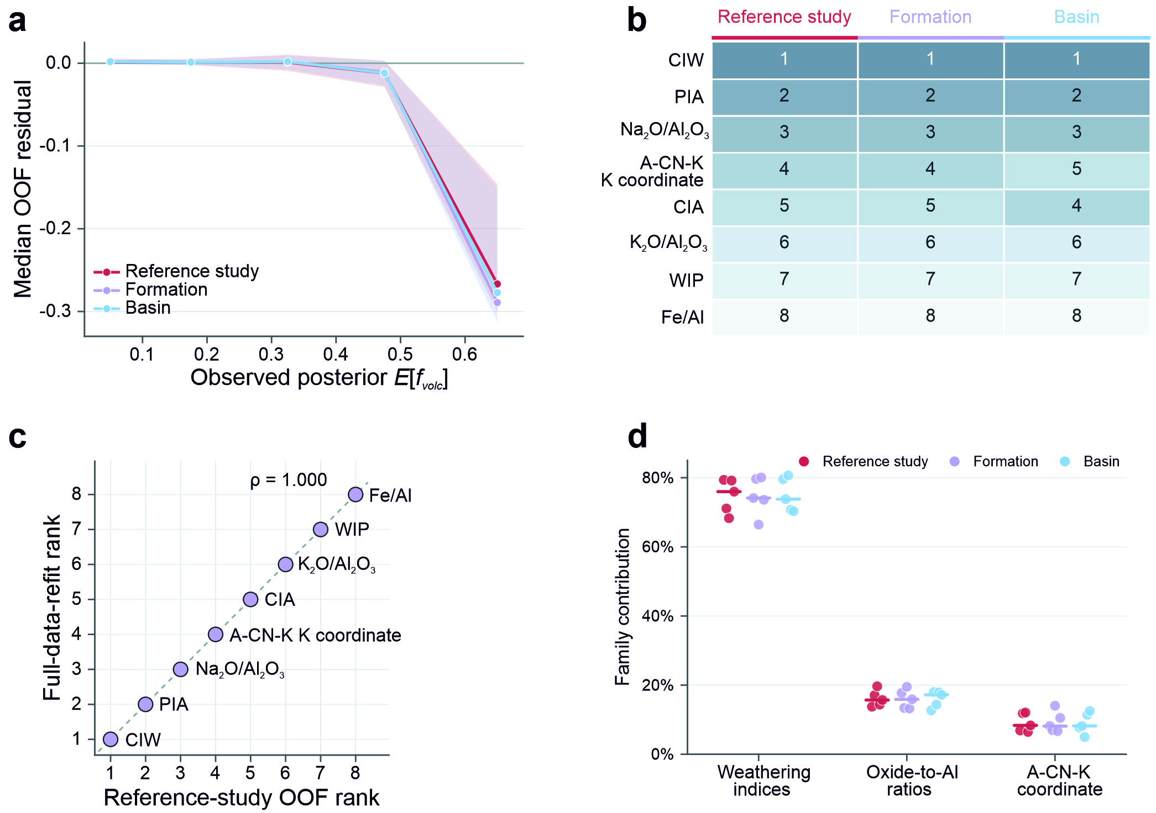
Supplementary Fig. S6 | Grouped out-of-fold (OOF) residual behaviour and Shapley additive explanations (SHAP) stability of the posterior-exposure emulator. a, Median OOF residuals (prediction minus archived posterior exposure) across score ranges under reference-study, formation and basin grouping. Shaded bands span the 25th–75th percentiles of OOF residuals within each score range. b, Pooled OOF SHAP feature ranks across the three schemes. c, Deployment-oriented full-data-refit ranks versus reference-study-grouped OOF ranks; the refit is not held-out performance evidence. d, Fold-level feature-family contributions by grouping scheme. Grouped OOF measures within-cohort grouped generalisation, not independent external validation; SHAP is non-causal fitted-model attribution conditional on correlated predictors.

Supplementary Tables
Supplementary Table 1 | Data layers and analysis-specific denominators
Sample-flow summary
Data layer or analysis | Analytical population | Primary requirement or role | Figures | Key note
Broad literature compilation | 56,915 rows; 56,659 unique samples | Source identities and geological metadata | Fig. S1 | Row and unique-sample denominators are reported separately
Major-element-complete layer | 26,522 unique samples | Complete ${\text{Al}}_{\text{2}}{\text{O}}_{\text{3}}\text{,}$ $\text{CaO,}$ ${\text{Na}}_{\text{2}}\text{O}$ and ${\text{K}}_{\text{2}}\text{O}$ | Fig. S1 | Broad database layer used to establish major-element coverage
Literature-curated black-shale cohort and posterior exposure ranking | $\text{n}\text{=1,546;}$ ${\text{M}}_{\text{0}}$/${\text{M}}_{\text{1}}$/${\text{M}}_{\text{2}}$ = 733/339/474 | A–CN–K and posterior $\text{E}\text{[}{\text{f}}_{\text{volc}}\text{]}$ analyses | Figs. 1, 2, 5, 6; Figs. S2, S3, S6 | Curated independently of the 26,522-sample layer
Weathering-index analyses | CIA/CIW/PIA: $\text{n}\text{=1,546;}$ WIP: $\text{n}\text{=1,512}$ | Pairwise finite posterior and index values | Fig. 2; Fig. S3 | WIP was unavailable for 34 samples
${\text{R}}_{\text{CIA}}$ departure screen | ${\text{M}}_{\text{0}}$ training: $\text{n}\text{=733;}$ projected population: $\text{n}\text{=1,546}$ | ${\text{M}}_{\text{0}}$ ilr-PCA–LOWESS reference baseline | Fig. 3; Fig. S4 | All cohort samples were projected to the ${\text{M}}_{\text{0}}$ baseline
Primary OSI–TOC analysis and loading-stability audit | Primary archived OSI–TOC: 673 → 508 → 434 → 406; paired subsets: 358/326/290/277. Loading audit: 673 complete, 21 excluded, 652 retained | Primary OSI–TOC QC and same-n modelling; audit-only PCA loading and construction stability | Fig. S5 | The 652-case audit did not define downstream regression scores or QC tiers
Posterior-emulator grouped-OOF evaluation and OOF SHAP | $\text{n}\text{=1,546;}$ 42 reference studies, 40 formations and 56 basins | Within-cohort grouped-OOF prediction and held-out fitted-model attribution | Figs. 5, 6; Fig. S6 | One OOF prediction and SHAP record per sample; full-data refit used only for deployment or secondary comparison
J10025 mineralogical module | XRD: 151; TOC: 142; SEM–EDS: 7 samples and 37 points | Mineral-phase, depth and targeted point-chemistry evidence | Fig. 4 | Seven selected samples are crosswalked in Supplementary Table 5
Note: Counts are unique samples unless explicitly identified as database rows or targeted SEM–EDS points. Each grouped-OOF record represents one prediction or SHAP attribution for a sample withheld with its complete grouping unit.
Supplementary Table 2 | Model-support libraries, posterior specification and numerical replay
Section A. Model-support libraries
Domain | Interpretation | Library n | A centre | CN centre | K centre | ${\text{ilr}}_{\text{1}}$ centre | ${\text{ilr}}_{\text{2}}$ centre | Envelope definition
$${\text{M}}_{\text{0}}$$ | Reference-like compositional domain | 2,219 | 0.73906 | 0.09188 | 0.16906 | 1.47427 | 0.35324 | Descriptive 85% ilr ellipse used for visualisation
$${\text{M}}_{\text{1}}$$ | Mafic–intermediate-affinity compositional domain | 112,587 | 0.58227 | 0.38287 | 0.03486 | 0.29645 | 2.12768 | Descriptive 85% ilr ellipse used for visualisation
$${\text{M}}_{\text{2}}$$ | Felsic-affinity compositional domain | 49,788 | 0.55039 | 0.32597 | 0.12364 | 0.37040 | 1.00536 | Descriptive 85% ilr ellipse used for visualisation

Section B. Primary posterior specification
Parameter | Primary setting
Main analytical n | 1,546
Seed | 20260427
Draws per model | 180,000
Nearest neighbours $\text{k}$ | 360
Calculation space | 2D orthonormal ilr: ${\text{z}}_{\text{1}}\text{=}\sqrt{\frac{\text{1}}{\text{2}}}\text{ln}\left(\frac{\text{A}}{\text{CN}}\right)\text{;}$ ${\text{z}}_{\text{2}}\text{=}\sqrt{\frac{\text{2}}{\text{3}}}\text{ln}\left(\frac{\sqrt{\text{A}\text{⋅CN}}}{\text{K}}\right)$
Neighbour search | KD-tree
Kernel | Gaussian weighting: ${\text{w}}_{\text{i}}\text{=exp[−}\frac{\text{1}}{\text{2}}{\left(\frac{{\text{d}}_{\text{i}}}{{\text{b}}_{\text{m}}}\right)}^{\text{2}}\text{];}$ Lm=max[k−1i​wi,10−300], without an added kernel-normalisation factor; implicit equal model weights $\frac{\text{1}}{\text{3}}\text{;}$ Pm=Lmj​Lj
Bandwidth definition | Historical A–CN–K-valid scoring set (44,558 rows) median $\text{k}$-th-neighbour distance; realised b: ${\text{M}}_{\text{0}}$ = 0.05, ${\text{M}}_{\text{1}}$ = 0.06256913768284394, ${\text{M}}_{\text{2}}$ = 0.05812579127550185
Bandwidth floor | 0.05
${\text{M}}_{\text{0}}$ prior/treatment | $\text{f}\text{=0;}$ implicit component weight = $\frac{\text{1}}{\text{3}}$
${\text{M}}_{\text{1}}$/${\text{M}}_{\text{2}}$ prior | Uniform $\text{U}\left(\text{0,1}\right)$ on $\text{f}\text{;}$ implicit component weight = $\frac{\text{1}}{\text{3}}$ each for ${\text{M}}_{\text{1}}$ and ${\text{M}}_{\text{2}}$
Reporting bins | Low $\text{≤0.10;}$ transitional $\text{>0.10 to <0.20;}$ high $\text{≥0.20}$; historical descriptive bins, distinct from the fixed 0.25 emulator operating point
Envelope role | Descriptive 85% envelopes used for visualisation.

Section C. Numerical replay
Quantity | Result
Matched n | 1,546
Spearman’s $\text{ρ}$ | 1.000
Pearson r | 1.000
Median signed difference | 0
Median absolute difference | $$\text{9.71×}{\text{10}}^{\text{−17}}$$
Maximum absolute difference | $$\text{7.30×}{\text{10}}^{\text{−15}}$$
Maximum rank shift | 0

Note: The 85% ilr ellipses are descriptive visual summaries rather than posterior inclusion boundaries. Numerical replay starts from the supplied frozen support arrays.
Supplementary Table 3 | Weathering-index responses, ${\text{R}}_{\text{CIA}}$ screening and compositional-geometry diagnostics
Section A. CIA-family index responses
Index or analysis | n | Spearman’s $\text{ρ}$ | Theil–Sen slope per 0.1 $\text{E}\text{[}{\text{f}}_{\text{volc}}\text{]}$ | Theil–Sen slope 95% CI | Calculation/sensitivity note
CIA primary | 1,546 | −0.703 | −5.871 | −6.085 to −5.648 | Primary pairwise finite analysis; slope per 0.1 $\text{E}\text{[}{\text{f}}_{\text{volc}}\text{].}$
CIW primary | 1,546 | −0.968 | −9.221 | −9.338 to −9.105 | Primary pairwise finite analysis; slope per 0.1 $\text{E}\text{[}{\text{f}}_{\text{volc}}\text{].}$
PIA primary | 1,546 | −0.953 | −10.891 | −11.093 to −10.694 | Primary pairwise finite analysis; slope per 0.1 $\text{E}\text{[}{\text{f}}_{\text{volc}}\text{].}$
WIP primary | 1,512 | 0.215 | 3.493 | 2.748 to 4.227 | Primary pairwise finite analysis; slope per 0.1 $\text{E}\text{[}{\text{f}}_{\text{volc}}\text{].}$
Phosphate-corrected-first CIA sensitivity | 1,546 | −0.682 | −5.882 | −6.107 to −5.649 | Phosphate-corrected-first; $\text{ρ}$ 95% CI from 1,000 bootstrap replicates, −0.720 to −0.645 (seed 20260628). One missing ${\text{P}}_{\text{2}}{\text{O}}_{\text{5}}$ value was treated as zero before the Na cap.

Section B. Primary ${\text{R}}_{\text{CIA}}$ definition and outcome
Parameter or outcome | Result
Display population | $$\text{n}\text{=1,546}$$
${\text{M}}_{\text{0}}$ training n | 733
${\text{M}}_{\text{0}}$/${\text{M}}_{\text{1}}$/${\text{M}}_{\text{2}}$ | 733/339/474
PCA input space | ${\text{M}}_{\text{0}}$-only mean-centred ${\text{ilr}}_{\text{1}}$ and ${\text{ilr}}_{\text{2}}\text{;}$ no variance standardisation; $\text{centre}\text{=}\left(\text{1.758797366650168,0.08711466948093365}\right)\text{;}$ signed ${\text{PC}}_{\text{1}}$ $\text{loading}\text{=}\left(\text{0.796968706825736,−0.6040205959572191}\right)\text{;}$ $\text{x}\text{=}\left(\text{z}\text{−}\text{centre}\right)\text{⋅}\text{loading}$
${\text{PC}}_{\text{1}}$ variance explained | 87.994% (full value 87.994231%)
LOWESS frac | 0.35
LOWESS robust iterations | 3
Endpoint extrapolation | Sorted duplicate x values averaged; constant endpoints 42.6843486949/66.0863846164; 6 below-range and 0 above-range samples retained
Residual centre | 0.179719
Residual MAD | 2.388060
Robust scale | $$\text{3.540538 }\left(\text{=1.4826×MAD}\right)$$
Baseline-consistent definition and count | $\text{|}{\text{R}}_{\text{CIA}}\text{|<2;}$ $\text{n}\text{=1,262}$
Caution definition and count | $\text{2≤|}{\text{R}}_{\text{CIA}}\text{|<3;}$ $\text{n}\text{=174}$
Strong-departure definition and count | $\text{|}{\text{R}}_{\text{CIA}}\text{|≥3;}$ $\text{n}\text{=110}$
${\text{M}}_{\text{0}}$ median | 0.000
${\text{M}}_{\text{1}}$ median | +1.868
${\text{M}}_{\text{2}}$ median | −0.442
Clipped plotting symbols | 6 samples; retained and drawn as boundary triangles
Bootstrap iterations | 500 ${\text{M}}_{\text{0}}$ row resamples with replacement; seed 20260723; refit centred-unscaled PCA, sign-align ${\text{PC}}_{\text{1}}$ by positive loading dot product, project all rows, refit LOWESS, recalculate residual centre/MAD/scale; empirical 2.5th/97.5th percentiles
Positive ${\text{R}}_{\text{CIA}}$ | Observed CIA above the residual-centred ${\text{M}}_{\text{0}}$/reference-like baseline (raw LOWESS plus the ${\text{M}}_{\text{0}}$ residual median)
Negative ${\text{R}}_{\text{CIA}}$ | Observed CIA below the residual-centred ${\text{M}}_{\text{0}}$/reference-like baseline (raw LOWESS plus the ${\text{M}}_{\text{0}}$ residual median)

Supplementary Table 3 (continued)
Section C. Robustness and sensitivity analyses
Sensitivity analysis | Variant/range | Main metric | Result | Interpretation boundary
Threshold perturbation ${\text{M}}_{\text{0}}$ | $\text{ΔMAD}$ −0.50 to +0.50 | Minimum exact agreement | 86.1% | Operational tier sensitivity only
Threshold perturbation ${\text{M}}_{\text{1}}$ | $\text{ΔMAD}$ −0.50 to +0.50 | Minimum exact agreement | 70.8% | Operational tier sensitivity only
Threshold perturbation ${\text{M}}_{\text{2}}$ | $\text{ΔMAD}$ −0.50 to +0.50 | Minimum exact agreement | 91.6% | Operational tier sensitivity only
LOWESS frac variants | 0.25, 0.35, 0.45 | Exact class agreement | 92.0%–100.0% | Same primary PCA coordinate
Robust-iteration variants | it = 0 or 3 | Exact class agreement | 92.0%–100.0% | Refits centre, MAD and scale
${\text{M}}_{\text{0}}$ bootstrap PCA–LOWESS | 500 resamples | Median exact agreement (95% interval) | 93.7% (84.5–98.0%) | Refit PCA, LOWESS and scale each iteration
Section D. Compositional diagnostics and analytical subsets
Diagnostic or subset | Definition | n or value | Role | Interpretation boundary
5,000-direction clr null | Archived phosphate-corrected-first composition-aware CIA route; alignment compared with 5,000 random clr directions | $$\text{P}\text{=0.3907}$$ | Shared-geometry diagnostic | Quantifies alignment expected from shared A–CN–K geometry
ilr-controlled partial rank | Rank residualisation against both A–CN–K ilr coordinates in the archived phosphate-corrected-first implementation | $\text{ρ}\text{=+0.156;}$ 95% CI +0.108 to +0.198 | Residual association diagnostic | Shared geometry is not interpreted as invalidating the displacement
Full analytical set | Full analytical cohort | 1,546 | Fig. S3 subset | Targeted cohort, not global prevalence
QC-cleaned | qc_flag = ok | 1,419 | Fig. S3 subset | Row-level QC category
Dilution-sensitive removed | Sensitivity subset excluding records classified as dilution-sensitive in the source analysis | 1,472 | Fig. S3 subset | Dilution-sensitivity diagnostic subset
Low-carbonate / low-LOI | Sensitivity subset retaining records classified as low carbonate and low LOI in the source analysis | 1,159 | Fig. S3 subset | Carbonate/LOI diagnostic subset
Tier 1 core exact | data_tier = Tier 1_core_exact | 1,218 | Fig. S3 subset | Literature-curation tier
Tier 3 partial major | data_tier = Tier 3_partial_major | 328 | Fig. S3 subset | Literature-curation tier
Best-model classes | best_model = ${\text{M}}_{\text{0}}$ / ${\text{M}}_{\text{1}}$ / ${\text{M}}_{\text{2}}$ | 733 / 339 / 474 | Fig. S3 subsets | Model-defined compositional affinity classes
Literature-coded evidence strength | volcanic_evidence_strength = moderate / strong | 1,465 / 81 | Fig. S3 subsets | Literature-curation metadata, distinct from posterior $\text{E}\text{[}{\text{f}}_{\text{volc}}\text{]}$
Sequential compositional controls | Unadjusted; +${\text{SiO}}_{\text{2}}\text{;}$ +$\text{CaO;}$ +Fe/Al; +${\text{P}}_{\text{2}}{\text{O}}_{\text{5}}\text{;}$ +carbonate proxy; +all controls | 1,546 / 1,422 / 1,546 / 1,546 / 1,545 / 1,546 / 1,421 | Fig. S3c denominators | Adjusted associations are descriptive, not causal effects

Note: Supplementary Data 3 provides sample-level index and ${\text{R}}_{\text{CIA}}$ values, sensitivity outputs, denominators and figure-membership fields.
Supplementary Table 4 | OSI loading-stability audit, primary OSI–TOC modelling, grouped-OOF emulator evaluation and SHAP attribution
Section A. Leverage-screened PCA loading and construction-stability audit
Proxy | Transformation | Standardisation | ${\text{PC}}_{\text{1}}$ loading | Sign orientation | n
$${\text{P}}_{\text{2}}{\text{O}}_{\text{5}}\text{/A}{\text{l}}_{\text{2}}{\text{O}}_{\text{3}}$$ | positive finite ratio; ${\text{log}}_{\text{10}}\text{;}$ no winsorisation | population z-score (ddof = 0); no imputation | 0.121 | ${\text{PC}}_{\text{1}}$ sign oriented to jointly higher redox/productivity proxy values; TOC not used | 652
$$\text{Ba/A}{\text{l}}_{\text{2}}{\text{O}}_{\text{3}}$$ | positive finite ratio; ${\text{log}}_{\text{10}}\text{;}$ no winsorisation | population z-score (ddof = 0); no imputation | 0.153 | ${\text{PC}}_{\text{1}}$ sign oriented to jointly higher redox/productivity proxy values; TOC not used | 652
$$\text{Cu/A}{\text{l}}_{\text{2}}{\text{O}}_{\text{3}}$$ | positive finite ratio; ${\text{log}}_{\text{10}}\text{;}$ no winsorisation | population z-score (ddof = 0); no imputation | 0.385 | ${\text{PC}}_{\text{1}}$ sign oriented to jointly higher redox/productivity proxy values; TOC not used | 652
$$\text{Ni/A}{\text{l}}_{\text{2}}{\text{O}}_{\text{3}}$$ | positive finite ratio; ${\text{log}}_{\text{10}}\text{;}$ no winsorisation | population z-score (ddof = 0); no imputation | 0.480 | ${\text{PC}}_{\text{1}}$ sign oriented to jointly higher redox/productivity proxy values; TOC not used | 652
$$\text{V/A}{\text{l}}_{\text{2}}{\text{O}}_{\text{3}}$$ | positive finite ratio; ${\text{log}}_{\text{10}}\text{;}$ no winsorisation | population z-score (ddof = 0); no imputation | 0.390 | ${\text{PC}}_{\text{1}}$ sign oriented to jointly higher redox/productivity proxy values; TOC not used | 652
$$\text{Mo/A}{\text{l}}_{\text{2}}{\text{O}}_{\text{3}}$$ | positive finite ratio; ${\text{log}}_{\text{10}}\text{;}$ no winsorisation | population z-score (ddof = 0); no imputation | 0.449 | ${\text{PC}}_{\text{1}}$ sign oriented to jointly higher redox/productivity proxy values; TOC not used | 652
$$\text{U/A}{\text{l}}_{\text{2}}{\text{O}}_{\text{3}}$$ | positive finite ratio; ${\text{log}}_{\text{10}}\text{;}$ no winsorisation | population z-score (ddof = 0); no imputation | 0.479 | ${\text{PC}}_{\text{1}}$ sign oriented to jointly higher redox/productivity proxy values; TOC not used | 652

Section B. Primary archived 673-case OSI–TOC model comparisons
Analytical subset | n | Baseline model | Extended model | Adjusted ${\text{R}}^{\text{2}}\text{,}$ baseline | Adjusted ${\text{R}}^{\text{2}}\text{,}$ extended | Δ adjusted ${\text{R}}^{\text{2}}$ | Additional comparison metric
raw complete-case | 358 | OSI only | OSI + posterior $\text{E}\text{[}{\text{f}}_{\text{volc}}\text{]}$ | 0.575 | 0.667 | 0.092 | Same-n paired comparison
QC-cleaned | 326 | OSI only | OSI + posterior $\text{E}\text{[}{\text{f}}_{\text{volc}}\text{]}$ | 0.552 | 0.658 | 0.106 | Same-n paired comparison
dilution-sensitive cleaned | 290 | OSI only | OSI + posterior $\text{E}\text{[}{\text{f}}_{\text{volc}}\text{]}$ | 0.586 | 0.662 | 0.076 | Same-n paired comparison
strict-cleaned | 277 | OSI only | OSI + posterior $\text{E}\text{[}{\text{f}}_{\text{volc}}\text{]}$ | 0.621 | 0.699 | 0.078 | Same-n paired comparison

Supplementary Table 4 (continued)
Section C. Posterior-emulator grouped-OOF evaluation and held-out SHAP
Model or cross-validation design | Predictor set | n | Folds/groups | $${\text{R}}^{\text{2}}$$ | RMSE | Spearman’s $\text{ρ}$ | Role in manuscript
Selected eight-feature ExtraTrees, reference-study-grouped OOF | CIA; WIP; K; CIW; PIA; ${\text{K}}_{\text{2}}\text{O}$/${\text{Al}}_{\text{2}}{\text{O}}_{\text{3}}\text{;}$ ${\text{Na}}_{\text{2}}\text{O}$/${\text{Al}}_{\text{2}}{\text{O}}_{\text{3}}\text{;}$ Fe/Al | 1,546 | 5 folds / 42 groups | 0.968 | 0.020 | 0.990 | Primary within-cohort grouped-OOF evaluation
RandomForest benchmark | CIA; WIP; K; CIW; PIA; ${\text{K}}_{\text{2}}\text{O}$/${\text{Al}}_{\text{2}}{\text{O}}_{\text{3}}\text{;}$ ${\text{Na}}_{\text{2}}\text{O}$/${\text{Al}}_{\text{2}}{\text{O}}_{\text{3}}\text{;}$ Fe/Al | 1,546 | 5 folds / 42 groups | 0.961 | 0.022 | 0.988 | Algorithm benchmark
XGBoost benchmark | CIA; WIP; K; CIW; PIA; ${\text{K}}_{\text{2}}\text{O}$/${\text{Al}}_{\text{2}}{\text{O}}_{\text{3}}\text{;}$ ${\text{Na}}_{\text{2}}\text{O}$/${\text{Al}}_{\text{2}}{\text{O}}_{\text{3}}\text{;}$ Fe/Al | 1,546 | 5 folds / 42 groups | 0.950 | 0.025 | 0.985 | Algorithm benchmark
Ridge benchmark | CIA; WIP; K; CIW; PIA; ${\text{K}}_{\text{2}}\text{O}$/${\text{Al}}_{\text{2}}{\text{O}}_{\text{3}}\text{;}$ ${\text{Na}}_{\text{2}}\text{O}$/${\text{Al}}_{\text{2}}{\text{O}}_{\text{3}}\text{;}$ Fe/Al | 1,546 | 5 folds / 42 groups | 0.872 | 0.040 | 0.964 | Algorithm benchmark
Formation-held-out | Selected eight-feature set | 1,546 | 5 folds / 40 groups | 0.966 | 0.021 | 0.989 | Within-cohort grouped-OOF sensitivity
Basin-held-out | Selected eight-feature set | 1,546 | 5 folds / 56 groups | 0.967 | 0.020 | 0.990 | Within-cohort grouped-OOF sensitivity
CIA-only ExtraTrees ablation | CIA | 1,546 | 5 folds / 42 groups | 0.438 | 0.085 | 0.612 | Single-index ablation
CIA-only Ridge ablation | CIA | 1,546 | 5 folds / 42 groups | 0.460 | 0.083 | 0.677 | Single-index linear ablation
A–CN–K coordinate-set ablation | A; CN; K; CIA | 1,546 | 5 folds / 42 groups | 0.963 | 0.022 | 0.990 | A, CN, K and CIA in archived feature set
Weathering-indices-only ablation | CIA; CIW; PIA; WIP | 1,546 | 5 folds / 42 groups | 0.949 | 0.025 | 0.989 | CIA, CIW, PIA and WIP
Section D. Computational reproducibility checks
Parameter | Setting
Explainer | TreeExplainer; tree_path_dependent
Model | Five independently fitted reference-study fold ExtraTrees models (primary)
Secondary SHAP comparison | One full-data refit; rank comparison only (Fig. S6c); no held-out evidence
Evaluated n | 1,546 held-out predictions; one OOF SHAP record per sample
Background/reference set | Training-path statistics within each fold
Interpretation type | Fold-refitted held-out model attribution; non-causal
Top-ranked variables | CIW; PIA; ${\text{Na}}_{\text{2}}\text{O}$/${\text{Al}}_{\text{2}}{\text{O}}_{\text{3}}\text{;}$ ACK_K (archived A–CN–K K-coordinate field); CIA; ${\text{K}}_{\text{2}}\text{O}$/${\text{Al}}_{\text{2}}{\text{O}}_{\text{3}}\text{;}$ WIP; Fe/Al
Posterior numerical replay | Identifier concordance, probability closure, best-model consistency and sample-level replay
Grouped-OOF replay | Three grouped GroupKFold designs, fold assignments, OOF predictions and pooled metrics
Out-of-fold SHAP reproducibility | Additivity, pooled importance, feature-family proportions, fold-rank stability and top-$\text{k}$ overlap
Grouped-OOF replay outcome | OOF predictions reproduced to floating-point precision; fold-assignment match = 100%
SHAP replay outcome | Maximum additivity error $\text{<6×}{\text{10}}^{\text{−15}}\text{;}$ family proportions = 75.1% weathering indices, 16.0% oxide-to-Al ratios and 8.9% A–CN–K coordinate; reference-study median fold-rank $\text{ρ}\text{=0.952;}$ top-three overlap = 66.7–100%; top-five overlap = 5/5
Deployment software tests | All 11 packaged software tests passed
Software availability | Validation materials and usage instructions are supplied in Supplementary Data 2 and 5
Evaluation scope | Computational replay and within-cohort grouped-OOF evaluation
Note: Out-of-fold predictions, held-out attribution records and computational validation materials are supplied in Supplementary Data 5.
Note: Paired OSI–TOC models use identical samples.
Note: OOF rows derive from held-out predictions or held-out TreeSHAP records.
Supplementary Table 5 | J10025 analytical records, identifier crosswalk and interpretive scope
Section A. Supporting datasets and analytical scope
Method | Analytical output used | n | Use in this study | Interpretive scope
XRD | Quantitative phase estimates, phase dictionary and ${\text{VMI}}_{\text{XRD}}$ values | 151 samples | Section-scale mineral-carrier characterisation and selected-sample comparison | Bulk mineralogical evidence; ${\text{VMI}}_{\text{XRD}}$ is a descriptive carrier index used only for local mineralogical context; quantitative material-content and provenance assignment lie outside its intended use.
SEM imaging | Representative backscattered-electron images from 7 selected samples | 7 samples | Textural documentation of representative grains and analytical sites | Qualitative microtextural context
SEM-EDS | 37 targeted point analyses across seven samples | 37 points | Identification of feldspar-like, Ti–Fe/mafic, Ca-phosphate and related point-chemistry classes | Targeted point counts document occurrence and are not modal, area-fraction or volume-fraction estimates
TOC | TOC values linked to sample depth | 142 samples | Local organic-carbon and stratigraphic context | Not used to calibrate posterior $\text{E}\text{[}{\text{f}}_{\text{volc}}\text{]}$ or ${\text{R}}_{\text{CIA}}$
Section B. Selected-sample identifier crosswalk
Figure/SEM sample ID | J10025 XRD/TOC sample ID | Depth (m) | TOC (wt.%) | Main XRD phases; ${\text{VMI}}_{\text{XRD}}$ (%) | EDS points | EDS point-class summary | Main-text figure panels
J10025-23 | J10025-13-23 | 3536.27 | 9.21 | quartz 35.8%; plagioclase 29.9%; carbonate 17.7%; clay 11.7%; ${\text{VMI}}_{\text{XRD}}$ 31.5% | 6 | feldspar-like 1; Ca-phosphate 1; mixed aluminosilicate 4 | Fig. 4a–c
J10025-26 | J10025-14-50 | 3546.73 | 7.72 | quartz 33.2%; plagioclase 32.0%; carbonate 18.7%; clay 10.5%; ${\text{VMI}}_{\text{XRD}}$ 34.6% | 5 | feldspar-like 3; Ti–Fe/mafic 1; mixed mafic–carbonate 1 | Fig. 4a–d
J10025-164 | J10025-16-9 | 3551.12 | 2.64 | plagioclase 44.7%; quartz 35.8%; clay 8.9%; carbonate 5.5%; ${\text{VMI}}_{\text{XRD}}$ 47.4% | 5 | feldspar-like 2; carbonate 3 | Fig. 4a–c
J10025-29 | J10025-16-21 | 3552.82 | 0.82 | carbonate 45.9%; quartz 19.7%; plagioclase 12.8%; clay 11.8%; ${\text{VMI}}_{\text{XRD}}$ 17.2% | 6 | feldspar-like 2; Fe-sulfide 2; mixed mafic–carbonate 2 | Fig. 4a–c
J10025-32 | J10025-17-25 | 3556.28 | 2.44 | plagioclase 42.9%; carbonate 30.5%; quartz 17.7%; clay 5.5%; ${\text{VMI}}_{\text{XRD}}$ 44.0% | 5 | feldspar-like 3; carbonate 1; quartz/silica 1 | Fig. 4a–c,e
J10025-36 | J10025-18-7 | 3565.56 | 2.64 | quartz 32.5%; clay 24.7%; plagioclase 16.5%; carbonate 14.7%; K-feldspar 5.5%; ${\text{VMI}}_{\text{XRD}}$ 22.0% | 5 | feldspar-like 4; carbonate 1 | Fig. 4a–c,g
J10025-57 | J10025-23-2 | 3626.36 | 1.69 | carbonate 31.4%; quartz 31.2%; plagioclase 19.5%; clay 13.2%; ${\text{VMI}}_{\text{XRD}}$ 21.7% | 5 | feldspar-like 3; Fe-sulfide 2 | Fig. 4a–c, f

Note: The crosswalk links Fig. 4 sample labels to the corresponding J10025 records.

