Author Statement
Manuscript Title: Multi-omics Mendelian Randomization Reveals the Causal Association and Mediating Mechanisms of PM_{2.5} with Depression: A Systematic Study Integrating Transcriptomics, Metabolomics, and Radiomics
Authors: Hanyan Wang¹, Ziru Zhou ^{1, 2}, Zhengliang Zhang ^{1, 2, 3}, Liru Zhang¹, Jingwen Xian⁴, Hangchi Liu⁴, Ruixi Wang⁴, Sijian Wang⁴, Yulan Yang¹, Dongmei Guo^{1*}, Shumin Zhang^{1*}
Contributions:
Hanyan Wang: Conceptualization, Data curation, Formal analysis, Methodology, Visualization, Writing – original draft, Writing – review & editing.
Ziru Zhou: validation, formal analysis, Project administration.
Zhengliang Zhang: Conceptualization, Investigation, Project administration.
Liru Zhang: validation, formal analysis, Investigation.
Jingwen Xian: Methodology, Project administration.
Hangchi Liu: Project administration.
Ruixi Wang: Conceptualization, Project administration.
Sijian Wang: Conceptualization, Project administration.
Yulan Yang: Conceptualization, Methodology, validation.
Dongmei Guo: Conceptualization, Data curation, Formal analysis, Methodology, Project administration, Supervision.
Shumin Zhang: Conceptualization, Funding acquisition, Software, Supervision, Writing – review & editing.
Explanation: All authors have read and agreed to the published version of the manuscript.

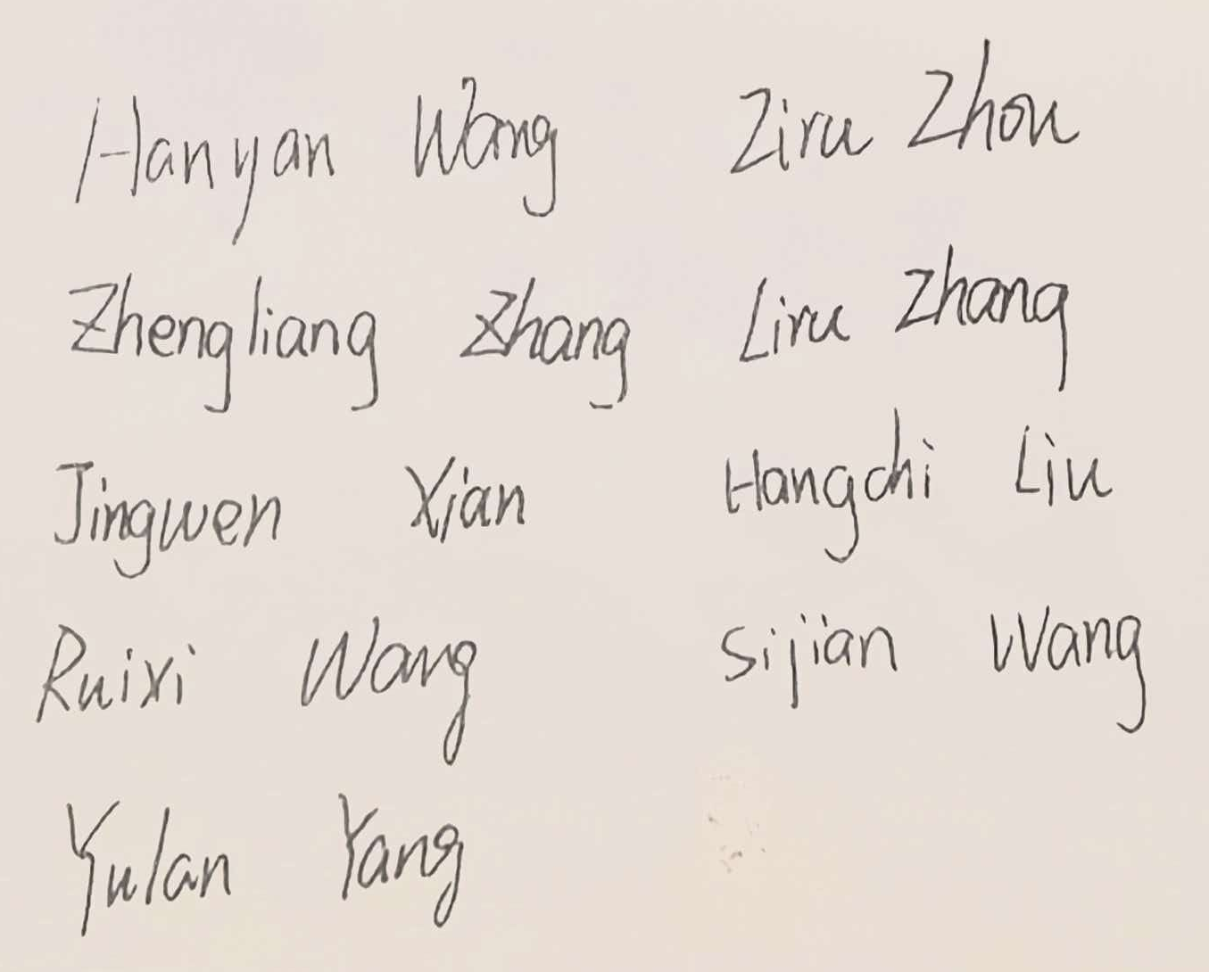
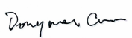
All authors: Corresponding authors:
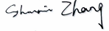

Date: March 12, 2026

