Additional file 1
Supplementary Tables
Table S1. Tumor response according to mRECIST.
 | Dur+Tre (n = 22) | Lenvatinib (n = 86) | p-value
Best overall response
Complete response | 2 (9.1%) | 1 (1.2%)
Partial response | 1 (4.5%) | 17 (19.8%)
Stable disease | 3 (13.6%) | 26 (30.2%)
Progressive disease | 10 (45.5%) | 17 (19.8%)
Not evaluable | 6 (27.3%) | 25 (29.1%)
Objective response rate | 3 (13.6%) | 18 (20.9%) | 0.556
Clinical benefit rate | 4 (18.2%) | 26 (30.2%) | 0.300
Disease control rate | 6 (27.3%) | 44 (51.2%) | 0.056
Dur+Tre, durvalumab plus tremelimumab; mRECIST, modified Response Evaluation Criteria in Solid Tumors; ORR, objective response rate; CBR, clinical benefit rate; DCR, disease control rate

Table S2. Liver function changes and subsequent treatment after discontinuation of second-line therapy
 | Dur+Tre (n = 16) | Lenvatinib (n = 64) | p-value
Liver function at discontinuation of second-line treatment and changes from baseline
Child–Pugh score at baseline | 6.0 [5.0–6.3] | 6.0 [5.0–7.0] | 0.620
Child–Pugh score at discontinuation | 7.5 [6.5–8.0] | 7.0 [6.0–8.0] | 0.705
Change in Child–Pugh score | 1.0 [0.0–3.0] | 1.0 [0.0–2.0] | 0.636
ALBI score at baseline | −2.19 [−2.37 to −1.76] | −2.22 [−2.53 to −1.97] | 0.482
ALBI score at discontinuation | −1.52 [−2.09 to −1.24] | −1.82 [−2.26 to −1.35] | 0.434
Change in ALBI score | 0.49 [−0.05 to 0.80] | 0.38 [0.13–0.63] | 0.947
Subsequent treatment after discontinuation of second-line treatment
Any subsequent treatment | 8 (50.0%) | 35 (54.7%) | 1.000
Subsequent systemic therapy | 6 (37.5%) | 28 (43.8%) | 0.784
Values are presented as median [interquartile range] or number (percentage). Changes were calculated as the value at treatment discontinuation minus the baseline value; positive values indicate worsening liver function. Analyses were performed using available cases without imputation. Dur+Tre, durvalumab plus tremelimumab; ALBI, albumin–bilirubin.

Supplementary Figures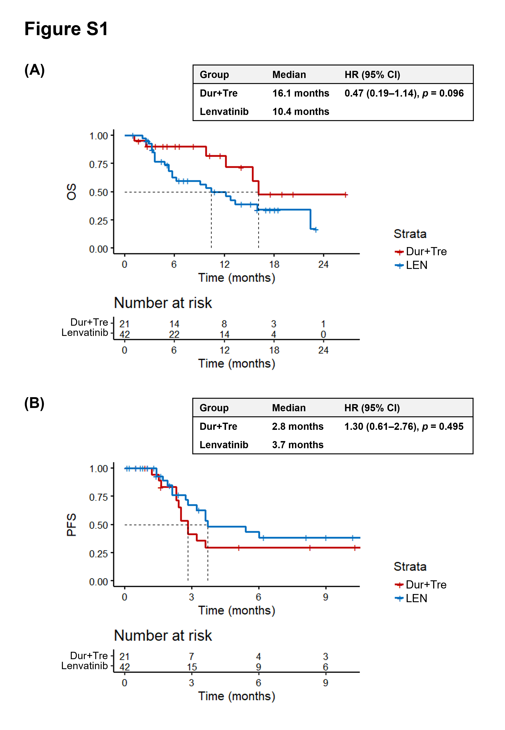
Figure S1. Sensitivity analysis in patients initiating second-line therapy in 2023 or later.
Kaplan–Meier curves compare durvalumab plus tremelimumab (Dur+Tre) and lenvatinib (LEN). (A) Overall survival (OS). The median OS was 16.1 months with Dur+Tre and 10.4 months with lenvatinib (hazard ratio [HR], 0.47; 95% confidence interval [CI], 0.19–1.14; p = 0.096). (B) Progression-free survival (PFS). The median PFS was 2.8 months with Dur+Tre and 3.7 months with lenvatinib (HR, 1.30; 95% CI, 0.61–2.76; p = 0.495).

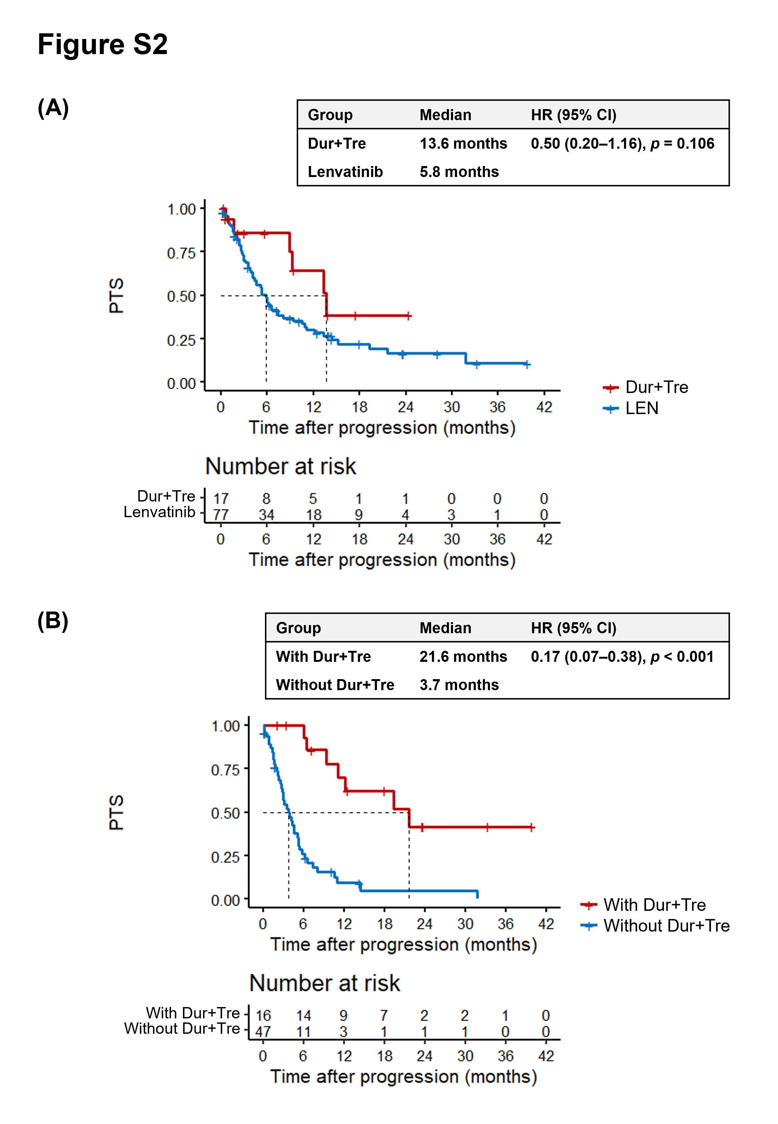
Figure S2. Post-treatment survival (PTS) after discontinuation of second-line therapy.
PTS was defined as the interval from discontinuation of second-line treatment to death from any cause. (A) PTS in the overall evaluable population (n = 94; 17 patients in the Dur+Tre group and 77 in the lenvatinib group). The median PTS was 13.6 months with Dur+Tre and 5.8 months with lenvatinib (HR, 0.50; 95% CI, 0.20–1.16; p = 0.106). (B) Among lenvatinib-treated patients with available subsequent-treatment information (n = 63), PTS is compared according to whether Dur+Tre was administered as a later-line treatment. The median PTS was 21.6 months in patients who subsequently received Dur+Tre and 3.7 months in those who did not (HR, 0.17; 95% CI, 0.07–0.38; p < 0.001). Because Dur+Tre exposure was defined after the PTS time origin, this comparison is subject to immortal-time and treatment-selection bias and should not be interpreted causally.
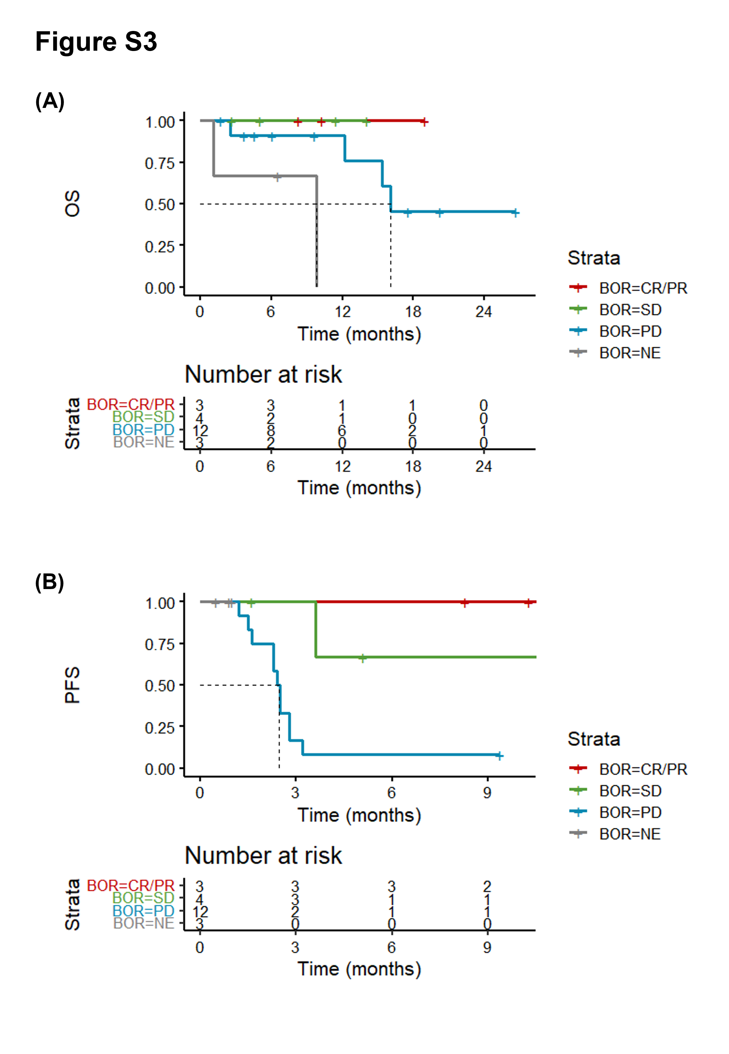
Figure S3. Survival according to best overall response in patients treated with durvalumab plus tremelimumab (Dur+Tre).
Kaplan–Meier curves in the Dur+Tre group are stratified by best overall response (BOR) assessed per RECIST version 1.1: complete or partial response (CR/PR), stable disease (SD), progressive disease (PD), and not evaluable (NE). (A) Overall survival (OS) according to BOR. (B) Progression-free survival (PFS) according to BOR. Patients who achieved disease control (CR/PR or SD) had more favorable OS and PFS than those with progressive disease or who were not evaluable for response.
Abbreviations: Atezo+Bev, atezolizumab plus bevacizumab; BOR, best overall response; CI, confidence interval; CR, complete response; Dur+Tre, durvalumab plus tremelimumab; HR, hazard ratio; LEN, lenvatinib; NE, not evaluable; OS, overall survival; PD, progressive disease; PFS, progression-free survival; PR, partial response; PTS, post-treatment survival; RECIST, Response Evaluation Criteria in Solid Tumors; SD, stable disease.

