Supplementary Material
Artificial intelligence for early sepsis detection in adults: a systematic review of opportunities for clinical decision support and antimicrobial stewardship, and the case for responsible use
Madina Ali, Aser Waleed Mohamed Marzok, Rasha Abdelsalam Elshenawy

Contents: Supplementary Table S1 (full search strings); Supplementary Table S2 (PICO framework); Supplementary Table S3 (full data-extraction table); Supplementary Table S4 (PROBAST+AI domain judgements); Supplementary Table S5 (reporting completeness); Supplementary Figure S1 (country of each study); Supplementary Figure S2 (reported accuracy against study size and risk of bias); PRISMA 2020 checklist; SWiM checklist.

Supplementary Table S1. Full search strings by database (searches run 2016–2026).
Database | Search string
PubMed | ("Sepsis"[MeSH Terms] OR sepsis[tiab] OR "septic shock"[tiab] OR "severe sepsis"[tiab] OR septicaemia[tiab] OR septicemia[tiab]) AND ("Artificial Intelligence"[MeSH Terms] OR "artificial intelligence"[tiab] OR "machine learning"[tiab] OR "deep learning"[tiab] OR "neural network*"[tiab] OR "predictive model*"[tiab] OR algorithm*[tiab] OR "clinical decision support"[tiab]) AND ("early detection"[tiab] OR "early prediction"[tiab] OR "early recognition"[tiab] OR "early diagnosis"[tiab] OR predict*[tiab] OR "diagnostic accuracy"[tiab]). Filters: 2016–2026, English, Humans.
CINAHL (EBSCOhost) | S1 (MH "Sepsis+") OR TI sepsis OR AB sepsis OR TI "septic shock" OR AB "severe sepsis" OR TI septicaemia OR AB septicemia; S2 (MH "Artificial Intelligence+") OR (MH "Machine Learning") OR TI "artificial intelligence" OR AB "machine learning" OR TI "deep learning" OR TI "neural network*" OR AB "predictive model*" OR TI algorithm* OR AB "clinical decision support"; S3 TI "early detection" OR AB "early detection" OR TI "early prediction" OR TI "early recognition" OR AB "early diagnosis" OR TI predict* OR AB "diagnostic accuracy"; S4 S1 AND S2 AND S3. Limits: 2016–2026, English, peer-reviewed.
Scopus | TITLE-ABS-KEY (sepsis OR "septic shock" OR "severe sepsis" OR septicaemia OR septicemia) AND TITLE-ABS-KEY ("artificial intelligence" OR "machine learning" OR "deep learning" OR "neural network*" OR "predictive model*" OR algorithm* OR "clinical decision support") AND TITLE-ABS-KEY ("early detection" OR "early prediction" OR "early recognition" OR "early diagnosis" OR predict* OR "diagnostic accuracy"). Limits: PUBYEAR > 2015, English.
Cochrane Library (CENTRAL) | #1 MeSH descriptor: [Sepsis] explode all trees; #2 (sepsis OR "septic shock" OR "severe sepsis" OR septicaemia OR septicemia):ti,ab,kw; #3 #1 OR #2; #4 MeSH descriptor: [Artificial Intelligence] explode all trees; #5 ("artificial intelligence" OR "machine learning" OR "deep learning" OR "neural network*" OR "predictive model*" OR algorithm*):ti,ab,kw; #6 #4 OR #5; #7 ("early detection" OR "early prediction" OR "early recognition" OR "early diagnosis" OR predict* OR "diagnostic accuracy"):ti,ab,kw; #8 #3 AND #6 AND #7. Date limit: 2016–2026.
Google Scholar (supplementary) | sepsis ("machine learning" OR "artificial intelligence" OR "deep learning") ("early detection" OR "early prediction" OR prediction); "Since 2016" filter; first 200 results screened.

Supplementary Table S2. PICO framework.
Element | Description
P — Population | Adults (≥18 years) with suspected or confirmed sepsis in acute, emergency or critical care settings
I — Intervention/exposure | AI or machine-learning models and clinical decision-support systems for early detection or prediction of sepsis and related outcomes, using vital signs, laboratory results and electronic health record data
C — Comparison | Conventional sepsis screening tools (SIRS, qSOFA, NEWS2/MEWS, SOFA) or standard clinical assessment, where reported
O — Outcome | Diagnostic accuracy (AUROC, sensitivity, specificity, calibration, net benefit), timeliness of detection, implementation outcomes, antibiotic-use and antimicrobial-resistance outcomes, and patient outcomes

Supplementary Table S3. Full data-extraction table for the 17 included studies.
Study [ref] | Design & setting | Population (n; sepsis) | AI/ML model & inputs | Prediction target & lead time (fit) | Performance & validation | Antibiotic / AMR relevance | Quality (CASP) | Main findings vs review objectives & outcome
Han et al. 2025 [15] | Retrospective single-database ML development; internal validation only (7:3 + 10-fold CV). ICU, elderly ≥65 y. | N=3,156 older ICU patients meeting Sepsis-3 criteria; outcome event = sepsis-associated encephalopathy (SAE) in 1,536 (48.7%). | 5 ML models, XGBoost best; 18 first-24 h features (vitals, severity scores, labs); SHAP. | Predicts SAE (a complication) after day 1 , not sepsis onset. (Indirect) | AUROC 0.898 (test, no CI); Sens 0.82, Spec 0.84, PPV 0.82. Internal only; calibration/DCA reported. | None reported. | Medium | XGBoost predicts SAE well and beats traditional scores, but the outcome is a complication of established sepsis, not early detection; single US database, retrospective, internal-only, no stewardship data.
Wang et al. 2021 [16] | Secondary analysis of a retrospective observational cohort; internal validation. ICU. | 4,449 infected ICU adults; sepsis onset in 3,539 (79.5%). | Random Forest; 20 clinical/lab features (Gini importance). | Predicts sepsis onset in infected ICU patients; no explicit lead time. (Direct) | AUROC 0.91 (test); Sens 0.95, PPV 0.89 (Spec NR). Internal only. (Abstract mislabels metrics.) | None reported. | Medium | Routine admission variables predict sepsis onset with high AUROC, supporting early-detection feasibility , but single-centre, internally validated only, with no implementation or stewardship outcome.
Nemati et al. 2018 [17] | Retrospective observational cohort with genuine external validation. ICU. (Not an RCT.) | Development ~27,527 ICU admissions (2,375 [8.6%] sepsis); external ~42,000 (MIMIC-III). | AISE , Weibull–Cox survival model; 65 features computed hourly from EMR. | Predicts sepsis onset 4–12 h before recognition (explicit lead time). (Direct) | AUROC 0.83–0.85 (4–12 h); Sens fixed 0.85, Spec 0.67 at 4 h (≈33% false alarms). Development ≈ external (robust). | ‘Sepsis interdiction’ (earlier antibiotics) discussed conceptually; not measured. | High | Strongest early-detection evidence: flags sepsis hours ahead with externally robust discrimination. However moderate specificity implies a real false-alarm burden, and no outcome or stewardship endpoint was tested.
Rahman et al. 2024 [18] | Retrospective prognostic-model development; internal only (SMOTE-balanced CV). ICU. | 4,240 patients meeting Sepsis-3 criteria (all already have sepsis); 30-day mortality in 783 (18.5%). | Stacking meta-classifier (‘Stacked LR’); 15 biomarkers. | Predicts 30-day mortality in patients with established sepsis , not detection. (Indirect) | AUROC 0.99 (optimism signal: SMOTE + internal only); Sens 0.96, Spec 0.94. | None reported. | Low | The near-perfect AUROC is an artefact of class-balancing and internal-only validation; the outcome is mortality, not sepsis onset , little relevance to the early-detection question.
Lin et al. 2025 [19] | Retrospective single-centre diagnostic study; internal validation; deployed (un-evaluated) web CDSS. ICU cases vs outpatient controls. | 1,492 (654 sepsis); ICU suspected pneumonia-sepsis vs stable outpatient controls. | LGBM (best of several); CBC + differential inputs only. | Cross-sectional sepsis vs non-sepsis classification (faster than culture, not hours-ahead). (Partial) | AUROC 0.90 (test; train 0.99 , gap); Sens 0.85, Spec 0.82, PPV 0.76. Internal; Brier calibration. | Conceptual link to faster antibiotics; not measured. | Medium | Routine CBC alone classifies sepsis well and is deployed as a CDSS, but outpatient controls bias the contrast, there is no outcome/RCT, and the stewardship benefit is asserted rather than measured.
Zhou H et al. 2026 [20] | Retrospective prediction-model development with external validation (eICU). ICU. | Training 5,561 (MIMIC-IV); external 2,259 (eICU); patients with sepsis progressing to shock. | 6 ML algorithms, Random Forest best; ~23 LASSO features; SHAP. | Predicts progression sepsis→septic shock (first-24 h) , a complication, not onset. (Indirect) | AUROC 0.785 (external; 95% CI 0.77–0.80); Sens 0.74, Spec 0.70. Good calibration (Brier 0.189). | None reported. | High | A methodologically honest external validation showing only moderate discrimination for shock progression , a key generalisability lesson (single-database performance does not transfer) , but not early sepsis detection.
Tranchellini et al. 2026 [21] | Retrospective multi-database deep-learning study; cross-database (external) generalisation. ICU. | 216,536 ICU stays; ~10,817 sepsis (4.6–6.3% across databases). | 3 deep-learning architectures (CNN most robust); 48 dynamic features. | Predicts sepsis onset 6 h ahead (label true 6 h before onset). (Direct) | AUROC ≈0.61–0.77 across database pairs (no CIs); discrimination only moderate cross-domain; Sens/Spec NR. | Antibiotic timing used only to define the label; no stewardship outcome. | High | The largest, most rigorous generalisation study: true early-detection AUROC falls to moderate when models cross hospitals/databases , central evidence that high single-database performance overstates real-world accuracy.
Despraz et al. 2026 [22] | Prospective before–after, quasi-experimental; deployed real-world Sepsis Learning Health System. | Sepsis registry 97,559 stays; SLHS 40,502; control wards 25,851. | HERACLES ensemble (Random Forest + LSTM); 240 features over 7-day windows. | Sepsis case identification/surveillance, computed every 6 h retrospectively (not real-time onset). (Partial) | AUROC 0.88 (confirmed sepsis, internal, no CI); Sens 0.62–0.83, PPV 0.60–0.76; rigorous test set exposed low recall. | Measured: pathway patients more likely to receive antibiotics within 1 h (propensity-matched). | High | The only real-world deployed learning-health-system; associated with faster antibiotics and reduced in-hospital mortality (20.5%→15.3%) , the strongest implementation and stewardship evidence , though single-institution and not an RCT.
Shi et al. 2025 [23] | Retrospective prognostic-model development; internal validation. ICU. | 2,389 ICU patients meeting Sepsis-3 criteria; in-hospital mortality 526 (22.0%). | LASSO + Cox PH nomogram (11 predictors); web calculator. | Predicts in-hospital mortality (survival) , not detection. (Indirect) | AUROC 0.85 (4-week validation, with 95% CIs); C-index 0.84; Sens/Spec NR; net benefit > SOFA. | None reported. | Medium | A well-calibrated mortality nomogram outperforming SOFA on decision-curve analysis, but a prognostic tool for patients with established sepsis (not early detection) and internally validated only.
Hwang et al. 2026 [24] | Retrospective secondary EMR analysis; internal 5-fold CV. Hospital-wide, non-ICU (ED/wards/outpatient). | 22,400 patients; sepsis 7,655 (34.2%). | CatBoost/XGBoost (best); routine labs at initial point of care. | Cross-sectional sepsis identification from early-presentation labs (non-ICU). (Partial) | AUROC 0.95 (CatBoost, internal, no CI); Sens 0.92, Spec 0.79, PPV 0.78. | Antibiotic-delay mortality cited as motivation; not measured. | Medium | High discrimination for early sepsis identification outside the ICU using only routine labs , extends AI beyond critical care , but internal-only, no clinical outcome, and the sepsis label is not strict Sepsis-3.
Drysch et al. 2025 [25] | Retrospective multicentre registry study; internal validation (bootstrapped CIs). Burn ICU. | 6,629 burn patients; sepsis 521 (7.9%). | Random Forest (6 EDA-selected features). | Admission-time sepsis risk stratification (any time during stay), not hours-ahead. (Partial) | AUROC 0.91 (95% CI 0.88–0.93); Sens 0.81, Spec 0.85, PPV 0.31 (low prevalence), NPV 0.99. | High NPV framed as supporting antibiotic rule-out/stewardship; not measured. | Medium | First burns-specific model; strong rule-out value (high NPV) of potential stewardship use, but population-specific, internally validated, and low PPV means many false positives.
Zhou K et al. 2026 [26] | Prospective exploratory, double-blind feasibility study. ICU. | 52 ICU patients meeting Sepsis-3 criteria. | Off-the-shelf LLMs (ChatGPT-4o, DeepSeek-R1) via structured prompts; no training. | Diagnostic-accuracy + prognosis (AKI/ARDS/mortality) on patients with established sepsis. (Indirect) | Best prognostic AUC ~0.85 (AKI); ARDS near chance; no sepsis-detection AUROC; Brier reported. | AI regimens judged more guideline-concordant by experts (not a measured outcome); weak on local AMR tailoring. | Low | Proof-of-concept that LLMs can recognise sepsis/complications and propose guideline-concordant plans, but n=52, no detection metric, and explicitly adjunctive , preliminary feasibility only.
Yang et al. 2026 [27] | Prospective national multicentre cohort; internal validation. ICU (suspected infection). | 2,963 adults with suspected infection; mortality 10.9%; MDR infection 18.1%. | Logistic Regression (best of 4); admission predictors; two nomograms. | Predicts mortality + MDR-infection risk at admission , not sepsis onset. (Indirect) | Mortality AUC 0.88 (0.84–0.91); MDR AUC 0.86 (0.83–0.90); internal only; PPV low (0.25 mortality). | Measured: the only AMR model , predicts multidrug-resistant infection; explicit stewardship motivation. | Medium | The only study modelling an AMR outcome , predicts MDR infection at ICU admission with good discrimination, directly serving the stewardship lens , although prognostic (not detection) and internally validated only.
Fransvea et al. 2026 [28] | Prospective multicentre cohort (secondary analysis); nested-CV (internal). Acute/emergency surgery, elderly. | 2,563 elderly surgical patients; post-op ‘sepsis’ (qSOFA ≥2) in 119 (4.6%) , extreme imbalance. | Ensemble + 5 learners (RF best); pre-operative data only. | Predicts post-op sepsis from pre-op data (forward). qSOFA-defined target. (Partial) | AUROC 0.96 (nested-CV, CIs) BUT majority-class baseline already 0.954; Sens/Spec contradictory between Results and Discussion; AuPRC ~0.66–0.71. | Perioperative antibiotic relevance noted; not measured. | Low | Headline accuracy is inflated by extreme class imbalance (baseline ≈ model) and the paper's own sensitivity/specificity figures are irreconcilable; the high AUROC should not be taken at face value, and the qSOFA target is weak.
Li et al. 2026 [29] | Retrospective survival + clustering study; single internal split (leakage flags). ICU. | 6,086 patients with sepsis (MIMIC-IV); 90-day mortality 23.9%. | 8 survival-ML algorithms (Ridge best) risk score + K-means subtypes. | 90-day mortality risk + subtyping of patients with established sepsis , not detection. (Indirect) | Harrell C-index 0.761 (no CI; authors: likely an upper bound due to leakage); no AUROC/Sens/Spec. | ‘Treatable traits’ hypothesised; not measured. | Medium | Generates mortality-risk subtypes for patients with established sepsis but with explicit data-leakage/optimism warnings; prognostic and phenotyping in nature, not early detection.
Jeong et al. 2026 [30] | Retrospective single-centre descriptive/unsupervised study. Emergency Department. | 14,402 suspected-sepsis ED adults; 28-day mortality 6.9%. | Unsupervised clustering (5 subtypes) + neural-network refinement. | Unsupervised ED phenotyping at presentation (no onset prediction). (Indirect) | No AUROC/Sens/Spec (unsupervised); reported 98% ‘accuracy’ = reproduction of self-generated labels, not detection; cluster indices only. | Measured: time-to-antibiotics by cluster (median 2.4 h; earliest phenotype 1.5 h). | Low | Identifies high-severity ED phenotypes that received antibiotics earlier, suggesting a triage ‘safety net’, but it is unsupervised with no ground-truth detection metric , hypothesis-generating only.
Shimabukuro et al. 2017 [31] | Randomised controlled trial (open-label); deployed real-time CDSS. Two mixed medical-surgical ICUs. | 142 ICU adults auto-enrolled; 67 experimental / 75 control. | Dascena MLA (InSight family); 0–100 risk score hourly; telephonic alert to charge nurse. | Predicts severe-sepsis onset (~4 h ahead per prior work); deployed in real time. (Direct) | Comparator AUROC 0.952 (vs SIRS/qSOFA); Sens 0.90, Spec 0.90 (few false alarms). Trial endpoints = outcomes (right). | Measured: antibiotics 2.76 h earlier and blood cultures 2.79 h earlier (note: fewer experimental patients received antibiotics overall). | Medium | The only interventional RCT: real-time ML alerts reduced hospital length of stay (13.0→10.3 days, −20.6%) and in-hospital mortality, with earlier antibiotics and cultures , the strongest causal and stewardship signal , but small, single-centre and open-label.

Supplementary Table S4. PROBAST+AI domain and overall risk-of-bias judgements for the 17 included studies.
Study [ref] | Participants | Predictors | Outcome | Analysis | Overall
Han et al. 2025 [15] | L | L | L | H | H
Wang et al. 2021 [16] | L | L | L | H | H
Nemati et al. 2018 [17] | L | L | L | U | U
Rahman et al. 2024 [18] | L | H | L | H | H
Lin et al. 2025 [19] | H | L | L | H | H
Zhou H et al. 2026 [20] | L | L | L | L | L
Tranchellini et al. 2026 [21] | L | L | L | U | U
Despraz et al. 2026 [22] | U | L | L | U | U
Shi et al. 2025 [23] | L | L | L | U | U
Hwang et al. 2026 [24] | H | L | H | H | H
Drysch et al. 2025 [25] | L | L | U | H | H
Zhou K et al. 2026 [26] | H | U | L | H | H
Yang et al. 2026 [27] | L | H | L | U | H
Fransvea et al. 2026 [28] | L | L | H | H | H
Li et al. 2026 [29] | L | L | U | H | H
Jeong et al. 2026 [30] | U | L | H | H | H
Shimabukuro et al. 2017 [31] | L | L | U | H | H
L = low risk of bias; U = unclear; H = high. Per PROBAST, the overall judgement is low only where every domain is low and high where any domain is high. Judgements were led by one reviewer and independently checked by a second, with disagreements resolved by consensus.

Supplementary Table S5. Reporting completeness across the 17 included studies (TRIPOD+AI-anchored audit).
Reporting element | Reported (n) | Not reported (n) | % reported
Accuracy (AUROC or C-index) | 16 | 1 | 94%
Sensitivity and specificity together | 9 | 8 | 53%
Calibration (plot, slope or Brier score) | 8 | 9 | 47%
95% confidence interval for the headline accuracy metric | 6 | 11 | 35%
Clinical usefulness (decision-curve analysis) | 6 | 11 | 35%
Tested in an independent dataset | 3 | 14 | 18%

Supplementary Figure S1. Country in which each of the 17 studies was conducted.
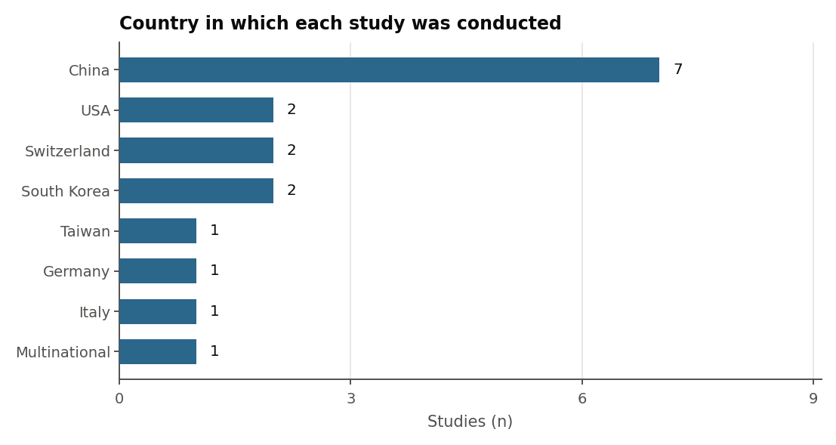
Alt text: Horizontal bar chart. China 7 studies, USA 2, Switzerland 2, South Korea 2, Taiwan 1, Germany 1, Italy 1, multinational 1.

Supplementary Figure S2. Reported accuracy against study size and risk of bias.
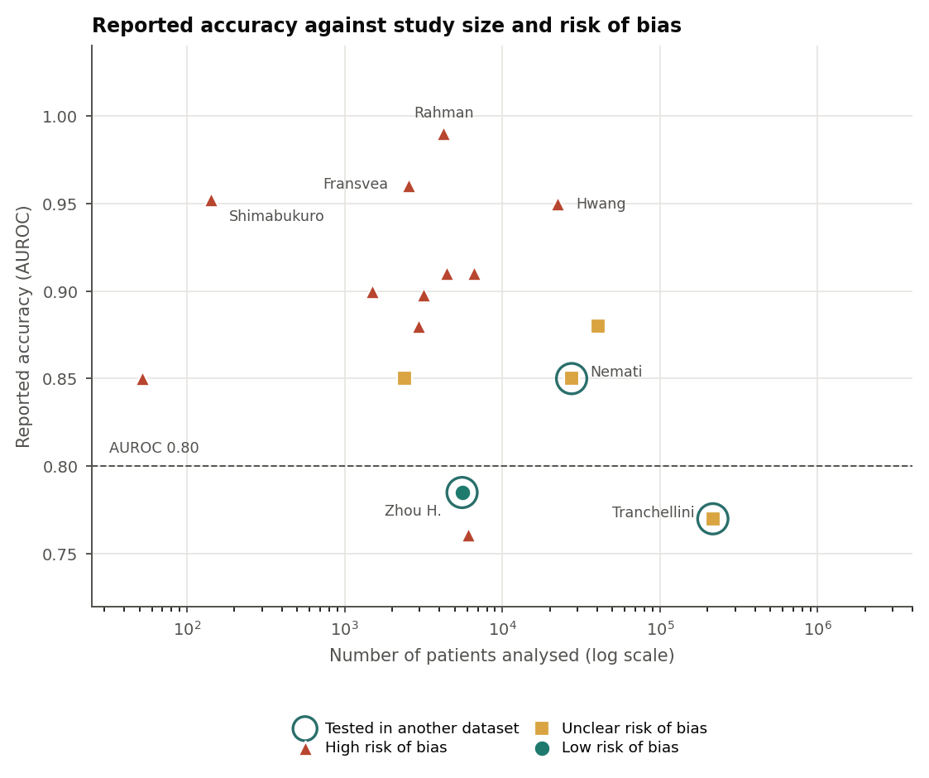
Each point is one study. Marker colour and shape denote overall risk of bias; rings mark the three studies tested in an independent dataset. The dashed line marks an accuracy of 0.80. Values are not pooled and the studies predict different outcomes; the figure shows that the studies with the strongest designs reported the most modest accuracy.
Alt text: Scatter plot of reported accuracy against number of patients analysed on a logarithmic scale. The three studies tested in an independent dataset, ringed, sit between 0.77 and 0.85 despite large sample sizes, while all values at or above 0.95 come from studies at high risk of bias that tested their models only in their own data.

PRISMA 2020 and SWiM checklists
[AUTHORS: attach the completed PRISMA 2020 checklist and the completed SWiM checklist here before submission. Both are required by the Methods section of the main article.]

