Solar Energy as Renewable Energy for the Degradation of Pollutants using High Active Ag@TiO₂/α-Fe₂O₃ Ternary Nanocomposite photocatalyst

Nesrine Ben Saber ^{a,*}

ª Department of Chemistry, College of Science, Taif University, P.O. Box 11099, Taif 21944, Saudi Arabia

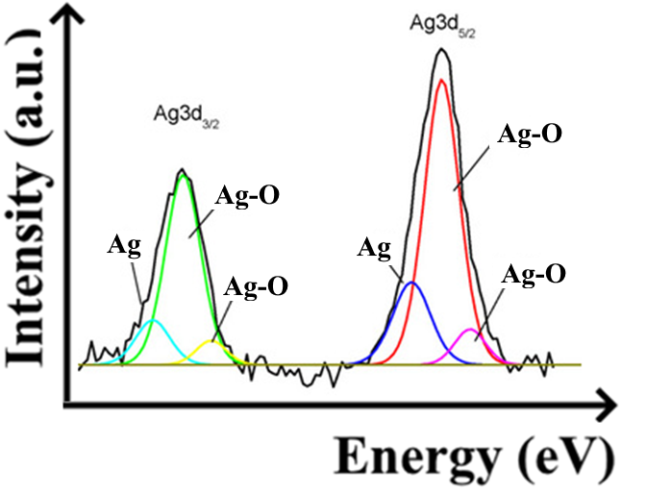
Figure S1. Deconvolution XPS spectrum of Ag element.

