Supporting Information
Construction of a CeO₂/ZnO/NH₂-MIL-101(Fe) Ternary Heterojunction for Efficient Visible-Light-Driven Photocatalytic Reduction of U(Ⅵ): Enhanced Charge Separation and Uranium Immobilization Mechanism
Table of Contents
Preparation method of CeO₂
Preparation method of ZnO
Preparation method of CeO₂/ ZnO
Figure S1 TGA of MIL and composite B
Figure S2. UV–vis DRS spectra for MIL and composites (A, B and C)
Figure S3. pseudo first order Kinetic for (a) MIL, (b) composite (A), (c) composite (B), and (d) composite (C).
Figure S4. Pseudo-second-order Kinetic for (a) MIL, (b) composite (A), (c) composite (B), and (d) composite (C).
Figure S5. XRD patterns of the composite (B) after 5 cycles
Figure S6. FTIR of the composite (B) after 5 cycles
Figure S7. PL spectra for MIL and composites (A, B and C)
Figure S8. (A) First-derivative EPR spectra of DMPO spin adducts
Table S1. Experimental conditions of the photocatalytic reduction of U(Ⅵ) using composite (B)
TableS2. Ion Leaching percentage of composite (B)
References

Preparation of CeO₂
CeO₂ nanorod was synthesized through combining hydrothermal reaction method and calcination as reported in literature[1]. 5.2 g of Ce(NO₃)₃·6H₂O was added to 10 mL deionized water under magnetic stirring. Slowly, 20 ml of 14 mol/L of NaOH solution was added to the preceding solution and stir for 30 min. The resulting mixed solution was transferred to a 100 mL Teflon-lined steel autoclave, heated at 110˚C for 24 h, and cooled to ambient temperature. The resulting precipitate was washed three times with de-ionized water and dried at 60˚C. Finally, the dry product was calcined at 200˚C for 1 h in a muffle furnace to obtain CeO₂ nanorods.

Preparation of ZnO
ZnO was synthesized by mechano-chemical approach as a green method; in which no solvent was employed, using a high energy ball milling machine (HEBM) according to the procedure reported[2]. The precursors are ZnCl₂ (50.32 g), Na₂CO₃ (39.22 g) and NaCl (173.16 g) were combined and milled by a ball milling machine (ball to powder weight ratio was 8:1 and molar ratio of NaCl to ZnCl₂ was 8:1) for 8 h. To prevent agglomeration of the produced nanoparticles, NaCl was added as an inert diluent. The reaction was carried out between ZnCl₂ and Na₂CO₃ as given in Equation [1]. The synthesis of ZnO was achieved by calcination of the products obtained after the milling process at 700˚C for 4 h according to the calcination procedure specified by Equation [2]. The product was completely washed in deionized water in an ultrasonic bath and dried at room temperature for 48 hours.
${ZnCl}_{2(s)}+ {Na}_{2}{CO}_{3(s)}→ {ZnCO}_{3(s)}+ {2NaCl}_{(s)}$ (1)
${ZnCO}_{3(s)}+{Na}_{2}{CO}_{3(s)}→{ZnO}_{(s)}+{CO}_{2(g)}$ (2)

Preparation method of CeO₂/ ZnO
Ce(NO₃)₃·6H₂O and Zn(NO₃)₂·6H₂O with 1: 2 ratios were dissolved in 20 ml deionized water. The mixture was stirred vigorously during slow adding of 1M NaOH till the pH became 9-10. A precipitate was form immediately and the stirring was continued for 4 h. The precipitate was centrifuged for 10 min and washed with deionized water for three times. The obtained precipitate was dried overnight at 80 C and calcined in a muffle furnace at 500℃ for 4 hours with heating rate of 2℃/min. After natural cooling, the calcined CeO₂/ZnO powder was ground to obtain fine powder. A stock solution of 10 mg/ml CeO₂/ZnO using DMF was sonicated for 30 min and used immediately to obtain a uniform dispersion.

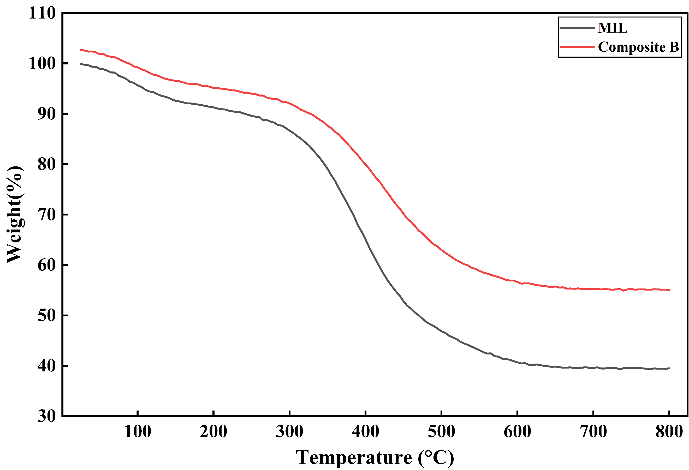
Figure S1 TGA of MIL and composite (B)

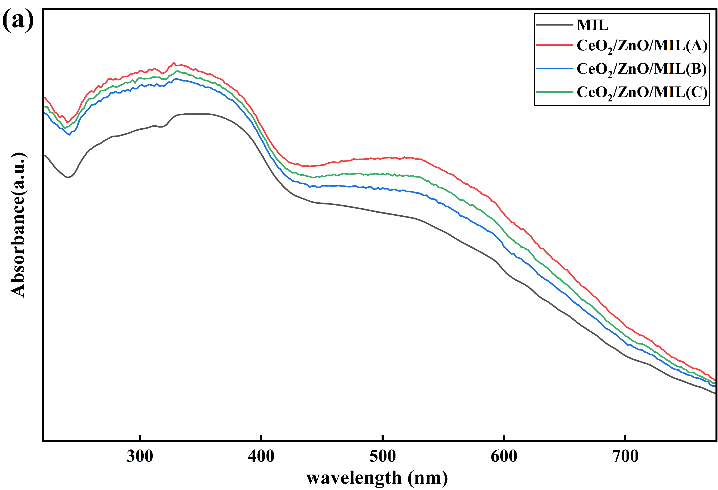
Figure S2. UV–vis DRS spectra for MIL and composites (A, B and C)

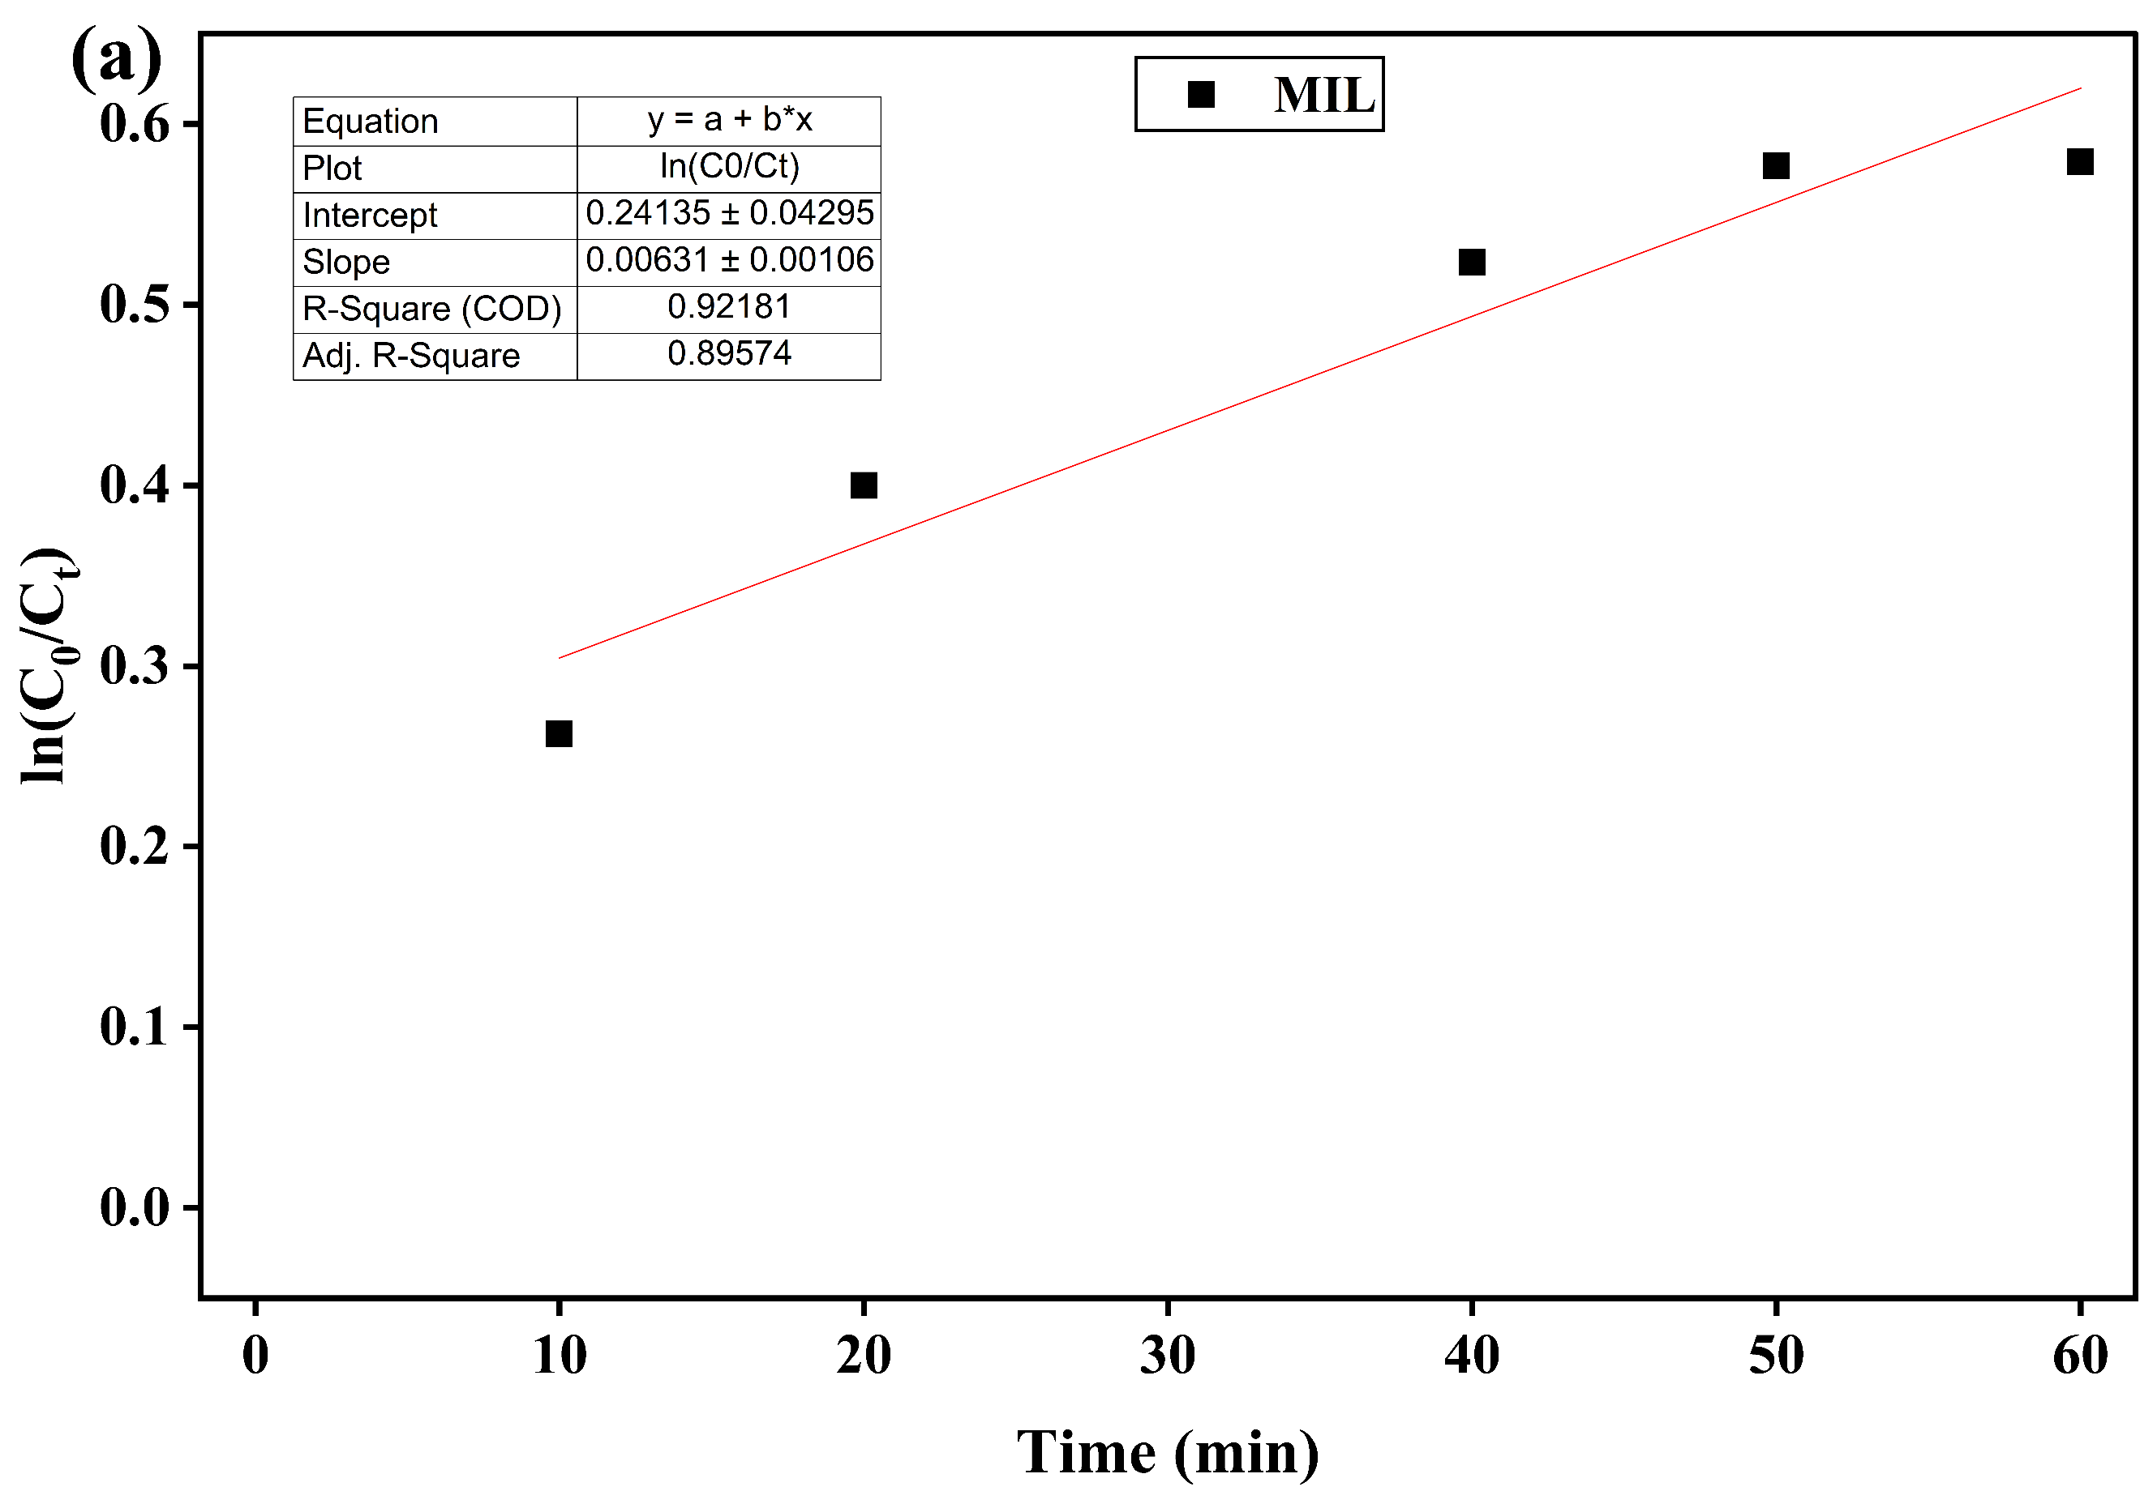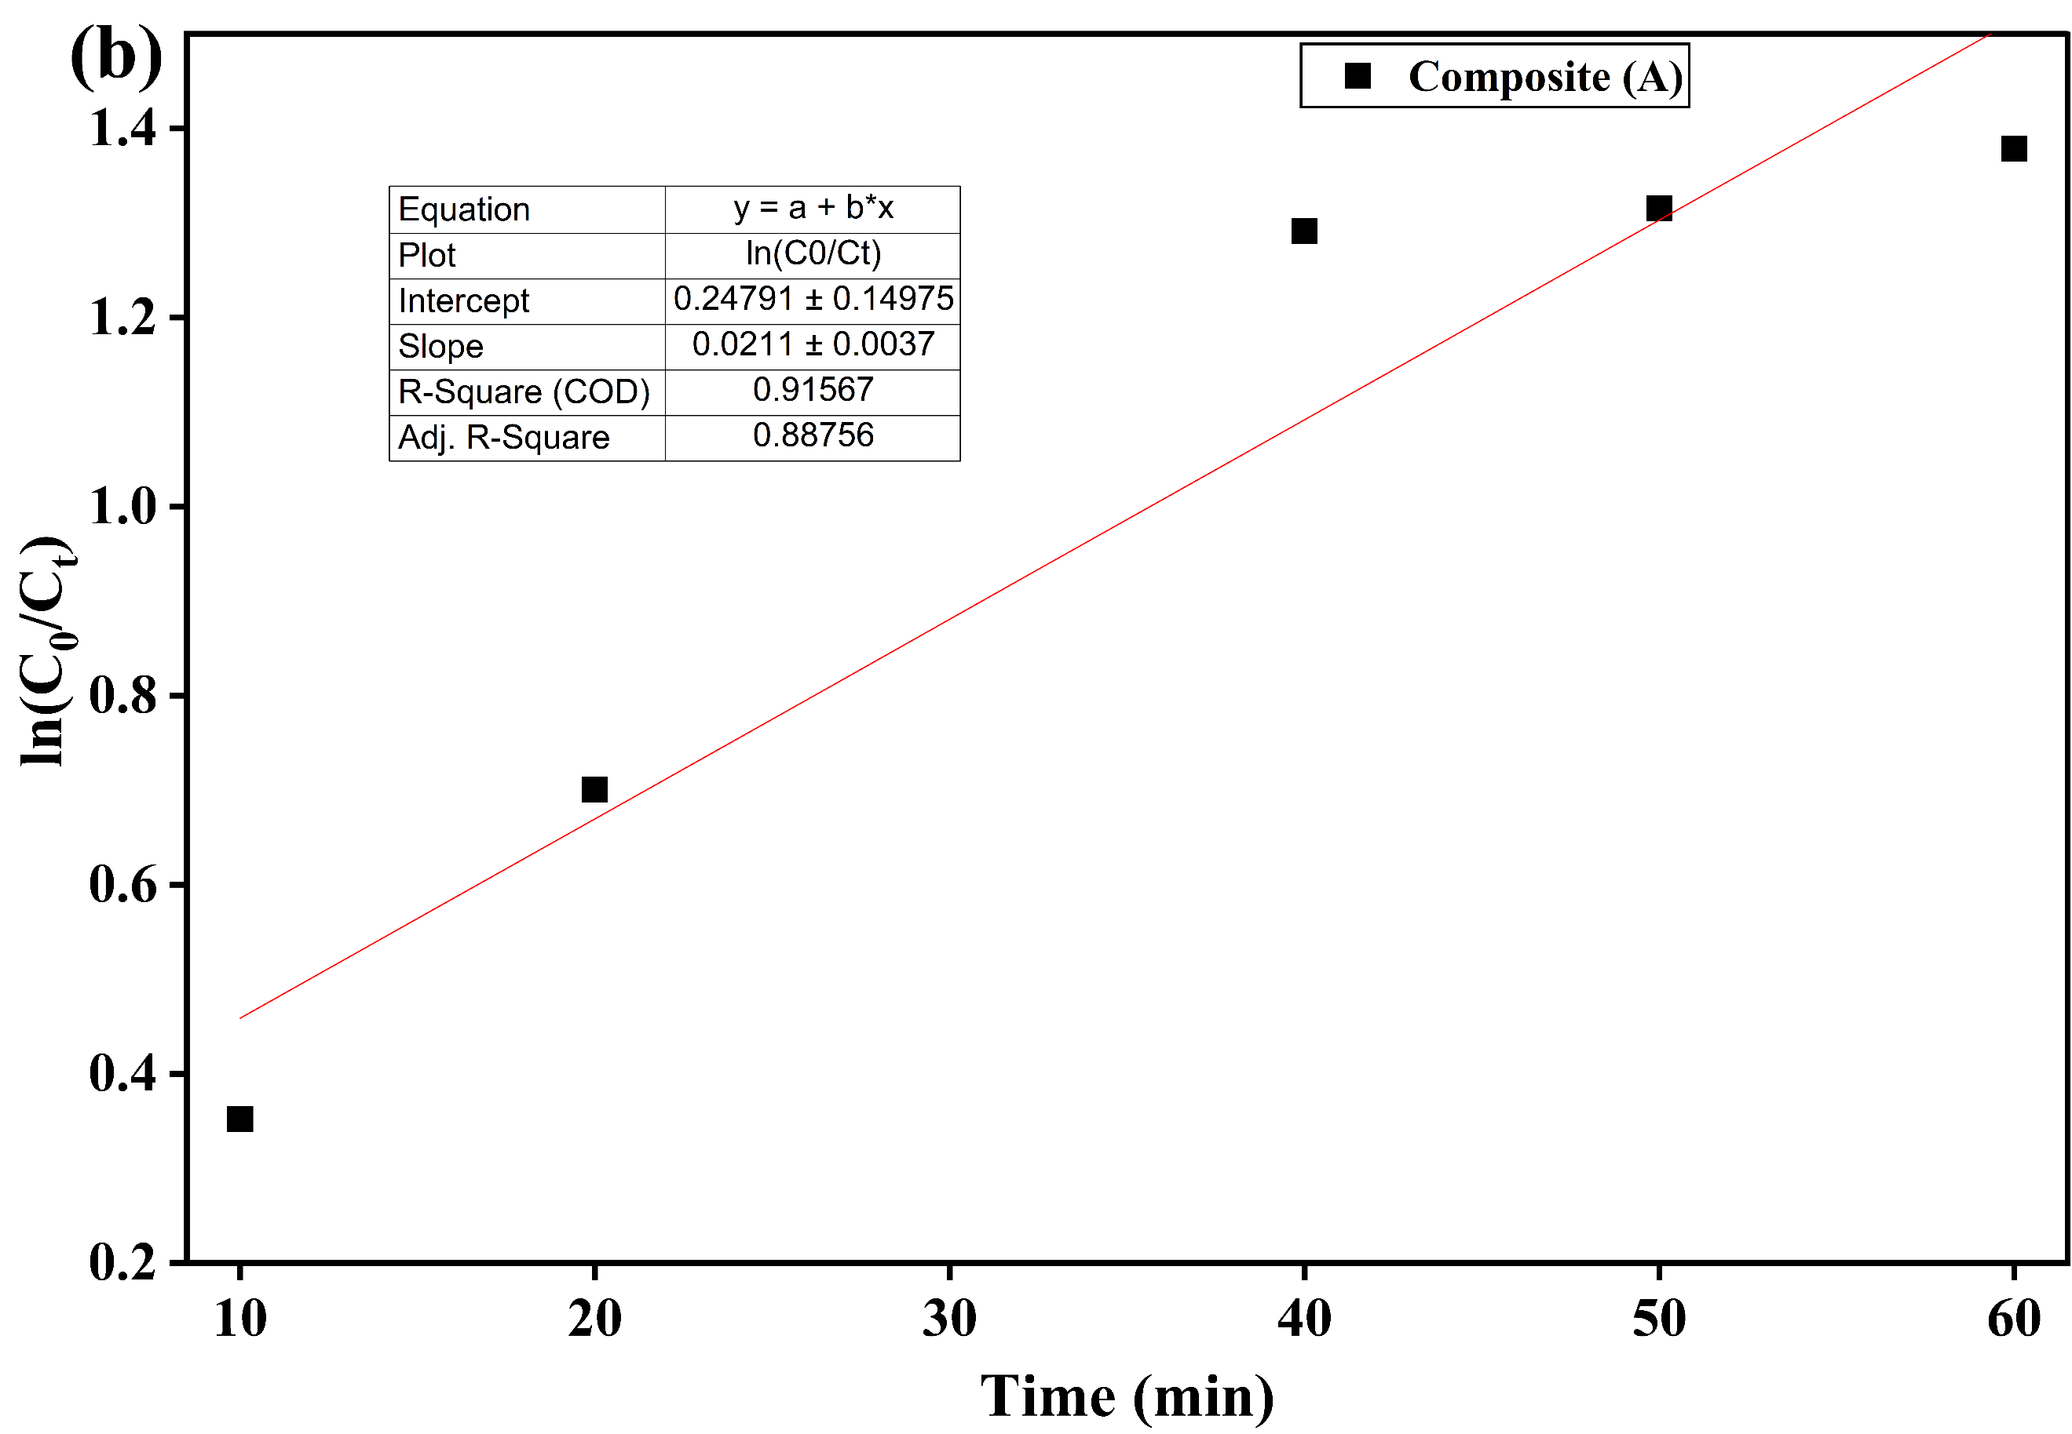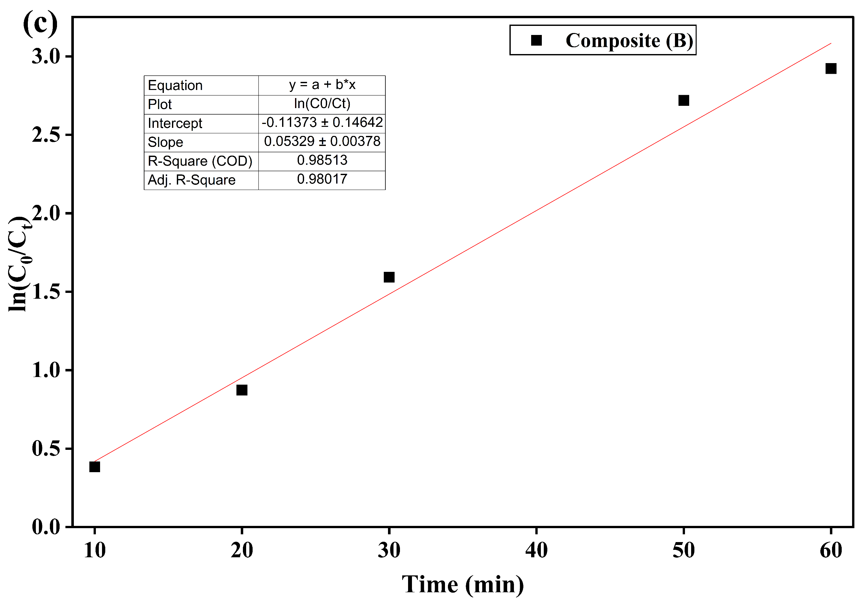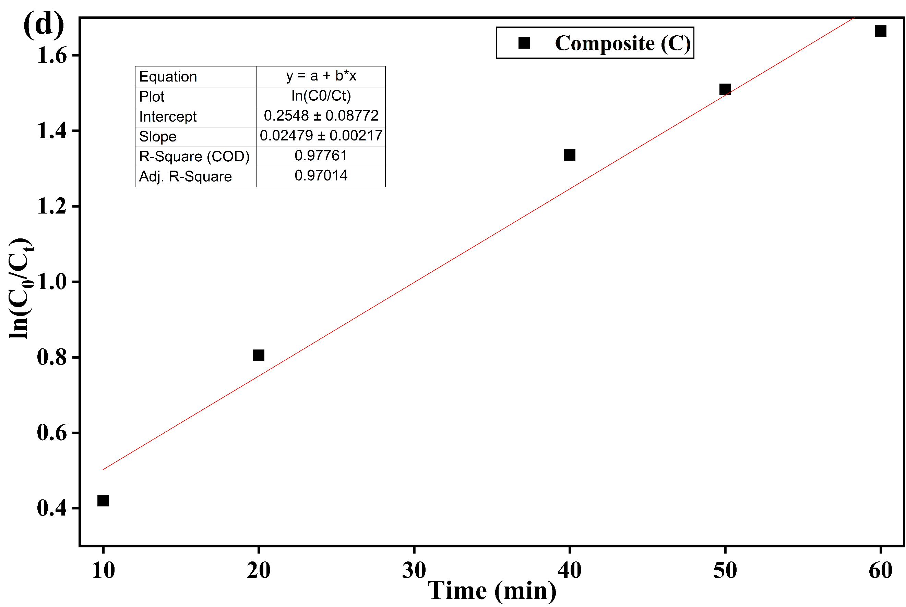
Figure S3. pseudo first order Kinetic for (a) MIL, (b) composite (A), (c) composite (B), and (d) composite (C).

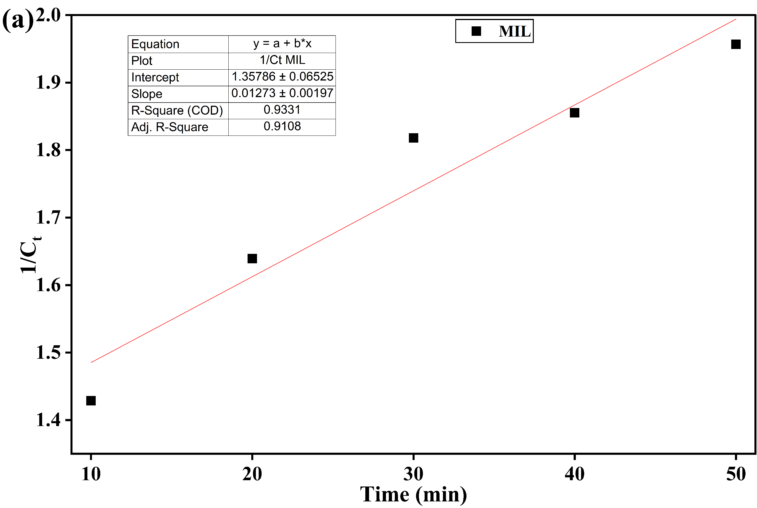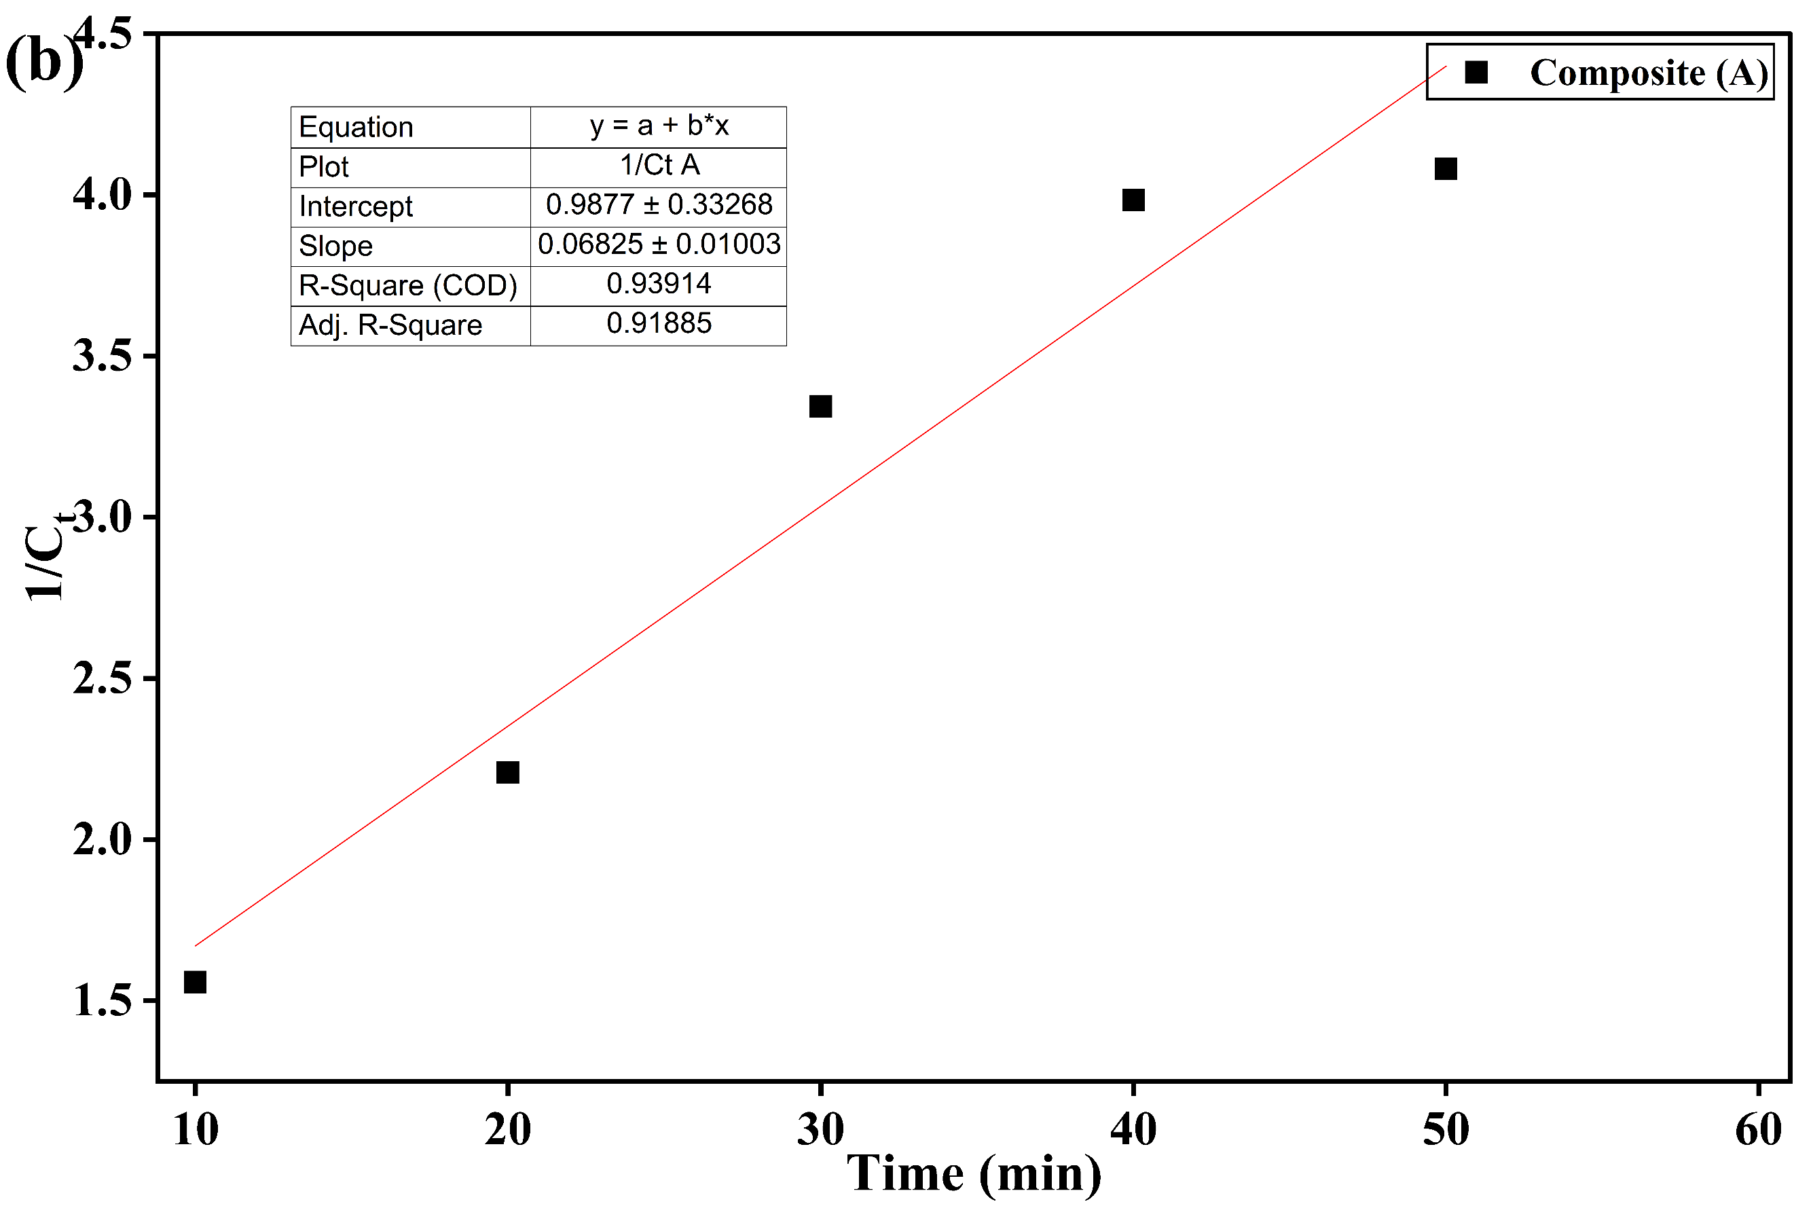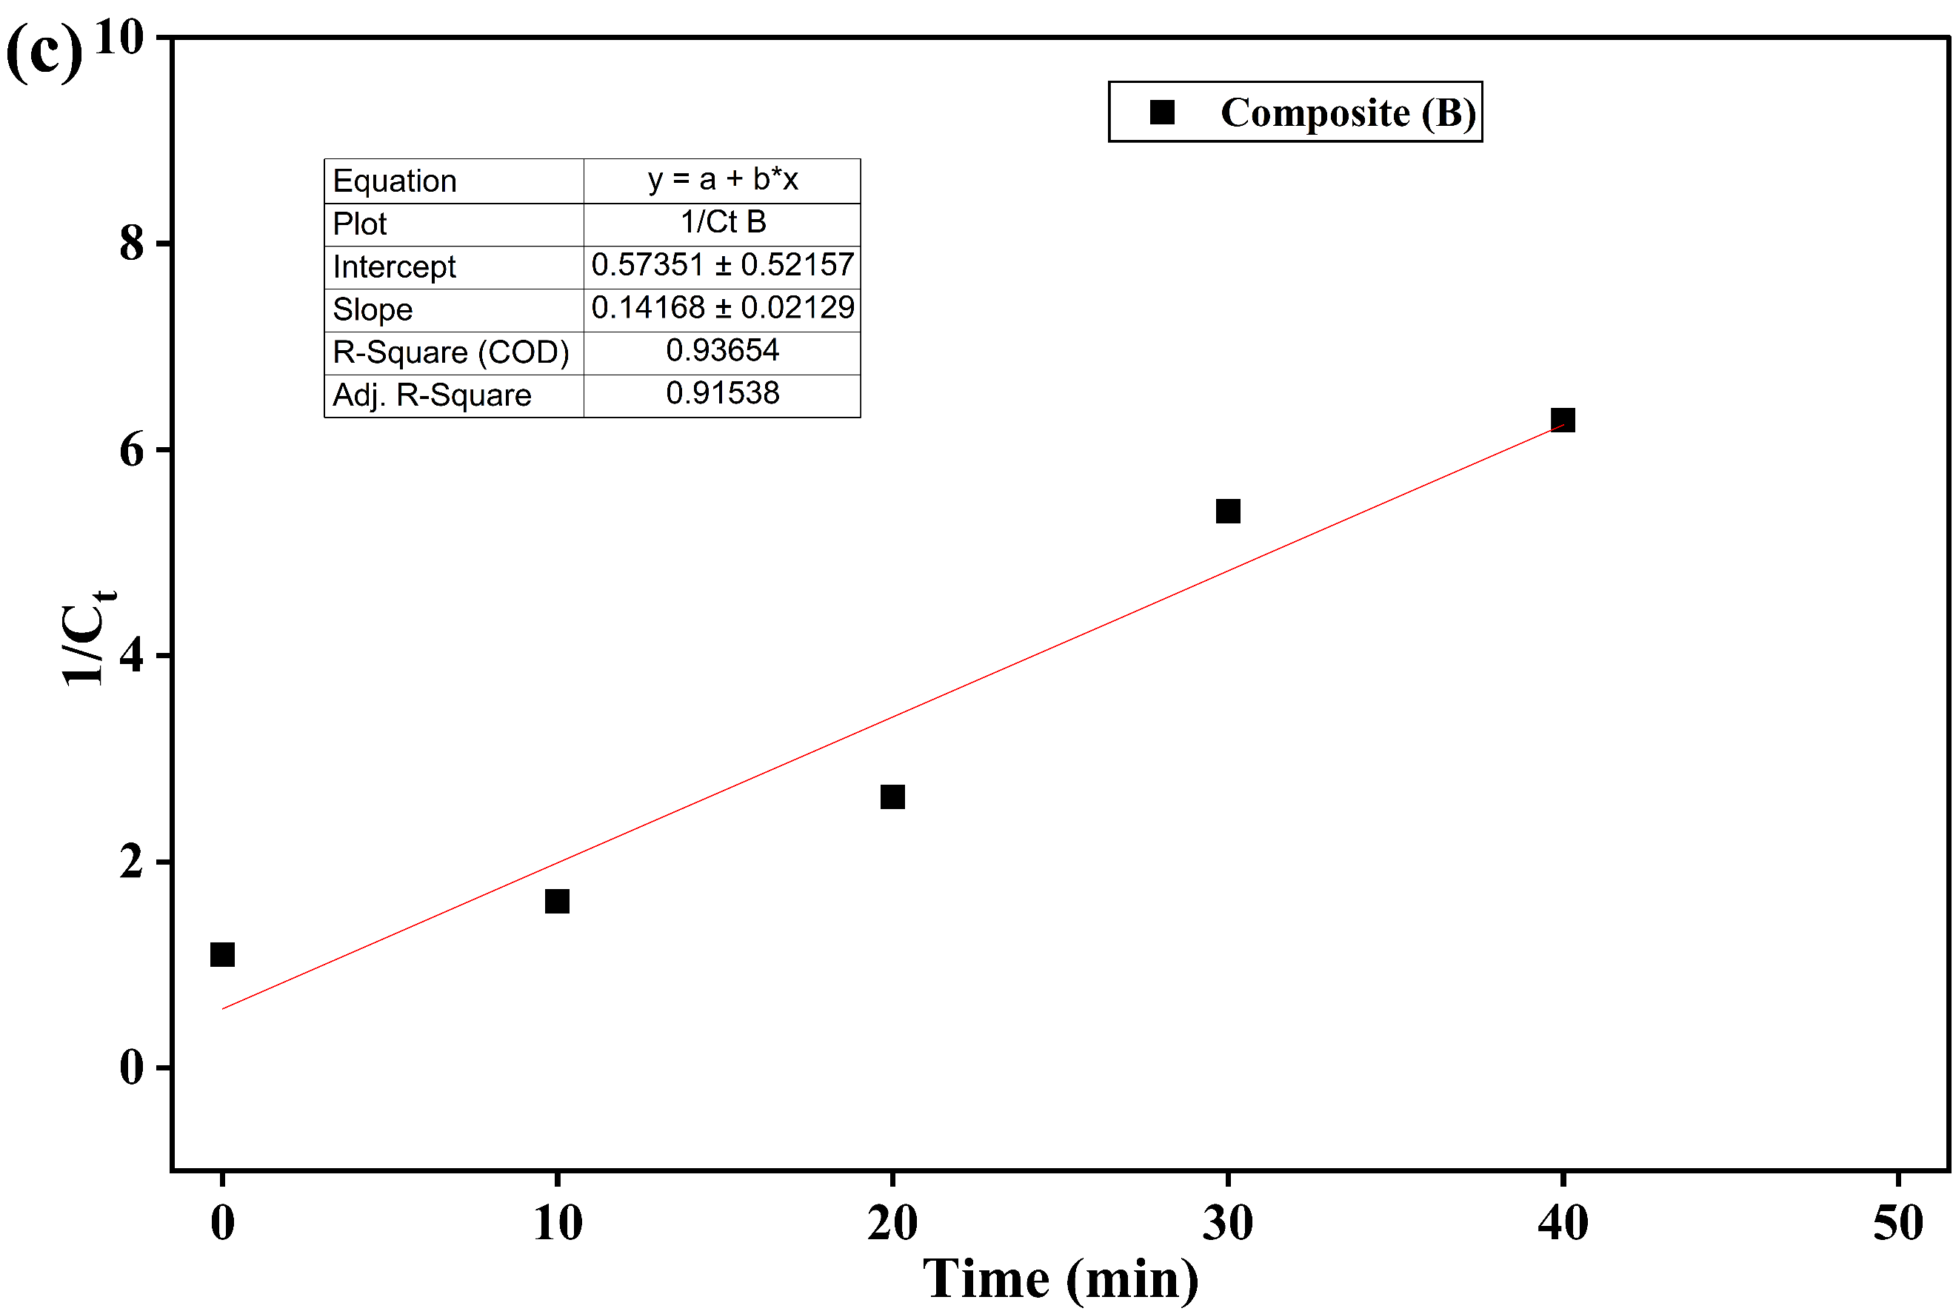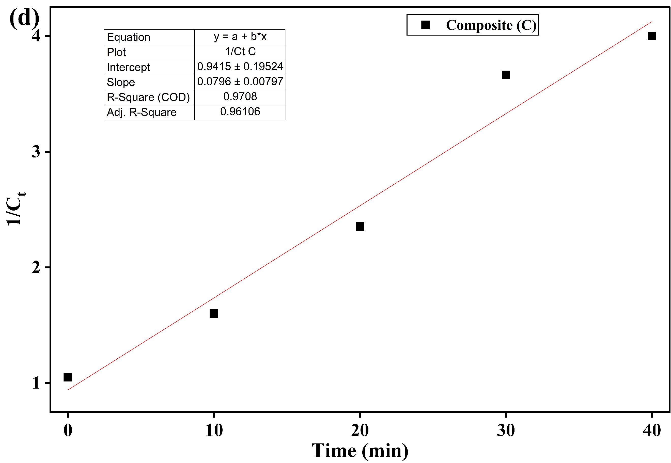
Figure S4. Pseudo-second-order Kinetic for (a) MIL, (b) composite (A), (c) composite (B), and (d) composite (C).

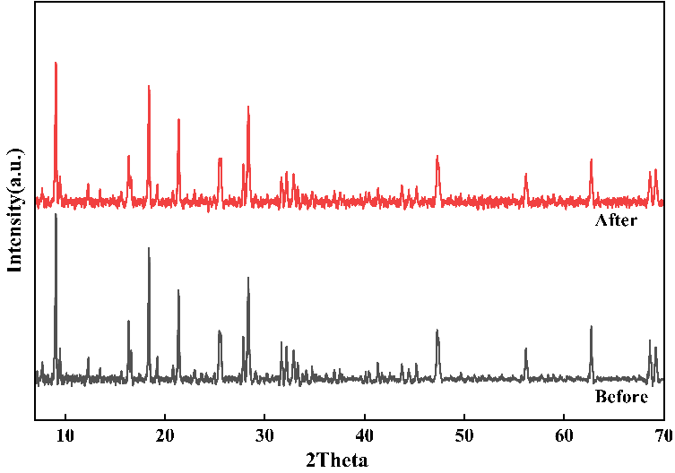
Figure S5. XRD patterns of composite (B) after 5 cycles

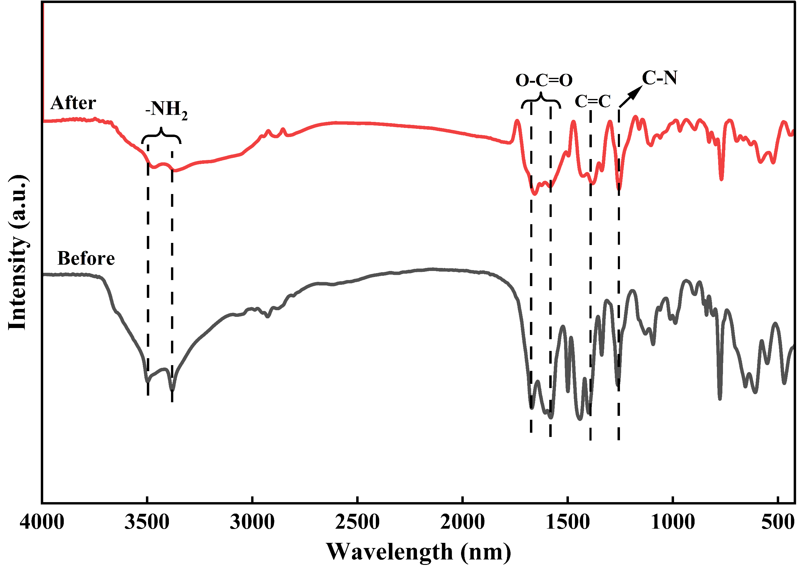
Figure S6. FTIR of the composite (B) after 5 cycles

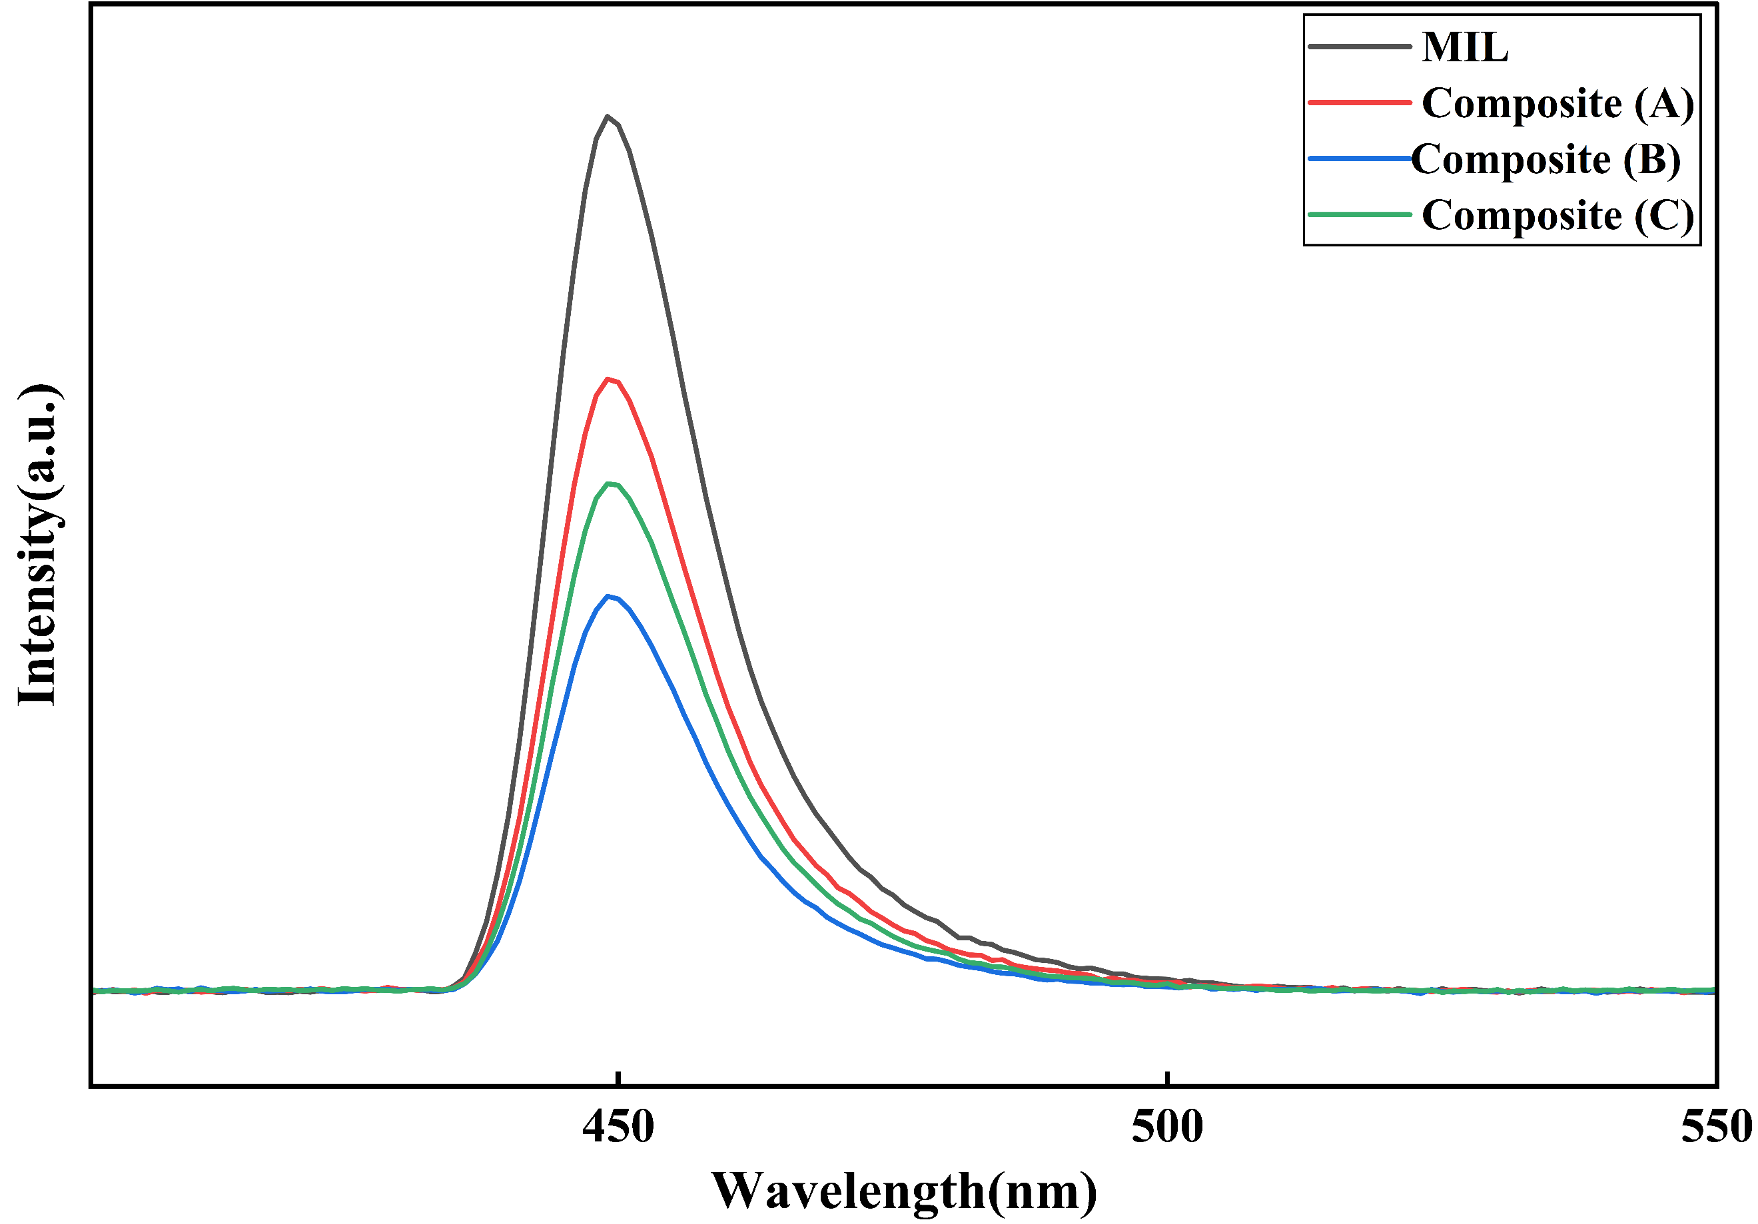
Figure S7. PL spectra for MIL and composites (A, B and C)

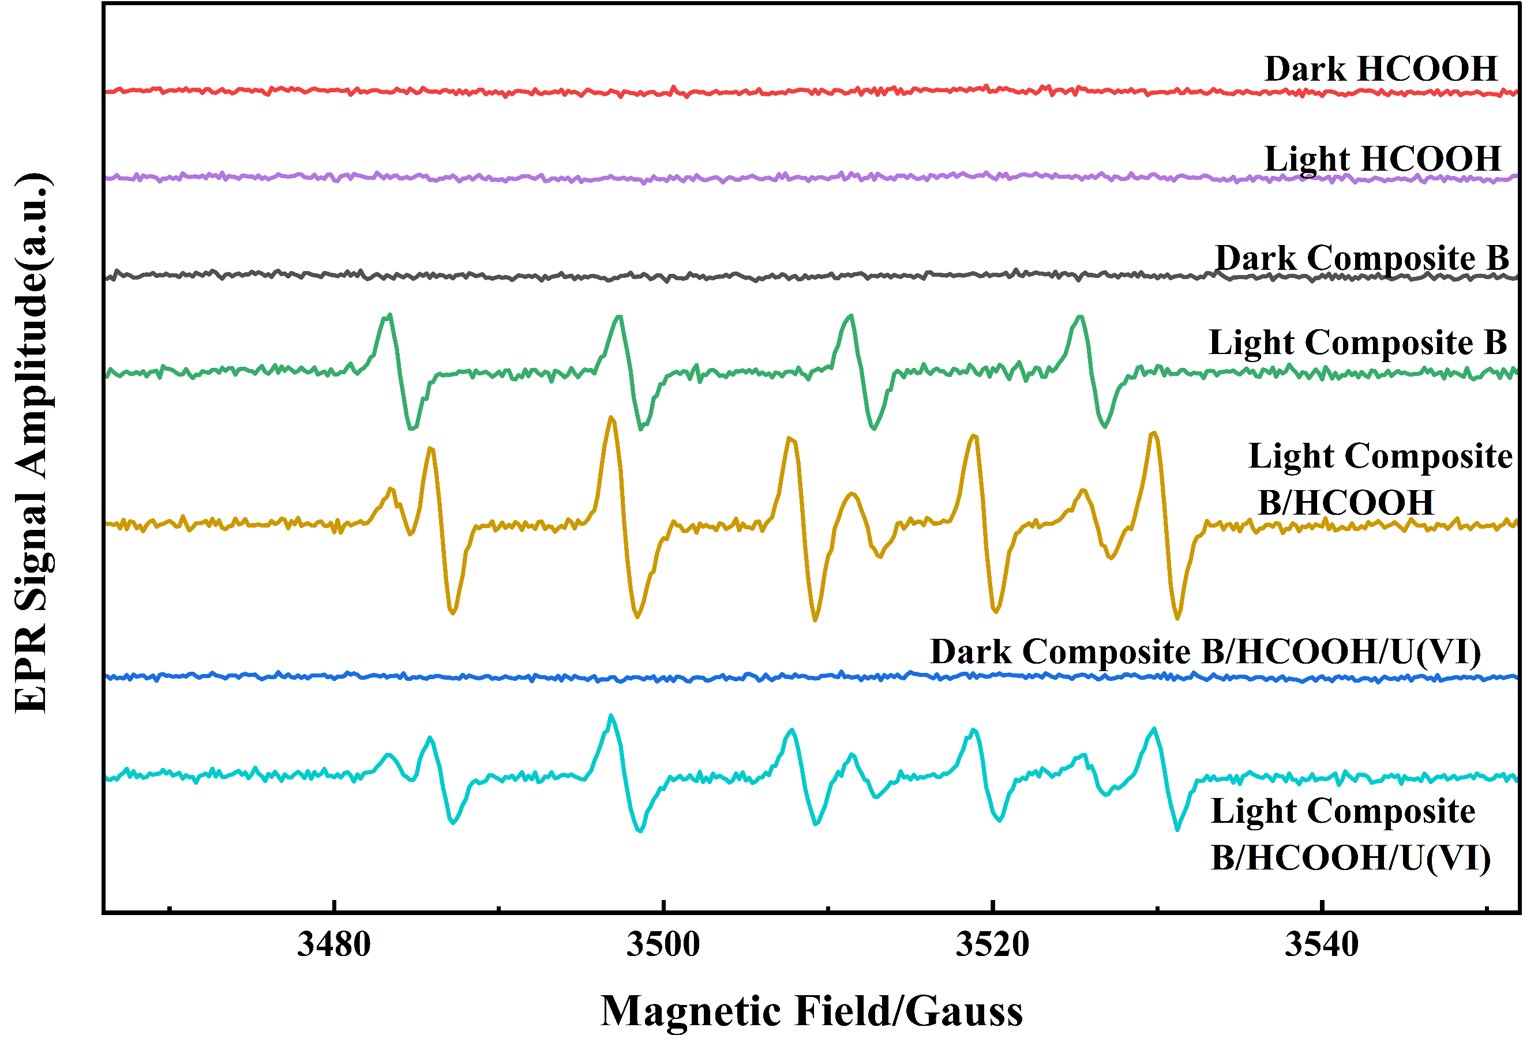
Figure S8. First-derivative EPR spectra of DMPO spin adducts

Table S1 Experimental conditions of the photocatalytic reduction of U(Ⅵ) using composite (B)
Experiment Conditions | Organic additives dosages (%) | U(Ⅵ) concentrations  (g/L) | Catalyst dosage (mg) | pH | Reduction efficiency % | K (min⁻¹) | R² | SSE
HCOOH | 1 | 20 | - | 5 | 3.5 | 4.64x10⁻⁴ | 0.71 | -
Composite (B) /HCOOH (dark) | 1 | 20 | 75 | 5 | 12 | 6.99x10⁻⁴ | 0.87 | -
Composite (B) /HCOOH (light on/air) | 1 | 10 | 75 | 5 | 92.9 | 0.0446 | 0.99 | 0.0558
Composite (B) /HCOOH (light on/N₂) | 1 | 20 | 75 | 5 | 95.1 | 0.051 | 0.981 | 0.144
Effect of HCOOH | 0 | 20 | 75 | 5 | 15 | 9.87x10⁻⁴ | 0.689 | -
Effect of HCOOH | 0.1 | 20 | 75 | 5 | 19 | 1.7x10⁻³ | 0.915 | -
Effect of HCOOH | 0.5 | 20 | 75 | 5 | 50 | 9.56x10⁻³ | 0.963 | 0.01
Effect of HCOOH | 1 | 20 | 75 | 5 | 95.1 | 0.051 | 0.981 | 0.144
 | 2 | 20 | 75 | 5 | 79 | 0.0257 | 0.98 | 0.022
Effect of CH₃OH | 1 | 20 | 75 | 5 | 34.9 | 5.41x10⁻³ | 0.917 | -
Effect of CH₃CH₂OH | 1 | 20 | 75 | 5 | 27.8 | 3.74x10⁻³ | 0.88 | -
Effect of HCOOH | 1 | 20 | 75 | 5 | 95.1 | 0.051 | 0.981 | 0.144
Effect of pH | 1 | 20 | 75 | 3 | 57 | 0.0119 | 0.918 | 0.035
Effect of pH | 1 | 20 | 75 | 4 | 81 | 0.0283 | 0.957 | 0.100
Effect of pH | 1 | 20 | 75 | 5 | 95.1 | 0.051 | 0.981 | 0.144
Effect of pH | 1 | 20 | 75 | 6 | 75 | 0.020 | 0.913 | 0.106
 | 1 | 20 | 75 | 7 | 51 | 0.010 | 0.978 | -
 | 1 | 20 | 75 | 8 | 31 | 4.83x10⁻³ | 0.971 | -
Composite B dosage | 1 | 20 | 25 | 5 | 57 | 0.012 | 0.919 | 0.030
Composite B dosage | 1 | 20 | 50 | 5 | 82 | 0.0281 | 0.995 | 0.010
Composite B dosage | 1 | 20 | 75 | 5 | 95.1 | 0.051 | 0.981 | 0.144
Effect of U(Ⅵ) initial concentration | 1 | 20 | 75 | 5 | 95.1 | 0.051 | 0.981 | 0.144
Effect of U(Ⅵ) initial concentration | 1 | 30 | 75 | 5 | 62.45 | 0.016 | 0.972 | 0.021
Effect of U(Ⅵ) initial concentration | 1 | 40 | 75 | 5 | 38 | 6.14x10⁻³ | 0.993 | -

Table S2 ion Leaching percentage of composite (B) after photocatalytic reduction experiment
Metal Ion | Dissolved concentration (mg/L) | Total leached mass in 100 ml (mg) | Metal leaching %
Fe | 1.61 | 0.161 | 1.0
Zn | 2.33 | 0.233 | 3.1
Ce | 0.34 | 0.034 | 0.9

References
[1] F. Chen, K. Bian, H. Li, and Y. Tang, “A novel CeO 2 / MIL101 ( Fe ) heterojunction for enhanced photocatalytic degradation of tetracycline under visible-light irradiation,” no. February, 2022, doi: 10.1002/jctb.7061.
[2] W. Ao, J. Li, H. Yang, X. Zeng, and X. Ma, “Mechanochemical synthesis of zinc oxide nanocrystalline,” Powder Technol., vol. 168, no. 3, pp. 148–151, 2006.

