Section A: Experimental procedure and tasks demonstration: Video
(https://drive.google.com/file/d/1rZfSks89uRx19oxzXjvEDxlvhJEoRB8E/view?usp=sharing)
The video demonstrates the experimental setup and task conditions: standing baseline, standing VR-CTT A and B, walking baseline, walking VR-CTT A and B.
Section B: Calculation of selected reaching features
Figure S1 illustrates the calculation and interpretation of selected kinematic measures used to characterize goal-directed reaching. Time to peak velocity was used to characterize the duration of the early reaching phase preceding maximal hand speed. Pre-peak alignment quantified how consistently hand motion was directed toward the target during this early phase. Movement smoothness was quantified using SPARC, which describes the spectral arc length of the normalized frequency representation of the hand-speed profile, with higher values reflecting smoother movement.
Figure S1. Schematic illustration of selected upper-limb kinematic features. (A) Representative inter-hit segment of one participant performing VR-CTT A, showing hand velocity (left axis) and the distance to the target (right axis). Peak velocity was identified as the maximal hand speed from which the hand-to-target distance decreased continuously, and time to peak velocity was defined as the interval from the beginning of the segment, expressed as a percentage of the total interval. (B) The spectral arc length (SPARC) calculation included a transformation of the hand speed profile to the frequency domain using a fast Fourier transform (FFT), extracting the arc length of the normalized magnitude spectrum. Smooth movements produce a less irregular spectral profile and higher SPARC values, whereas jerky movements produce a longer, more irregular spectral arc and lower SPARC values. (C) Pre-peak alignment was quantified as the directional correspondence between the instantaneous hand-movement vector and the direction from the hand toward the target during the pre-peak interval. A greater proportion of target-directed movement indicates better directional alignment during the early reaching phase.
Section C: Toe-off events detection from toe marker data-validation vs. force plate data
We conducted a validation procedure to assess the temporal accuracy of toe-off (TO) detection based on toe marker positional data against kinetic force plate (FP) data. Kinematically, TO was defined as the time of local minimum in the vertical position signal of the toe marker. For the FP data, which served as our gold-standard reference, TO was identified at the moment the vertical component of the ground reaction force dropped below a 20 N threshold (Fig S2).
Adopting the validation protocol of Bondi et al (1), we calculated the timing offsets between the two systems across all gait cycles using timing true error (TE; kinematic time minus force plate time) and absolute error (AE=|TE|). Across 5 participants with a total of 444 strides from the baseline task, the grand average mean value of TE was -31.38 ± 54 msec (indicating that kinematic identification slightly precedes the force plates), and the grand mean AE was 35.75 ± 51 msec. These low error values demonstrate that utilizing the kinematic method provides reliable approximation of true toe-off timing during walking, consistent with the kinematic validation parameters previously established for heel strikes.
Fig S2. Temporal alignment of kinematic and kinetic TO detection methods. Synchronized 10-second data window of one participant performing the walking baseline. The left y-axis (black) shows the vertical trajectory of the left toe marker (m), with overlaid kinematic TO events (black circles). The right y-axis (red) shows the vertical ground reaction force (N), with kinetic TO events (red crosses).

Section D: Statistical properties and model designs for study metrics
Table S1
Statistical properties and model designs for study metrics
Metric | Hypothesis / LMM Design | Transformation | N (Obs.) | N (Subj.) | Shapiro-Wilk (p) | Skewness | Kurtosis
Completion time (s) | 2x2 Task performance | log | 114 | 29 | 0.128 | 0.12 | 0.86
Hit rate variability (%) | 2x2 Task performance | log | 114 | 29 | 0.008 | 0.53 | 0.53
Path efficiency (ratio) | 2x2 reaching movements | NA | 114 | 29 | 0.567 | 0.19 | -0.36
Time to peak velocity (s) | 2x2 reaching movements | NA | 114 | 29 | 0.511 | 0.13 | 0.23
Spatial coherence (r) | 2x2 reaching movements | Reflected log | 114 | 29 | 0.077 | 0.45 | 0.24
Temporal delay (s) | 2x2 reaching movements | Shifted log | 114 | 29 | 4.358e-04 | 0.80 | 2.35
Pre-Peak Alignment (s) | 2x2 reaching movements | NA | 114 | 29 | 0.510 | 0.31 | 0.38
SPARC | 2x2 reaching movements | Reflected log | 114 | 29 | 0.086 | 0.24 | 1.43
Mean sway velocity (m/s) | One-Way Posture | log | 86 | 29 | 0.023 | 0.56 | -0.02
Walking Speed (m/s) | One-Way locomotion | NA | 84 | 28 | 0.049 | 0.16 | 1.24
Walking Speed variability (%) | One-Way locomotion | log | 84 | 28 | 0.661 | 0.03 | -0.33
Stride-to-stride time variability (%) | One-Way locomotion | log | 84 | 28 | 0.063 | 0.58 | 0.97
Step width (m) | One-Way locomotion | NA | 84 | 28 | 0.188 | 0.22 | -0.44
Step length (m) | One-Way locomotion | NA | 84 | 28 | 0.008 | -0.25 | 2.44
PCI (%) | One-Way locomotion | log | 84 | 28 | 0.337 | 0.42 | 0.75
Temporal asymmetry (%) | One-Way locomotion | log | 84 | 28 | 0.109 | 0.33 | 1.19
Note. SPARC is the spectral arc length, and PCI is the phase shift coordination

Section E: Within-participant interference profile analysis
To explore whether cognitive interference was expressed consistently across motor domains, selected cognitive DTEs were standardized and ranked within each participant separately for standing and walking VR-CTT tasks. Five outcomes were included in each condition: completion time, time to peak velocity, path efficiency, temporal delay, and either sway mean velocity during standing or stride CV during walking. Within each participant, ranks ranged from 1 to 5, with rank 5 indicating the feature showing the greatest relative deterioration. Participants were then grouped according to their highest-ranked feature. The distribution of dominant features was heterogeneous, with no single outcome observed among most participants (Table S2).
The participant-level heatmap further illustrates that the relative ranking of interference varied across features and motor conditions (Fig. S3), supporting the presence of heterogeneous, domain-specific interference profiles.
Table S2. Dominant Selected-Feature Profiles by Motor Condition
Feature | Standing, n (%) | Walking, n (%)
Completion time cost | 5 (17.9%) | 3 (10.7%)
Time to peak velocity | 7 (25.0%) | 6 (21.4%)
Path efficiency | 3 (10.7%) | 7 (25.0%)
Temporal delay | 8 (28.6%) | 5 (17.9%)
Sway mean velocity | 5 (17.9%) | —
Stride CV | — | 7 (25.0%)
Total | 28 (100.0%) | 28 (100.0%)
Note. Values represent the number and percentage of participants for whom each standardized feature-level cognitive DTE was the highest within the corresponding motor condition. Higher scores indicate greater deterioration.
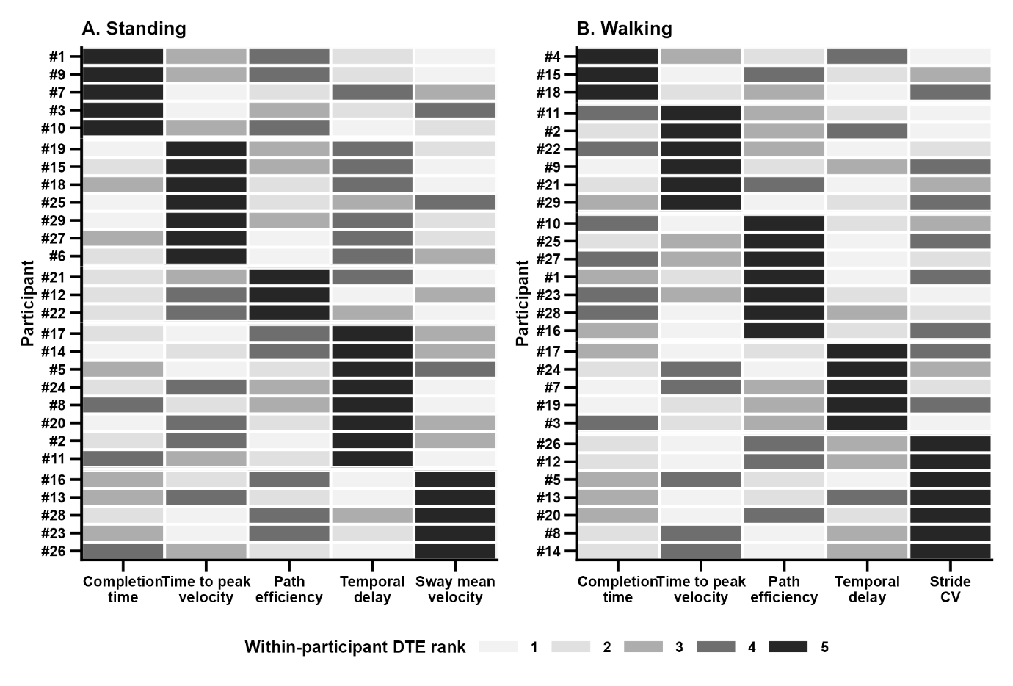
Figure S3. Participant-level cognitive dual-task effect rankings across selected motor features. Heatmaps display the within-participant ranking of cognitive DTEs during (A) standing and (B) walking. Data from each participant is depicted in one row. Columns represent completion time, time to peak velocity, path efficiency, temporal delay, and either sway mean velocity for standing or stride CV for the walking condition. For each participant, the five outcomes were ranked from 1 to 5, with darker shading and higher ranks indicating greater relative deterioration. Participants are ordered according to the feature receiving their highest rank.

