Table S1. RsfMRI results displaying clusters with a significant increase in AIC-seeded rsFC following dACC stimulation.
dACC group (n = 23) |  | Paired t test (post > pre) (P_{FWE-corr} < 0.05)
 | Cluster No. | Brain regions | T (P value) | k | Peak MNI coordinates,  x y z | AAL for the peak MNI
rAIC-seeded | Cluster 1 | Bilateral precuneus;  Right superior parietal gyrus | 4.50 (P_{FWE-corr} = 0.001; P_{FDR-corr} = 0.015) | 128 | 12 -60 54 | Precuneus_R
rAIC-seeded | Cluster 2 | Right lingual gyrus;  Right precuneus;  Right calcarine | 5.50 (P_{FWE-corr} = 0.005; P_{FDR-corr} = 0.025) | 102 | 12 -57 6 | Lingual_R
rAIC-seeded | Cluster 3 | Right fusiform;  Right parahippocampal gyrus | 4.44 (P_{FWE-corr} = 0.030; P_{FDR-corr} = 0.102) | 67 | 30 -48 -15 | Fusiform_R
rAIC-seeded | Cluster 4 | Bilateral middle and posterior cingulate cortex;  Right supplementary motor area;  Right paracentral lobule | 4.68 (P_{FWE-corr} = 0.045; P_{FDR-corr} = 0.109) | 60 | 18 -27 48 | Cingulum_Mid_R
lAIC-seeded | Cluster 1 | Right middle occipital gyrus;  Right superior occipital gyrus;  Right cuneus;  Right calcarine | 5.55 (P_{FWE-corr} = 0.001; P_{FDR-corr} = 0.005) | 144 | 30 -81 33 | Occipital_Mid_R
lAIC-seeded | Cluster 2 | Right superior parietal gyrus;  Right precuneus | 4.97 (P_{FWE-corr} = 0.007; P_{FDR-corr} = 0.024) | 96 | 15 -60 54 | Parietal_Sup_R
lAIC-seeded | Cluster 3 | Right lingual gyrus;  Right calcarine | 5.61 (P_{FWE-corr} = 0.014; P_{FDR-corr} = 0.032) | 82 | 15 -60 6 | Lingual_R
RsfMRI: resting-state functional magnetic resonance imaging; AIC: anterior insular cortex; rsFC: resting-state functional connectivity; dACC: dorsal anterior cingulate cortex.

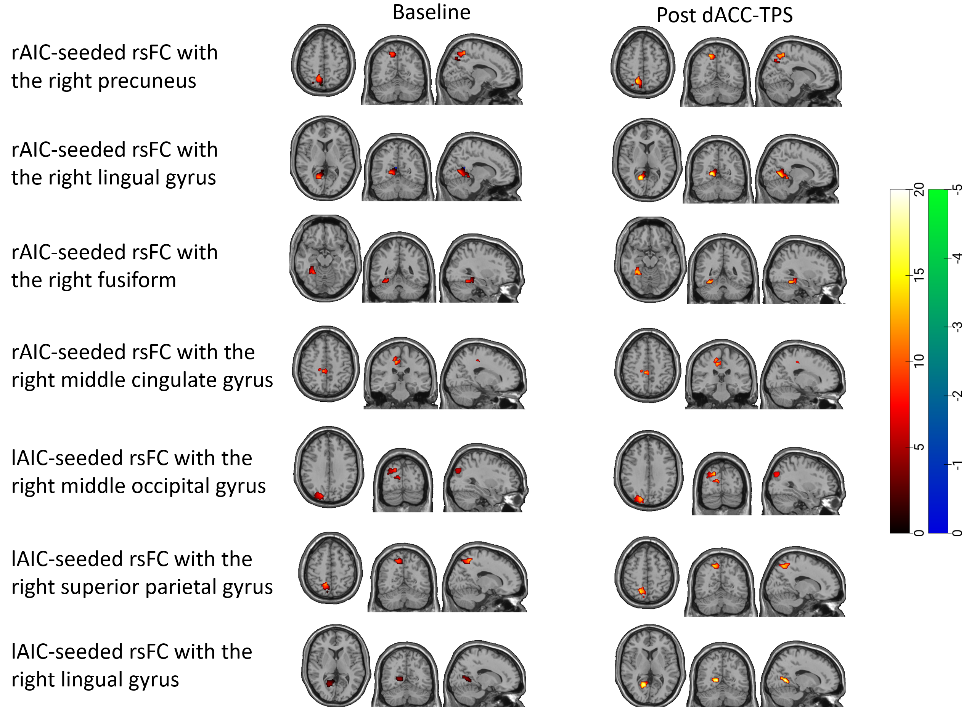
Figure S1. Increases in the AIC-seeded rsFC following dACC stimulation. Upper panel (rAIC-seeded cluster 1 with a cluster size of 128, T = 4.50, cluster-level false discovery rate [FDR]-corrected P = 0.015, peak MNI coordinates: x = 12, y = -60, y = 54): the bilateral precuneus, right superior parietal gyrus; the second panel (rAIC-seeded cluster 2 with a cluster size of 102, T = 5.50, cluster-level FDR-corrected P = 0.025, peak MNI coordinates: x = 12, y = -57, y = 6): the right lingual gyrus, precuneus, and calcarine; the third panel (rAIC-seeded cluster 3 with a cluster size of 67, T = 4.44, cluster-level familywise error rate [FWE]-corrected P = 0.030, peak MNI coordinates: x = 30, y = -48, y = -15): the right fusiform and parahippocampal gyrus; the fourth panel (rAIC-seeded cluster 4 with a cluster size of 60, T = 4.68, cluster-level FWE-corrected P = 0.045, peak MNI coordinates: x = 18, y = -27, y = 48): the bilateral middle cingulate gyrus, right supplementary motor area and paracentral lobule gyrus; the fifth panel (lAIC-seeded cluster 1 with a cluster size of 144, T = 5.55, cluster-level FDR-corrected P = 0.005, peak MNI coordinates: x = 30, y = -81, y = 33): the right superior and middle occipital gyrus, cuneus, and calcarine; the sixth panel (lAIC-seeded cluster 2 with a cluster size of 96, T = 4.97, cluster-level FDR-corrected P = 0.024, peak MNI coordinates: x = 15, y = -60, y = 54): the right superior parietal gyrus and precuneus; lower panel (lAIC-seeded cluster 3 with a cluster size of 82, T = 5.61, cluster-level FDR-corrected P = 0.032, peak MNI coordinates: x = 15, y = -60, y = 6): the right lingual gyrus and calcarine.
Table S2. Correlation analysis between the dACC-seeded rsFC changes with significant changes from baseline and BART performance (average number of pumps and number of exploded balloons)
dACC group (n = 23) |  |  | Pearson’s correlation (correlation coefficient; uncorrected p-value)
 | Cluster No. | Clusters with a significant enhancement from baseline | Correlation between the changed rsFC (pre vs. post) and the changed average number of pumps (pre vs. post) |  | Correlation between the changed rsFC (pre vs. post) and the changed number of exploded balloons (pre vs. post)
rdACC-seeded | Cluster 1 | Bilateral precuneus;  Bilateral cuneus;  Bilateral superior parietal cortex;  Bilateral superior occipital cortex;  Right angular cortex | r = -0.293 | p = 0.186 | r = -0.056 | p = 0.804
ldACC-seeded | Cluster 1 | Bilateral precuneus;  Bilateral cuneus;  Bilateral superior parietal cortex;  Bilateral superior occipital cortex;  Right angular cortex | r = -0.195 | p = 0.385 | r = -0.048 | p = 0.832
ldACC-seeded | Cluster 2 | Right dorsolateral prefrontal cortex | r = -0.142 | p = 0.528 | r = 0.032 | p = 0.889
rAIC-seeded | Cluster 1 | Bilateral precuneus;  Right superior parietal cortex | r = -0.349 | p = 0.112 | r = 0.130; | p = 0.565
rAIC-seeded | Cluster 2 | Right lingual cortex;  Right precuneus;  Right calcarine | r = -0.380 | p = 0.081 | r = -0.010 | p = 0.966
rAIC-seeded | Cluster 3 | Right fusiform;  Right paraHippocampal cortex | r = -0.055 | p = 0.809 | r = 0.153 | p = 0.496
rAIC-seeded | Cluster 4 | Bilateral middle cingulate cortex;  Right supplementary motor area;  Right paracentral lobule | r = -0.379 | p = 0.082 | r = 0.063 | p = 0.779
lAIC-seeded | Cluster 1 | Right middle occipitall cortex;  Right superior occipital cortex;  Right cuneus;  Right calcarine | r = -0.151 | p = 0.502 | r = -0.026 | p = 0.908
lAIC-seeded | Cluster 2 | Right superior parietal cortex;  Right precueus | r = -0.198 | p = 0.378 | r = 0.233 | p = 0.318
lAIC-seeded | Cluster 3 | Right lingual cortex;  Right calcarine | r = -0.241 | p = 0.279 | r = 0.200 | p = 0.372
dACC: dorsal anterior cingulate cortex; BART: balloon analog risk task; rdACC: right dorsal anterior cingulate cortex; ldACC: left dorsal anterior cingulate cortex; rAIC: right anterior insular cortex; lAIC: left anterior insular cortex; rsFC: resting-state functional connectivity.

Table S3. Correlation analysis between the AIC-seeded rsFC changes with significant changes from baseline and BART (adjusted average number of pumps)
AIC group (n = 21) |  |  | Pearson’s correlation (correlation coefficient; uncorrected p-value)
 | Cluster No. | Clusters with a significant enhancement from baseline | Correlation between the changed rsFC (pre vs. post) and the changed adjusted average number of pumps (pre vs. post)
rAIC-seeded | Cluster 1 | Left caudate;  Left putamen | r = 0.435 | p = 0.049
rAIC-seeded | Cluster 2 | Right putamen | r = 0.203 | p = 0.378
lAIC-seeded | Cluster 1 | Right putamen;  Right pallidum;  Right caudate | r = 0.328 | p = 0.147
lAIC-seeded | Cluster 2 | Right supramarginal cortex;  Right superior temporal cortex | r = -0.037 | p = 0.872
AIC: anterior insular cortex; BART: balloon analog risk task; rAIC: right anterior insular cortex; lAIC: left anterior insular cortex; rsFC: resting-state functional connectivity.

