Additional file 1. Supplementary methods and results for “Perceived passenger invisibility, psychological distress, and interactional intentions among ride-hailing drivers in China: evidence from two surveys and a vignette-based study”
A. Full descriptive statistics and correlations
Tables S1-S3 provide the full matrices, including demographic variables. Table 1 in the main manuscript presents the focal-variable subsets.
Table S1. Descriptive statistics and correlations, Study 1 (N = 272)
Variable | M | SD | 1 | 2 | 3 | 4 | 5
1. Perceived passenger invisibility | 2.42 | 1.00 | —
2. Psychological distress | 1.99 | 0.67 | .46*** | —
3. Gender | — | — | −.08 | −.16** | —
4. Age | 34.36 | 8.52 | .08 | −.06 | −.12 | —
5. Monthly income | 4.94 | 1.20 | −.23*** | −.12 | −.14* | .03 | —
Note. Gender: 1 = male, 2 = female. *p < .05, **p < .01, ***p < .001.
Table S2. Descriptive statistics and correlations, Study 2 (N = 338)
Variable | M | SD | 1 | 2 | 3 | 4 | 5 | 6
1. Perceived passenger invisibility | 2.56 | 0.71 | —
2. Need threat | 2.26 | 0.62 | .39*** | —
3. Psychological distress | 2.12 | 0.66 | .48*** | .62*** | —
4. Gender | — | — | .02 | .12* | .15** | —
5. Age | 31.68 | 7.40 | −.09 | −.08 | −.09 | −.02 | —
6. Monthly income | 4.23 | 1.63 | −.04 | −.10 | −.06 | −.06 | .20*** | —
Note. Gender: 1 = male, 2 = female. *p < .05, **p < .01, ***p < .001.
Table S3. Descriptive statistics and correlations, Study 3 (N = 328)
Variable | M | SD | 1 | 2 | 3 | 4 | 5 | 6 | 7 | 8 | 9 | 10 | 11
1. Perceived passenger invisibility | 5.94 | 0.82 | —
2. Belonging threat | 3.85 | 0.92 | .37*** | —
3. Self-esteem threat | 3.47 | 0.82 | .19*** | .21*** | —
4. Meaningful-existence threat | 3.61 | 0.89 | .34*** | .51*** | .30*** | —
5. Control threat | 3.78 | 0.82 | .19*** | .23*** | .68*** | .39*** | —
6. Confrontation | 2.97 | 0.83 | .22*** | .13* | −.09 | .07 | −.14* | —
7. Endurance | 3.27 | 0.95 | −.15** | .02 | −.13* | −.03 | −.16** | −.44*** | —
8. Constructive communication | 4.16 | 0.78 | .07 | −.03 | −.12* | −.05 | −.08 | .07 | −.06 | —
9. Gender | — | — | −.10 | −.10 | .02 | −.02 | .03 | −.14* | .13* | .05 | —
10. Age | 31.68 | 7.77 | −.16** | −.08 | −.004 | −.03 | .02 | −.11 | .06 | −.07 | .13* | —
11. Monthly income | 4.37 | 1.58 | −.02 | .01 | .03 | .01 | .04 | −.11* | −.09 | −.07 | −.10 | .22*** | —
Note. Perceived passenger invisibility was rated on a 7-point scale; other variables on 5-point scales. Gender: 1 = male, 2 = female. *p < .05, **p < .01, ***p < .001.

Study 3 note. Each participant rated all three vignettes. Ratings were averaged across vignettes to form participant-level scores, and the participant (N = 328) was the unit of analysis.
B. Indirect-effect decompositions
Table S4. Indirect-effect decomposition for perceived passenger invisibility, need threat, and psychological distress, Study 2 (N = 338)
Effect | Estimate | Boot SE | 95% CI lower | 95% CI upper | Proportion
Total effect | .45 | .04 | .36 | .53
Direct effect | .27 | .04 | .19 | .35 | 60.0%
Indirect effect | .18 | .03 | .12 | .24 | 40.0%
Note. Covariate: gender. Bootstrap samples = 5,000.
Table S5. Indirect-effect decomposition for perceived passenger invisibility, control threat, and confrontation, Study 3 (N = 328)
Effect | Estimate | Boot SE | 95% CI lower | 95% CI upper
Total effect (c) | .20 | .06 | .09 | .31
Direct effect (c′) | .23 | .06 | .12 | .34
Indirect effect (ab) | −.04 | .02 | −.07 | −.01
Note. Covariates: gender, age, and monthly income. Because the direct and indirect effects have opposite signs, control threat acts as a suppressor rather than as a mediator (|ab/c′| = 15.1%). Bootstrap samples = 5,000.
Table S6. Indirect-effect decomposition for perceived passenger invisibility, control threat, and endurance, Study 3 (N = 328)
Effect | Estimate | Boot SE | 95% CI lower | 95% CI upper
Total effect (c) | −.15 | .06 | −.28 | −.02
Direct effect (c′) | −.12 | .07 | −.24 | .01
Indirect effect (ab) | −.03 | .02 | −.07 | −.01
Note. Covariates: gender and age. The indirect effect was significant whereas the direct effect was not, a pattern consistent with full mediation. Because the design is cross-sectional, the model does not establish a causal or temporal sequence. Bootstrap samples = 5,000.
C. Measurement instruments
All measures were administered in Chinese; English wording is provided here. The K10 was administered using the published Chinese version cited in the main manuscript. The need-threat items were adapted from Ren et al. (2016). The original Chinese-language materials are available from the authors for translation verification.
C.1 Perceived Passenger Invisibility Scale (Study 1; 3 items)
Response scale: 1 = never, 5 = always. Instruction: please indicate how often each situation has occurred in your work over the past month.
1. Passengers often ignore me.
2. Passengers often look right through me, as if I were invisible.
3. Passengers rarely notice me, to the point of forgetting that I am there.
C.2 Kessler Psychological Distress Scale (K10; Studies 1 and 2; 10 items)
Response scale: 1 = none of the time, 5 = all of the time. Instruction: during the past 30 days, about how often did you feel …
1. … tired out for no good reason?
2. … nervous?
3. … so nervous that nothing could calm you down?
4. … hopeless?
5. … restless or fidgety?
6. … so restless you could not sit still?
7. … depressed?
8. … that everything was an effort?
9. … so sad that nothing could cheer you up?
10. … worthless?
C.3 Perceived Passenger Invisibility Questionnaire (Study 2; 8 items)
Response scale: 1 = never, 5 = always. Instruction: please indicate how often each situation has occurred in your work over the past month.
1. Passengers are cold or indifferent in attitude during the ride.
2. Passengers ignore my reminders or show impatience.
3. Passengers show a disrespectful attitude toward me or my occupation.
4. Passengers do not take care of the in-car environment (e.g. eating or smoking).
5. Passengers arbitrarily change the drop-off point or the route.
6. When boarding, passengers do not proactively confirm the last digits of their phone number, or keep me waiting for a long time.
7. When I remind passengers to fasten their seatbelt or to be careful when getting out, they ignore me.
8. Passengers do not express any thanks for the services I provide (e.g. helping with luggage).
C.4 Fundamental psychological need-threat scale (Study 2; 12 items; adapted from Ren et al., 2016)
Response scale: 1 = strongly disagree, 5 = strongly agree. Higher total scores indicate greater need threat; items marked (R) are reverse-scored. Dimensions are shown for reference and were not labelled for participants.
Belonging
– I feel isolated.
– I feel rejected.
– I feel like an outsider.
Self-esteem
– I feel good about myself. (R)
– I have a high level of self-esteem. (R)
– I feel likeable. (R)
Meaningful existence
– I feel unnoticeable.
– I feel that my existence is meaningless.
– I feel that I have no sense of presence.
Control
– I feel powerful. (R)
– I feel in control of the interaction. (R)
– I feel outstanding. (R)
C.5 Study 3 vignette materials (three scenarios rated by each participant)
For each vignette, participants imagined themselves as the driver and then completed an attention-check item, a perceived-invisibility item (1 = not at all, 7 = strongly), four need-threat items (1 = strongly disagree, 5 = strongly agree; belonging and meaning positively scored, self-esteem and control reverse-scored), and three behavioral-response items (1 = strongly disagree, 5 = strongly agree). The need-threat items in each scenario were: “If you were this driver, would you feel that you were like an outsider? / that you were likeable? (R) / that you were unnoticeable? / that you were outstanding? (R)”.
Vignette 1 (in-car environment)
Mr Li is a ride-hailing driver who has driven for three years and takes great care of his car, cleaning it thoroughly every day. One evening he receives an order; when he arrives at the pick-up point, two young passengers come out of a KTV, one holding a half-finished cup of bubble tea. After getting in, the passenger laughs loudly with a friend while shaking the cup. Through the rear-view mirror, Mr Li sees some tea spill onto the back seat. Just as he is about to say something, the passenger casually wipes it with a hand and keeps chatting.
Attention check: How did the passenger react after the tea spilled? (a) apologized and cleaned it immediately; (b) wiped it with a hand and kept chatting; (c) did not notice.
Behavioural responses — Confrontation: “Stop the car and ask the passenger to pay a cleaning fee.” Endurance: “To avoid trouble, silently put up with it and clean up yourself after the passenger leaves.” Constructive communication: “Tactfully remind the passenger not to drink in the car, or hand over a tissue/wet wipe.”
Vignette 2 (disrespect toward the occupation)
Lao Zhang is an experienced ride-hailing driver; the morning and evening rush hours are his busiest times. On a winter morning he receives an order to the city centre. The passenger, a smartly dressed young man, seems agitated as soon as he gets in, repeatedly checking his watch with an impatient look, and begins a loud, hurried phone call about work. Lao Zhang notices that the passenger repeatedly mentions “ride-hailing” with a hint of contempt—saying things like “No choice, I had to take a ride-hail” and “This lousy ride-hail is so slow.” Although the passenger does not address these remarks to Lao Zhang directly, they reach his ears clearly.
Attention check: What was the passenger’s attitude toward “ride-hailing” on the phone? (a) grateful; (b) contemptuous; (c) indifferent.
Behavioural responses — Confrontation: “At an appropriate moment, respond in a firm tone to express dissatisfaction with such disrespectful remarks.” Endurance: “Stay silent and keep driving, trying to ignore the passenger’s remarks.” Constructive communication: “After arriving, talk with the passenger in a calm tone, hoping they will show more understanding and respect for the ride-hailing profession.”
Vignette 3 (ignored safety reminder)
A Qiang is a young ride-hailing driver who likes to earn money by driving at night. On a weekend night he picks up an intoxicated passenger who sways and slurs his speech. For safety, A Qiang reminds the passenger to fasten the seatbelt, but the passenger impatiently waves a hand and does nothing. A Qiang repeats the reminder several times; the passenger remains unresponsive and even closes his eyes, ignoring A Qiang altogether.
Attention check: How did the passenger respond to A Qiang’s reminder? (a) fastened the seatbelt immediately; (b) waved a hand to indicate it was unnecessary; (c) argued angrily.
Behavioural responses — Confrontation: “Insist that the passenger fasten the seatbelt, and refuse the ride if the passenger still refuses.” Endurance: “Worried that a conflict with a drunk passenger could cause trouble, reluctantly keep driving while feeling uneasy.” Constructive communication: “Patiently communicate with the passenger while slowing down to reduce the safety risk.”
D. Indirect-effect diagrams
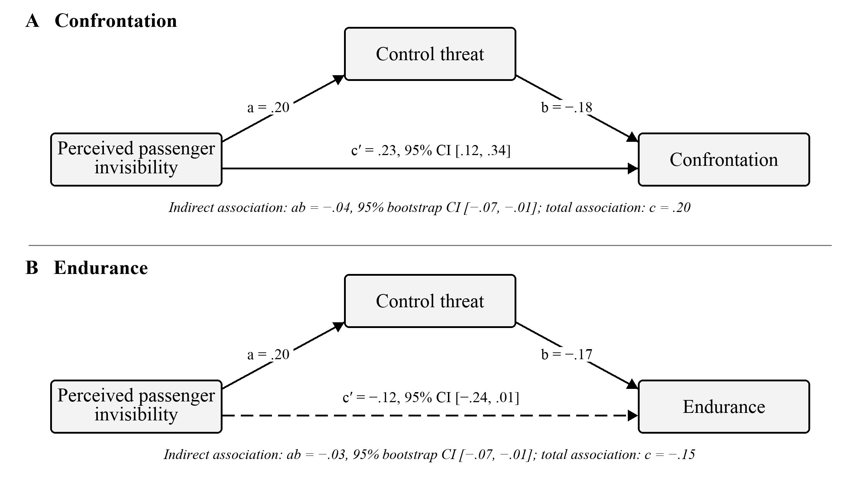
Figure S1. Person-level indirect-effect models through control threat (Study 3). Note. Panel A concerns confrontation; Panel B concerns endurance. Values are unstandardized coefficients. The dashed direct path in Panel B indicates that its 95% CI included zero. Indirect effects were estimated with 5,000 bootstrap samples. Covariates were gender, age, and monthly income in Panel A and gender and age in Panel B; covariates are not shown. Perceived passenger invisibility and control threat were rated after the same vignettes and averaged across scenarios.

