Supplementary data
Degaga TS, et al, Impact of enhanced malaria surveillance processes and data feedback on data comprehensiveness and malaria case management in Arba Minch Zuriya District, Ethiopia: a pre-post implementation study

Table of Contents
Table S1: Ethiopian guidelines for primaquine phosphate dose: 0.25 mg base per kg daily schedule for 14 days for P. vivax malaria 2
Table S2: Ethiopian guidelines for primaquine phosphate dose: 0.25 mg base per kg (single dose primaquine for P. falciparum malaria) 3
Table S3: Ethiopian guidelines on chloroquine dosing for P. vivax malaria 4
Table S4: Ethiopian guidelines for artemether (20 mg) - lumefantrine (120 mg) dosing for patients with P. falciparum or mixed species malaria 5
Table S5: Microscopy slide positivity rate by health centre 6
Table S6: Baseline demographic characteristics by centre (excludes patients with missing Plasmodium species) 7
Table S7: Distribution of malaria species by centre and study period 9
Table S8: Primaquine inadvertent treatment in primaquine ineligible patients 10
Table S9: Prescription accuracy by centre, age group, and sex 11
Table S10: Risk of recurrent malaria during the study period 13
Figure S1: Malaria cases per month by Plasmodium species, centre and study period 14

Table S1: Ethiopian guideline for primaquine phosphate dose: 0.25 mg base per kg daily schedule for 14 days for P. vivax malaria

NB: The weight bands were operationally defined based on the dosing categories specified in the national guideline. Where the guideline did not explicitly define the boundary between adjacent weight bands, patients with weights exceeding the upper limit of a band were classified into the next weight band (i.e., 8–18, 18.1–24, 24.1–35, 35.1–50, and ≥50.1 kg).

Weight (kg) | Number of primaquine tablets per day for 14 days
Weight (kg) | 7.5 mg tablet | 15 mg tablet
8 -18 | ½ tablet | -
19 – 24 | ¾ tablet | -
25 – 35 | 1 tablet | ½ tablet
36 – 50 | 1 ½ tablet | 1 tablet
50+ | 2 tablets | 1.5 tablet

Table S2: Ethiopian guideline for primaquine phosphate dose: 0.25 mg base per kg (single dose primaquine for P. falciparum malaria)

NB: The weight bands were operationally defined based on the dosing categories specified in the national guideline. Where the guideline did not explicitly define the boundary between adjacent weight bands, patients with weights exceeding the upper limit of a band were classified into the next weight band (i.e., 8–18, 18.1–24, 24.1–35, 35.1–50, and ≥50.1 kg).

Weight (kg) | 7.5 mg tablet
8-18 | ½ tab
19 – 24 | ¾
25 – 35 | 1
36 – 50 | 1 ½
50+ | 2

Table S3: Ethiopian guideline for chloroquine dosing for P. vivax malaria
NB: Chloroquine is available as 250mg tablets (which is equal to 150 mg base) or as syrup (50 mg base per 5 ml). The dose is 25 mg/kg which is given in divided doses over three days. The weight bands were operationally defined based on the dosing categories specified in the national guideline. Where the guideline did not explicitly define the boundary between adjacent weight bands, patients with weights exceeding the upper limit of a band were classified into the next weight band (i.e., 5–6, 6.1–10, 10.1–14, 14.1–18, 18.1–24, 24.1–35, 35.1–50 and ≥50.1 kg).

Weight (kg) | Day 1 | Day 2 | Day 3
5 – 6 | ½ tablet OR  5 ml syrup | ¼ tablet OR  5 ml syrup | ¼ tablet OR  2.5 ml syrup
7 – 10 | ½ tablet OR  7.5 ml syrup | ½ tablet OR  7.5 ml syrup | ½ tablet OR  5 ml syrup
11 – 14 | 1 tablet OR  12.5 ml syrup | 0.5 tablet OR  12.5 ml syrup | 0.5 tablet OR  7.5 ml syrup
15 – 18 | 1 tablet OR  15 ml syrup | 1 tablet OR  15 ml syrup | 1 tablet OR  15 ml syrup
19 – 24 | 1 ½ tablets OR  20 ml syrup | 1 ½ tablets OR  20 ml syrup | 1 tablet OR  15 ml syrup
25-35 | 2 ½ tablets | 2 tablets | 1 tablet
36-50 | 3 tablets | 2 tablets | 2 tablets
51+ | 4 tablets | 4 tablets | 2 tablets

Table S4: Ethiopian guideline for artemether (20 mg) - lumefantrine (120 mg) dosing for patients with P. falciparum or mixed species malaria
NB: The weight bands were operationally defined based on the dosing categories specified in the national guideline. Where the guideline did not explicitly define the boundary between adjacent weight bands, patients with weights exceeding the upper limit of a band were classified into the next weight band (i.e., <14, 14.1–24, 24.1–34, and >34.1 kg).
Weight (KG) | Day 1 |  | Day 2 |  | Day 3 |  | Total tablets | Color code
Weight (KG) | Immediate | After 8 hours | Morning | Evening | Morning | Evening | Total tablets
<14kg | 1 tablet | 1 tablet | 1 tablet | 1 tablet | 1 tablet | 1 tablet | 6 | Yellow*
15-24 kg | 2 tablets | 2 tablets | 2 tablets | 2 tablets | 2 tablets | 2 tablets | 12 | Blue*
25-34 kg | 3 tablets | 3 tablets | 3 tablets | 3 tablets | 3 tablets | 3 tablets | 18 | Brown
>35 | 4 tablets | 4 tablets | 4 tablets | 4 tablets | 4 tablets | 4 tablets | 24 | Green
* (Yellow, Blue) flavored pediatric formulation (dispersible tablets) of Artemether-Lumefantrine (AL) is available for enhancing its use in young children.

Table S5: Microscopy slide positivity rate by health centre

Centre | Total positive | Total examined | Slide positivity rate
Shelle Health Centre | 6,230 | 34,389 | 18.1
Lante Health Centre | 7,300 | 25,005 | 29.2
Total | 13,530 | 59,394 | 22.8

Table S6: Baseline demographic characteristics of malaria patients by centre (excludes patients with missing Plasmodium species)

Category | Shelle Health Centre  (N= 5,573) | Lante Health Centre  (N=6,572) | Total  (N =12,145)
Study period
Pre-CQI | 2,542 (45.6%) | 3,527 (53.7%) | 6,069 (50.0%)
Transition | 509 (9.1%) | 873 (13.3%) | 1,382 (11.4%)
First CQI | 931 (16.7%) | 683(10.4%) | 1,614 (13.3%)
Second CQI | 1,028 (18.5%) | 1,066 (16.2%) | 2,094 (17.2%)
Third CQI | 563 (10.1%) | 423 (6.4%) | 986 (8.1%)
Species, n (%)
P. falciparum | 2,284 (41.0%) | 3,136 (47.7%) | 5,420 (44.6%)
P. vivax | 3,266 (58.6%) | 3,300 (50.2%) | 6,566 (54.1%)
Mixed | 23 (0.4%) | 136 (2.1%) | 159 (1.3%)
Age
Median (IQR) | 13.0 (7.0-24.0) | 19.0 (12.0-26) | 17.0 (9.0-25.0)
Age groups, n (%)
<1 year | 112 (2.0%) | 1 (0.0%) | 113 (0.9%)
1–<5 year | 821 (14.7%) | 595 (9.1%) | 1,416 (11.7%)
5–<15 years | 1,966 (35.3%) | 1,498 (22.8%) | 3,464 (28.5%)
≥15 years | 2,475 (44.4%) | 4,459 (67.9%) | 6,934 (57.1%)
Unknown | 199 (3.6%) | 19 (0.3%) | 218 (1.8%)
Weight in kg by age group, mean (SD) ª
<1 year | 7.4 (2.2) | - | 7.4 (2.2)
1–<5 year | 12.2 (2.7) | 13.1 (3.6) | 12.5 (3.1)
5–<15 year | 28.2 (10.2) | 29.1 (10.7) | 28.5 (10.4)
>15 year | 57.3 (10.2) | 59.5 (10.3) | 58.6 (10.3)
Unknown | 41.1 (19.8) | 9.0 (3.7) | 38.4 (21.0)
Sex, n (%)
Male | 3,172 (56.9%) | 4,090 (62.2%) | 7,262 (59.8%)
Female | 2,303 (41.3%) | 2,478 (37.7%) | 4,781 (39.4%)
Missing | 98 (1.8%) | 4 (0.1%) | 102 (0.8%)
Pregnancy status, n (%) ª
No | 467 (74.5%) | 681 (85.8%) | 1,148 (80.8%)
Yes | 109 (17.4%) | 40 (5.0%) | 149 (10.5%)
Missing | 51 (8.1%) | 73 (9.2%) | 124 (8.7%)
Breast feeding status, n (%) ª
No | 533 (85.0%) | 699 (88.0%) | 1,232 (86.7%)
Yes | 43 (6.9%) | 26 (3.3%) | 69 (4.9%)
Missing | 51 (8.1%) | 69 (8.7%) | 120 (8.4%)
Ethnicity, n (%) ª
Gamo | 2,853 (94.1%) | 2,835 (93.1%) | 5,688 (93.6%)
Wolaita | 1 (0.0%) | 14 (0.5%) | 15 (0.3%)
Amhara | 5 (0.2%) | 3 (0.1%) | 8 (0.1%)
Tigray | 3 (0.1%) | 0 (0.0%) | 3 (0.1%)
Other | 100 (3.3%) | 5 (0.2%) | 105 (1.7%)
Missing | 69 (2.3%) | 188 (6.2%) | 257 (4.2%)

ª Data only collected during post-CQI phase

Table S7: Distribution of malaria species by centre and study period

Species | Shelle Health Centre |  |  | Lante Health Centre |  |  | Total (both health centres)
Species | Pre-CQI | Post-CQI | Total | Pre-CQI | Post-CQI | Total | Pre-CQI | Post-CQI | Total
P. falciparum | 1,036  (40.8%) | 1,248  (41.2%) | 2,284  (41.0%) | 1,495  (42.4%) | 1,641  (53.9%) | 3,136  (47.7%) | 2,531  (41.7%) | 2,889  (47.5%) | 5,420  (44.6%)
P. vivax | 1,499  (59.0%) | 1,767  (58.3%) | 3,266  (58.6%) | 1,933  (54.8%) | 1,367  (44.9%) | 3,300  (50.2%) | 3,432  (56.5%) | 3,134  (51.6%) | 6,566  (54.1%)
Mixed | 7  (0.3%) | 16  (0.5%) | 23  (0.4%) | 99  (2.8%) | 37  (1.2%) | 136  (2.1%) | 106  (1.7%) | 53  (0.9%) | 159  (1.3%)
Total | 2,542  (45.6%) | 3,031  (54.4%) | 5,573  (100.0%) | 3,527  (53.7%) | 3,045  (46.3%) | 6,572  (100.0%) | 6,069  (50.0%) | 6,076  (50.0%) | 12,145 (100.0%)

Table S8: Inadvertent primaquine treatment in primaquine ineligible patients
Category | Centre | Pre-CQI | Transition period | 1st CQI | 2nd CQI | 3rd CQI | Total
Pregnant women | Shelle | - | 0/8  (0.0%) | 0/37 (0.0%) | 0/42  (0.0%) | 0/22  (0.0%) | 0/109  (0.0%)
Pregnant women | Lante | - | 0/10  (0.0%) | 0/6  (0.0%) | 1/17  (5.9%) | 0/7  (0.0%) | 1/40  (2.5%)
Breast feeding women | Shelle | - | 2/5  (40.0%) | 7/13  (53.8%) | 11/17  (64.7%) | 2/8  (25.0%) | 22/43  (51.2%)
Breast feeding women | Lante | - | 2/8  (25.0%) | 2/4  (50.0%) | 4/12  (33.3%) | 0/2  (0.0%) | 8/26  (30.8%)
Under six months | Shelle | 3/18  (16.7%) | 0/1  (0.0%) | 0/10  (0.0%) | 1/9  (11.1%) | 2/5  (40.0%) | 6/43  (14.0%)
 | Lante | 0/1  (0.0%) | 0/0 | 0/0 | 0/0 | 0/0 | 0/1  (0.0%)
Total |  | 3/19  (15.8%) | 4/32  (12.5%) | 9/71  (12.7%) | 17/97  (17.5%) | 4/44  (9.1%) | 37/263  (14.1%)
Limited to patients with a documented Plasmodium species

Table S9: Prescription accuracy by centre, age group, and sex
Drug | Variable | Subgroup | Correct | Underdose | Overdose | Total
Chloroquine | Centre | Shelle Health Centre | 1,144 (94.6%) | 11  (0.9%) | 54  (4.5%) | 1,209 (100.0%)
Chloroquine | Centre | Lante Health Centre | 980  (84.2%) | 30  (2.6%) | 154  (13.2%) | 1,164 (100.0%)
Chloroquine | Age group | <1 year | 1  (100.0%) | 0  (0.0%) | 0  (0.0%) | 1  (100.0%)
Chloroquine | Age group | 1–<5 year | 32  (52.5%) | 2  (3.3%) | 27  (44.3%) | 61  (100.0%)
Chloroquine | Age group | 5–<15 year | 693  (84.2%) | 34  (4.1%) | 96  (11.7%) | 823  (100.0%)
Chloroquine | Age group | >15 year | 1,353 (94.0%) | 4  (0.3%) | 82  (5.7%) | 1,439 (100.0%)
Chloroquine | Age group | Unknown | 45  (91.8%) | 1  (2.0%) | 3  (6.1%) | 49  (100.0%)
Chloroquine | Sex | Male | 1,213 (90.1%) | 20  (1.5%) | 113  (8.4%) | 1,346 (100.0%)
Chloroquine | Sex | Female | 911  (88.7%) | 21  (2.0%) | 95  (9.3%) | 1,027 (100.0%)
Artemether-lumefantrine | Centre | Shelle Health Centre | 1,697 (98.1%) | 20  (1.2%) | 12  (0.7%) | 1,729 (100.0%)
Artemether-lumefantrine | Centre | Lante Health Centre | 1,627 (95.7%) | 26  (1.5%) | 47  (2.8%) | 1,700 (100.0%)
Artemether-lumefantrine | Age group | <1 year | 49  (100.0%) | 0  (0.0%) | 0  (0.0%) | 49  (100.0%)
Artemether-lumefantrine | Age group | 1–<5 year | 525  (94.6%) | 15  (2.7%) | 15  (2.7%) | 555  (100.0%)
Artemether-lumefantrine | Age group | 5–<15 year | 806  (92.5%) | 25  (2.9%) | 40  (4.6%) | 871  (100.0%)
Artemether-lumefantrine | Age group | >15 year | 1,899 (99.5%) | 5  (0.3%) | 4  (0.2%) | 1,908 (100.0%)
Artemether-lumefantrine | Age group | Unknown | 45 (97.8%) | 1  (2.2%) | 0  (0.0%) | 46  (100.0%)
Artemether-lumefantrine | Sex | Male | 1,997 (96.7%) | 31  (1.5%) | 38  (1.8%) | 2,066 (100.0%)
Artemether-lumefantrine | Sex | Female | 1,327 (97.4%) | 15  (1.1%) | 21  (1.5%) | 1,363 (100.0%)
14-day primaquine | Centre | Shelle Health Centre | 1,537 (95.6%) | 36  (2.2%) | 35  (2.2%) | 1,608 (100.0%)
14-day primaquine | Centre | Lante Health Centre | 1,047 (85.6%) | 73  (6.0%) | 103  (8.4%) | 1,223 (100.0%)
14-day primaquine | Age group | <1 year | 13  (100.0%) | 0  (0.0%) | 0  (0.0%) | 13  (100.0%)
14-day primaquine | Age group | 1–<5 year | 388  (95.6%) | 9  (2.2%) | 9  (2.2%) | 406  (100.0%)
14-day primaquine | Age group | 5–<15 year | 811  (86.2%) | 64  (6.8%) | 66  (7.0%) | 941  (100.0%)
14-day primaquine | Age group | >15 year | 1,322 (93.4%) | 34  (2.4%) | 60  (4.2%) | 1,416 (100.0%)
14-day primaquine | Age group | Unknown | 50  (90.9%) | 2 (3.6%) | 3 (5.5%) | 55 (100.0%)
14-day primaquine | Sex | Male | 1,539 (91.6%) | 66 (3.9%) | 74 (4.4%) | 1,679  (100.0%)
14-day primaquine | Sex | Female | 1,045 (90.7%) | 43  (3.7%) | 64  (5.6%) | 1,152 (100.0%)
Primaquine single dose | Centre | Shelle Health Centre | 1,015 (90.4%) | 29  (2.6%) | 79  (7.0%) | 1,123 (100.0%)
Primaquine single dose | Centre | Lante Health Centre | 1,306 (85.1%) | 31  (2.0%) | 197  (12.8%) | 1,534 (100.0%)
Primaquine single dose | Age group | <1 year | 3  (100.0%) | 0  (0.0%) | 0  (0.0%) | 3  (100.0%)
Primaquine single dose | Age group | 1–<5 year | 194  (84.7%) | 6  (2.6%) | 29  (12.7%) | 229  (100.0%)
Primaquine single dose | Age group | 5–<15 year | 572  (79.2%) | 36  (5.0%) | 114 (15.8%) | 722  (100.0%)
Primaquine single dose | Age group | >15 year | 1,525 (91.2%) | 18  (1.1%) | 129  (7.7%) | 1,672 (100.0%)
Primaquine single dose | Age group | Unknown | 27  (87.1%) | 0  (0.0%) | 4  (12.9%) | 31  (100.0%)
Primaquine single dose | Sex | Male | 1,488 (88.2%) | 35  (2.1%) | 164  (9.7%) | 1,687 (100.0%)
Primaquine single dose | Sex | Female | 833  (85.9%) | 25  (2.6%) | 112  (11.5%) | 970  (100.0%)

Table S10: Risk of recurrent malaria during the study period
 | Pre-CQI |  | Post-CQI
 | Within 42 days | Within 120 days | Within 42 days | Within 120 days
Risk of P. falciparum recurrence after P. falciparum | 3.0% (732/2,448) | 4.2% (102/2,448) | 1.9% (49/2,655) | 4.4%  (116/2,655)
Risk of P. vivax recurrence after P. vivax | 4.4% (139/3,182) | 9.5%  (303/3,182) | 3.3% (95/2,851) | 9.0%  (256/2,851)

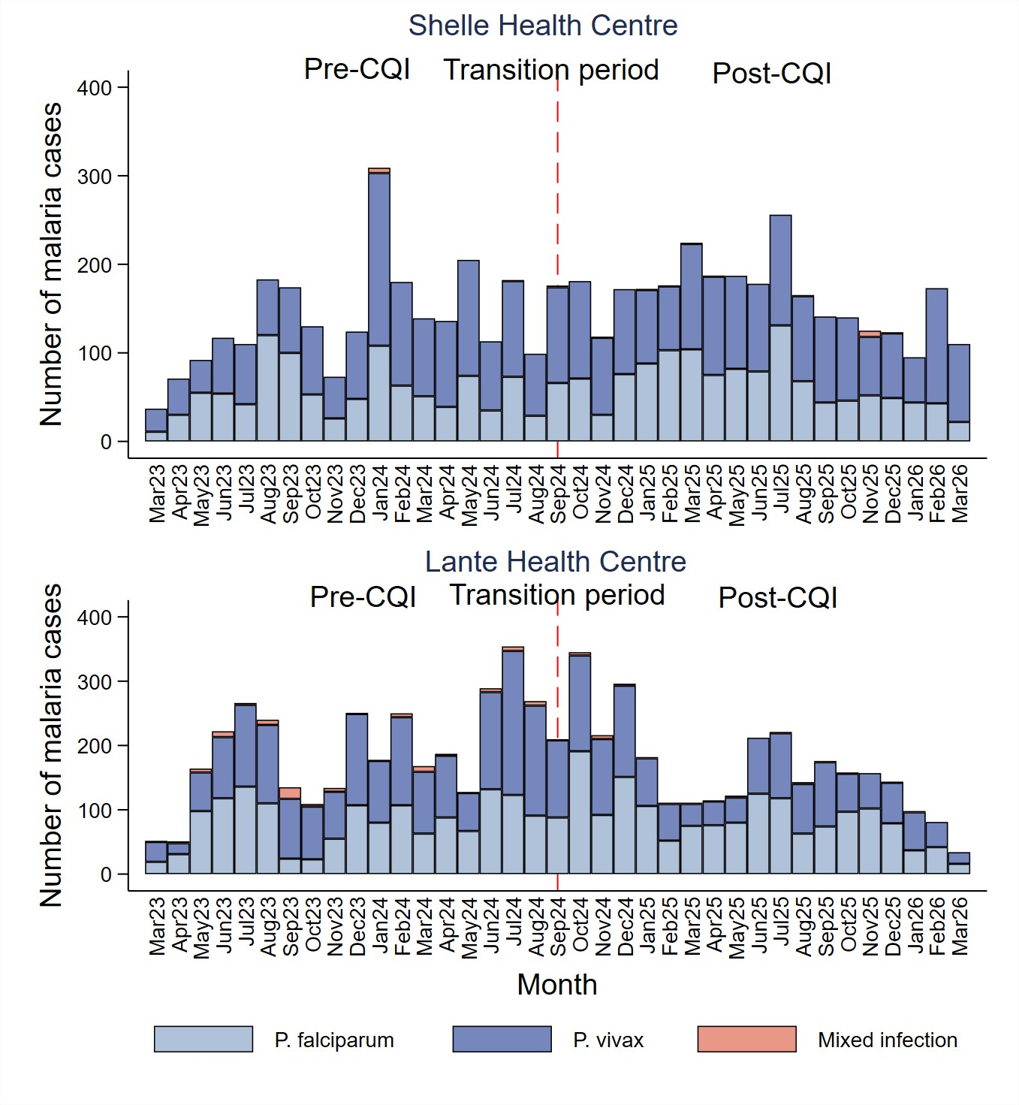

Figure S1: Malaria cases per month by Plasmodium species, centre and study period

