Supplementary data

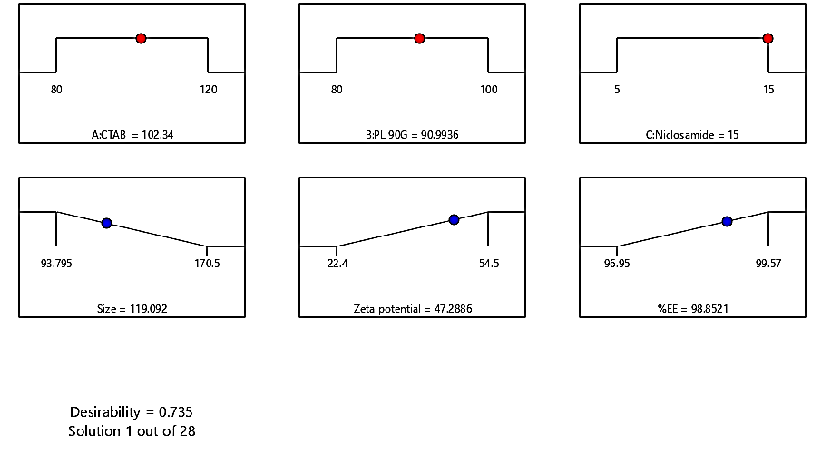
Supplementary Fig. SF1. Desirability graph given by BBD.
Note: CTAB: Hexadecyltrimethylammonium bromide, PL 90G: Phospholipon® 90G, EE: Entrapment efficiency.

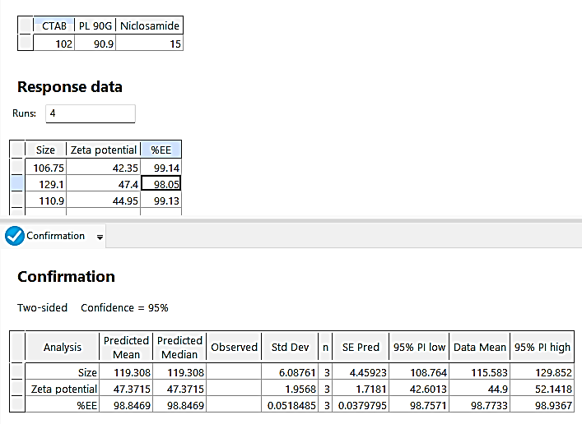
Supplementary Fig. SF2. Validation of BBD by Design Expert®.
Note: CTAB: Hexadecyltrimethylammonium bromide, PL 90G: Phospholipon® 90G, EE: Entrapment efficiency.

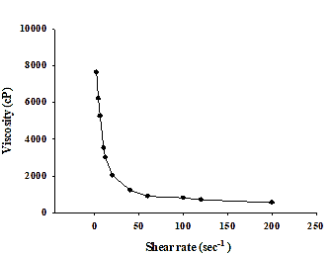
Supplementary Fig. SF3. Viscosity graph of NCD-LPX-HPMC gel.
Note: NCD-LPX-HPMC gel: Niclosamide loaded leciplex hydroxypropyl methyl cellulose gel. Each value represents the mean ± Standard deviation n=3

Supplementary Table 1. R² values of dependent variables.
Response | p-value | R² | Predicted R² | Adjusted R² | Adequate precision
PS | 0.0004 | 0.9455 | 0.8438 | 0.8988 | 16.5460
ZP | 0.0046 | 0.9802 | 0.7442 | 0.9357 | 18.6767
%EE | 0.0001 | 0.9965 | 0.9826 | 0.9935 | 72.7584
Note: PS: Particle size, ZP: Zeta potential, EE: Entrapment efficiency.

Supplementary Table 2. Desirability of NCD-LPX given by BBD.
Run | CTAB (mg) | PL90G (mg) | NCD (mg) | P.S (nm) | Z.P (mV) | EE (%)
1 | 102 | 90 | 15 | 106.6 ± 2.26 | 42.35 ± 1.34 | 99.11 ± 0.003
2 | 102 | 90 | 15 | 129.1 ± 6.08 | 42.4 ± 3.25 | 98.04 ± 0.007
3 | 102 | 90 | 15 | 110.45 ± 2.05 | 44.95 ± 2.47 | 99.13 ± 0.003
Note: PS: Particle size, ZP: Zeta potential, EE: Entrapment efficiency, CTAB: Hexadecyltrimethylammonium bromide, PL 90G: Phospholipon® 90G, NCD: Niclosamide. Each value represents the mean ± Standard deviation n=2

