Supplementary Tables:
Table S1: Molecular non-bond interactions of the lead compounds with SARS-CoV-2 Mpro.

Compounds |  | Binding Energy (kcal/mol) |  |  | Interacting amino acid residues |  | Bond distance (Å) |  | Interaction category |  | Type of Interaction
 | D3 |  | -9 |  |  | Lys5 |  | 3.18811 |  | H Bond |  | Conventional H Bond
 |  |  |  |  |  | Gln127 |  | 1.96948 |  | H Bond |  | Conventional H Bond
 |  |  |  |  |  | Thr199 |  | 2.73816 |  | H Bond |  | Conventional H Bond
 |  |  |  |  |  | Tyr239 |  | 3.08282 |  | H Bond |  | Conventional H Bond
 |  |  |  |  |  | Glu290 |  | 2.32965 |  | H Bond |  | Conventional H Bond
 |  |  |  |  |  | Glu290 |  | 2.4741 |  | H Bond |  | Conventional H Bond
 |  |  |  |  |  | Cys128 |  | 4.18542 |  | Hy |  | Alkyl
 |  |  |  |  |  | Leu272 |  | 4.62448 |  | Hy |  | Alkyl
 |  |  |  |  |  | Met276 |  | 4.81011 |  | Hy |  | Alkyl
 |  |  |  |  |  | Leu287 |  | 4.39105 |  | Hy |  | Alkyl
 |  |  |  |  |  | Leu287 |  | 4.92891 |  | Hy |  | Alkyl
 | D4 |  | -9 |  |  | Lys5 |  | 3.10079 |  | H Bond |  | Conventional H Bond
 |  |  |  |  |  | Lys5 |  | 3.21669 |  | H Bond |  | Conventional H Bond
 |  |  |  |  |  | Gln127 |  | 2.42541 |  | H Bond |  | Conventional H Bond
 |  |  |  |  |  | Arg131 |  | 2.87127 |  | H Bond |  | Conventional H Bond
 |  |  |  |  |  | Lys137 |  | 3.37926 |  | H Bond |  | Conventional H Bond
 |  |  |  |  |  | Thr199 |  | 2.72871 |  | H Bond |  | Conventional H Bond
 |  |  |  |  |  | Lys236 |  | 2.05867 |  | H Bond |  | Conventional H Bond
 |  |  |  |  |  | Tyr239 |  | 3.1074 |  | H Bond |  | Conventional H Bond
 |  |  |  |  |  | Leu271 |  | 2.30234 |  | H Bond |  | Conventional H Bond
 |  |  |  |  |  | Glu288 |  | 2.76694 |  | H Bond |  | Conventional H Bond
 |  |  |  |  |  | Glu290 |  | 2.52323 |  | H Bond |  | Conventional H Bond
 |  |  |  |  |  | Cys128 |  | 4.20417 |  | Hy |  | Alkyl
 |  |  |  |  |  | Leu272 |  | 4.64398 |  | Hy |  | Alkyl
 |  |  |  |  |  | Leu287 |  | 4.3672 |  | Hy |  | Alkyl
D6 |  | -9 |  | Lys5 |  |  | 3.21471 |  |  | H Bond |  | Conventional H Bond
 |  |  |  | Arg131 |  |  | 3.32975 |  |  | H Bond |  | Conventional H Bond
 |  |  |  | Thr199 |  |  | 1.91788 |  |  | H Bond |  | Conventional H Bond
 |  |  |  | Lys236 |  |  | 2.63432 |  |  | H Bond |  | Conventional H Bond
 |  |  |  | Tyr239 |  |  | 3.07891 |  |  | H Bond |  | Conventional H Bond
 |  |  |  | Asp289 |  |  | 2.98127 |  |  | H Bond |  | Conventional H Bond
 |  |  |  | Cys128 |  |  | 4.18076 |  |  | Hy |  | Alkyl
 |  |  |  | Leu272 |  |  | 4.69047 |  |  | Hy |  | Alkyl
 |  |  |  | Met276 |  |  | 4.6921 |  |  | Hy |  | Alkyl
 |  |  |  | Leu287 |  |  | 4.89155 |  |  | Hy |  | Alkyl
 |  |  |  | Leu287 |  |  | 4.36695 |  |  | Hy |  | Alkyl
D7 |  | -9 |  | Lys5 |  |  | 3.2562 |  |  | H Bond |  | Conventional H Bond
 |  |  |  | Arg131 |  |  | 2.89633 |  |  | H Bond |  | Conventional H Bond
 |  |  |  | Lys137 |  |  | 3.38785 |  |  | H Bond |  | Conventional H Bond
 |  |  |  | Thr199 |  |  | 2.67653 |  |  | H Bond |  | Conventional H Bond
 |  |  |  | Lys236 |  |  | 3.25925 |  |  | H Bond |  | Conventional H Bond
 |  |  |  | Lys236 |  |  | 2.0077 |  |  | H Bond |  | Conventional H Bond
 |  |  |  | Tyr239 |  |  | 3.0657 |  |  | H Bond |  | Conventional H Bond
 |  |  |  | Glu290 |  |  | 2.22898 |  |  | H Bond |  | Conventional H Bond
 |  |  |  | Cys128 |  |  | 4.18513 |  |  | Hy |  | Alkyl
 |  |  |  | Leu272 |  |  | 4.62242 |  |  | Hy |  | Alkyl
 |  |  |  | Met276 |  |  | 4.75972 |  |  | Hy |  | Alkyl
 |  |  |  | Leu287 |  |  | 4.90274 |  |  | Hy |  | Alkyl
 |  |  |  | Leu287 |  |  | 4.35549 |  |  | Hy |  | Alkyl
H= Hydrogen, Hy= Hydrophobic

Table S2: Non-covalent interactions of nine docked complex after 50ns molecular dynamics simulation.
Complex | Amino Acid Residue | Bond Distance(Å) | Bond Type
D1 | Lys137  Tyr239  Glu288  Asp289  Thr199  Leu287  Asp289  Glu288  Leu272  Met276 | 2.90  2.67  1.58  1.51  2.49  2.43  2.38  2.73  5.07  4.92 | Hydrogen  Hydrogen  Hydrogen  Hydrogen  Hydrogen  Hydrogen  Hydrogen  Hydrogen  Alkyl  Alkyl
D2 | Lys137  Tyr239  Glu288  Asp289  Leu287  Asp289  Leu272  Met276 | 2.65  1.82  1.67  1.73  2.58  2.80  5.01  4.36 | Hydrogen  Hydrogen  Hydrogen  Hydrogen  Hydrogen  Hydrogen  Alkyl  Alkyl
D3 | Lys137  Tyr239  Asp289  Leu287  Met276  Lys5  Cys128  Tyr126 | 2.64  1.92  2.81  1.60  4.21  5.32  3.88  5.10 | Hydrogen  Hydrogen  Hydrogen  Hydrogen  Alkyl  Alkyl  Alkyl  Pi-alkyl
D4 | Lys137  Tyr239  Leu271  Glu288  Asp289  Asp197  Thr199  Leu287  Leu272 | 2.39  2.25  2.39  1.76  1.67  2.24  2.47  2.23  5.03 | Hydrogen  Hydrogen  Hydrogen  Hydrogen  Hydrogen  Hydrogen  Hydrogen  Hydrogen  Alky
D5 | Lys5  Asp289  Leu287  Glu290  Leu282  Glu288  Gln127  Gly283  Lys137 | 2.52  2.04  2.18  1.72  1.96  1.74  2.21  2.92  4.855 | Hydrogen  Hydrogen  Hydrogen  Hydrogen  Hydrogen  Hydrogen  Hydrogen  Hydrogen  Alkyl
D6 | Lys137  Tyr239  Thr199  Glu288  Gln127  Glu290  Asp289  Leu287  Leu272  Met276 | 2.80  1.80  2.67  1.64  1.71  1.82  1.73  2.71  5.13  4.34 | Hydrogen  Hydrogen  Hydrogen  Hydrogen  Hydrogen  Hydrogen  Hydrogen  Hydrogen  Alkyl  Alkyl
D7 | Lys137  Tyr239  Asp289  Thr199  Leu287  Met276 | 2.004  1.83  1.67  2.56  2.92  4.05 | Hydrogen  Hydrogen  Hydrogen  Hydrogen  Hydrogen  Alkyl
D8 | Lys5  Lys137  Tyr239  Glu290  Asp289  Thr199  Glu288  Leu287  Leu272  Met276  Cys128  Tyr126 | 2.06  2.63  2.60  1.89  1.74  2.56  2.49  5.15  5.34  4.32  4.28  5.35 | Hydrogen’  Hydrogen  Hydrogen  Hydrogen  Hydrogen  Hydrogen  Hydrogen  Alkyl  Alkyl  Alkyl  Alkyl  Pi-Alkyl
D9 | Arg222  Arg279  Glu270  Gly275  Phe219  Trp218  Leu271 | 2.14  2.05  2.97  2.97  2.83  5.36  5.08 | Hydrogen  Hydrogen  Hydrogen  Hydrogen  Hydrogen  Pi-Pi-T-shaped  Pi-Alkyl

Supplementary Figures:
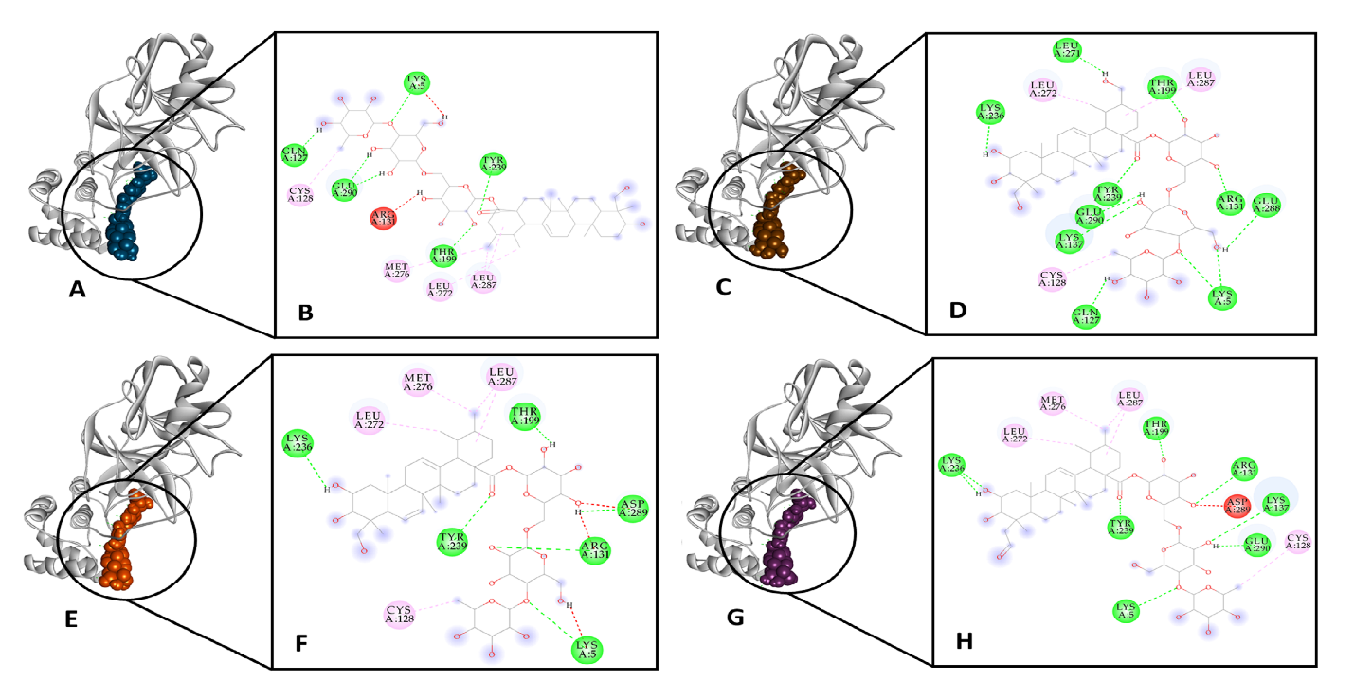

Figure S1: Three-dimensional structures are showing the binding sites of D3 (A), D4 (C), D6 (E) and D7 (G) in the catalytic site of Mpro, and the main residues involved in molecular interactions of D3 (B), D4 (D), D6 (F) and D7 (H) with the Mpro protein.

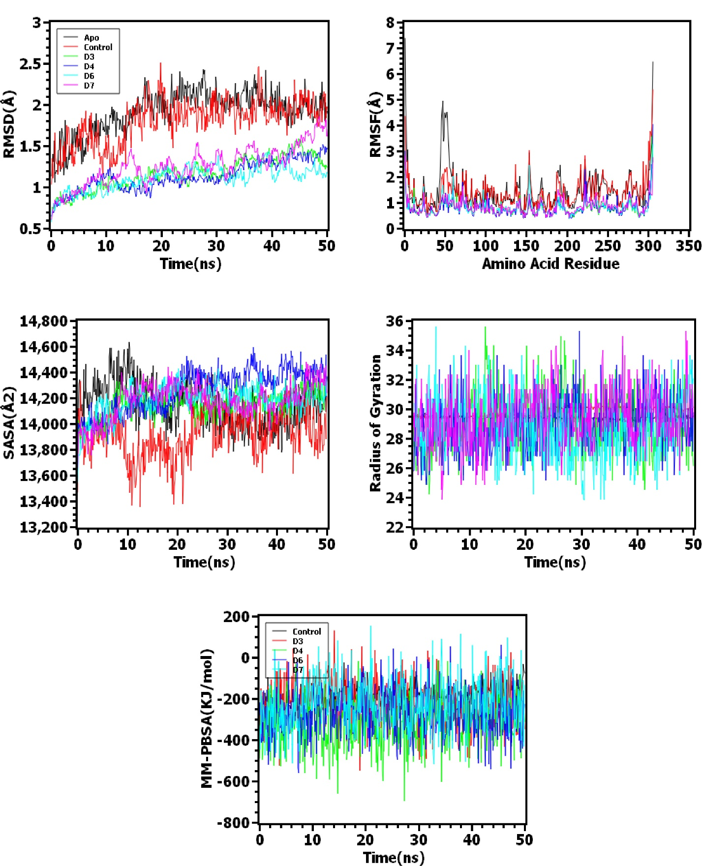
Figure S2: Molecular Dynamics Simulation and Binding Free Energy Calculation. Here, black, red, green, violet, cyan, and purple color denotes apo (without ligand), control (main protease PDB), D3, D4, D6, D7 respectively.

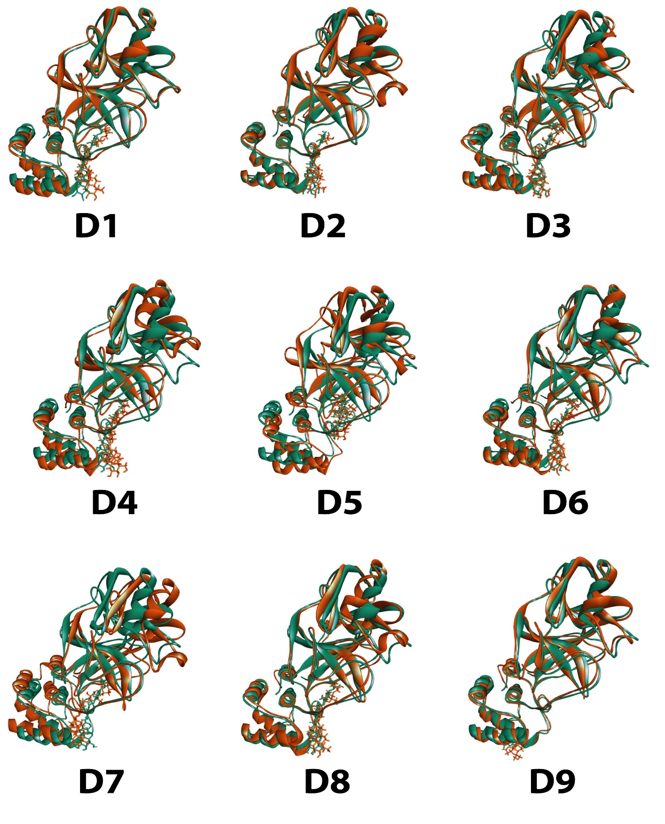
Figure S3: Superimposed structures of the 9 Docking complexes after MD Analysis.
Figure S4: Stability of the Hydrogen bond during the Molecular Dynamics Simulation Trajectory.

