Supporting information

Glideosomal GAP50 binders that inhibit invasion and restrict malaria parasite in vitro and in vivo

Prakhar Agrawal¹, Surekha Kumari^{2,3}, Upendra Sharma^{2,3} and Dinkar Sahal^{1*}

¹International Centre for Genetic Engineering and Biotechnology, New Delhi,110067, India
²Chemical Technology Division, CSIR-Institute of Himalayan Bioresource Technology, Palampur, 176061, India
³Academy of Scientific and Innovative Research (AcSIR), Ghaziabad-U.P. 201002, India

Corresponding author

DR. DINKAR SAHAL
GROUP LEADER, MALARIA DRUG DISCOVERY GROUP, ICGEB, NEW DELHI
EMAIL: dsahal@gmail.com

Table of contents

Serial no. | Contents | Page no.
 | Figure 1: Structure of in-house Synthetic (quinolines and Azepino) molecules | 4
 | Figure 2: Structure of molecules isolated from C. pareria. | 6
 | Figure 3: Dot plot showing docking and MMGBSA score of 951 small molecules against PfGAP50. | 7
 | Figure 4: Effect of pathogen box (Plate A, B, C, D and E) compounds (400 molecules) on melting temperature (δ Tm) of PfGAP50 as seen by differential scanning fluorimetry. | 8
 | Figure 5: Effect of pandemic box (Plate A, B, C, D and E) compounds (400 molecules) on melting temperature (δ Tm) of PfGAP50 as seen by differential scanning fluorimetry. | 9
 | Figure 6: Effect of synthetic (quinolines and Azepino) molecules on melting temperature (δ Tm) of PfGAP50. | 10
 | Table 1: Synthetic (quinolines and Azepino) molecules and Phytometabolites (from C. pareira) selected for in vitro against P. falciparum culture. | 11
 | Isolation and characterization of Curine. | 12
 | Figure 7: Cloning of PfGAP50 in pET28a+ vector. | 14
 | Figure 8: Purification of PfGAP50. | 14
 | Figure 9: Time dependence treatment of 6 h to 12 h p.i rings (PfINDO). | 15
 | Figure 10: Variable time treatments of schizonts (PfINDO 32 to 36 h p.i) to find kill kinetics of different test molecules. | 16
 | Figure 11. Binding of lead antiplasmodial molecules (ball and stick formats) to Pf GAP50 (ribbon format). | 17
 | Table 2: Evaluation of binding of lead compounds to PfGAP50 by Surface Plasmon Resonance. thermal shift fluorimetry assay and in silico Schrodinger drug discovery suite. | 17
 | Table 3: Details of malaria proteins taken for cross docking to identify alternate targets for GAP50 inhibitors. | 18
 | Table 4: Proteins interacting with MMV688271, their docking score and MM-GBSA dG of binding score. | 26
 | Table 5: Proteins interacting with Bedaquiline, their docking score and MM-GBSA dG of binding score. | 30
 | Table 6: Proteins interacting with Brilacidin, their docking score and MM-GBSA dG of binding score. | 33
 | Table 7: Proteins interacting with Hayatinin, their docking score and MM-GBSA dG of binding score. | 35
 | Table 8: Proteins interacting with Curine, their docking score and MM-GBSA dG of binding score. | 37
 | Table 9: Common target as assessed by cross docking. | 40
 | Table 10: Acute toxicity parameters. | 40
 | References | 41

Figure 1: Structure of in-house Synthetic (quinolines and Azepino) molecules

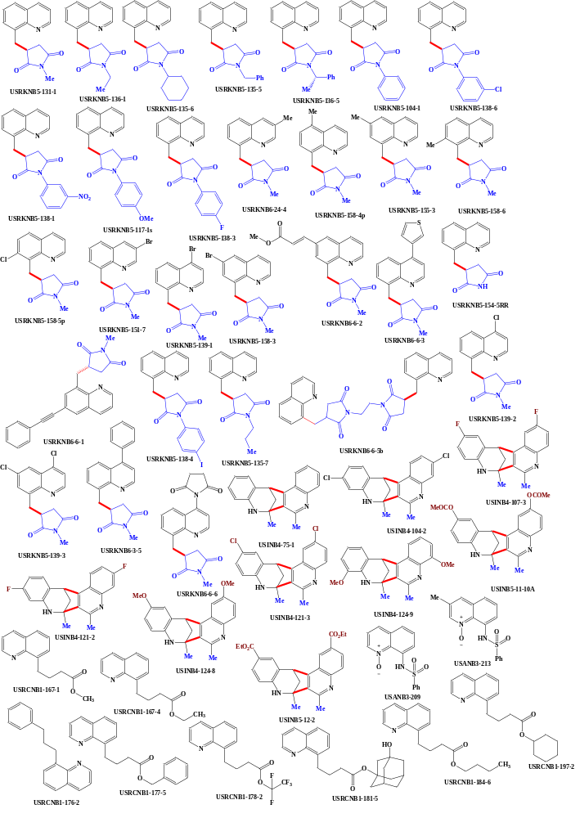
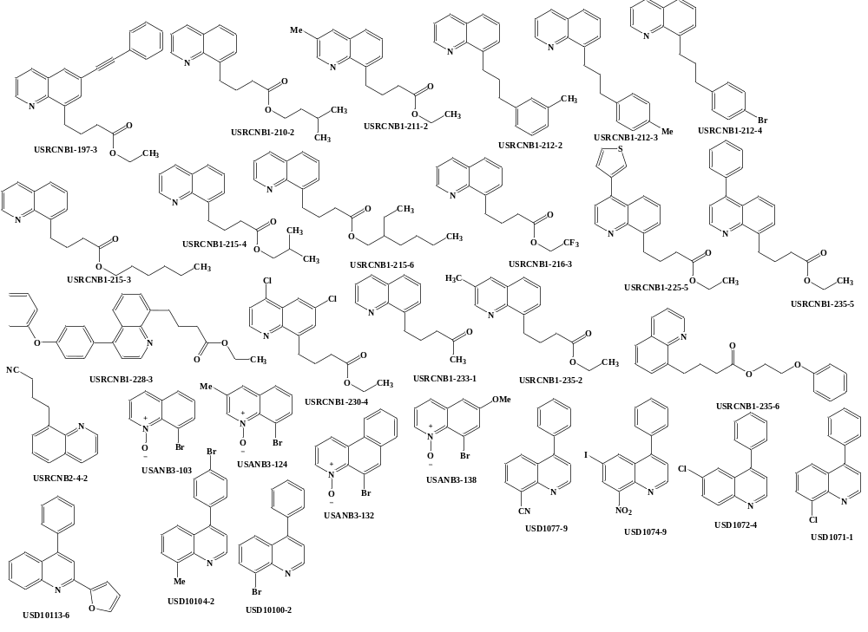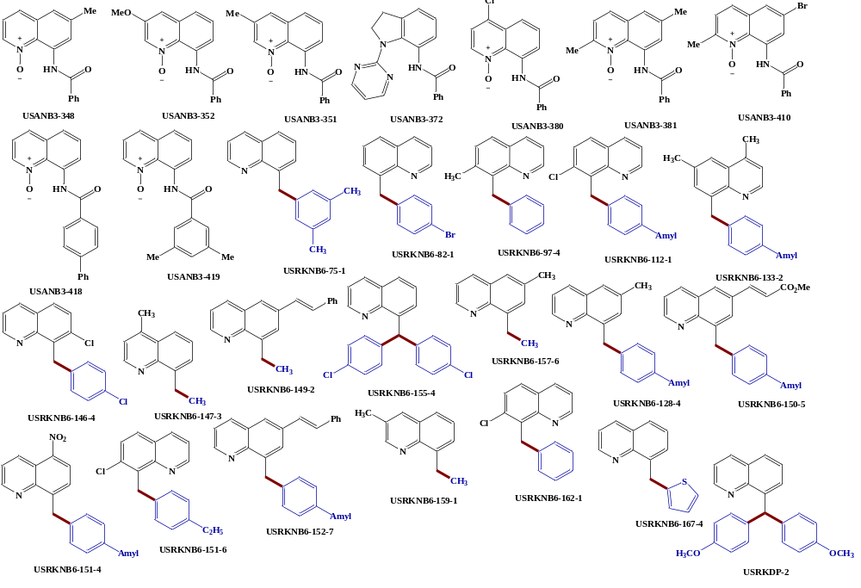

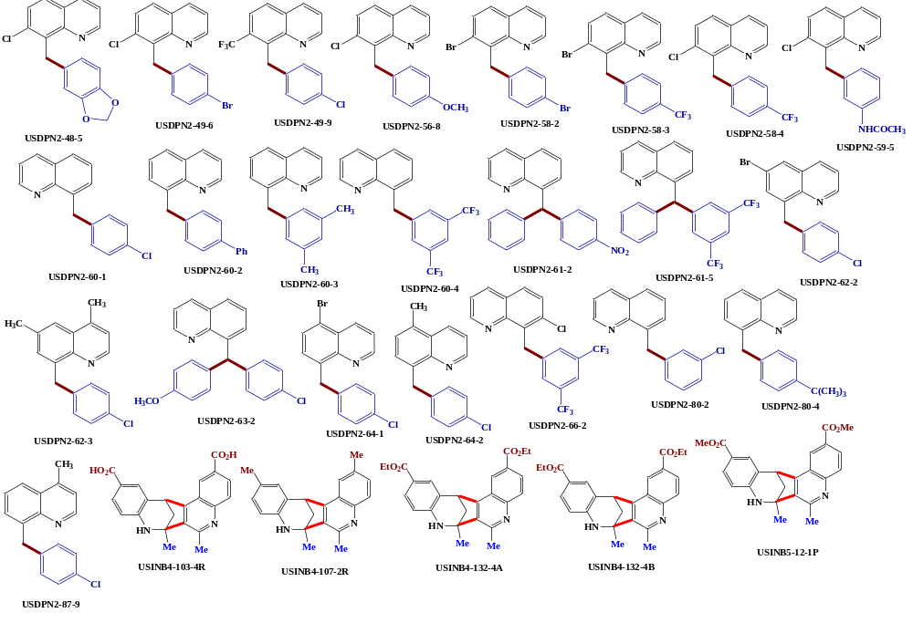

Figure 2: Structure of molecules isolated from C. pareria

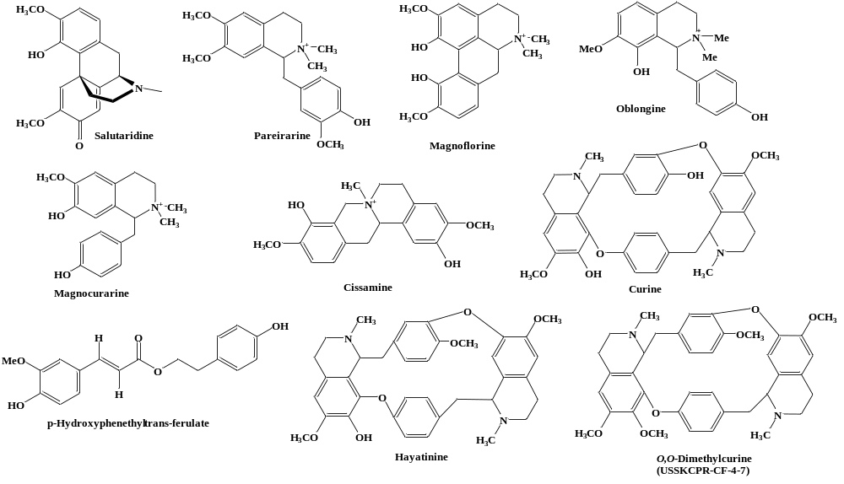

Screening of small molecules against PfGAP50 using in silico Schrödinger drug discovery suite

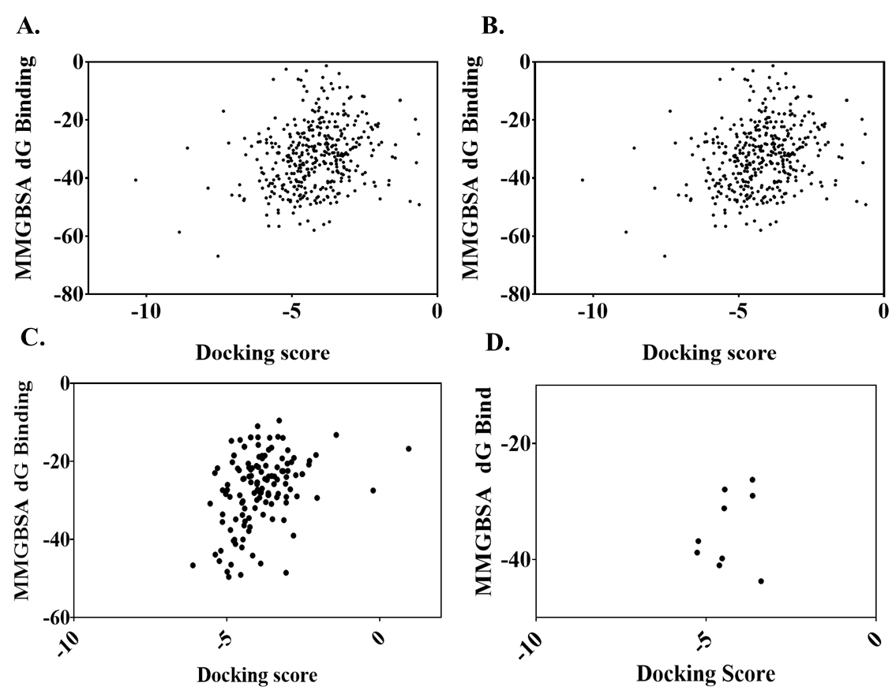

Figure 3: Dot plot showing docking and MMGBSA score of 951 small molecules against PfGAP50. (A) Pathogen box, (B) Pandemic box, (C) azepino quinolone derivatives, (D) isolates from Cissampelos pareira.

Screening of small molecules against PfGAP50 using differential scanning fluorimetry
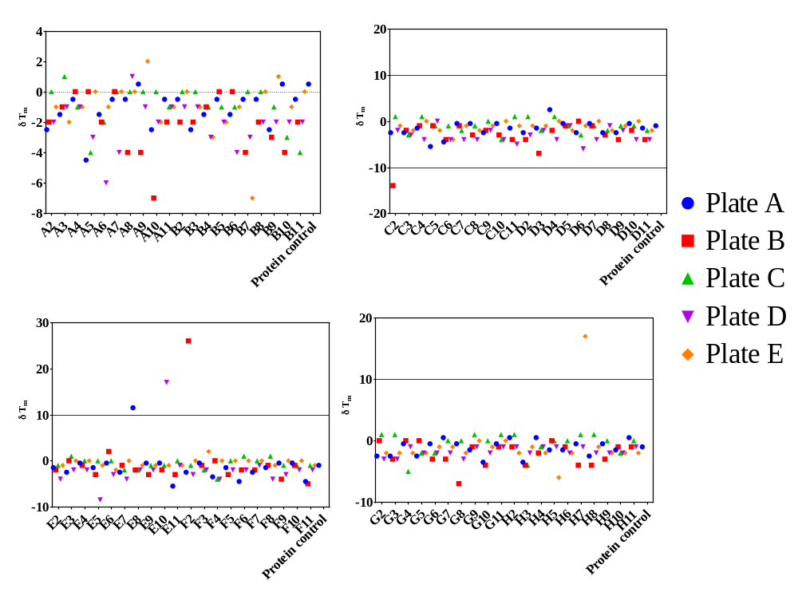
Figure 4: Effect of pathogen box (Plate A, B, C, D and E) compounds (400 molecules) on melting temperature (δ T_{m}) of PfGAP50 as seen by differential scanning fluorimetry.
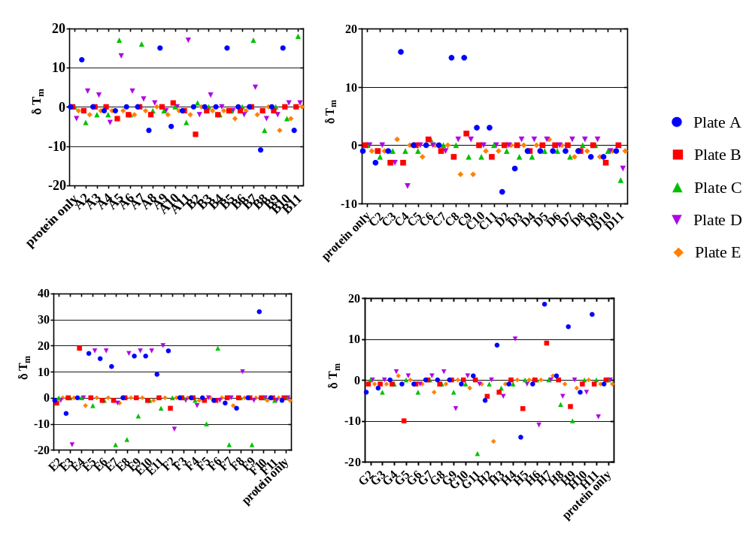
Figure 5: Effect of pandemic box (Plate A, B, C, D and E) compounds (400 molecules) on melting temperature (δ T_{m}) of PfGAP50 as seen by differential scanning fluorimetry.

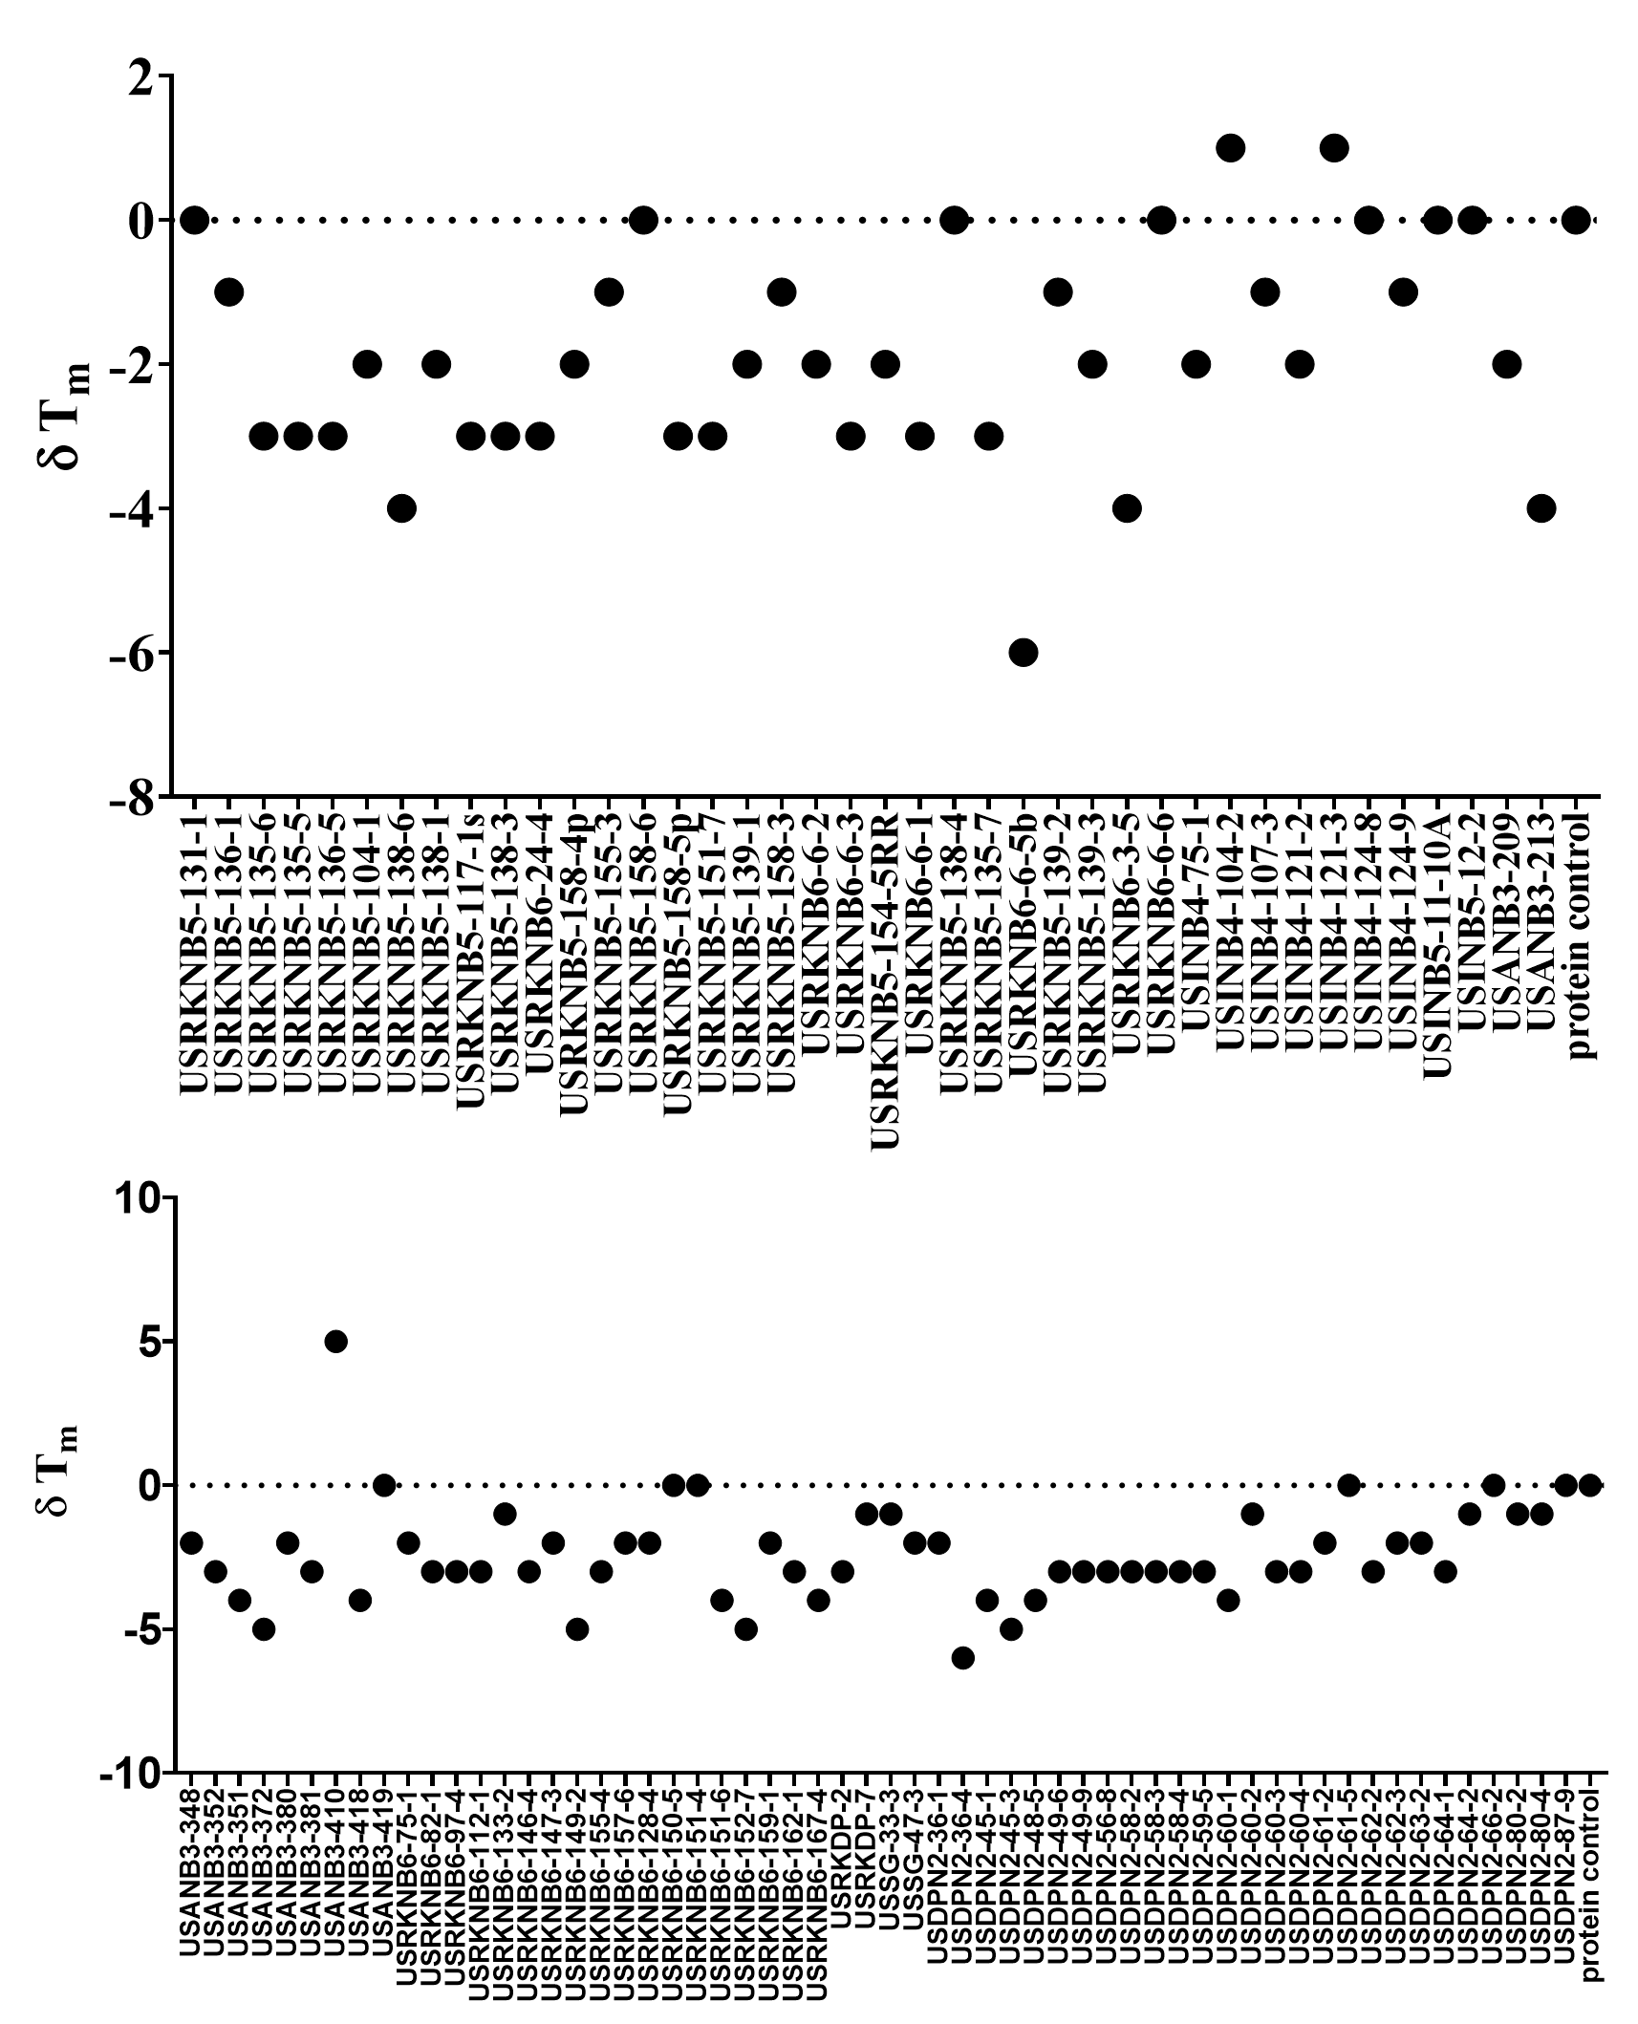

SI-Figure 6: : Effect of synthetic (quinolines and Azepino) molecules on melting temperature (δ Tm) of PfGAP50

Table 1: Synthetic (quinolines and Azepino) molecules and Phytometabolites (from C. pareira) selected for in vitro against P. falciparum culture.

S. No. | Sample Code | Structure | Reported method of synthesis (References)
1. | USSG-33-3 | 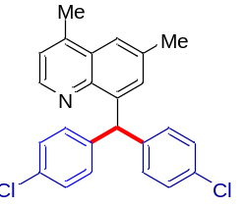 | Chem. Eur. J. 2020, 26, 4396.
2. | USRKNB6-150-5 | 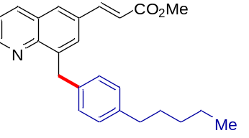 | Chem. Eur. J. 2020, 26, 4396.
3. | USRCNB1-228-3 | 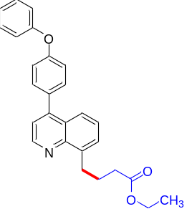 | J. Org. Chem. 2020, 85, 1181.
4. | USINB4-124-8 | 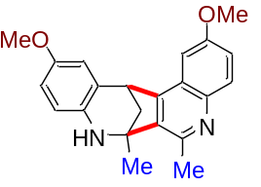 | ACS Sustain. Chem. Eng. 2020, 8, 12902–12910.
5. | USINB4-107-3 | 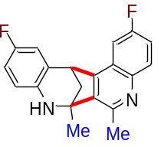 | ACS Sustain. Chem. Eng. 2020, 8, 12902–12910.
6. | USINB4-107-2R | 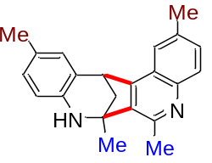 | ACS Sustain. Chem. Eng. 2020, 8, 12902–12910.
7. | USINB5-12-2 | 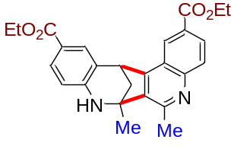 | ACS Sustain. Chem. Eng. 2020, 8, 12902–12910.
8. | USINB4-132-4A |  | ACS Sustain. Chem. Eng. 2020, 8, 12902–12910.
9. | USINB4-132-4B |  | ACS Sustain. Chem. Eng. 2020, 8, 12902–12910.
10. | Hayatinine | 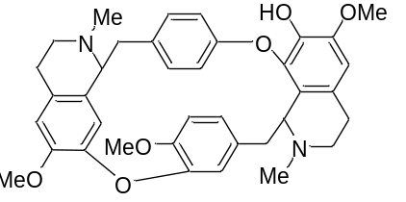 | J. Ethnopharmacol. 2020, 262, p.113185.
11. | Magnocurarine | 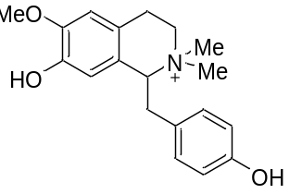 | J. Ethnopharmacol. 2020, 262, p.113185.
12. | Curine | 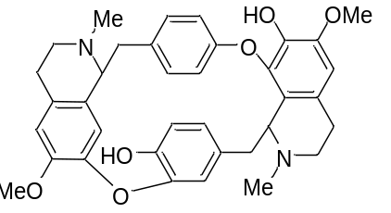 | Planta Med., 2000, 66, 537-540.
13 | O,O-Dimethylcurine  (USSKCPR-CF-4-7) | 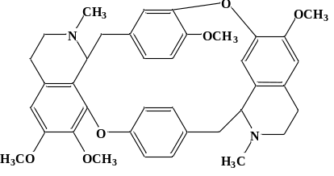 | Gazzetta Chimica Italiana, 105, 1207-13;  J. Nat. Prod., 42, 1.

Note: Compound having Serial No.7 (USINB5-12-2) is the racemic mixture of compounds USINB4-132-4A and USINB4-132-4B. Compounds having Serial No. 8 and 9 (USINB4-132-4A and USINB4-132-4B) are the isolated pure enantiomers (Enantiomers are isolated using chiral prep-HPLC and the exact stereochemistry of both the molecules is not determined).

Isolation and characterization of Curine:

Shade-dried 2 Kg powdered roots (Cissampelos pareira) were extracted thrice with ethanol: water (4:1, v/v) by percolation method and combined percolates were dried in rotary evaporator at 50 °C to obtain 239.2 g hydro-ethanolic crude extract. This dried crude extract was dissolved in 700 mL distilled water and fractionated with organic solvents i.e., n-hexane, chloroform, and n-butanol to yield fractions of different polarity [n-hexane (31.0 g), chloroform (12.4 g), n-butanol (33.4 g) and water (142.6 g).
Water fraction was chromatographed over HP-20 resin and eluted with H₂O: MeOH (10.0: 0.0, 7.5: 2.5, 5.0:5.0, 2.5: 7.5 and 0.0: 10.0, v/v). From this, we collected total five fractions. Formation of precipitates was observed in one fraction collected in pure MeOH. So, it was left overnight and then precipitates were separated from solution to obtain a pure compound which was characterized as Curine on the basis of comparison of 1D and 2D NMR and ESI-MS spectroscopic data with those reported in literature (L et al. 2000).

PfGAP50 cloning and expression

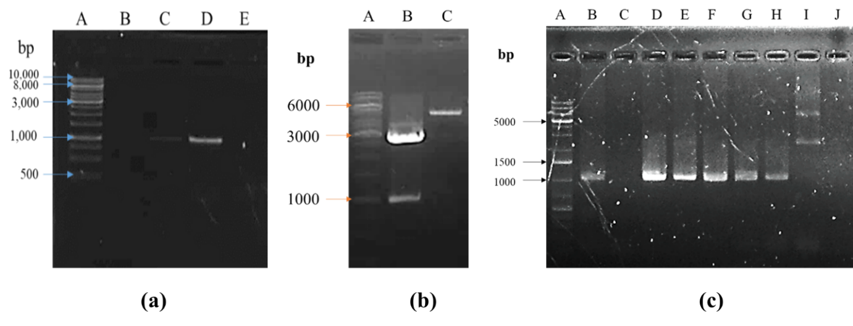
Figure 7: Cloning of PfGAP50 in pET28a⁺ vector; (a) Temperature gradient for selection of annealing temperature; lane A: 1 kb gene ruler marker, (b) Double digestion of pJET 1.2 vector with GAP50 and pET28a+ vector with Bam HI and Nde I. Lane A: 1 kb gene ruler marker, lane B: pJET 1.2 vector with GAP50 double digested, lane C: pET28a+ vector double digested. (c) colony PCR for GAP50 positive isolates; lane B, D-H are positive for GAP50.

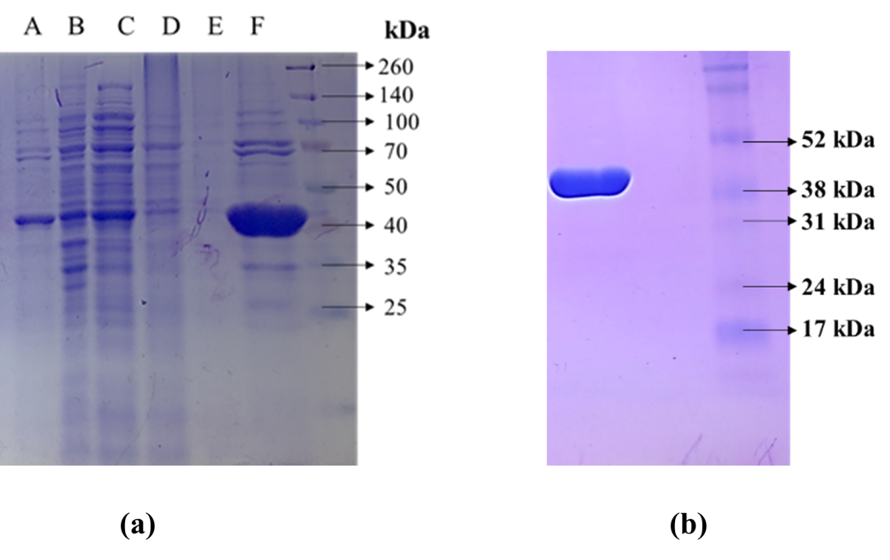
Figure 8: Purification of PfGAP50; (a) Metal affinity purification: lane A: pellet, lane B: supernatant, lane C: flow through, lane D and E: wash with 10 mM imidazole and lane F: elution with 300 mM imidazole; (b) Protein purification using phenyl sepharose column chromatography.

Stage specific activity of GAP50 binders against chloroquine resistant PfINDO strain

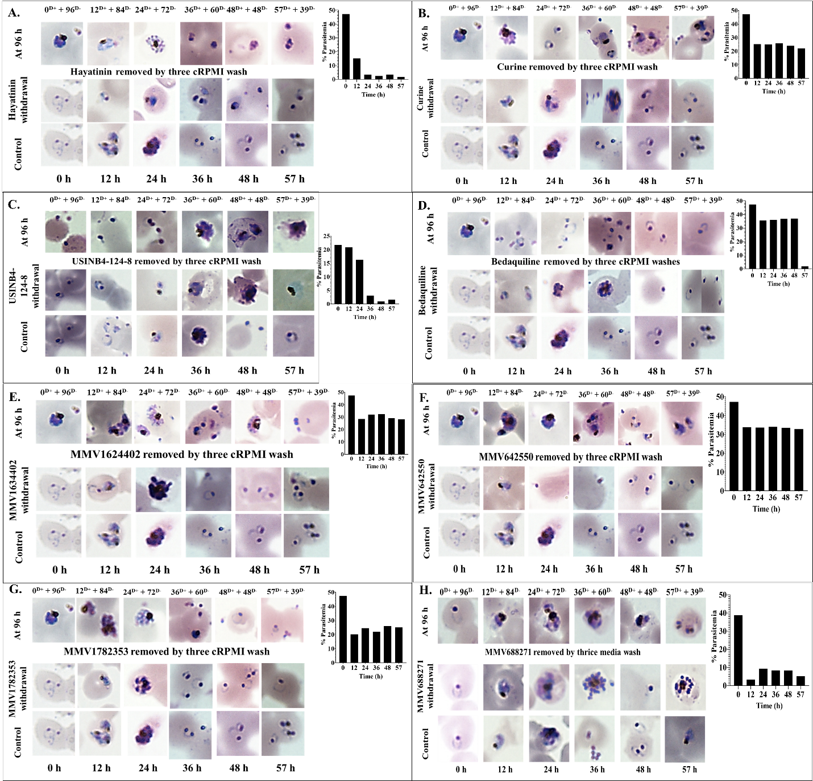

Figure 9: Time dependence treatment of 6 h to 12 h p.i rings (PfINDO) with (A) Hayatinin ^{(0.41 µM)} (B) Curine ^{(0.51 µM)} (C) USINB4-124-8 ^{(2.42 µM)} (D) Bedaquiline ^{(1.09 µM)} (E) MMV1634402 ^{(0.67 µM)} (F) MMV642550 ^{(1.2 µM)} (G) MMV1782353 ^{(0.4 µM)} (H) MMV688271 ^{(0.25 µM)}. Hayatinine, USINB4-124-8 and MMV688271 are showing acute toxicity against PfINDO. Bedaquiline is preventing invasion of merozoites.
*Superscripts represent dose of treatment. Histograms represent % parasitemia measured at D⁺+D⁻ 96 h for cultures treated with A-H for variable times indicated on the X axis.
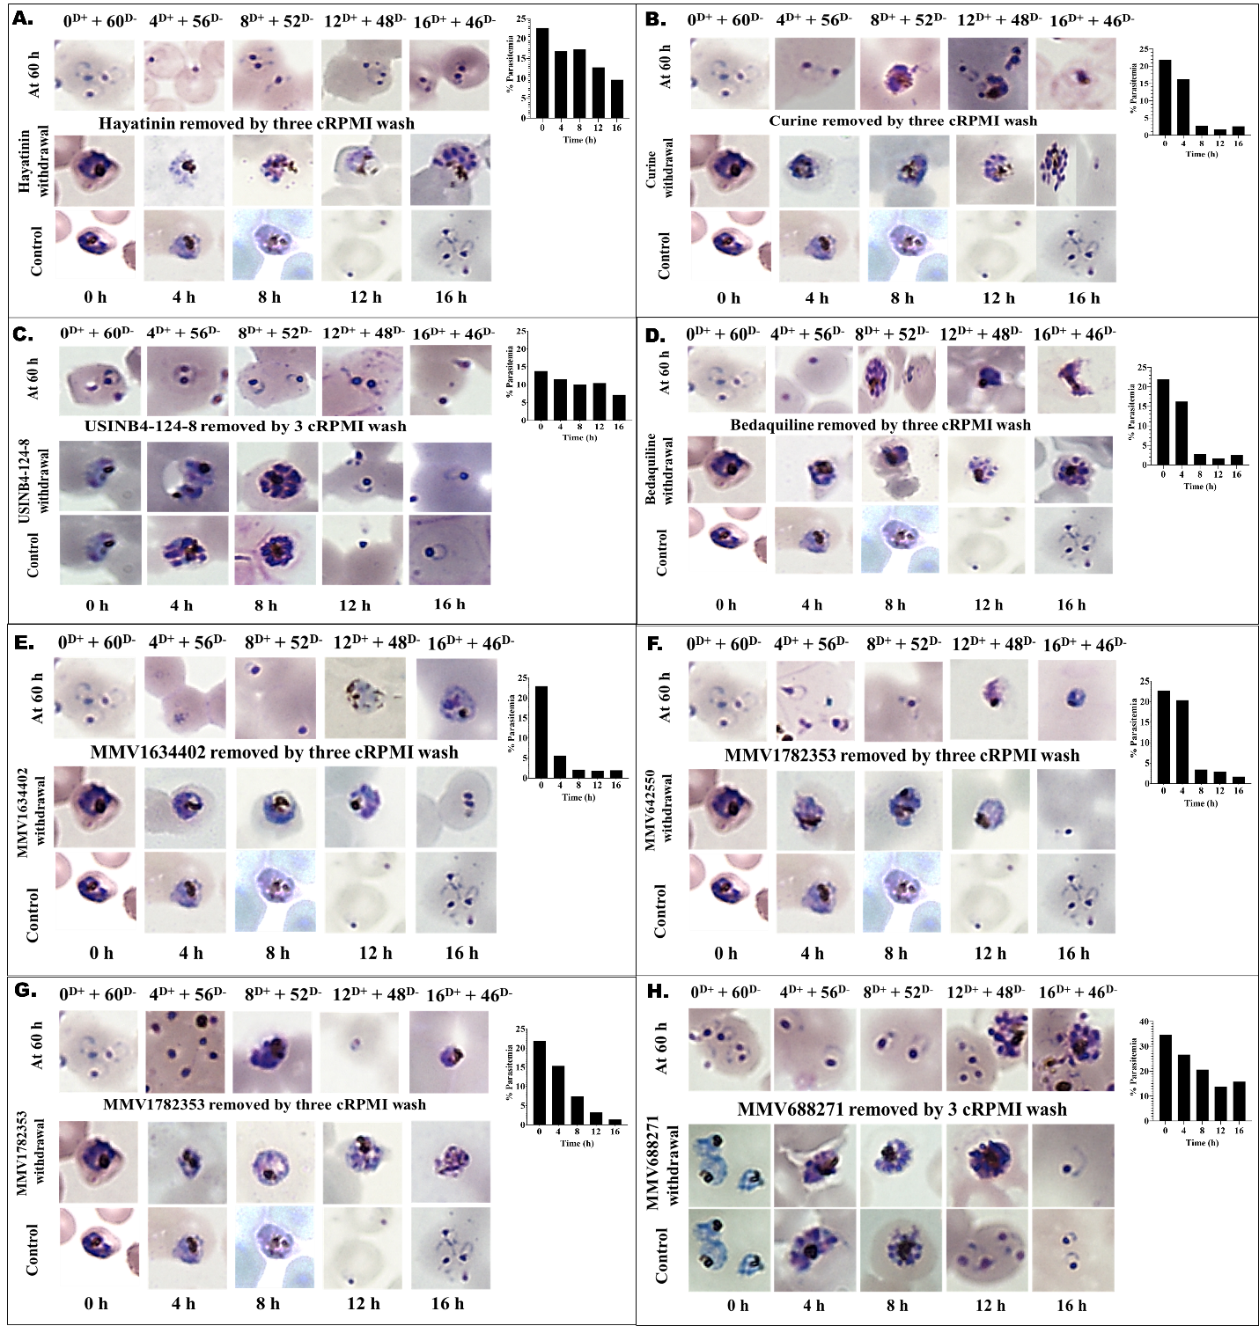

Figure 10: Variable time treatments of schizonts (PfINDO 32 to 36 h p.i) to find kill kinetics of different test molecules: with (A) Hayatinine ^{(2.02 µM)} (B), Curine ^{(10.68 µM)} (C), USINB4-124-8 ^{(108.64 µM)} (D), Bedaquiline ^{(3.08 µM)} (E), MMV1634402 ^{(8.80 µM)} (F), MMV642550 ^{(8.26 µM)} (G), MMV1782353 ^{(9.90 µM)} (H) MMV688271 ^{(1.16 µM)}. Bedaquiline (D), Curine (B), MMV642550 (F) and MMV1634402 (E) are schizontocidal after 4 h of treatment whereas MMV1782353 (G) kills schizonts in 12 h. *Superscripts indicate 2x IC₅₀ dose of treatment.

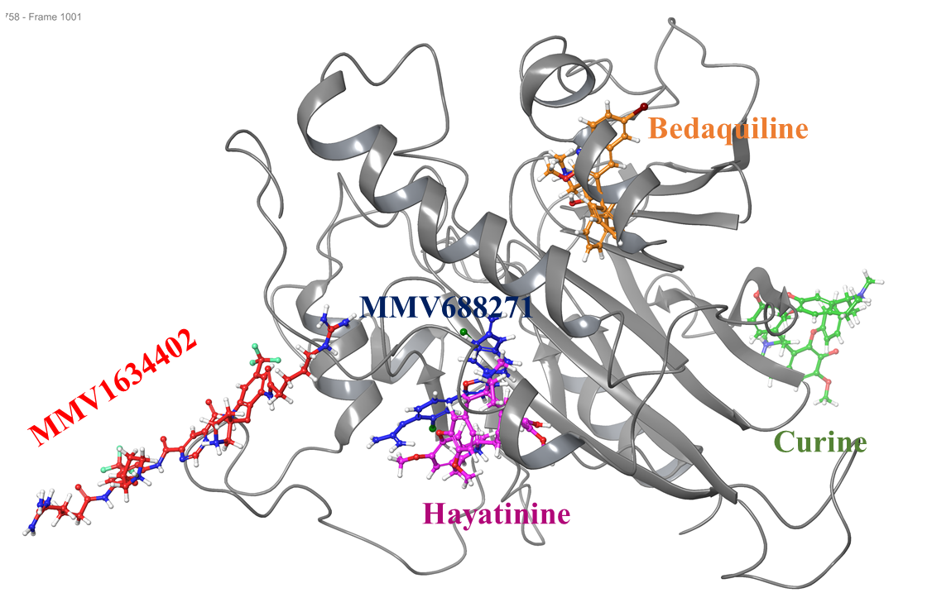

Figure 11. Binding of lead antiplasmodial molecules (ball and stick formats) to Pf GAP50 (ribbon format).

Table 2: Evaluation of binding of 8 lead compounds to PfGAP50 by Surface Plasmon Resonance. thermal shift fluorimetry assay and in silico Schrödinger drug discovery suite.

Serial No. | Test molecule | SPR |  |  | Thermal shift assay (TSA) | In silico PfGAP50 binding assay
Serial No. | Test molecule | ka (1/Ms) | kd (1/s) | KD (M) | Δ T_{m} | Docking score | -dG binding (kcal/mol)
 | Bedaquiline | 1.97E+03 | 1.82E-02 | 9.27E-06 | - 4.5 | -4.32 | -36.9
 | Hayatinine | 5.75E+02 | 1.45E-02 | 2.53E-05 | + 2.0 | - 4.75 | - 48.94
 | USINB4-124-8 | 1.97E+03 | 7.57E-03 | 3.84E-06 | 0.0 | -2.82 | -39.02
 | MMV1782353 | 9.87E+04 | 1.22E-02 | 1.23E-07 | - 1.0 | - 4.85 | - 58.42
 | MMV642550 | 4.45E+02 | 2.57E-03 | 5.78E-06 | 0.0 | - 4.93 | - 51.30
 | MMV1634402 | 2.12E+04 | 5.96E-02 | 2.81E-06 | - 3.0 | - 8.80 | - 64.82
 | MMV688271 | 1.56E+03 | 3.12E-02 | 2.00E-05 | 17.0 | - 5.67 | - 41.89
 | Curine | 1.59E+02 | 1.18E-02 | 7.45E-05 | 0.0 | - 4.5 | - 52.13

Table 3: Details of malaria proteins taken for cross docking to identify alternate targets for PfGAP50 binders.
*Essential for parasite survival

S.No. | PDB | Protein | PlasmoDb ID | Stage expressed | Co-Crystallised ligand | Docking Score | MMGBSA (kcal/mol)
1 | 1CJB | Adenylate Kinase | PF3D7_1012400 | Trophozoites | (1S)-1(9-Deazahypoxanthin-9yl)1,4-dideoxy-1,4-imino-d-ribitol-5-phosphate | -8.027 | -59.48
2 | 1D5C | Plasmodium Falciparum Rab6* | PF3D7_1144900 | late trophozoites, schizonts, gametocyte stage V and ookinete | Guanosine Diphosphate (GDP) | 12.48 | -80.63
3 | 1HBK | Acyl-COA Binding Protein | PF3D7_1477800 | schizonts and merozoites | Coenzyme A | -10.95 | -59.25
4 | 1J3I | Dihydrofolate reductase-thymidylatesynthase (PfDHFR-TS) | PF3D7_0417200 | late trophozoites | WR99210 | -10.28 | -108.84
5 | 1LS5 | Plasmepsin IV | PF3D7_1407800 | Rings and merozites | Pepstatin A | -7.52 | -97.34
6 | 1LTK | Phosphoglycerate Kinase* | PF3D7_0922500 | Rings and Trophozoites | AMP | -7.65 | -35.95
7 | 1ONF | Glutathione reductase | PF3D7_1419800 | Trophozoites | Flavin Adenine Dinucleotide (FAD) | -11.9 | -107
8 | 1P9B | Adenylosuccinate synthetase | PF3D7_1354500 | Trophozoites | 6-Phosphoryl-Inosine Monophosphate | 16.17 | -72.95
9 | 1QNG | Cyclophilin | PF3D7_1115600 | schizonts | Cyclosporin A | -1.948 | -65.44
10 | 1RL4 | Peptide Deformylase* | PF3D7_0907900 | trophozoites, gametocyte stage V | 2-{N0-[2-(5-amino-1-phenylcarbamoyl-pentylcarbamoyl)-hexyl]-hydrazinomethyl}1.4-hexanoic acid-(5-amino-1-phenylcarbamoyl-pentyl)-amide | -2.268 | -93.57
11 | 1T24 | Lactate dehydrogenase* | PF3D7_1324900 | Rings and trophozoites | -Hydroxy-1,2,5-oxadiazole-3-carboxylic acid | -3.78 | -17.66
12 | 1V0O | PfPK5 | PF3D7_1356900 | Rings | Indirubin-5-sulphonate | -7.03 | -46.32
13 | 1VYQ | Erythrocyte Binding Antigen Region II Region 175 | PF3D7_1127100 | Late trophozites and oocysts | ,3-deoxy-3-fluoro-5-O-trityluridine | -7.61 | -65.7
14 | 1Y13 | Pyruvoyl Tetrahydropterin Synthase(PTPS) | PF3D7_0628000 | Trophozoites | Biopterin | -3.38 | -43.89
15 | 1YWG | Glyceraldehyde-3-PhosphateDehydrogenase* | PF3D7_1462800 | Late trophozites | Nicotinamide Adenine Dinucleotide (NAD) | -14.37 | -60.81
16 | 1Z6G | Guanylate Kinase | PF3D7_0928900 | Late rings and Trophozites | (2-Hydroxyethyl)-1-piperazine ethanesulfonic acid | -4.32 | -53.77
17 | 2BJU | Plasmepsin II | PF3D7_1408000 | Trophozoites | N-(R-CARBOXY-ETHYL)-ALPHA-(S)-(2-PHENYLETHYL) | -14.72 | -137.17
18 | 2BSX | Purine Nucleoside Phosphorylase* | PF3D7_0513300 | Trophozoites | Inosine | -8.38 | -54.43
19 | 2PBF | Protein-L-isoaspartateO-methyltransferaseb-aspartatemethyltransferase | PF3D7_1432700 | Late trophozoites | SAM | -8.22 | -112.68
20 | 2PLW | Ribosomal RNA Methyltransferase* | PF3D7_1309600 | Rings, Trophozoites and gametocytes | S-Adenosyl-L-homocysteine (SAM) | -8.051 | -87.05
21 | 2PMO | Ser/Thr protein kinase* | PF3D7_0213400 | Trophozoites and Schizonts | Hymenialdisine | -2.25 | -46.27
22 | 2QU8 | Nucleolar GTP-binding protein 1* | PF3D7_0612900 | Rings | GDP | -13.5 | -71.61
23 | 2RCY | Pyrroline carboxylate reductase | PF3D7_1357900 | Trophozoites and gametocytes | NADP | -11.956 | -91.9
24 | 2VWA | Malaria Sporozoite Protein Uis3 | PF3D7_1302200 | Schizonts | Phosphatidylethanolamine | -4.445 | -51.09
25 | 2W41 | Glycerol Kinase | PF3D7_1351600 | Schizonts, Merozoites, gametocytes V | ADP | -9.75 | -45.15
26 | 2YOG | Thymidylate Kinase | PF3D7_1251300 | Schizonts, Gametocytes II, V | 1-[4-Chloranyl-3-(trifluoromethyl)-phenyl]-3-[[(2R,3S)-5-[5-methyl-2,4-bis-(oxidanylidene)pyrimidin-1-yl]-3-oxidanyl-oxolan-2-yl]methyl]thiourea | -6.18 | -90.28
27 | 3AZB | Beta-Hydroxyacyl-Acyl Carrier Protein Dehydratase | PF3D7_1323000 | Rings | 5-chloro-8-[(3-chlorobenzyl)-oxy]-quinoline | -4.46 | -50.56
28 | 3BFK | GTPase Rab11 | PF3D7_1320600 | Rings and Schizonts | GDP | -10.559 | -62.66
29 | 3C02 | Aquaglyceroporin | PF3D7_1132800 | Schizonts | beta-Octylglucoside | -2.74 | -47.11
30 | 3CLV | Rab5 protein | PF3D7_0211200 | Trophozoites and Schizonts | GDP | -17.36 | -95.62
31 | 3EBH | PfA-M1* | PF3D7_1311800 | Trophozoites | N-[(2-{2-[(N-{(2S,3R)-3-amino-4-[4-(benzyloxy)-phenyl]-2-hydroxybutanoyl}-L-alanyl)amino]ethoxy}ethoxy)acetyl]-4-benzoyl-L-phenylalanyl-N6-hex-5-ynoyllysinamide | -12.48 | -77.57
32 | 3IED | HSP90* | PF3D7_1443900 | Trophozoites | Adenylyl-Imidodiphosphate (AMPPN) | -8.11 | -56.01
33 | 3K7Y | Aspartate Aminotransferase | PF3D7_0204500 | Rings, Trophozoites | Pyridoxal phosphate (PLP) | -3.68 | -49.58
34 | 3LLT | Serine/threonine kinase-1* | PF3D7_1445400 | Rings, Trophozoites | Phosphoaminophosphonic acid-adenylate ester | -14.176 | -53.62
35 | 3LT0 | Enoyl-ACP Reductase | PF3D7_0615100 | Schizonts | 4-(2,4-dichlorophenoxy)-3-hydroxybenzaldehyde | -9.03 | -64.26
36 | 3NIE | MAP-2 kinase | PF3D7_1113900 | schizonts and merozoites | Phosphoaminophosphonic acid-adenylate ester | -14.07 | -71.98
37 | 3PEH | HSP90* | PF3D7_1443900 | Trophozoites | 2-amino-4-{2,4-dichloro-5-[2-(diethylamino)-ethoxy]-phenyl}-N-ethylthieno[2,3-d]-pyrimidine-6-carboxamide | -5.421 | -90.33
38 | 3PR3 | Glucose-6-phosphate isomerase* | PF3D7_1436000 | Late rings and Trophozites | Fructose-6-phosphate | -11.52 | -47.98
39 | 3Q2B | Actin Depolymerizing Factor* | PF3D7_0503400 | Late schizonts and merozoites | D(-)-tartaric acid | -4.63 | -14.79
40 | 3QVI | Histo-Aspartic Protease (Hap) | PF3D7_1407900 | Rings | KNI-10,395 | -8.317 | -64.57
41 | 3S9Y | Orotidine 50-MonophosphateDecarboxylase | PF3D7_1023200 | Rings and Trophozoites | 6-amino-5-fluorouridine 50-(dihydrogen phosphate) | -16.29 | -56.03
42 | 3SL1 | Arginase | PF3D7_0906500 | Rings, Schizonts and Merzoites | 6-(dihydroxyboranyl)-2-methyl-L-norleucine | -5.69 | -46.2
43 | 3T64 | Plasmodium falciparum dUTPase | PF3D7_1127100 | Trophozoites | 20,50-Dideoxy-50-[(diphenylmethyl)amino]-uridine | -10.9 | -72.81
44 | 3T8V | PfA-M1* | PF3D7_1311800 | Trophozoites | N-[(2-{2-[(N-{(2S,3R)-3-amino-4-[4-(benzyloxy)-phenyl]-2-hydroxybutanoyl}-L-alanyl)amino]ethoxy}ethoxy)acetyl]-4-benzoyl-L-phenylalanyl-N6-hex-5-ynoyllysinamide | -10.91 | -104.69
45 | 3TGH | Glideosomal associated protein 50* | PF3D7_0918000 | schizonts | - | - | -
46 | 3U31 | Sir2A | PF3D7_1328800 | Schizonts, Merzoites and Rings | NAD | -14.14 | -114.57
47 | 3UJB | PhosphoethanolamineMethyltransferase | PF3D7_1343000 | Trophozoites and Schizonts | Amodiaquine | -8.5 | -105.22
48 | 3UOW | PfA-M17 | PF3D7_1012600 | Rings | N-[(1R)-2-(hydroxyamino)-2-oxo-1-(30,40,50-trifluorobiphenyl-4-yl)-ethyl]-2,2-dimethylpropanamide | -8.5 | -33.49
49 | 3VI2 | Orotidine 50-MonophosphateDecarboxylase | PF3D7_1023200 | Rings and Trophozoites | (2-Hydroxy-4-methoxyphenyl)-4-oxobutanoic acid | -5.27 | -24.13
50 | 4C81 | 2C-methyl-D-erythritol-2,4-cyclodiphosphate synthase (IspF) | PF3D7_0209300 | Trophozoites and Schizonts | Cytidine-50-diphosphate | -6.126 | -15.88
51 | 4CQ8 | Dihydroorotate dehydrogenase | PF3D7_0603300 | Trophozoites | 5-(4-Cyano-2-methyl-1H-benzimidazol-1-yl)-N-cyclopropylthiophene-2-carboxamide | -11.19 | -114.82
52 | 4FGZ | Phosphoethanolamine N-methyltransferase | PF3D7_1343000 | Schizonts | Amodiaquine | -4.66 | -59.04
53 | 4J56 | Thioredoxin reductase | PF3D7_0923800 | Trophozoites and Schizonts | FAD | -15.55 | -144.66
54 | 4J75 | Tryptophanyl-tRNA synthetase* | PF3D7_1336900 | Trophozoties | Tryptophanyl-50-AMP | -18.87 | -140.51
55 | 4JNO | Erythrocyte Binding Antigen 140* | PF3D7_1301600 | Schizonts | O-sialic acid | -9.7 | -35.98
56 | 4MVF | CDPK2 | PF3D7_0610600 | Trophozoites and Schizonts | Staurosporine | -10.05 | -98.74
57 | 4MZB | PfGrx1 | PF3D7_0306300 | Trophozoties | 3-[N-morpholino]-propane sulfonic acid | -2.52 | -33.53
58 | 4NBI | aminoacyl-tRNA deacylase (DTD) | PF3D7_1108200 | Trophozoites and Schizonts | 30-deoxy-30-(D-tyrosylamino)-adenosine | -10.99 | -73.2
59 | 4OFG | cGMP-dependent protein kinase | PF3D7_1436600 | Schizonts | Cyclic Guanosine Monophosphate (cGMP) | -10.71 | -78.48
60 | 4QOX | CDPK4 | PF3D7_0717500 | Schizonts | 3-(3-bromobenzyl)-1-tert-butyl-1H-pyrazolo-[3,4-d]pyrimidin-4-amine | -11.063 | -89.1
61 | 4QT3 | FK506 | PF3D7_1247400 | Trophozites | Rapamycin | -2.36 | -24.97
62 | 4R1E | MTIP* | PF3D7_1246400 | Schizonts | 5-{[(2-aminoethyl)-sulfanyl]methyl}furan-2-carbaldehyde | -4.44 | -30.97
63 | 4WI1 | Prolyl-tRNA synthetase* | PF3D7_1213800 | Rings and Trophozoites | Halofuginone | -10.01 | -88.02
64 | 4ZEV | PfHAD1 | PF3D7_1033400 | Trophozoites | Mannose-6-Phosphate | -8.6 | -26.58
65 | 4ZW3 | PfA-M1* | PF3D7_1311800 | Trophozoites | Tert-Butyl [(1S)-1-(4-bromophenyl)-2-(hydroxyamino)-2-oxoethyl]-carbamate | -8.23 | -41.69
66 | 4ZXG | Glutathione-S-Transferase | PF3D7_1419300 | Trophozoites | Ligandin | -3.1 | -36.82
67 | 5JAZ | DXR* | PF3D7_1467300 | Late Trophozoites and Early Schizonts | [(2R)-2-{2-[hydroxy(methyl)amino]-2-oxoethyl}-5-(naphthalen-1-yl)pentyl]phosphonicacid | -13.47 | -95.58
68 | 5TPX | Histone acetyltransferase GCN5* | PF3D7_0823300 | Rings, trophozoites and Schizonts | (1S, 2S)-N1,N1-dimethyl-N2-(3-methyl-[1,2,4]triazolo[3,4-a]phthalazin-6-yl)-1-phenylpropane-1,2-diamine | -5.87 | -88.77

Table 4: Docking scores and MM-GBSA dG binding scores for MMV688271 binding to diverse Plasmodial proteins

Serial no. | PDB id | Protein | Docking Score | MMGBSA
 | 3TGH | GAP50 | -5.67 | -41.89
1 | 4QT3 | FK506 | -9.321 | -71.68
2 | 4CQ8 | Dihydroorotate dehydrogenase | -8.428 | -78.81
3 | 3T8V | PfA-M1 | -7.828 | -108.02
4 | 3U31 | Sir2A | -7.686 | -86.25
5 | 4QOX | CDPK4 | -7.562 | -80.39
6 | 4R1E | MTIP | -7.411 | -76.02
7 | 3PEH | HSP90 | -7.347 | -86.24
8 | 4MVF | CDPK2 | -7.008 | -79.64
9 | 1J3I | Dihydrofolate reductase-thymidylatesynthase (PfDHFR-TS) | -6.897 | -74.88
10 | 2PMO | Ser/Thr protein kinase | -6.663 | -67.3
11 | 5JAZ | DXR | -6.326 | -66.16
12 | 4OFG | cGMP-dependent protein kinase | -6.091 | -71.15
13 | 1LS5 | Plasmepsin IV | -5.575 | -80.69
14 | 4ZXG | Glutathione-S-Transferase | -5.474 | -55.12
15 | 3UOW | PfA-M17 | -5.235 | -69.19
16 | 2PLW | Ribosomal RNA Methyltransferase | -5.229 | -60.62
17 | 3NIE | MAP-2 kinase | -5.163 | -45.73
18 | 3LLT | Serine/threonine kinase-1 | -5.114 | -41.83
19 | 2BSX | Purine Nucleoside Phosphorylase | -5.113 | -62.04
20 | 4JNO | Erythrocyte Binding Antigen 140 | -4.92 | -68.25
21 | 3QVI | Histo-Aspartic Protease (Hap) | -4.913 | -67.53
22 | 3T64 | dUTPase | -4.639 | -45.51
23 | 1ONF | Glutathione reductase | -4.555 | -60.71
24 | 4WI1 | Prolyl-tRNA synthetase | -4.537 | -58.09
25 | 1V0O | PfPK5 | -4.496 | -77
26 | 5TPX | Histone acetyltransferase GCN5 | -4.459 | -76.79
27 | 1LTK | Phosphoglycerate Kinase | -4.179 | -68.57
28 | 4NBI | aminoacyl-tRNA deacylase (DTD) | -4.071 | -68.67
29 | 1RL4 | Peptide Deformylase | -4.05 | -66.28
30 | 3EBH | PfA-M1 | -3.959 | -81.11
31 | 4ZW3 | PfA-M1 | -3.902 | -68.7
32 | 1HBK | Acyl-COA Binding Protein | -3.597 | -48
33 | 2RCY | Pyrroline carboxylate reductase | -3.432 | -39.92
34 | 1VYQ | Erythrocyte Binding Antigen Region II Region 175 | -3.417 | -42.68
35 | 1YWG | Glyceraldehyde-3-PhosphateDehydrogenase | -3.377 | -55.08
36 | 3LT0 | Enoyl-ACP Reductase | -3.374 | -60.25
37 | 1Y13 | Pyruvoyl Tetrahydropterin Synthase(PTPS) | -3.35 | -61.15
38 | 3K7Y | Aspartate Aminotransferase | -3.329 | -63.16
39 | 4FGZ | Phosphoethanolamine N-methyltransferase | -3.093 | -82.33
40 | 4C81 | 2C-methyl-D-erythritol-2,4-cyclodiphosphate synthase (IspF) | -3.032 | -48.68
41 | 4J75 | Tryptophanyl-tRNA synthetase | -2.824 | -74.54
42 | 3IED | HSP90 | -2.762 | -39.69
43 | 1Z6G | Guanylate Kinase | -2.752 | -46.22
44 | 3VI2 | Orotidine 50-MonophosphateDecarboxylase | -2.658 | -28.26
45 | 3SL1 | Arginase | -2.54 | -45.59
46 | 4MZB | PfGrx1 | -2.526 | -47.13
47 | 1QNG | Cyclophilin | -2.475 | -49.78
48 | 3S9Y | Orotidine 50-MonophosphateDecarboxylase | -2.423 | -39.82
49 | 2BJU | Plasmepsin II | -2.412 | -79.06
50 | 2W41 | Glycerol Kinase | -2.344 | -33.62
51 | 2VWA | Malaria Sporozoite Protein Uis3 | -2.303 | -36.84
52 | 2PBF | Protein-L-isoaspartateO-methyltransferaseb-aspartatemethyltransferase | -2.293 | -44.2
53 | 3AZB | Beta-Hydroxyacyl-Acyl Carrier Protein Dehydratase | -2.25 | -57.6
54 | 3C02 | Aquaglyceroporin | -2.225 | -43.76
55 | 3BFK | GTPase Rab11 | -2.175 | -41.17
56 | 3PR3 | Glucose-6-phosphate isomerase | -2.13 | -35.5
57 | 3CLV | Rab5 protein | -1.974 | -18.86
58 | 1D5C | Plasmodium Falciparum Rab6 | -1.547 | -48.9
59 | 4J56 | Thioredoxin reductase | -1.298 | -65.78
60 | 2YOG | Thymidylate Kinase | -1.244 | -73.33
61 | 3UJB | PhosphoethanolamineMethyltransferase | -1.017 | -78.26
62 | 2QU8 | Nucleolar GTP-binding protein 1 | -0.498 | -33.45
63 | 1P9B | Adenylosuccinate synthetase | -0.381 | -6.49

Table 5: Docking scores and MM-GBSA dG of binding scores for Plasmodial Proteins interacting with Bedaquiline.

Serial no. | PDB id | Protein | Docking Score | MMGBSA
 | 3TGH | GAP50 | -4.32 | -36.9
1 | 3PEH | HSP90 | -8.752 | -83.75
2 | 3QVI | Histo-Aspartic Protease (Hap) | -8.03 | -70.95
3 | 1LS5 | Plasmepsin IV | -7.119 | -82.36
4 | 2BJU | Plasmepsin II | -7.056 | -24.68
5 | 3LT0 | Enoyl-ACP Reductase | -6.695 | -81.49
6 | 2PMO | Ser/Thr protein kinase | -6.108 | -2.53
7 | 5JAZ | DXR | -5.692 | -38.7
8 | 3UOW | PfA-M17 | -5.451 | -58.67
9 | 1LTK | Phosphoglycerate Kinase | -5.249 | -59.61
10 | 3T8V | PfA-M1 | -5.218 | -41.11
11 | 3EBH | PfA-M1 | -4.8 | -48.15
12 | 1HBK | Acyl-COA Binding Protein | -4.745 | -55.74
13 | 4CQ8 | Dihydroorotate dehydrogenase | -4.294 | -59.08
14 | 3AZB | Beta-Hydroxyacyl-Acyl Carrier Protein Dehydratase | -4.273 | -68.5
15 | 1VYQ | Erythrocyte Binding Antigen Region II Region 175 | -4.039 | -44.28
16 | 2BSX | Purine Nucleoside Phosphorylase | -4.012 | -72.61
17 | 3LLT | Serine/threonine kinase-1 | -3.829 | -44.26
18 | 3U31 | Sir2A | -3.536 | -60.5
19 | 4OFG | cGMP-dependent protein kinase | -3.364 | -57.51
20 | 3T64 | Plasmodium falciparum dUTPase | -3.267 | -52.76
21 | 3IED | HSP90 | -3.237 | -49.77
22 | 1YWG | Glyceraldehyde-3-PhosphateDehydrogenase | -3.224 | -45.83
23 | 2YOG | Thymidylate Kinase | -3.195 | -45.06
24 | 1QNG | Cyclophilin | -3.088 | -44.39
25 | 2W41 | Glycerol Kinase | -3.056 | -59.48
26 | 1RL4 | Peptide Deformylase | -3.04 | -64.29
27 | 1Z6G | Guanylate Kinase | -3.028 | -53.73
28 | 1ONF | Glutathione reductase | -2.823 | -31.47
29 | 3PR3 | Glucose-6-phosphate isomerase | -2.703 | -55.28
30 | 2RCY | Pyrroline carboxylate reductase | -2.671 | -44.9
31 | 1Y13 | Pyruvoyl Tetrahydropterin Synthase(PTPS) | -2.626 | -45.19
32 | 3CO2 | Aquaglyceroporin | -2.619 | -38.45
33 | 4C81 | 2C-methyl-D-erythritol-2,4-cyclodiphosphate synthase (IspF) | -2.607 | -44.68
34 | 4J56 | Thioredoxin reductase | -2.601 | -46.09
35 | 1D5C | Plasmodium Falciparum Rab6 | -2.503 | -42.29
36 | 2QU8 | Nucleolar GTP-binding protein 1 | -2.395 | -22.55
37 | 3S9Y | Orotidine 50-MonophosphateDecarboxylase | -2.186 | -30.31
38 | 3BFK | GTPase Rab11 | -2.029 | -54.82
39 | 4MZB | PfGrx1 | -2.019 | -30.82
40 | 3Q2B | Actin Depolymerizing Factor | -1.896 | -33.32
41 | 3SL1 | Arginase | -1.671 | -22.22
42 | 2VWA | Malaria Sporozoite Protein Uis3 | -1.585 | -32.33
43 | 2PLW | Ribosomal RNA Methyltransferase | -1.393 | -44.16
44 | 3CLV | Rab5 protein | -1.275 | -10.94
45 | 3K7Y | Aspartate Aminotransferase | -1.08 | -45.89
46 | 1V0O | PfPK5 | -0.846 | 2.27
47 | 1J3I | Dihydrofolate reductase-thymidylatesynthase (PfDHFR-TS) | 3.137 | -22.15

Table 6: Docking scores and MM-GBSA dG of binding scores for Brilacidin binding to diverse Plasmodial proteins

Serial no. | PDB id | Protein | Docking Score | MMGBSA
 | 3TGH | GAP50 | -8.8 | -64.82
1 | 1LS5 | Plasmepsin IV | -13.159 | -143.48
2 | 3T8V | PfA-M1 | -10.217 | -125.38
3 | 2BJU | Plasmepsin II | -9.116 | -107.82
4 | 1ONF | Glutathione reductase | -6.365 | -43.71
5 | 1YWG | Glyceraldehyde-3-PhosphateDehydrogenase | -6.331 | -57.86
6 | 2RCY | Pyrroline carboxylate reductase | -6.315 | -54.79
7 | 3QVI | Histo-Aspartic Protease (Hap) | -6.026 | -96.96
8 | 3U31 | Sir2A | -5.947 | -73.64
9 | 2VWA | Malaria Sporozoite Protein Uis3 | -5.901 | -52.9
10 | 2W41 | Glycerol Kinase | -5.194 | -62.2
11 | 4C81 | 2C-methyl-D-erythritol-2,4-cyclodiphosphate synthase (IspF) | -4.94 | -84.86
12 | 1QNG | Cyclophilin | -4.902 | -58.4
13 | 1RL4 | Peptide Deformylase | -3.877 | -62.31
14 | 4J56 | Thioredoxin reductase | -3.583 | -78.36
15 | 3CO2 | Aquaglyceroporin | -2.971 | -53.83
16 | 1HBK | Acyl-COA Binding Protein | -1.919 | -50.59
17 | 3LLT | Serine/threonine kinase-1 | -1.165 | -78.06
18 | 2QU8 | Nucleolar GTP-binding protein 1 | 1.52 | -41.58

Table 7: Docking scores and MM-GBSA dG of binding scores for Hayatinin binding with diverse Plasmodial proteins.

Serial no. | PDB id | Protein | Docking Score | MMGBSA
 | 3TGH | GAP50 | -4.75 | -48.94
1 | 1LS5 | Plasmepsin IV | -7.025 | -64.81
2 | 3QVI | Histo-Aspartic Protease (Hap) | -5.234 | -61.78
3 | 3T8V | PfA-M1 | -5.017 | -39.11
4 | 3IED | HSP90 | -4.076 | -43.26
5 | 1YWG | Glyceraldehyde-3-PhosphateDehydrogenase | -3.752 | -62.85
6 | 1Y13 | Pyruvoyl Tetrahydropterin Synthase(PTPS) | -3.163 | -26.1
7 | 3UOW | PfA-M17 | -3.078 | -60.21
8 | 3PEH | HSP90 | -2.935 | -53.74
9 | 2VWA | Malaria Sporozoite Protein Uis3 | -2.927 | -41.9
10 | 3EBH | PfA-M1 | -2.807 | -22.44
11 | 3LLT | Serine/threonine kinase-1 | -2.711 | -30.84
12 | 2PLW | Ribosomal RNA Methyltransferase | -2.614 | -29.77
13 | 2YOG | Thymidylate Kinase | -2.53 | -40.4
14 | 1Z6G | Guanylate Kinase | -2.302 | -13
15 | 3AZB | Beta-Hydroxyacyl-Acyl Carrier Protein Dehydratase | -2.286 | -42.57
16 | 3U31 | Sir2A | -2.115 | -42.49
17 | 1ONF | Glutathione reductase | -1.97 | -30.68
18 | 1D5C | Plasmodium Falciparum Rab6 | -1.612 | -27.74
19 | 3CLV | Rab5 protein | -1.529 | -8.84
20 | 3SL1 | Arginase | -1.527 | -25.25
21 | 2W41 | Glycerol Kinase | -1.088 | -40.14
22 | 5JAZ | DXR | -1.082 | -49.84
23 | 1LTK | Phosphoglycerate Kinase | -0.94 | -39.26
24 | 1QNG | Cyclophilin | -0.609 | -50.6
25 | 1HBK | Acyl-COA Binding Protein | -0.599 | -40.55
26 | 1VYQ | Erythrocyte Binding Antigen Region II Region 175 | -0.41 | -44.39
27 | 2RCY | Pyrroline carboxylate reductase | -0.076 | -48.31
28 | 3T64 | Plasmodium falciparum dUTPase | -0.056 | -51.47
29 | 3S9Y | Orotidine 50-MonophosphateDecarboxylase | -0.033 | -32.31
30 | 2QU8 | Nucleolar GTP-binding protein 1 | 1.191 | -44.93
31 | 3BFK | GTPase Rab11 | 1.638 | -30.36

Table 8: Docking score and MM-GBSA dG of binding score for Curine binding to diverse Plasmodial proteins

Serial no. | PDB id | Protein | Docking Score | MMGBSA
 | 3TGH | GAP50 | -4.5 | -52.13
1 | 3QVI | Histo-Aspartic Protease (Hap) | -8.029 | -70.49
2 | 3T8V | PfA-M1 | -6.972 | -47.25
3 | 2BJU | Plasmepsin II | -5.893 | -51.31
4 | 1LS5 | Plasmepsin IV | -4.962 | -67.15
5 | 5JAZ | DXR | -4.842 | -51.7
6 | 3U31 | Sir2A | -4.446 | -41.68
7 | 1LTK | Phosphoglycerate Kinase | -4.234 | -49.06
8 | 1RL4 | Peptide Deformylase | -4.099 | -47.87
9 | 1Y13 | Pyruvoyl Tetrahydropterin Synthase(PTPS) | -3.931 | -20.35
10 | 1VYQ | Erythrocyte Binding Antigen Region II Region 175 | -3.854 | -42.07
11 | 2RCY | Pyrroline carboxylate reductase | -3.695 | -45.3
12 | 3EBH | PfA-M1 | -3.685 | -40.21
13 | 2W41 | Glycerol Kinase | -3.666 | -57.42
14 | 2YOG | Thymidylate Kinase | -3.38 | -22.94
15 | 2BSX | Purine Nucleoside Phosphorylase | -3.33 | -27.9
16 | 3PEH | HSP90 | -3.274 | -47.93
17 | 1QNG | Cyclophilin | -3.182 | -38.52
18 | 3UOW | PfA-M17 | -3.071 | -65.26
19 | 3LLT | Serine/threonine kinase-1 | -2.789 | -36.29
20 | 4J75 | Tryptophanyl-tRNA synthetase | -2.647 | -39.8
21 | 2VWA | Malaria Sporozoite Protein Uis3 | -2.283 | -31.23
22 | 1YWG | Glyceraldehyde-3-PhosphateDehydrogenase | -2.269 | -32.52
23 | 1ONF | Glutathione reductase | -2.239 | -24.06
24 | 4CQ8 | Dihydroorotate dehydrogenase | -2.091 | -44.12
25 | 1Z6G | Guanylate Kinase | -1.721 | -12.54
26 | 3SL1 | Arginase | -1.685 | -24.87
27 | 3LT0 | Enoyl-ACP Reductase | -1.683 | -16.51
28 | 2PLW | Ribosomal RNA Methyltransferase | -1.535 | -38.34
29 | 2QU8 | Nucleolar GTP-binding protein 1 | -1.51 | -13.02
30 | 1D5C | Plasmodium Falciparum Rab6 | -1.497 | -23.41
31 | 3PR3 | Glucose-6-phosphate isomerase | -1.442 | -53.66
32 | 4C81 | 2C-methyl-D-erythritol-2,4-cyclodiphosphate synthase (IspF) | -1.267 | 11.63
33 | 3S9Y | Orotidine 50-MonophosphateDecarboxylase | -1.204 | -30.96
34 | 1HBK | Acyl-COA Binding Protein | -1.102 | -53.72
35 | 3CLV | Rab5 protein | -0.907 | -8.68
36 | 3IED | HSP90 | -0.522 | -23.48
37 | 4MZB | PfGrx1 | -0.397 | -11.4
38 | 3BFK | GTPase Rab11 | -0.135 | -54.78
39 | 3T64 | Plasmodium falciparum dUTPase | 0.414 | -50.12
40 | 3AZB | Beta-Hydroxyacyl-Acyl Carrier Protein Dehydratase | 2.027 | -40.85
41 | 3K7Y | Aspartate Aminotransferase | 7.822 | -19.98

Table 9: Protein targets of selected molecules as assessed by cross docking

Names | PDB id
Bedaquiline, Brilacidin, Curine, Hayatinin, MMV688271 | 2RCY, 1YWG, 1HBK, 1LS5, 1ONF, 2QU8, 3T8V, 3U31, 2W41, 1QNG, 3LLT, 2VWA, 3QVI
Bedaquiline, Brilacidin, Curine, MMV688271 | 4C81, 2BJU, 1RL4
Bedaquiline, Curine, Hayatinin, MMV688271 | 2PLW, 3BFK, 1LTK, 3IED, 1Y13, 5JAZ, 3AZB, 3CLV, 3SL1, 1VYQ, 3PEH, 3UOW, 3S9Y, 2YOG, 1Z6G, 1D5C, 3EBH, 3T64
Bedaquiline, Brilacidin, MMV688271 | 4J56
Bedaquiline, Curine, MMV688271 | 3PR3, 3LT0, 3K7Y, 4CQ8, 4MZB, 2BSX
Bedaquiline, MMV688271 | 1J3I, 2PMO, 1V0O, 4OFG
Curine, MMV688271 | 4J75
MMV688271 | 3CO2
Bedaquiline | 4WI1, 4MVF, 3VI2, 3UJB, 4FGZ, 5TPX, 2PBF, 4NBI, 4R1E, 4QOX, 4QT3, 1P9B, 3NIE, 3C02, 4ZXG, 4ZW3, 4JNO
Brilacidin | 3Q2B

Table 10: Acute toxicity observed in mice after test molecule dosing

All mice were observed for 45 min after dosing of small molecules in each group. The Control group was given vehicle solutions only.

 | USINB4-124-8 | Control
Bodyweight | No change | No change
Temperature | No change | No change
Appetite Loss | No | No
Water intake | Normal | Normal
Urination | Normal | Normal
Rate of respiration | Normal | Normal
Changes in skin | No change | No change
Drowsiness | No | No
Sedation | No | No
Eye color | No change | No change
Diarrhea | No | No
Lacrimation | No | No
Coma | No | No
Death | No | No

References

- Bhatt Vinod, Surekha Kumari, Pooja Upadhyay, Prakhar Agrawal, Anmol, Dinkar Sahal, and Upendra Sharma. 2020. “Chemical Profiling and Quantification of Potential Active Constituents Responsible for the Antiplasmodial Activity of Cissampelos Pareira.” Journal of Ethnopharmacology 262 (November): 113185.

- L, Mambu, Martin MT, Razafimahefa D, Ramanitrahasimbola D, Rasoanaivo P, and Frappier F. 2000. “Spectral Characterisation and Antiplasmodial Activity of Bisbenzylisoquinolines from Isolona Ghesquiereina.” Planta Medica 66 (6): 537–40. https://doi.org/10.1055/S-2000-8610.

- Kumar, Inder, Shiv Shankar Gupta, Rakesh Kumar, Rohit Kumar, Prakhar Agrawal, Dinkar Sahal, and Upendra Sharma. 2020. “Photocatalytic Unsymmetrical Coupling of 2-Substituted Quinolines: Synthesis and Evaluation of the Antiplasmodial Potential of β-Norbenzomorphan Frameworks.” ACS Sustainable Chemistry & Engineering 8 (34): 12902–10. https://doi.org/10.1021/ACSSUSCHEMENG.0C03415.

