Supporting information to the manuscript

Figure1.Volcano plots of differentially expressed genes from acute-cystitis-associated GEO datasets.. 2

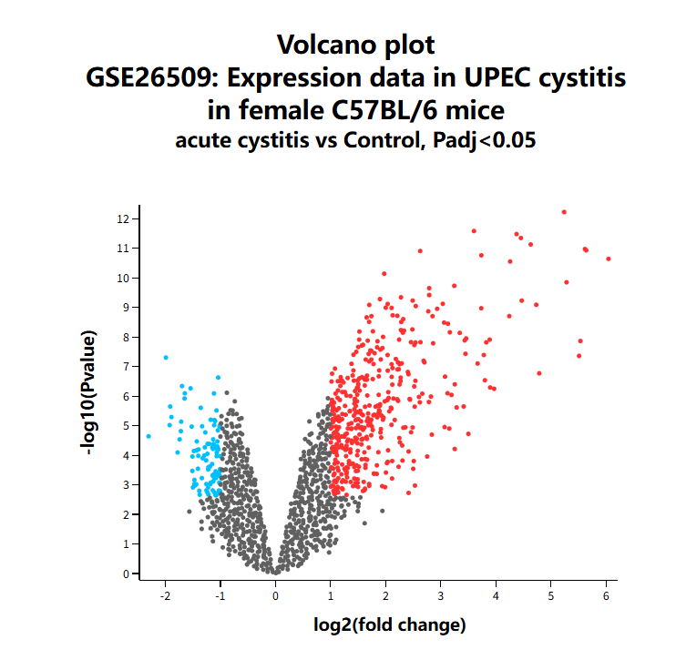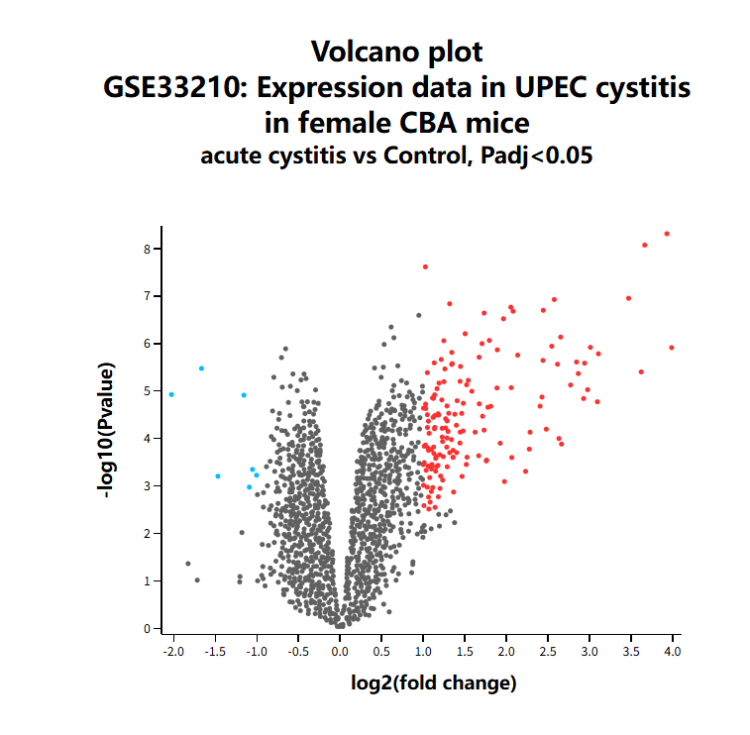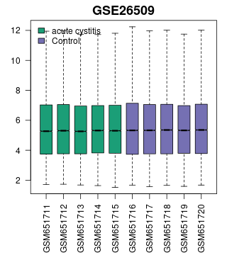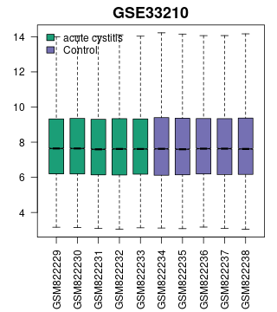

Figure1.Volcano plots of differentially expressed genes from acute-cystitis-associated GEO datasets.Volcano plots display differential gene-expression profiles of dataset GSE33210 and GSE26509. Differentially expressed genes were filtered using thresholds: |log₂FC| > 1, adjusted-P < 0.05. Up-regulated genes linked to acute cystitis were extracted and incorporated into the disease-gene set for subsequent Venn intersection analysis.

