Supplemental Materials:
Supplemental Material 1. Key Driver Diagram

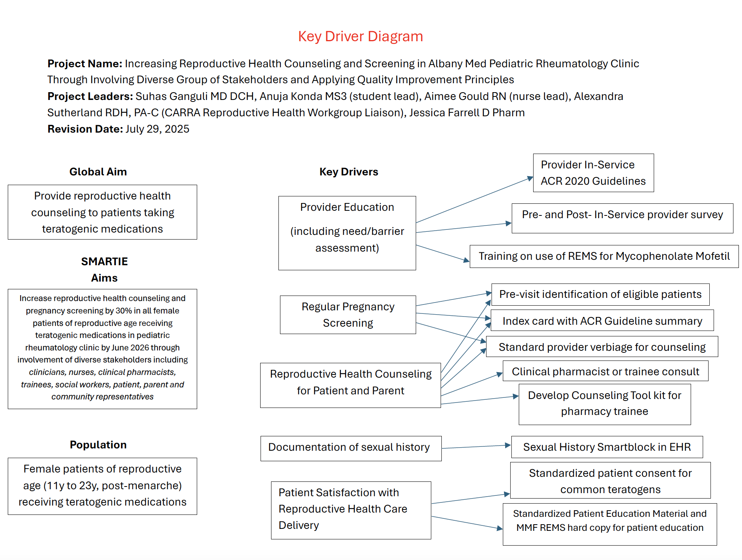
Supplemental Material 2. Poster in patient exam rooms
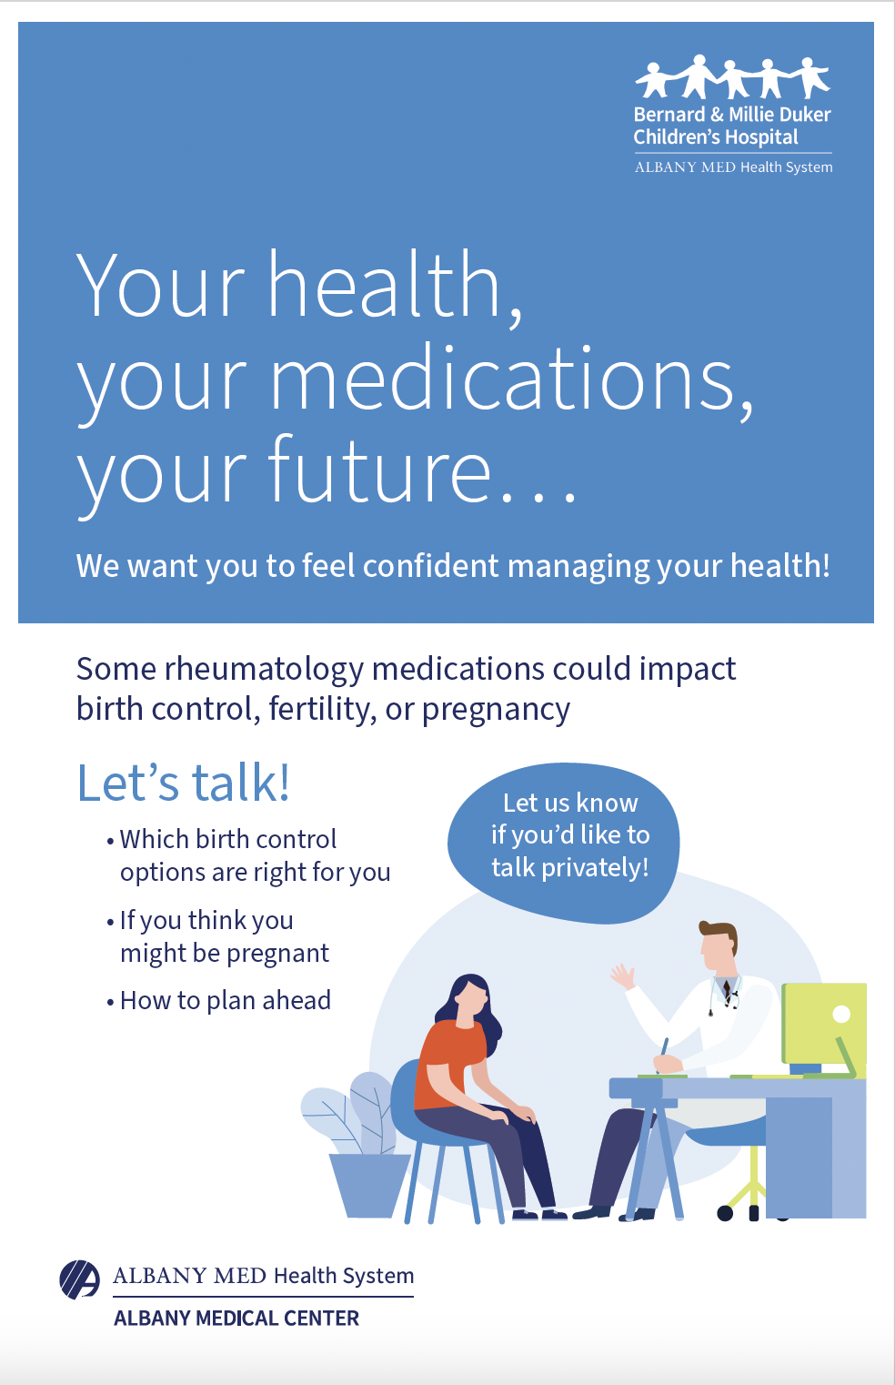

Supplemental Material 3. Verbiage quick reference sheet for providers
