Supplementary Material
Table S1. Number of heatwave days per calendar year, 2015-2025
Year | 2015 | 2016 | 2017 | 2018 | 2019 | 2020 | 2021 | 2022 | 2023 | 2024 | 2025
n | 12 | 10 | 10 | 11 | 4 | 10 | 11 | 14 | 3 | 15 | 6

Table S2. 311 service request categories, descriptors, and record counts included in the exploratory screening analysis, New York City, 2015–2025.
Category  Problem Detail (formerly descriptor) | N
Air Conditioning | 52,478
Noise: air condition/ventilation equipment (NV1) | 47,394
Air Conditioning Problem | 3,212
Door Open with Air Conditioning On | 1,869
Noise: Air Condition/Ventilation Equip, Commercial (NJ2) | 2
Illegal Air Conditioning During Drought (CJO) | 1
Beach/Pool/Sauna Complaint | 1,921
Beach/Pool Water | 928
Facility Maintenance | 569
Safety Equipment/Signs | 351
Beach/Pool/Sauna Unpermitted | 54
Indoor Pool Over Capacity | 19
Note: Excluded records with Location = Sauna/Steam Room.
Cooling Tower | 232
Broken/Defective | 136
Unsanitary Condition | 96
Water Hydrant | 281,565
Hydrant Running Full (WA4) | 107,586
Hydrant Running (WC3) | 102,490
Fire Hydrant Emergency (FHE) | 55,142
Illegal Use Of A Hydrant (CIN) | 15,734
Request To Open A Hydrant (WC4) | 380
Remove Hydrant Locking Device (WC6) | 233
Hose | 678
Illegal Use Of Hose - Other (CCO) | 319
Illegal Use Of Hose - Private Residence (CCR) | 239
Illegal Use Of Hose - Private Residence | 120
New Tree Request | 182,303
For One Address | 182,302
For Whole Block | 1
Odor | 144,996
Air: Odor/Fumes, Vehicle Idling (AD3) | 48,877
Chemical Vapors/Gases/Odors | 23,185
Sewer Odor (SA2) | 15,462
Chemical Odor (HD1) | 14,764
Sewage Odor | 11,914
Air: Odor/Fumes, Restaurant (AD2) | 8,494
Taste/Odor, Musty/Stale (QA4) | 3,118
Odor | 3,056
Smoke/Odor | 2,683
unknown odor/taste in drinking water (QA6) | 2,364
Taste/Odor, Bitter/Metallic (QA3) | 1,799
Taste/Odor, Chemical (QA2) | 1,607
Plants- Odor Related Problems (PO1) | 1,435
Taste/Odor, Sewer (QA5) | 1,338
Taste/Odor, Chlorine (QA1) | 1,323
Air: Odor, Nail Salon (AD8) | 975
Pigeon Odor | 770
Odor In Sewer/Catch Basin (ICB) | 607
Air: Odor, Sweet From Unknown Source (AZ1) | 490
Animal Odor | 457
Air: Odor/Fumes, Dry Cleaners (AD1) | 137
Air: Odor/Fumes | 108
Air: Odor/Fumes, Other (Use Comments) (AD6) | 22
Taste/Odor | 9
Air: Odor/Fumes, Other (Use Comments)-For Dep Internal Use Only (YAD6) | 1
Air: Odor/Fumes, Restaurant - For Dep Internal Use Only (YAD2) | 1
Power Outage | 65,223
Power Outage | 65,223
Ventilation | 34,590
Ventilation System | 21,534
Ventilation | 13,056
Total | 763,986
Note: Records with Location = Sauna/Steam Room were excluded from the Beach/Pool/Sauna category.

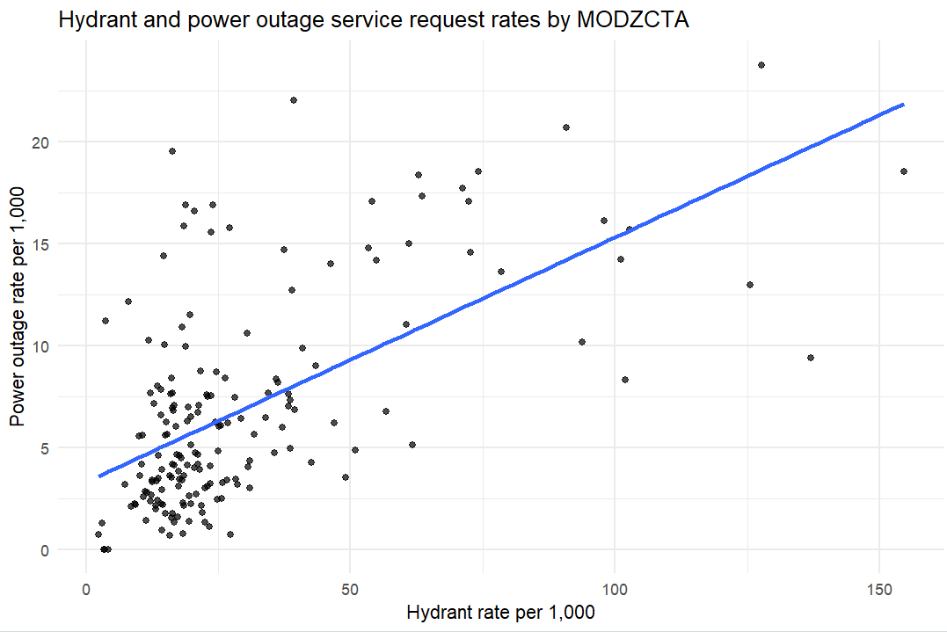
Figure S3. Correlation between hydrant and power outage service request rates by Modified ZIP Code Tabulation Area, New York City, 2015–2025. Each point represents one MODZCTA (n = 177). Rates are expressed per 1,000 residents. Pearson r = 0.60.
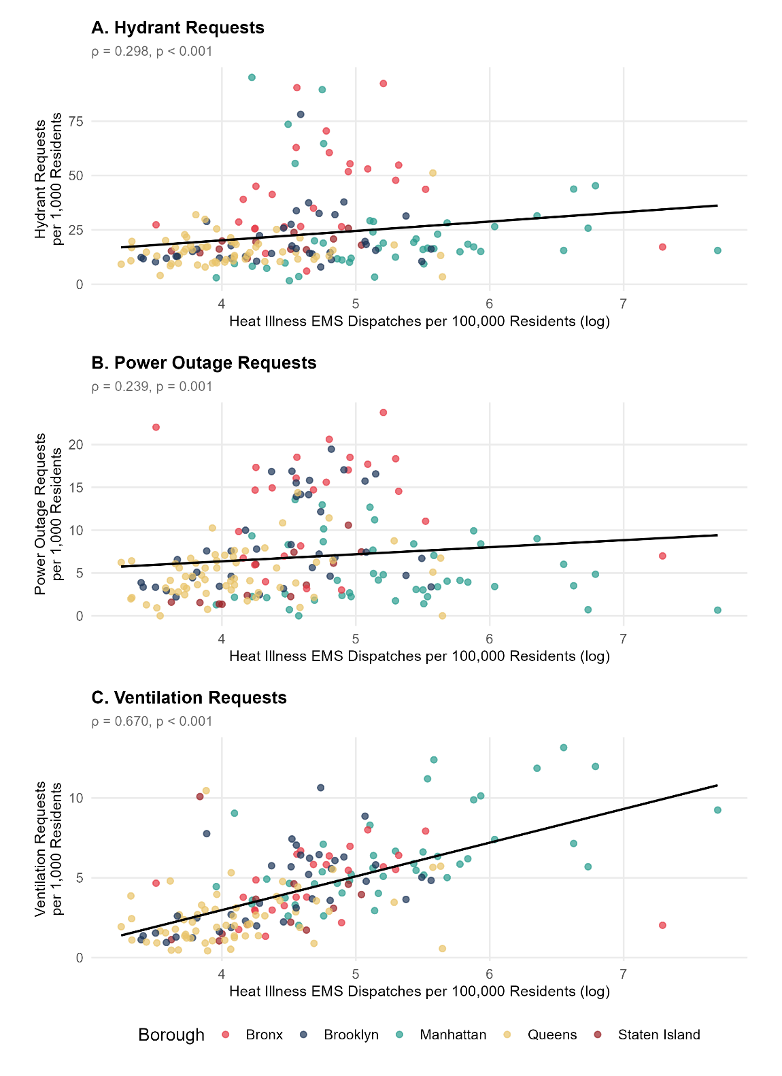
Figure S4. Heat illness EMS dispatch rates and heat-related 311 service request rates by Modified ZIP Code Tabulation Area, New York City, 2015–2025. Scatterplots show the relationship between neighborhood-level heat illness EMS dispatch rates (per 100,000 residents, log-transformed) and rates of hydrant, power outage, and ventilation 311 service requests across 177 MODZCTAs. EMS dispatch data were obtained from the NYC Emergency Medical Services incident dataset and filtered to confirmed heat-related calls (final call type = HEAT, 2015–2025). EMS incidents were linked to MODZCTAs via ZIP code using the MODZCTA boundary file; 70 incidents (0.8%) could not be matched and were excluded. EMS rates were log-transformed (log(rate + 1)) to address right skew driven by low-population MODZCTAs with inflated residential rates, particularly in lower Manhattan where daytime population substantially exceeds residential population. Spearman rank correlations are reported in each panel. Points are colored by borough.

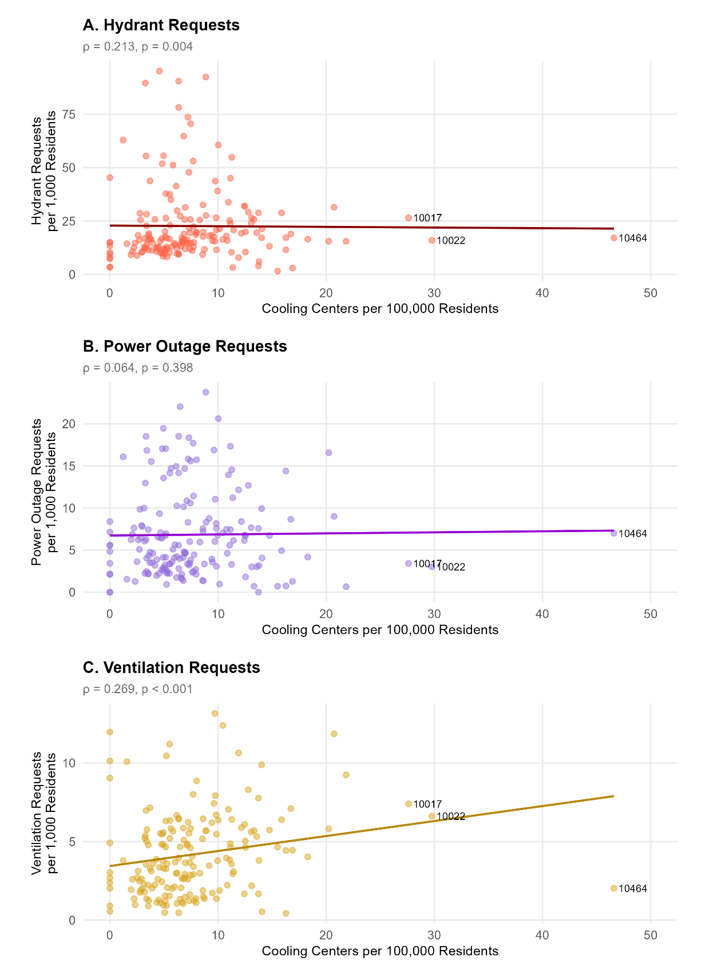
Figure S5. Cooling center density and heat-related 311 service request rates by Modified ZIP Code Tabulation Area, New York City, 2015–2025. Scatterplots show the relationship between cooling center density (per 100,000 residents) and neighborhood-level rates of hydrant, power outage, and ventilation 311 service requests across 177 MODZCTAs. Cooling centers include facilities designated as "Cooling Center" or "Other Indoor Cool Option" in the NYC Cool Options Finder (nyc.gov/coolingcenters, accessed June 2026; n = 602). Spearman rank correlations are reported in each panel. MODZCTA 10464 (City Island, Bronx) and MODZCTAs 10017 and 10022 (Midtown Manhattan) are labeled because of their unusually high cooling center density, likely reflecting the concentration of public and institutional facilities in these areas. Service request rates reflect neighborhood averages across eleven years (2015–2025).

