Supplementary figures
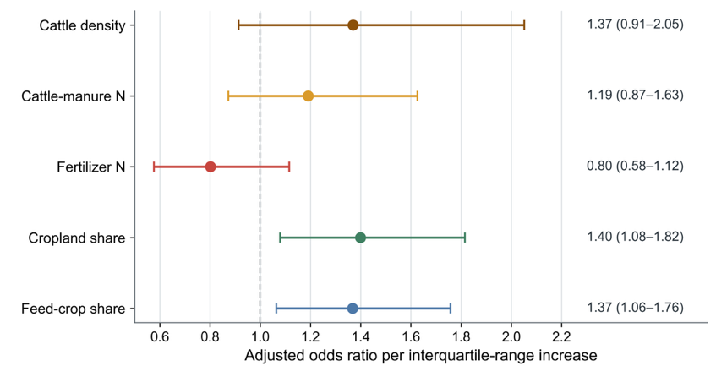
Fig. S1 Nonlinear agricultural exposure-response relationships with groundwater nitrate
Fully adjusted associations between agricultural exposures and groundwater nitrate exceedance. Points show odds ratios for nitrate-N ≥10 mg l⁻¹ per interquartile-range increase in each exposure; horizontal bars show HUC10-cluster-robust 95% confidence intervals, and the dashed vertical line denotes an odds ratio of one. Models were estimated using a common complete-case sample of 19,270 site-years from 8,246 wells in 1,694 HUC10 watersheds and adjusted for year, correlated agricultural variables, precipitation, temperature, well depth, aquifer vulnerability, pH and state fixed effects. Cattle density and cattle-manure nitrogen were evaluated in parallel models because they represent related livestock-exposure domains. Associations are observational and should not be interpreted as causal effects.

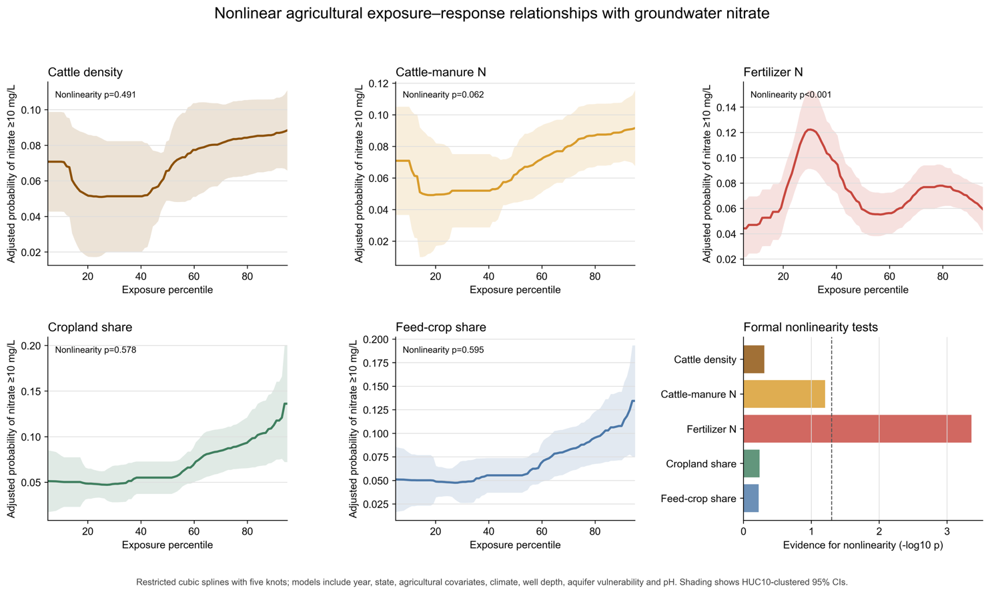
Fig. S2 Nonlinear agricultural exposure-response relationships with groundwater nitrate

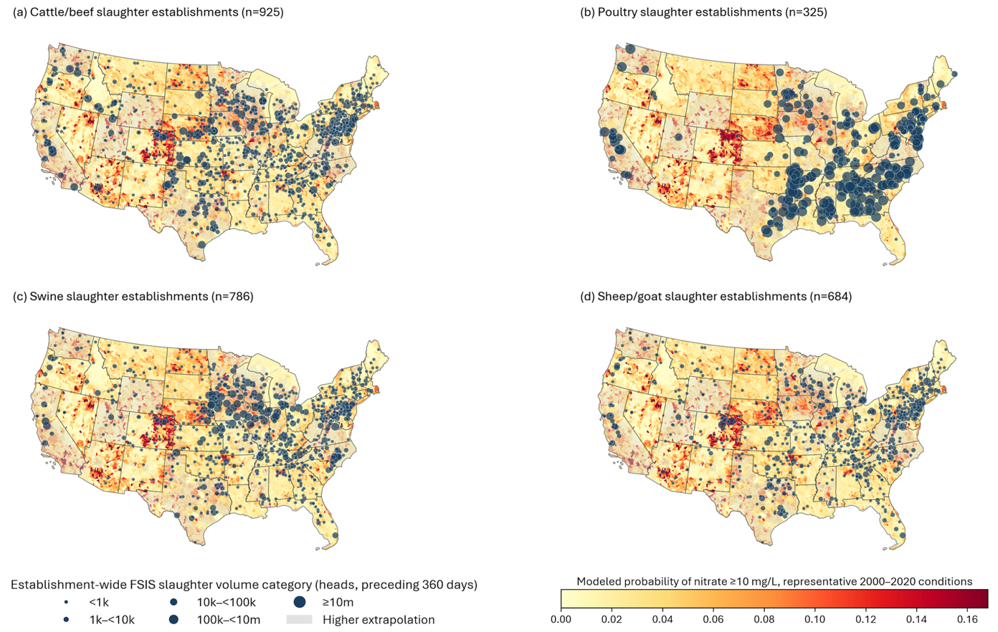
Fig S3. Current FSIS slaughter establishments and modeled groundwater nitrate susceptibility across the conterminous United States

