Sensitivity analysis results

1.Parameters related to consumer behavior.
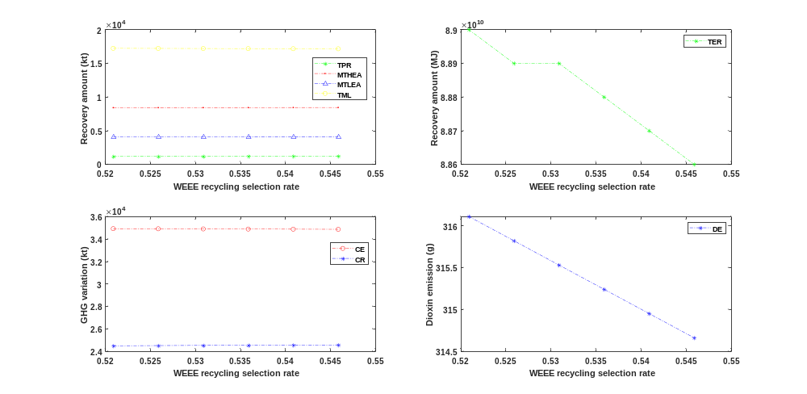
Fig.A.1. The impact of increasing the waste plastic recycling selection rate from WEEE sources

Table A.1. Sensitivity analysis of the waste plastic recycling selection rate from WEEE sources
WEEE to Recycle ($ζ_{EREC}$) | Unit | 0.5209 | 0.5259 | 0.5309 | 0.5359 | 0.5409 | 0.5459
Total Product Recovery (TPR) | kt | 1148.6 | 1159.6 | 1170.6 | 1181.7 | 1192.7 | 1203.7
High end application (MTHEA) | kt | 8390.0 | 8395.3 | 8400.5 | 8405.8 | 8411.1 | 8416.4
Low end application (MTLEA) | kt | 4076.6 | 4075.7 | 4074.7 | 4073.8 | 4072.8 | 4071.9
Energy recovery (TER) | MJ | 8.90*10^10 | 8.89*10^10 | 8.89*10^10 | 8.88*10^10 | 8.87*10^10 | 8.86*10^10
Lost (TML) | kt | 17199.6 | 17186.1 | 17172.6 | 17159.1 | 17145.6 | 17132.1
Carbon emissions (CE) | kt | 34904.8 | 34893.2 | 34881.5 | 34869.9 | 34858.2 | 34846.5
Carbon reduction (CR) | kt | 24473.6 | 24489.0 | 24504.4 | 24519.8 | 24535.1 | 24550.5
Dioxin emissions (DE) | g | 316.11 | 315.82 | 315.53 | 315.24 | 314.95 | 314.66

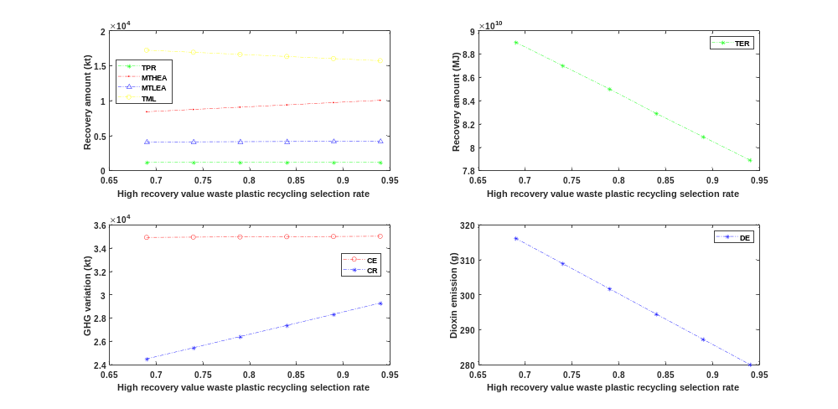
Fig.A.2. The impact of increasing the waste plastic recycling selection rate from household sources (high recovery value)

Table A.2. Sensitivity analysis of the waste plastic recycling selection rate from household sources (high recovery value)
High recovery value waste plastic to keep for sale ($ζ_{HKFS1}$) | Unit | 0.69 | 0.74 | 0.79 | 0.84 | 0.89 | 0.94
Total Product Recovery (TPR) | kt | 1148.6 | 1148.6 | 1148.6 | 1148.6 | 1148.6 | 1148.6
High end application (MTHEA) | kt | 8390.0 | 8718.5 | 9046.9 | 9375.4 | 9703.9 | 10032.3
Low end application (MTLEA) | kt | 4076.6 | 4095.4 | 4114.2 | 4133.0 | 4151.8 | 4170.5
Energy recovery (TER) | MJ | 8.90*10^10 | 8.70*10^10 | 8.50*10^10 | 8.29*10^10 | 8.09*10^10 | 7.89*10^10
Lost (TML) | kt | 17199.6 | 16898.6 | 16597.5 | 16296.5 | 15995.5 | 15694.4
Carbon emissions (CE) | kt | 34904.8 | 34924.2 | 34943.6 | 34962.9 | 34982.3 | 35001.6
Carbon reduction (CR) | kt | 24473.6 | 25431.7 | 26389.9 | 27348.0 | 28306.1 | 29264.3
Dioxin emissions (DE) | g | 316.11 | 308.89 | 301.67 | 294.45 | 287.23 | 280.01

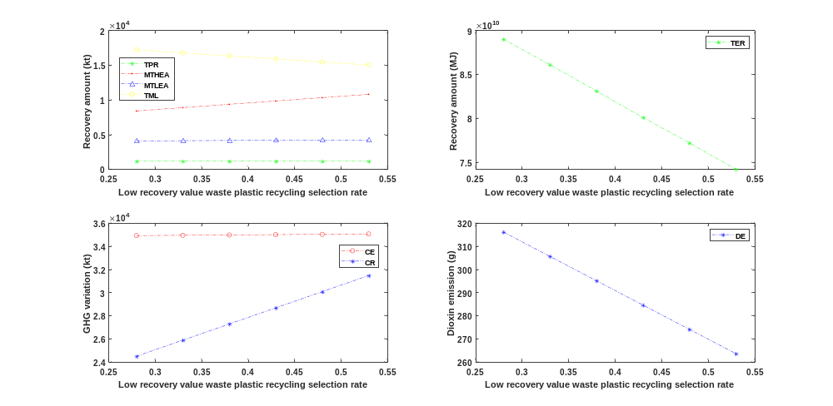
Fig.A.3. The impact of increasing the waste plastic recycling selection rate from household sources (low recovery value)

Table A.3. Sensitivity analysis of the waste plastic recycling selection rate from household sources (low recovery value)
Low recovery value waste plastic to keep for sale ($ζ_{HKFS2}$) | Unit | 0.28 | 0.33 | 0.38 | 0.43 | 0.48 | 0.53
Total Product Recovery (TPR) | kt | 1148.6 | 1148.6 | 1148.6 | 1148.6 | 1148.6 | 1148.6
High end application (MTHEA) | kt | 8390.0 | 8868.6 | 9347.2 | 9825.7 | 10304.3 | 10782.9
Low end application (MTLEA) | kt | 4076.6 | 4104.0 | 4131.4 | 4158.7 | 4186.1 | 4213.4
Energy recovery (TER) | MJ | 8.90*10^10 | 8.61*10^10 | 8.31*10^10 | 8.01*10^10 | 7.72*10^10 | 7.42*10^10
Lost (TML) | kt | 17199.6 | 16761.0 | 16322.4 | 15883.8 | 15445.1 | 15006.5
Carbon emissions (CE) | kt | 34904.8 | 34933.0 | 34961.2 | 34989.5 | 35017.7 | 35045.9
Carbon reduction (CR) | kt | 24473.6 | 25869.6 | 27265.7 | 28661.7 | 30057.7 | 31453.7
Dioxin emissions (DE) | g | 316.11 | 305.59 | 295.07 | 284.55 | 274.03 | 263.52

2.Parameters related to technological progress.
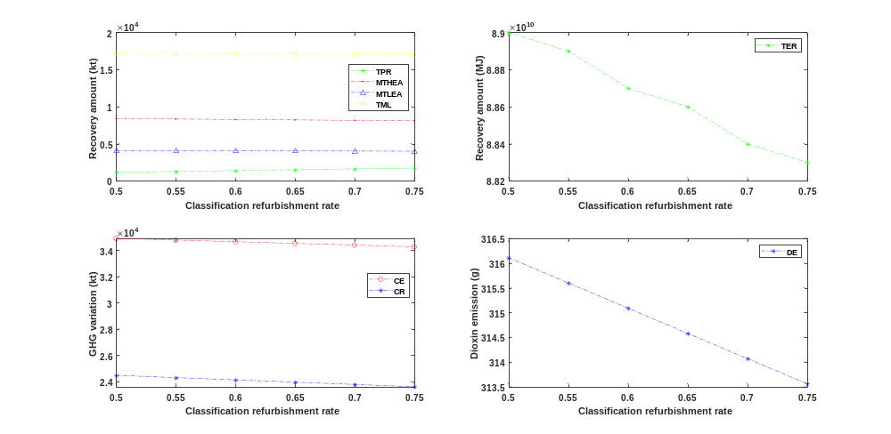
Fig.A.4. The impact of increasing the classification refurbishment rate

Table A.4. Sensitivity analysis of the classification refurbishment rate
Classification refurbishment rate ($η_{Ru}$) | Unit | 0.50 | 0.55 | 0.60 | 0.65 | 0.70 | 0.75
Total Product Recovery (TPR) | kt | 1148.6 | 1263.4 | 1378.3 | 1493.2 | 1608.0 | 1722.9
High end application (MTHEA) | kt | 8390.0 | 8330.7 | 8271.3 | 8212.0 | 8152.7 | 8093.3
Low end application (MTLEA) | kt | 4076.6 | 4060.2 | 4043.8 | 4027.4 | 4010.9 | 3994.5
Energy recovery (TER) | MJ | 8.90*10^10 | 8.89*10^10 | 8.87*10^10 | 8.86*10^10 | 8.84*10^10 | 8.83*10^10
Lost (TML) | kt | 17199.6 | 17163.8 | 17128.0 | 17092.1 | 17056.3 | 17020.5
Carbon emissions (CE) | kt | 34904.8 | 34776.6 | 34648.4 | 34520.2 | 34392.0 | 34263.7
Carbon reduction (CR) | kt | 24473.6 | 24300.5 | 24127.4 | 23954.4 | 23781.3 | 23608.2
Dioxin emissions (DE) | g | 316.11 | 315.60 | 315.09 | 314.58 | 314.07 | 313.56

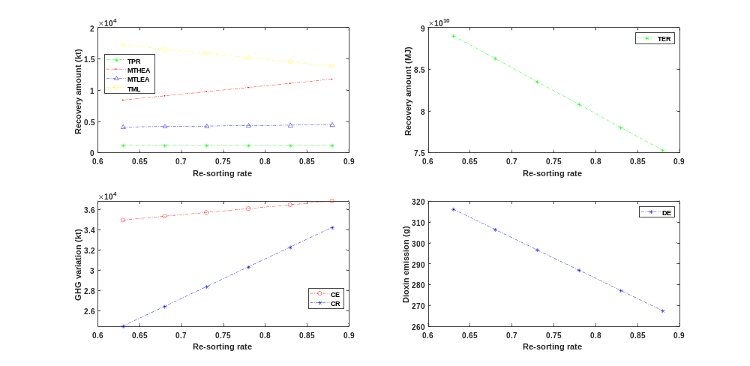
Fig.A.5. The impact of increasing the re-sorting rate

Table A.5. Sensitivity analysis of the re-sorting rate
Sorting to waste plastic plant ($η_{SREC}$) | Unit | 0.63 | 0.68 | 0.73 | 0.78 | 0.83 | 0.88
Total Product Recovery (TPR) | kt | 1148.6 | 1148.6 | 1148.6 | 1148.6 | 1148.6 | 1148.6
High end application (MTHEA) | kt | 8390.0 | 9055.9 | 9721.7 | 10387.6 | 11053.5 | 11719.4
Low end application (MTLEA) | kt | 4076.6 | 4149.9 | 4223.1 | 4296.3 | 4369.5 | 4442.7
Energy recovery (TER) | MJ | 8.90*10^10 | 8.63*10^10 | 8.35*10^10 | 8.08*10^10 | 7.80*10^10 | 7.53*10^10
Lost (TML) | kt | 17199.6 | 16522.9 | 15846.2 | 15169.4 | 14492.7 | 13816.0
Carbon emissions (CE) | kt | 34904.8 | 35280.3 | 35655.8 | 36031.3 | 36406.8 | 36782.3
Carbon reduction (CR) | kt | 24473.6 | 26416.0 | 28358.3 | 30300.7 | 32243.0 | 34185.4
Dioxin emissions (DE) | g | 316.11 | 306.37 | 296.62 | 286.88 | 277.13 | 267.39

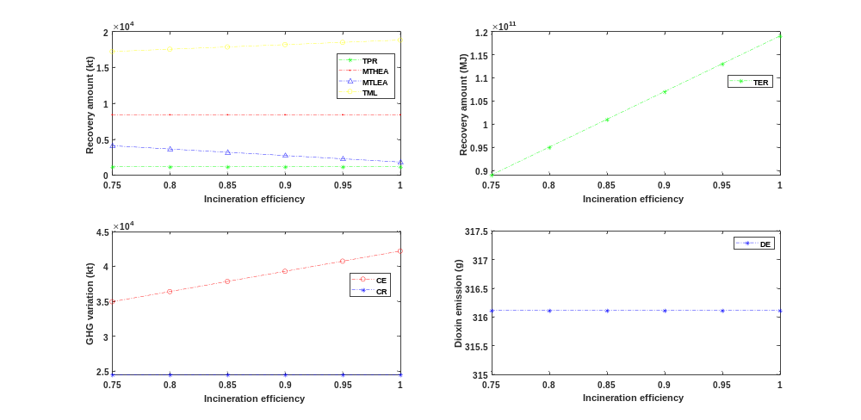
Fig.A.6. The impact of increasing the incineration efficiency

Table A.6. Sensitivity analysis of the incineration efficiency
Incineration efficiency ($η_{INC}$) | Unit | 0.75 | 0.80 | 0.85 | 0.90 | 0.95 | 1.00
Total Product Recovery (TPR) | kt | 1148.6 | 1148.6 | 1148.6 | 1148.6 | 1148.6 | 1148.6
High end application (MTHEA) | kt | 8390.0 | 8390.0 | 8390.0 | 8390.0 | 8390.0 | 8390.0
Low end application (MTLEA) | kt | 4076.6 | 3622.3 | 3167.9 | 2713.6 | 2259.2 | 1804.9
Energy recovery (TER) | MJ | 8.90*10^10 | 9.50*10^10 | 1.01*10^11 | 1.07*10^11 | 1.13*10^11 | 1.19*10^11
Lost (TML) | kt | 17199.6 | 17519.1 | 17838.6 | 18158.1 | 18477.5 | 18797.0
Carbon emissions (CE) | kt | 34904.8 | 36353.7 | 37802.5 | 39251.3 | 40700.2 | 42149.0
Carbon reduction (CR) | kt | 24473.6 | 24473.6 | 24473.6 | 24473.6 | 24473.6 | 24473.6
Dioxin emissions (DE) | g | 316.11 | 316.11 | 316.11 | 316.11 | 316.11 | 316.11

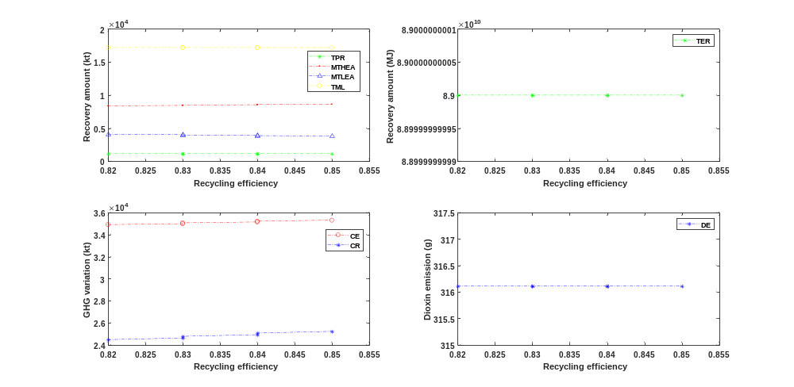
Fig.A.7. The impact of increasing the recycling efficiency of waste plastics

Table A.7. Sensitivity analysis of the recycling efficiency of waste plastics
Recycling efficiency of waste plastics ($η_{REC}$) | Unit | 0.82 | 0.825 | 0.83 | 0.835 | 0.84 | 0.845
Total Product Recovery (TPR) | kt | 1148.6 | 1148.6 | 1148.6 | 1148.6 | 1148.6 | 1148.6
High end application (MTHEA) | kt | 8390.0 | 8441.2 | 8492.3 | 8543.5 | 8594.6 | 8645.8
Low end application (MTLEA) | kt | 4076.6 | 4026.5 | 3976.4 | 3926.2 | 3876.1 | 3826.0
Energy recovery (TER) | MJ | 8.90*10^10 | 8.90*10^10 | 8.90*10^10 | 8.90*10^10 | 8.90*10^10 | 8.90*10^10
Lost (TML) | kt | 17199.6 | 17198.6 | 17197.6 | 17196.5 | 17195.5 | 17194.5
Carbon emissions (CE) | kt | 34904.8 | 34985.2 | 35065.5 | 35145.8 | 35226.1 | 35306.4
Carbon reduction (CR) | kt | 24473.6 | 24622.8 | 24772.1 | 24921.3 | 25070.5 | 25219.8
Dioxin emissions (DE) | g | 316.11 | 316.11 | 316.11 | 316.11 | 316.11 | 316.11

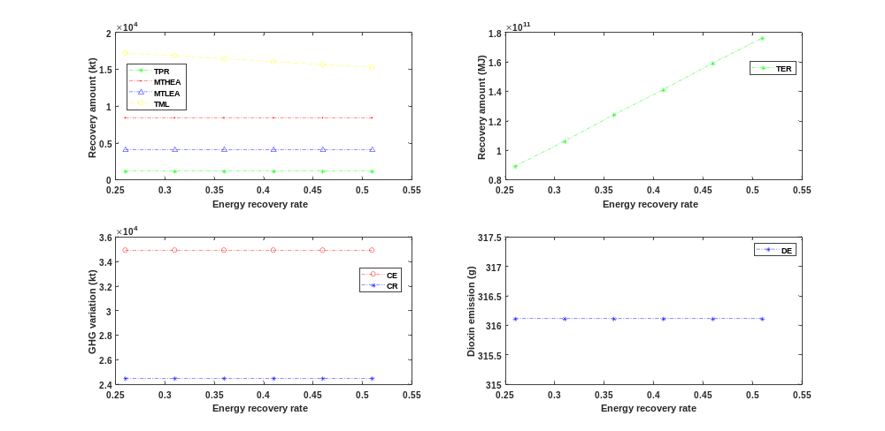
Fig.A.8. The impact of increasing the energy recovery rate of waste plastic incineration

Table A.8. Sensitivity analysis of the energy recovery rate of waste plastic incineration
Energy recovery rate of waste plastic incineration (${TP}_{wp}$) | Unit | 0.256 | 0.306 | 0.356 | 0.406 | 0.456 | 0.506
Total Product Recovery (TPR) | kt | 1148.6 | 1148.6 | 1148.6 | 1148.6 | 1148.6 | 1148.6
High end application (MTHEA) | kt | 8390.0 | 8390.0 | 8390.0 | 8390.0 | 8390.0 | 8390.0
Low end application (MTLEA) | kt | 4076.6 | 4076.6 | 4076.6 | 4076.6 | 4076.6 | 4076.6
Energy recovery (TER) | MJ | 8.90*10^10 | 1.06*10^11 | 1.24*10^11 | 1.41*10^11 | 1.59*10^11 | 1.76*10^11
Lost (TML) | kt | 17199.6 | 16804.5 | 16409.3 | 16014.2 | 15619.1 | 15223.9
Carbon emissions (CE) | kt | 34904.8 | 34904.8 | 34904.8 | 34904.8 | 34904.8 | 34904.8
Carbon reduction (CR) | kt | 24473.6 | 24473.6 | 24473.6 | 24473.6 | 24473.6 | 24473.6
Dioxin emissions (DE) | g | 316.11 | 316.11 | 316.11 | 316.11 | 316.11 | 316.11

3.Parameters related to government policy.
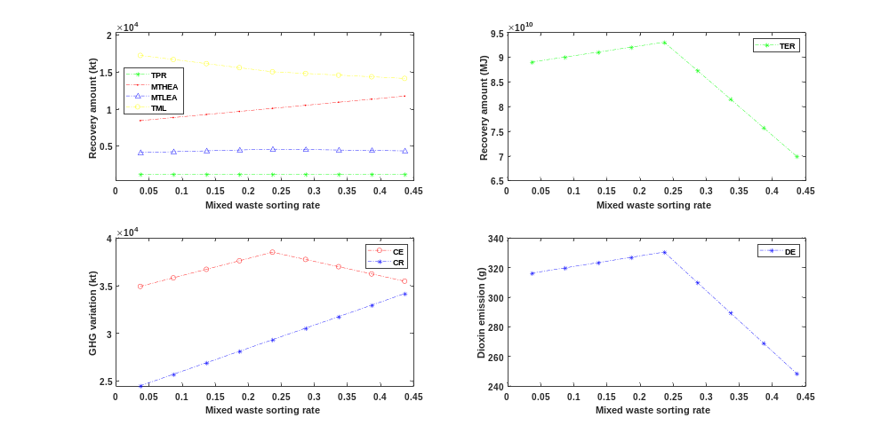
Fig.A.9. The impact of increasing the mixed waste sorting rate

Table A.9. Sensitivity analysis of the mixed waste sorting rate
Mixed waste to classification recovery ($ε_{MWREC}$) | Unit | 0.037 | 0.087 | 0.137 | 0.187 | 0.237 | 0.287 | 0.337 | 0.387 | 0.437
Total Product Recovery (TPR) | kt | 1148.6 | 1148.6 | 1148.6 | 1148.6 | 1148.6 | 1148.6 | 1148.6 | 1148.6 | 1148.6
High end application (MTHEA) | kt | 8390.0 | 8804.4 | 9218.7 | 9633.1 | 10047.5 | 10461.8 | 10876.2 | 11290.6 | 11704.9
Low end application (MTLEA) | kt | 4076.6 | 4191.4 | 4306.1 | 4420.8 | 4535.6 | 4477.4 | 4419.2 | 4361.0 | 4302.8
Energy recovery (TER) | MJ | 8.90*10^10 | 9.00*10^10 | 9.10*10^10 | 9.20*10^10 | 9.30*10^10 | 8.73*10^10 | 8.15*10^10 | 7.57*10^10 | 6.99*10^10
Lost (TML) | kt | 17199.6 | 16647.7 | 16095.8 | 15543.9 | 14992.0 | 14767.1 | 14542.1 | 14317.2 | 14092.2
Carbon emissions (CE) | kt | 34904.8 | 35800.2 | 36695.6 | 37591.0 | 38486.4 | 37727.5 | 36968.6 | 36209.6 | 35450.7
Carbon reduction (CR) | kt | 24473.6 | 25682.3 | 26891.0 | 28099.7 | 29308.5 | 30517.2 | 31725.9 | 32934.6 | 34143.3
Dioxin emissions (DE) | g | 316.11 | 319.67 | 323.23 | 326.79 | 330.36 | 309.85 | 289.35 | 268.85 | 248.35

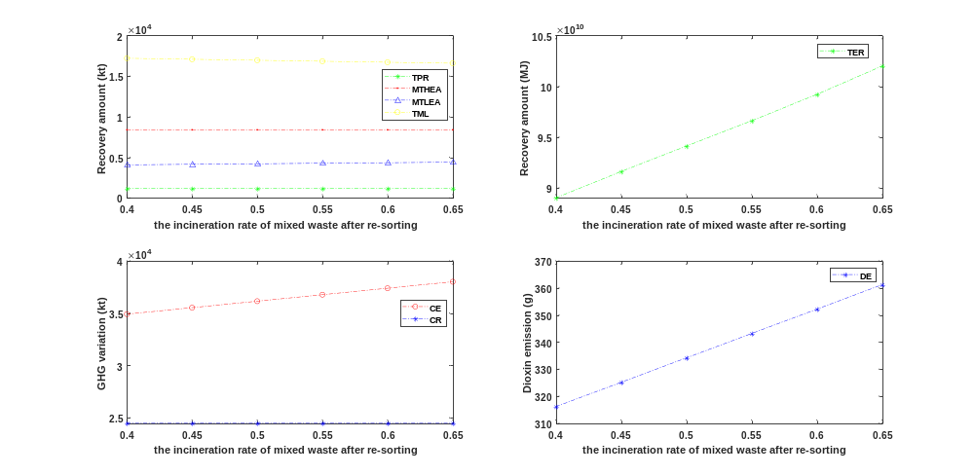
Fig.A.10. The impact of increasing the incineration rate of mixed waste after re-sorting

Table A.10. Sensitivity analysis of the incineration rate of mixed waste after re-sorting
Mixed waste in waste plastic market to incineration ($ε_{SINC}$) | Unit | 0.4 | 0.45 | 0.5 | 0.55 | 0.6 | 0.65
Total Product Recovery (TPR) | kt | 1148.6 | 1148.6 | 1148.6 | 1148.6 | 1148.6 | 1148.6
High end application (MTHEA) | kt | 8390.0 | 8390.0 | 8390.0 | 8390.0 | 8390.0 | 8390.0
Low end application (MTLEA) | kt | 4076.6 | 4141.4 | 4206.2 | 4271.0 | 4335.8 | 4400.5
Energy recovery (TER) | MJ | 8.90*10^10 | 9.16*10^10 | 9.41*10^10 | 9.66*10^10 | 9.92*10^10 | 1.02*10^11
Lost (TML) | kt | 17199.6 | 17077.1 | 16954.7 | 16832.2 | 16709.7 | 16587.3
Carbon emissions (CE) | kt | 34904.8 | 35524.5 | 36144.2 | 36763.9 | 37383.6 | 38003.3
Carbon reduction (CR) | kt | 24473.6 | 24473.6 | 24473.6 | 24473.6 | 24473.6 | 24473.6
Dioxin emissions (DE) | g | 316.11 | 325.12 | 334.14 | 343.15 | 352.16 | 361.18

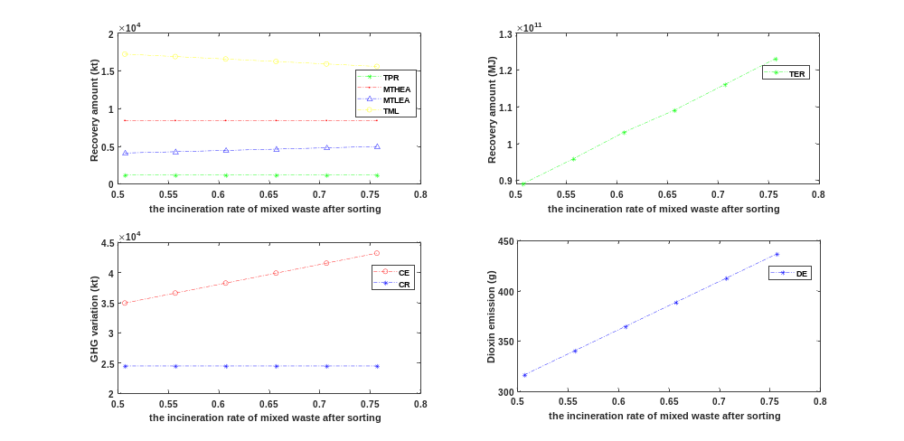
Fig.A.11. The impact of increasing the incineration rate of mixed waste after sorting

Table A.11. Sensitivity analysis of the incineration rate of mixed waste after sorting
Mixed waste to incineration ($ε_{MWINC}$) | Unit | 0.507 | 0.557 | 0.607 | 0.657 | 0.707 | 0.757
Total Product Recovery (TPR) | kt | 1148.6 | 1148.6 | 1148.6 | 1148.6 | 1148.6 | 1148.6
High end application (MTHEA) | kt | 8390.0 | 8390.0 | 8390.0 | 8390.0 | 8390.0 | 8390.0
Low end application (MTLEA) | kt | 4076.6 | 4249.6 | 4422.5 | 4595.4 | 4768.4 | 4941.3
Energy recovery (TER) | MJ | 8.90*10^10 | 9.58*10^10 | 1.03*10^11 | 1.09*10^11 | 1.16*10^11 | 1.23*10^11
Lost (TML) | kt | 17199.6 | 16872.7 | 16545.7 | 16218.8 | 15891.9 | 15564.9
Carbon emissions (CE) | kt | 34904.8 | 36559.2 | 38213.5 | 39867.9 | 41522.2 | 43176.6
Carbon reduction (CR) | kt | 24473.6 | 24473.6 | 24473.6 | 24473.6 | 24473.6 | 24473.6
Dioxin emissions (DE) | g | 316.11 | 340.17 | 364.24 | 388.30 | 412.36 | 436.43

