Supplementary Information
The following supplementary Figures and tables support the main text. All electrochemical data were collected as described in Section 2.4; all UV-Vis data were collected as described in Section 2.5.

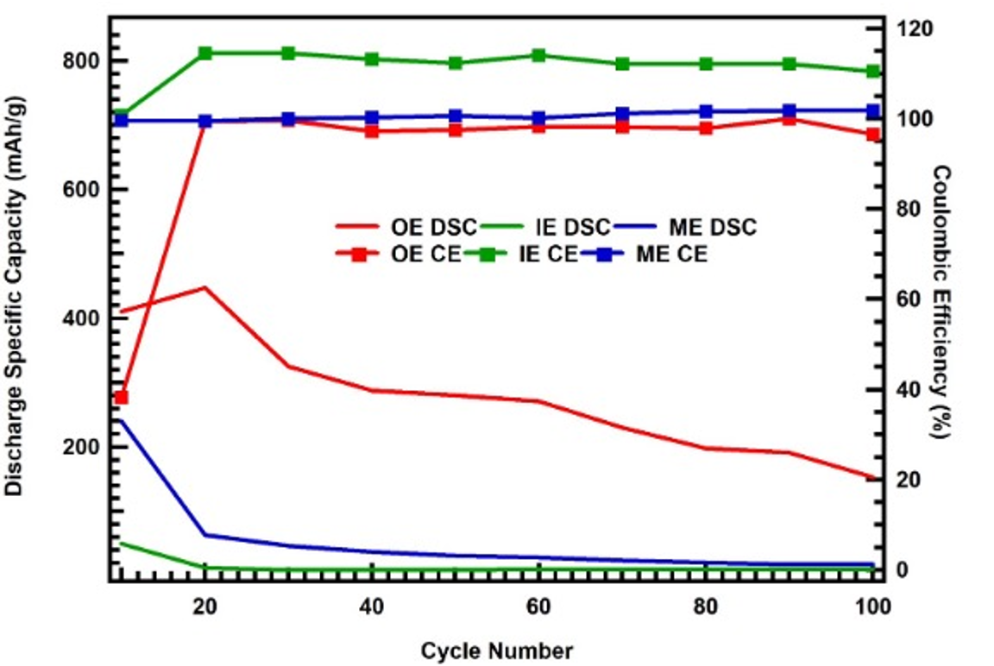
Figure S1. Discharge specific capacity and Coulombic efficiency vs. cycle number (0.56 mA, 0.5-3.1 V) for OE, ILE, and ME cells over 100 cycles. The ILE and ME cells maintain Coulombic efficiency ≥99% from cycle 10 onward. The OE cell shows persistently lower Coulombic efficiency (<99%) from cycle 10 onward, indicative of greater charge loss to the polysulfide shuttle than ILE and ME. Especially, below cycle number 20, OE can be as low as (<40%) for CE, which demonstrates a significant charge loss due to polysulfide shuttling.
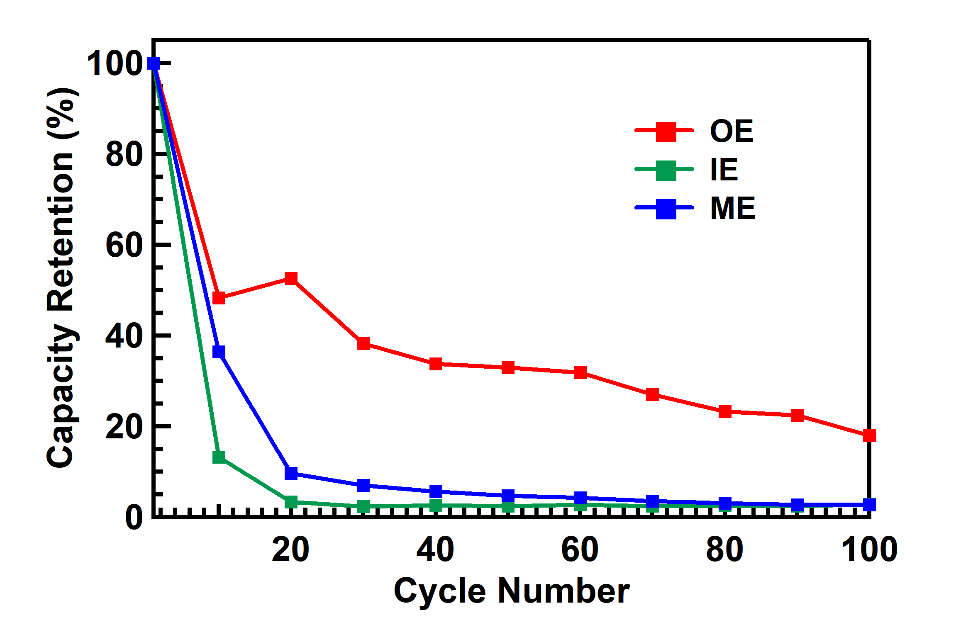
Figure S2. Discharge specific capacity and capacity retention vs. cycle number (0.56 mA, 0.5-3.1 V) for OE, ILE, and ME cells over 100 cycles. The OE cell delivers the highest initial discharge capacity but exhibits the steepest capacity fade. The ME cell shows intermediate initial capacity with more stable retention relative to ILE over extended cycling.

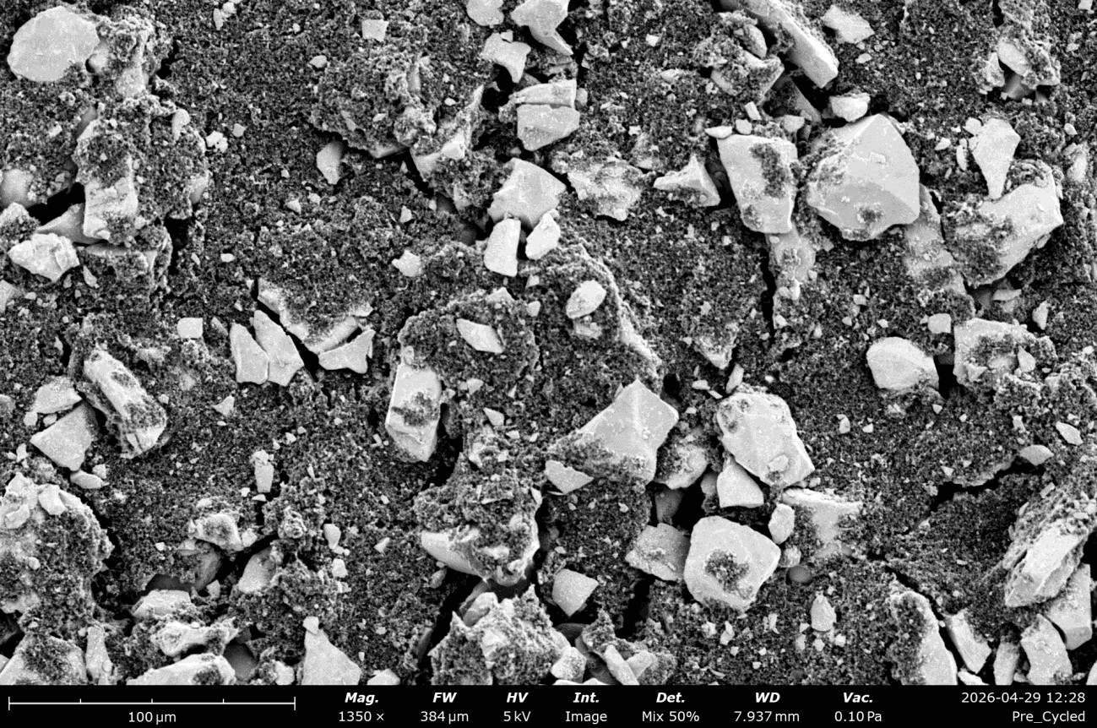
Figure S3. FESEM image of the pre-cycled FeS₂ cathode showing large FeS₂ particles (bright contrast) distributed within a carbon black matrix (dark contrast). The heterogeneous microstructure is characteristic of a slurry-cast composite electrode.

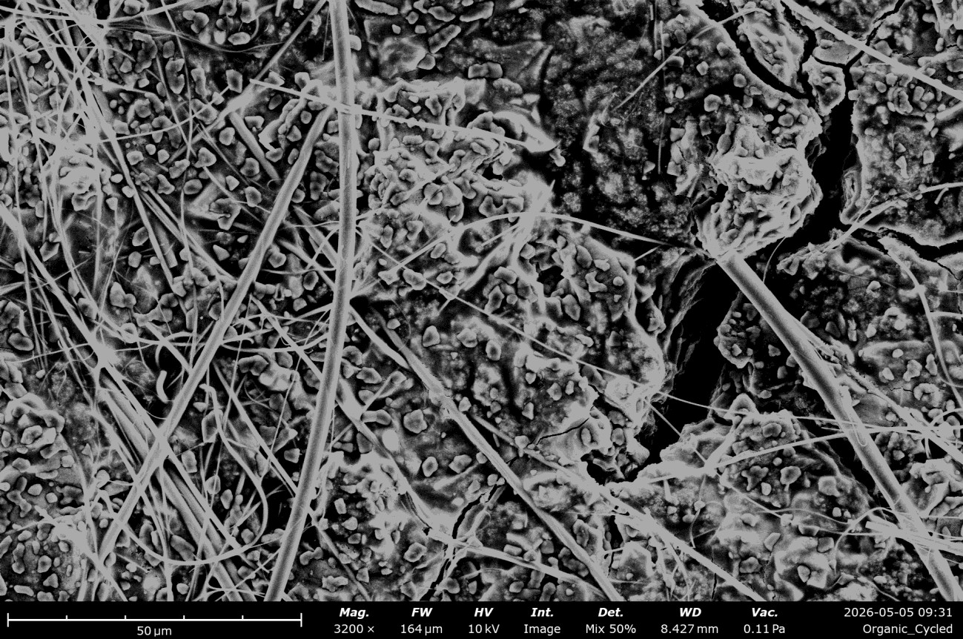
Figure S4. FESEM image of the FeS₂ cathode after 3 cycles in OE (0.56 mA, 0.5-3.1 V). The post-cycled electrode exhibits a range of particle morphologies including rods and fine particles, indicative of partial conversion and recrystallization of FeS₂ during cycling.

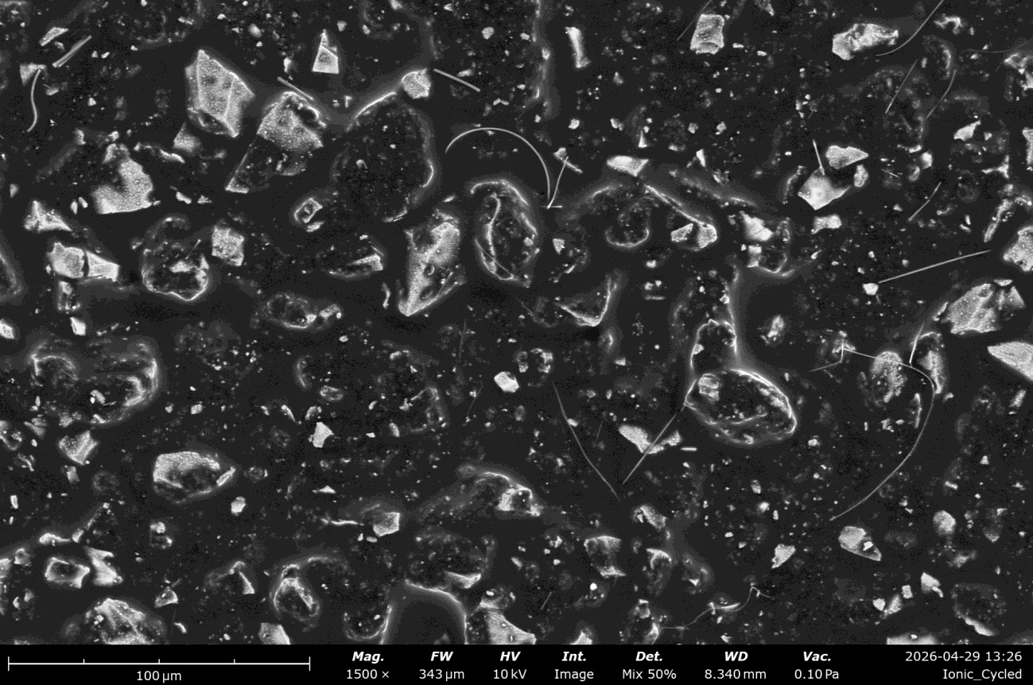
Figure S5. FESEM image of the FeS₂ cathode after 3 cycles in ILE (0.56 mA, 0.5-3.1 V). The FeS₂ particle density is reduced relative to the pre-cycled electrode and the OE-cycled electrode, suggesting greater active-material consumption or dissolution during cycling in the ionic liquid medium.

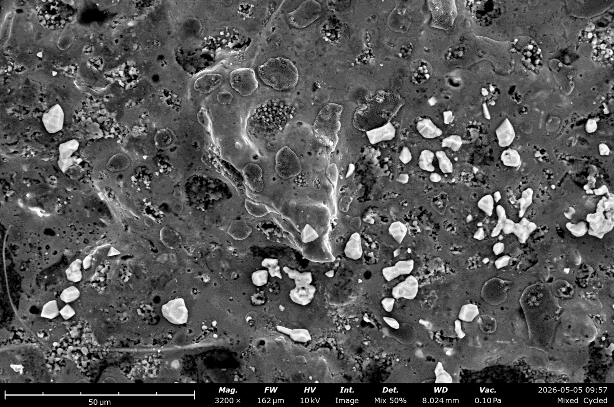
Figure S6. FESEM image of the FeS₂ cathode after 3 cycles in ME (0.56 mA, 0.5-3.1 V). Residual FeS₂ particle size and density are intermediate between those of the OE- and ILE-cycled electrodes, consistent with a balanced conversion and dissolution behavior in the hybrid electrolyte.

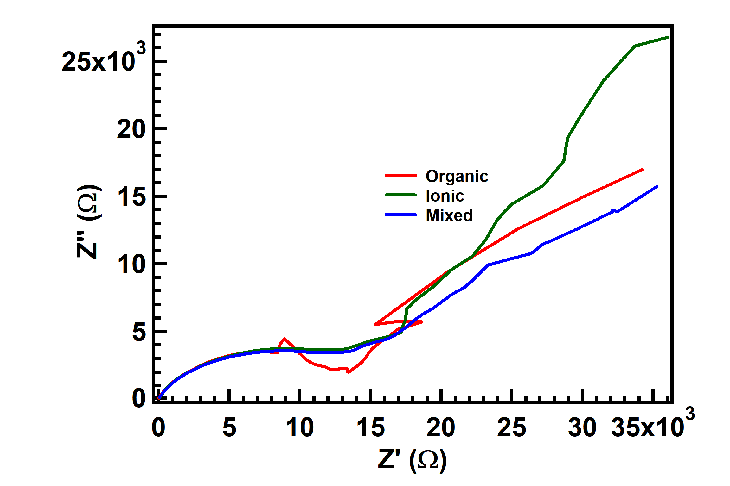
Figure S7. Electrochemical impedance spectra (EIS, 100 kHz-10 mHz, 10 mV perturbation) of pre-cycled Li/FeS₂ cells in OE (red), ILE (green), and ME (blue). Charge-transfer resistance (Rᴄₜ) is 1.4 × 10⁴ Ω for OE, and ~2.0 × 10⁴ Ω for both ILE and ME, consistent with the higher ionic conductivity of the carbonate-based OE prior to cycling.

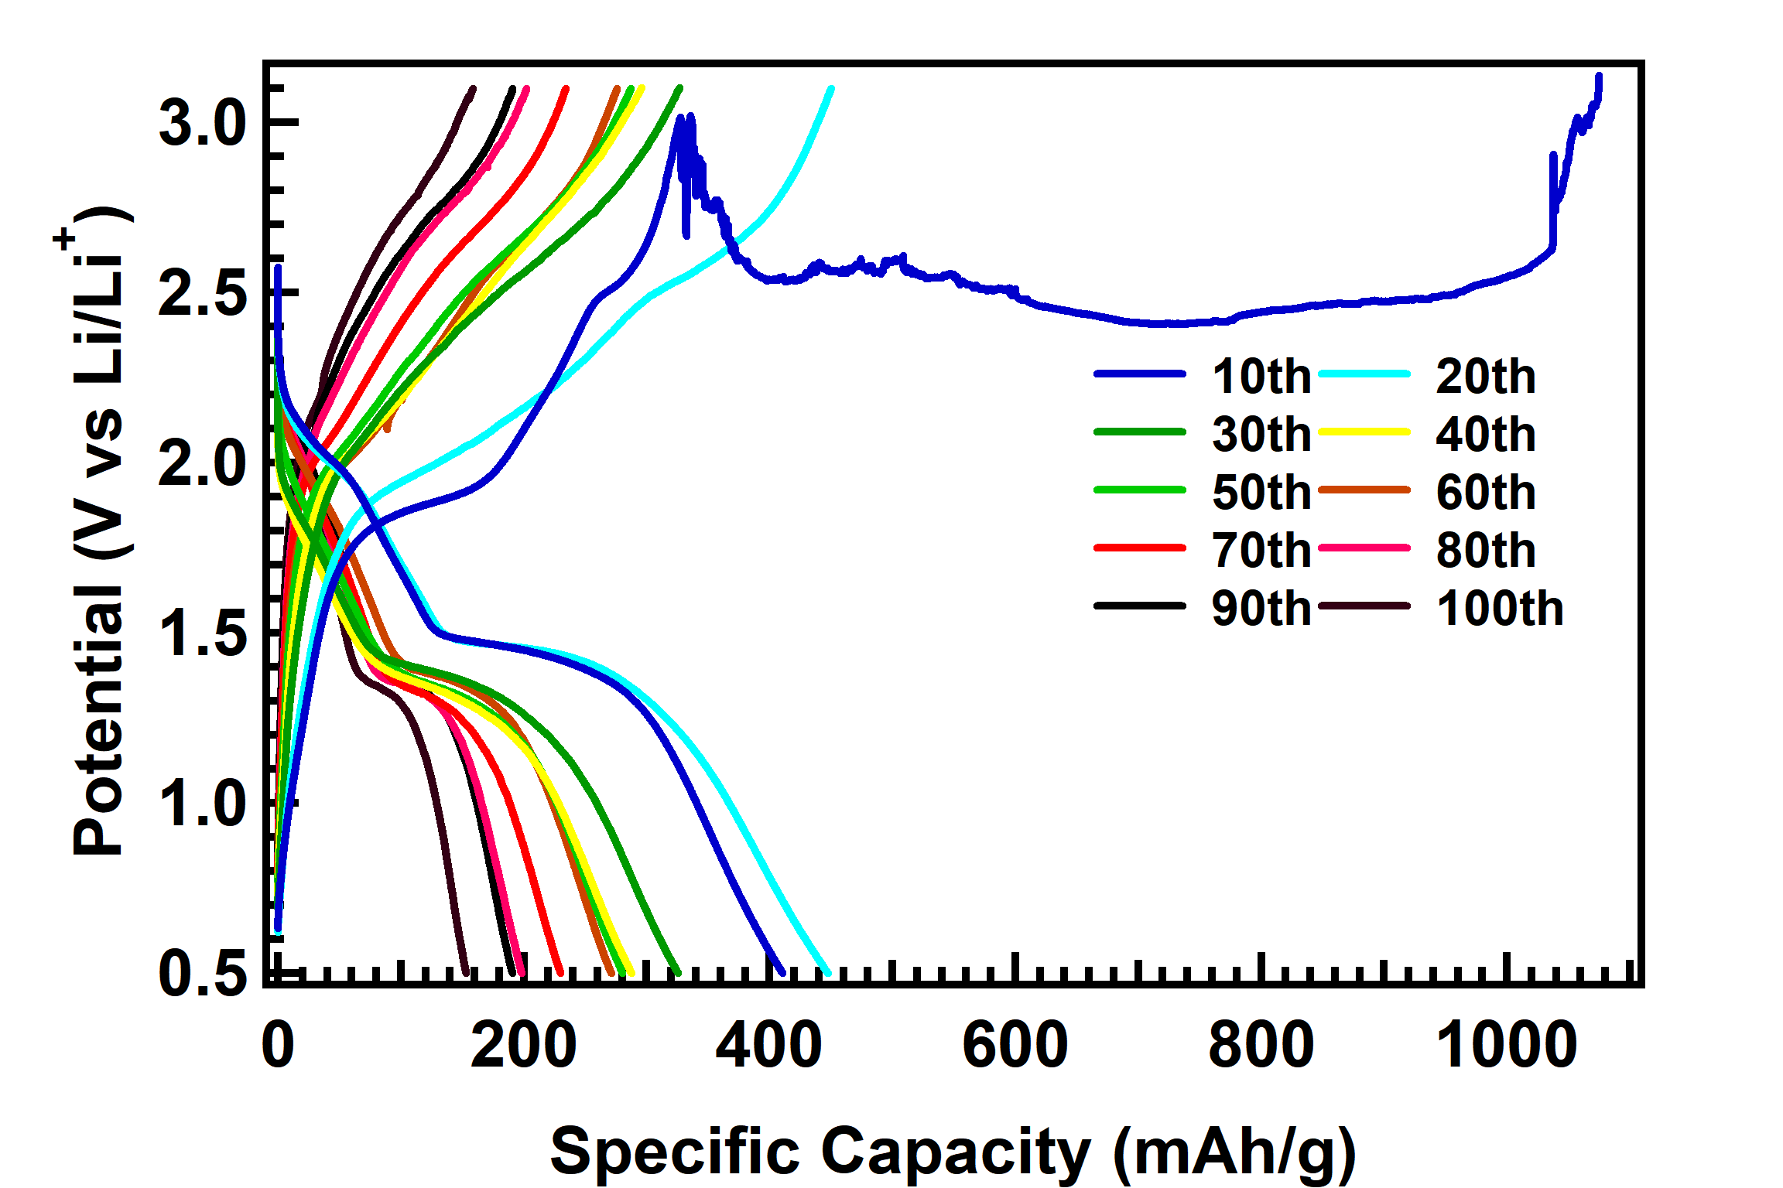
Figure S8. GCD profiles of the FeS₂ cell in OE at the 10th, 20th, 30th, 40th, 50th, 60th, 70th, 80th, 90th, and 100th cycle (0.56 mA, 0.5-3.1 V). Profiles show progressive capacity fade and increasing polarization with cycle number.

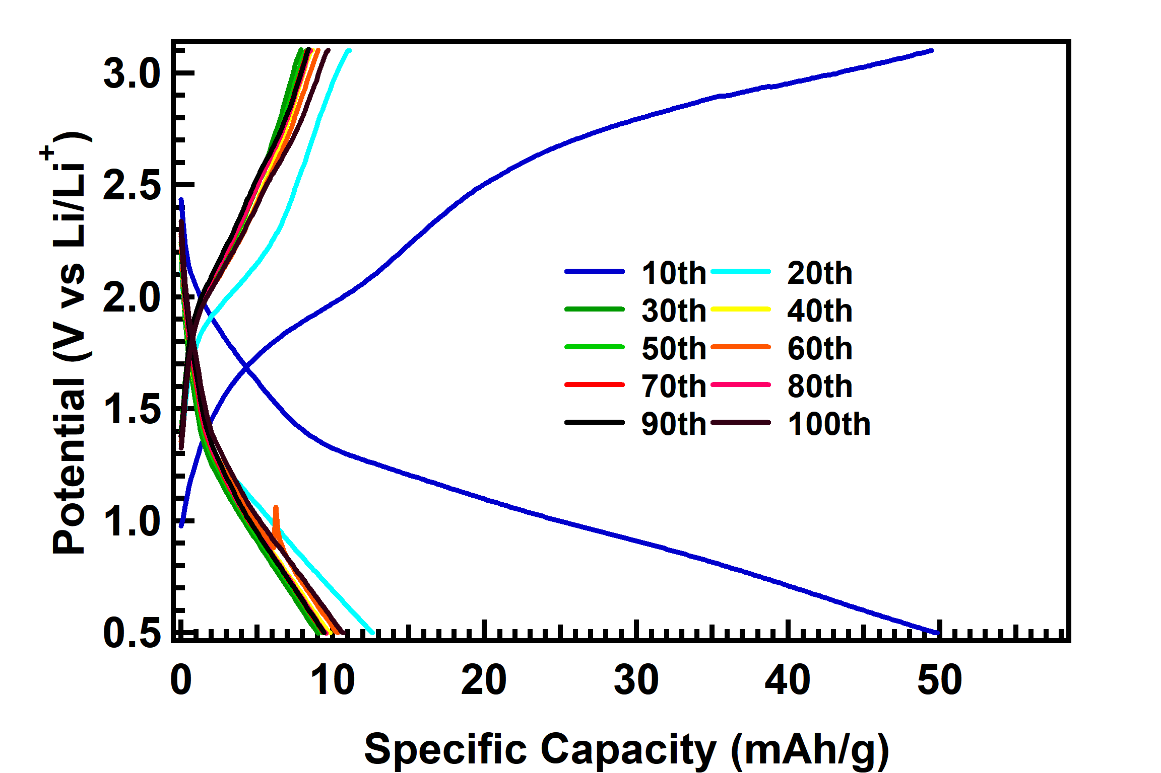
Figure S9. GCD profiles of the FeS₂ cell in ILE at the 10th, 20th, 30th, 40th, 50th, 60th, 70th, 80th, 90th, and 100th cycle (0.56 mA, 0.5-3.1 V). Profiles show moderate capacity fade with relatively stable plateau structure, consistent with partial SEI passivation in the ionic liquid medium.

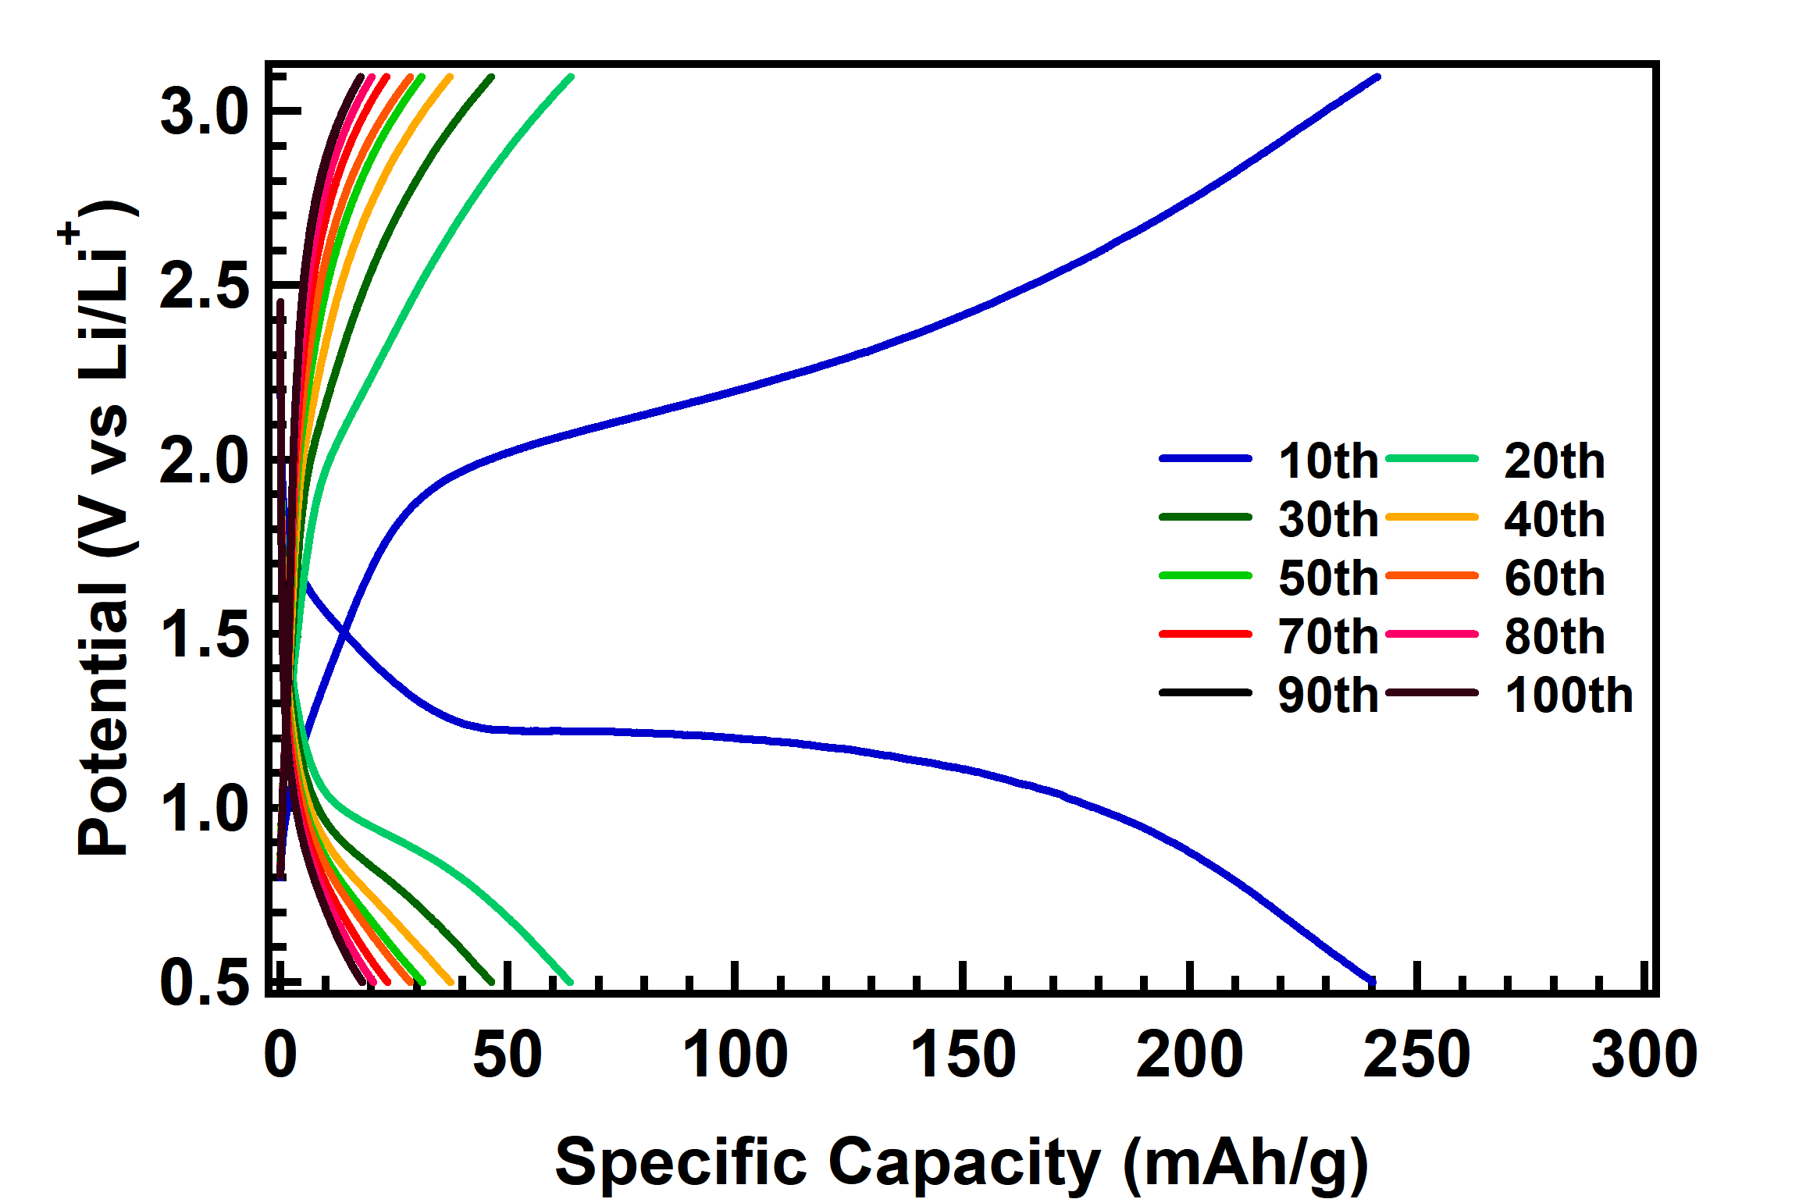
Figure S10. GCD profiles of the FeS₂ cell in ME at the 10th, 20th, 30th, 40th, 50th, 60th, 70th, 80th, 90th, and 100th cycle (0.56 mA, 0.5-3.1 V). Profiles exhibit the most consistent plateau structure and smallest cycle-to-cycle variation among the three electrolytes.

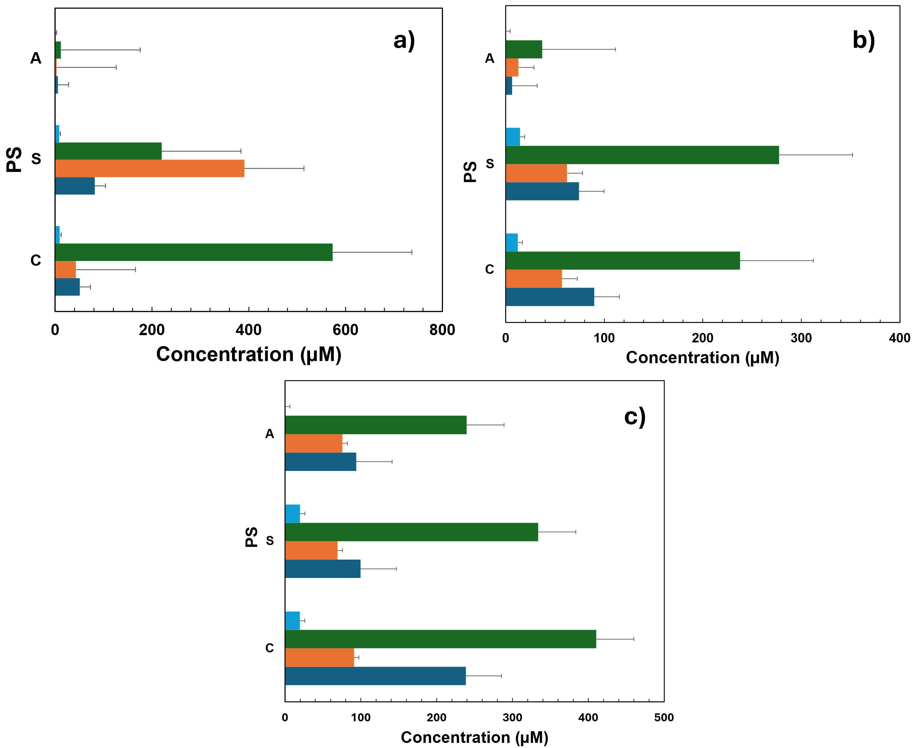
Figure S11. Bar charts of polysulfide species concentrations (μM) in DOL soaks of the anode (A), separator (S), and cathode (C) for (a) OE, (b) ILE, and (c) ME cells after 3 formation cycles. Species: S₈ (dark blue), S₆²⁻ (orange), S₄²⁻ (green), S₃•⁻ (cyan). S₄²⁻ is the dominant species in nearly all components and electrolytes; S₃•⁻ is consistently the least abundant. In the OE separator, S₆²⁻ exceeds S₄²⁻, reflecting selective transport of longer-chain polysulfides through the cell.

Table S1. Molar absorptivity (ε) and characteristic wavelengths for polysulfide species used in Beer-Lambert concentration analysis for the cathode and separator.
Species | Wavelength (nm) | ε (M⁻¹ cm⁻¹)
S₈ | 260, 270 | 7000
S₆²⁻ | 325 | 2575
S₄²⁻ | 306, 410 | 1033
S₃•⁻ | 611 | 4115-4500

Table S2. Molar absorptivity (ε) and characteristic wavelengths for polysulfide species used in Beer-Lambert concentration analysis for the anode.
Species | Wavelength (nm) | ε (M⁻¹ cm⁻¹)
S₈ | 267, 278 | 7000
S₆²⁻ | 363, 488 | 2575
S₄²⁻ | 310, 441 | 1033
S₃•⁻ | - | - (not detected)

Table S3. Polysulfide concentrations in DOL soak of cathode cycled with OE.
Polysulfide Species | Absorbance (a.u.) | Concentration (μM)
S₈ | 0.3550 | 50.71
S₆²⁻ | 0.1096 | 42.55
S₄²⁻ | 0.5919 | 573.02
S₃•⁻ | 0.0421 | 9.36-10.24

Table S4. Polysulfide concentrations in DOL soak of separator cycled with OE.
Polysulfide Species | Absorbance (a.u.) | Concentration (μM)
S₈ | 0.5709 | 81.56
S₆²⁻ | 1.0060 | 390.67
S₄²⁻ | 0.2272 | 219.92
S₃•⁻ | 0.0363 | 8.06-8.82

Table S5. Polysulfide concentrations in DOL soak of anode cycled with OE.
Polysulfide Species | Absorbance (a.u.) | Concentration (μM)
S₈ | 0.0382 | 5.46
S₆²⁻ | 0.0079 | 3.08
S₄²⁻ | 0.0123 | 11.90
S₃•⁻ | - | - (not detected)

Table S6. Polysulfide concentrations in DOL soak of cathode cycled with ILE.
Polysulfide Species | Absorbance (a.u.) | Concentration (μM)
S₈ | 0.6288 | 89.82
S₆²⁻ | 0.1468 | 57.02
S₄²⁻ | 0.2456 | 237.76
S₃•⁻ | 0.0555 | 12.34-13.49

Table S7. Polysulfide concentrations in DOL soak of separator cycled with ILE.
Polysulfide Species | Absorbance (a.u.) | Concentration (μM)
S₈ | 0.5203 | 74.33
S₆²⁻ | 0.1604 | 62.30
S₄²⁻ | 0.2867 | 277.50
S₃•⁻ | 0.0656 | 14.59-15.95

Table S8. Polysulfide concentrations in DOL soak of anode cycled with ILE.
Polysulfide Species | Absorbance (a.u.) | Concentration (μM)
S₈ | 0.0455 | 6.50
S₆²⁻ | 0.0335 | 12.99
S₄²⁻ | 0.0382 | 37.00
S₃•⁻ | - | - (not detected)

Table S9. Polysulfide concentrations in DOL soak of cathode cycled with ME.
Polysulfide Species | Absorbance (a.u.) | Concentration (μM)
S₈ | 1.6684 | 238.34
S₆²⁻ | 0.2344 | 91.04
S₄²⁻ | 0.4239 | 410.39
S₃•⁻ | 0.0873 | 19.40-21.22

Table S10. Polysulfide concentrations in DOL soak of separator cycled with ME.
Polysulfide Species | Absorbance (a.u.) | Concentration (μM)
S₈ | 0.6968 | 99.54
S₆²⁻ | 0.1784 | 69.28
S₄²⁻ | 0.3449 | 333.87
S₃•⁻ | 0.0890 | 19.77-21.62

Table S11. Polysulfide concentrations in DOL soak of anode cycled with ME
Polysulfide Species | Absorbance (a.u.) | Concentration (μM)
S₈ | 0.6569 | 93.84
S₆²⁻ | 0.1949 | 75.67
S₄²⁻ | 0.2474 | 239.53
S₃•⁻ | - | - (not detected)

