Supplementary Material
Multiparametric Rectus Femoris Ultrasound With and Without Serum Biomarkers for Identifying Sarcopenia in Type 2 Diabetes Mellitus: A Cross-Sectional Model-Development Study
Contents: Supplementary Table S1 (Firth penalized model), Supplementary Table S2 (age-stratified performance), Supplementary Table S3 (influence diagnostics for all 209 patients), Supplementary Table S4 (sex and BMI sensitivity), Supplementary Figures S1 and S2 (descriptive decile plots for EI and SII_Z).

Supplementary Table S1. Full Firth penalized logistic regression for the combined model (n = 209).
Predictor | Adjusted OR | 95% CI | P value
Intercept | 15153.149 | 0.061 to 66275844558.049 | 0.1314
Age (years) | 1.148 | 1.026 to 1.331 | 0.0138
STD-RFthick | 0.139 | 0.026 to 0.388 | 4.88e-06
SWEmean | 0.233 | 0.054 to 0.486 | 1.62e-09
EI | 1.137 | 1.053 to 1.298 | 0.0001
TyG_Z | 10.863 | 2.593 to 88.331 | 0.0002
SII_Z | 3.399 | 1.400 to 11.652 | 0.0052
Note. Penalized-likelihood (Firth) estimation addresses sparse-data bias and near-separation. All coefficients were finite and direction-consistent with the conventional model (Table 3). The TyG_Z estimate was attenuated from the conventional maximum-likelihood estimate of 26.490 to 10.863, with a wide confidence interval. The Firth model is reported as a coefficient-stability sensitivity analysis; penalized estimation does not correct calibration or establish transportability.

Supplementary Table S2. Model performance within the two AWGS 2025 age strata.
Age stratum (AWGS 2025) | n | Sarcopenia events | Age only | Model 1 (age + ultrasound) | Model 2 (age + serum) | Model 3 (combined) | Model 1, coefficients fixed from full cohort
< 65 years | 89 | 6 | 0.775 | 0.980 | 0.988 | 1.000 | 0.916
≥ 65 years | 120 | 59 | 0.603 | 0.986 | 0.877 | 0.995 | 0.973
Note. Model 1 values in the main Model 1 column were obtained from models refitted within each age stratum; the final column applies the full-cohort Model 1 coefficients within each stratum without refitting. In participants aged 50-64 years, only 6 sarcopenia events occurred, so all subgroup AUC estimates are unstable and exploratory. In participants aged 65 years or older (59 events), the age-only AUC was 0.603, the within-stratum Model 1 AUC was 0.986, and the fixed-coefficient Model 1 AUC was 0.973. Together with the full-cohort no-age analysis, these findings suggest that the observed discrimination cannot be explained solely by the age dependence of the AWGS 2025 definition. No interaction testing was performed.

Supplementary Table S3. Influence diagnostics for the combined model: all 209 patients.
Patient ID | Cook's distance | Leverage | DFBETA TyG_Z | DFBETA SII_Z | DFBETA SWEmean | Cook's D > 4/n | Leverage > 3p/n
1 | 0.2829 | 0.3363 | -0.7968 | -0.5362 | 0.2396 | Yes | Yes
2 | 0.0000 | 0.0000 | 0.0000 | 0.0000 | -0.0000 | No | No
3 | 0.0191 | 0.1777 | 0.0575 | 0.1254 | -0.1063 | No | Yes
4 | 0.0000 | 0.0000 | 0.0000 | 0.0000 | -0.0000 | No | No
5 | 0.0000 | 0.0000 | 0.0000 | 0.0000 | -0.0000 | No | No
6 | 0.0000 | 0.0000 | 0.0000 | 0.0000 | -0.0000 | No | No
7 | 0.0000 | 0.0000 | 0.0000 | 0.0000 | -0.0000 | No | No
8 | 0.0000 | 0.0000 | 0.0000 | 0.0000 | -0.0000 | No | No
9 | 0.0000 | 0.0000 | 0.0000 | 0.0000 | -0.0000 | No | No
10 | 0.0000 | 0.0000 | 0.0000 | 0.0000 | -0.0000 | No | No
11 | 0.0000 | 0.0000 | 0.0000 | 0.0000 | -0.0000 | No | No
12 | 0.0000 | 0.0006 | 0.0002 | 0.0001 | -0.0001 | No | No
13 | 0.3107 | 0.1945 | 0.1050 | -0.1542 | 0.1318 | Yes | Yes
14 | 0.0305 | 0.4149 | -0.0262 | -0.0849 | 0.0580 | Yes | Yes
15 | 0.0000 | 0.0002 | 0.0000 | 0.0000 | -0.0000 | No | No
16 | 0.0000 | 0.0000 | 0.0000 | 0.0000 | -0.0000 | No | No
17 | 0.0065 | 0.1127 | 0.0206 | 0.0758 | -0.0368 | No | Yes
18 | 0.0000 | 0.0011 | 0.0003 | 0.0001 | -0.0002 | No | No
19 | 0.0000 | 0.0000 | 0.0000 | 0.0000 | -0.0000 | No | No
20 | 0.0000 | 0.0000 | 0.0000 | 0.0000 | -0.0000 | No | No
21 | 0.0033 | 0.1861 | 0.0797 | -0.0168 | -0.0255 | No | Yes
22 | 0.0000 | 0.0000 | 0.0000 | 0.0000 | -0.0000 | No | No
23 | 0.0000 | 0.0029 | 0.0010 | 0.0006 | -0.0009 | No | No
24 | 0.0000 | 0.0000 | 0.0000 | 0.0000 | -0.0000 | No | No
25 | 0.3818 | 0.4418 | 0.1019 | -0.0225 | -0.0621 | Yes | Yes
26 | 0.0000 | 0.0000 | 0.0000 | 0.0000 | -0.0000 | No | No
27 | 0.0000 | 0.0000 | 0.0000 | 0.0000 | -0.0000 | No | No
28 | 0.0000 | 0.0001 | 0.0000 | 0.0000 | -0.0000 | No | No
29 | 0.0000 | 0.0089 | 0.0014 | 0.0004 | -0.0017 | No | No
30 | 0.0000 | 0.0000 | 0.0000 | 0.0000 | -0.0000 | No | No
31 | 0.0000 | 0.0000 | 0.0000 | 0.0000 | -0.0000 | No | No
32 | 0.0000 | 0.0000 | 0.0000 | 0.0000 | -0.0000 | No | No
33 | 0.0000 | 0.0000 | 0.0000 | 0.0000 | -0.0000 | No | No
34 | 0.0000 | 0.0000 | 0.0000 | 0.0000 | -0.0000 | No | No
35 | 0.0000 | 0.0000 | 0.0000 | 0.0000 | -0.0000 | No | No
36 | 0.0000 | 0.0000 | 0.0000 | 0.0000 | -0.0000 | No | No
37 | 0.0000 | 0.0000 | 0.0000 | 0.0000 | -0.0000 | No | No
38 | 0.0000 | 0.0004 | 0.0001 | 0.0000 | -0.0001 | No | No
39 | 0.0000 | 0.0001 | 0.0000 | 0.0000 | -0.0000 | No | No
40 | 0.0000 | 0.0001 | 0.0000 | 0.0000 | -0.0000 | No | No
41 | 0.0000 | 0.0003 | 0.0001 | 0.0000 | -0.0001 | No | No
42 | 0.0000 | 0.0030 | 0.0008 | 0.0006 | -0.0007 | No | No
43 | 0.0000 | 0.0064 | 0.0026 | 0.0014 | -0.0016 | No | No
44 | 0.0000 | 0.0000 | 0.0000 | 0.0000 | -0.0000 | No | No
45 | 0.0000 | 0.0004 | 0.0001 | 0.0001 | -0.0001 | No | No
46 | 0.0209 | 0.2144 | 0.0375 | -0.0323 | -0.0234 | Yes | Yes
47 | 0.0044 | 0.1918 | 0.0751 | -0.0027 | -0.0665 | No | Yes
48 | 0.0000 | 0.0000 | 0.0000 | 0.0000 | -0.0000 | No | No
49 | 0.0000 | 0.0000 | 0.0000 | 0.0000 | -0.0000 | No | No
50 | 0.0000 | 0.0000 | 0.0000 | 0.0000 | -0.0000 | No | No
51 | 0.0103 | 0.2022 | 0.0261 | 0.0558 | -0.0325 | No | Yes
52 | 0.0000 | 0.0003 | 0.0001 | 0.0001 | -0.0001 | No | No
53 | 0.0000 | 0.0000 | 0.0000 | 0.0000 | -0.0000 | No | No
54 | 0.0000 | 0.0000 | 0.0000 | 0.0000 | -0.0000 | No | No
55 | 0.0000 | 0.0005 | 0.0001 | 0.0001 | -0.0001 | No | No
56 | 0.0034 | 0.0906 | 0.0693 | 0.0377 | -0.0413 | No | No
57 | 0.0000 | 0.0067 | 0.0028 | 0.0017 | -0.0015 | No | No
58 | 0.0359 | 0.1840 | 0.0746 | 0.0442 | 0.0662 | Yes | Yes
59 | 0.0000 | 0.0000 | 0.0000 | 0.0000 | -0.0000 | No | No
60 | 0.0000 | 0.0057 | 0.0021 | 0.0010 | -0.0008 | No | No
61 | 0.0000 | 0.0001 | 0.0000 | 0.0000 | -0.0000 | No | No
62 | 0.0000 | 0.0004 | 0.0001 | 0.0001 | -0.0001 | No | No
63 | 0.0000 | 0.0009 | 0.0002 | 0.0001 | -0.0002 | No | No
64 | 0.0002 | 0.0683 | 0.0007 | 0.0031 | -0.0097 | No | No
65 | 0.0000 | 0.0000 | 0.0000 | 0.0000 | -0.0000 | No | No
66 | 0.0000 | 0.0021 | 0.0006 | 0.0003 | -0.0005 | No | No
67 | 0.0000 | 0.0020 | 0.0002 | 0.0002 | -0.0003 | No | No
68 | 0.0000 | 0.0000 | 0.0000 | 0.0000 | -0.0000 | No | No
69 | 0.0015 | 0.0871 | 0.0401 | 0.0192 | -0.0214 | No | No
70 | 0.0000 | 0.0000 | 0.0000 | 0.0000 | -0.0000 | No | No
71 | 0.0568 | 0.4023 | 0.3047 | -0.0634 | 0.0298 | Yes | Yes
72 | 0.0010 | 0.0842 | 0.0601 | 0.0385 | -0.0364 | No | No
73 | 0.0014 | 0.1190 | 0.0611 | 0.0376 | -0.0290 | No | Yes
74 | 0.0000 | 0.0115 | 0.0037 | 0.0022 | -0.0036 | No | No
75 | 0.0000 | 0.0008 | 0.0003 | 0.0002 | -0.0002 | No | No
76 | 0.0000 | 0.0000 | 0.0000 | 0.0000 | -0.0000 | No | No
77 | 0.0000 | 0.0005 | 0.0001 | 0.0001 | -0.0001 | No | No
78 | 0.0000 | 0.0000 | 0.0000 | 0.0000 | -0.0000 | No | No
79 | 0.0000 | 0.0166 | 0.0038 | 0.0002 | -0.0024 | No | No
80 | 0.0000 | 0.0000 | 0.0000 | 0.0000 | -0.0000 | No | No
81 | 0.0000 | 0.0000 | 0.0000 | 0.0000 | -0.0000 | No | No
82 | 0.0000 | 0.0018 | 0.0006 | 0.0003 | -0.0004 | No | No
83 | 0.0000 | 0.0092 | 0.0036 | 0.0022 | -0.0029 | No | No
84 | 0.0208 | 0.2733 | 0.2109 | 0.0417 | 0.0294 | Yes | Yes
85 | 0.0000 | 0.0001 | 0.0000 | 0.0000 | -0.0000 | No | No
86 | 0.0000 | 0.0000 | 0.0000 | 0.0000 | -0.0000 | No | No
87 | 0.0000 | 0.0020 | 0.0008 | 0.0004 | -0.0005 | No | No
88 | 0.0001 | 0.0539 | 0.0088 | 0.0076 | -0.0158 | No | No
89 | 0.0000 | 0.0000 | 0.0000 | 0.0000 | -0.0000 | No | No
90 | 0.0000 | 0.0098 | 0.0037 | 0.0026 | -0.0030 | No | No
91 | 0.0000 | 0.0022 | 0.0008 | 0.0004 | -0.0006 | No | No
92 | 0.0000 | 0.0146 | 0.0052 | 0.0023 | -0.0047 | No | No
93 | 0.0000 | 0.0000 | 0.0000 | 0.0000 | -0.0000 | No | No
94 | 0.0000 | 0.0000 | 0.0000 | 0.0000 | -0.0000 | No | No
95 | 0.0000 | 0.0000 | 0.0000 | 0.0000 | -0.0000 | No | No
96 | 0.0000 | 0.0000 | 0.0000 | 0.0000 | -0.0000 | No | No
97 | 0.0000 | 0.0000 | 0.0000 | 0.0000 | -0.0000 | No | No
98 | 0.0000 | 0.0000 | 0.0000 | 0.0000 | -0.0000 | No | No
99 | 0.0000 | 0.0001 | 0.0000 | 0.0000 | -0.0000 | No | No
100 | 0.0008 | 0.0751 | 0.0296 | 0.0224 | -0.0352 | No | No
101 | 0.0000 | 0.0000 | 0.0000 | 0.0000 | -0.0000 | No | No
102 | 0.0000 | 0.0000 | 0.0000 | 0.0000 | -0.0000 | No | No
103 | 0.0000 | 0.0000 | 0.0000 | 0.0000 | -0.0000 | No | No
104 | 0.0000 | 0.0000 | 0.0000 | 0.0000 | -0.0000 | No | No
105 | 0.0000 | 0.0000 | 0.0000 | 0.0000 | -0.0000 | No | No
106 | 0.0000 | 0.0372 | 0.0123 | 0.0062 | -0.0096 | No | No
107 | 0.0000 | 0.0000 | 0.0000 | 0.0000 | -0.0000 | No | No
108 | 0.0000 | 0.0002 | 0.0001 | 0.0000 | -0.0000 | No | No
109 | 0.0000 | 0.0002 | 0.0000 | 0.0000 | -0.0000 | No | No
110 | 0.0000 | 0.0001 | 0.0000 | 0.0000 | -0.0000 | No | No
111 | 0.0000 | 0.0001 | 0.0000 | 0.0000 | -0.0000 | No | No
112 | 0.0000 | 0.0000 | 0.0000 | 0.0000 | -0.0000 | No | No
113 | 0.0000 | 0.0000 | 0.0000 | 0.0000 | -0.0000 | No | No
114 | 0.0000 | 0.0000 | 0.0000 | 0.0000 | -0.0000 | No | No
115 | 0.0000 | 0.0000 | 0.0000 | 0.0000 | -0.0000 | No | No
116 | 0.0000 | 0.0000 | 0.0000 | 0.0000 | -0.0000 | No | No
117 | 0.0000 | 0.0000 | 0.0000 | 0.0000 | -0.0000 | No | No
118 | 0.0000 | 0.0000 | 0.0000 | 0.0000 | -0.0000 | No | No
119 | 0.0000 | 0.0000 | 0.0000 | 0.0000 | -0.0000 | No | No
120 | 0.0000 | 0.0000 | 0.0000 | 0.0000 | -0.0000 | No | No
121 | 0.0000 | 0.0000 | 0.0000 | 0.0000 | -0.0000 | No | No
122 | 0.0000 | 0.0001 | 0.0000 | 0.0000 | -0.0000 | No | No
123 | 0.0000 | 0.0125 | 0.0032 | 0.0019 | -0.0033 | No | No
124 | 0.0000 | 0.0002 | 0.0001 | 0.0000 | -0.0000 | No | No
125 | 0.0000 | 0.0000 | 0.0000 | 0.0000 | -0.0000 | No | No
126 | 0.0000 | 0.0009 | 0.0003 | 0.0001 | -0.0002 | No | No
127 | 0.0012 | 0.1130 | 0.0635 | 0.0276 | -0.0132 | No | Yes
128 | 0.0879 | 0.1782 | -0.3620 | -0.0301 | 0.1834 | Yes | Yes
129 | 0.0000 | 0.0000 | 0.0000 | 0.0000 | -0.0000 | No | No
130 | 0.0105 | 0.0781 | 0.1016 | 0.0069 | -0.0703 | No | No
131 | 0.0603 | 0.2915 | -0.1610 | 0.1423 | -0.1016 | Yes | Yes
132 | 0.0000 | 0.0000 | 0.0000 | 0.0000 | -0.0000 | No | No
133 | 0.0000 | 0.0007 | 0.0002 | 0.0001 | -0.0001 | No | No
134 | 0.0000 | 0.0001 | 0.0000 | 0.0000 | -0.0000 | No | No
135 | 0.0000 | 0.0001 | 0.0000 | 0.0000 | -0.0000 | No | No
136 | 0.0040 | 0.1053 | 0.0503 | 0.0527 | -0.0215 | No | Yes
137 | 0.0000 | 0.0000 | 0.0000 | 0.0000 | -0.0000 | No | No
138 | 0.0000 | 0.0046 | 0.0012 | 0.0009 | -0.0011 | No | No
139 | 0.0000 | 0.0000 | 0.0000 | 0.0000 | -0.0000 | No | No
140 | 0.0000 | 0.0006 | 0.0001 | 0.0001 | -0.0001 | No | No
141 | 0.0000 | 0.0004 | 0.0001 | 0.0001 | -0.0001 | No | No
142 | 0.0000 | 0.0000 | 0.0000 | 0.0000 | -0.0000 | No | No
143 | 0.0000 | 0.0001 | 0.0000 | 0.0000 | -0.0000 | No | No
144 | 0.0082 | 0.2127 | 0.0583 | -0.0233 | -0.0908 | No | Yes
145 | 0.0000 | 0.0000 | 0.0000 | 0.0000 | -0.0000 | No | No
146 | 0.0000 | 0.0000 | 0.0000 | 0.0000 | -0.0000 | No | No
147 | 0.0000 | 0.0000 | 0.0000 | 0.0000 | -0.0000 | No | No
148 | 0.0000 | 0.0000 | 0.0000 | 0.0000 | -0.0000 | No | No
149 | 0.0000 | 0.0000 | 0.0000 | 0.0000 | -0.0000 | No | No
150 | 0.0000 | 0.0000 | 0.0000 | 0.0000 | -0.0000 | No | No
151 | 0.0000 | 0.0000 | 0.0000 | 0.0000 | -0.0000 | No | No
152 | 0.0000 | 0.0000 | 0.0000 | 0.0000 | -0.0000 | No | No
153 | 0.0000 | 0.0000 | 0.0000 | 0.0000 | -0.0000 | No | No
154 | 0.0000 | 0.0001 | 0.0000 | 0.0000 | -0.0000 | No | No
155 | 0.0000 | 0.0000 | 0.0000 | 0.0000 | -0.0000 | No | No
156 | 0.0000 | 0.0000 | 0.0000 | 0.0000 | -0.0000 | No | No
157 | 0.0000 | 0.0000 | 0.0000 | 0.0000 | -0.0000 | No | No
158 | 0.0000 | 0.0004 | 0.0001 | 0.0001 | -0.0001 | No | No
159 | 0.0000 | 0.0000 | 0.0000 | 0.0000 | -0.0000 | No | No
160 | 0.0095 | 0.2113 | 0.2119 | 0.0887 | -0.1178 | No | Yes
161 | 0.0000 | 0.0005 | 0.0001 | 0.0001 | -0.0001 | No | No
162 | 0.0000 | 0.0001 | 0.0000 | 0.0000 | -0.0000 | No | No
163 | 0.0000 | 0.0015 | 0.0005 | 0.0003 | -0.0004 | No | No
164 | 0.0001 | 0.0355 | 0.0164 | 0.0069 | -0.0136 | No | No
165 | 0.0000 | 0.0000 | 0.0000 | 0.0000 | -0.0000 | No | No
166 | 0.0000 | 0.0000 | 0.0000 | 0.0000 | -0.0000 | No | No
167 | 0.0000 | 0.0000 | 0.0000 | 0.0000 | -0.0000 | No | No
168 | 0.0000 | 0.0178 | 0.0115 | 0.0060 | -0.0065 | No | No
169 | 0.0000 | 0.0039 | 0.0015 | 0.0006 | -0.0010 | No | No
170 | 0.0000 | 0.0000 | 0.0000 | 0.0000 | -0.0000 | No | No
171 | 0.0003 | 0.0780 | 0.0079 | 0.0106 | -0.0206 | No | No
172 | 0.0000 | 0.0012 | 0.0004 | 0.0002 | -0.0003 | No | No
173 | 0.0000 | 0.0005 | 0.0001 | 0.0001 | -0.0001 | No | No
174 | 0.0000 | 0.0001 | 0.0000 | 0.0000 | -0.0000 | No | No
175 | 0.0017 | 0.1203 | 0.0637 | 0.0110 | -0.0201 | No | Yes
176 | 0.0000 | 0.0000 | 0.0000 | 0.0000 | -0.0000 | No | No
177 | 0.0000 | 0.0000 | 0.0000 | 0.0000 | -0.0000 | No | No
178 | 0.0000 | 0.0000 | 0.0000 | 0.0000 | -0.0000 | No | No
179 | 0.0000 | 0.0001 | 0.0000 | 0.0000 | -0.0000 | No | No
180 | 0.0290 | 0.3274 | 0.1255 | 0.1378 | 0.0328 | Yes | Yes
181 | 0.0989 | 0.3037 | -0.2192 | -0.0102 | 0.2072 | Yes | Yes
182 | 0.0005 | 0.0575 | 0.0291 | 0.0233 | -0.0256 | No | No
183 | 0.0000 | 0.0000 | 0.0000 | 0.0000 | -0.0000 | No | No
184 | 0.0000 | 0.0002 | 0.0000 | 0.0000 | -0.0000 | No | No
185 | 0.0066 | 0.1660 | 0.1339 | 0.1064 | -0.0638 | No | Yes
186 | 0.0000 | 0.0000 | 0.0000 | 0.0000 | -0.0000 | No | No
187 | 0.0000 | 0.0000 | 0.0000 | 0.0000 | -0.0000 | No | No
188 | 0.0000 | 0.0023 | 0.0008 | 0.0005 | -0.0005 | No | No
189 | 0.0000 | 0.0000 | 0.0000 | 0.0000 | -0.0000 | No | No
190 | 0.0006 | 0.1118 | 0.0249 | 0.0199 | -0.0391 | No | Yes
191 | 0.0000 | 0.0003 | 0.0001 | 0.0000 | -0.0001 | No | No
192 | 0.0000 | 0.0000 | 0.0000 | 0.0000 | -0.0000 | No | No
193 | 0.0000 | 0.0010 | 0.0003 | 0.0002 | -0.0002 | No | No
194 | 0.1198 | 0.2618 | -0.1127 | -0.1016 | 0.0644 | Yes | Yes
195 | 0.0001 | 0.0405 | 0.0091 | 0.0073 | -0.0130 | No | No
196 | 0.0000 | 0.0000 | 0.0000 | 0.0000 | -0.0000 | No | No
197 | 0.0000 | 0.0000 | 0.0000 | 0.0000 | -0.0000 | No | No
198 | 0.0000 | 0.0002 | 0.0000 | 0.0000 | -0.0000 | No | No
199 | 0.0000 | 0.0000 | 0.0000 | 0.0000 | -0.0000 | No | No
200 | 0.0000 | 0.0001 | 0.0000 | 0.0000 | -0.0000 | No | No
201 | 0.0000 | 0.0000 | 0.0000 | 0.0000 | -0.0000 | No | No
202 | 0.0000 | 0.0000 | 0.0000 | 0.0000 | -0.0000 | No | No
203 | 0.0000 | 0.0000 | 0.0000 | 0.0000 | -0.0000 | No | No
204 | 0.0010 | 0.0854 | 0.0322 | 0.0378 | -0.0347 | No | No
205 | 0.0000 | 0.0249 | 0.0108 | 0.0058 | -0.0091 | No | No
206 | 0.0000 | 0.0068 | 0.0031 | 0.0017 | -0.0022 | No | No
207 | 0.0000 | 0.0003 | 0.0001 | 0.0000 | -0.0001 | No | No
208 | 0.1068 | 0.0495 | -0.7372 | -0.2925 | 0.3197 | Yes | No
209 | 0.0001 | 0.0294 | 0.0166 | 0.0126 | -0.0150 | No | No
Note. Thresholds: Cook's distance > 4/n (0.0191) flagged 14 observations; leverage > 3p/n (0.0861) flagged 26; 27 patients were flagged by either criterion. Refitting the combined model after removing the 27 flagged patients (n = 182) produced non-convergence of the conventional maximum-likelihood estimates for TyG_Z, SWEmean, and EI, with fitted probabilities numerically equal to 0 or 1. This indicates substantial sensitivity of the combined-model coefficients to a subset of influential observations and supports treating Model 3 as exploratory.

Supplementary Table S4. Sensitivity of the combined model to the inclusion of sex and BMI.
Model specification | AUC | TyG_Z OR | SII_Z OR | SWEmean OR | EI OR | Maximum VIF
Model 3 (combined) | 0.9953 | 26.49 | 5.18 | 0.127 | 1.202 | 5.04
+ sex | 0.9956 | 33.87 | 5.68 | 0.117 | 1.202 | 5.95
+ BMI | 0.9962 | 29.04 | 5.79 | 0.112 | 1.218 | 6.05
+ sex and BMI | 0.9962 | 48.17 | 6.92 | 0.092 | 1.222 | 8.21
Note. Adding sex, BMI, or both produced little change in apparent discrimination (AUC 0.9953-0.9962) but increased the maximum VIF from 5.04 to 8.21 and increased the TyG_Z estimate across the sensitivity specifications. The prespecified primary model was not changed post hoc on the basis of these sensitivity analyses. The results do not establish that sex or BMI are clinically unimportant.

Supplementary Figure S1. Observed proportion of sarcopenia by decile of the echogenicity index (EI).
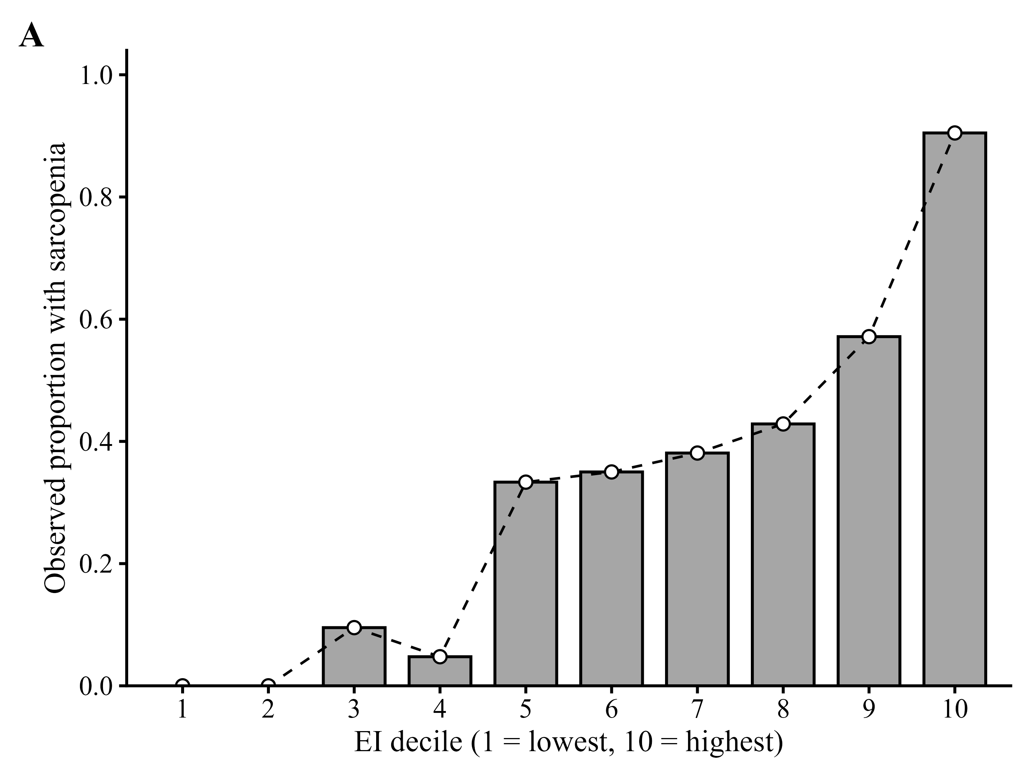
Note. Bars show the observed proportion of sarcopenia within each decile of EI (n = 20-21 per decile). Observed proportions were generally higher in the upper EI deciles and reached 0.90 in the highest decile, although the decile sequence was not strictly monotonic. The restricted-cubic-spline nonlinearity test for EI gave P = 0.107, so the plot is descriptive and is not interpreted as evidence of a threshold or a statistically significant nonlinear relation.

Supplementary Figure S2. Observed proportion of sarcopenia by decile of the Z-standardized systemic immune-inflammation index (SII_Z).
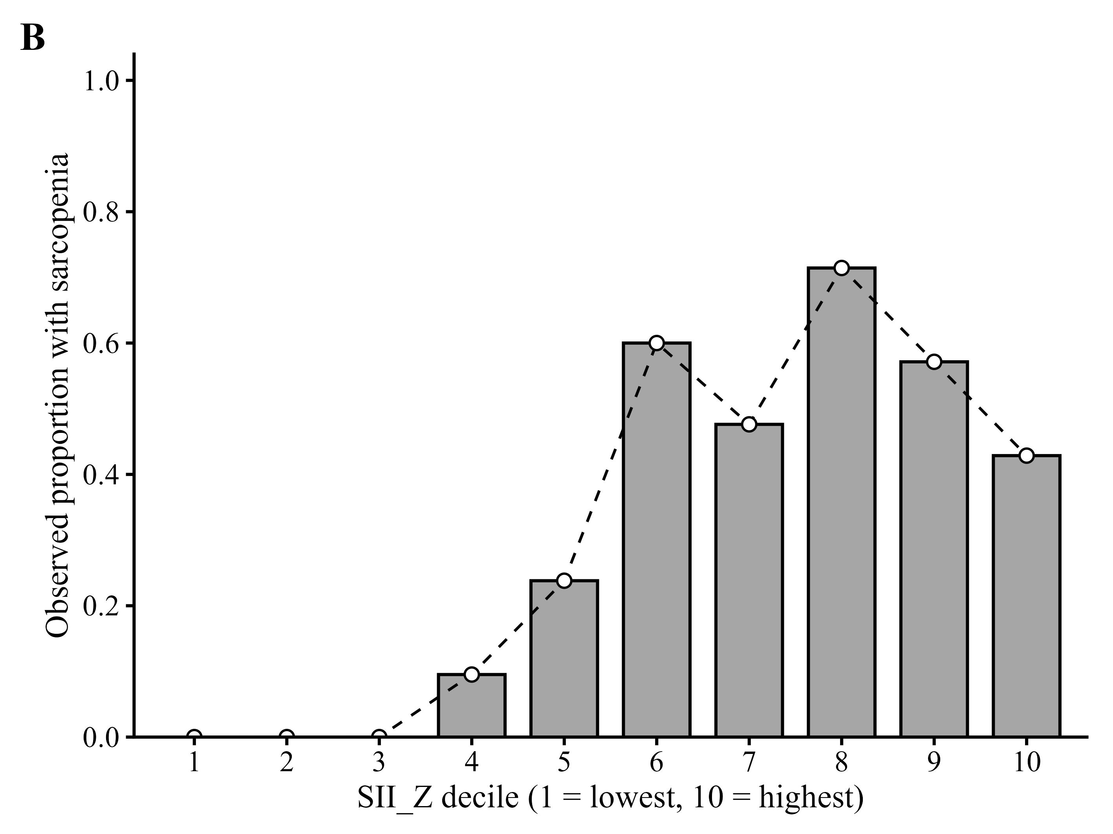
Note. Bars show the observed proportion of sarcopenia within each decile of SII_Z (n = 20-21 per decile). The proportion rises to a peak at the eighth decile (0.71) and falls in the top two deciles. The restricted-cubic-spline nonlinearity test for SII_Z gave P = 0.261; no nonlinearity claim is made (revised Methods).

