Neuronal ABHD6 Exacerbates Ischemic Brain Injury Through 2-AG Depletion and DDIT3/BNIP3-Dependent Autophagy Dysregulation

Dan Liu^{2,a}, Zixuan Cao^{2,a}, Lin Zhao^{1,3,a}, Kangyi Yue², Zhicheng Tian², Kai Qi², Zhuoyuan Zhang², Yangxuanye Wang², Hanjiang Xue², Peng Luo²*, Xiangyu Gao^{1,3}*, Xin Li⁴*

¹ Department of Neurosurgery, 900th Hospital of PLA Joint Logistic Support Force, Fuzong Clinical Medical College of Fujian Medical University, Fuzhou 350001, China
² Department of Neurosurgery, Xijing Hospital, Fourth Military Medical University, Xi’an 710032, China
³ Department of Neurosurgery, 900th Hospital of PLA Joint Logistic Support Force, Fuzong Teaching Hospital of Fujian University of Traditional Chinese Medicine, Fuzhou 350001, China
⁴ Department of Anesthesiology, Xijing Hospital, Fourth Military Medical University, Xi’an 710032, China

ªDan Liu, Zixuan Cao, and Lin Zhao have contributed equally to this work.

Correspondence:
Xin Li
Email: lixinmail@fmmu.edu.cn
Xiangyu Gao
Email: gaoxiangyu@fmmu.edu.cn
Peng Luo
Email: pengluo@fmmu.edu.cn

1. Supplemental Results
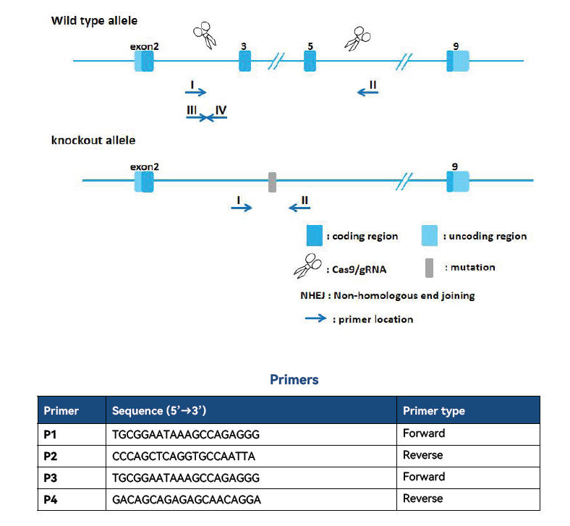
Figure S1. The ABHD6-KO genotyping protocol. Knockout mouse model at Abhd6 gene locus was constructed via CRISPR/Cas9 technology.

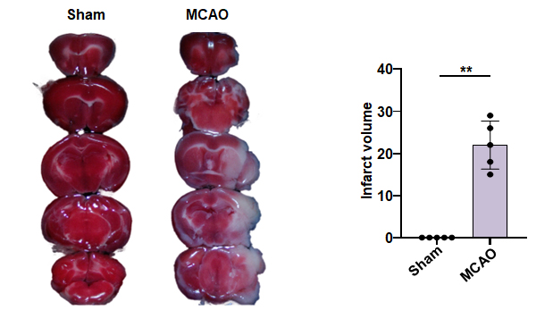
Figure S2. The infarct volume was counted by TTC staining (n=5). The data were presented as the mean ± SEM. **, P < 0.01.

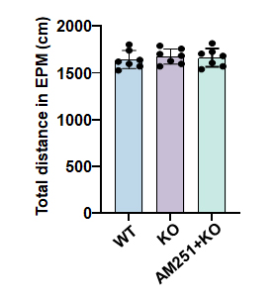
Figure S3. The total distance of mouse activity in EPM test (n=7). The data were presented as the mean ± SEM.

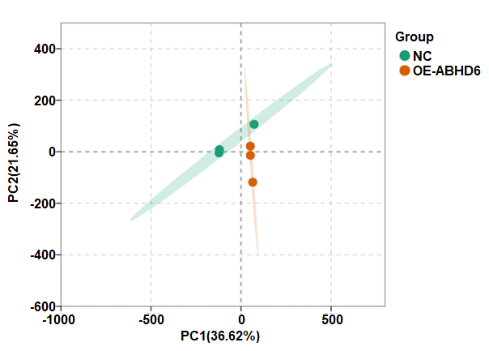
Figure S4. PCA of global transcriptomic profiles following ABHD6 overexpression (n=3).

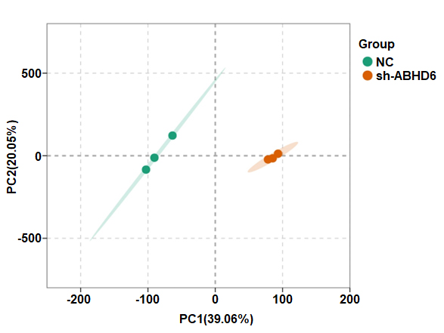
Figure S5. PCA of global transcriptomic profiles following ABHD6 knockdown (n=3).

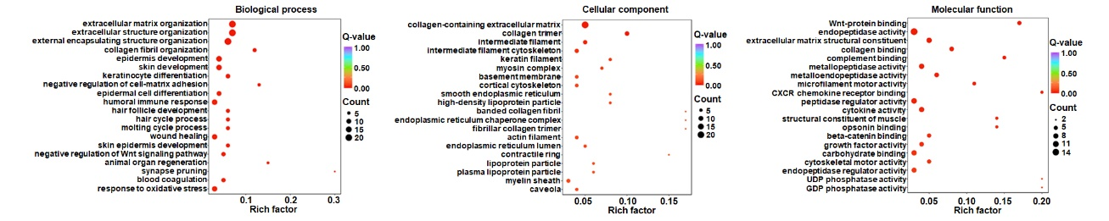
Figure S6. Differential gene GO annotation analysis strip histogram of biological process, cellular component, and molecular function (OE-ABHD6 vs. NC).

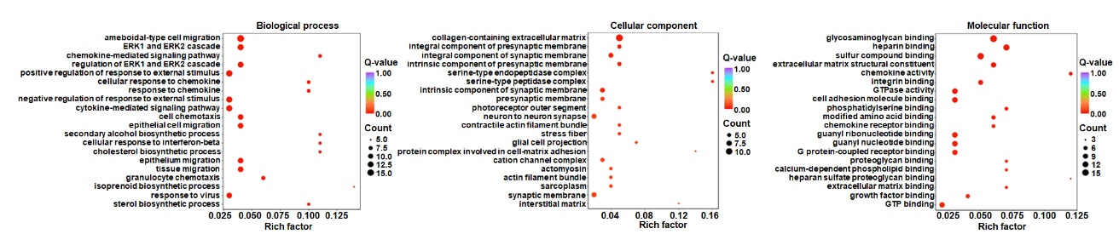
Figure S7. Differential gene GO annotation analysis strip histogram of biological process, cellular component, and molecular function (sh-ABHD6 vs. NC).

2. Supplemental Tables
Table S1. Sequences of the synthesized oligonucleotides and primers (mouse).
Name | Forward | Reverse
β-actin | 5’-GGCTGTATTCCCCTCCATCG-3’ |  | 5’-CCAGTTGGTAACAATGCCATGT-3’
ABHD6 | 5’- GGCATTTGTTGCGTCTTTCCTCC-3’ |  | 5’-CGGAAGGAGTAACAGAACTGATAG-3’
BNIP3 | 5’-GCTCCAAGAGTTCTCACTGTGAC-3’ |  | 5’-GTTTTTCTCGCCAAAGCTGTGGC-3’
DDIT3 | 5’-GGAGGTCCTGTCCTCAGATGAA-3’ |  | 5’-GCTCCTCTGTCAGCCAAGCTAG-3’

