Raw data of western blot: Figure 1E ABHD6
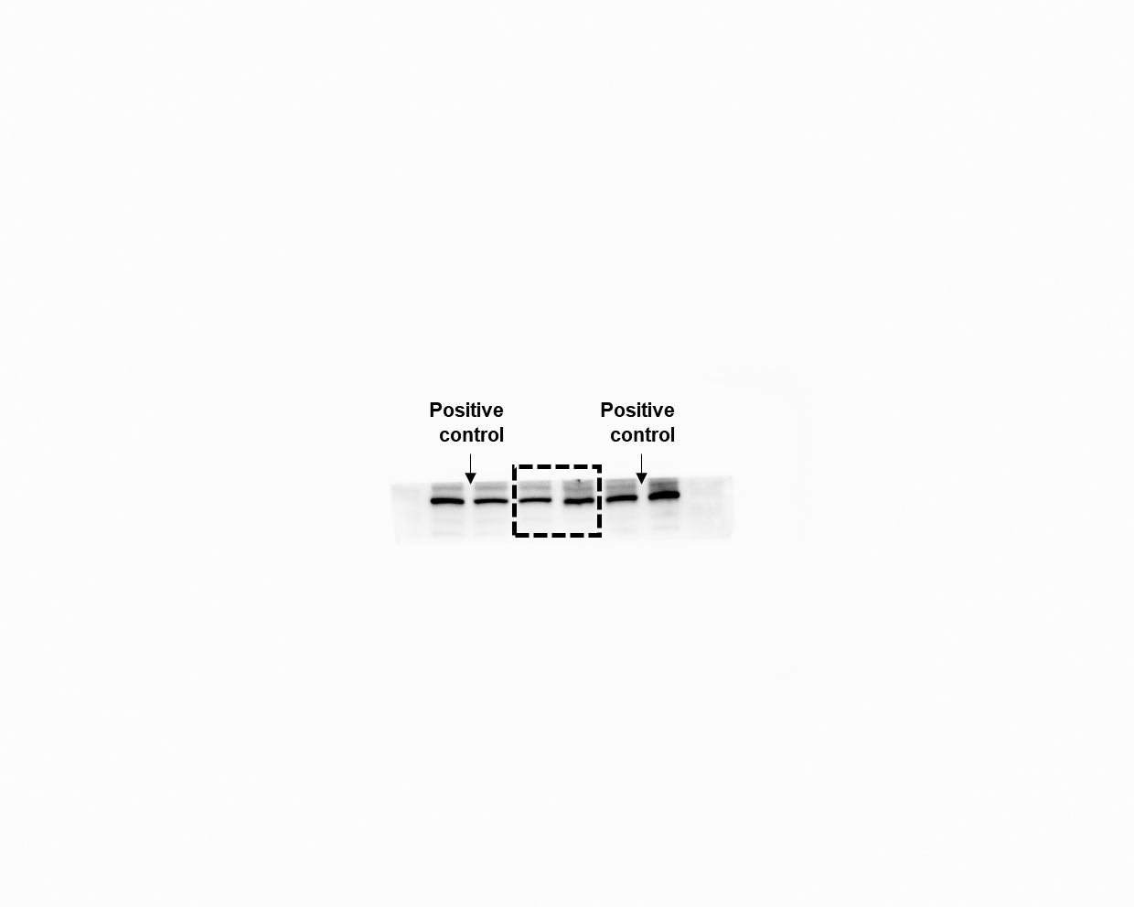

Raw data of western blot: Figure 1E β-Tubulin
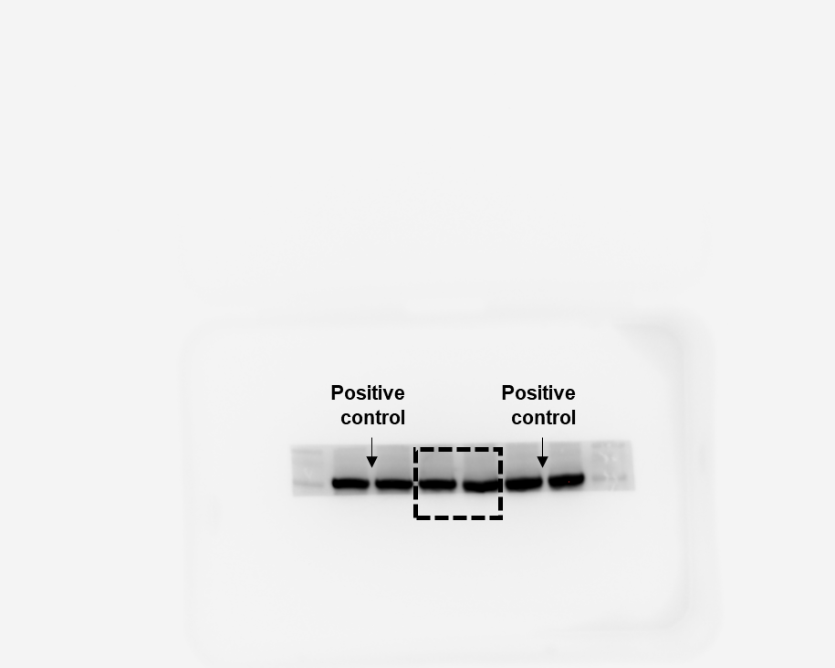

Raw data of western blot: Figure 1K ABHD6
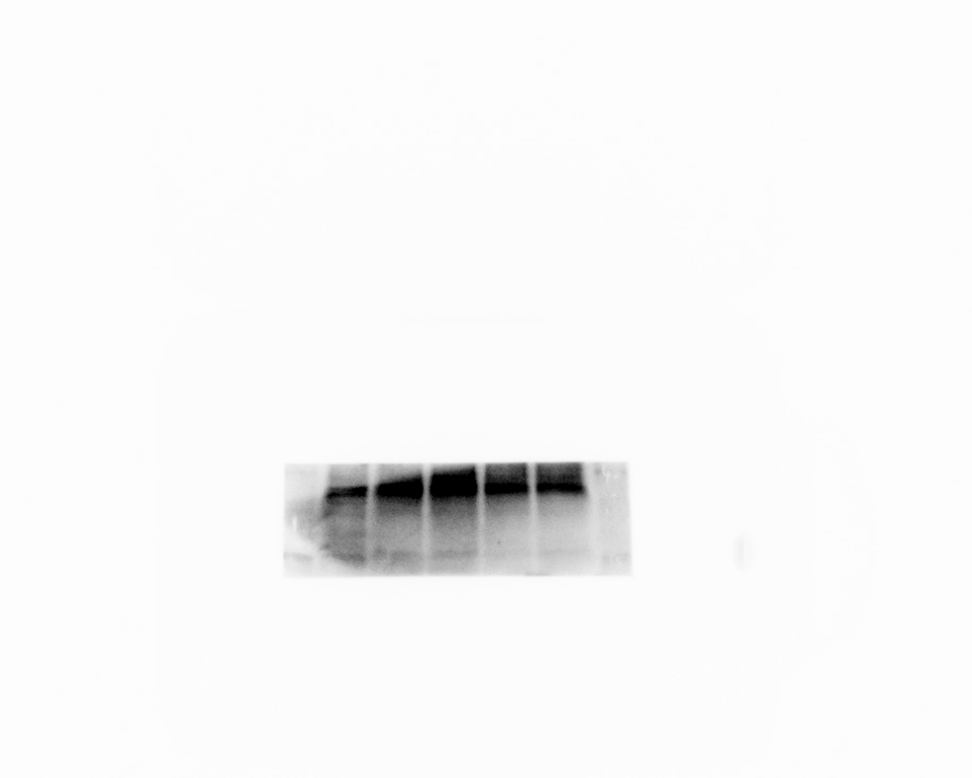

Raw data of western blot: Figure 1K β-Tubulin
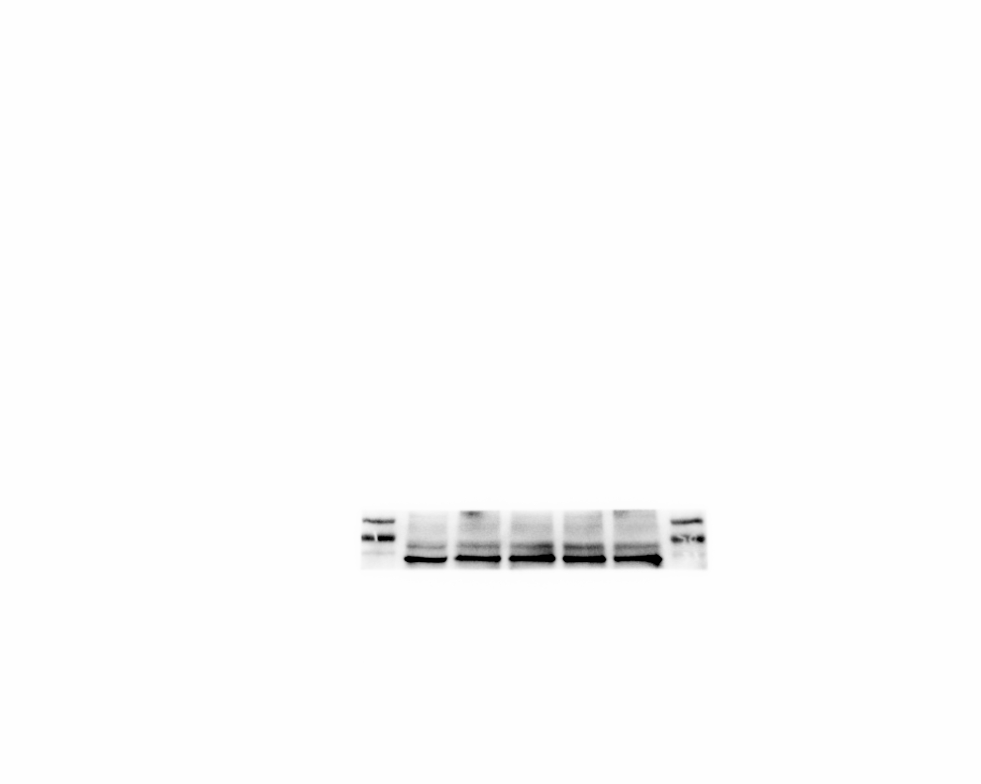

Raw data of western blot: Figure 3B ABHD6

Raw data of western blot: Figure 3B β-Tubulin

Raw data of western blot: Figure 4A ABHD6
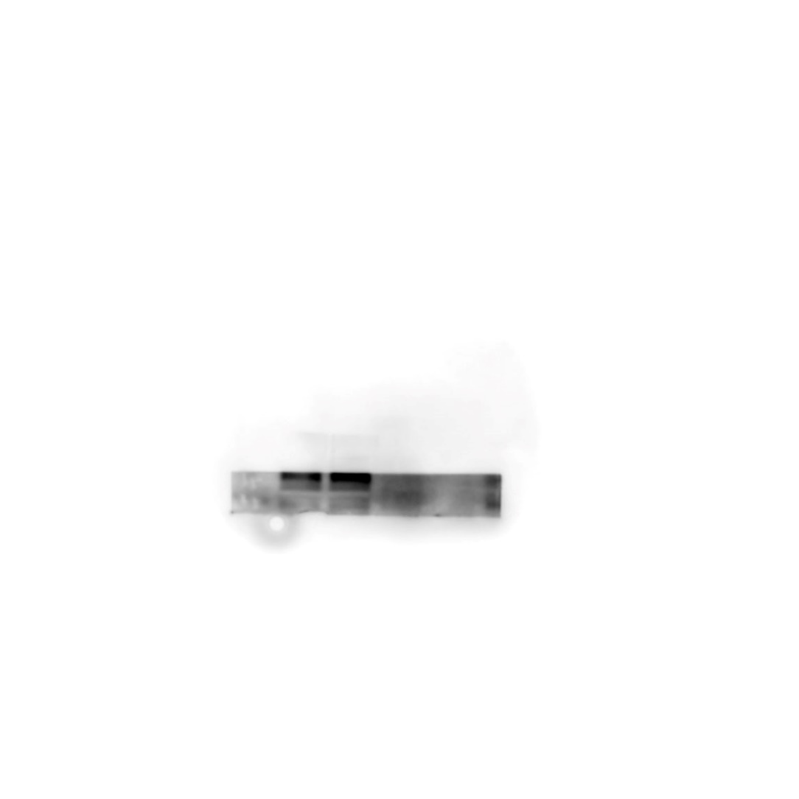
Raw data of western blot: Figure 4A β-Tubulin

Raw data of western blot: Figure 6E Ddit3

Raw data of western blot: Figure 6E Bnip3

Raw data of western blot: Figure 6E β-Tubulin

Raw data of western blot: Figure 6H LC3-I and LC3-II
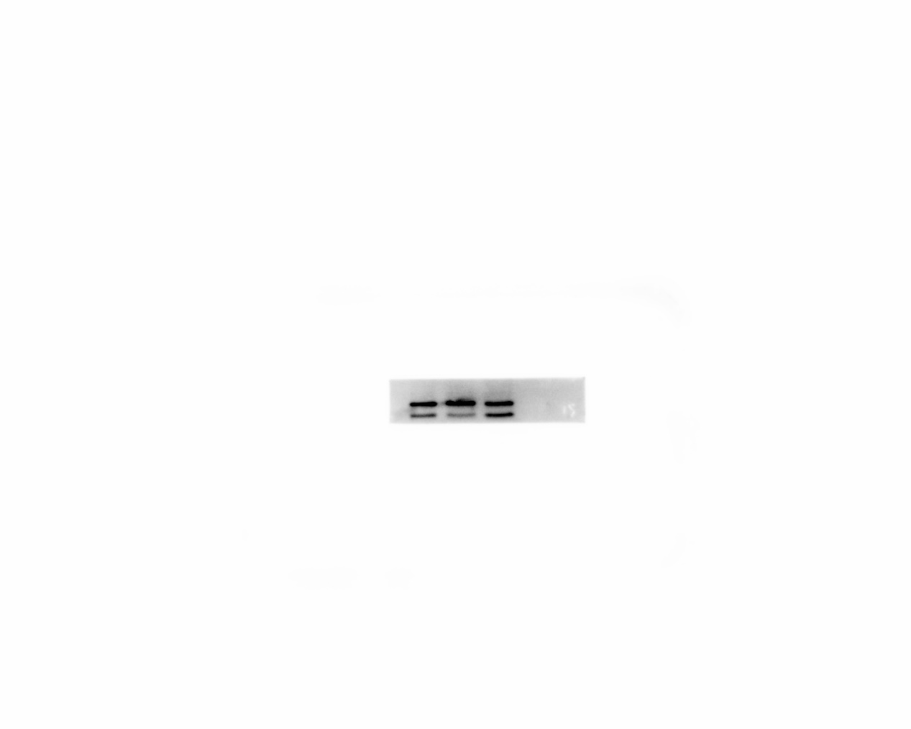

Raw data of western blot: Figure 6H p62

Raw data of western blot: Figure 6H β-Tubulin

Raw data of western blot: Figure 7C Bnip3

Raw data of western blot: Figure 7C Ddit3

Raw data of western blot: Figure 7C β-Tubulin

Raw data of western blot: Figure 7F p62

Raw data of western blot: Figure 7F LC3-I and LC3-II

Raw data of western blot: Figure 7F β-Tubulin

