Appendix
Supplementary table 6:
Table: List of sampled plots, specifying their geographic location, dominant and secondary tree species (<10%), and soil type.
Species | Forest_name | Pair_ID | Coordinates_ invaded plot |  | Coordinates_control plot |  | Forest stand | Soil
 |  |  | N | E | N | E
P. serotina | Compiègne | P1 | 690804 | 6916493 | 692351 | 6914864 | beech | Alisol
P. serotina | Compiègne | P2 | 690952 | 6919378 | 692351 | 6914864 | oak - beech | Podzol
P. serotina | Compiègne | P3 | 690082 | 6922352 | 689943 | 6922489 | oak - hornbeam - (beech) | Alisol
P. serotina | Compiègne | P4 | 692575 | 6922432 | 692740 | 6922529 | beech - (oak) | Cambisol
P. serotina | Compiègne | P5 | 691602 | 6923131 | 691658 | 6923166 | beech - (oak) | Podzol
P. serotina | Compiègne | P6 | 691900 | 6923700 | 691854 | 6923640 | oak - beech | Podzol
P. serotina | La Londe Rouvray | P7 | 557944 | 6919585 | 558895 | 6919430 | beech - chestnut | Cambisol
P. serotina | La Londe Rouvray | P8 | 558408 | 6920958 | 558521 | 6921433 | oak - (maple) | Cambisol
P. serotina | La Londe Rouvray | P9 | 558797 | 6921231 | 560129 | 6920134 | oak - beech - (maple) | Cambisol
P. serotina | La Londe Rouvray | P10 | 560199 | 6920223 | 559091 | 6920115 | oak - beech - (maple) | Cambisol
P. serotina | Raisme Saint Amant | P11 | 734573 | 7035098 | 732104 | 7037392 | oak | Gleysol
P. serotina | Raisme Saint Amant | P12 | 734710 | 7036353 | 734233 | 7038398 | oak - birch | Gleysol
P. serotina | Raisme Saint Amant | P13 | 734518 | 7036408 | 733264 | 7037329 | oak | Cambisol
P. serotina | Raisme Saint Amant | P14 | 734412 | 7036530 | 734539 | 7038583 | oak -(birch) | Gleysol
P. serotina | Raisme Saint Amant | P15 | 734170 | 7036518 | 735091 | 7038257 | birch - oak | Gleysol
R. ponticum | Vasterival | R18 | 553726 | 6981577 | 553643 | 6981641 | pine | Cambisol
R. ponticum | Montmorency | R20 | 646333 | 6880892 | 646284 | 6880941 | oak - hornbeam | Gleysol
R. ponticum | Montmorency | R21 | 646408 | 6881288 | 646472 | 6881274 | oak - hornbeam | Alisol
R. ponticum | Rambouillet | R16 | 607213 | 6848785 | 607241 | 6848794 | birch - (pine) | Podzol
R. ponticum | Rambouillet | R17 | 607052 | 6848645 | 607133 | 6848791 | oak - (pine - birch) | Podzol
R. ponticum | Epinay | R19 | 592721 | 6947947 | 592805 | 6947996 | oak - birch - (hornbeam) | Alisol
R. ponticum | Chandeliez | R13 | 607508 | 7041778 | 607438 | 7041819 | beech - (oak) | Alisol
R. ponticum | Chandeliez | R14 | 607516 | 7041918 | 607359 | 7041922 | beech - (oak) | Alisol
R. ponticum | Chandeliez | R15 | 607330 | 7041370 | 607258 | 7041404 | beech - oak | Alisol
R. ponticum | Breuil | R3 | 496228 | 6927152 | 496263 | 6926975 | oak - (pine - beech) | Cambisol
R. ponticum | Breuil | R5 | 495623 | 6926607 | 495570 | 6926394 | oak - (pine) | Cambisol
R. ponticum | Breuil | R7 | 495949 | 6926941 | 496170 | 6926729 | beech - oak - (pine) | Cambisol
R. ponticum | Breuil | R8 | 495689 | 6925948 | 495726 | 6925825 | oak - (beech - hornbeam) | Cambisol
R. ponticum | Breuil | R9 | 495883 | 6925642 | 496009 | 6925462 | oak - beech - (hornbeam) | Cambisol
R. ponticum | Breuil | R10 | 495983 | 6926485 | 496041 | 6926380 | oak - (beech - pine) | Cambisol
Legend: The table reports the name of the species studied (Species), the name of the forest (Forest_name), the ID of the pair of invaded and control plots (Pair_ID), the geographic coordinates of the invaded plot projected in Lambert 93 (Coordinates_invaded_plot) and the associated control plot (Coordinates_control_plot), the tree stand, with the dominant vegetation listed first and those accounting for less than 5% listed in parentheses (Forest stand), and the soil type (Soil).

Supplementary Fig. 4:
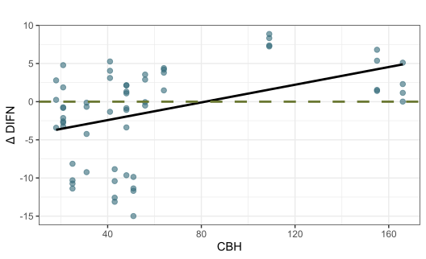
Relationship between the circumference in cm used as proxy of age of invasion (CBH), expressed in centimeters and differences between invaded and control plots for the light incidence fraction (DIFN) at sites invaded by P. serotina. The line represents predictions from a linear mixed-effects model (n = 119, p = 0.087).
Supplementary Fig. 5:
Correlogram showing the correlations between all environmental and functional variables in pairs; Pearson's correlation coefficient is shown only for statistically significant correlations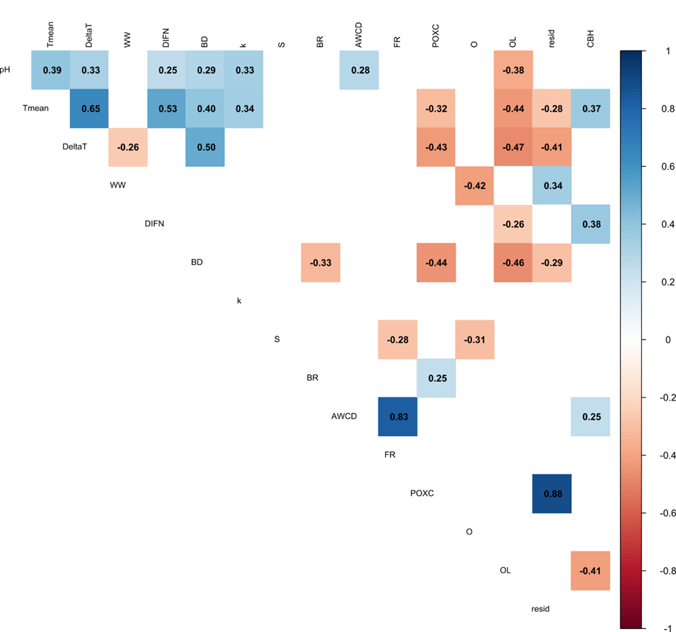
Legend: Variables included in the correlation analysis were mean soil temperature (Tmean), thermal amplitude (DeltaT), water content (WW), light availability (DIFN), bulk density (BD), carbon decomposition rate (k), stabilization factor (S), basal respiration (BR), average well colour development (AWCD), functional richness (FR), labile carbon content (POXC), thickness of the humic horizon (O), litter thickness (OL), model residuals (resid), and circumference at breast height (CBH).

