Supplemental Materials
Cross-Band Coupling of EEG Infraslow Oscillations during NREM Sleep in Mice
Max Tan^{1,2}, Oscar D. Ramirez-Plascencia¹, Wei Wang³, Amanda Studnicki⁴, J. Kent Werner⁴, Elizaveta Tremsina^{2,5}, Shiqian Shen³, Can Zhang⁶, Tingying Helen Zeng², Robert J. Thomas⁷, Haoqi Sun^{1,*}

¹ Department of Neurology, Beth Israel Deaconess Medical Center, Boston, MA 02215
² InnoBridge Institute, Cambridge, MA 02142
³ Department of Anesthesiology, Massachusetts General Hospital, Charlestown, MA 02129
⁴ Uniformed Services University, Bethesda, MD 20814
⁵ Department of Electrical Engineering & Computer Science, Massachusetts Institute of Technology, Cambridge, MA 02139
⁶ Department of Neurology, Massachusetts General Hospital, Charlestown, MA 02129
⁷ Division of Pulmonary, Critical Care and Sleep Medicine, Department of Medicine, Beth Israel Deaconess Medical Center, Harvard Medical School, Boston, MA 02215

* Correspondence:
Haoqi Sun, PhD
Neurology, Beth Israel Deaconess Medical Center
Harvard Medical School
330 Brookline Ave, Boston, MA 02215, USA
Email: hsun3@bidmc.harvard.edu

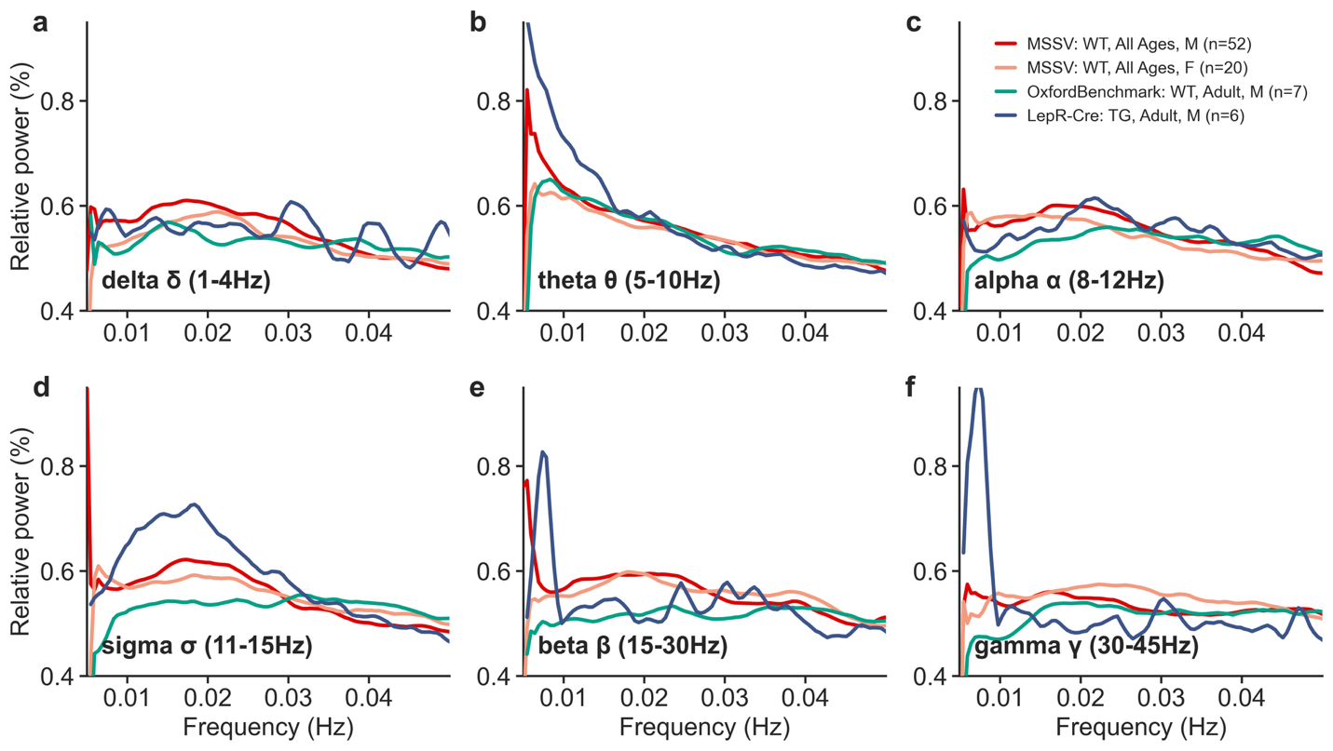
Figure S1. The FOOOF-corrected EEG ISO PSD per frequency band, averaged across all subjects per dataset and band, with males and females as separate strata in the MSSV dataset. The relative power (%) of the ISO PSD is shown after normalization by its total power between 0.005-0.1Hz.

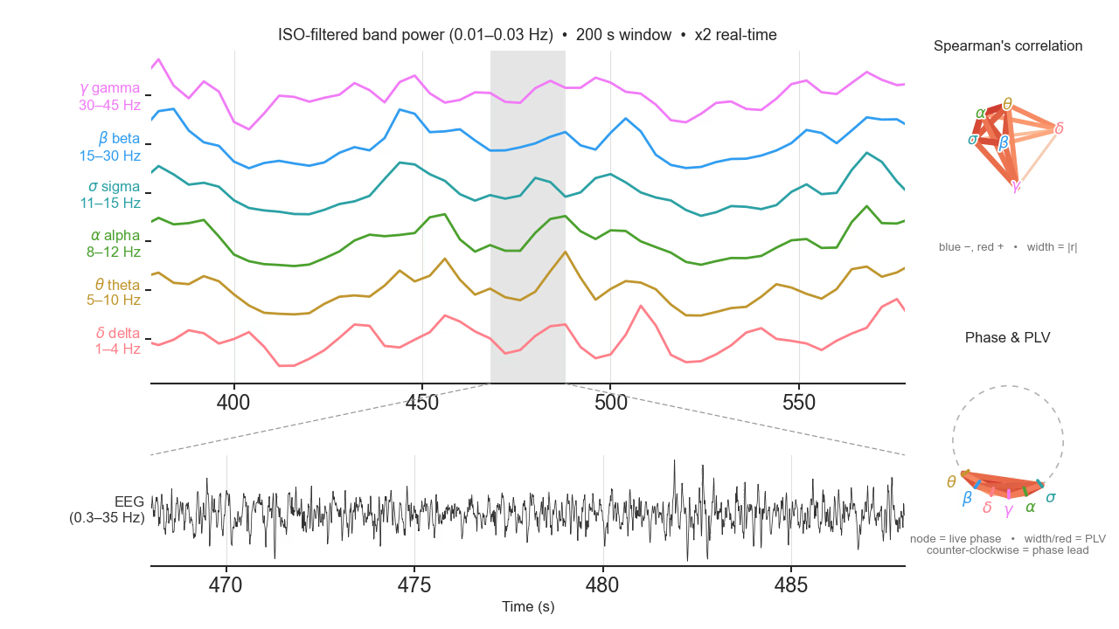
Video S1. Please refer to the uploaded supplementary video mp4 file. We show a dynamic illustration of 2 minutes of EEG played at 2x real time, with a dynamic Spearman’s correlation network based on the current 200-second EEG, and each band's instantaneous ISO phase as a rotating node on a phase circle with links indicating the PLV.

