Supplement
The reference image is the image acquired by the IncuCyte S3 in phase contrast and GFP fluorescence. With the analysis software individual AMs were segmented from the phase contrast images based on shape and contrast as cell area confluence [µm²] (yellow). In the next step GFP integrated intensity per well [GCU] (red) was determined. Then the GFP integrated intensity per well can be normalized to the cell area confluence (mask overlay of yellow and red). With an appropriated threshold of GFP integrated intensity and cell number per well by segmentation, percentage of positive cells can be calculated.

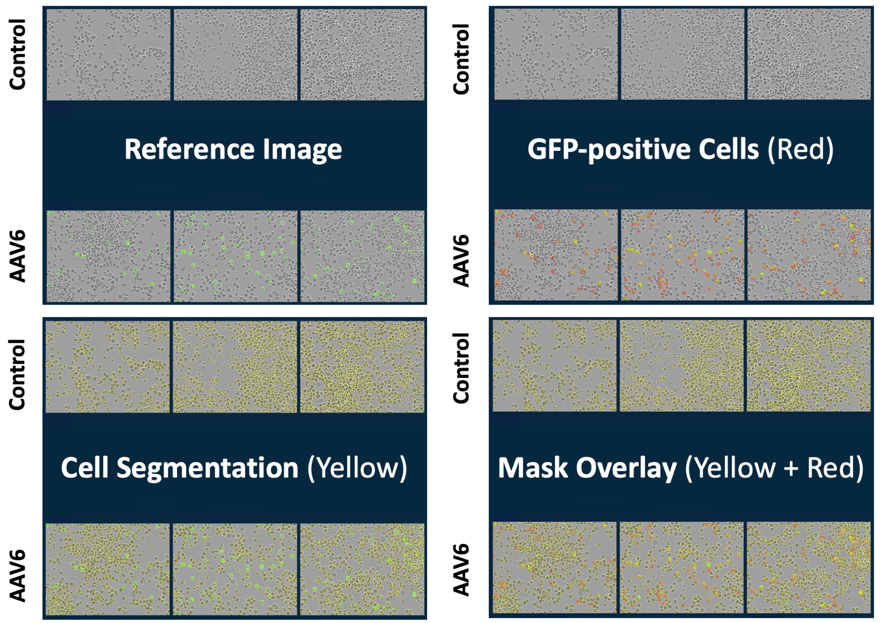
Supplemental figure 1: example of segmentation analysis for positively-transduced cells
Not transduced AMs as control and AAV6-CMV-GFP transduced AMs.
Reference image: phase contrast and GFP fluorescence.
Cell segmentation: cell area confluence [µm²] (yellow)
GFP-positive cells: GFP integrated intensity per well [GCU] (red)
Mask overlay: GFP integrated intensity x cell area confluence/ well (mask overlay yellow + red)

Primary AMs were isolated and cultured from BAL of 8-week-old female mice. The absence of a typical marker for BMDM, CD11b, was confirmed by FACS analysis (supplemental figure 2).

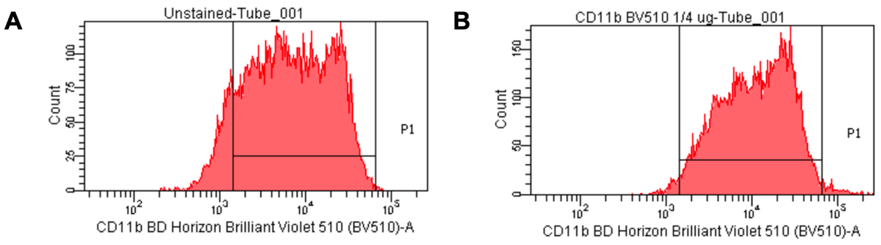
Supplemental figure 2: AM phenotype
(A) FACS for CD11b unstained,
(B) FACS for CD11b stained.

Additional to Figure 2, Supplemental figure 3 shows phase contrast images of the AMs transduced with AAV6-GFP with different MOI.

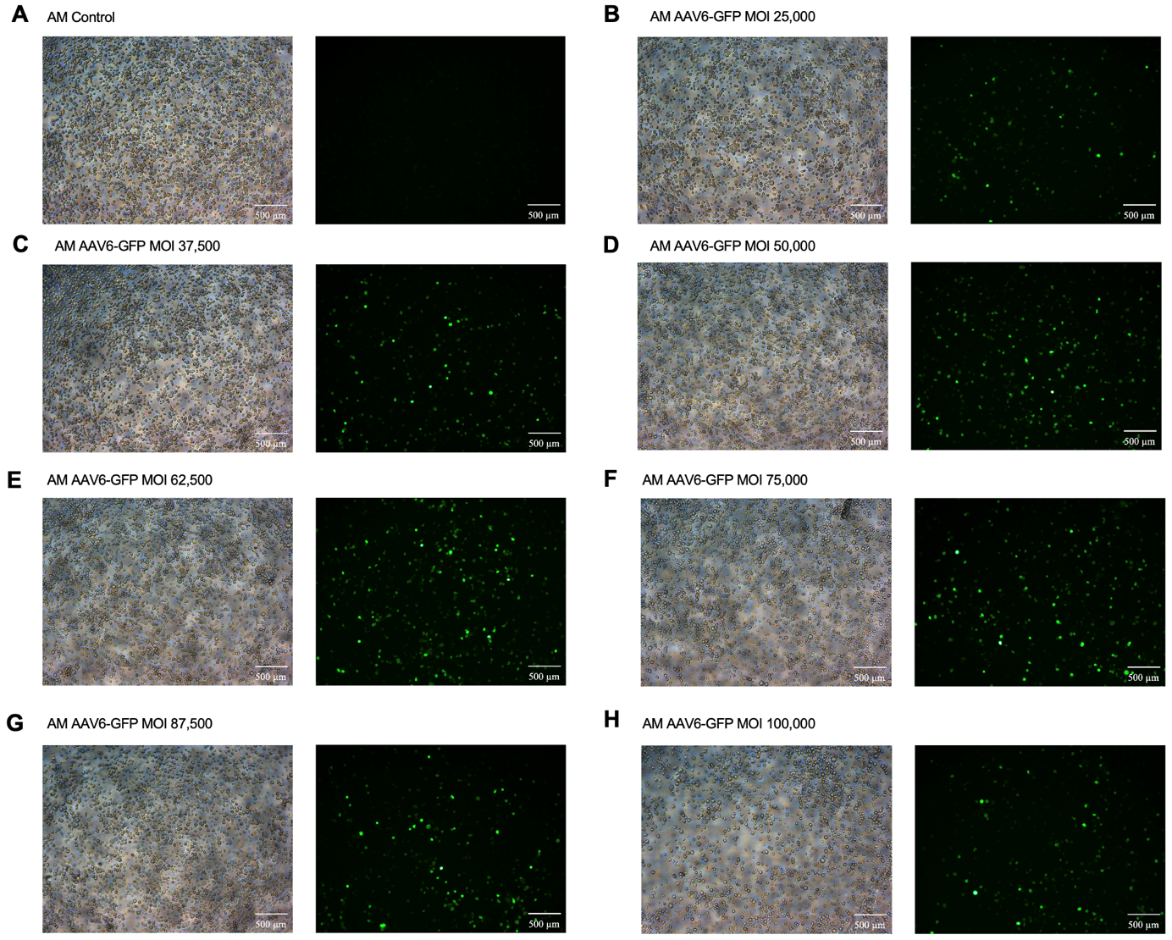
Supplemental figure 3: AMs transduced with AAV6-GFP with different MOI
Phase contrast or GFP Fluorescence Microscopy of AMs transduced with AAV6-GFP with different MOI (scale bar 500 µm), 6 days post transduction. (A) Control (B) MOI 25,000 (C) MOI 37,500 (D) MOI 50,000 (E) MOI 62,500 (F) MOI 75,000 (G) MOI 87,500 (H) MOI 100,000.

Additional to Figure 3, Supplemental figure 4 shows phase contrast images of the AMs transduced with different AAV-GFP serotypes with MOI 87,500.

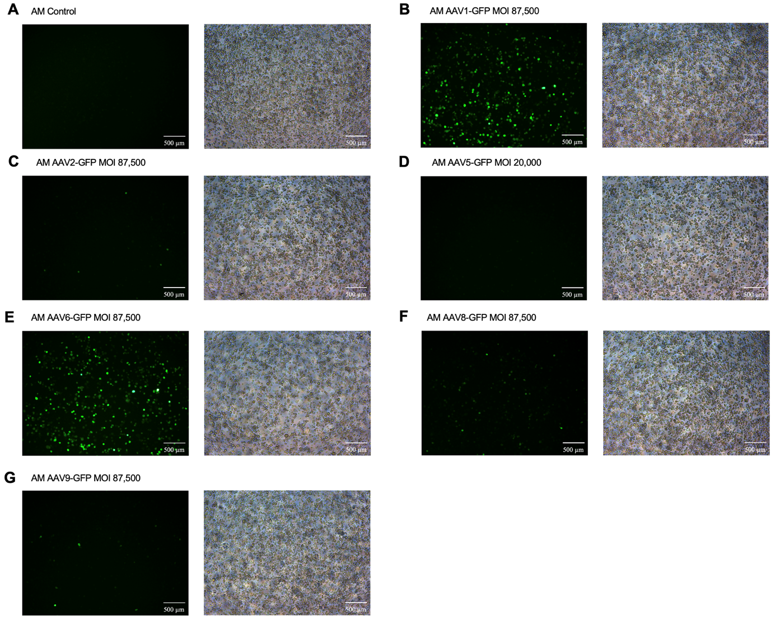
Supplemental figure 4: AMs transduced with different AAV-GFP Serotypes
Phase contrast or GFP Fluorescence Microscopy of AMs transduced with different AAV6-GFP Serotypes with MOI 87,500, except AAV5 MOI 20,000 because of low titer (scale bar 500 µm), 6 days post transduction. (A) Control without AAV-GFP (B) AAV1 (C) AAV2 (D) AAV5 (E) AAV6 (F) AAV8 (G) AAV9.

On the cell line HEK293T the functionality and tropism of the constructed AAV-GFP serotypes were shown. HEK293T cells were transduced with serotypes 1, 2, 5, 6, 8, and 9 with GFP at an MOI of 10,000 (supplemental figure 5). With AAV2, high transduction efficiency was demonstrated by fluorescence microscopy 5 days after transduction. AAV1 and AAV6 show lower efficiency but still successful transduction. AAV5, AAV8, and AAV9 showed hardly any signal. The GFP gene expression normalized to the housekeeping gene Hprt1 5 days after transduction confirms strong expression after transduction with AAV2. Transduction with AAV1 and AAV6 also leads to increased gene expression compared to the control, but significantly lower than with AAV2. AAV5, AAV8, and AAV9 show little to no increase in gene expression compared to the non-transduced control. These data demonstrate the functionality of the constructed AAV.

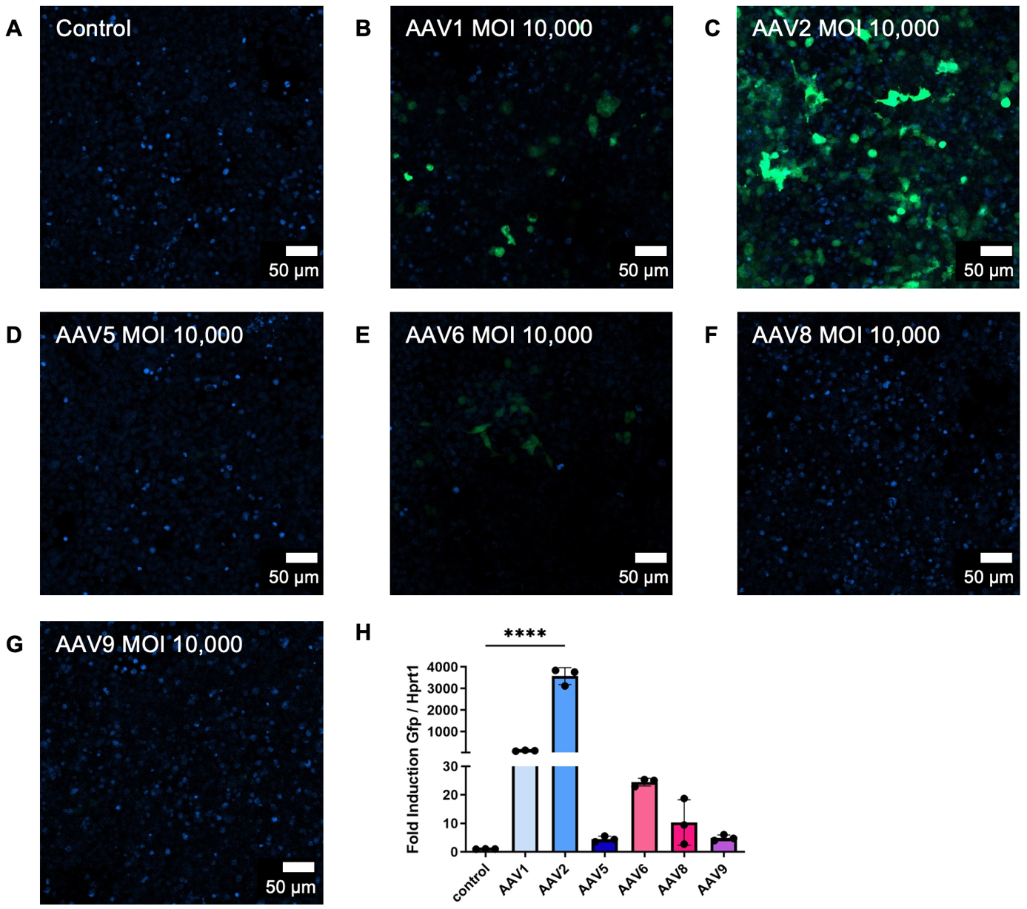
Supplemental figure 5: Transduction of HEK293T with different AAV-GFP serotypes
Confocal microscopy of HEK293T cells transduced with different AAV-GFP Serotypes with MOI 10,000 (scale bar 50 µm), 5 days after transduction. (A) Control without AAV-GFP (B) AAV1 (C) AAV2 (D) AAV5 (E) AAV6 (F) AAV8 (G) AAV9.
(H) qRT-PCR of Gfp normalized to Hprt1. n = 3
AMs were transduced with AAV6-GFP with MOI 87,500. 5 days after transduction they were stimulated with 1 µg/ml LPS for 20 h. Figure 4E shows more % GFP-positive cells after LPS treatment. Microscopy pictures in supplemental figure 6 show the cells to the data. Due to LPS-stimulation more cells are GFP-positive and cells look more stretched and bigger.

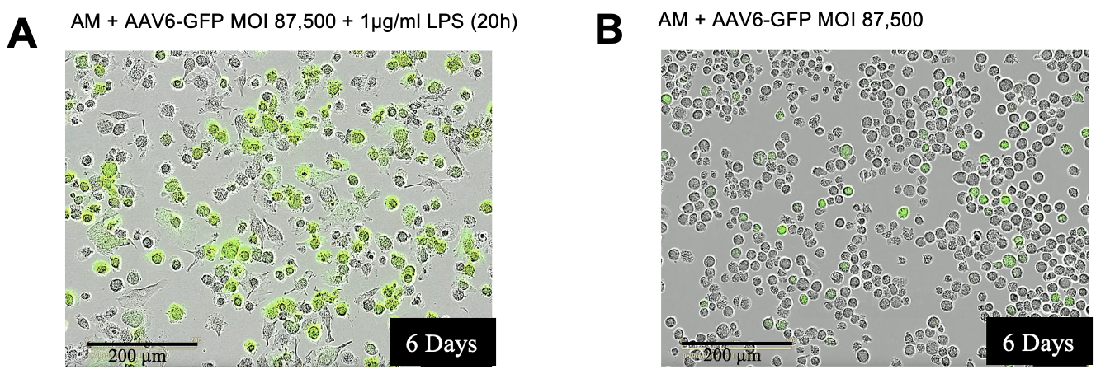
Supplemental figure 6: LPS modulates transgene signal intensity in AMs transduced with AAV6-GFP
Microscopic pictures to Figure 4E: AM transduced with AAV6-GFP with MOI 87,500 stimulated with 1 µg/ml LPS for 20 h (scale bar 200 µm). (A) with stimulation (B) without stimulation.

To improve the transduction efficiency of macrophages different groups have already tested different substances.
The group of Zaiss et al. investigated the influence of the complement system on macrophage transduction with AAV. However, they used primary mouse macrophages derived from bone marrow and the human cell line THP-1, rather than primary AM. They showed that the complement protein C3 is important for efficient transduction, as it enhances the internalization of AAV2 in macrophages while simultaneously activating the macrophages [29]. In own experiments with AM the cells died in culture with 10 % mouse serum (Sigma, Ref. S7273) instead of FBS. Physiological AMs are not in contact with serum due to their location on epithelial cells (supplemental figure 7C).
Polybrene (Sigma, Ref. TR-1003-G) is a cationic polymer designed to improve the efficiency of retroviral and lentiviral transduction. According to the manufacturer, it neutralizes charge repulsion between the cell surface and virions. When using 8 µg/ml (the manufacturer recommends 5 to 10 µg/ml) on the AMs, no increase in AAV transduction efficiency was observed; instead, a decrease in cell count was observed (supplemental figure 7D). The substance was added while transduction and was incubated 24 h with the AAV on the cells.
The group of Aronoff et al. used AMs from rats and mice. They showed that prostaglandin E2 acts via the EP2 receptor and inhibits phagocytosis. Forskolin (Stemcell Technologies, Vancouver, BC, Canada, Ref. 72112) had the same effect independently of receptors [30]. In own experiments, forskolin was used in the concentration specified in the publication (100 µM) (supplemental figure 7E) and in a lower concentration (10 µM) (supplemental figure 7F). The aim was to show whether inhibition of phagocytosis could improve the transduction efficiency of AAV on AMs. No increase in efficiency was observed with the use of forskolin independent of the concentration being used. The substance was added 15 min before transduction and was incubated 24 h with the AAV on the cells.
The next tested substance was Hydroxychloroquine (Sigma, Ref. H0915), which is an active ingredient used to treat malaria that acts as an antagonist for TLR9. The group of Chandler et al. was able to generate three times higher GFP expression when treated one hour before transduction with AAV2 or AAV8 using ubiquitous and photoreceptor-specific promoters. They demonstrated increased transgene expression for up to 8 weeks in vitro, ex vivo, and in vivo. The research group used mouse embryonic fibroblasts, primate retinal pigment epithelial cells, and human retinal explants. After treatment with hydroxychloroquine, the localization of AAV shifted from the cytosol to the cell nucleus [31]. The two concentrations used in the publication (18.75 µM (supplemental figure 7G) and 3.13 µM (supplemental figure 7H)) were tested for AAV transduction on the AMs in own experiments and showed no increase in efficiency. The substance was added 1 h before transduction and was incubated 24 h with the AAV on the cells.
Supplemental table 1 summarizes the efficiency of AAV transduction on AMs with different substances 6 days after transduction. AMs were transduced with AAV6-GFP with MOI 87,500. With ImageJ total number of cells on microscopic pictures was counted. Then with ImageJ GFP-positive cells were counted. And the percentage of GFP-positive cells of total cell number was calculated.
Supplemental table 1: AM AAV6-GFP Optimization methods
Optimization method | Control | 8 µg/ml Polybrene | 100 µM Forskolin | 10 µM Forskolin | 18.75 µM Hydroxy-chloroquine | 3.13 µM Hydroxy-chloroquine
ImageJ (Day 6) | 9,4 % ± 0,9 % | 10,0 % ± 0,6 % | 8,3 % ± 0,0 % | 6,6 % ± 2,0 % | 7,2 % ± 2,3 % | 7,4 % ± 0,5 %

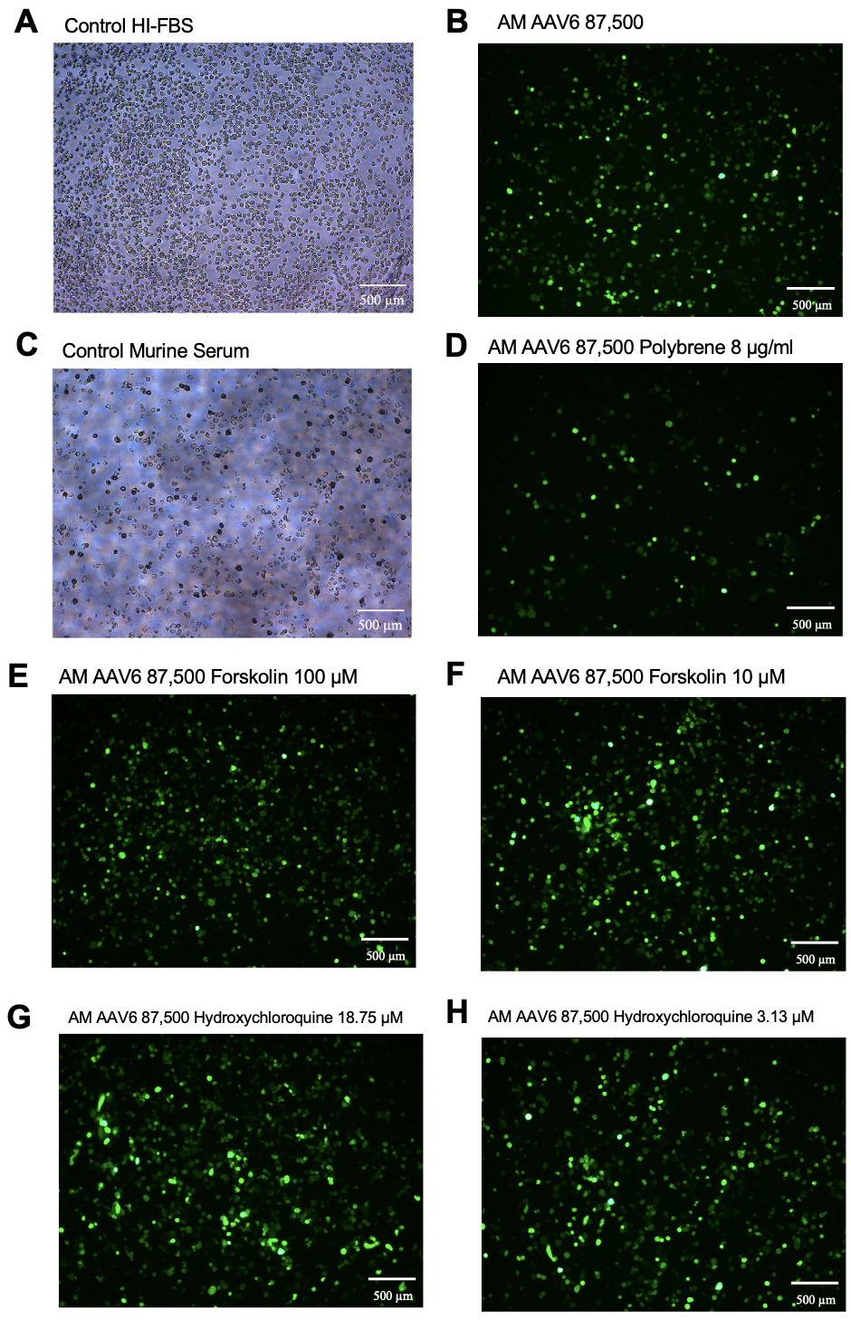
Supplemental figure 7: Optimization methods for transduction
Phase contrast or GFP Fluorescence Microscopy of AMs transduced with AAV6-GFP with MOI 87,500 (scale bar 500 µm), 6 days post transduction. (A) Control phase contrast (B) Control GFP fluorescence (C) 10 % mouse serum instead of 10 % HI-FBS, phase contrast (D) 8 µg/ml Polybrene (E) 100 µM Forskolin (F) 10 µM Forskolin (G) 18.75 µM Hydroxychloroquine (H) 3.13 µM Hydroxychloroquine.

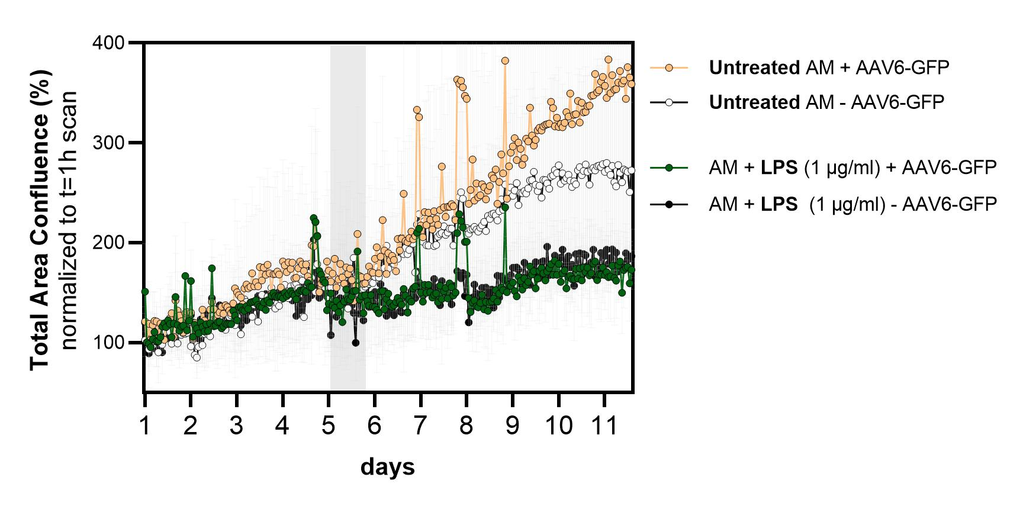
Supplemental figure 8: Growth curve AM after AAV transduction and LPS stimulation
AM confluency normalized to start conditions after AAV transduction. Grey bar means 20 h stimulation with 1 µg/ml LPS. More than 100 % shows proliferation.

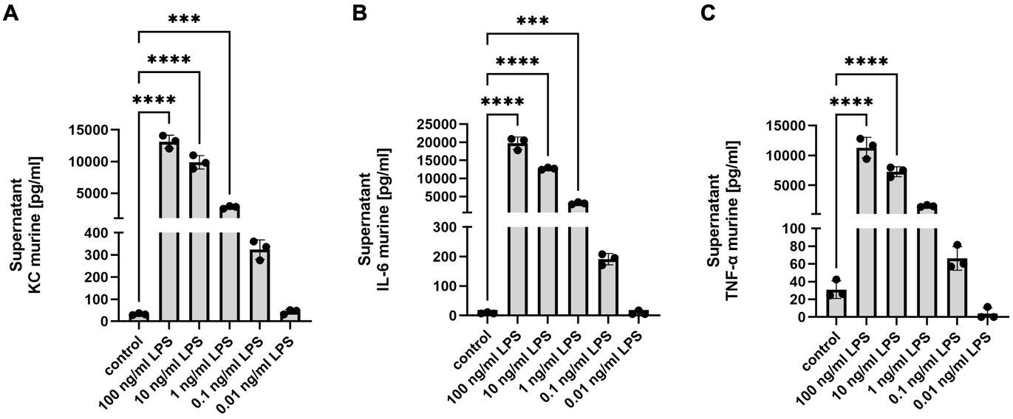
Supplemental figure 9: Titration of response of AM to LPS stimulation
ELISA of supernatant of AMs with stimulation with 100/ 10/ 1/ 0.1/ 0.01 ng/ml LPS for 20 h. (A) KC, (B) IL-6, (C) TNF-$α$. n = 3.

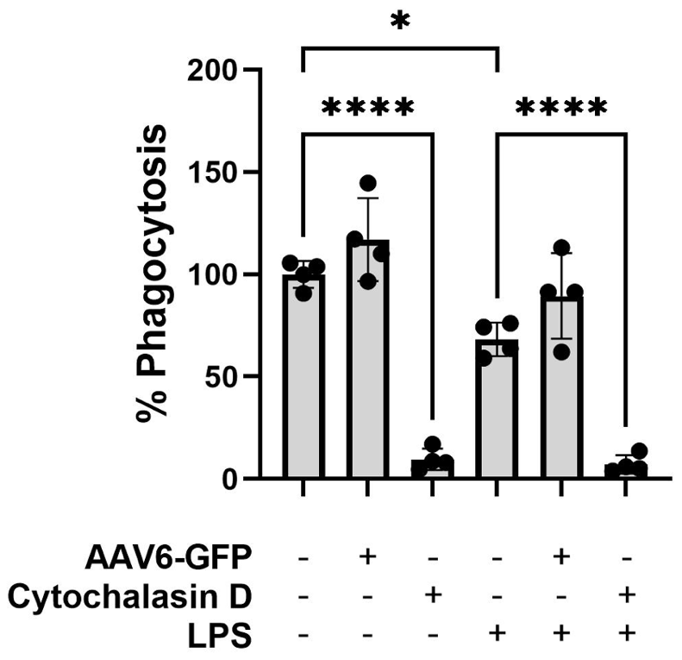
Supplemental figure 10: Phagocytosis
Phagocytosis of AM after AAV6-GFP transduction and 1 µg/ml LPS stimulation for 20 h. Negative control treated with 20 µM Cytochalasin D for 1 h before Assay. n = 4.

