Supplement

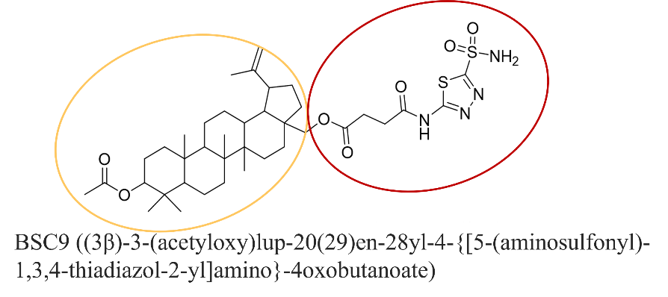
Supplemental Figure 1: Chemical structure of BSC9. The 3-O-acetylbetulinyl group is shown in orange, while the sulfonamide acetazolamide moiety is highlighted in red.

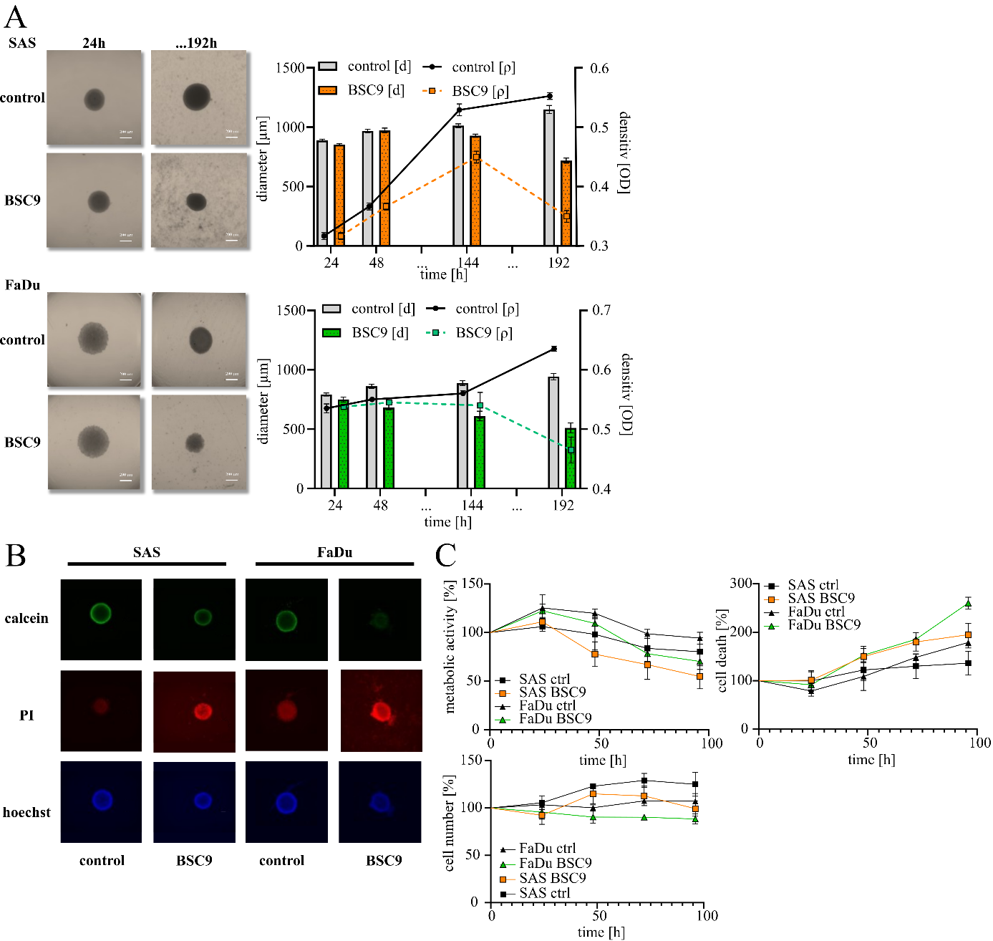
Supplemental Figure 2: Growth, density and vitality of 3D HNSCC models. Spheroid growth and density was measured and analyzed over 192 h and were treated with BSC9 (A). Spheroids are shown in representative pictures. Calcein, PI and Hoechst staining was analyzed and representative pictures are shown (B). Fluorescence intensity was quantified using Python (C). The data represent the mean values (± SDs) of at least three independent experiments.
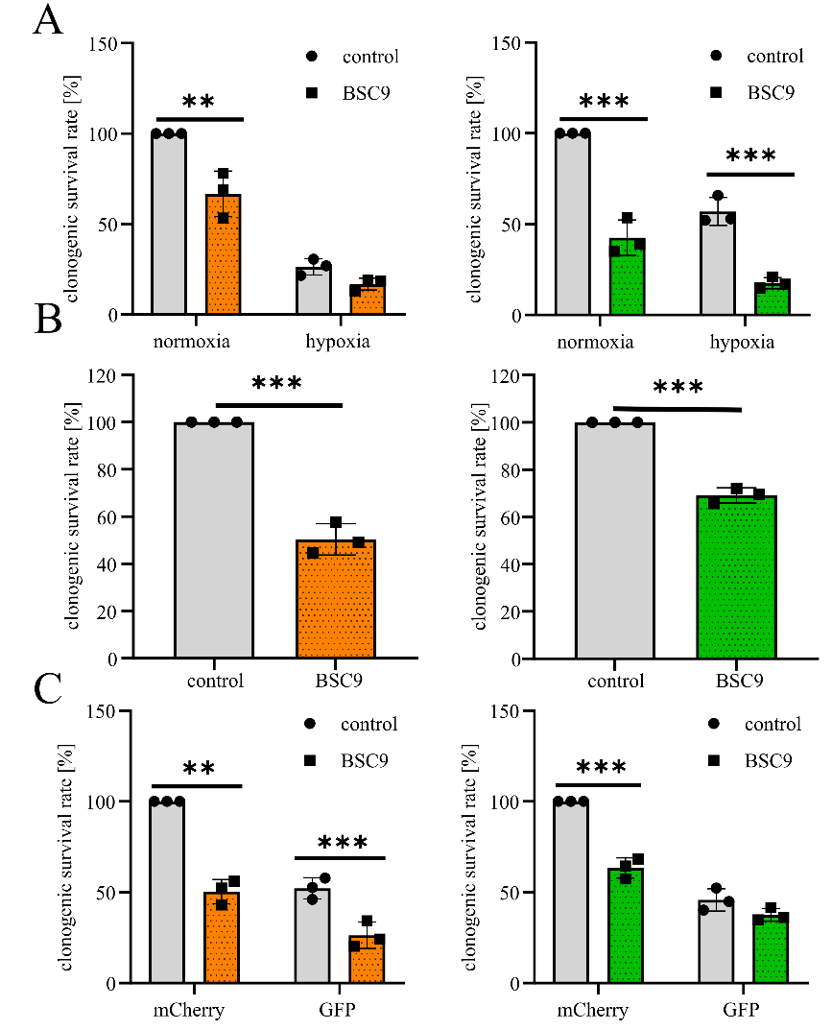
Supplemental Figure 3: Clonogenic survival rate of 2D and 3D HNSCC models. Clonogenic survival rate of SAS (left, orange) and FaDu (right, green) of 2D models (A) and SAS (orange) and FaDu (green) 3D models (B) as well as GFP- and mCherry-labeled 3D models of SAS (orange) and FaDu (green) (C) after treatment with BSC9. Clonogenic survival rate [%] is relative to the normoxic/mCherry-labeled control cells. The data represent the mean values (± SDs) of at least three independent experiments. Significant p values are highlighted with asterisks (* p < 0.05; ** p < 0.01, *** p < 0.001).

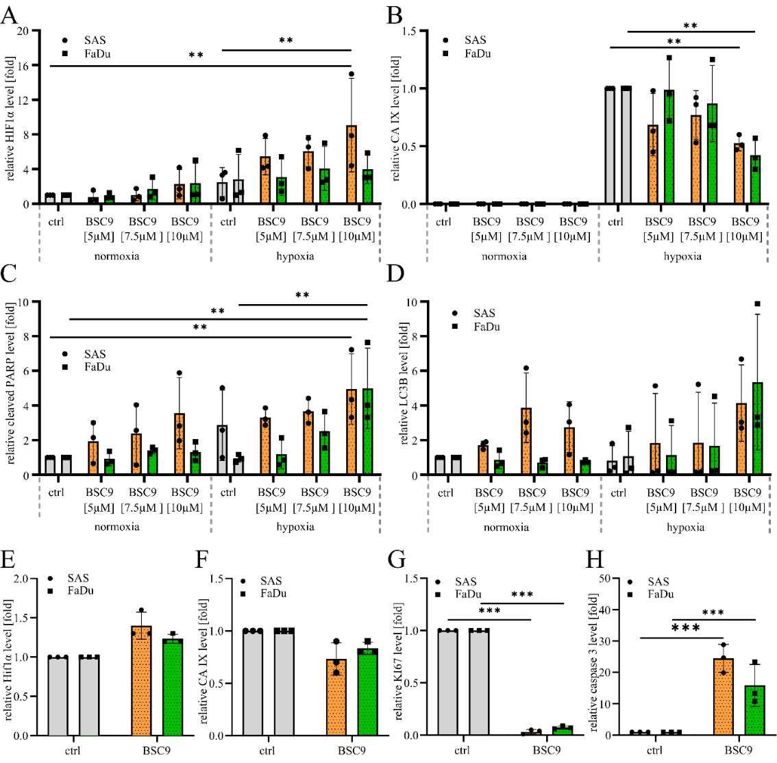
Supplemental Figure 4. Quantification of protein levels via western blot and IHC. Western blot protein levels of HIF1α (A), CA IX (B), cleaved PARP (C) and LC3B (D) and IHC quantification of HIF1α (E), CA IX (F) KI67 (G) and cleaved caspase 3 (H)of SAS (orange) and FaDu (green) cells after BSC9 treatment. The data represent the mean values (± SDs) of at least three independent experiments. Significant p values are highlighted with asterisks (* p < 0.05; ** p < 0.01, *** p < 0.001).

Supplemental Table 1: Top 15 ranked differentially expressed genes following BSC9 treatment in SAS cells under normoxic and hypoxic conditions. Differentially expressed genes in SAS cells following BSC9 treatment under normoxic (N) or hypoxic (H) conditions were ranked according to a product score (p-score) integrating effect size and statistical significance (|log₂(FC)| × −log₁₀(FDR)). The 15 highest-ranked genes for each oxygen condition are shown together with their log₂ fold change (Log₂(FC)), false discovery rate (FDR), and corresponding product score. The BSC9 treatment is compared with the respective untreated DMSO control. Shared genes are highlighted as follows: SAS N/H, yellow; SAS/FaDu N, blue; SAS/FaDu H, green; genes shared across multiple conditions, red.
SAS_N_BSC9 | Log₂(FC) | FDR | p-score | SAS_H_BSC9 | Log₂(FC) | FDR | p-score
ANXA10 | -4,59 | 1,75E-37 | 1,69E+02 | MFSD2A | 6,42 | 3,07E-98 | 6,26E+02
S100A7 | -6,54 | 2,07E-26 | 1,68E+02 | G0S2 | 4,55 | 2,47E-58 | 2,62E+02
S100A9 | -3,88 | 1,28E-32 | 1,24E+02 | CSF2 | 4,59 | 3,09E-56 | 2,55E+02
KLK13 | -3,62 | 4,54E-28 | 9,89E+01 | ALPP | -6,68 | 1,04E-36 | 2,41E+02
INHBE | 5,17 | 5,71E-18 | 8,92E+01 | MAGOHB | 3,71 | 2,11E-65 | 2,40E+02
CHAC1 | 3,24 | 3,15E-28 | 8,92E+01 | APOL4 | -8,40 | 1,15E-28 | 2,35E+02
G0S2 | 3,12 | 2,73E-28 | 8,61E+01 | TAF13 | 3,63 | 1,53E-59 | 2,14E+02
PTGES | -2,46 | 8,30E-33 | 7,88E+01 | TIMP3 | -3,30 | 7,82E-65 | 2,12E+02
SLC6A9 | 2,95 | 3,87E-27 | 7,80E+01 | CLCA2 | -5,27 | 1,77E-39 | 2,04E+02
PADI3 | -4,28 | 6,37E-19 | 7,79E+01 | ATF3 | 3,35 | 7,24E-59 | 1,95E+02
NNMT | -2,65 | 8,60E-28 | 7,17E+01 | ARF4 | 3,20 | 3,52E-60 | 1,90E+02
KLK10 | -2,67 | 1,44E-26 | 6,90E+01 | CCDC80 | -3,65 | 7,66E-50 | 1,79E+02
SERPINE1 | 2,53 | 4,08E-26 | 6,43E+01 | FGFR3 | -3,94 | 1,21E-44 | 1,73E+02
JDP2 | 2,31 | 2,07E-26 | 5,92E+01 | MATN2 | -4,25 | 5,13E-41 | 1,71E+02
APOL4 | -4,52 | 1,49E-13 | 5,80E+01 | KRT16 | -5,13 | 8,92E-34 | 1,70E+02

Supplemental Table 2: Top 15 ranked differentially expressed genes following BSC9 treatment in FaDu cells under normoxic and hypoxic conditions. Differentially expressed genes in FaDu cells following BSC9 treatment under normoxic (N) or hypoxic (H) conditions were ranked according to a product score (p-score) integrating effect size and statistical significance (|log₂(FC)| × −log₁₀(FDR)). The 15 highest-ranked genes for each oxygen condition are shown together with their log₂ fold change (Log₂(FC)), false discovery rate (FDR), and corresponding product score. The BSC9 treatment is compared with the respective untreated DMSO control. Shared genes are highlighted as follows: SAS N/H, yellow; SAS/FaDu N, blue; SAS/FaDu H, green; genes shared across multiple conditions, red.
FaDu_N_BSC9 | Log₂(FC) | FDR | p-score | FaDu_H_BSC9 | Log₂(FC) | FDR | p-score
INHBE | 5,50 | 9,76E-29 | 1,54E+02 | TBX3 | 3,67 | 2,97E-49 | 1,78E+02
FIBIN | 8,44 | 2,26E-09 | 7,30E+01 | MT1E | 2,79 | 2,08E-60 | 1,66E+02
DIRAS3 | -4,34 | 3,26E-15 | 6,29E+01 | SLC30A1 | 3,19 | 7,44E-46 | 1,44E+02
ANXA10 | -4,58 | 5,08E-13 | 5,63E+01 | CSF2 | 5,69 | 5,04E-17 | 9,27E+01
MMP12 | -4,59 | 4,77E-12 | 5,20E+01 | G0S2 | 5,24 | 3,35E-17 | 8,64E+01
SLC1A4 | 3,07 | 3,08E-17 | 5,08E+01 | IL1RL1 | 5,05 | 8,94E-18 | 8,61E+01
MT1F | 2,89 | 4,15E-18 | 5,02E+01 | ATF3 | 3,37 | 5,86E-26 | 8,50E+01
SCN4A | 5,86 | 6,10E-09 | 4,82E+01 | ODC1 | 2,72 | 1,47E-27 | 7,31E+01
SLC6A9 | 2,94 | 9,49E-17 | 4,71E+01 | MFSD2A | 4,04 | 4,80E-17 | 6,59E+01
GRB10 | 2,50 | 2,20E-19 | 4,67E+01 | SPX | 6,64 | 5,78E-10 | 6,13E+01
CYP1A1 | 2,22 | 9,07E-22 | 4,67E+01 | DUSP8 | 4,24 | 3,89E-15 | 6,11E+01
ALDH1L2 | 2,57 | 8,82E-19 | 4,63E+01 | MPZL2 | -2,62 | 6,26E-24 | 6,08E+01
ECM2 | 3,59 | 9,53E-13 | 4,32E+01 | UPP1 | 2,33 | 1,41E-25 | 5,80E+01
G0S2 | 4,14 | 7,64E-11 | 4,19E+01 | ERAP2 | -3,35 | 5,22E-18 | 5,79E+01
NUPR1 | 3,70 | 8,65E-12 | 4,09E+01 | WNT7B | -2,61 | 1,15E-22 | 5,72E+01

Supplemental Table 3: Categorization into functional biological groups of significantly enriched KEGG pathways after BSC9 treatment. Significantly enriched KEGG pathways in SAS and FaDu cells following treatment with BSC9 or BA under normoxic (N), hypoxic (H), or both conditions (B). Enriched pathways (p.adjusted < 0.05 of GSEA KEGGs) were assigned to eight major biological categories (I–VIII). Pathways significantly enriched under normoxic, hypoxic, or both conditions are indicated by red boxes. In addition, pathways exclusively enriched following BSC9 treatment are highlighted in red, whereas pathways exclusively enriched following BA treatment are highlighted in orange.
category | KEGG pathways | BSC9 |  |  | BA
category | KEGG pathways | N | H | B | N | H | B
I. cell cycle, DNA damage & repair | BASAL_TRANSCRIPTION_FACTORS
I. cell cycle, DNA damage & repair | BASE_EXCISION_REPAIR
I. cell cycle, DNA damage & repair | CELL_CYCLE
I. cell cycle, DNA damage & repair | DNA_REPLICATION
I. cell cycle, DNA damage & repair | NUCLEOTIDE_EXCISION_REPAIR
I. cell cycle, DNA damage & repair | P53_SIGNALING_PATHWAY
I. cell cycle, DNA damage & repair | RNA_DEGRADATION
I. cell cycle, DNA damage & repair | RNA_POLYMERASE
I. cell cycle, DNA damage & repair | SPLICEOSOME
II. signal transduction | B_CELL_RECEPTOR_SIGNALING_PATHWAY
II. signal transduction | CALCIUM_SIGNALING_PATHWAY
II. signal transduction | ERBB_SIGNALING_PATHWAY
II. signal transduction | HEDGEHOG_SIGNALING_PATHWAY
II. signal transduction | INSULIN_SIGNALING_PATHWAY
II. signal transduction | JAK_STAT_SIGNALING_PATHWAY
II. signal transduction | MAPK_SIGNALING_PATHWAY
II. signal transduction | MTOR_SIGNALING_PATHWAY
II. signal transduction | NEUROACTIVE_LIGAND_RECEPTOR_INTERACTION
II. signal transduction | NEUROTROPHIN_SIGNALING_PATHWAY
II. signal transduction | VEGF_SIGNALING_PATHWAY

category | KEGG pathways | BSC9 |  |  | BA
category | KEGG pathways | N | H | B | N | H | B
III. cell adhesion, migration & microenvironment | ADHERENS_JUNCTION
III. cell adhesion, migration & microenvironment | AXON_GUIDANCE
III. cell adhesion, migration & microenvironment | CELL_ADHESION_MOLECULES_CAMS
III. cell adhesion, migration & microenvironment | ECM_RECEPTOR_INTERACTION
III. cell adhesion, migration & microenvironment | FOCAL_ADHESION
III. cell adhesion, migration & microenvironment | GAP_JUNCTION
III. cell adhesion, migration & microenvironment | LEUKOCYTE_TRANSENDOTHELIAL_MIGRATION
III. cell adhesion, migration & microenvironment | REGULATION_OF_ACTIN_CYTOSKELETON
III. cell adhesion, migration & microenvironment | TIGHT_JUNCTION
IV. metabolism & detoxification | ARACHIDONIC_ACID_METABOLISM
IV. metabolism & detoxification | ASCORBATE_AND_ALDARATE_METABOLISM
IV. metabolism & detoxification | CITRATE_CYCLE_TCA_CYCLE
IV. metabolism & detoxification | DRUG_METABOLISM_CYTOCHROME_P450
IV. metabolism & detoxification | GLYCOSAMINOGLYCAN_DEGRADATION
IV. metabolism & detoxification | GLYOXYLATE_AND_DICARBOXYLATE_METABOLISM
IV. metabolism & detoxification | LINOLEIC_ACID_METABOLISM
IV. metabolism & detoxification | METABOLISM_OF_XENOBIOTICS_BY_CYTOCHROME_P450
IV. metabolism & detoxification | OXIDATIVE_PHOSPHORYLATION
IV. metabolism & detoxification | PENTOSE_AND_GLUCURONATE_INTERCONVERSIONS
IV. metabolism & detoxification | PURINE_METABOLISM
IV. metabolism & detoxification | PYRIMIDINE_METABOLISM
IV. metabolism & detoxification | RETINOL_METABOLISM
IV. metabolism & detoxification | STARCH_AND_SUCROSE_METABOLISM
IV. metabolism & detoxification | STEROID_BIOSYNTHESIS
IV. metabolism & detoxification | STEROID_HORMONE_BIOSYNTHESIS
IV. metabolism & detoxification | SULFUR_METABOLISM
IV. metabolism & detoxification | TERPENOID_BACKBONE_BIOSYNTHESIS
IV. metabolism & detoxification | VALINE_LEUCINE_AND_ISOLEUCINE_DEGRADATION
V. apoptosis, protein homeostasis & cellular stress | AMINOACYL_TRNA_BIOSYNTHESIS
V. apoptosis, protein homeostasis & cellular stress | ENDOCYTOSIS
V. apoptosis, protein homeostasis & cellular stress | GLUTATHIONE_METABOLISM
V. apoptosis, protein homeostasis & cellular stress | LYSOSOME
V. apoptosis, protein homeostasis & cellular stress | PROTEASOME
V. apoptosis, protein homeostasis & cellular stress | PROTEIN_EXPORT
V. apoptosis, protein homeostasis & cellular stress | RIBOSOME
V. apoptosis, protein homeostasis & cellular stress | UBIQUITIN_MEDIATED_PROTEOLYSIS
VI. immunomodulation & inflammation | ANTIGEN_PROCESSING_AND_PRESENTATION
VI. immunomodulation & inflammation | AUTOIMMUNE_THYROID_DISEASE
VI. immunomodulation & inflammation | CYTOKINE_CYTOKINE_RECEPTOR_INTERACTION
VI. immunomodulation & inflammation | EPITHELIAL_CELL_SIGNALING_IN_HELICOBACTER_PYLORI
VI. immunomodulation & inflammation | HEMATOPOIETIC_CELL_LINEAGE
VI. immunomodulation & inflammation | NOD_LIKE_RECEPTOR_SIGNALING_PATHWAY
VI. immunomodulation & inflammation | SYSTEMIC_LUPUS_ERYTHEMATOSUS
VI. immunomodulation & inflammation | T_CELL_RECEPTOR_SIGNALING_PATHWAY
VII. circadian, neuronal & sensory pathways | ALZHEIMERS_DISEASE
VII. circadian, neuronal & sensory pathways | CIRCADIAN_RHYTHM_MAMMAL
VII. circadian, neuronal & sensory pathways | HUNTINGTONS_DISEASE
VII. circadian, neuronal & sensory pathways | LONG_TERM_DEPRESSION
VII. circadian, neuronal & sensory pathways | OLFACTORY_TRANSDUCTION
VII. circadian, neuronal & sensory pathways | PARKINSONS_DISEASE
VIII. tumor- and organ-specific signaling pathways | ACUTE_MYELOID_LEUKEMIA
VIII. tumor- and organ-specific signaling pathways | ARRHYTHMOGENIC_RIGHT_VENTRICULAR_CARDIOMYOPATHY
VIII. tumor- and organ-specific signaling pathways | BASAL_CELL_CARCINOMA
VIII. tumor- and organ-specific signaling pathways | BLADDER_CANCER
VIII. tumor- and organ-specific signaling pathways | CHRONIC_MYELOID_LEUKEMIA
VIII. tumor- and organ-specific signaling pathways | COLORECTAL_CANCER
VIII. tumor- and organ-specific signaling pathways | DILATED_CARDIOMYOPATHY
VIII. tumor- and organ-specific signaling pathways | ENDOMETRIAL_CANCER
VIII. tumor- and organ-specific signaling pathways | HYPERTROPHIC_CARDIOMYOPATHY_HCM
VIII. tumor- and organ-specific signaling pathways | MELANOGENESIS
VIII. tumor- and organ-specific signaling pathways | MELANOMA
VIII. tumor- and organ-specific signaling pathways | NON_SMALL_CELL_LUNG_CANCER
VIII. tumor- and organ-specific signaling pathways | PANCREATIC_CANCER
VIII. tumor- and organ-specific signaling pathways | PATHWAYS_IN_CANCER
VIII. tumor- and organ-specific signaling pathways | PROSTATE_CANCER
VIII. tumor- and organ-specific signaling pathways | RENAL_CELL_CARCINOMA
VIII. tumor- and organ-specific signaling pathways | SMALL_CELL_LUNG_CANCER
VIII. tumor- and organ-specific signaling pathways | THYROID_CANCER

