Supplementary material
Rapid and High-Sensitive Microwave Field Imaging Technology Based on NV Centers and Digital Lock-in Amplification

Contents
S1: spatial resolution 2
S2: Origin of the Fitting Formula in the Experiment 4
S3: Derivation of the Formula for Magnetic Field Calculation 8
S4: Diamond testing 11
S5: Photo supplement 15

S1: spatial resolution
Spatial resolution refers to the actual field of view resolution (that is, the actual distance represented by each pixel point). In our experiment, we used the American standard field calibration plate to calibrate our market resolution. This product is designed and manufactured according to the US military standard MIL-STD-150A. Its different resolution units are marked with corresponding groups and elements, and the resolution of each unit can be obtained by referring to the table. It is widely applied, from complex optical systems in aviation, aerospace and astronomy telescopes to the manufacturing and production of common optical products in daily life. It is not only applicable to the evaluation of imaging quality of various optical instruments and equipment (such as stereomicroscopes, collimating light tubes and telescopes, etc.), but also very suitable for the evaluation of imaging quality of various lenses and optical components (such as aerial reconnaissance lenses, aerial mapping lenses, projection objective lenses, microscopes, camera lenses, video camera lenses and industrial camera lenses, etc). As shown in Fig. S1, by observing the calibration plate, he only had 7 groups. We can clearly see all the horizontal lines.
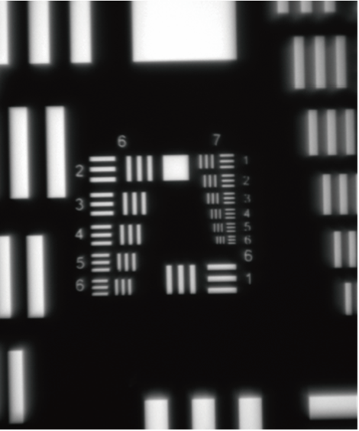
Fig. S1. Calibration plate under quantum wide-field microscope
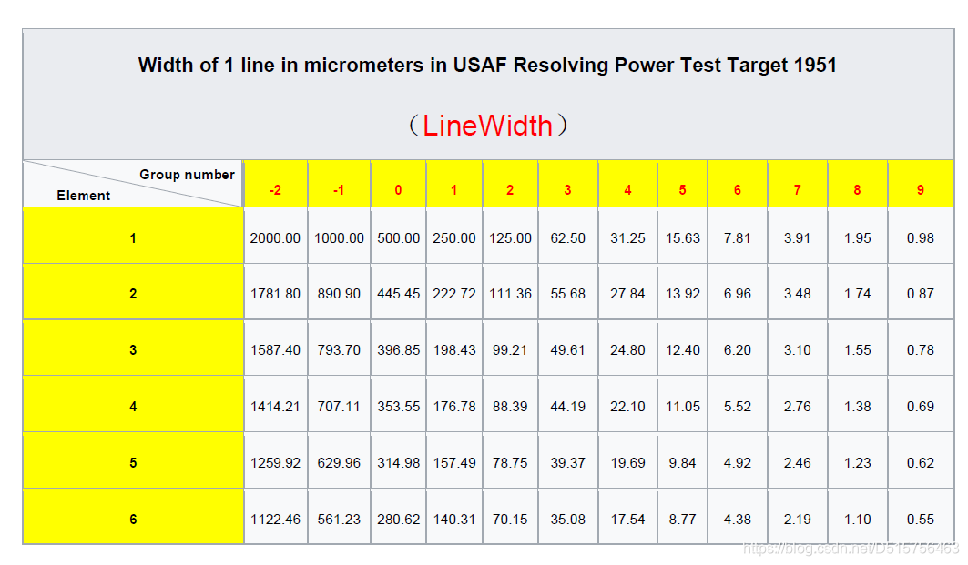
Tab. S1. USAF 1951 Resolution Version Lookup Table
As shown in Table S1, limited by the imaging resolution of the target plate, only seven line‑pair groups could be clearly distinguished in the experiment, while higher‑density line‑pair structures could not be resolved. To address this, a GP50001‑C microscope was used to calibrate the pixel size with a calibration target (correction ruler). The calibration result is presented in Fig. S2. The measurement shows that a standard line‑pair spacing of 100 µm corresponds to 61 pixels in the image. From this, the single‑pixel physical resolution is calculated as $100/61≈1.6 μ\text{m}\text{/}\text{pixel}$.

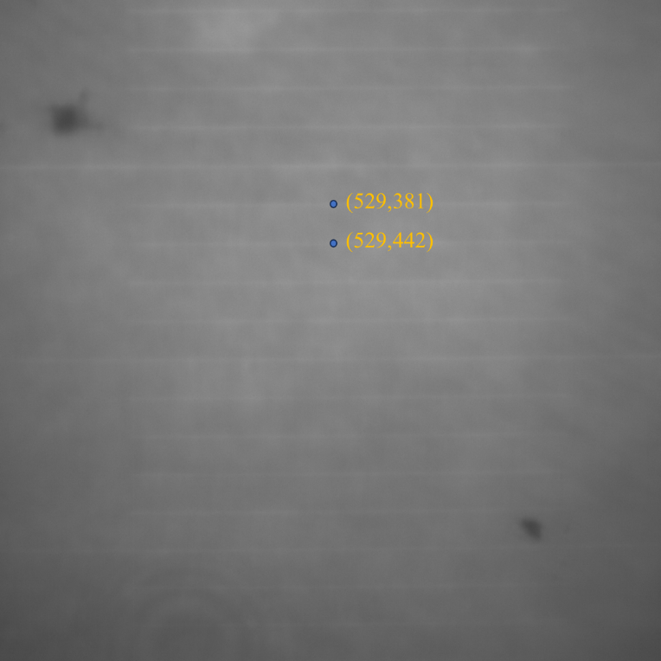
Fig. S2. The microscopic correction ruler GP50001-C captured by the imaging system.

S2: Origin of the Fitting Formula in the Experiment
Gaussian or Lorentzian functions are commonly used to fit the optically detected magnetic resonance (ODMR) signals of nitrogen-vacancy (NV) centers. In this work, the ODMR lineshape is modified by applying frequency modulation (FM) to the microwave signal. As shown in Fig. S1(a), a 5-seconds ideal ODMR signal is generated using a Gaussian function. A perturbation signal at 100 Hz is then introduced via FM modulation, with a perturbation time $x(t_{\text{perturbed}})=0.01s$. After introducing the perturbation, the original ODMR signal evolves into the waveform shown in Fig. S1(b), with magnified details in panels (c) and (d).
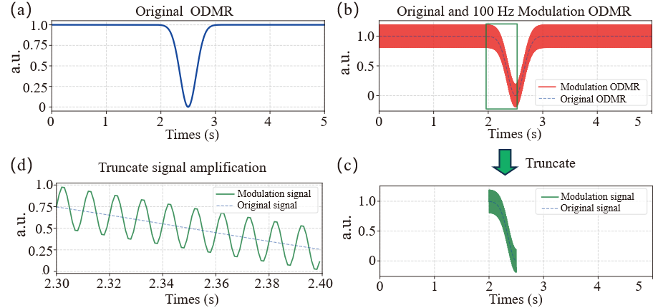
Fig. S3. (a) Ideal ODMR curve under a Gaussian function. (b) ODMR curve under frequency-modulated microwave excitation. (c, d) Enlarged view of the region marked by the green dashed box in (b), showing the modulated sinusoidal.

Mathematically, the time-perturbed signal can be approximated to first order as:
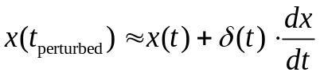
where $δ\left(t\right)=δ_{\text{max}}\sin\left(2πf_{m}t\right)$ is the time offset, $dx/dt$ is the derivative of the original signal, x(t) is the original ODMR signal (Fig. S3(a)), $x\left(t_{\text{perturbed}}\right)$is the modulated ODMR signal (Fig. S3(b)), and $f_{m}$ is the FM modulation frequency $(100 \text{Hz}$ in this case). Quadrature demodulation is performed by multiplying the perturbed signal with reference signals at the same modulation frequency:
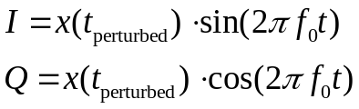
Substituting the first-order approximation and using $f_{0}=f_{m}=100 \text{Hz}$:
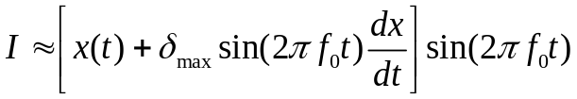
Expanding and applying the identity $\sin^{2}{θ}=\frac{1}{2}\left[1-\cos\left(2θ\right)\right]$:
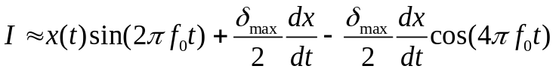
A low-pass filter with a cutoff frequency of $f_{\text{cutoff}}=f_{0}/20=10 \text{Hz}$ (well below $f_{0}$ and ${2f}_{0}$) is applied to extract the derivative term. High-frequency components are rejected, leaving only the DC term: $I_{\text{filtered}}≈\frac{δ_{\text{max}}}{2}\frac{dx}{dt}$. This derivation shows that quadrature demodulation followed by low-pass filtering successfully extracts the derivative $\frac{dx}{dt}$ of the original signal. The constant factor $\frac{δ_{\text{max}}}{2}$ scales the amplitude but preserves the lineshape. $I_{\text{filtered}}$ is thus a scaled version of the derivative of the Gaussian signal ($Q_{\text{filtered}} is also$), which is the core principle of lock-in amplification: extracting weak derivative signals via modulation and demodulation. In ODMR experiments, this method enables high-sensitivity detection of the signal slope (differential response at the resonance frequency), superior to direct measurement.
We therefore use the derivative of a Gaussian function as the fitting model for experimental data. Fig. S4 shows the demodulated output from the digital lock-in process applied to the signal in Fig. S3(b).
The effective data used for analysis is the Q-path filtering output in Fig. 4. The gray shaded region before the stable point arises from uncompensated phase offset in the digital lock-in implementation, as the reference signal is computed internally rather than supplied externally. The derivative of a Gaussian function is then used to fit the Q-path output to extract key parameters.

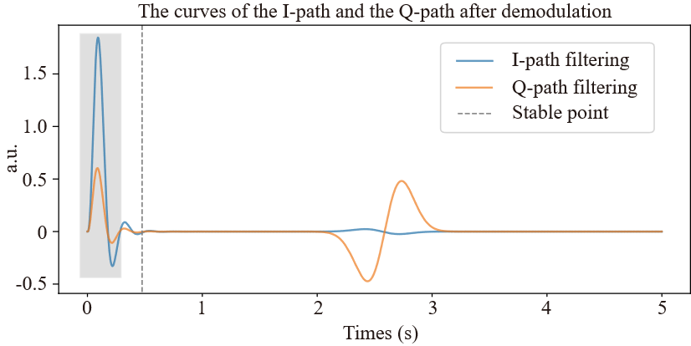
Fig. S4. Results of digital lock-in demodulation applied to the signal in Fig. S3(b), showing the I and Q path filtering outputs. The shaded gray region indicates the interval of auto-phase alignment.

Original Gaussian function:
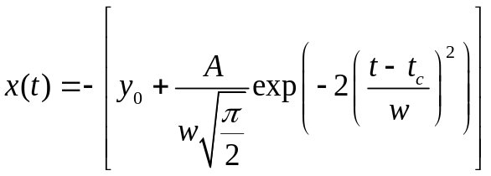
Its derivative:
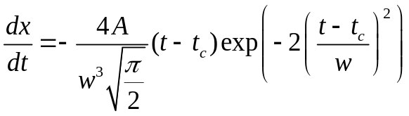
We then apply quadrature demodulation, low-pass filtering, and fitting to measured data. Fig. S5(a) shows the raw ODMR signal from a single camera pixel without FM modulation, and Fig. S5(b) shows the signal with 100 Hz FM modulation. Panel (a) is dominated by noise, while (b) contains both noise and the modulated response.
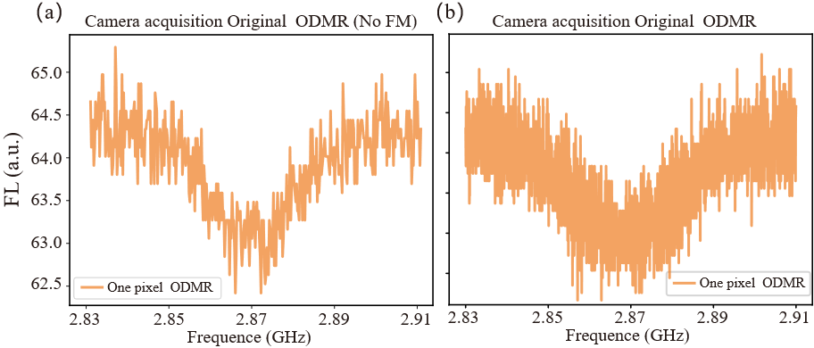
Fig. S5. Comparison of ODMR signals acquired from a single pixel of the camera without and with modulated microwave excitation.
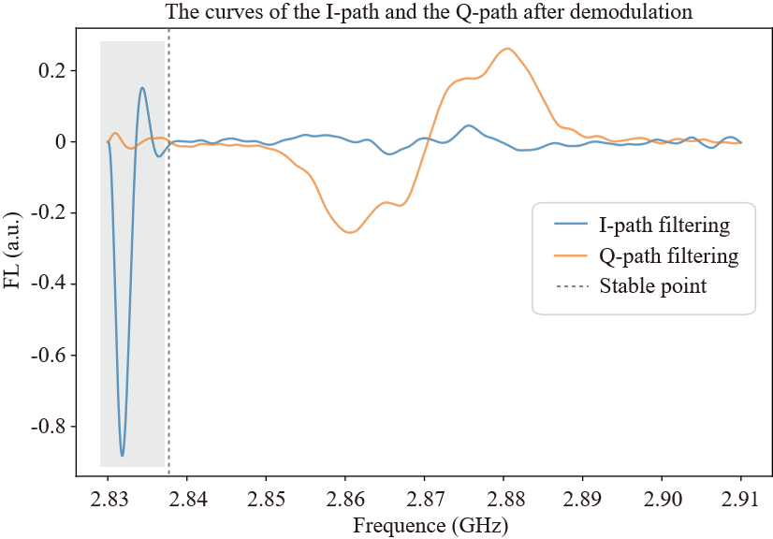
Fig. S6. Results of digital lock-in demodulation applied to the signal in Fig. S5(b), showing the I and Q path filtering outputs. The shaded blue region indicates the interval of auto-phase alignment.
The demodulation result of the signal in Fig. S5(b) is presented in Fig. S5. Fitting the Q-path filtering curve using the derivative of a Gaussian yields Fig. S7 and S8. The separation between the maximum and minimum of the fitting curve, defined as ω, is a key parameter for subsequent analysis.

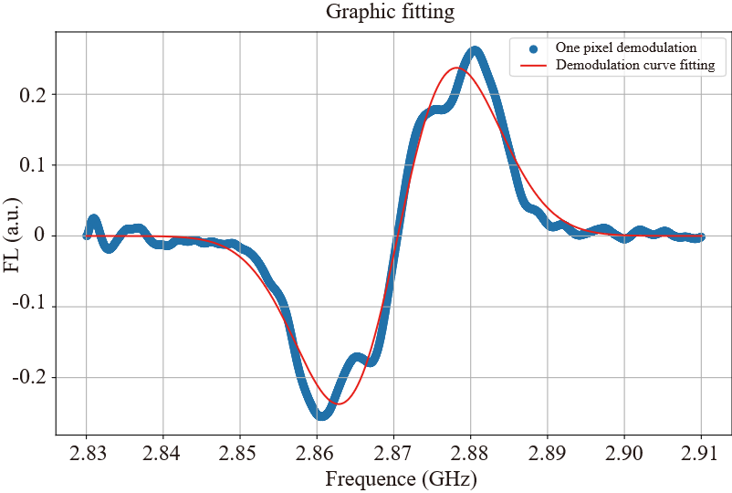

Fig. S7. Curve fitting of the Q-channel signal obtained from Fig. S6.
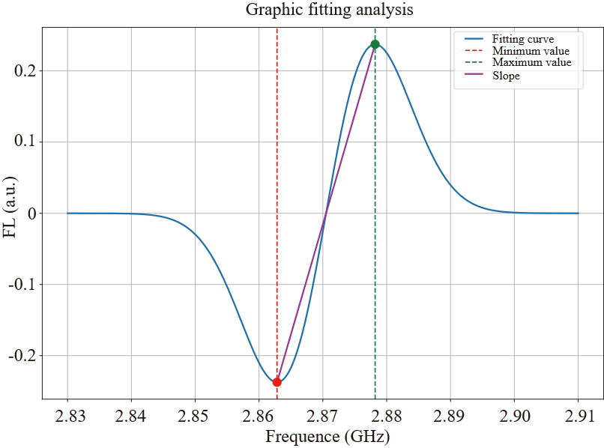
Fig. S8. Analysis of the Fig. S6 fitted curve, revealing key parameters including the linewidth and slope.

S3: Derivation of the Formula for Magnetic Field Calculation
In quantum sensing, diamond NV centers are widely used for detecting microwave magnetic fields, with ODMR-based linewidth measurement being a powerful technique. The NV center is excited by a continuous-wave green laser, and a frequency-swept microwave field is applied via a microstrip antenna. Resonance occurs when the microwave frequency matches the NV center’s zero-field splitting, strongly reducing fluorescence intensity. This intensity change enables precise acquisition of ODMR spectra and high-sensitivity microwave magnetic field detection. Similarly, this also influences the parameter ω in Eq. S6.
Power broadening is a significant effect in magnetic resonance: the spectral linewidth (full width at half maximum, FWHM) increases with applied radio-frequency (RF) power. Consider a two-level model for an NV center with ground states $|0⟩$ and $|1⟩$, coupled by the resonant Rabi frequency $Ω_{R}∝\sqrt{P_{\text{MW}}}\left(rad/s\right)$, where $P_{\text{MW}}$is the microwave power. Let $T_{1}$ and $T_{2}$ be the longitudinal and transverse relaxation times, with decay rates $γ_{1}=1/T_{1}$ and $γ_{2}=1/T_{2}$. The system is optically pumped into $|0⟩$ at a rate $Γ_{P}$ . Using the Bloch equations, the steady-state ODMR signal as a function of frequency $ν$ (Hz) is:^{1,2}
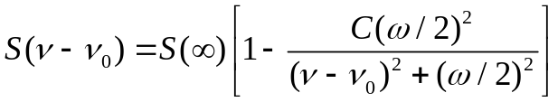
$S\left(∞\right)$ represents the off-resonance signal when the microwave is detuned $(\left|ν-ν_{0}\right|→∞)$, $C$ denotes the resonance contrast, and $ω$ is the full width at half maximum (FWHM) measured in Hz. In our experiments, the signal consists of the photoluminescence (PL) detected from nitrogen-vacancy (NV) centers. Due to the optical pumping of NV centers, which enhances the population of the $|0⟩$ state, the PL signal reaches its maximum because the fluorescence intensity of the $|0⟩$ state is higher than that of the $|1⟩$ state. When the microwave magnetic field is on resonance with the NV center transition, the population is transferred from the $|0⟩$ state to the $|1⟩$ state, resulting in a characteristic dip in fluorescence.
The full width at half maximum (FWHM) can be expressed as:
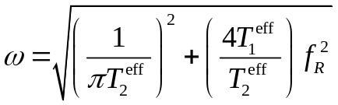
In this context, $f_{R}=Ω_{R}/\left(2π\right)$ represents the Rabi frequency measured in Hz. The "effective" relaxation times are determined by the optical pumping rate $Γ_{p}$, defined as $1/T_{1}^{\text{eff}}=1/T_{1}+Γ_{p} and 1/T_{2}^{\text{eff}}=1/T_{2}+Γ_{p}/2$. At low microwave (MW) power levels, the magnetic resonance width is approximately $ω≈1/\left(πT_{2}^{\text{eff}}\right)$. Increasing the MW power induces power broadening; in the high-power regime, the full width at half maximum (FWHM) increases and becomes proportional to the Rabi frequency, scaled by a factor of $2\sqrt{T_{1}^{\text{eff}}/T_{2}^{\text{eff}}}$.
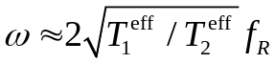
Eq. (S8) remains valid for both a single two-level atom and an ensemble of identical two-level systems. However, NV centers within an ensemble are inherently distinct due to their varying local environments. This inhomogeneous broadening can be modeled with a full width at half maximum (FWHM) of $Δν_{\text{inh}}∝1/T_{2}^{*}$. Generally, in solid-state systems, the relaxation times satisfy $T_{2}≤2T_{1}$ and $T_{2}^{\text{intr}}≫T_{2}^{*}$. The ensemble-averaged optically detected magnetic resonance (ODMR) signal is then given by:
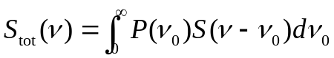
Where $S\left(ν-ν_{0}\right)$ denotes the ODMR signal for a single NV center with a resonance frequency $\nu_0$. The FWHM of the total ODMR signal can be determined by calculating $S_{\text{tot}}\left(ν\right)$ according to Eq. (S10). If the resonance frequencies follow a Gaussian probability distribution $P\left(ν_{0}\right)∝\exp\left(-ν_{0}^{2}/2σ^{2}\right)$—where $σ$ is defined such that the FWHM is $Δν_{\text{inh}}≈2.35$—then the lineshape of $S_{\text{tot}}\left(ν\right)$ will be a Voigt profile, which can be evaluated using the complex error function. Conversely, if the resonance frequencies exhibit a Lorentzian probability distribution, the resulting lineshape of $S_{\text{tot}}\left(ν\right)$ remains Lorentzian, with a FWHM given by:
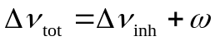
Here, $Δν_{\text{inh}}=1/\left(πT_{2}^{*}\right)$ and $ω$ is given by Eq. (S8). Although a Gaussian distribution might be the most natural choice for $P\left(ν_{0}\right)$, we assume a Lorentzian probability distribution for $P\left(ν_{0}\right)$ instead. The primary motivation for this assumption is to derive a simplified analytical expression for the FWHM, as shown in Eq. (S11), which facilitates the subsequent fitting and analysis of experimental data.
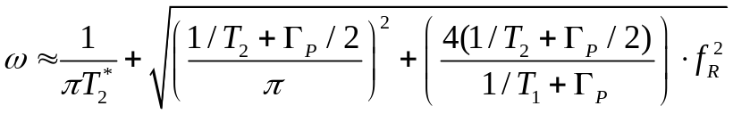
Where $f_{R}$ represents the Rabi frequency, $T_{2}^{*}$ is the dephasing time of the electron spin, and $T_{1}$ and $T_{2}$ denote the longitudinal and transverse relaxation times at room temperature, respectively. $Γ_{p}$ corresponds to the optical pumping rate determined by the laser intensity. Consequently, the Rabi frequency can be estimated by measuring the FWHM, while the strength of the microwave (MW) magnetic field determines the period of the Rabi oscillations.
Therefore, the magnitude of the MW magnetic field can be derived from the Rabi frequency using the following equation:
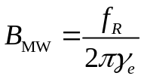
As the MW power applied to the diamond increases, the FWHM of the ODMR spectrum broadens accordingly. Consequently, the intensity of the MW magnetic field can be quantified by analyzing this FWHM. By substituting Eq. (S13) into Eq. (S12), one obtains:
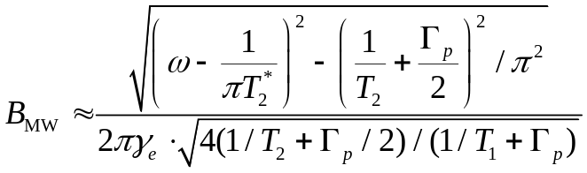

S4: Diamond testing
The diamond samples used in this experiment were purchased from Element Six. They are type IIa high-purity single-crystal diamonds grown via chemical vapor deposition (CVD), with dimensions of 3 mm × 3 mm × 0.5 mm. To accurately characterize the spin dynamics of the nitrogen-vacancy (NV) centers, key parameters including the spin coherence times $T_{1}$, $T_{2}$, and $T_{2}^{*}$, as well as the photon correlation parameter $Γ_{p}$, were measured. A series of characterization experiments were designed and performed accordingly.
Next, we introduce the measurement of coherence time. Coherent manipulation of nitrogen-vacancy (NV) centers is a crucial prerequisite for realizing numerous applications; consequently, the measurement of NV spin coherence times has long been a focal point in related research fields. There are three key relaxation time constants—$T_{2}^{*}$, $T_{2}$, and $T_{1}$—associated with the electronic spins of NV centers. The spin dephasing time $T_{2}^{*}$ describes the decay time of the coherent precession between the superposition states$|m_{s}=0$ and $|m_s=+1⟩$ (or $|m_{s}=-1$). To initiate such a free precession, a resonant $π/2$ microwave pulse is typically applied; an identical $π/2$ pulse is then used to terminate it. Generally, $T_{2}^{*}$ ranges from hundreds of nanoseconds to several microseconds. The aforementioned spin impurities undergo random polarization, generating fluctuating magnetic fields at the NV center sites. For an ensemble of NV centers, this results in inhomogeneous broadening of the transition during measurement. Simultaneously, under the influence of magnetic field fluctuations, the NV spins lose coherent information regarding the relative phase between the two states. Thus, $T_{2}^{*}$ characterizes the exponential decay arising from the dephasing of the electronic spins in NV centers [1].
The homogeneous spin decoherence time $T_{2}$ corresponds to the coherence decay time measured in a spin‑echo experiment, in which a resonant $π$ microwave pulse is applied at the midpoint of the free precession interval. The use of such a refocusing pulse reverses static interactions in the Hamiltonian, thereby suppressing low‑frequency noise. In a typical spin‑echo measurement, $T_{2}$ can reach several hundred microseconds. Moreover, $T_{2}$ can be further extended by applying a series of $π$ pulses (e.g., in dynamical decoupling sequences).
The spin‑lattice relaxation time $T_{1}$ describes the characteristic time for a polarized NV center to relax toward the statistical average of its three spin sublevels.
The spin properties of nitrogen‑vacancy (NV) centers can be characterized using the following experimental protocols: continuous‑wave optically detected magnetic resonance (CW‑ODMR), Rabi oscillation measurements, free‑induction decay (FID) experiments, spin‑echo measurements, and longitudinal relaxation $T_{1}$ measurements.
First, the resonance frequency of the NV centers is determined using the continuous‑wave optically detected magnetic resonance (CW‑ODMR) technique. In this measurement, a green laser and microwave field are applied simultaneously to excite the NV centers, while the fluorescence emitted by the NV centers is continuously collected. The microwave frequency is swept across the expected resonance range. When the microwave frequency matches the transition frequency of the NV spin states, population transfer occurs between the states, resulting in a detectable dip in the collected fluorescence intensity.
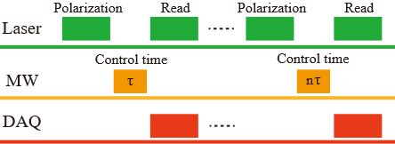
Fig. S9. Rabi oscillation regulation sequence.
Once the transition frequency has been determined, the microwave pulse width is calibrated via a Rabi oscillation measurement, as illustrated in Fig. S9. By sweeping the duration of the resonant microwave pulse, the NV centers undergo coherent population oscillations between the two spin states. After the duration of a $π$ pulse is determined from the Rabi oscillation period, the dephasing time $T_{2}^{*}$ is subsequently measured using the Ramsey interference sequence, shown in Fig. S10.
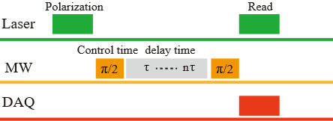
Fig. S10. Ramsey regulation sequence.
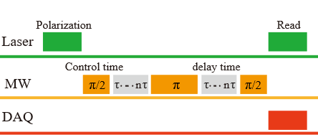
Fig. S11. Hahn echo control sequence.
In the spin‑echo sequence (Fig. S11), an additional $π$ pulse is inserted at the midpoint of the Ramsey sequence to invert the spin states. This refocusing step cancels dephasing due to slowly varying fluctuations, though high‑frequency noise still leads to decoherence. The coherence time $T_{2}$ is then obtained by sweeping the free evolution interval. Finally, the longitudinal relaxation time $T_{1}$ and the parameter $Γ_{p}$ are measured using a dedicated pulse sequence, shown in Fig. S12. These approaches constitute the core experimental techniques currently employed for NV‑center‑based sensing.
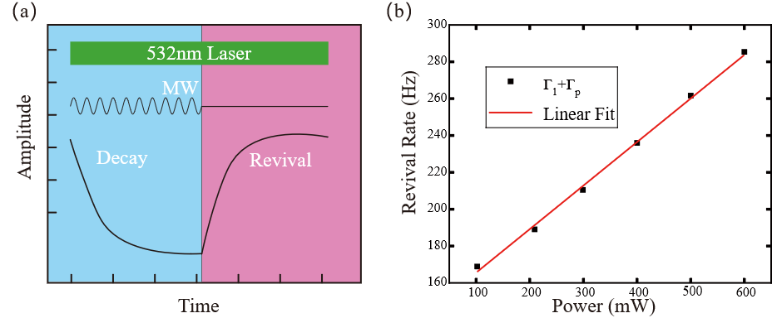
Fig. S12. Measurement of longitudinal relaxation. (a) When resonant microwave irradiation is applied, the NV fluorescence exhibits a decay; upon removal of the microwave field, the fluorescence recovers. (b) The recovery rate shows a linear dependence on the detected photoluminescence (PL) intensity. From a linear fit, the intercept gives the longitudinal relaxation rate $Γ_{1}=1/T_{1}=141±4 \text{Hz}$, while the slope is $0.24±0.01 \text{Hz}\text{/}\text{mW}$. This slope directly relates to the optical pumping rate $Γ_{\text{p}}$ per unit laser power, which was determined to be $Γ_{\text{p}}=205.6 \text{Hz}$ under the experimental optical power.
The experiments performed in this study utilized a continuous‑wave (CW) microwave source with a central frequency of 2.87 GHz. As shown in Fig. S13, data acquired using the Rabi sequence demonstrate that the duration of the $π$ pulse is 115.8 ns.
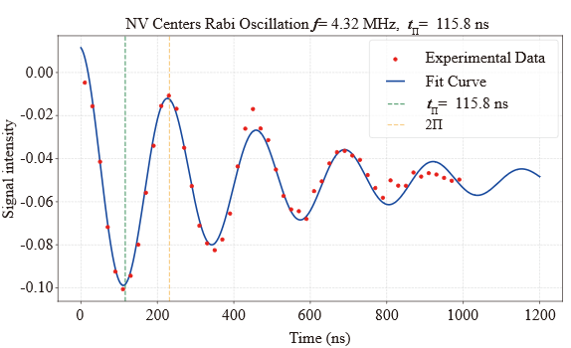
Fig. S13. Rabi oscillation results.

After the $π$-pulse duration was determined, the Ramsey interference sequence was employed to measure the spin dephasing time $T_{2}^{*}$. The experimental results are presented in Fig. S14, from which $T_{2}^{*}$ is extracted by fitting the decaying oscillation of the spin-state population. The obtained value falls within the typical range of several hundred nanoseconds to a few microseconds, consistent with expectations for ensemble NV centers under the present experimental conditions.
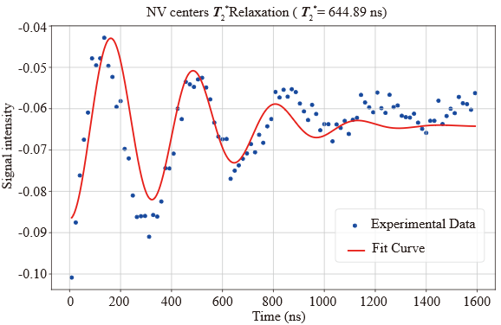
Fig. S14. Ramsey oscillation results.

Subsequently, the spin decoherence time $T_{2}$ was measured using the spin‑echo sequence, as illustrated in Fig. S15.
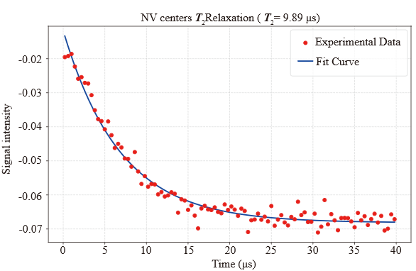
Fig. S15. Hahn echo oscillation results.

S5: Photo supplement
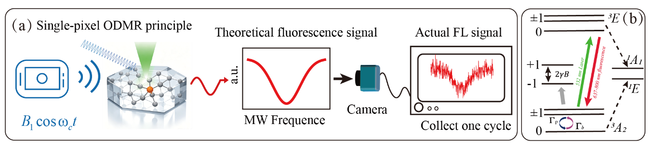
Fig. S16. (a) In conventional ODMR imaging, a green laser excites NV centers to emit red fluorescence, and under the influence of a frequency-swept MW field, the fluorescence exhibits an ODMR spectrum. However, the presence of laser noise, camera noise, and other sources causes severe fluctuations in the acquired signal, making precise fitting difficult. (b) Energy level of NV centers.

1. Jensen, K., Acosta, V. M., Jarmola, A. & Budker, D. Light narrowing of magnetic resonances in ensembles of nitrogen-vacancy centers in diamond. Phys. Rev. B 87, 014115 (2013).
2. Appel, P., Ganzhorn, M., Neu, E. & Maletinsky, P. Nanoscale microwave imaging with a single electron spin in diamond. New J. Phys. 17, 112001 (2015).

