Enhanced Rhizomucor miehei Lipase Production through Morphological and Fermentation Optimization in Aspergillus oryzae

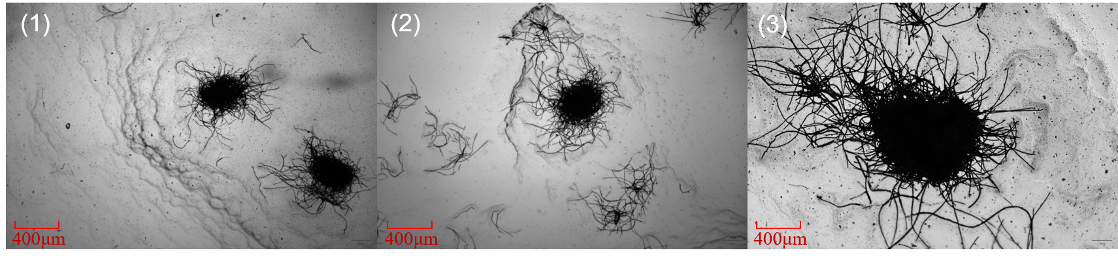
Fig. S1. Representative microscopic pellet images (40×): (1) 200 rpm without talc; (2) 200 rpm with 1 g/L 200-mesh talc; and (3) 150 rpm with 1 g/L 400-mesh talc.

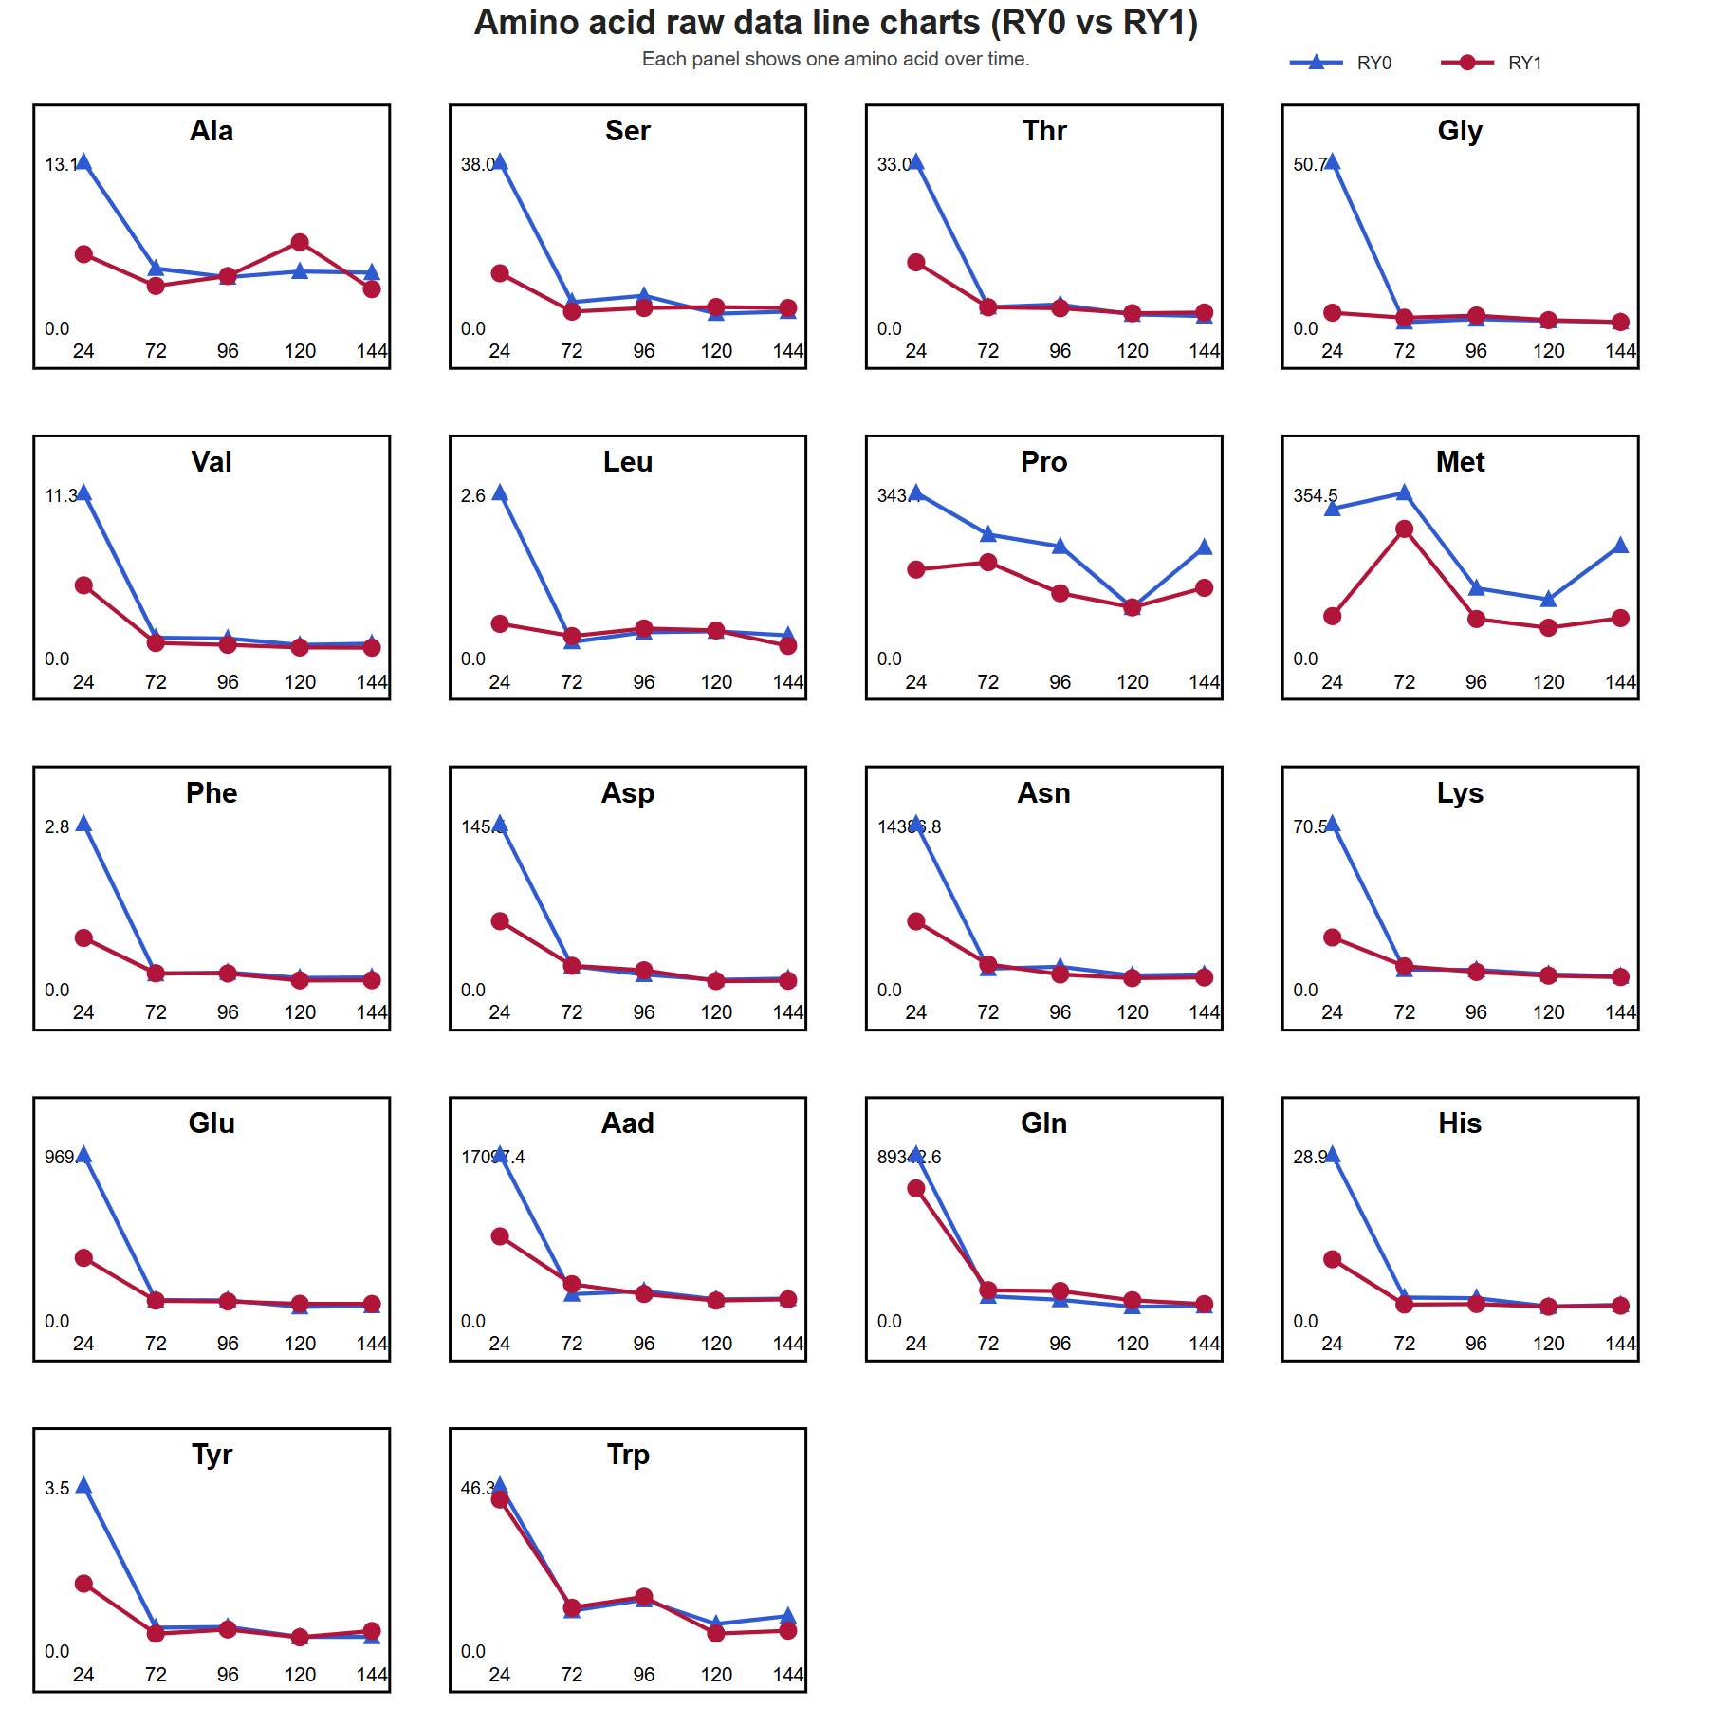
Fig. S2. Time-course profiles of intracellular amino acid contents during the control process RY0 (blue lines) and the optimized dynamic process RY1 (red lines). Fermentation times are 24, 72, 96, 120, and 144 h; the ordinate in each panel represents the absolute intracellular content of the indicated amino acid.

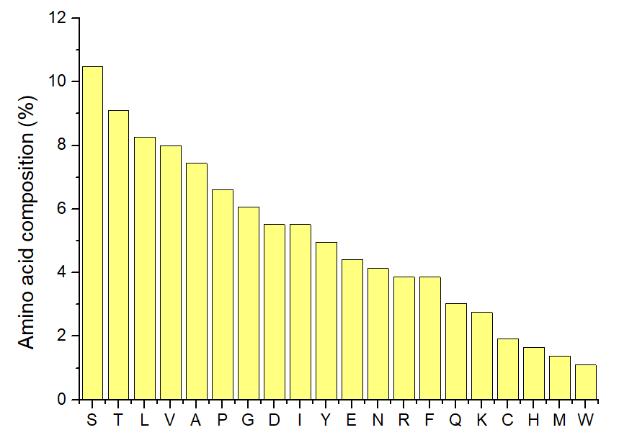
Fig. S3. Amino acid composition of the recombinant Rhizomucor miehei lipase precursor. The x-axis indicates the one-letter amino acid codes, and the y-axis indicates the percentage of each amino acid residue in the full-length precursor protein.

