Supplementary Information

Endogenous Gdf15 activation limits adiposity and increases fecal energy excretion in mice
Sarah Engelbeen^{1,2,†}, Kornelia Johann^{1,2,†}, Casper M. Sigvardsen^{3,†}, Franziska L. Sörgel⁴, Alina Blenninger⁴, Christopher A. Bishop^{1,2}, Christian T. Voldstedlund³, Soeren Ocvirk^{5,6}, Joan Miquel Pasano³, Heike Vogel^{2,7}, Erik A. Richter³, Alberto Cebrian-Serrano^{2,4,‡,*}, Maximilian Kleinert^{1,2,8,‡,*}
¹Department of Molecular Physiology of Exercise and Nutrition, German Institute of Human Nutrition (DIfE) Potsdam-Rehbruecke, Nuthetal, Germany.
²German Center for Diabetes Research (DZD), 85764 Munich-Neuherberg, Germany
³Department of Nutrition, Exercise and Sports, Faculty of Science, University of Copenhagen, Denmark
⁴Institute for Diabetes and Obesity, Helmholtz Zentrum München, Neuherberg, Germany
⁵Gnotobiology Research Unit, German Institute of Human Nutrition Potsdam-Rehbruecke, Nuthetal, Germany.
⁶Research Group WESTGUT, ZIEL - Institute for Food & Health, Technical University of Munich, Freising, Germany
⁷Department of Experimental Diabetology, German Institute of Human Nutrition Potsdam- Rehbruecke, Nuthetal, Germany.
⁸University of Potsdam, Institute of Nutritional Sciences, 14558 Nuthetal, Germany.
†Co-first authors
‡Shared last authors
*Corresponding authors
Alberto Cebrian-Serrano (alberto.cebrian@helmholtz-munich.de); Institute for Diabetes and Obesity; Helmholtz Center Munich; Ingolstädter Landstraße 1; 85764 Neuherberg; Germany
Maximilian Kleinert (maximilian.kleinert@dife.de); Department of Molecular Physiology of Exercise and Nutrition; German Institute of Human Nutrition Potsdam-Rehbruecke (DIfE); Arthur-Scheunert-Allee 114-116; 14558 Nuthetal; Germany
Supplementary Figures 1–5

Supplementary Figure 1
Supplementary Figure 1. Intravenous dose response of CRISPRa-Gdf15. Chow-fed 7–10-week-old male C57BL/6J mice were injected intravenously with vehicle or MyoAAV-dCas9-VP64 control vectors (MyoAAV2a-C-dCas9-VP64 plus MyoAAV2a-N-dCas9; 5 × 10¹¹ vg). Treatment groups received MyoAAV-CRISPRa-Gdf15 (MyoAAV2a-C-dCas9-VP64, MyoAAV2a-N-dCas9, and MyoAAV2a-SAM-gRNA5+7) at low (1 × 10¹¹ vg), medium (2.5 × 10¹¹ vg), or high (5 × 10¹¹ vg) doses. Three weeks later mice were euthanized and (a) Gdf15 mRNA were determined in gastrocnemius muscle and (b) plasma GDF15 was measured by ELISA. Data are means +/- SEM with each dot representing a distinct animal.

Supplementary Figure 2
Supplementary Figure 2. Effect of intravenous delivery of CRISPRa-Gdf15 on Gdf15 expression in different tissues in wildtype mice. Gdf15 mRNA abundance was determined in the indicated (a-h) tissues from the study described in Figure 2. Data are means +/- SEM with each dot representing a distinct animal.

Supplementary Figure 3
Supplementary Figure 3. Metabolic phenotyping after intramuscular delivery of CRISPRa-Gdf15 in wildtype mice. (A) Schematic of study design (with samples size per group shown except for E and F) with chow-fed male mice receiving intramuscularly injections with vehicle or MyoAAV2a encoding for eGFP or MyoAAV2a encoding for different component of the CRISPRa system. One week later all mice were switched to a HFHSD (EF D12331, ssniff Spezialdiäten GmbH, Germany) containing 58 kcal% fat. Over the course of the experiment, (B) plasma GDF15 levels, (C) body weight change, (D) fat-free mass and fat mass, and (E) cumulative food intake (n = 3-4 with mice double-housed), were measured. (F) Energy expenditure was determined (n = 5-6) by indirect calorimetry in week 14. (G) Glucose tolerance was tested in week 13. (B-E, G) data are presented as mean values +/− SEM with individual dots representing distinct animals. Statistic: (B-E, G) repeated measures two-way (time x treatment) ANOVA with Šidák post hoc testing. Data in (F) were analyzed using ANCOVA with body weight as co-variate.

Supplementary Figure 4
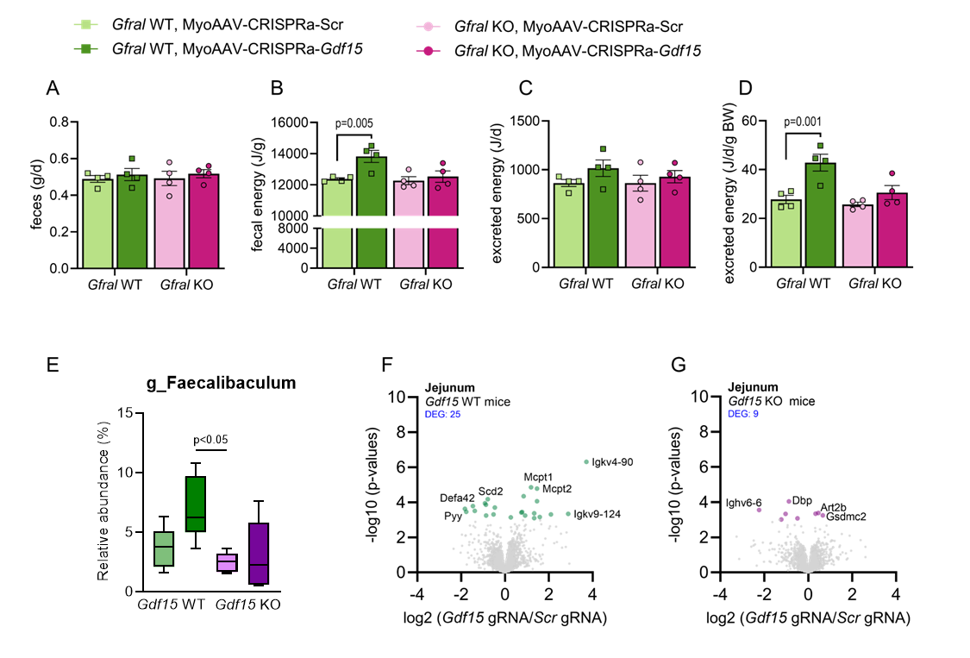
Supplementary Figure 4. Energy excretion and intestinal profiling in knockout mice. (A-D): In the study shown in Figure 3, feces were collected in week 11 to determine (A) total feces mass, (B) fecal energy density and (C,D) overall energy excreted. (E) differential abundance of microbial genera in cecum as described in Figure 5 and on (F,G) gene expression (RNAseq) in jejunum from Gdf15 WT and Gdf15 KO mice as described in Figure 5. (A-D) data are presented as mean values +/− SEM with individual dots representing the average of two animals (mice were double housed). (E) data are presented as Tukey box plots with median, IQR, and whiskers. Statistic: (A-D) Two-way (genotype x treatment) ANOVA with Šidák post hoc testing. (E) Wilcoxon Rank Sum Test with multiple testing correction by the Benjamini–Hochberg method for adjusted p-values. For E sample sizes are: Gdf15 WT, MyoAAV-CRISPRa-Scr (n = 5); Gdf15 WT, MyoAAV-CRISPRa-Gdf15 (n = 6); Gdf15 KO, MyoAAV-CRISPRa-Scr (n = 6); Gdf15 KO, MyoAAV-CRISPRa-Gdf15 (n = 6). For F and G samples sizes are: Gdf15 WT, MyoAAV-CRISPRa-Scr (n = 5); Gdf15 WT, MyoAAV-CRISPRa-Gdf15 (n = 5); Gdf15 KO, MyoAAV-CRISPRa-Scr (n = 6); Gdf15 KO, MyoAAV-CRISPRa-Gdf15 (n = 6).

Supplementary Figure 5
Supplementary Figure 5. Effects of CRISPRa-mediated Gdf15 activation on energy balance in diet-induced obese (DIO) female mice. Female mice were switched from chow to a high-fat, high-sucrose diet (HFHSD) at 8 weeks of age and, at 36 weeks, received a tail-vein injection of MyoAAV2a encoding the split CRISPRa system with Gdf15-targeting gRNAs (gRNAs 5+7; CRISPRa-Gdf15) or a scrambled control gRNA (CRISPRa-Scr). (A) Body weight over time. (B) Change in body weight; (C) cumulative food intake; (D,E) changes in fat mass and fat-free mass, respectively, over time after MyoAAV-CRISPRa administration. (F) Glucose tolerance and (G–J) fecal energy analyses performed 14 weeks after MyoAAV-CRISPRa administration. Data are mean ± SEM. Statistical significance was assessed by repeated-measures two-way ANOVA (time × treatment) with Šidák’s multiple-comparisons test (B,D,F); or unpaired two-tailed t-test (G–J). For (A,B,D,E), n = 8 CRISPRa-Scr and n = 7 CRISPRa-Gdf15 mice. For (F), n = 7 per group; one CRISPRa-Scr mouse was excluded because blood glucose did not increase following glucose administration. For (C,G–J), n = 4 cages for MyoAAV-CRISPRa-Scr and n = 3 cages for MyoAAV-CRISPRa-Gdf15; mice were housed two per cage, except for one MyoAAV-CRISPRa-Gdf15 cage containing three mice.

