Supplemental Figures
Human cytomegalovirus co-opts FcRn-mediated IgG transport across trophoblast barriers

Rebecca Göttler¹, Ying Pang¹, Ann-Kathrin Kohl¹, Ricarda Oschwald¹, Miriam Sütterle¹, Lino Rohrer¹, Laura Näther¹, Harikrishnan Balachandran², Sandra Hägele¹, Joshua Hatterschide³, Florian Full¹, Mirjam Kunze⁴, Madhuri Salker^{5,6,7}, Karl Oliver Kagan⁸, Tina Ganzenmüller⁹, R. Keith Reeves^{2,10}, Carolyn Coyne³, Katja Hoffmann¹, Hartmut Hengel¹, Philipp Kolb^{1*}

1) Institute of Virology, University Medical Center, Faculty of Medicine, University of Freiburg, Freiburg, Germany
2) Division of Innate and Comparative Immunology, Center for Human Systems Immunology, Duke University School of Medicine, Durham, NC, USA.
3) Department of Integrative Immunobiology, Duke University School of Medicine, Durham, NC, USA
4) Department of Obstetrics and Gynecology, Medical Center, Faculty of Medicine, University of Freiburg, Freiburg, Germany
5) Department of Women’s Health, University of Tübingen, Germany
6) University of British Columbia, Vancouver, BC Canada
7) BC Women’s Hospital, Vancouver, BC Canada.
8) Department of Women’s Health, University Hospital, Tübingen, Germany
9) Institute of Medical Virology and Epidemiology of Viral Diseases, University Hospital Tübingen, Tübingen, Germany
10) Department of Surgery, Duke University School of Medicine, Durham, NC, USA

*Corresponding author:
Philipp Kolb
Institute of Virology,
Medical Center, Faculty of Medicine,
University of Freiburg,
Hermann-Herder-Str. 11
79104 Freiburg, Germany
Phone: +49 761 270-83345
Fax: +49 761 270-83479
E-mail: philipp.kolb@uniklinik-freiburg.de
Fig. S1: A) Cellular composition of 2D trophoblast organoid culture. Seeding of homogenised TO in 96-well plate and staining for STB (anti–chorionic gonadotropin subunit beta 3), CTB (anti-ITGA6) and DAPI after 10 days of culture. Immunofluorescence at 10x magnification. B) Quality control of transcytosis culture performed before and after each experiment. 110 kDa Dextran flow tests monolayer to be tight for IgG and transepithelial electrical resistance (TEER) ensures exclusion of salt exchanges between compartments. Symbols show mean of individual measurements over time (left to right). C) TB40/E HCMV can infect BeWo b30 cells and primary human trophoblast organoids (TO) but infection is inefficient and remains non-productive. 10x magnification, indicated MOI and cells. HCMV-IE1 (FITC) stain for infection. Placenta 1 exemplarily for TO immunofluorescence stains. DAPI stained nuclei. Bar graphs show average infectious virion release (focus forming units, FFU) from BeWo b30 or TO cell culture supernatant following infection at MOI=10 after indicated time points; 100μl SN measured on HFF cells (48hpi). day 0 is input control. Symbols show independent experiments. Placenta 1 and 2 from different TO donors. D) Western Blot of FcRn expression by TOs of Placenta 1 (P1) and Placenta 2 (P2). Indicated volumes of 1x10⁶ cells lysed in 1 ml of lysis buffer. GAPDH staining of the same membrane after stripping serves as a loading control.
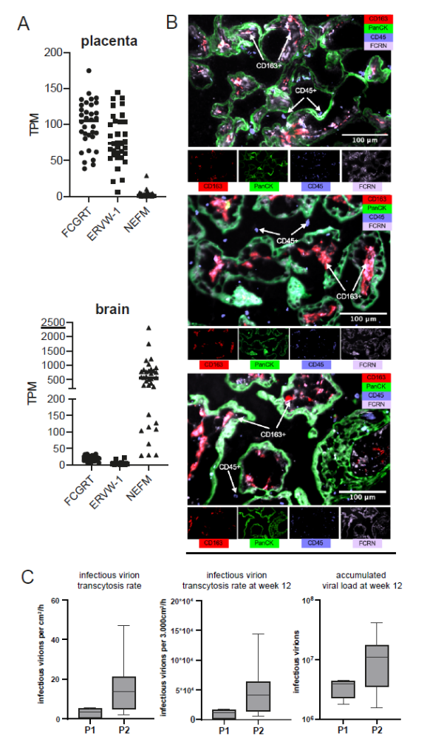
Fig. S2: A) FCGRT is expressed in the 1st trimester of pregnancy. Reanalysis of GEO dataset GSM5691255 (Benjamin A Devlin, Duke University). Next generation bulk RNA sequencing of 34 individuals of matched tissues (fetal brain and fetal placenta) from human fetuses collected via elective termination at 72-82 days post conception. RNA from human tissue was prepared for sequencing using an Illumina TrueSeq RNA Exome kit and sequenced on an Illumina NovaSeq 6000 configured for a S2 flow cell at 50bp PE. TPM = transcripts per million reads. FCGRT expression in placenta or brain was compared to a typical syncytiotrophoblast protein (Sycytin-1, ERVW-1) or a typical neuron protein (Neurofilament medium polypeptide, NEFM) B) Placental tissue imaging of a full-term human placenta and two early-second trimester (9wk) RM placentae, demonstrating robust FCRN expression on trophoblasts lining the villous wall (stained by pancytokeratin) and Hofbauer cells (stained by CD163) within the villi. Extravillous immune cells (CD45+) were found not to express FCRN. FcRn expression early trimester in imaging cytometry. C) Left: Transcytosis rate calculated from B. P1 and P2 indicated rates across TOs from two individual placentas. Middle: Week 12 placenta surface is estimated at 3.000cm². Right: Accumulated infectious virions over 12 weeks of gestation assuming continuous placenta surface growth until 3.000cm² and blood flow from week 10. Averages from 48 h transcytosis measurements extrapolated to total bottom chamber volume and accounting for removed samples at earlier timepoints. Box plots show range and median from individual calculations derived from separate measurements (P1 n=6; P2 n=8). TB40/E + IgG. Error bars are SD.
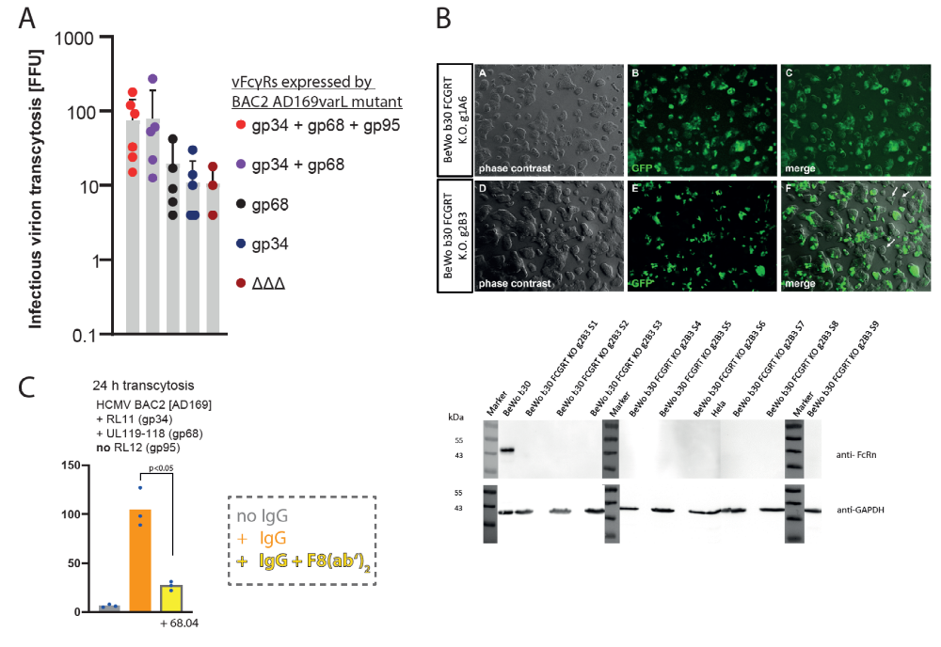
Fig. S3: A) Combined vFcγR deletion variants of BAC2-derived AD169varl were applied to a transcytosis culture assay as in Fig. 2. 48h time point on BeWo b30 cells. IgG is infliximab. Symbols show means of individual experiments performed in technical duplicates. Bars show means of measurements. Error bars = SD. ΔΔΔ = vFcγR deleted mutant B) Immunofluoresecence microscopy showing GFP expression of BeWo b30 cells following nucleofection with gRNAs according to the protocol of the OriGene KN2 CRISPR-KO Kit manufacturer. Two exemplary clones before subcloning. Western Blot shows FcRn expression of derived subclones compared to parental BeWo b30 cells or Hela cells. GAPDH loading control. C) Transcytosis of HCMV virions in the presence of human IgG1 (ofatumumab) +/- 68.04 F(ab’)₂. Unpaired t-test. Symbols indicate mean values from individual samples measured in technical triplicates. Bars show mean of measurements.

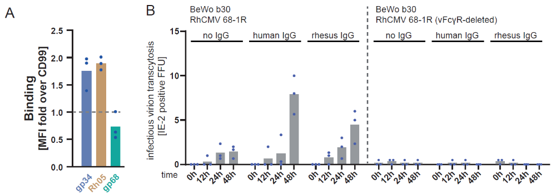
Fig. S4: A) RhCMV Rh05 binds human FcRn directly. As in Fig. 4. 293T cells stably expressing human CD20 were transfected to transiently co-express individual vFcγRs. Recombinant human FcRn (non-covalently complexed FCGRT and β2m) binding was detected via 6xHis-tag staining in flow cytometry. Symbols show mean of individual experiments (mean fluorescence intensity, MFI) performed in technical triplicates. Bars represent mean of measurements. B) Transcytosis assessment of RhCMV strain 68-1R or a vFcγR-deleted variant and at indicated timepoints probing with RhCMV and human IgG1 (trastuzumab) or rhesus IgG1 (rhesusised anti-RhCD4, OHSU, Portland OR, USA) or in the absence of IgG. Infectious virion transcytosis (FFU) was quantified in 100µl samples from the bottom chamber by titration on telomerised rhesus fibroblasts (TRF) using RhCMV-specific IE2 staining. Symbols represent individual experiments performed in technical triplicates. Bars represent mean of measurements. FFU per 100µl. symbols are independent experiments. Bars are mean of 3 independent experiments.

