Distinct skin transcriptional patterns among salamander populations across an ectoparasite infestation gradient
Daniele Romeo¹; Gena Yip¹; Anthony Lau¹
¹Division of Science, Wu Jieh Yee School of Interdisciplinary Studies, Lingnan University, Hong Kong, China

Corresponding author: Anthony Lau (antlau@ln.edu.hk (A. Lau))
Keywords: Paramesotriton hongkongensis, ectoparasitism, skin transcriptomics, host immune response.

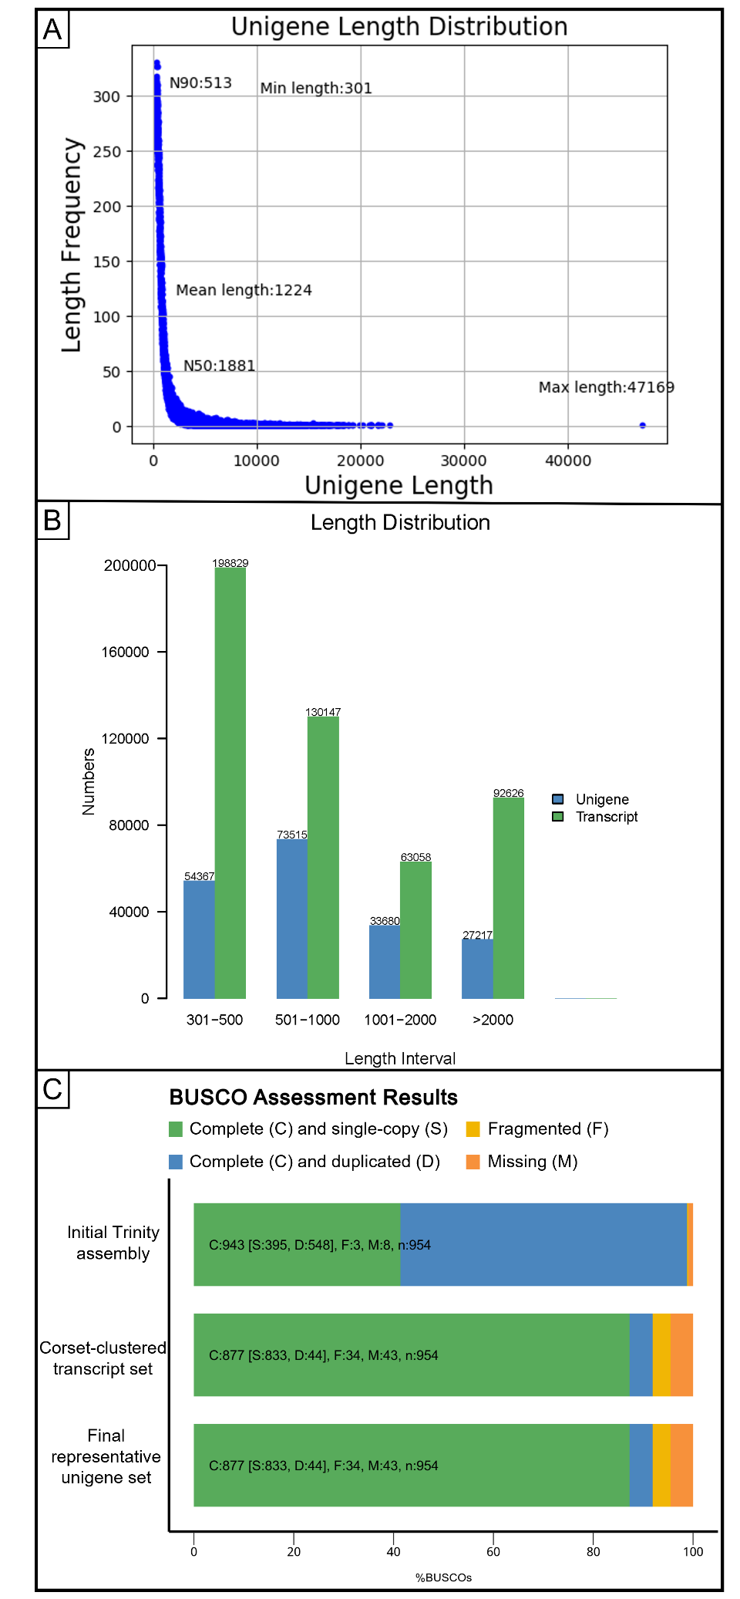
Supplementary Figures

Supplementary Figure 1: Assembly characteristics and completeness of the de novo transcriptome. (A) Length distribution of the 188,779 representative unigenes, with minimum, mean, maximum, N50 and N90 sequence lengths indicated. (B) Numbers of transcripts from the initial Trinity assembly and representative unigenes within four sequence-length intervals. (C) BUSCO assessment of the initial Trinity transcript assembly, the Corset-clustered transcript set and the final representative unigene set. Bars show the proportions of complete single-copy (S), complete duplicated (D), fragmented (F) and missing (M) orthologues among the 954 BUSCOs evaluated.
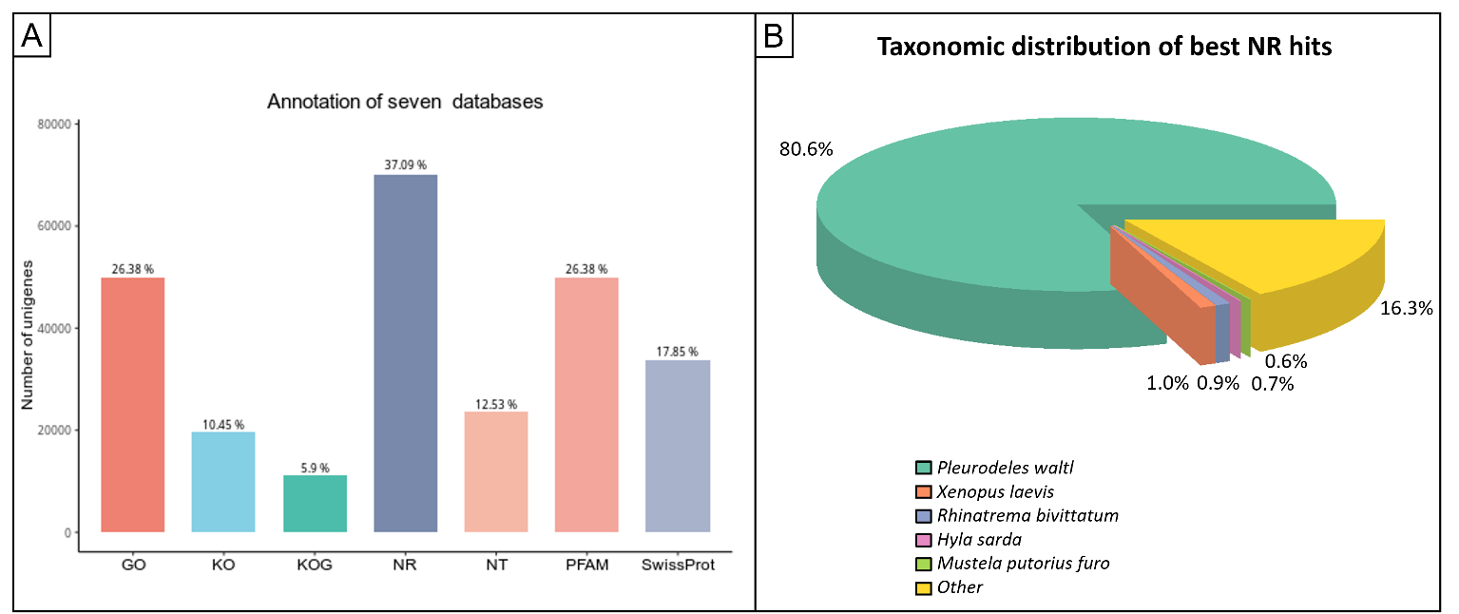
Supplementary Figure 2: Functional annotation of the final non-redundant reference transcriptome. (A) Number and percentage of representative unigenes annotated against the GO, KO, KOG, NR, NT, Pfam, and Swiss-Prot databases. (B) Taxonomic distribution of the best matches obtained for NR-annotated unigenes. The five most represented species are shown individually, while all remaining species are grouped as “Other”.

